1. Show Windows and Kali can communicate

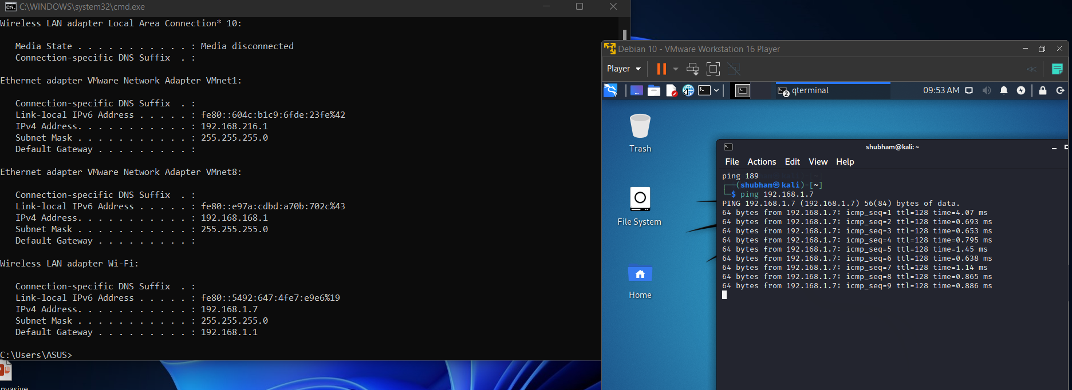

Ping windows ip on Kali VM

1. How to open RDP and new ports on windows VM

RDP PORT(3399):

If windows Pro then it can be turned on simply from Settings-> RDP Connection

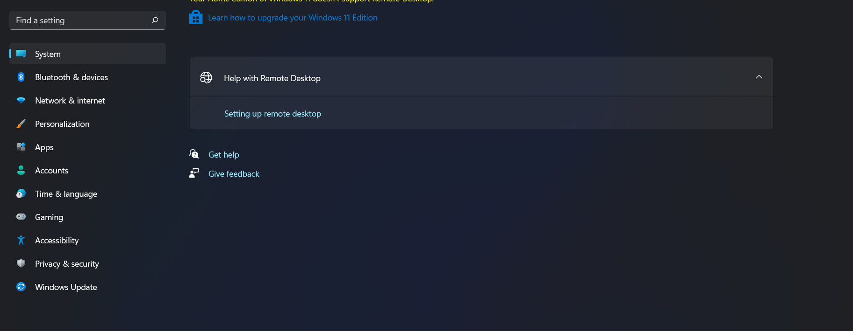

Else we need to install [Releases · stascorp/rdpwrap (github.com)](https://github.com/stascorp/rdpwrap/releases) for Windows Home

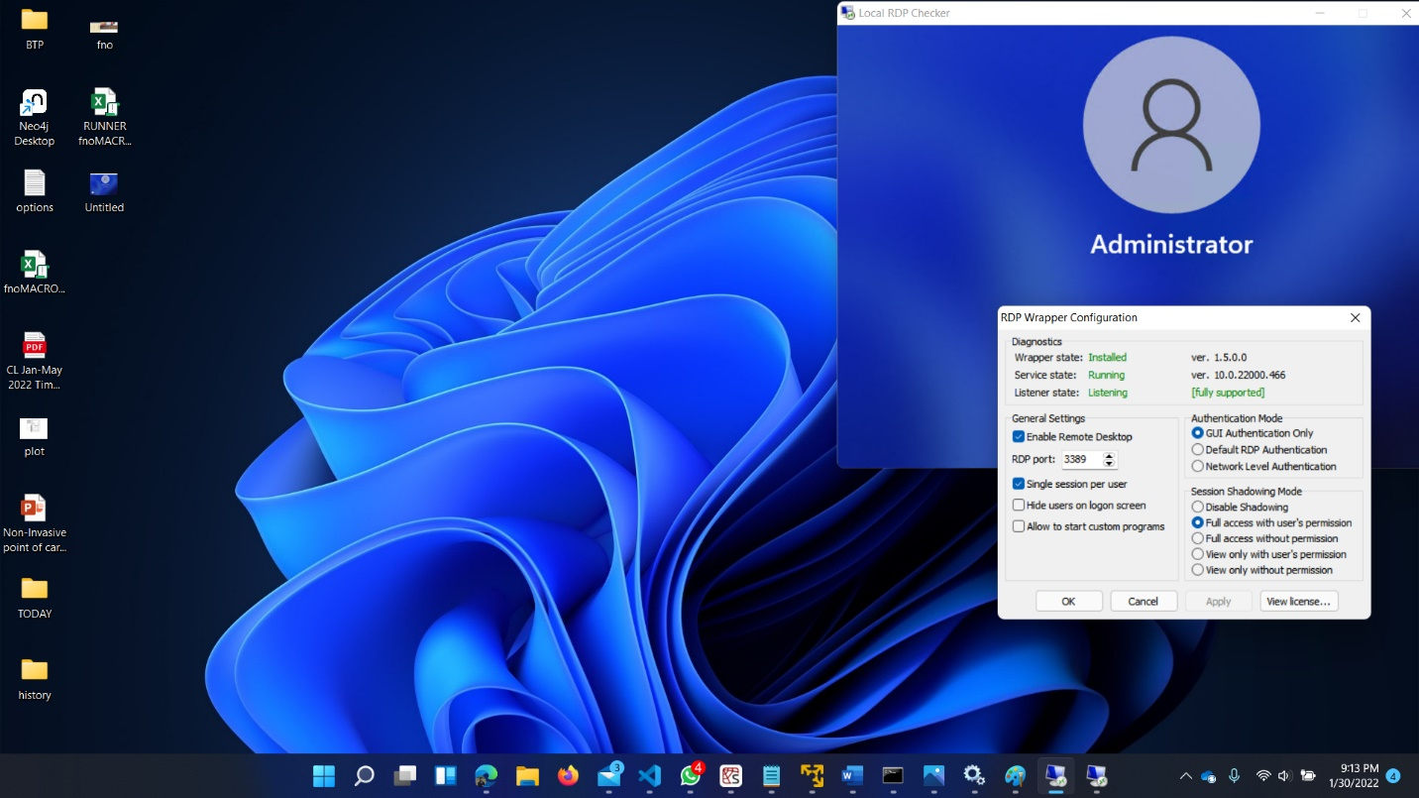

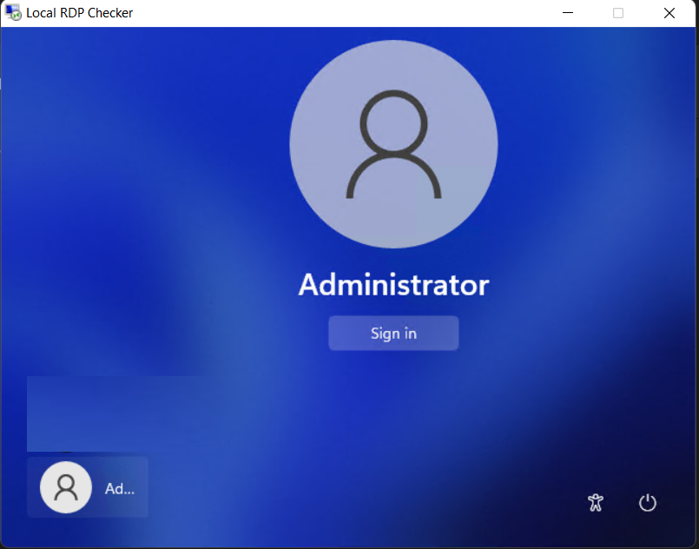

RDP: If its Kali linux we can use xrdp to setup RDP

New ports: using firewall and clicking new on inbound rules

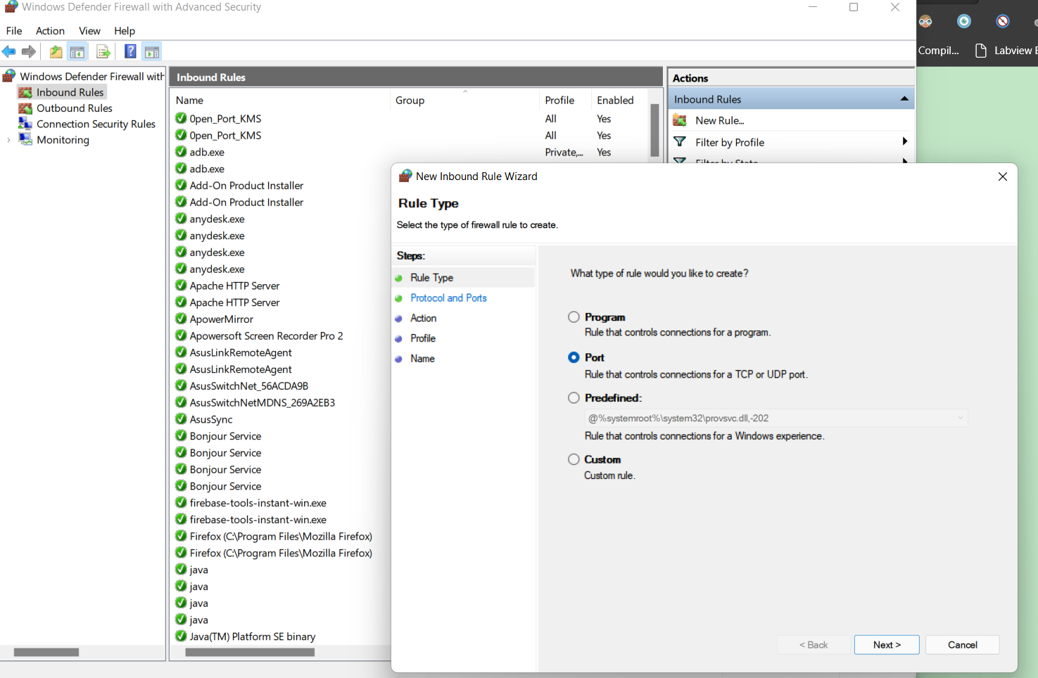

1. Nmap to scan ports on Windows VM

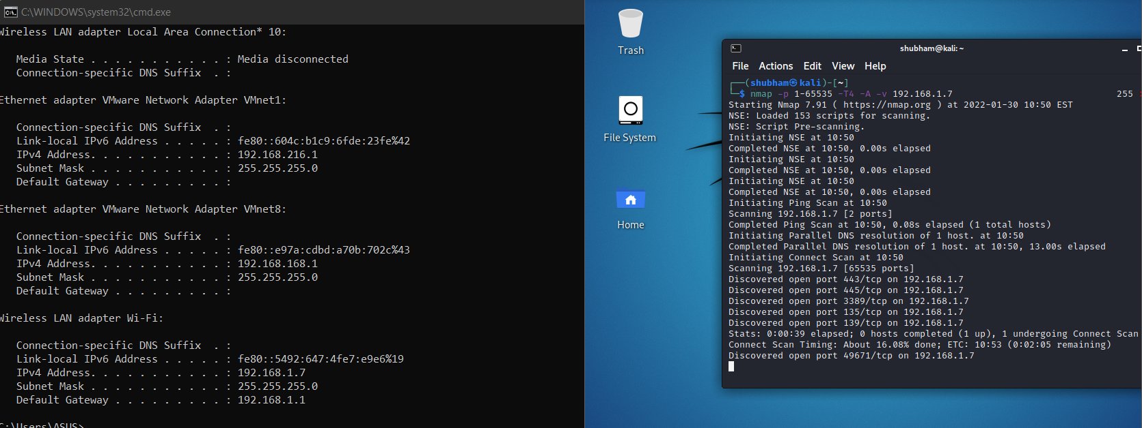

1. Firewall logs port scan shows Received Packets

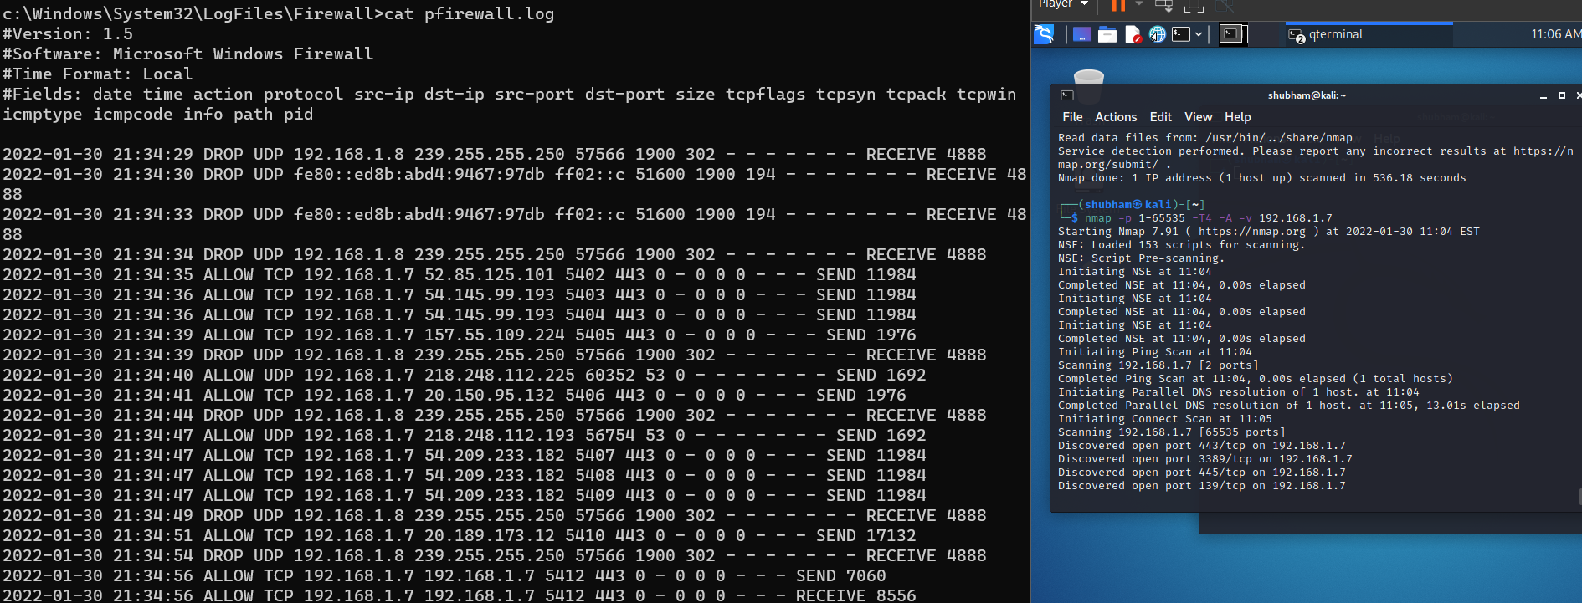

1. Firewall Logs Session connection

Using xfreerdp we can connect to windows VM from Kali VM

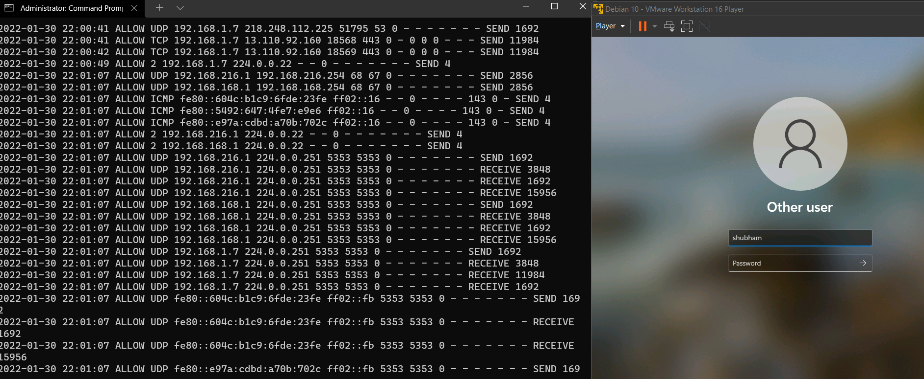

1. Wireshark on windows VM

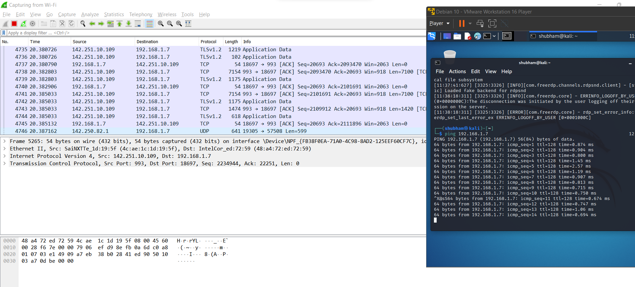

1. PING Wireshark

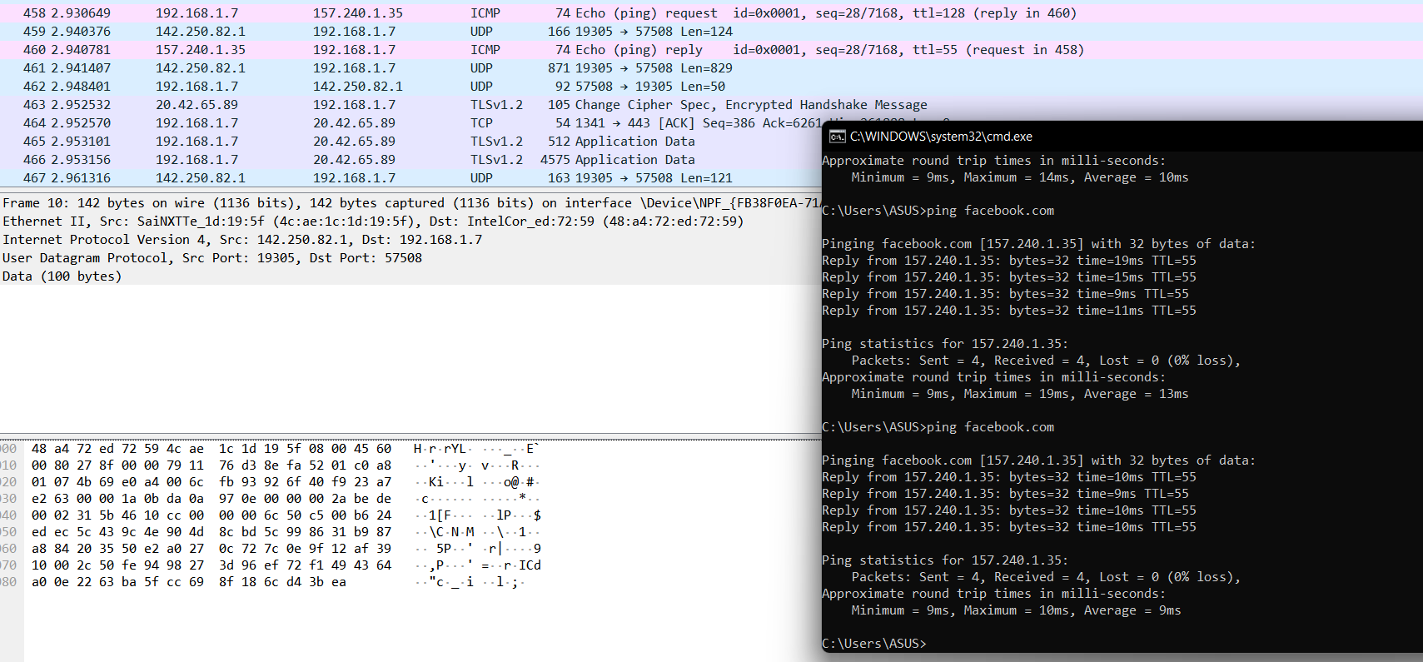

1. DNS

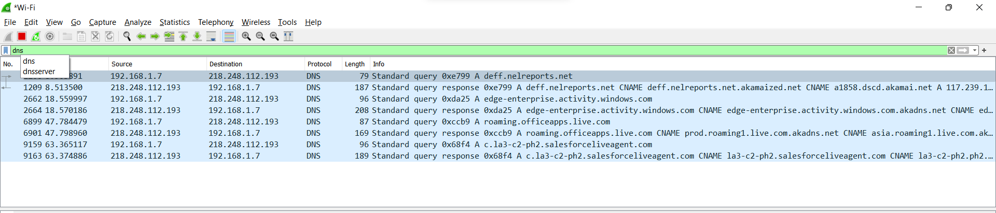

1. ICMP

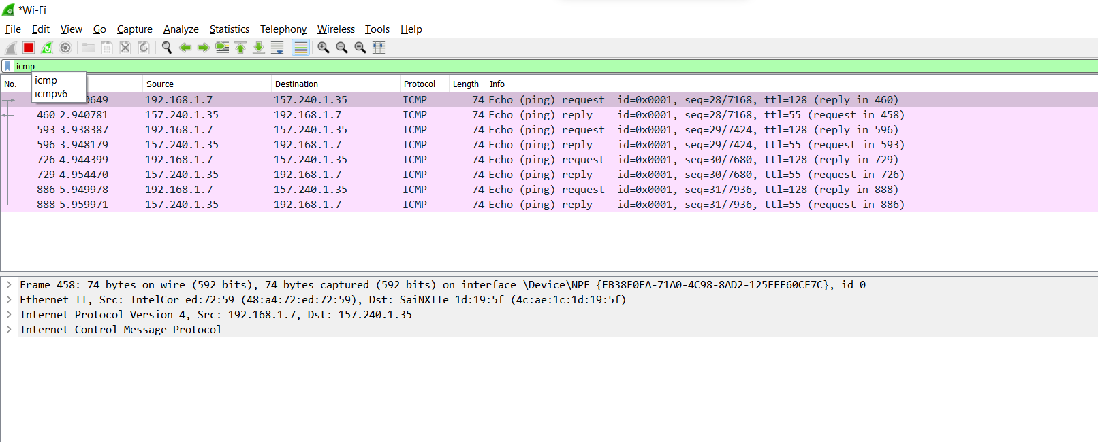

1. Website hello

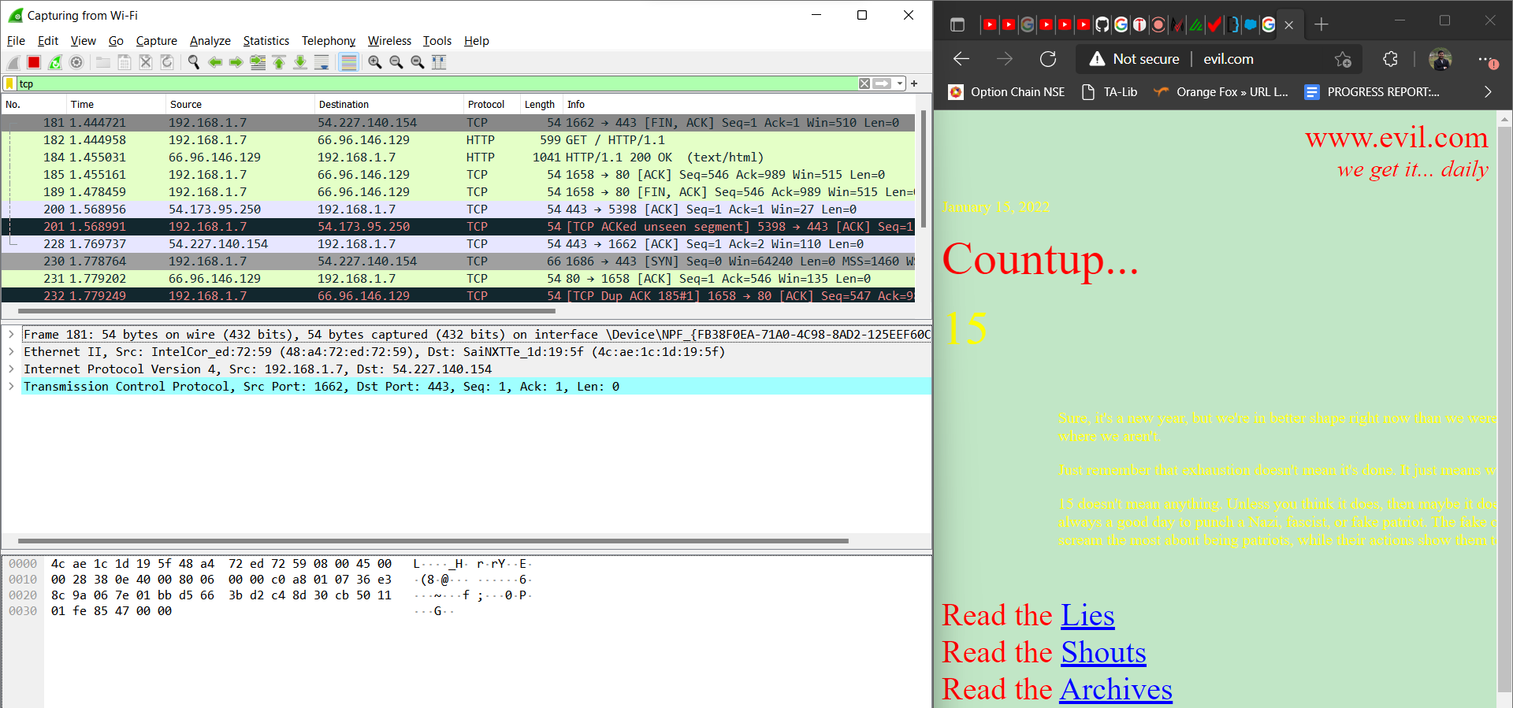

1. Website server ports shown in wireshark

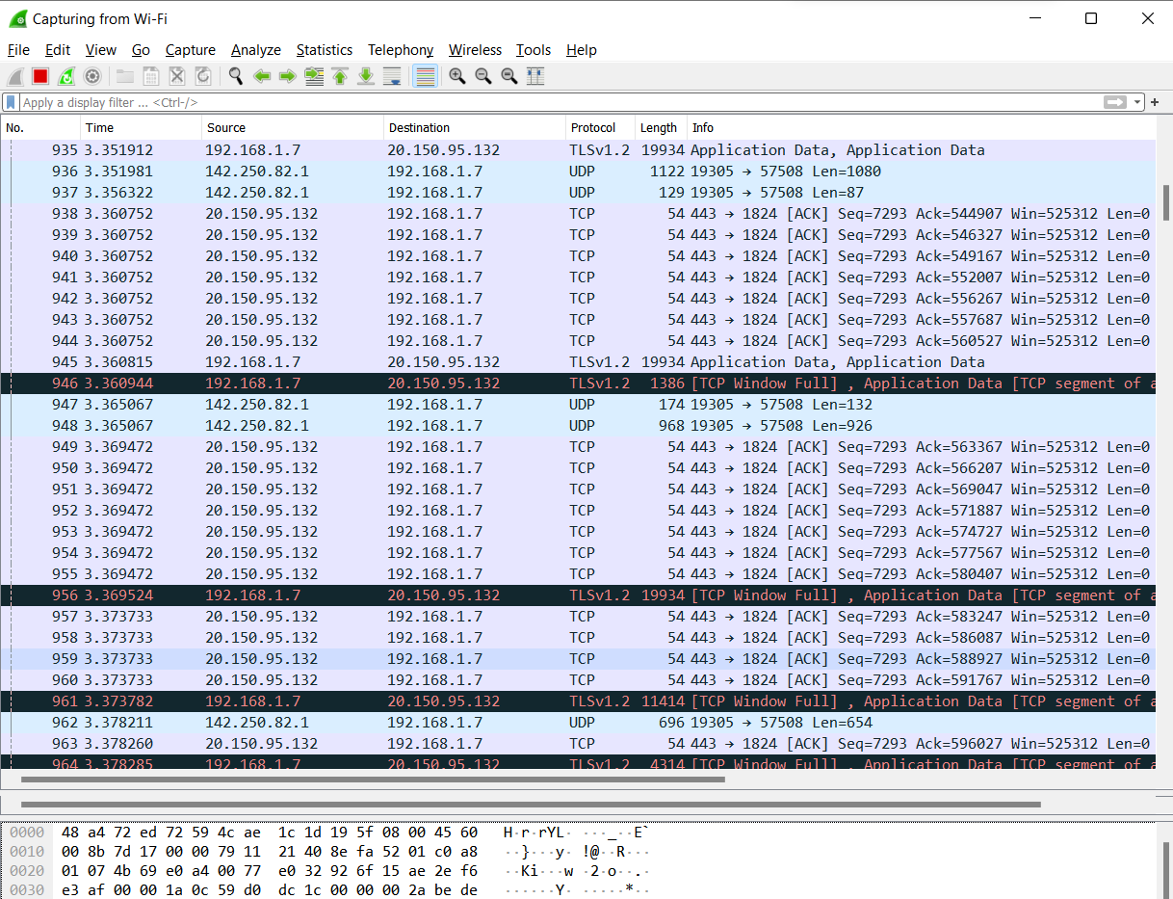

Or using nmap

