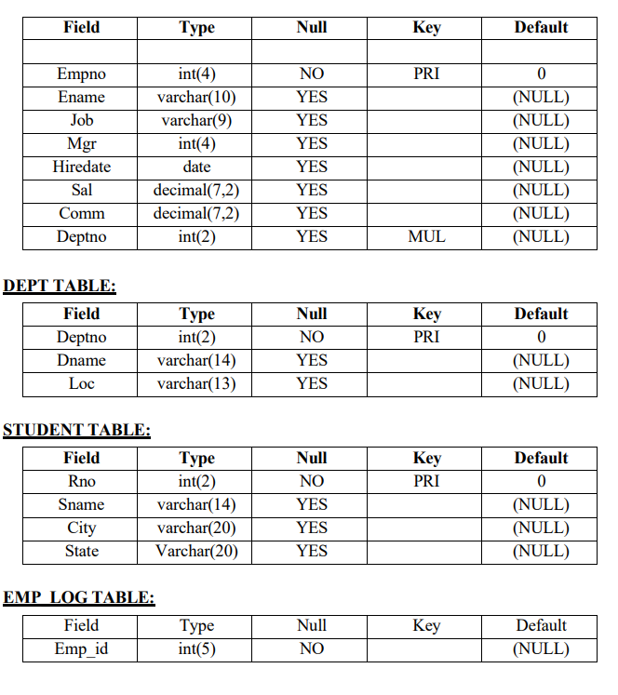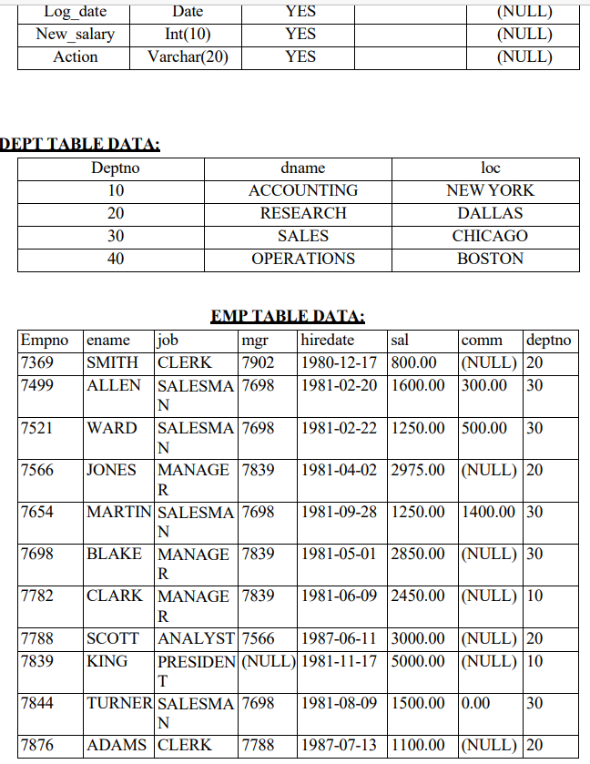

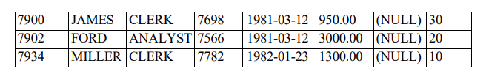

**Answer:**

CREATE DATABASE RDBMS_Java;

USE rdbms_java;

CREATE TABLE Emp_table

(

Empno INT(4) PRIMARY KEY,

Ename VARCHAR(10) NOT NULL,

Job VARCHAR(9) NOT NULL,

Mgr INT(4) NOT NULL,

Hiredate DATE NOT NULL,

Sal DECIMAL(7,2) NOT NULL,

Comm DECIMAL(7,2) NOT NULL,

Deptno INT(2) NOT NULL

);

CREATE TABLE Dept_Table

(

Deptno INT(2) PRIMARY KEY,

Dname VARCHAR(14) NOT NULL,

Loc VARCHAR(13) NOT NULL

);

CREATE TABLE Student_Table

(

Rno INT(2) PRIMARY KEY,

Sname VARCHAR(14) NOT NULL,

City VARCHAR(20)NOT NULL,

State VARCHAR(20) NOT NULL

);

CREATE TABLE Emp_Log_Table

(

Emp_id INT(5),

Log_date DATE NOT NULL,

New_Salary INT(10) NOT NULL,

ACTION VARCHAR(20) NOT NULL

);

INSERT INTO Dept_table VALUES(10,"Accounting","New York");

INSERT INTO Dept_table VALUES(20,"Research","Dallas");

INSERT INTO Dept_table VALUES(30,"Sales","Chicago");

INSERT INTO Dept_table VALUES(40,"Operations","Boston");

INSERT INTO Emp_table VALUES(7369,"Smith","Clerk",7902,'1980-12-17',800.00,NULL,20);

INSERT INTO Emp_table VALUES(7499,"Allen","Salesman",7698,'1981-02-20',1600.00,300.00,30);

INSERT INTO Emp_table VALUES(7521,"Ward","Salesman",7698,'1981-02-22',1250.00,500.00,30);

INSERT INTO Emp_table VALUES(7566,"Jones","manager",7839,'1981-04-02',2975.00,NULL,20);

INSERT INTO Emp_table VALUES(7654,"Martin","Salesman",7698,'1981-09-28',1250.00,1400.00,30);

INSERT INTO Emp_table VALUES(7698,"Blake","Manager",7839,'1981-05-01',2850.00,NULL,30);

INSERT INTO Emp_table VALUES(7782,"Clark","Manager",7839,'1981-06-09',2450.00,NULL,10);

INSERT INTO Emp_table VALUES(7788,"Scott","Analyst",7566,'1987-06-11',3000.00,NULL,20);

INSERT INTO Emp_table VALUES(7839,"King","President",NULL,'1981-11-17',5000.00,NULL,10);

INSERT INTO Emp_table VALUES(7844,"Turner","Salesman",7698,'1981-08-09',1500.00,0.00,30);

INSERT INTO Emp_table VALUES(7876,"Adams","Clerk",7788,'1987-07-13',1100.00,NULL,20);

INSERT INTO Emp_table VALUES(7900,"James","Clerk",7698,'1981-03-12',950.00,NULL,30);

INSERT INTO Emp_table VALUES(7902,"Ford","Analyst",7566,'1981-03-12',3000.00,NULL,20);

INSERT INTO Emp_table VALUES(7934,"Miller","Clerk",7782,'1982-01-23',1300.00,NULL,10);

1. Select unique job from EMP table.

Answer: SELECT * FROM emp_table WHERE Job="President";

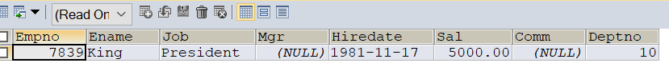

2. List the details of the emps in asc order of the Dptnos and desc of Jobs?

Answer: SELECT * FROM emp_table ORDER BY deptno ASC, job DESC;

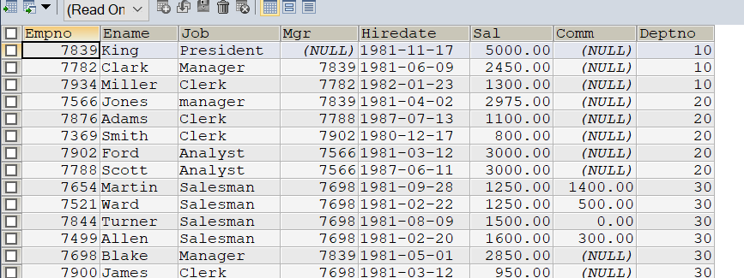

3. Display all the unique job groups in the descending order?

Answer: SELECT DISTINCT job FROM emp_table ORDER BY job DESC;

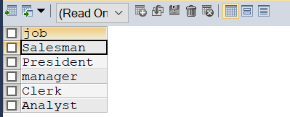

4. List the emps who joined before 1981

Answer: SELECT * FROM Emp_table WHERE hiredate < '1981-01-01';

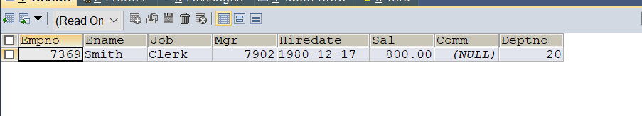

5. List the Empno, Ename, Sal, Daily sal of all emps in the asc order of Annsal

Answer: SELECT empno,ename,sal,(sal/30) AS Daily_sal,(sal*12) AS Annaul_sal FROM emp_table ORDER BY annaul_sal ASC;

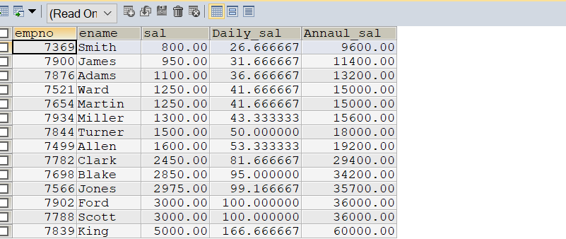

6. List the Empno, Ename, Sal, Exp of all emps working for Mgr 7369.

Answer: SELECT empno,ename,sal,ROUND((CURRENT_DATE - hiredate)/365) AS EXP FROM emp_table WHERE mgr=7369;

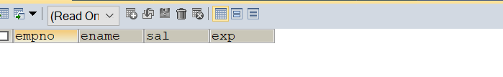

7. Display all the details of the emps who’s Comm. Is more than their Sal?

Answer: SELECT * FROM emp_table WHERE comm > sal;

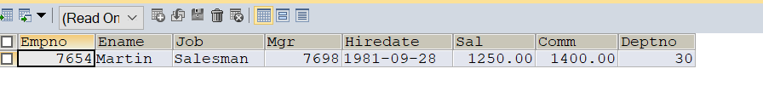

8. List the emps who are either ‘CLERK’ or ‘ANALYST’ in the Desc order

Answer: SELECT * FROM emp_table WHERE job="Clerk" OR job="Analyst" ORDER BY job DESC;

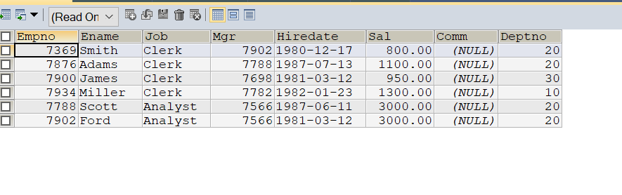

9. List the emps Who Annual sal ranging from 22000 and 45000.

Answer: SELECT * FROM emp_table WHERE (sal*12) BETWEEN 22000 AND 45000;

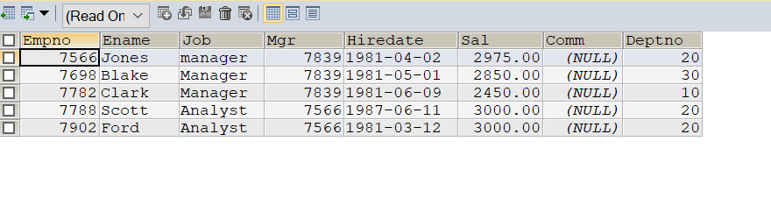

10. List the Enames those are starting with ‘S’ and with five characters.

Answer: SELECT ename FROM emp_table WHERE ename LIKE 's____%';

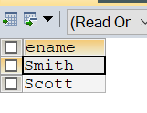

11. List the emps whose Empno not starting with digit78

Answer: SELECT * FROM emp_table WHERE empno NOT LIKE '78%';

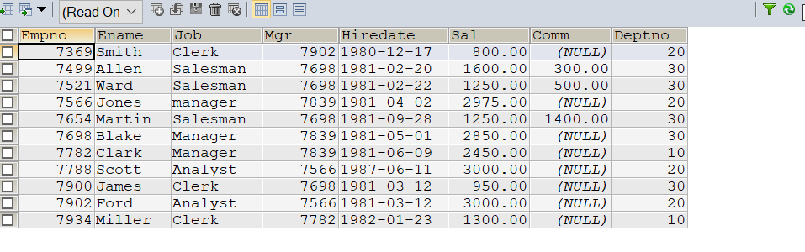

12. List all the Clerks of Deptno 20.

Answer: SELECT * FROM emp_table WHERE job="Clerk" AND deptno=20;

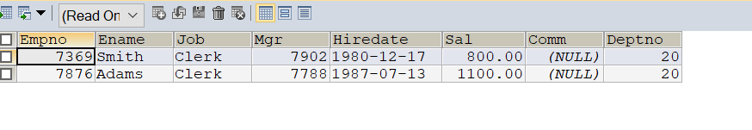

13. List the Emps who are senior to their own MGRS.

Answer:

14. List the Emps of Deptno 20 who’s Jobs are same as Deptno10.

Answer: SELECT * FROM emp_table WHERE deptno=20 AND job IN(SELECT DISTINCT job FROM emp_table WHERE deptno=10);

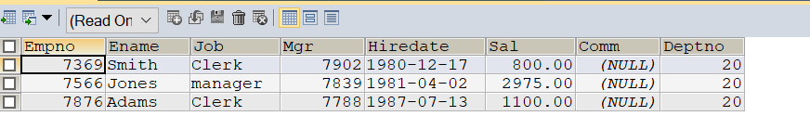

15. List the Emps who’s Sal is same as FORD or SMITH in desc order of Sal.

Answer: SELECT * FROM emp_table WHERE sal=(SELECT sal FROM emp_table WHERE ename="Ford") OR sal=(SELECT sal FROM emp_table WHERE ename="Smith") ORDER BY sal DESC;

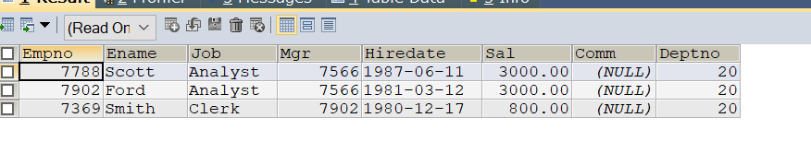

16. List the emps whose jobs same as SMITH or ALLEN

Answer: SELECT * FROM emp_table WHERE job=(SELECT job FROM emp_table WHERE ename="Smith") OR job=(SELECT job FROM emp_table WHERE ename="Allen");

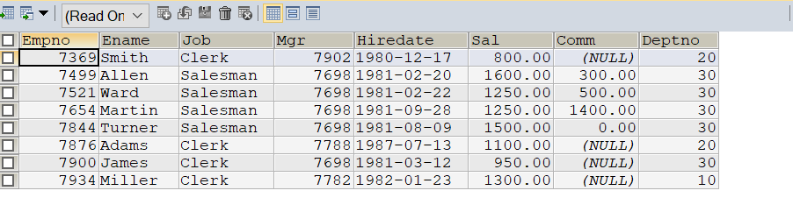

17. Any jobs of deptno 10 those that are not found in deptno 20.

Answer: SELECT * FROM emp_table WHERE deptno=10 AND job NOT IN(SELECT DISTINCT job FROM emp_table WHERE deptno=20);

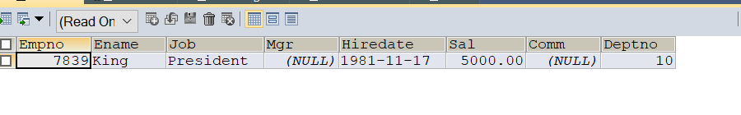

18. Find the highest sal of EMP table

Answer: SELECT MAX(sal) AS Highest_Salary FROM emp_table;

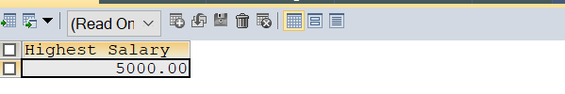

19. Find details of highest paid employee.

Answer: SELECT * FROM emp_table WHERE sal=5000.00;

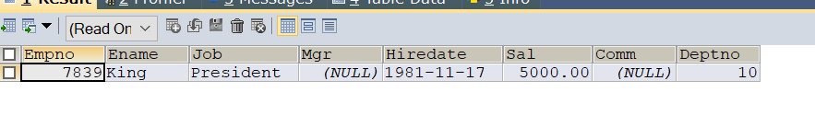

20. Find the total sal given to the MGR

Answer: SELECT SUM(sal) AS total_sal FROM emp_table WHERE empno IN (SELECT DISTINCT mgr FROM emp_table WHERE mgr IS NOT NULL);

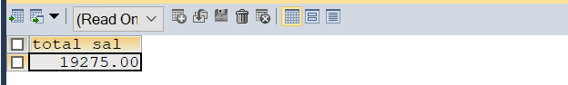

21. List the emps whose names contains ‘A’

Answer: SELECT * FROM emp_table WHERE ename LIKE 'A%';

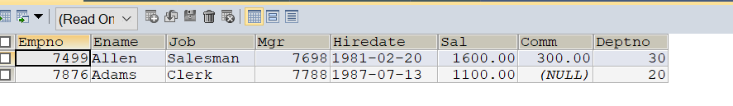

22. Find all the emps who earn the minimum Salary for each job wise in ascending order.

Answer: SELECT * FROM Emp_table e WHERE sal=(SELECT MIN(sal) FROM emp_table WHERE job=e.job) ORDER BY job ASC;

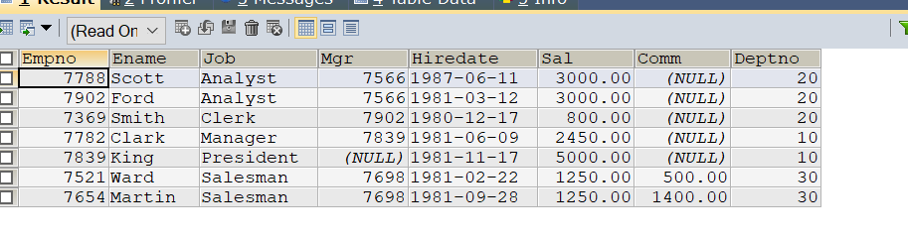

23. List the emps whose sal greater than Blake’s sal.

Answer: SELECT * FROM emp_table WHERE sal > (SELECT sal FROM emp_table WHERE ename="Blake");

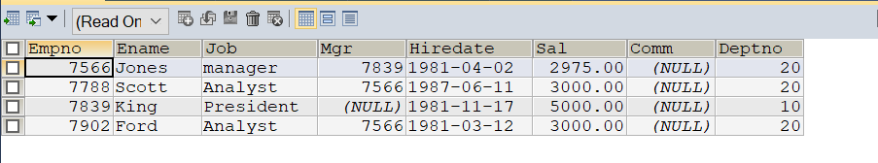

24. Create view v1 to select ename, job, dname, loc whose deptno are same

Answer: CREATE VIEW v1 AS SELECT e.ename,e.job,d.dname,d.loc FROM emp_table e JOIN dept_table d WHERE e.deptno=d.deptno;

