**TOPS** TECHNOLOGIES

Training | Outsourcing | Placement | Study Abroad

**Software Engineering**

**Assignment**

**Module:- 1**

SE – Overview of IT Industry

**1. What is software? What is software engineering?**

**Answer :** **Software** is the set of instruction , data or program used to operate computer and execute the specific Tasks.

**Software Engineering** that deals with the design, development, testing and maintenance of software applications. Software Engineer apply principle and knownledge of programming languages to built Software.

**2. Explain types of software.**

**Answer : Types of Software:-**

* System Software
* Application Software
* Driver Software
* Middleware Software
* Programming Software

**System Software:-**

**System Software** is software that directly operates the Computer Hardware and provides the basic functionality to the users as well as to the other software to operate smoothly.

Example:-Calculator, Calender, Clock, etc.

**Application Software:-**

Software that performs special functions or provides functions that are much more than the basic operation of the computer is known as **Application Software.**

Example:-Facebook, Whatsapp, Instagram, Bgmi, etc.

**3. What is SDLC? Explain each phase of SDLC**

**Answer :** Software Development Life Cycle(SDLC)

-A step by step approach to develop any product/software with high quality, lowest cost with Shortest possible time.

Phases of SDLC:-

**Planning and Requirment**

Planning is a crucial step in everything, just as in software development. In this same stage, requirement analysis is also performed by the developers of the organization.

**Analysis**

In this stage, all the requirements for the target software are specified. These requirements get approval from customers.

And Analysis by Software Requirement Specification.

**Designing**

Software Requirements Specification is a reference for software designers to come up with the best architecture for the software.

**Implementation**

At this stage, the fundamental development of the product starts. For this, developers use a specific programming code as per the design.

**Testing and Integration**

After the development of the product, testing of the software is necessary to ensure its smooth execution.

**Maintenance**

After detailed testing, the conclusive product is released in phases as per the organization’s strategy. Then it is tested in a real industrial environment. It is important to ensure its smooth performance.

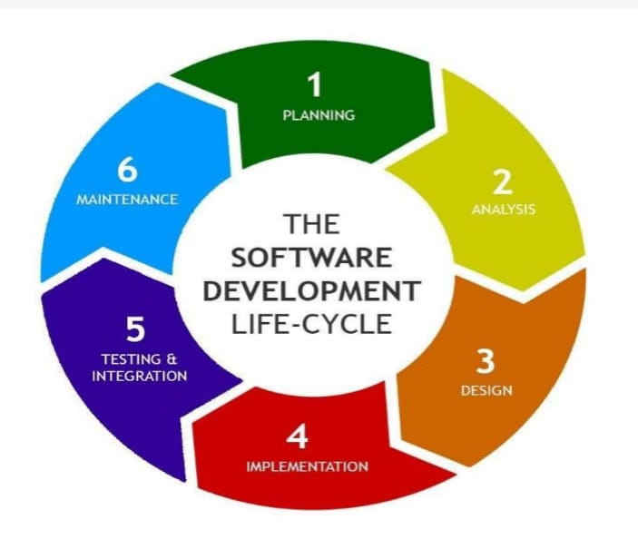

**4. What is DFD? Create a DFD diagram on Flipkart.**

**Ans.** Data Flow Diagram (DFD) is a graphical representation used to visualize the flow of data through a system. It helps to illustrate how data moves from input to output, highlighting the processes that transform data and how data is stored and utilized.

Component of DFD:-

-External Entity

-Process

-Data Flow

-Data Store

**-:DFD Diagram of Flipkart:-**

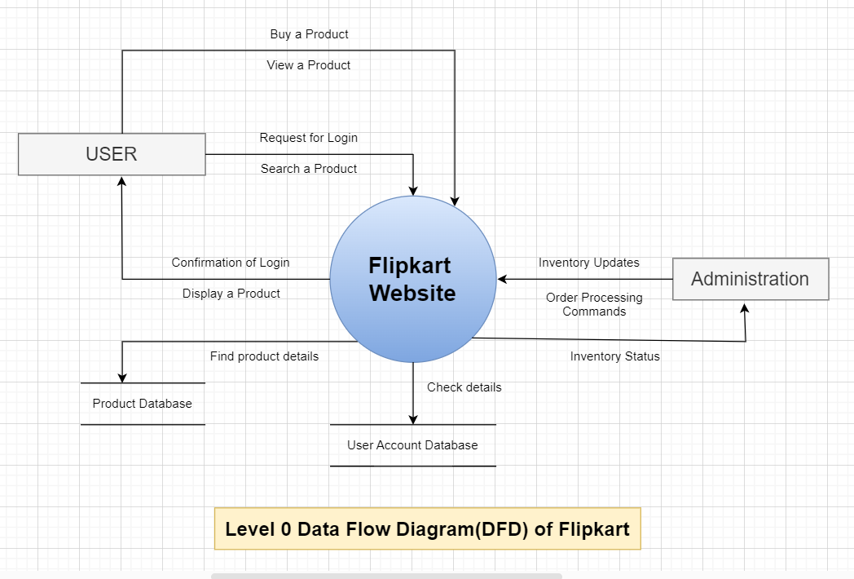

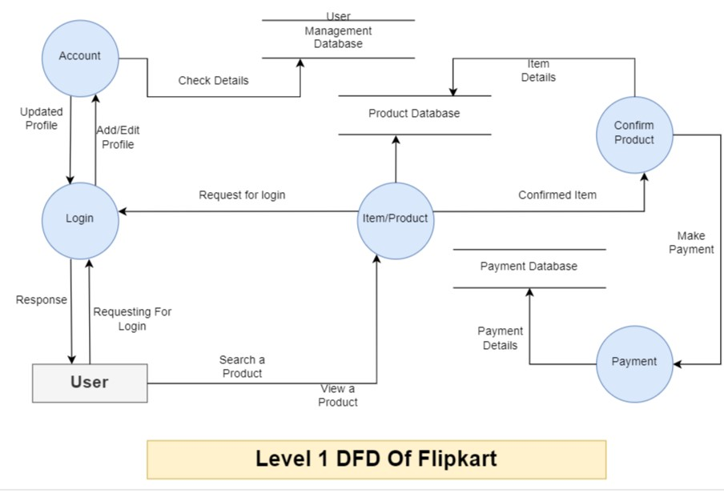

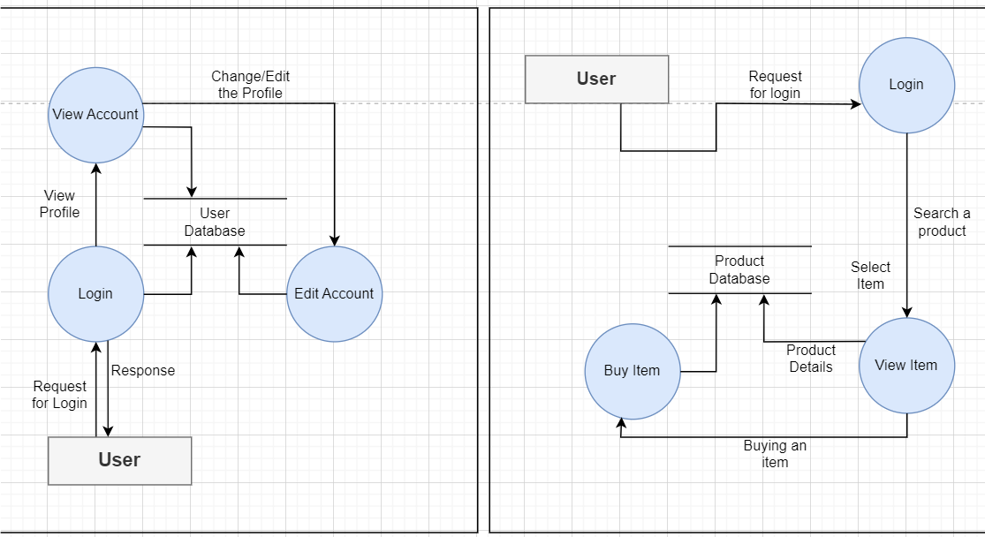

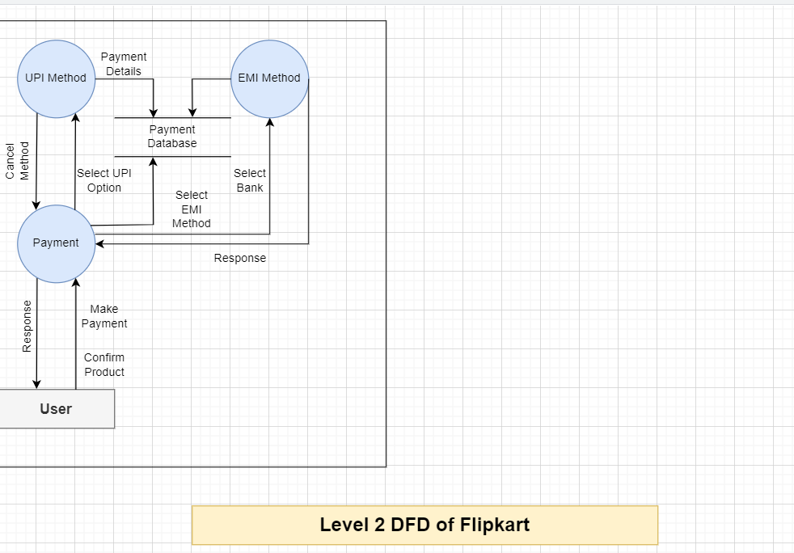

**Description of level 0 DFD on Flipkart:-**

**User to Flipkart:**

-User can buy the product/item or view the details about the product.

-User can login or Registration their username, Password and Mobile no., etc into the website

**Flipkart to User:**

-They First of all check the user details in the database then confirm their login.

-If the user search the product site will display the product.

**Administration to Flipkart:**

-Order Processing Command to the site and inventory updates gives to the site.

**Description of Level 1 DFD of Flipkart:**

-User can requesting for login in the login process then they response back to the User

-In Account process user can change or edit the profile.

-In Product Process we can search a product ,compare the product that they display from the the product database.

-After selecting the product we confirm the order and doing further process.

-At the end we select the payment option to make a payment which is store in payment database.

**Description of Level 2 DFD of Flipkart:**

1. Account Process:

-User first of all register or login in the site. They fill the details which is store in User management Database.

-We can add or edit the profile in the account process.

2) Product/Item Process:

-User can search the product. Site will display a number of product related to their search.

-User can select the item and view the details about the item in details.

-At the end if the User want that product they select buy option for further process.

1. Payment Process:

-If the User performing all the process at the end there is a payment process in that you can select the option of payment that how the payment you pay for example: UPI, Debit/Credit Card, COD, etc.

-That all are store in the Payment Database as **we mention in above Level 2 DFD Diagram.**

**5. What is Flow chart? Create a flowchart to make addition of two numbers.**

**Ans.** Flowchart is a graphical representation of an algorithm. Programmers often use it as a program-planning tool to solve a problem. It makes use of symbols which are connected among them to indicate the flow of information and processing.

**Flowchart of addition of two number**

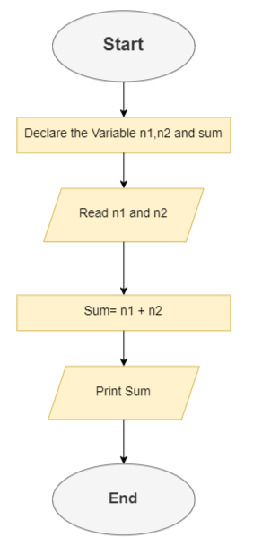

**6. What is Use case Diagram? Create a use-case on bill payment on paytm.**

**Ans.** A Use Case Diagram is a vital tool in system design, it provides a visual representation of how users interact with a system. It serves as a blueprint for understanding the functional requirements of a system.

**Use Case Diagram of bill payment on paytm.**

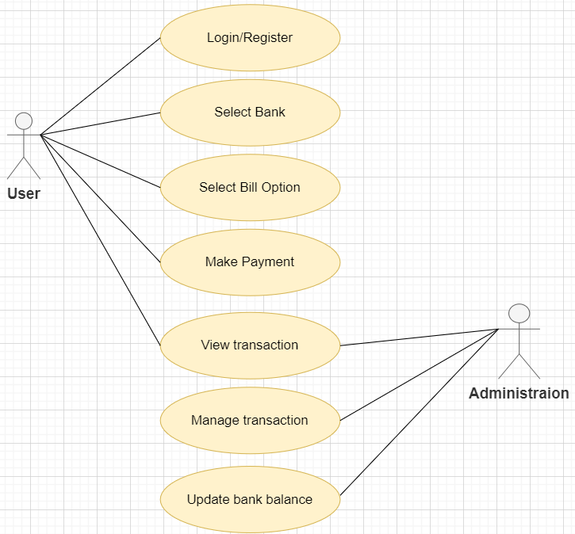

**Submitted By Ansari Amanhusain Kalimuddin**