|  |
| --- |
| **TOPS** TECHNOLOGIES |

Training | Outsourcing | Placement | Study Abroad

**Software Engineering**

**Assignment**

**Module:-3**

OOPS Concept

1. WAP to print “Hello World” using C++

Ans:-

Input:-

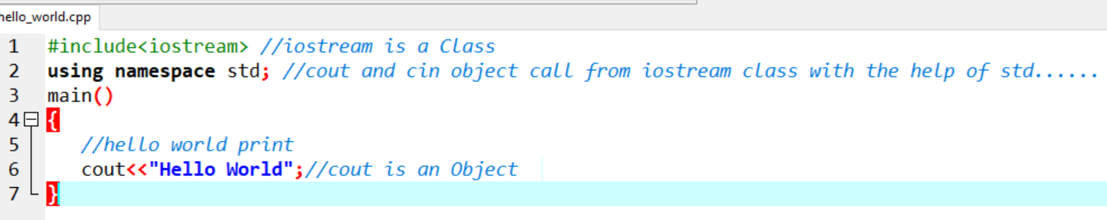

Output:-

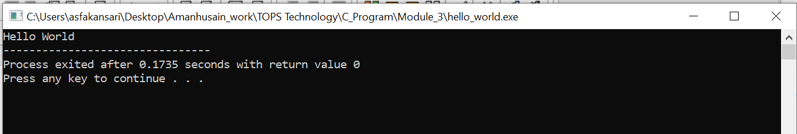

1. What is OOP? List OOP concepts

Ans :- Object-oriented programming (OOP) is a programming model that organizes code around objects and classes instead of functions and logic. In OOP, programs are made up of objects that interact with each other, and these objects can contain data and code.

There are some basic concepts that act as the building blocks of OOPs i.e.

* Class
* Object
* Encapsulation
* Abstraction
* Polymorphism
* Inheritance

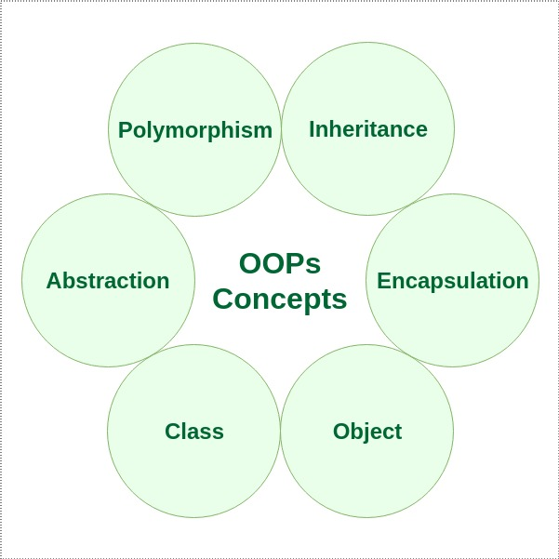

1. What is the difference between OOP and POP?

Ans :-

|  |  |
| --- | --- |
| OOPS | POP |
| Program is divided into objects. | Program is divided into functions. |
| Bottom-up approach. | Top-down approach. |
| It uses access specifier. | It doesn’t use access specifier. |
| Adding new data and functions is easy | Expanding new data and functions is not easy. |
| The existing code can be reused. | No code reusability. |
| use for solving big problems. | Not suitable for solving big problems |
| C++, Java | C |

**Submitted By :- Ansari Amanhusain Kalimuddin**