|  |
| --- |
| **SQL Queries** |

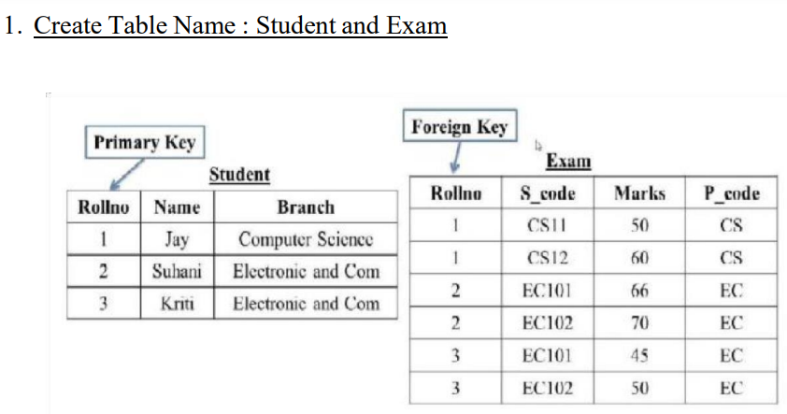

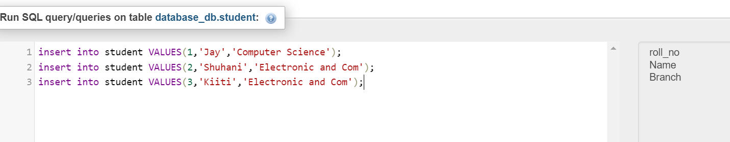

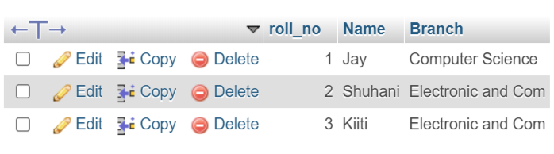

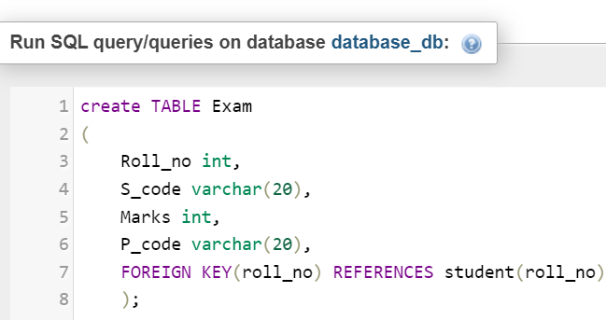

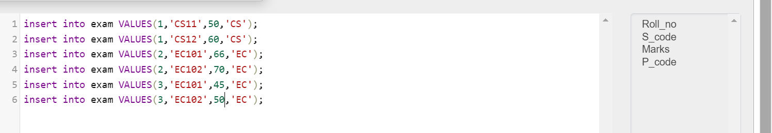

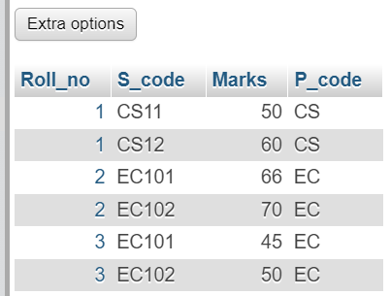

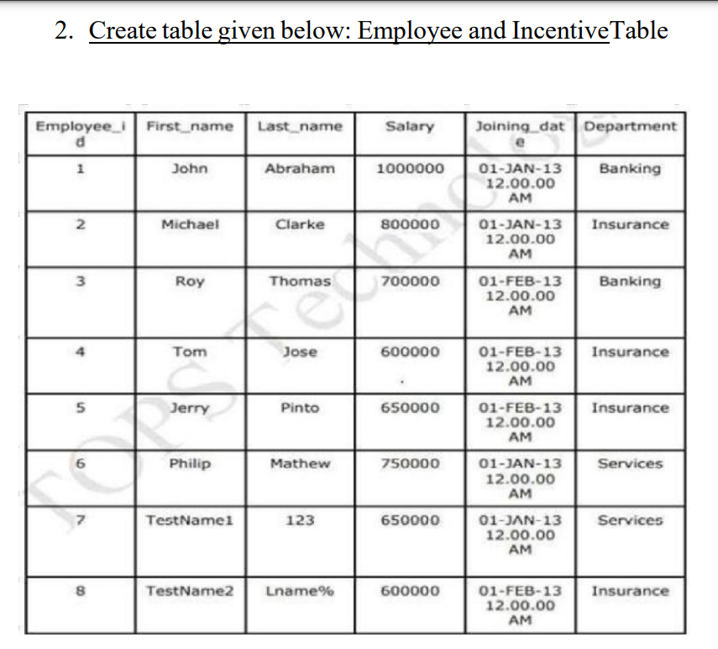

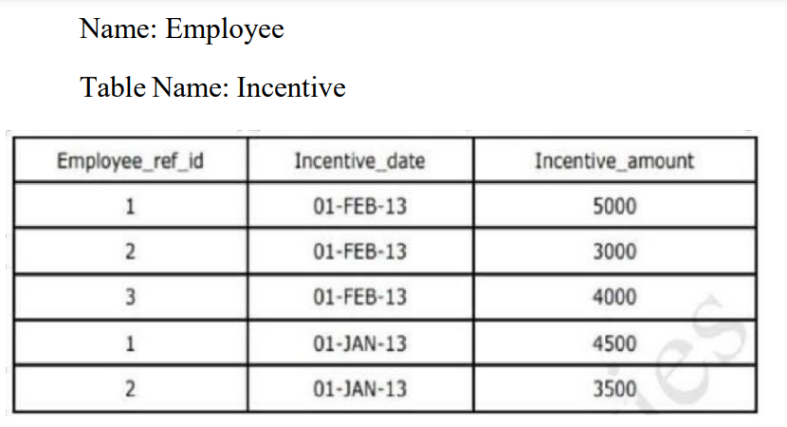

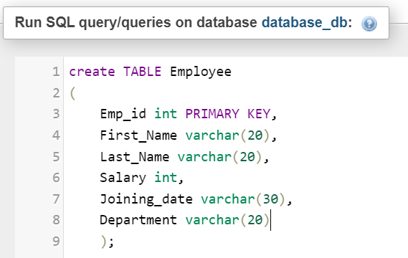

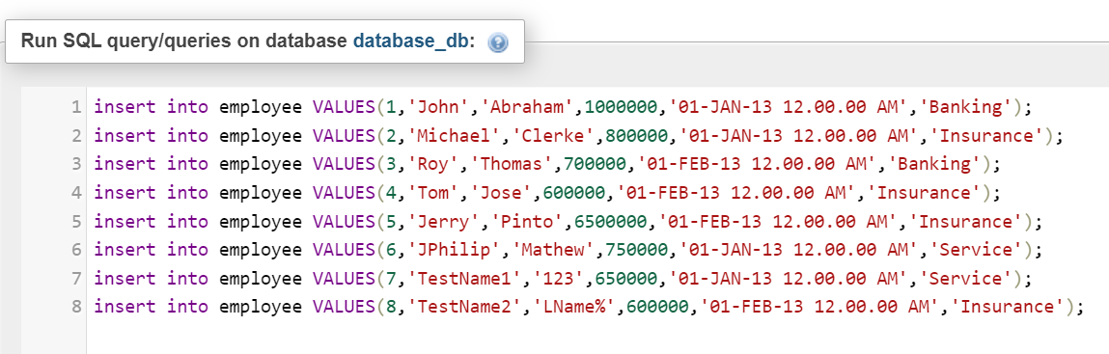

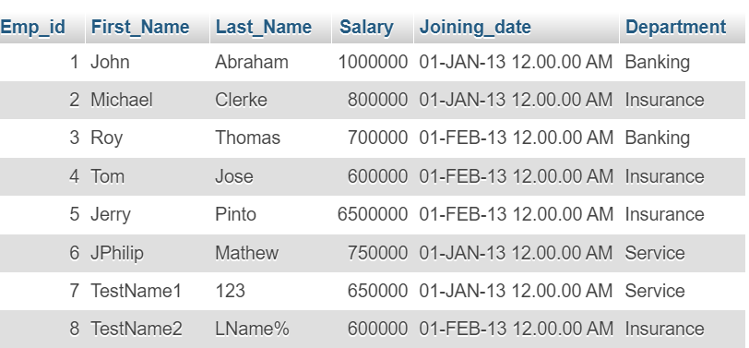

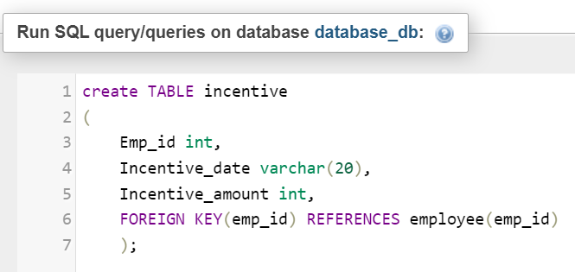

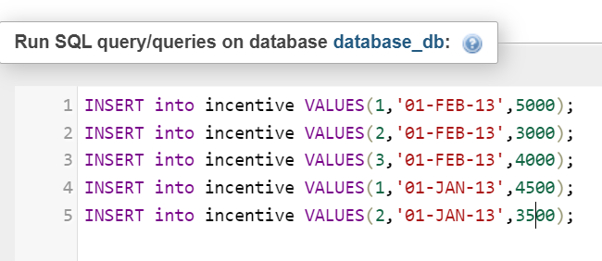

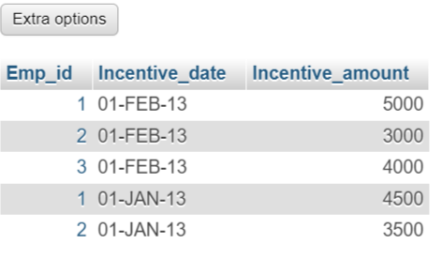

3. Get First_Name from employee table using Tom name “Employee Name”.

Answer : [SELECT](http://localhost/phpmyadmin/url.php?url=https://dev.mysql.com/doc/refman/8.0/en/select.html) First_Name from employee where first_name='Tom';

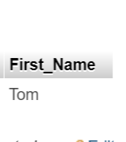

4. Get FIRST_NAME, Joining Date, and Salary from employee table.

Answer : [SELECT](http://localhost/phpmyadmin/url.php?url=https://dev.mysql.com/doc/refman/8.0/en/select.html) first_name,Joining_date,salary from employee;

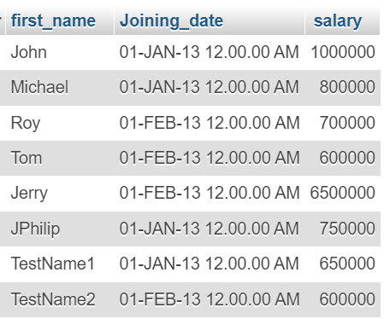

5. Get all employee details from the employee table order by First_Name

Ascending and Salary descending?

Answer : [SELECT](http://localhost/phpmyadmin/url.php?url=https://dev.mysql.com/doc/refman/8.0/en/select.html) * FROM `employee` ORDER BY First_Name,Salary DESC;

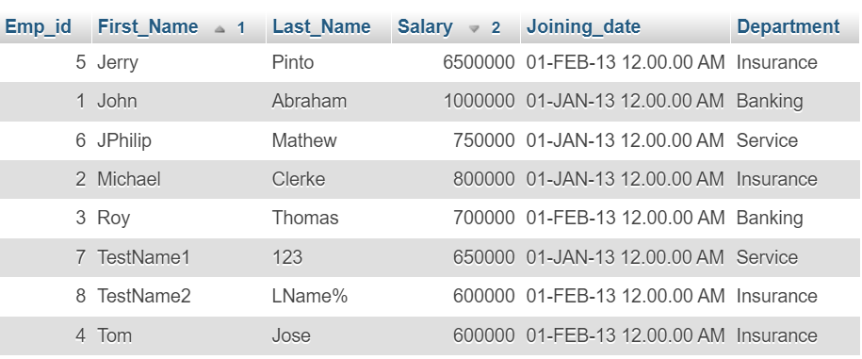

6. Get employee details fromemployee table whose first name contains ‘J’.

Answer : [SELECT](http://localhost/phpmyadmin/url.php?url=https://dev.mysql.com/doc/refman/8.0/en/select.html) * FROM `employee` where First_Name [like](http://localhost/phpmyadmin/url.php?url=https://dev.mysql.com/doc/refman/8.0/en/string-comparison-functions.html%23operator_like) 'j%';

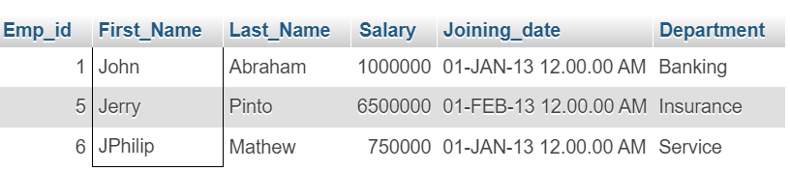

7. Get department wise maximum salary from employee table order by salary ascending.

Answer : [SELECT](http://localhost/phpmyadmin/url.php?url=https://dev.mysql.com/doc/refman/8.0/en/select.html) department,[MAX](http://localhost/phpmyadmin/url.php?url=https://dev.mysql.com/doc/refman/8.0/en/aggregate-functions.html%23function_max)(Salary) as 'Maximum Salary' from employee GROUP BY Department ORDER BY Salary;

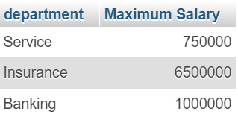

9. Select first_name, incentive amount from employee and incentives table forthose employees who have incentives and incentive amount greater than 3000.

Answer : [SELECT](http://localhost/phpmyadmin/url.php?url=https://dev.mysql.com/doc/refman/8.0/en/select.html) e.first_name, i.incentive_amount from employee e INNER JOIN incentive i on e.emp_id=i.Emp_id WHERE i.Incentive_amount > 3000;

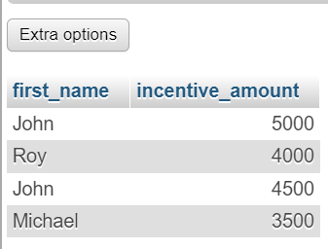

10. Create After Insert trigger on Employee table which insert records in view table.

Answer :-

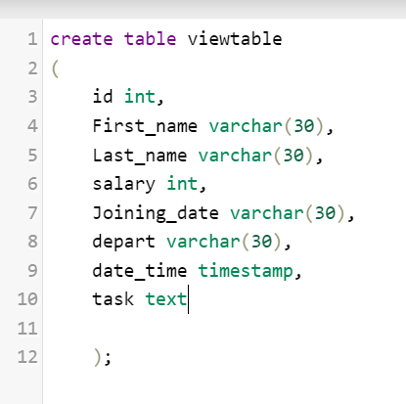

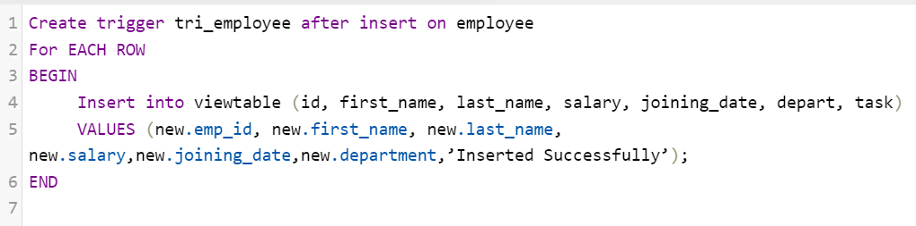

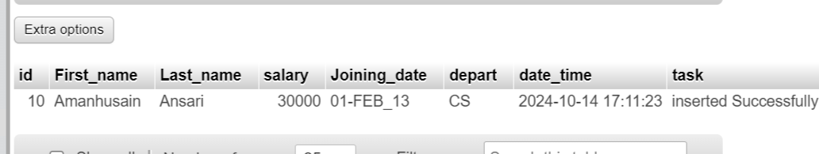

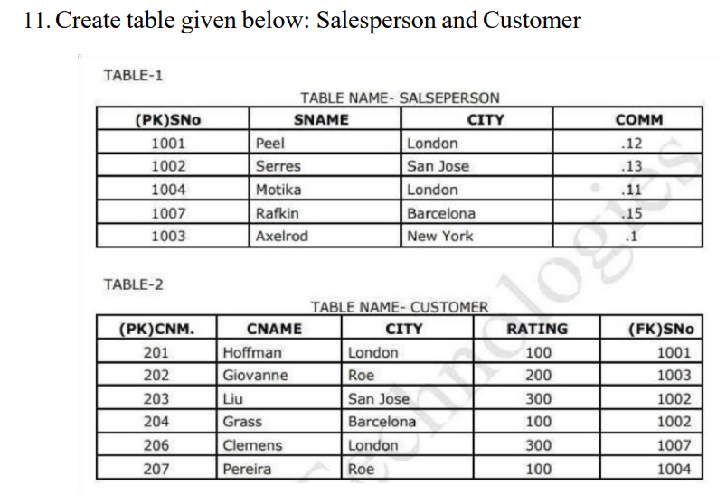

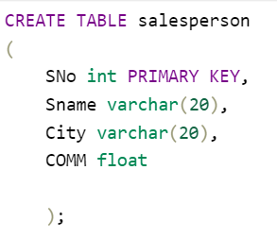

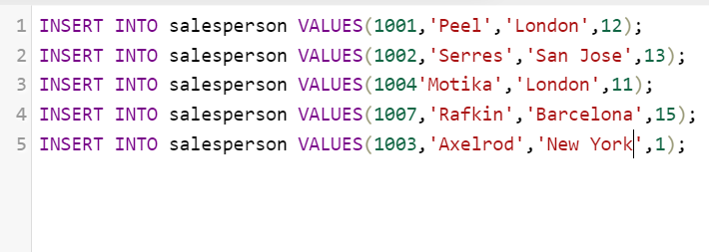

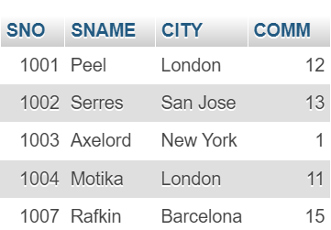

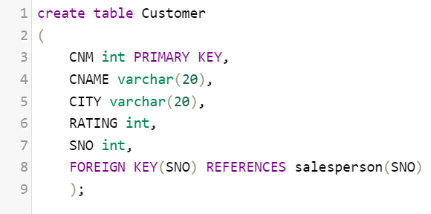

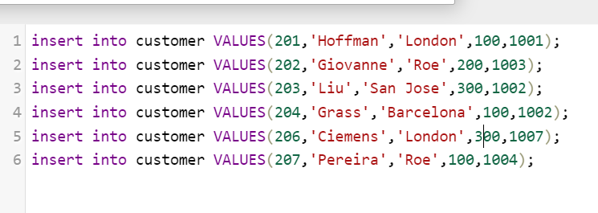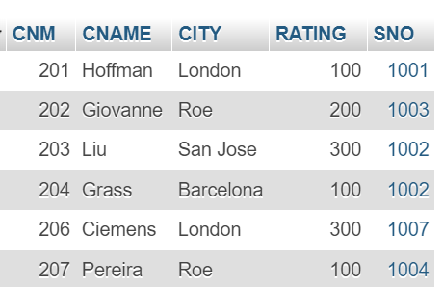

13. All Customer name whose rating is more than 100.

Answer :- [SELECT](http://localhost/phpmyadmin/url.php?url=https://dev.mysql.com/doc/refman/8.0/en/select.html) * FROM customer where RATING > 100;

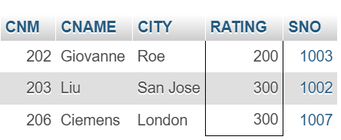

14.Names and cities of all salespeople in London with commission above 0.12.

Answer :- [SELECT](http://localhost/phpmyadmin/url.php?url=https://dev.mysql.com/doc/refman/8.0/en/select.html) SName, CITY from salesperson where CITY='London' [AND](http://localhost/phpmyadmin/url.php?url=https://dev.mysql.com/doc/refman/8.0/en/logical-operators.html%23operator_and) COMM > 0.12;

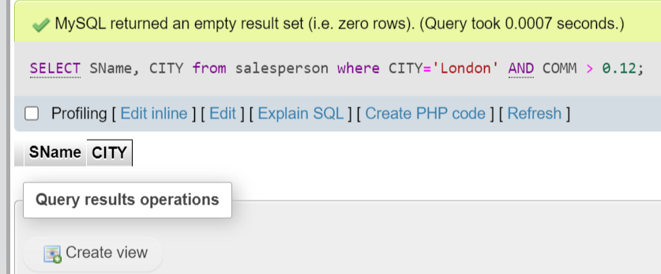

15.All salespeople either in Barcelona or in London.

Answer :- [SELECT](http://localhost/phpmyadmin/url.php?url=https://dev.mysql.com/doc/refman/8.0/en/select.html) * from salesperson WHERE CITY = 'Barcelona' [OR](http://localhost/phpmyadmin/url.php?url=https://dev.mysql.com/doc/refman/8.0/en/logical-operators.html%23operator_or) CITY = 'London';

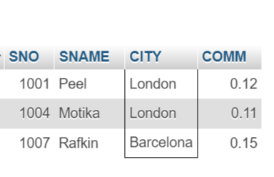

16. All salespeople with commission between 0.10 and 0.12. (Boundary values should be excluded).

Answer :- [SELECT](http://localhost/phpmyadmin/url.php?url=https://dev.mysql.com/doc/refman/8.0/en/select.html) * from salesperson where COMM BETWEEN 0.10 [AND](http://localhost/phpmyadmin/url.php?url=https://dev.mysql.com/doc/refman/8.0/en/logical-operators.html%23operator_and) 0.12;

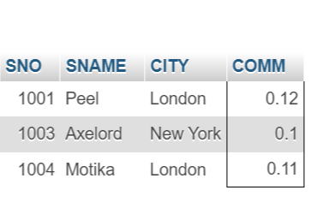

17. All customers excluding those with rating <= 100 unless they are located in Rome.

Answer :- [SELECT](http://localhost/phpmyadmin/url.php?url=https://dev.mysql.com/doc/refman/8.0/en/select.html) * FROM customer WHERE RATING <= 100 [AND](http://localhost/phpmyadmin/url.php?url=https://dev.mysql.com/doc/refman/8.0/en/logical-operators.html%23operator_and) CITY = 'Roe';

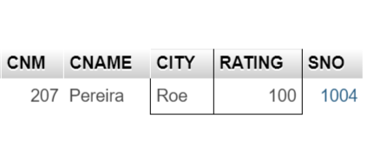

18. Write a SQL statement that displays all the information about all salespeople.

Answer :-

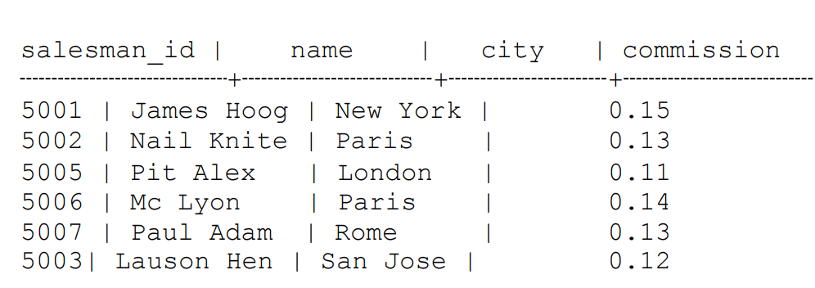

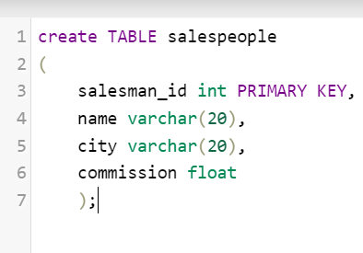

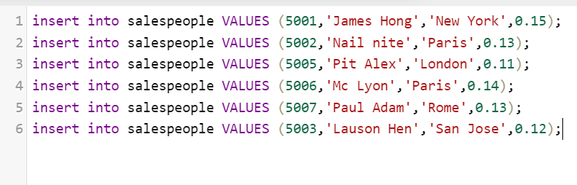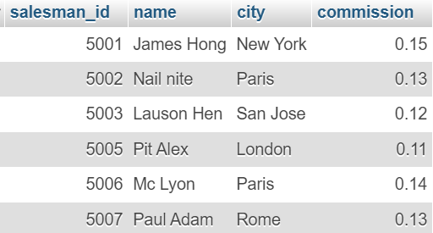

19. From the following table, write a SQL query to find orders that are delivered by a salesperson with ID. 5001. Return ord_no, ord_date, purch_amt.

Answer :-

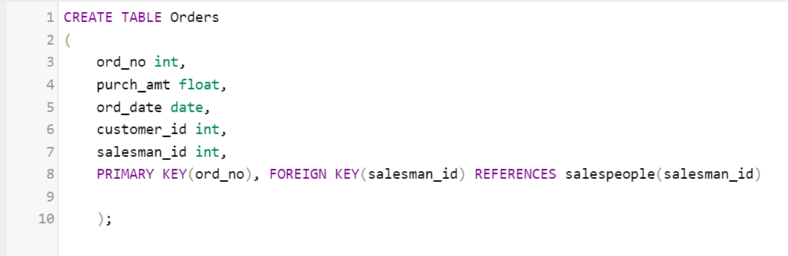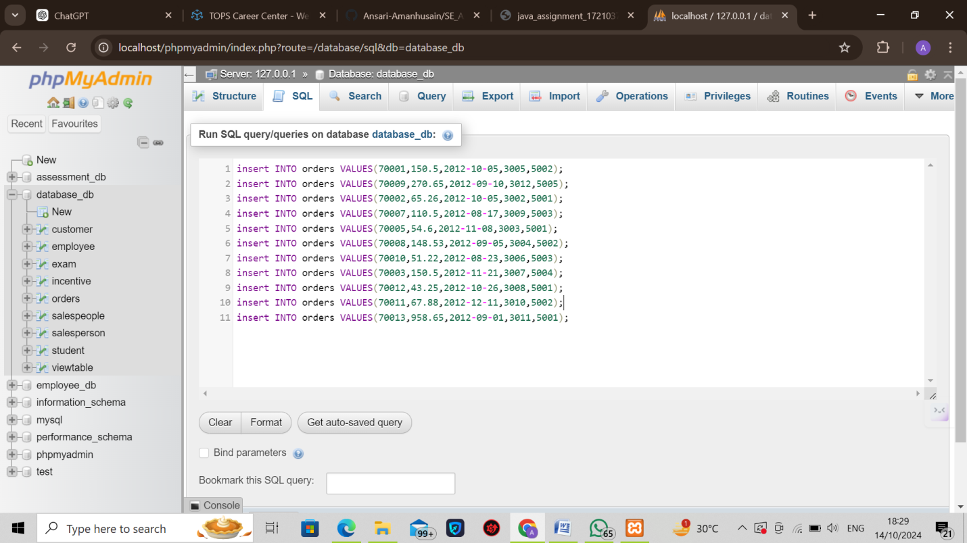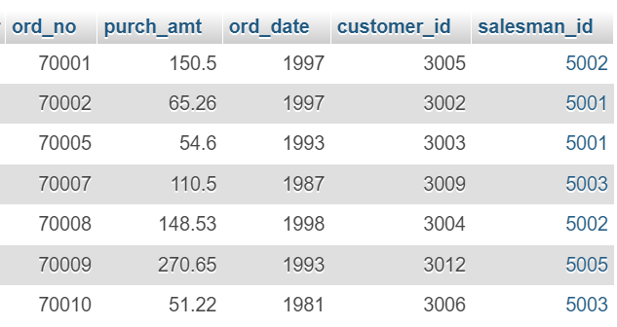

[SELECT](http://localhost/phpmyadmin/url.php?url=https://dev.mysql.com/doc/refman/8.0/en/select.html) ord_no,ord_date,purch_amt from orders WHERE salesman_id=5001;

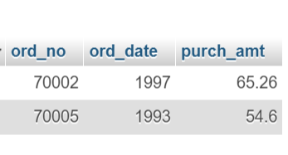

20. From the following table, write a SQL query to select a range of products whose price is in the range Rs.200 to Rs.600. Begin and end values are included. Return pro_id, pro_name, pro_price, and pro_com.

Sample table: item_mast

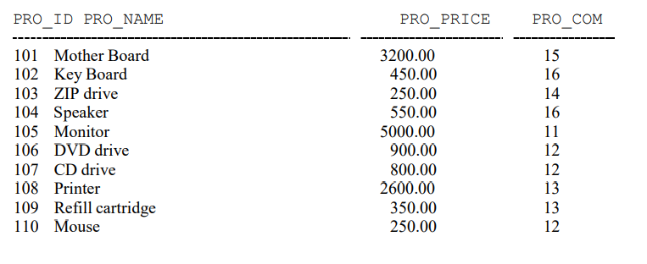

Answer :-

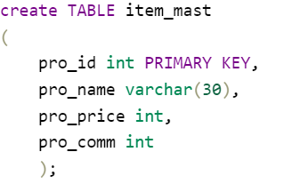

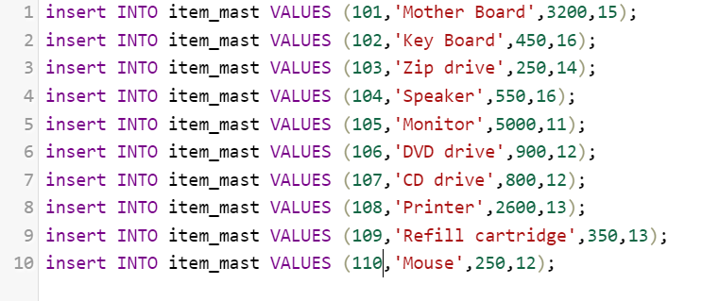

[SELECT](http://localhost/phpmyadmin/url.php?url=https://dev.mysql.com/doc/refman/8.0/en/select.html) * FROM `item_mast` WHERE pro_price BETWEEN 200 [AND](http://localhost/phpmyadmin/url.php?url=https://dev.mysql.com/doc/refman/8.0/en/logical-operators.html%23operator_and) 600;

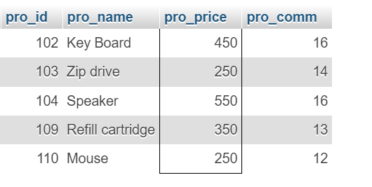

21. From the following table, write a SQL query to calculate the average price for a manufacturer code of 16. Return avg.

Answer :-

[SELECT](http://localhost/phpmyadmin/url.php?url=https://dev.mysql.com/doc/refman/8.0/en/select.html) [AVG](http://localhost/phpmyadmin/url.php?url=https://dev.mysql.com/doc/refman/8.0/en/aggregate-functions.html%23function_avg)(pro_price) AS average from item_mast where pro_comm=16;

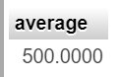

22. From the following table, write a SQL query to display the pro_name as 'Item Name' and pro_priceas 'Price in Rs.'

Answer :-

[SELECT](http://localhost/phpmyadmin/url.php?url=https://dev.mysql.com/doc/refman/8.0/en/select.html) pro_name AS "item_name", pro_price AS "Price in RS" from item_mast;

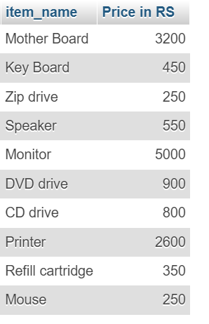

23. From the following table, write a SQL query to find the items whose prices are higher than or equal to $250. Order the result by product price in descending, then product name in ascending. Return pro_name and pro_price.

Answer :-

[SELECT](http://localhost/phpmyadmin/url.php?url=https://dev.mysql.com/doc/refman/8.0/en/select.html) pro_name, pro_price from item_mast where pro_price >= 250 order BY pro_name, pro_price DESC;

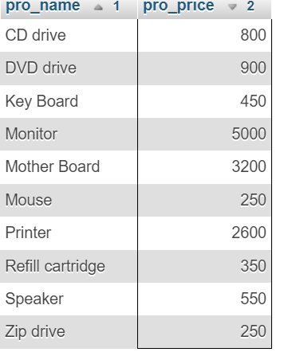

24. From the following table, write a SQL query to calculate average price of the items for each company. Return average price and company code.

Answer :-

[SELECT](http://localhost/phpmyadmin/url.php?url=https://dev.mysql.com/doc/refman/8.0/en/select.html) pro_comm AS "Company code", [AVG](http://localhost/phpmyadmin/url.php?url=https://dev.mysql.com/doc/refman/8.0/en/aggregate-functions.html%23function_avg)(pro_price) AS "Average Price" FROM item_mast GROUP BY pro_comm;

