**Module 1: Effective Communication**

**Task: Write professional emails based on any 5 of the following scenarios. Ensure clarity, conciseness, and a formal tone.**

1. Thank you Email

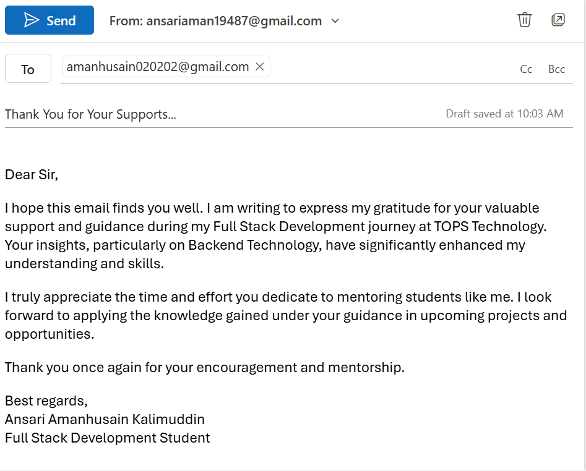

2. Letter of Apology

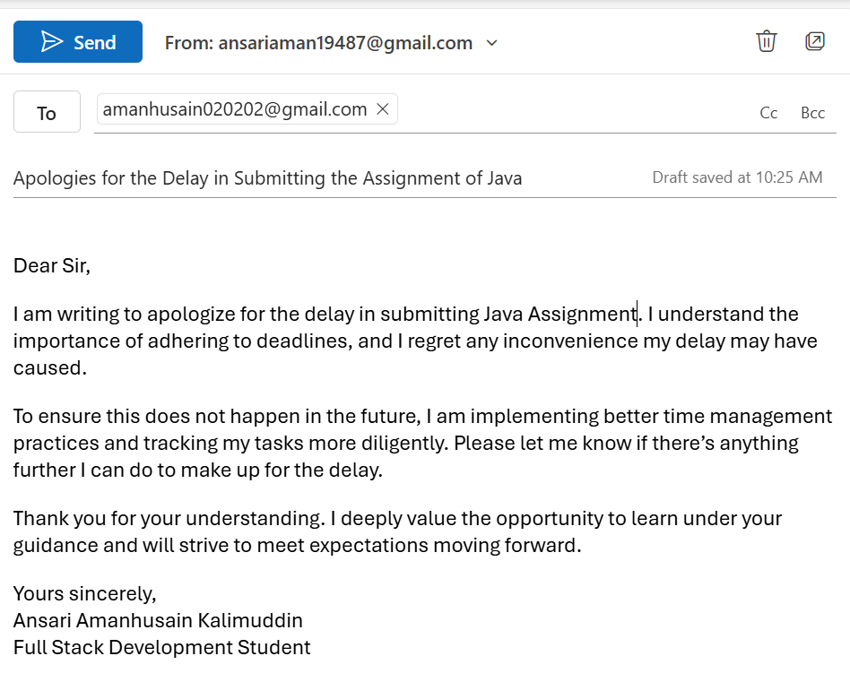

3. Reminder Email

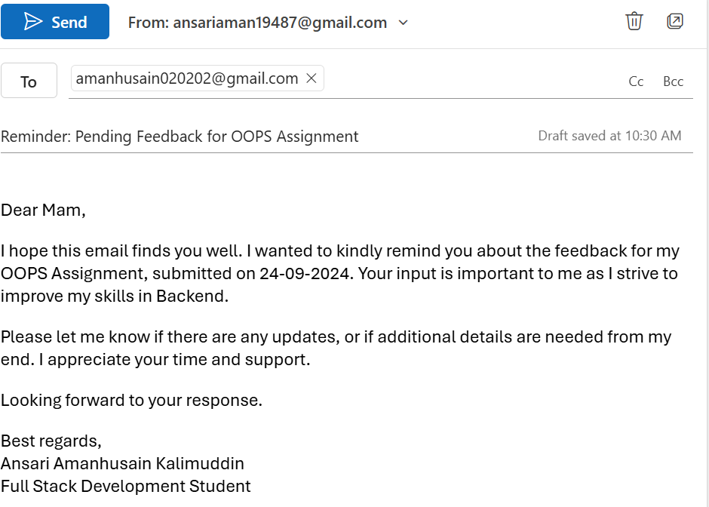

4. **Email Asking for a Status Update**

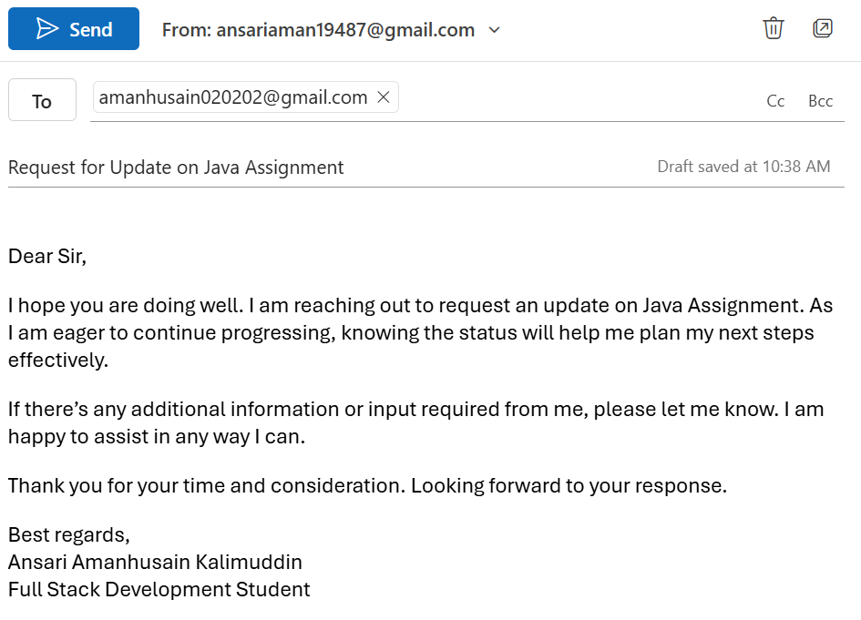

5. **Resignation Email**

