1. **Component Name : Input**

**Description :**

In order to Fetch Data From User Common Component which is used is Text Field. Fortunately Material Ui provides us An input field. I customized that text field and save for my future use in multiple places. I saved this Input field in the form of reusable component. It contains all required props : value , variant , onChange , label , disabled , id , color , id and more we can add as per requirements.

**Output :**

1. **Component Name : Button**

**Description :**

In order to receive send or upload data or performed some actions which is dependent upon Button component we use material’s designed button with prebuilt props init , similarly as I made my own input component here I make button component and reuse it at multiple places by importing it. Some of the props are : onClick, loading , variant , label , end/startIcon , color , sx , disabled and more as per user’s requirement.

**Output :**

Button with icon : loading button:

1. **Component Name : Table**

**Description :**

In order to display data in the proper viewable format we use table prebuilt usable component from material ui. We can pass columns and rows init and it will automatically generated proper format table for us. As more props we can use as per requirements such as checkboxes , table to table navigation buttons , page size , rows per page , table cell , table data and more. I built my own reusable component so I can use it in multiple places.

**Output :**

1. **Component Name : Switch**

**Description :**

In order to receive response from the use either in two way such as true or false and display or perform some action in return we can use material ui’s switches easy to use and also have some prebuilt props such as : controls , onChange , checked , label , color , and also we can add custom styles as I did in my component and then I reuse it in multiple places as per requirement.

**Output :**

BEFORE :

AFTER :

1. **Component Name : checkbox**

**Description :**

In order to display user something as per thier choice either in two states such as true or false . either use checked the box or not and some changes reflected as coded in the checkboxes. There is a checkbox component in material ui which we can use. I make my own checkbox component and reusing it in multiple places some props it also receive such as color , color , onclick , icon , label and more.

**Output :**

BEFORE :

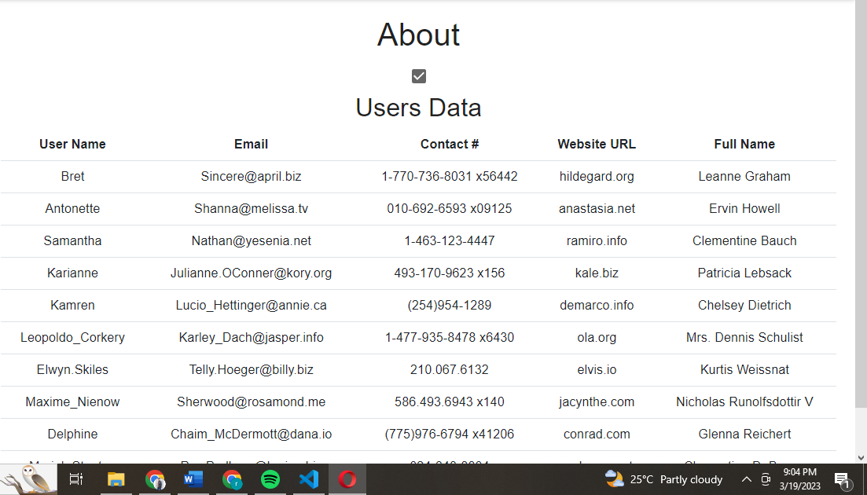

AFTER :

1. **Component Name : radio**

**Description :**

It can also receive and some and display output based on the provided input accordingly. Here ! we won’t restricted in the true false context of instance. Instead we can add multiple radio buttons and set their input / ouput codebase as we want. I make my own radio button and added some actions on it as whenever use interacted with radio buttons. It also received some props such as : onSubmit , onChange , value , color , variant , helper text and more.

**Output :**

BEFORE :

AFTER :

1. **Component Name : radio**

**Description :**

Based to provided a fully easy to read formatted view to the use and some functionalities provided to the use init as table component does we see earlier. Here also I make my own component resuble from material’s support which allowed me to use anywhere else I want to use that component. It also contains some props such as rows or columns data , no of pages no of columns per scale etc and more.

**Output :**

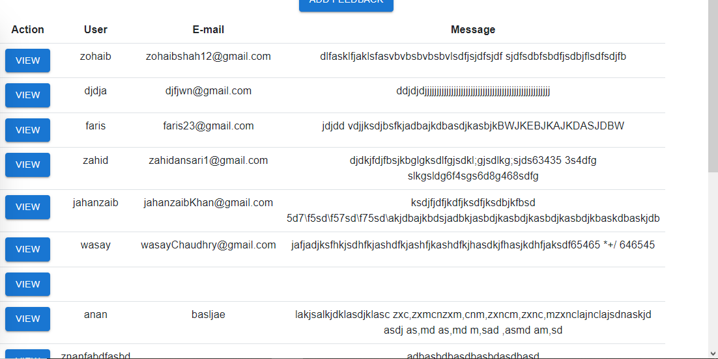

1. **Component Name : modal**

**Description :**

Modal can be viewable as user interacts with some components like buttons or buttonicons etc. a popup like window open with focus and contains information inside it. It could be form or other else a message. Using materials ui I make my own reusebale modal which I can use at many places. It also receive some props such as : open , close , title , inner content , modal footer and more.

**Output :**

1. **Component Name : showmessage**

**Description :**

Whenever user interacts with ui we have to add pops ups option that when invoke as anything happened in the screen either in backend a message should be popped up to let use know instead user just wait to for something happened in the screen against use output. We can set error message , success message when user fill some form logout in or logout message when use leaves the site. I make my own component using material ui snackbar which is handy to use also receive some props and display as accordance the results.

**Output :**