# gudlavalleru engineering college

(An Autonomous Institute with Permanent Affiliation to JNTUK, Kakinada)

Seshadri Rao Knowledge Village, Gudlavalleru - 521356, Krishna District

Department of Electronics and Communication Engineering

B. TECH MPMC project work

Academic Year: 2019-2020

**Batch no**:18 Date:29/02/2020

**Name of the students Roll numbers**:

1. M.A.A. Ansari (17481A04C9)

2. M. Bhagya Raj (17481A04D1)

3. B. Pavan Kalyan (18485A0431)

**Title of the project Work**: 8-bit Binary Counter by interfacing with LEDs using 8051 Microcontroller

**Abstract of the proposal work**:

The main principle of this circuit is to interface LEDs to the 8051-family micro controller. It describes and shows simple binary counting on LED’s. It is a 8-bit counter, hence it counts from 0 to 255. The decimal number increases from 0 to 255 each time the momentary push-button is pushed. Delay function is used to generate an arbitrary delay to pause the led count for some time for viewing the led output clearly. For loop is counting from 0 to 255 and count variable is updated every time. **P1=count**statement displays the counter value on the led’s connected to port-1.

**Hardware requirements**:

* AT89S51 (8051 Microcontroller)
* 8 LEDs
* 8 Resistors – 1KΩ
* Crystal oscillator – 11.0592MHz
* 2 Capacitors – 33pF
* 2 Resistors – 10KΩ
* 1 Capacitor – 10μF
* 1 Push Button
* Programmer
* 5V Power Supply

**Software requirements:**

* Keil Software
* Proteus Software

**BLOCK DIAGRAM:**

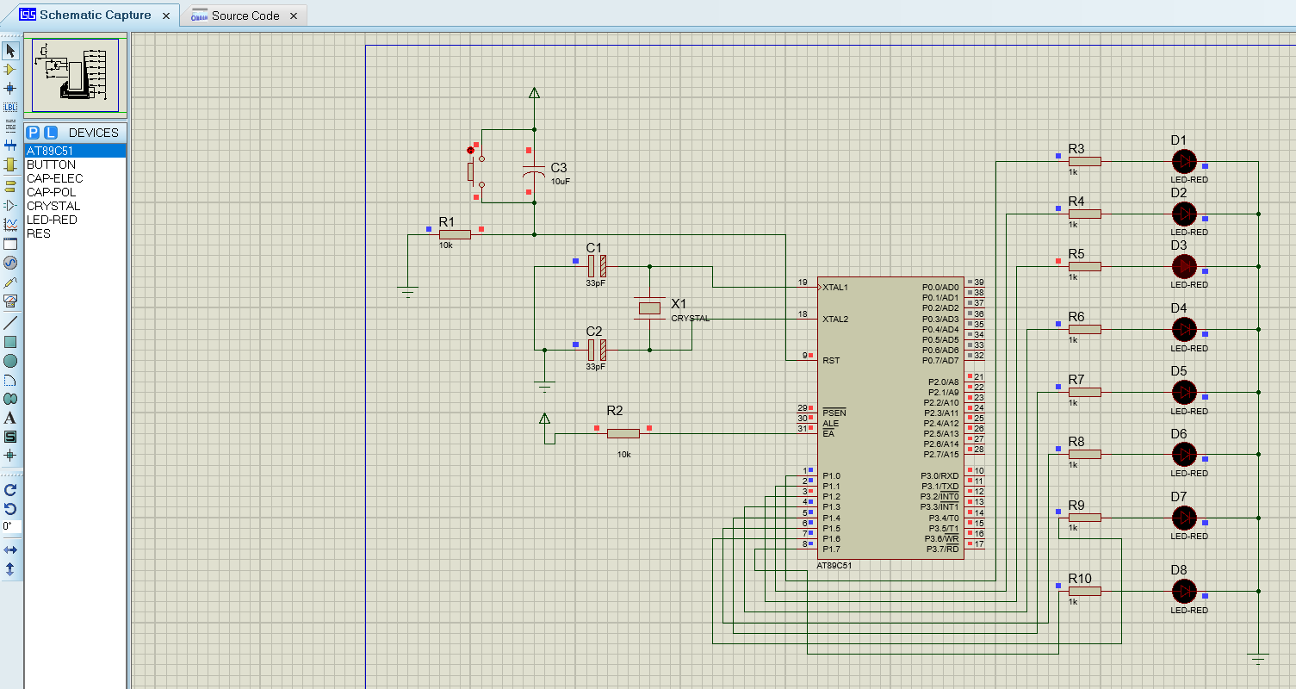

Figure: 8 bit Binary Counter on LEDs with 8051

Signature of the Student

17481A04C9

17481A04D1

18485A0431

Remarks by the Guide:

Signature & Name of the guide with date:

Signature of the Class Teacher with date: