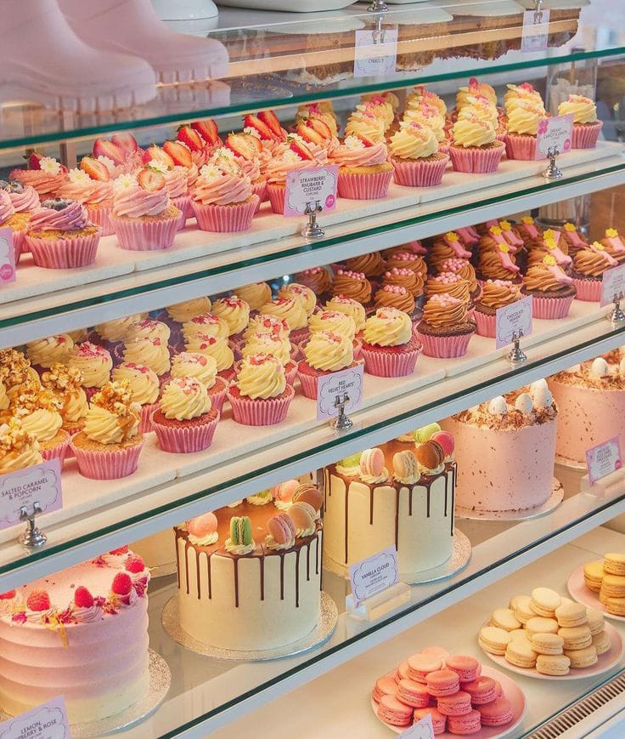
Cake Shop Management System Using MySQL
18-12-2025
ANSARI LABEEQUA
CAKE SHOP MANAGEMENT
SQL PROJECT

Cakeshop Management

Description:
The Cake Shop Management System is a MySQL-based project designed to manage customer details, cake information, and order records efficiently. It uses relational tables with primary and foreign keys to maintain data integrity. The project demonstrates core SQL concepts such as joins, aggregate functions, string functions, and window functions to analyze sales and customer orders. This system helps in understanding real-world database design and data analysis using SQL.

Tables in the Database:
- Customers Table- The customers table stores information about customers such as customer ID, name, phone number, email, and address. It helps in identifying customers who place orders.

- Cakes Table- The cakes table contains details of cakes available in the shop, including cake ID, cake name, flavor, price, weight, and availability status.

- Orders Table- The orders table records order information such as order ID, order date, total amount, and order status. It is linked to the customers table to track which customer placed each order.

- Order_Items Table- The order_items table stores details of cakes included in each order. It connects orders and cakes and records the quantity and price of each cake ordered.
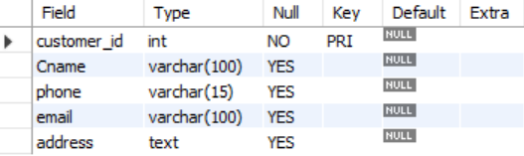
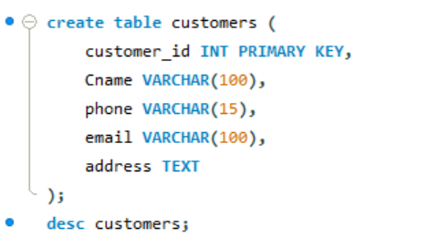
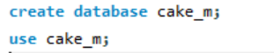
Insight: The customers table stores information about customers such as customer ID, name, phone number, email, and address. It helps in identifying customers who place orders.

Output:
Creating Table:
Question: Create a table named Customers with the following columns:
customer_id (Primary Key), Cname, phone, email, address
Input Query:

Insight: A separate database is created to manage Cakeshop operations.
Output:
Queries:
Creating Database:
Question: Creating Database and Use Database
Input Query:
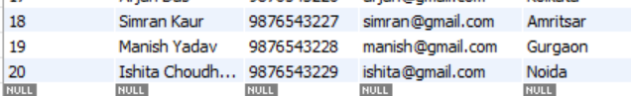
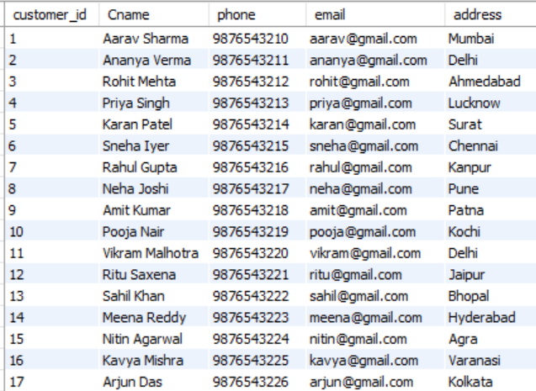
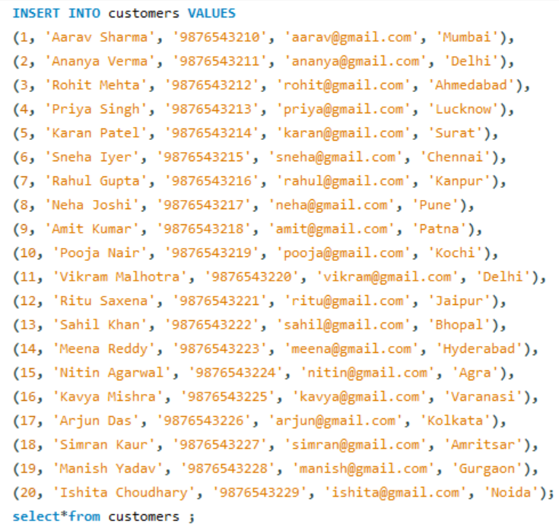
Insight: Stores customer information required to identify buyers and link them with their orders.
Output:
Inserting Values:
Question: Inserting values in each column.
Input Query:

Creating Table:
Question: Create a table named Orders with the following columns:
order_id (Primary Key), customer_id (Foreign Key), order_date, total_amount, order_status
The customer_id should reference the Customers table.
Input Query:

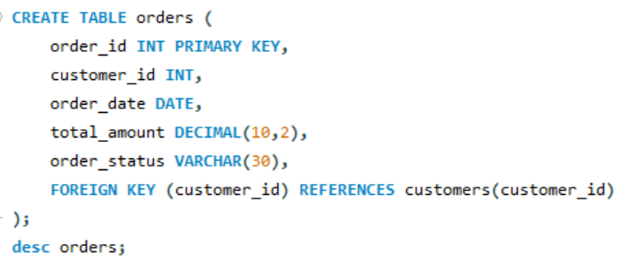
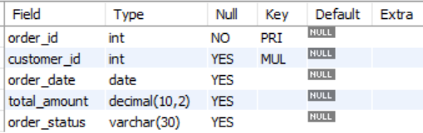
Output:
Insight: The orders table records order information such as order ID, order date, total amount, and order status. It is linked to the customers table to track which customer placed each order.

Inserting Values:
Question: Inserting values in each column.
Input Query:

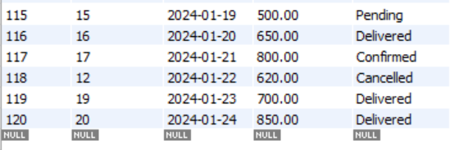
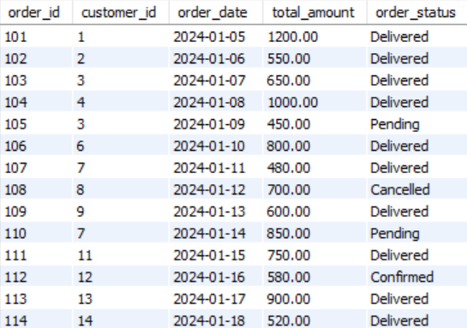
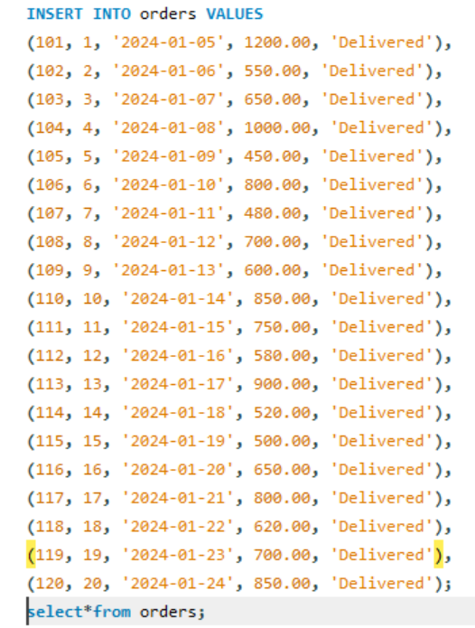
Insight: Records order transactions, tracking order date, total amount, and status for sales management.
Output:
Creating Table:
Question: Create a table named Cakes with following columns:
Cake_id(Primary Key), Cake_name, flavor, price, weight, availability
Input Query:
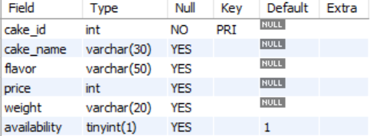
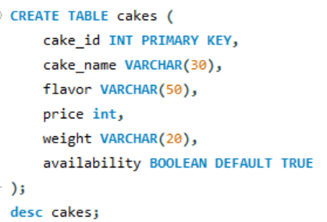
Output:
Insight: The cakes table contains details of cakes available in the shop, including cake ID, cake name, flavor, price, weight, and availability status.

Inserting Values:
Question: Inserting values in each column.
Input Query:

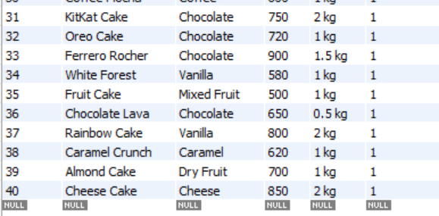
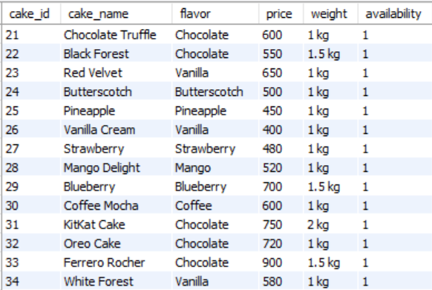
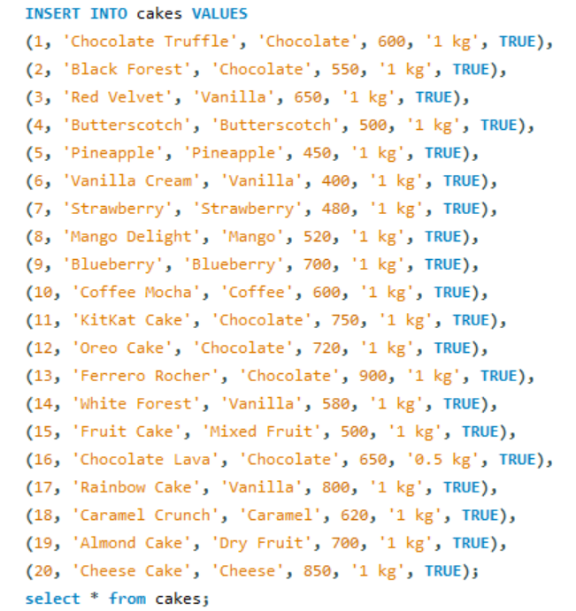
Insight: Maintains details of available cakes, including flavor, price, weight, and availability for sales tracking.
Output:
Creating Table:
Question: Create a table named Order_Items with the following columns:
order_item_id (Primary Key), order_id (Foreign Key), cake_id (Foreign Key), quantity, price
The order_id should reference the Orders table and cake_id should reference the Cakes table.
Input Query:

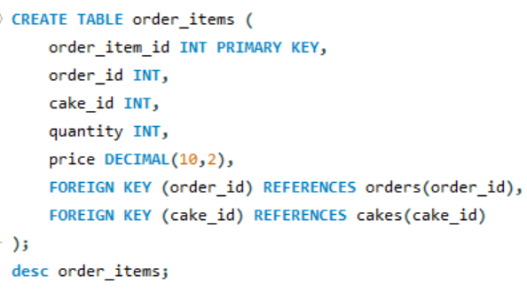
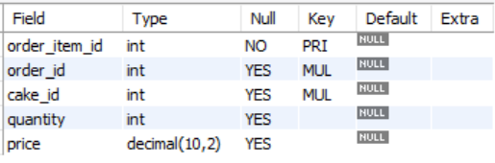
Output:
Insight: The order_items table stores details of cakes included in each order. It connects orders and cakes and records the quantity and price of each cake ordered.
Inserting Values:
Question: Inserting values in each column.
Input Query:

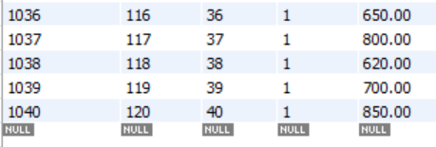
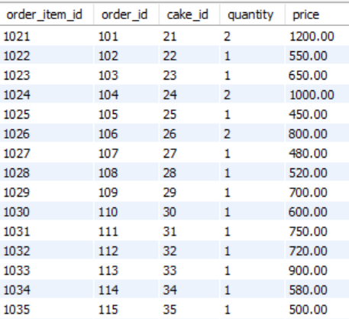
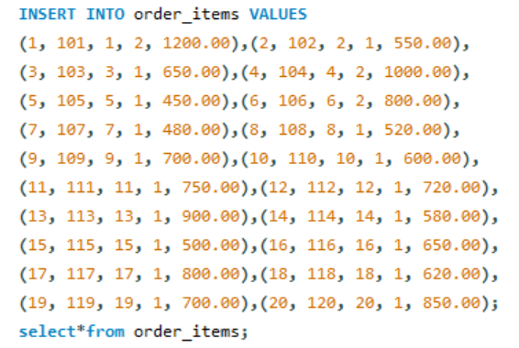
Insight: Connects orders with cakes, capturing quantity and price details for accurate order and sales analysis.
Output:
ENTITY RELATIONSHIP DIAGRAM:
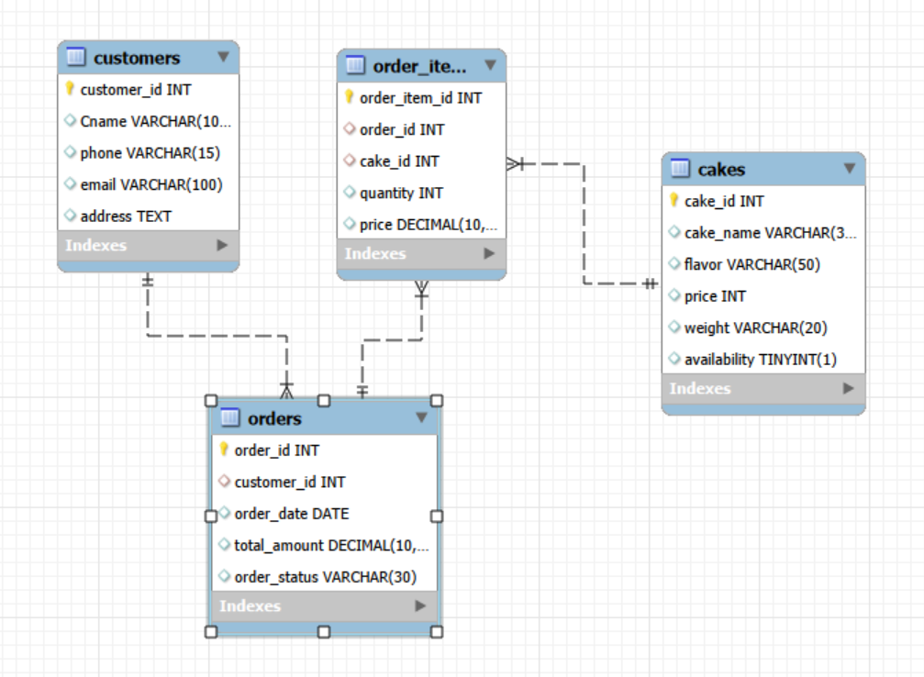
CARDINALITIES

1. Customers ↔ Orders
Relationship: One-to-Many (1 : M)
One customer can place many orders
One order belongs to only one customer

2. Orders ↔ Order_Items
Relationship: One-to-Many (1 : M)
One order can contain many order items
Each order item belongs to one order

3. Cakes ↔ Order_Items
Relationship: One-to-Many (1 : M)
One cake can appear in many order items
Each order item refers to one cake

4. Orders ↔ Cakes
Relationship: Many-to-Many (M : M)

- Orders with status Pending
Insight:
Identifies orders that are yet to be processed or delivered, helping manage pending work and improve customer service.
Used: WHERE clause, Comparison operator: =
Output:
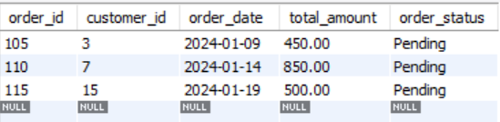

- Total number of customers
Insight: Measures the size of the customer base and helps track business growth over time.
Used: Aggregate function: COUNT()
Output:
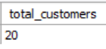

3. Total number of orders
Insight: Indicates overall demand and customer engagement with the cake shop.
Used: Aggregate function: COUNT()
Output:
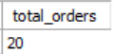

- Total sales amount
Insight: Shows total revenue generated, which is critical for evaluating business performance.
Used: Aggregate function: SUM()
Output:
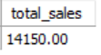

- Customers who placed orders
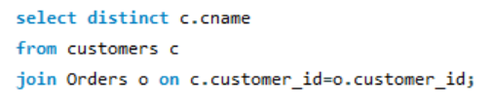
Insight: Identifies active customers who contribute to sales.
Used: JOIN (INNER JOIN), DISTINCT keyword
Output:


6. Customer-wise total spending
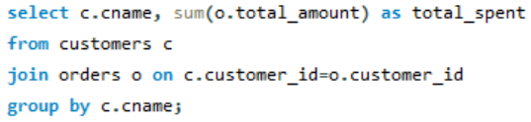
Insight: Helps identify high-value customers for loyalty programs and targeted marketing.
Used: Aggregate function: SUM(), JOIN, GROUP BY
Output:
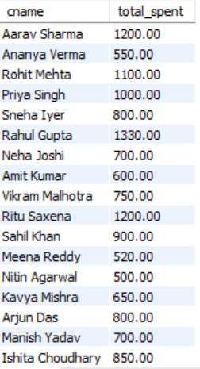

7. Customer who spent the most
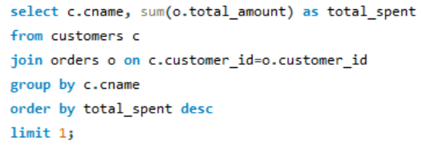
Insight: Identifies the top customer contributing the highest revenue.
Used: Aggregate function: SUM(), JOIN, GROUP BY, ORDER BY, LIMIT
Output:
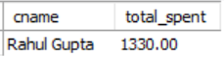

8. Maximum and minimum cake price
Insight:
Identifies the highest and lowest priced cakes, helping in understanding the price range and making pricing or promotion decisions.
Used: Aggregate function: MAX(), MIN()
Output:
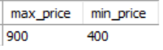

9. Flavor-wise cake sold (quantity)
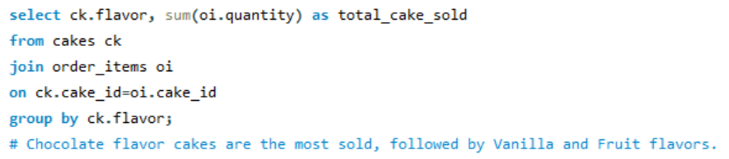
Insight: Helps understand customer flavor preferences for better product planning.
Used: Aggregate function: SUM(), JOIN, GROUP BY
Output:
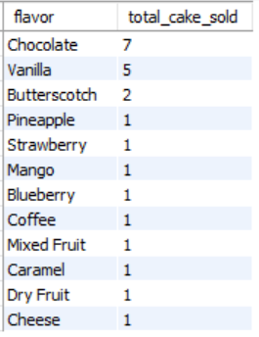

10. Flavour-wise sales amount
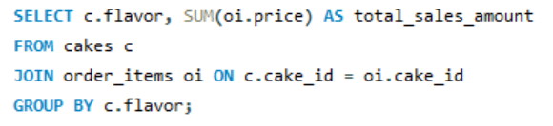
Insight: Identifies the most profitable flavors, guiding marketing and pricing strategies.
Used: Aggregate function: SUM(), JOIN, GROUP BY
Output:
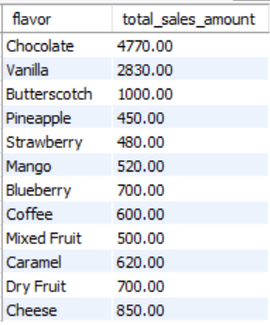

11. Orders with total amount greater than 800
Insight: Highlights high-value orders that contribute significantly to revenue.
Used: Comparison operator: >, WHERE clause
Output:
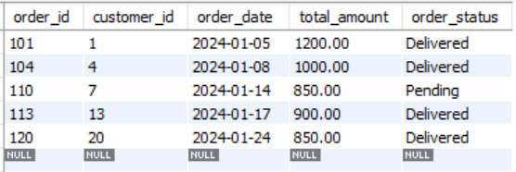
12. Cake flavor-wise count
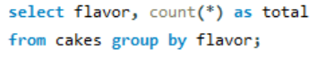
Insight: Displays the number of cakes available for each flavor, helping identify flavor variety and demand focus.
Used: Aggregate function: COUNT(), GROUP BY clause
Output:
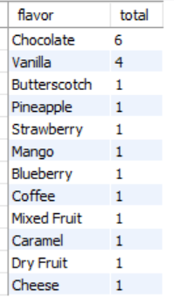

13. Most expensive cake
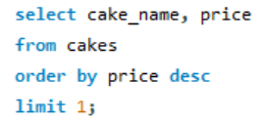
Insight: Identifies the most expensive cake, helping in premium product pricing and revenue strategy.
Used: ORDER BY (DESC), LIMIT
Output:
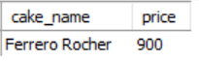
14. Customers whose name contains an
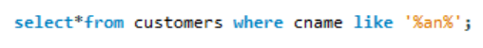
Insight: Filters and displays customers whose names contain the text “an” for pattern-based search.
Used: Pattern matching operator: LIKE,
Wildcard: % (matches any number of characters)
Output:
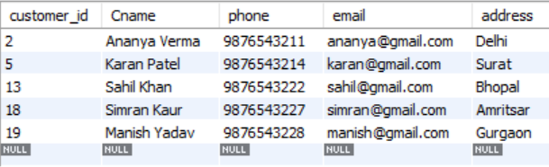

15. Concatenate cake name and flavor
Insight: Combines cake name and flavor into a single readable label for better display and reporting.
Used: String function: CONCAT()
Output:
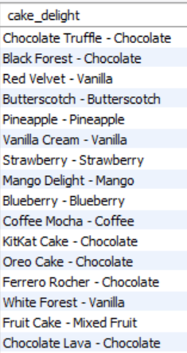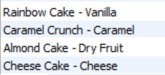

Project Conclusion
The Cake Shop Management System effectively organizes customer, product, and order data using a relational database. It enables efficient data storage, retrieval, and analysis through SQL queries. The project demonstrates how database insights support better business decisions and operational efficiency.

