Sentiment Analysis of Tweets on Taylor Swift

1. Introduction
This project focuses on performing sentiment analysis on tweets related to Taylor Swift. The objective is to classify tweets into positive, neutral, and negative sentiments using machine learning techniques.

2. Data Collection & Preprocessing
A dataset of 100 tweets related to Taylor Swift was created. The tweets were manually labeled as positive, neutral, or negative. Preprocessing steps included converting text to lowercase, removing stopwords, and cleaning the data.

3. Data Splitting
The dataset was split into 80% training data and 20% testing data. This split helps in evaluating the model effectively while avoiding overfitting.

4. Model Training & Classification
Three classifiers were used: Naive Bayes, Support Vector Machine (SVM), and Logistic Regression. TF-IDF vectorization was used to convert text into numerical features.

5. Model Evaluation
The models were evaluated using Accuracy, Precision, and Recall metrics.

6. Results (Graphs)
Accuracy Comparison:
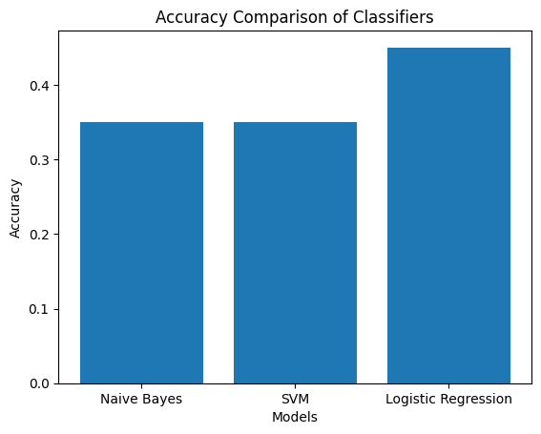
Precision Comparison:
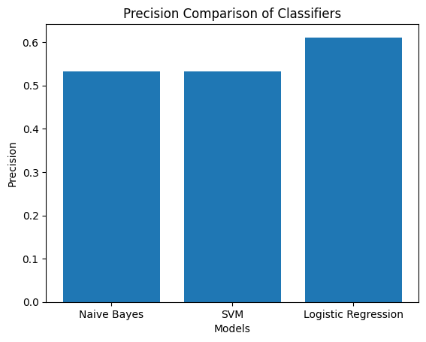
Recall Comparison:
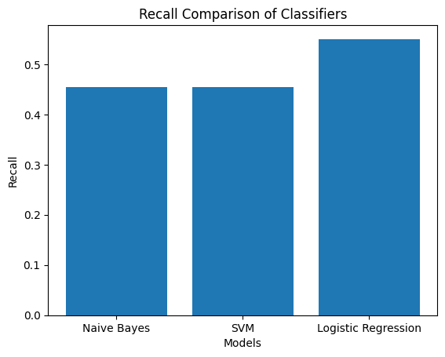

7. Conclusion
From the results, Logistic Regression performed better compared to Naive Bayes and SVM in terms of accuracy, precision, and recall. Thus, Logistic Regression is the best classifier for this dataset.

