# Question 1

Each student at Central Middle School wears a uniform consisting of 1 shirt and 1 pair of pants. The table shows the colors available for each item of clothing. How many different uniforms are possible?  
  
| Shirt Color | Pants Color |  
| :---: | :---: |  
| Tan | Black |  
| Red | Khaki |  
| White | Navy |  
| Yellow | |

* A) Three
* B) Four
* C) Seven
* D) Ten
* E) Twelve

**Curriculum Tags:**Quantitative Math > Problem Solving > Data Analysis

## Explanation

Multiply the number of shirt options (4) by pants options (3). The empty cell implies all shirts can pair with all pants: \(4 \times 3 = 12\) combinations.

# Question 2

The top view of a rectangular package of 6 tightly packed balls is shown below.

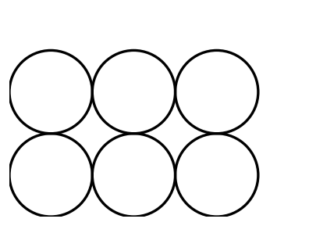

* A) \(2 \times 3 \times 6\)
* B) \(4 \times 6 \times 6\)
* C) \(2 \times 4 \times 6\)
* D) \(4 \times 8 \times 12\)
* E) \(6 \times 8 \times 12\)

**Curriculum Tags:**Quantitative Math > Problem Solving > Geometry

## Explanation

Each ball has diameter \(4\) cm. For 3×2 arrangement:  
- Width: \(3 imes 4 = 12\) cm  
- Height: \(2 imes 4 = 8\) cm  
- Depth: \(4\) cm