An explanation of findings:
1.) Histogram of the Frequency of Hand Sums Prior to Loss
The frequency of losing with a given hand sum increases nearly linearly with size, with an increased chance at twenty. This is to be expected since the number of cards you can draw to win decreases the greater your hand sum is For 20, there are only four possible cards you can draw to win (the four aces).

2.) Hisstogram of Frequency of Card Values in Winning Hands
Beyond a shadow of a doubt, the ace is found in the most winning hands by a large margin. Trailing behind is 2 and 3, followed by 5, 6, 7, 8, the face cards, and 9. thhe face cards are all near the same value, since they are all worth ten. The ace is significant because it can be an 11 or 1 at the convenience of the player.

3.) Histogram of theh Frequency of Winning hand Sizes
Hands closer to size 3 tend to win most.
4.) Winning Starting Hand Sums
A hand that starts at 11 most always winds most, and those hands closest too 11 tend to win next in line, following nearly a distribution if not forr the excess of 11. Again, the ace makes an exceptional impact on the game

5.) Losing Starting Hand Sums
Hands of 20 are an exception, otherwise hands around 12, 13, 14, and 15 have a surprisingly high loss rate, followed in a disitribtuion by other hand sizes

Conclusions:
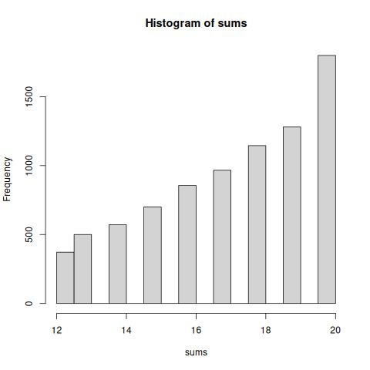
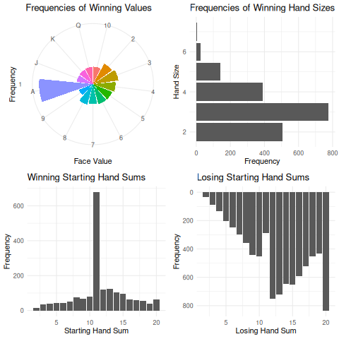
Ace is greaat, pray for lower cards, fold on hands higher than 11, stop at 17

