|  |  |  |  |  |
| --- | --- | --- | --- | --- |
| Kernel type | Final value | | Training error  RMSE | Testing error  RMSE |
| C |  |
| Linear | 0.700 | -- | 0.0701 | 0.0524 |
| Polynomial | 8.3293 | 0.8101 | 0.0701 | 0.0524 |
| RBF | 5.2442 | 0.1201 | 0.0701 | 0.0605 |

|  |  |  |  |  |  |  |  |  |
| --- | --- | --- | --- | --- | --- | --- | --- | --- |
| Type | MSE | | MAE | | NMSE | | MRE | |
| SVM | PSO-SVM | SVM | PSO-SVM | SVM | PSO-SVM | SVM | PSO-SVM |
| Linear | 0.0090 | 0.0027 | 0.0744 | 0.0370 | 0.0035 | 0.0011 | 0.0028 | 0.0014 |
| Polynomial | 0.0044 | 0.0027 | 0.0474 | 0.0370 | 0.0017 | 0.0011 | 0.0018 | 0.0014 |
| RBF | 3.8018 | 0.0037 | 1.0786 | 0.0436 | 4.4472 | 0.0014 | 0.0376 | 0.0016 |

修改后的程序结果截图如下，各种误差均会在命令窗口中显示，图也是分开了的

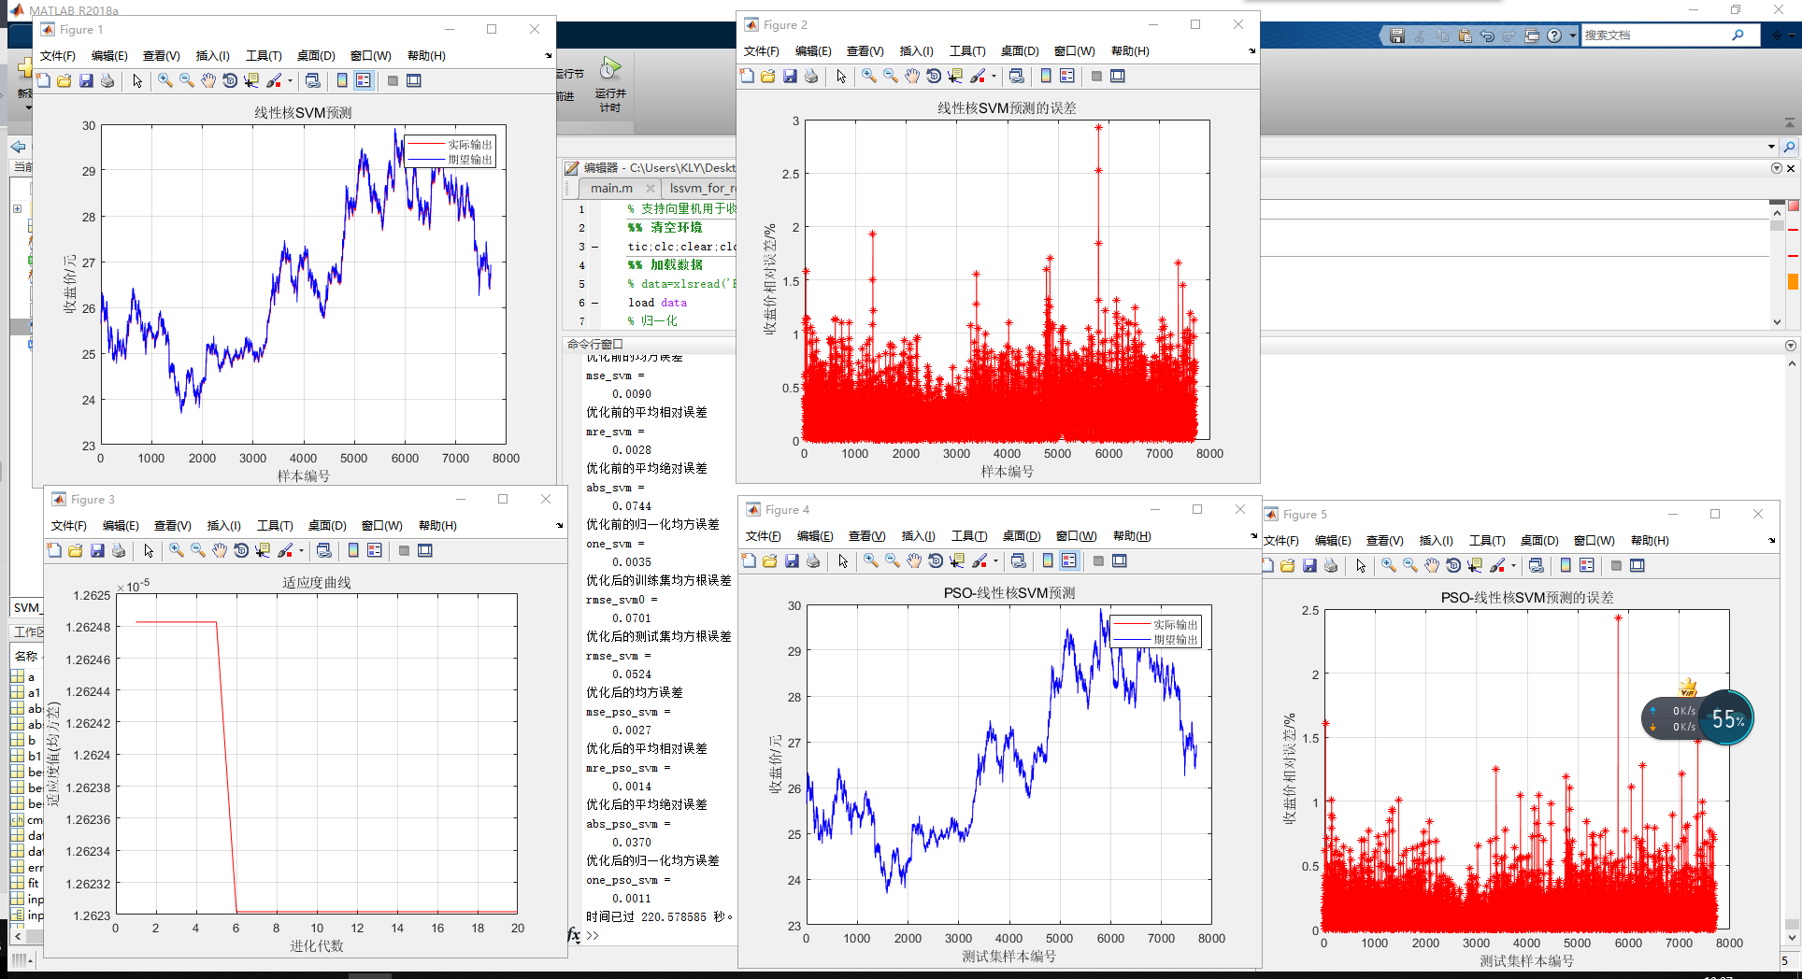

error_svm与error_pso_svm分别是优化前后的svm的测试集的实际输出与期望输出的相对误差，要画上午说的那个盒型图就用这两个变量