 

**College Data Management**

Name : Manav Mehta Name : Shivang Kosty

Roll No : 11 RollNo : 14

Enrollment No : 22002170110074 Enrollment No : 22002170110059

Branch : C.E. Batch : D-1 Branch : C.E. Batch : D-1

Name : Ansh Patel Name : Dhrumil Trada

Roll No : 12 RollNo : 25

Enrollment No : 22002170110104 Enrollment No : 22002170110194

Branch : C.E. Batch : D-1 Branch : C.E. Batch : D-1

Name : Jay Patel

Roll No : 26

Enrollment No : 22002170210070

Branch : I.T. Batch : D-1

Tables and their respective syntax :

1. CREATE TABLE Students (

Student_ID SERIAL PRIMARY KEY,

Enrollment_No BIGINT ,

First_Name VARCHAR(50) NOT NULL,

Last_Name VARCHAR(50) NOT NULL,

Date_Of_Birth DATE,

Gender VARCHAR(10) CHECK (Gender IN ('Male','Female')),

Contact_Number VARCHAR(10) UNIQUE,

Email VARCHAR(100) UNIQUE,

Address VARCHAR(255),

Division VARCHAR(5),

Admission_year INT,

Department_ID INT,

FOREIGN KEY (Department_ID) REFERENCES Departments(Department_ID)

);

2. CREATE TABLE Courses (

Course_ID INT PRIMARY KEY,

Course_Name VARCHAR(50) NOT NULL,

Department_ID INT,

Credits INT CHECK(Credits BETWEEN 0 AND 10),

FOREIGN KEY (Department_ID) REFERENCES Departments(Department_ID)

);

3. CREATE TABLE Results (

Result_ID SERIAL PRIMARY KEY,

Student_ID INT,

Course_ID INT,

Score INT CHECK (Score BETWEEN 0 AND 100),

FOREIGN KEY (Student_ID) REFERENCES Students(Student_ID),

FOREIGN KEY (Course_ID) REFERENCES Courses(Course_ID)

);

4. CREATE TABLE Professors (

Professor_ID SERIAL PRIMARY KEY,

First_Name VARCHAR(50) NOT NULL,

Last_Name VARCHAR(50) NOT NULL,

Date_Of_Birth DATE,

Gender VARCHAR(10) CHECK (Gender IN ('Male','Female')),

Contact_Number VARCHAR(10) UNIQUE,

Email VARCHAR(100) UNIQUE,

Course_ID INT,

FOREIGN KEY (Course_ID) REFERENCES Courses(Course_ID)

);

5. CREATE TABLE Departments (

Department_ID SERIAL PRIMARY KEY,

Department_Name VARCHAR(50)

);

6. CREATE TABLE Timetable (

Timetable_ID SERIAL PRIMARY KEY,

Division VARCHAR(10),

Professor_ID INT,

Day_Of_Week VARCHAR(15),

Start_Time TIME,

End_Time TIME,

Class_ID INT,

FOREIGN KEY (Professor_ID) REFERENCES Professors(Professor_ID),

FOREIGN KEY (Class_ID) REFERENCES Classes(Class_ID)

);

7. CREATE TABLE Classes (

Class_ID SERIAL PRIMARY KEY,

Class_Number VARCHAR(10)

);

Queries for different questions and their respective output :

1. **Query to find professor at a certain time and the division he/she is teaching at particular day and time.**

* select professor_id, class_id, division from timetable where day_of_week = 'TUESDAY' and Start_time < '12:00:00' and end_time > '12:00:00' order by professor_id;

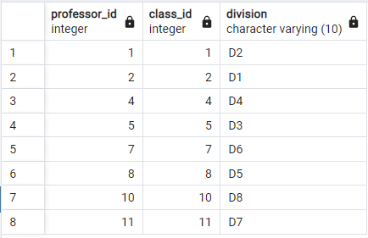

1. **Query to find which classes are empty at particular day and time.**

* select Class_number from classes where class_id not in(select class_id from timetable where day_of_week = 'MONDAY' and Start_time < '12:00:00' and end_time > '12:00:00' );

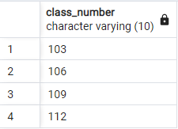

1. **Query to find which classes are assigned to particular department.**

* select class_number from classes where class_id in(select class_id from timetable where professor_id in (select professor_id from professors where course_id in (select course_id from courses where department_id in (select department_id from departments where department_name = 'Civil'))))

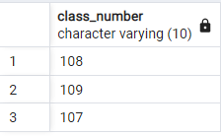

1. **Query to find total marks of all students in all subjects.**

* select enrollment_no,first_name,last_name,sum(score) from students join results on students.Student_id = results.student_id group by results.Student_id,enrollment_no,first_name,last_name;

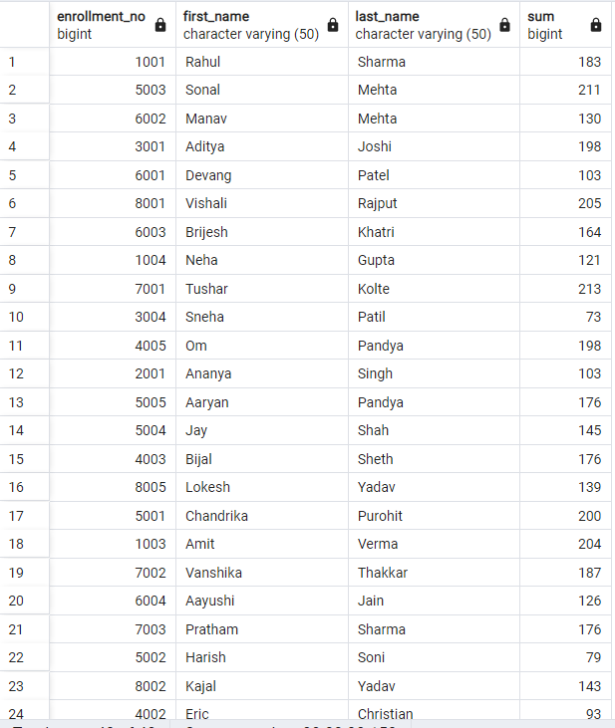

1. **Query to find average marks course/subject wise.**

* select results.course_id,course_name,cast(avg(score) as decimal(5,2)) from courses join results on courses.course_id = results.course_id group by results.course_id,course_name;
* 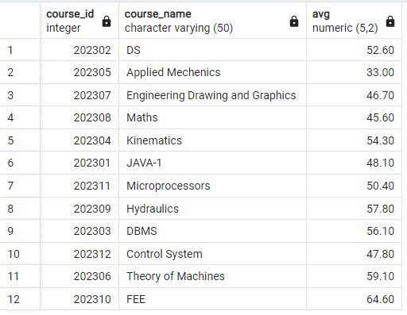

1. **Query to display details of professors in particular department.**

* select * from professors where course_id in (select course_id from courses where department_id in (select department_id from departments where department_name ='CS'));

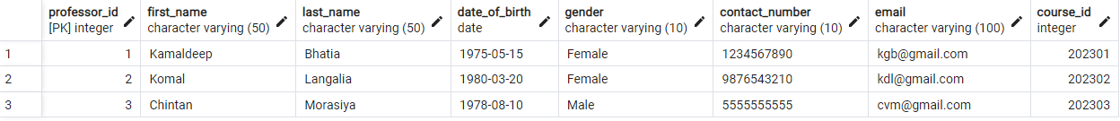

1. **Query to display details of students in particular department.**

* select * from students where department_id in (select department_id from departments where department_name ='Mechanical');

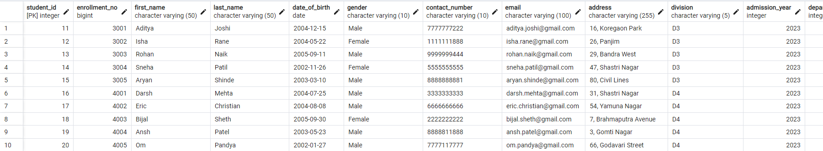

1. **Query to display average marks of all department.**

* select department_name,cast(avg(score) as decimal(5,2)) from departments join courses on departments.department_id = courses.department_id join results on results.course_id = courses.course_id group by department_name;

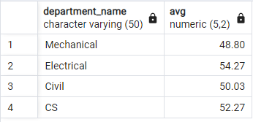

1. **Query to find count of male and female students.**

* select gender,count(gender) from students group by gender;

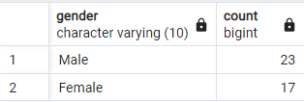

1. **Query to print timetable of a particular department.**

* select day_of_week,start_time,end_time,class_number,course_name from timetable,classes,professors,courses where timetable.class_id = classes.class_id and timetable.professor_id = professors.professor_id and professors.course_id=courses.course_id and Division = 'D2' order by day_of_week,start_time ;

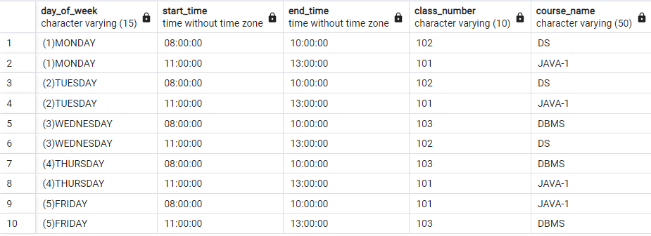

**FUNCTIONS :**

1. **To display students by their given divisions :**

* CREATE OR REPLACE PROCEDURE display_division_wise(div VARCHAR) AS $$

DECLARE

var students%ROWTYPE;

c1 CURSOR FOR SELECT * FROM students WHERE Division = div;

BEGIN

OPEN c1;

LOOP

FETCH c1 INTO var;

EXIT WHEN NOT FOUND;

RAISE NOTICE 'Enrollment_No = % , Name = % % , Gender = % , DOB = % , Email = %',var.Enrollment_No,var.First_Name,var.Last_Name,var.Gender, var.Date_Of_Birth, var.Email ;

END LOOP;

CLOSE c1;

END;

$$

LANGUAGE plpgsql;

* CALL display_division_wise('D4');

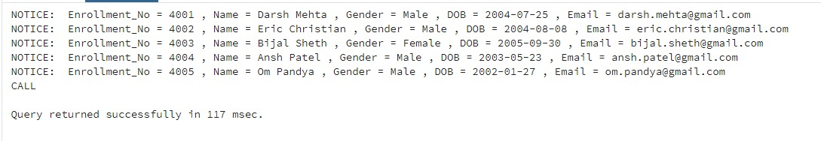

1. **To calculate spi from given enrolment number of a student :**

* CREATE OR REPLACE PROCEDURE calculate_spi(enroll_no INT) AS $$

DECLARE

sub NUMERIC = 0;

cred INT = 0;

total NUMERIC(5,2) = 0;

c_id INT;

var Students%ROWTYPE;

c1 CURSOR FOR SELECT Score,Course_ID FROM Results WHERE Student_id IN (SELECT Student_id FROM Students WHERE Enrollment_No = enroll_no);

BEGIN

SELECT * FROM Students WHERE Enrollment_No = enroll_no INTO var;

OPEN c1;

LOOP

FETCH c1 INTO sub,c_id;

EXIT WHEN NOT FOUND;

SELECT Credits FROM Courses WHERE course_id = c_id INTO cred;

total = total + (sub * cred);

END LOOP;

CLOSE c1;

total = total / 15;

RAISE NOTICE 'Enrollment_No : %',var.Enrollment_No;

RAISE NOTICE 'Name : % %',var.First_Name,var.Last_Name;

RAISE NOTICE 'SPI : %',total;

END;

$$

LANGUAGE plpgsql;

* CALL calculate_spi(1002);

