

Foundations of Programming

Assignment No. : 01
- PROBLEM STATEMENT:
Write a program in C to check whether a given year is a Leap Year

OBJECTIVE:

- To understand the use of conditional statements in C programming.
- To implement logical conditions for solving real-world problems.
- To develop problem-solving skills using decision control structures.

THEORY:
- Theory for conditional statements with syntax (if , if-else, if-else ladder) are used in C programming
If condition
DEFINITION:
If the condition in the parentheses is true, the code inside the curly braces runs.
SYNTAX:
if (condition) {
// CODE to execute if condition is true
}
CODE:
#include <stdio.h>
void main()
{
int a;
printf("Enter a number: ");
scanf("%d",&a);
if(a%2==0)
{
printf("Even Number");
}
}
OUTPUT:
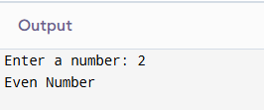

If-else statements
DEFINITION:
if-else statements are used to make decisions. They allow your code to take different paths depending on whether a specific condition is True or False.
SYNTAX:
if (condition) {
// CODE to execute if condition is True
}
else{
//CODE will execute when if statement is False
}
CODE:
#include <stdio.h>
void main()
{
int age;
printf("Enter your age: ");
scanf("%d",&age);
if(age>17){
printf("Eligible to vote");
}
else{
printf("NOT Eligible to vote");
}
}
OUTPUT:
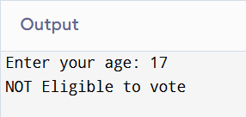

If-else Ladder
DEFINITION:
An if-else ladder is a common programming structure used to test a series of conditions in order. It executes one block of code from several mutually exclusive options.
SYNTAX:
if (condition) {
// CODE to execute if condition is true
}
else if (condition){
// CODE to execute if condition is true
}
else {
// CODE to execute if condition is true
}
CODE:
#include <stdio.h>
void main()
{
float a;
printf("Enter your marks: ");
scanf("%f",&a);
if(a> 89){
printf("Grade A+");
}
else if(a>79){
printf("Grade A");
}
else if(a>69){
printf("Grade B+");
}
else if(a>59){
printf("Grade B");
}
else if(a>49){
printf("Grade C");
}
else if(a>39){
printf("Grade D");
}
else{
printf("Fail");
}
}

OUTPUT:
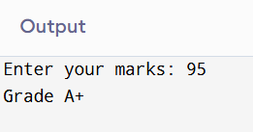

- Theory for a Leap Year - year that contains 366 days instead of the usual 365 days.
Rules:
• A year is a leap year if it is divisible by 400, OR
• A year is a leap year if it is divisible by 4 but not divisible by 100.

- Algorithm
Step 1: Start
Step 2: Read the value of year
Step 3: If value of year%400==0 or value of year%4==0 but value of year%100!=0 then display(“Leap Year”)
Step 4: Else display(“NOT a Leap Year”)
Step 5: Stop
PLATFORM: Linux

INPUT: Enter a year (integer value).

PROGRAM:
#include <stdio.h>
void main()
{
int a;
printf("\nEnter the year: ");
scanf("%d",&a);
if((a%4==0 && a%100!=0) || a%400==0)
{printf("Leap Year");}
else{
printf("NOT a Leap Year");
}
}

OUTPUT: Displays whether the entered year is a Leap Year or Not a Leap Year.
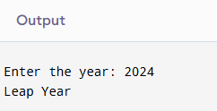
Sample INPUT
2024
Sample OUTPUT
2024 is a Leap Year
CONCLUSION: Thus, the program successfully checks whether a given year is a Leap Year using conditional statements in C.

FAQs:
- What is a leap year?
- Why is the year 1900 not a leap year but 2000 is?
- Which operators are used in this program?
- Difference between if and if–else statements.

