

Foundations of Programming

Lab Assignment No. : 03

PROBLEM STATEMENT:
Write a program in C to generate multiplication tables for a given number.
OBJECTIVES:
- To understand the use of looping statements in C.
- To generate multiplication tables using loops.
- To improve program logic and execution flow understanding.

THEORY:
- Syntax for for loop example program:
for (initialization; condition; increment/decrement) {
// code to be executed
}

- Syntax for while loop example program:
while (condition) {
// code to be executed
// update statement (to eventually make the condition false)
}

- Syntax for do while loop example program:
do {
// Statement(s) to be executed
} while (condition);

ALGORITHM:
Step 1: Start
Step 2: Read variables a,i
Step 3: From i=1 to i=10,
display ‘a*i=’,a*i
Step 4: Stop

CODE:
#include<stdio.h>
void main()
{
int i,a,product;
printf("Enter a number: ");
scanf("%d",&a);
for(i=1;i<=10;i++)
{
product = a*i;
printf("\n%d x %d = %d",a,i,product);
}
}

PLATFORM:
Linux

INPUT:
Choice of operation and two numbers

SAMPLE INPUT:
5
SAMPLE OUTPUT:
5 x 1 = 5
5 x 2 = 10
5 x 3 = 15
5 x 4 = 20
5 x 5 = 25
5 x 6 = 30
5 x 7 = 35
5 x 8 = 40
5 x 9 = 45
5 x 10 = 50

OUTPUT:
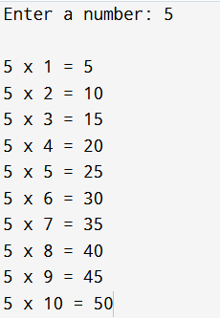
CONCLUSION:
Thus, the menu driven program in C successfully performs basic arithmetic operations using switch–case statements.

FAQs:
- Which loop is best suited for generating multiplication tables?
- What is the role of loop initialization?
- Difference between for loop, while loop and do while loop?
- Can a do–while loop be used to generate multiplication tables? Explain.
- Why is the do–while loop called an exit-controlled loop?

