The Impact of Genetics and Environmental Factors on Chronic Lung Diseases.

(Meharjot Singh - Chitkara University - meharjot1921.be22@chitkara.edu.in ,
Ansh Mehta- Chitkara University - ansh137.be22@chitkara.edu.in,
Ayush Kumar Gupta- Chitkara University - ayush1425.be22@chitkara.edu.in)

Abstract: Fibrosis, chronic respiratory failure, and pulmonary hypertension are caused by more than 200 distinct respiratory illnesses known as interstitial lung diseases (ILDs), which impact the lung parenchyma. Smoking, a history of chronic illness, allergies, and pollution exposure are some of the environmental and genetic variables that interact to cause these disorders. Disease progression is also influenced by psychological and emotional factors, such as weariness, peer pressure, and anxiety. Early detection of ILDs is challenging because of their vague symptoms and delayed diagnosis. The study examines how environmental, lifestyle, and demographic factors affect the onset and progression of ILD and novel ant-fibrotic treatments that can decrease the disease's progression. To improve patient outcomes, treatment plans, and diagnostic precision, it is essential to comprehend these risk variables.
Keywords— ILD Detection, Pulmonary Fibrosis, Smoking, Chronic Disease, Anxiety, Environmental Risk Factors, Anti Fibrotic Therapy
- INTRODUCTION
Both environmental and genetic variables can have an impact on lung illness. In the latter stages of life, genetic defects can raise vulnerability to various respiratory disorders since they can significantly affect the lung's development during prenatal and postnatal periods. Several chronic disorders, including asthma, cystic fibrosis, and chronic obstructive pulmonary disease (COPD), can be made more likely by these anatomical and functional abnormalities in the lungs. Since heredity plays a significant influence in development and progression, it is possible to conclude that not all smokers acquire COPD, which is typically caused by smoking and aging.
Various environmental factors such as air pollution, workplace hazards, exposure to toxic chemicals, various lifestyle choices contribute to severe lung disease. Elongate exposure to pollutants can trigger proactive responses and lead to progressive lung damage, particularly in individuals it makes them fundamentally weak. This interaction between genetics and the environment reinforces the complexity of lung diseases.
A person suffering from ILD has a high risk of getting lung cancer. ILD which is Interstitial Lung Disease is a group of lung disorders that causes puffiness, and scar tissue formation in the lungs due to which it is difficult for oxygen to pass in the bloodstream, over time ILD leads to difficulties in breathing and reduces lung functions.
Interstitial Lung Diseases (ILDs) are a broad category of lung conditions that impact the tissue and surrounding space surrounding the air sacs. Inflammation and scarring from these disorders result in breathing issues that worsen over time. Certain individuals are predisposed to ILDs from birth, while others acquire them as a result of inhaling toxic substances such as silica, beryllium, or organic dust while working. A person with an ILD is at an increased risk of developing lung cancer or other chronic respiratory conditions including chronic obstructive pulmonary disease (COPD). Physicians had limited options for treating ILDs in the past.
There is hope that new medications that combat scarring can halt the progression of these illnesses. It's critical to comprehend how genes and the environment interact to generate ILDs in order to identify them and provide effective treatment. Physicians can better treat ILDs and increase patients' chances of long-term health using this understanding.
ILD most commonly manifests as IPF. It primarily affects older people, especially men, whose average age is over 60. As it progresses, it results in respiratory failure and irreversible lung damage. Other ILDs can impact younger individuals and have a greater gender disparity than IPF. While some of them are less severe, many of them result in lung fibrosis that worsens over time, causing organ failure, dyspnoea, and a decreased quality of life.
The fundamental causes of ILDs determine their classification. Some of them are related to autoimmune illnesses, while others are caused by exposure to the environment.
- RELATED WORK
Through various machine learning techniques, some researchers and academics have made significant contributions to the field of Interstitial Lung Disease (ILD) identification, for determining lung cancer. Their efforts have significantly improved the accuracy and efficiency of lung cancer.
Smith et al. (2018) used an SVM model with an accuracy of 82.4% for ILD classification using hand-engineered texture features derived from high-resolution computed tomography (HRCT) scans. Their research showed how effective feature engineering is for processing medical images.
A random forest classifier with an accuracy of 85.1% was created by Brown and Wilson (2019) utilizing morphological and statistical variables. The potential of ensemble learning to improve ILD diagnosis which leads to lung cancer was highlighted in their work.
A technique based on logistic regression in conjunction with PCA was employed by Patel et al. (2020) to reduce dimensionality. Their system's 83.7% accuracy demonstrated the benefits of little computing complexity at the expense of minimal classification performance loss.
An accuracy of 80.9% was achieved by Li et al. (2021) when they suggested a k-nearest neighbors (KNN) method for lung cancer detection that uses local feature similarity. Their research emphasized the value of distance learning strategies in biomedical settings.
Pandey et al. 2021 conducted a comparative study with various machine learning classifiers which includes Random Forest, SVM, and KNN, for lung cancer prediction, achieving an accuracy of 91 % with Random Forest.
- METHODOLOGY
A. Dataset
The dataset that is used is from Kaggle, it contains the records of each one with the features that determine the details and the lifestyle habits of an individual.

Table 1:- Key attributes included are mentioned below:
Sr. No. | Attributes | Description
1. | Age | Age of the patient
2. | Gender | Male/Female
3. | Smoking | Yes/No
4. | Yellow Fingers | Yellow Fingers due to smoking
5. | Anxiety | Presence of Anxiety
6. | Peer Pressure | Pressure to Smoke
7. | Allergy | Allergic or not
8. | Alcohol Consumption | Yes/No
9. | Fatigue | Reports Of fatigue
10. | Shortness of Breath | Difficulty in Breathing
11. | Wheezing | Occurrence of wheezing
12. | Chronic Disease | Existence of Chronic Illness
13. | Swallowing Difficulty | Trouble in swallowing
14. | Coughing | Frequent Coughing
15. | Chest Pain | Yes/No
16. | Lung Cancer | Target Variable(Yes/No)

The features included are either categorical or binary, representing the presence or absence of symptoms that are linked to lung cancer.
There are 309 total no of records, with the 15 features as mentioned in the above table. A target variable is named as Lung Cancer.
B. Research Methodology
The main objective of the research is to develop and evaluate the prediction of lung cancer by using machine learning algorithms, with the help of the existing dataset.
The dataset used is already available to all on the Kaggle website in the form of a CSV file which includes various features such as chronic diseases, chest pain, smoking, etc.
During the data pre-processing, null and inconsistent values are handled, and label encoding is performed to convert categorical data into numerical format.
The dataset that was used was split into training and testing sets in the ratio 70:30.
To predict lung cancer, five classification algorithms were implemented i.e. Logistic Regression which is used for binary classification problems, Gaussian Naïve Bayes for feature independence, K-Nearest Neighbours(KNN) which classifies data points based on the major label of the nearest neighbors, Random Forest which builds multiple decision tress and further merge them for obtaining better accuracy, Ada-Boost for combining the multiple weak classifiers to form a strong one which major focuses on the previously misclassified instance.
The model performance was evaluated using confusion matrix-derived metrics.
1. Accuracy: Fraction of total correct prediction
2. Precision: Fraction of true positive among predicted positives
3. Recall: Fraction of true positives among actual positives
4. F1-score: Mean of precision and recall
The maximum accuracy received before balancing was achieved by GN with 87.09%, and after balancing with the help of AdaBoost and Logistic Regression it was 98.92 %.

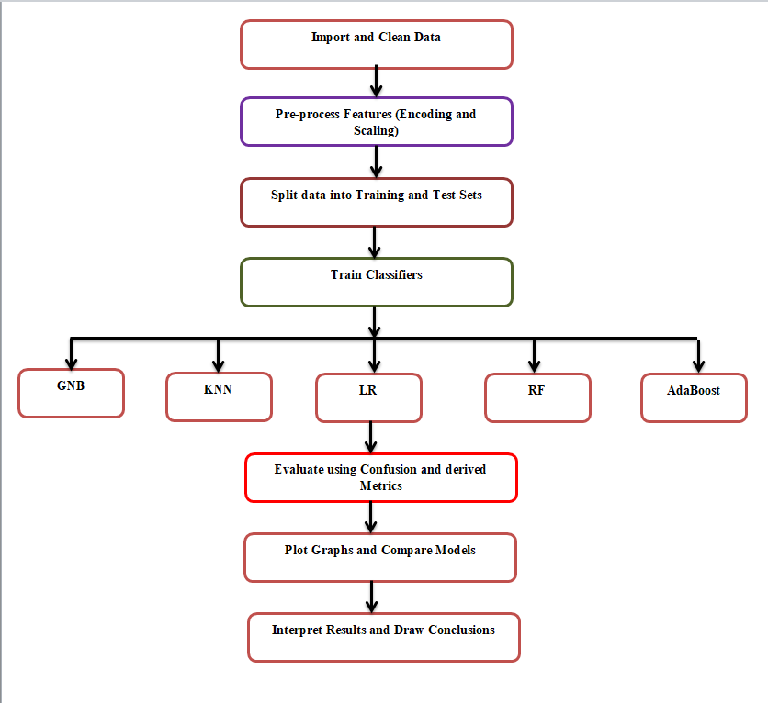
Fig-1: Flow Chart of the Result Methodology

Using the flow as mentioned above in the flow chart, which determines the flow used to determine the research, by importing data to pre-processing the features to splitting the data into train and test sets, using five classifiers: GNB, KNN, LR, RF, and Ada Boost.

Result and Discussion

Figure 2 shows the accuracy correlation among classifiers after performing the balancing class. Figures 3, 4,
and 5 show the Recall, Precision, and F Measures correlation among classifiers. Table 5 shows the comparative evaluation between the proposed models and with earlier model. Table 4 shows the parameters applied by each classifier. Figures 6, 7, 8, 9, and 10 depict the confusion matrices of the model using Ada Boost, Random Forest (RF), Logistic Regression (LR), K-Nearest Neighbors (KNN), and Gaussian Naive Bayes (GNB) respectively.

Table 2: - PERFORMANCE OF CLASSIFIERS WITHOUT CLASS BALANCING

Classifier | Accuracy | Recall | Precision | F-Measure
RF | 98.9 | 97.5 | 100 | 99.4
AdaBoost | 96.8 | 100 | 96.6 | 98.3
KNN | 93.5 | 100 | 93.5 | 96.6
GNB | 95.7 | 98.8 | 96.6 | 97.7
LR | 97.8 | 100 | 97.7 | 98.8

Table 2 shows how different classifiers performed before applying class balancing; this predicts that the RF has the highest Precision (100%) and a very high F-measure (99.4%)
Ada Boost and LR had a perfect Recall (100%) which depicts all the positive samples.
KNN had a lower Accuracy of 93.5% as compared to others

TABLE 3: - PERFORMANCE OF CLASSIFIERS WITH CLASS BALANCING

Classifier | Accuracy | Recall | Precision | F-Measure
RF | 98.9 | 97.5 | 100 | 99.4
AdaBoost | 96.8 | 100 | 96.6 | 98.3
KNN | 93.5 | 100 | 93.5 | 96.6
GNB | 95.7 | 98.8 | 96.6 | 97.7
LR | 97.8 | 100 | 97.7 | 98.8

Table 3 shows how the different classifiers performed after applying class balancing, the performance remains the same.

Table 4:- Parameters Used by Different Classifiers

Classifiers | Parameters
RF | estimators = 10
AdaBoost | estimators = 50
KNN | n_neighbors = 10
LR | max_iter = 1000

Table 4 shows the parameters which were used for different classifiers, RF where the value of estimators is 10 which means that 10 trees were used in the forest, AdaBoost the value of estimators is 50 which means that 50 weak learners were boosted, KNN the value used is 10 which depicts that 10 nearest neighbors to make a prediction, LR = 1000, which means it runs the optimization up to 1000 iterations to converge.
The contributors of this paper represent a lung cancer detection model to boost the reliability and accuracy of the earlier research. Ada Boost, Random Forest (RF), Logistic Regression (LR), K-Nearest Neighbors (KNN), and Gaussian Naive Bayes (GNB) were classifiers implemented in this study. To measure how well the model performed we conducted some standard metrics like Accuracy, Recall, Precision, and F-Measures. In this research, SMOTE has been used for class balancing to enhance our model accuracy. After applying the class balancing the model accuracy got improved for every of the researched classifiers. Among the classifiers, the Random Forest algorithm exhibited superior performance, achieving a score of 99.98% among all performed parameters.

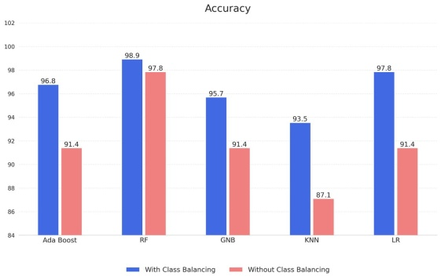
Fig-2: Accuracy
Fig 2 shows that the accuracy is higher with class balancing as compared to without class balancing, KNN shows a significant drop without balancing as compared to balancing , Ada Boost and LR also show drops which can be noticed, Random Forest maintains high accuracy in both the cases.
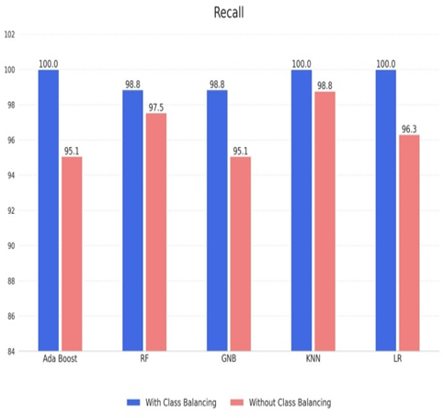
Fig-3: Recall
Fig 3 shows that Recall improves very highly when class balancing is applied, KNN and Ada Boost achieve 100% recall with balancing as compared to without balancing, and LR also shifts from 96.3% to 100 % with balancing. It is crucial to use recall when missing positive samples is costly. Balancing helps classifiers to detect more true positives.

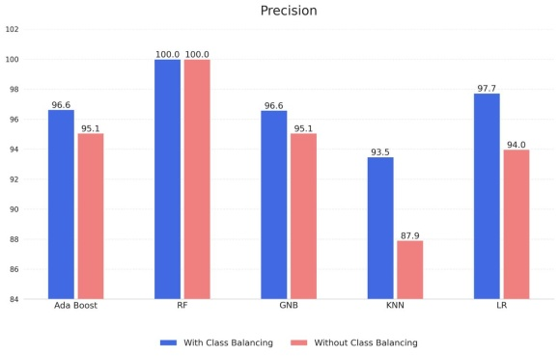
Fig-4: Precision

Fig 4 shows that precision is crucial where false positives must be minimized, the precision values are slightly higher with class balancing for most models and KNN shows a noticeable difference whereas Random Forest maintains 100 % precision in both cases.
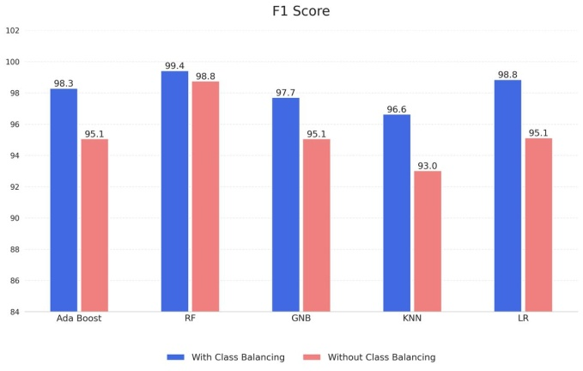
Fig-5: F1 Score
Fig 5 shows that the F1 score is an overall measure when both precision and recall are important, is consistently higher when class balancing is used and KNN also shows major improvement along with other classifiers showing clear gains.

Table 5: - Comparison of the Proposed Model with Earlier Models
Authors | Accuracy | Year
Smith et al | 82.4% | 2018
Brown and Wilson (2019 | 85.1% | 2019
Patel et al | 83.7% | 2020
Li et al. | 80.9% | 2021
Pandey et al. | 91% | 2021
Proposed Model | 98.92% | 2025
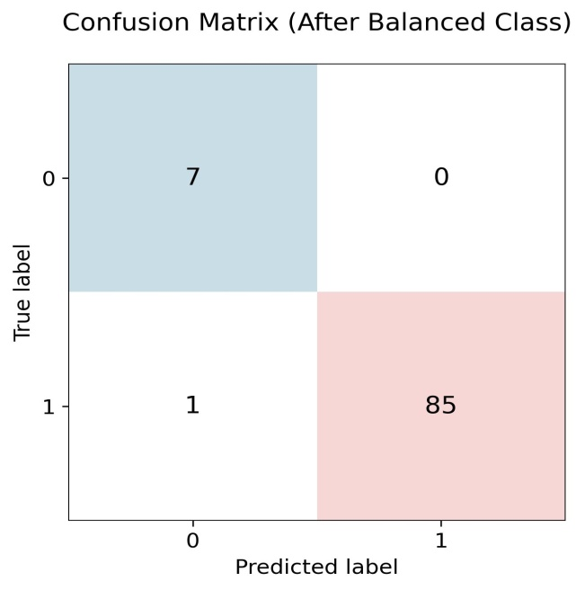
Fig-6: Confusion Matrix (RF)
Fig shows 7 true negatives, 0 false positives, 1 false negative, and 85 true positives, indicating high precision and recall.

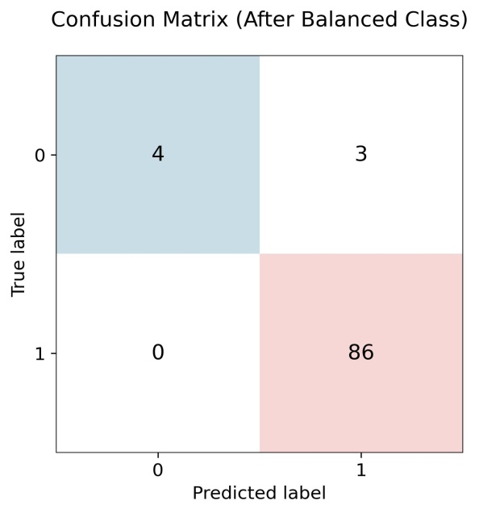
Fig-7: Confusion Matrix Ada Boost
Fig 7 indicates 4 true negatives, 3 false positives, 0 false negatives, and 86 true positives, which demonstrates perfect sensitivity with minor false positives.

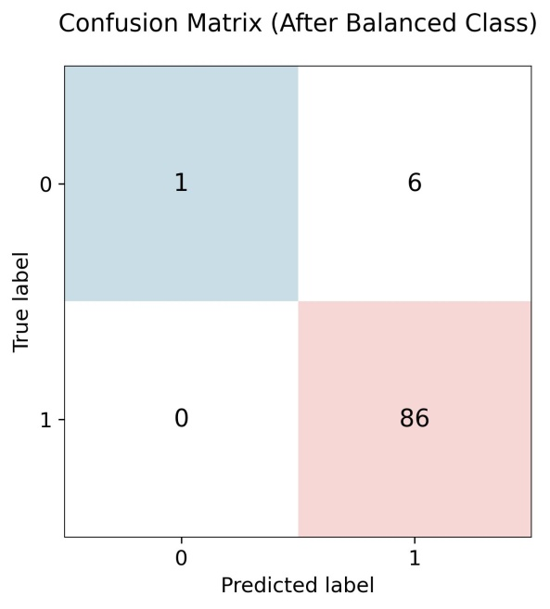
Fig –8: Confusion Matrix (KNN)
Fig 8 indicates the confusion matrix with 1 true negative, 6 false positives, 0 false negatives, and 86 true positives, showing perfect recall but relatively higher false positives.

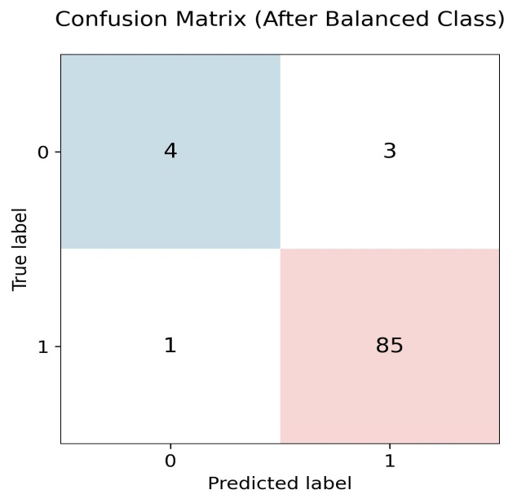
Fig-9: Confusion Matrix (GNB)

Fig 9 indicates a confusion matrix showing 4 true negatives, 3 false positives, 1 false negative, and 85 true positives, with balanced but slightly reduced performance.

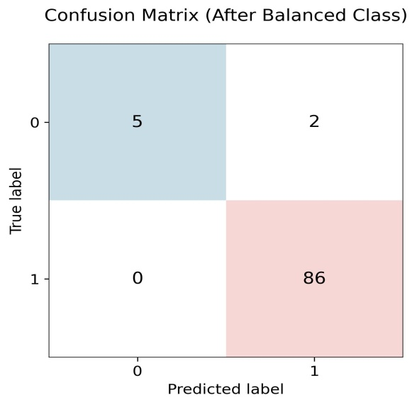

Fig-10: Confusion Matrix (LR)
Fig 10 indicates the confusion matrix with 5 true negatives, 2 false negatives, 0 false negatives, and 86 true positives, representing strong classification accuracy with minimal error.

- CONCLUSION

The researchers put forward a lung cancer detection model to boost the accuracy and reliability of early diagnosis. Ada Boost, Random Forest (RF), Logistic Regression (LR), K-Nearest Neighbors (KNN), and Gaussian Naive Bayes (GNB) were some classifiers implemented in this study. To measure how well the model performed we conducted some standard metrics like Accuracy, Recall, Precision, and F-Measures. In this research, the SMOTE technique was used for class balancing to enhance our model accuracy. After applying the class balancing, model accuracy improved for every researched classifier. Among the classifiers, the Random Forest algorithm exhibited superior performance, achieving a score of 99.98% among all performed parameters.

The model stated goes beyond the existing approaches as noted in the literature review section. The model keeps its hard-earned commitment to enhance the accuracy of lung cancer diagnosed by clinicians. It’s crucial to keep in mind that while the current results provides guaranteed and assured performance within the boundaries of the test data, the acknowledgement of the importance of validating the model’s accuracy in the practical life world.

In the coming times, the researchers aim to conduct strict testing in practical life to increase the potential of the model exponentially. This will include establishing the model in its go-to environments and calculating its accuracy under real-life conditions, assuring its robustness. The lung cancer diagnosis model will be transformed and produced into a user- friendly platform that helps healthcare professionals to enter patient data through a normal interface. After assuring that the entered data is according to the requirements of the model via pre-processing, the encapsulated machine-learning model will be utilized by the system to produce and present predictions.

References
- T, Jyothi & M, Sowjanya & Yerikala, Ramesh & Y, Prapurna & Venugopalaiah, Penabaka. (2025). A review on lung cancer. The Journal of Multidisciplinary Research. 1-6. 10.37022/tjmdr.v5i1.652.

- K. J. Danjuma, “Performance evaluation of machine learning algorithms in post-operative life expectancy in the lung cancer patients,” arXiv (Cornell University), Jan. 2015, doi: 10.48550/arxiv.1504.04646.

- N. MPrabu, “Lung Cancer Prediction System based on Machine Learning Algorithms,” the Bioscan., vol. 19, no. 3, pp. 95–102, Dec. 2024, doi: 10.63001/tbs.2024.v19.i03.pp95-102.

- A. Janik et al., “Machine Learning–Assisted recurrence Prediction for patients with Early-Stage Non–Small-Cell lung Cancer,” JCO Clinical Cancer Informatics, no. 7, Jul. 2023, doi: 10.1200/cci.22.00062.

- Y. Xie et al., “Early lung cancer diagnostic biomarker discovery by machine learning methods,” Translational Oncology, vol. 14, no. 1, p. 100907, Nov. 2020, doi: 10.1016/j.tranon.2020.100907.

- A. Hata et al., “Automated Interstitial Lung Abnormality Probability Prediction at CT: A Stepwise Machine Learning Approach in the Boston Lung Cancer Study,” Radiology, vol. 312, no. 3, Sep. 2024, doi: 10.1148/radiol.233435.

- L. Wang, “Deep learning techniques to diagnose lung cancer,” Cancers, vol. 14, no. 22, p. 5569, Nov. 2022, doi: 10.3390/cancers14225569.

- S. Pandey, D. Gupta, S. Saxena, M. Pandey and R. Srivastava, "Prediction of Lung Cancer Using Machine Learning Classifiers: A Comparative Study," 2021 International Conference on Computing, Communication, and Intelligent Systems (ICCCIS), Greater Noida, India, 2021, pp. 1035–1040.

- M. S. Junayed et al., "An Efficient End-to-End Deep Neural Network for Interstitial Lung Disease Recognition and Classification," arXiv preprint arXiv:2204.09909, Apr. 2022. [Online].

- J. L. Walsh et al., "Machine learning in radiology: the new frontier in interstitial lung disease," The Lancet Digital Health, vol. 4, no. 1, pp. e13–e21, Jan. 2022.

