

PROJECT REPORT
On

The Impact of Genetics and Environmental Factors on Chronic Lung Diseases

Submitted in partial fulfillment of the requirement for
The Course Integrated Project(IP) of

COMPUTER SCIENCE AND ENGINEERING

B.E. Batch-2022



Under the Guidance of  Mr. Ravi Sachdeva | Submitted By:  Tanisha(2210992440)  Akshit Kansal(2210990092)

DEPARTMENT OF COMPUTER SCIENCE AND ENGINEERING

CHITKARA UNIVERSITY
PUNJAB

CERTIFICATE
This is to be certified that the project entitled “The Impact of Genetics and Environmental Factors on Chronic Lung Diseases.” has been submitted for the Bachelor of Computer Science Engineering at Chitkara University, Punjab during the academic semester January 2025- May-2025 is a Bonafide piece of project work carried out by Tanisha (2210992440), Akshit Kansal(2210990092) as team 20 towards the partial fulfilment for the award of the course Integrated Project under the guidance of Mr. Ravi Sachdeva and supervision.

Signature of Project Guide: Name of Project Guide: (Designation & Department)

CANDIDATE’S DECLARATION

I Tanisha (2210992440), Akshit Kansal(2210990092) of the Chitkara University, Punjab hereby declare that the Integrated Project Report entitled “The Impact of Genetics and Environmental Factors on Chronic Lung Diseases.” is an original work and data provided in the study is authentic to the best of our knowledge. This report has not been submitted to any other Institute for the award of any other course.

Signature of students

- Tanisha 2210992440
- Akshit Kansal 2210990092

ACKNOWLEDGEMENT
It is our pleasure to be indebted to various people, who directly or indirectly contributed in the development of this work and who influenced my thinking, behavior, and acts during the course of study.

We express our sincere gratitude to all for providing me an opportunity to undergo Integrated Project as the part of the curriculum.

We are thankful to Mr. Ravi Sachdeva for his support, cooperation, and motivation provided to us during the training for constant inspiration, presence, and blessings.
Lastly, we would like to thank the almighty and our parents for their moral support and friends with whom we shared our day-to-day experience and received lots of suggestions that improved our quality of work.

The report must consist of following chapters:

  - Abstract/Keywords

  - Introduction to the project

    - Background

    - Problem Statement

  - Software and Hardware Requirement Specification

    - Methods

    - Programming/Working Environment

    - Requirements to run the application

  - Dataset Analyzing, design and implementation (If any)

  - Program’s Structure Analyzing and GUI Constructing (Project Snapshots)

  - Code-Implementation and Database Connections (If any)

  - System Testing (if any)

  - Limitations (if any)

  - Conclusion

  - Future Scope

  - Bibliography/References

Abstract/ Keywords

Lung cancer remains one of the most lethal forms of cancer worldwide, primarily due to late-stage diagnosis and the complexity of early detection. This project presents a machine learning–based approach to detect lung cancer using a publicly available dataset. The objective is to classify patients into cancer-positive and cancer-negative categories by leveraging various machine learning classifiers, including Logistic Regression, Gaussian Naive Bayes, K-Nearest Neighbors (KNN), Random Forest, and Ada Boost.
Each model was evaluated based on key metrics derived from the confusion matrix—Accuracy, Precision, Recall (Sensitivity), and F1-score—to measure predictive performance. Visual representations of confusion matrices before and after applying class balancing were generated to support comparative analysis.
The study demonstrates that ensemble methods like Ada Boost and Random Forest provide robust performance, particularly when trained on balanced data. The findings emphasize the importance of pre-processing techniques in improving model generalization on imbalanced medical datasets. This project not only contributes to the domain of intelligent cancer detection but also lays a foundation for further research in automated diagnostic systems using artificial intelligence.

Keywords: Lung Cancer, classifiers, Accuracy, Precision, datasets, Artificial Intelligence.

Introduction to the project

The increasing burden of chronic illnesses and cancers has highlighted the need for innovative solutions that assist in early diagnosis and treatment. During the topic selection phase, we were particularly drawn to real-world healthcare problems where technology could have a measurable impact. After reviewing several options, we decided to focus on lung cancer detection using machine learning due to its high fatality rate and the fact that early detection can significantly improve patient outcomes.

We chose this topic because lung cancer is often diagnosed at an advanced stage, where treatment options are limited and survival rates are low. With advancements in machine learning and increased availability of medical datasets, there is a growing opportunity to build models that can predict health risks early and accurately. Our goal was to explore how data-driven technologies could assist in identifying potential lung cancer cases based on common symptoms and health indicators, thereby aiding medical professionals in early intervention.

Once the topic was finalized, we identified a relevant dataset (survey_lung_cancer.csv) and started analyzing various features such as age, smoking history, fatigue, and shortness of breath. Using these features, we developed and evaluated several machine learning models including Logistic Regression, Random Forest, Gaussian Naive Bayes, K-Nearest Neighbors (KNN), and Ada Boost. We also addressed challenges such as class imbalance using SMOTE and analyzed the models through confusion matrix–based metrics like accuracy, precision, recall, and F1-score.

Lung diseases such as Interstitial Lung Disease (ILD), which often leads to lung cancer, are complex and result from a combination of genetic predispositions and environmental exposures. ILD causes inflammation and scarring of lung tissues, making it difficult for oxygen to pass into the bloodstream. Over time, this leads to severe breathing difficulties, respiratory failure, and increased risk of lung cancer. Through this project, we aimed not only to build predictive models but also to raise awareness of how machine learning can be a powerful tool in tackling critical health issues like lung cancer.

This project was managed through a structured process involving problem understanding, data preprocessing, model building, evaluation, and thorough documentation. The experience gave us deep insights into both the technical and healthcare aspects of predictive modeling and reinforced the importance of using technology for societal good.

Background
Lung cancer remains one of the leading causes of cancer-related deaths globally, largely due to late diagnosis and the aggressive nature of the disease. Common risk factors include smoking, prolonged exposure to air pollutants, occupational hazards, and genetic predispositions. Traditional diagnostic methods like imaging and biopsy are often expensive, time-consuming, and not easily accessible in underdeveloped regions. Early detection is crucial for improving survival rates, but it is hindered by non-specific symptoms and the lack of advanced screening tools.
In recent years, technological advancements have opened new avenues in healthcare, particularly through the use of Machine Learning (ML) and Artificial Intelligence (AI). These techniques have shown great promise in identifying disease patterns from patient data, allowing for early and more accurate detection. Several research studies have applied ML algorithms for disease classification, but many face challenges such as data imbalance, low precision, or limited evaluation.
In our project, we address these issues by using a real-world dataset (survey_lung_cancer.csv) that includes features like age, fatigue, chronic cough, and smoking history. Our aim is to evaluate and compare different ML classifiers—such as Logistic Regression, Random Forest, Naive Bayes, KNN, and AdaBoost—to predict lung cancer likelihood and assess their performance through standard evaluation metrics. By applying SMOTE for class balancing and visualizing confusion matrix–based results, we strive to contribute a reliable and explainable approach to lung cancer prediction.

Problem Statement
Lung cancer continues to be one of the leading causes of death globally due to its late detection and vague early symptoms. Traditional diagnostic methods like X-rays, CT scans, and biopsies are often costly, time-consuming, and not easily accessible to people in rural or underdeveloped areas. As a result, early-stage lung cancer frequently goes undiagnosed until it becomes severe and harder to treat.
Furthermore, existing computer-aided diagnostic tools face several limitations, such as poor prediction accuracy, difficulty in handling imbalanced datasets, and a lack of interpretability. These issues limit their effectiveness in real-world clinical environments.
To address this, there is a need for an intelligent, cost-effective, and accurate prediction system that can support early diagnosis of lung cancer using easily available patient data. This system should handle class imbalance effectively and be evaluated using reliable performance metrics like Accuracy, Precision, Recall, and F1-Score.
The goal of this project is to build such a solution using machine learning classifiers—such as Logistic Regression, Random Forest, K-Nearest Neighbors, Gaussian Naive Bayes, and Ada Boost—and improve prediction quality using class balancing (SMOTE) and confusion matrix–based metric visualization.

Software and Hardware Requirement Specification

To successfully develop, test, and run the machine learning models for lung cancer detection, the following software and hardware resources were required.

Software Requirements:

Operating System : Windows 10 / Linux Ubuntu / mac OS

Programming Language: Python 3.8 or above

IDE: Google Collab

Libraries & Packages: pandas, numpy, scikit-learn, matplotlib, seaborne, imblearn

Visualization Tools: Matplotlib, Seaborn

Data Handling Tools: Pandas, NumPy

Hardware Requirements:

Graphics: Integrated Graphics sufficient for visualization

Internet : Required

Dataset Analyzing, Design and Implementation

4.1 Dataset Overview
The dataset utilized in this research is sourced from Kaggle, containing detailed records related to patient demographics, lifestyle habits, and symptoms pertinent to chronic lung diseases, specifically lung cancer prediction. The dataset comprises 309 records with 15 key features representing various risk factors and symptoms such as age, gender, smoking status, allergy, anxiety, chest pain, and others.
These features are a mix of categorical (e.g., Gender, Smoking) and binary variables (presence or absence of symptoms). The target variable indicates whether the individual is diagnosed with lung cancer.

4.2 Data Analysis
Initial exploratory data analysis was performed to understand the distribution and relationships among the features and the target variable. The analysis helped identify any missing or inconsistent data, distribution imbalances (notably class imbalance between cancer-positive and cancer-negative cases), and correlations between variables.
Key observations include:
- A significant portion of individuals with smoking habits also show symptoms like yellow fingers and shortness of breath.
- Anxiety, peer pressure, and lifestyle factors showed moderate correlation with lung disease presence.
- Class imbalance was present, necessitating techniques such as SMOTE for balancing.

4.3 Data Preprocessing
To prepare the dataset for model training, several preprocessing steps were undertaken:
- Handling Missing Values: Null or inconsistent entries were identified and either imputed or removed.
- Encoding Categorical Variables: Categorical features such as Gender and Smoking were label encoded into numerical values to facilitate model compatibility.
- Feature Scaling: Although many features are binary or categorical, numerical features such as age were normalized where applicable.
- Class Balancing: The dataset exhibited imbalance in the target classes (lung cancer positive vs negative). To counter this, the Synthetic Minority Over-sampling Technique (SMOTE) was applied, which synthesizes new samples in the minority class to balance the dataset, improving classifier performance on minority classes.
4.4 Dataset Design
The dataset design was structured to include relevant risk factors based on literature review and clinical significance which includes age, gender, smoking, yellow fingers, anxiety , peer pressure, allergy, alcohol consumption, fatigue, shortness of breath, coughing, swallowing difficulty, coughing, chest pain.

4.5 Implementation Details
The dataset was implemented in CSV format, loaded into Python using data analysis libraries (such as pandas and numpy). The preprocessing pipeline was coded to automate cleaning, encoding, and balancing steps, ensuring reproducibility.
The dataset was then split into training and testing subsets with a 70:30 ratio to build and evaluate machine learning classifiers. Five different classification algorithms were applied to predict lung cancer presence:
- Logistic Regression
- Gaussian Naïve Bayes
- K-Nearest Neighbors (KNN)
- Random Forest
- AdaBoost
Each algorithm was trained on the preprocessed dataset, and hyperparameters were tuned for optimal performance.
Evaluation was done through confusion matrix–based metrics such as accuracy, precision, recall, and F1-score to ensure balanced model assessment.

Program’s Structure Analysing
The program developed for lung cancer detection is designed with a modular and systematic structure that facilitates efficient data processing, model training, evaluation, and prediction. The program is divided into multiple key components, each responsible for specific tasks in the machine learning pipeline.
1. Data Loading and Preprocessing:
The first module is responsible for importing the dataset (CSV format) from the source (Kaggle). It handles data cleaning tasks such as dealing with missing or inconsistent values and performs label encoding to convert categorical variables (e.g., Gender, Smoking) into numerical form suitable for machine learning algorithms. This ensures that all features are in the correct format for analysis.
2. Data Splitting:
After preprocessing, the dataset is divided into training and testing subsets, typically using a 70:30 ratio. This separation is essential to evaluate the model’s ability to generalize on unseen data. The training set is used to build the predictive models, while the test set assesses their performance.
3. Model Implementation:
This component implements multiple classification algorithms to predict the presence of lung cancer based on the features. The classifiers used include:
- Logistic Regression (LR): For binary classification problems.
- Gaussian Naive Bayes (GNB): Assumes feature independence to simplify computation.
- K-Nearest Neighbors (KNN): Classifies data points based on the nearest neighbors.
- Random Forest (RF): An ensemble of decision trees to improve accuracy and reduce overfitting.
- AdaBoost: Boosting algorithm that combines multiple weak classifiers to create a strong classifier.
Each classifier is implemented as a separate module or function with defined parameters and training procedures.
4. Class Balancing:
Due to class imbalance in the dataset (fewer positive lung cancer cases), Synthetic Minority Oversampling Technique (SMOTE) is applied as a preprocessing step before training the classifiers. This module ensures balanced representation of classes, which helps improve prediction accuracy and reduces bias toward the majority class.
5. Model Training and Evaluation:
This part handles training the classifiers on the balanced training data. It then predicts on the test set and evaluates model performance using metrics derived from the confusion matrix: Accuracy, Precision, Recall, and F1-Score. The evaluation module outputs performance summaries and visualizes confusion matrices for each classifier.
6. Visualization and Reporting:
Results such as accuracy comparisons, precision-recall graphs, and confusion matrices are generated here. These visualizations help in understanding the relative strengths and weaknesses of each model and support decision-making for selecting the best-performing classifier.

Code Implementation

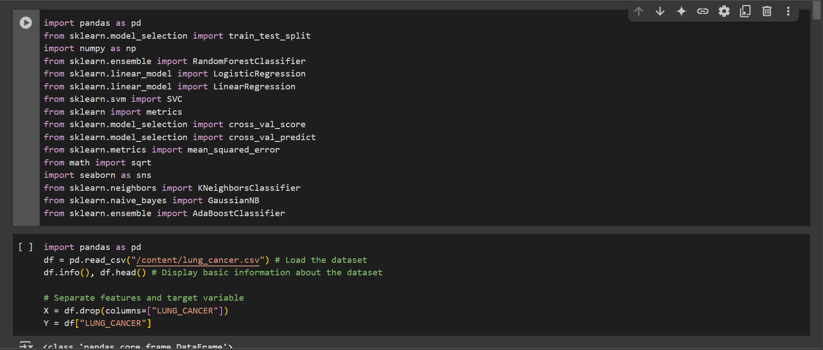

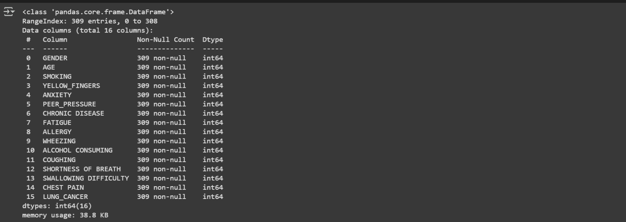

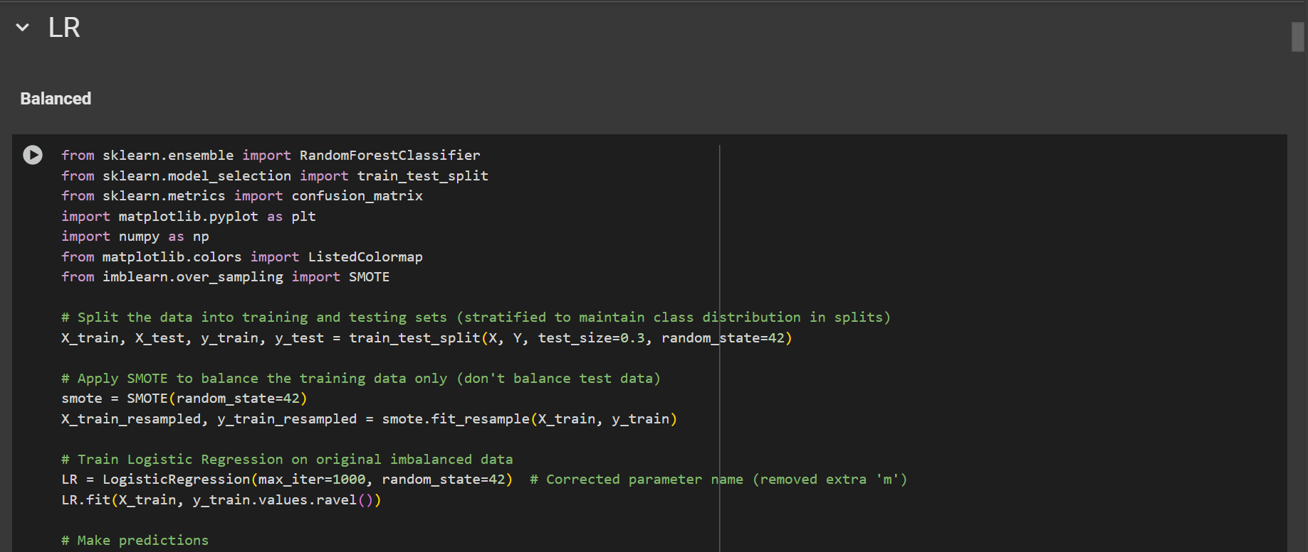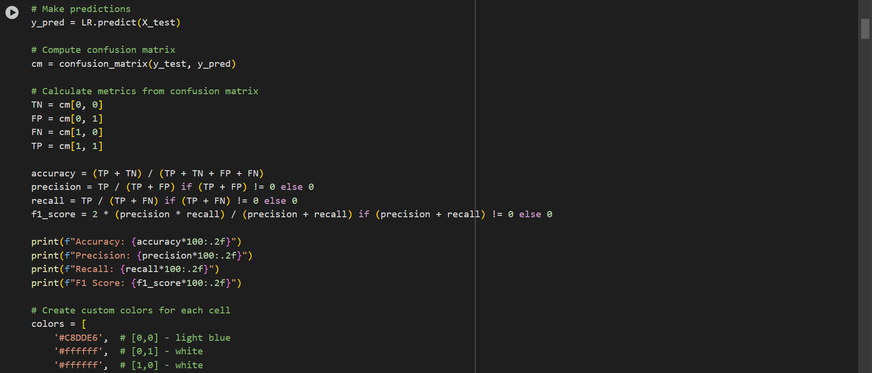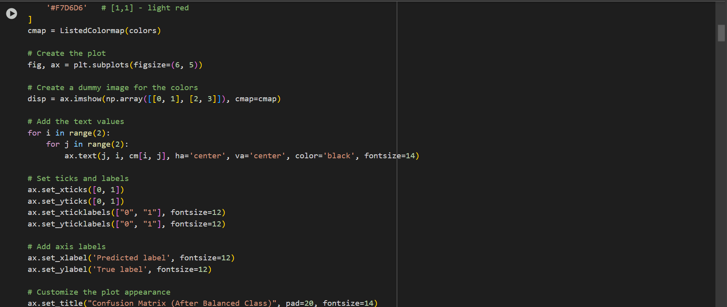

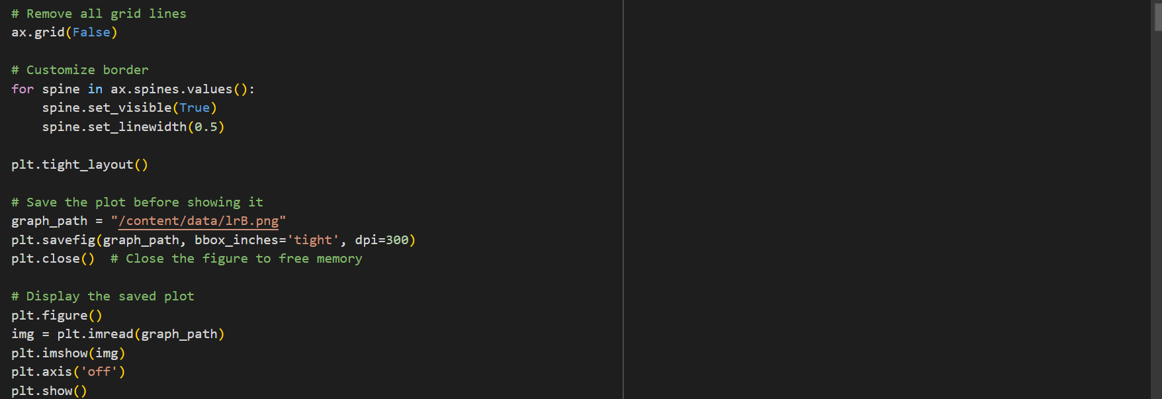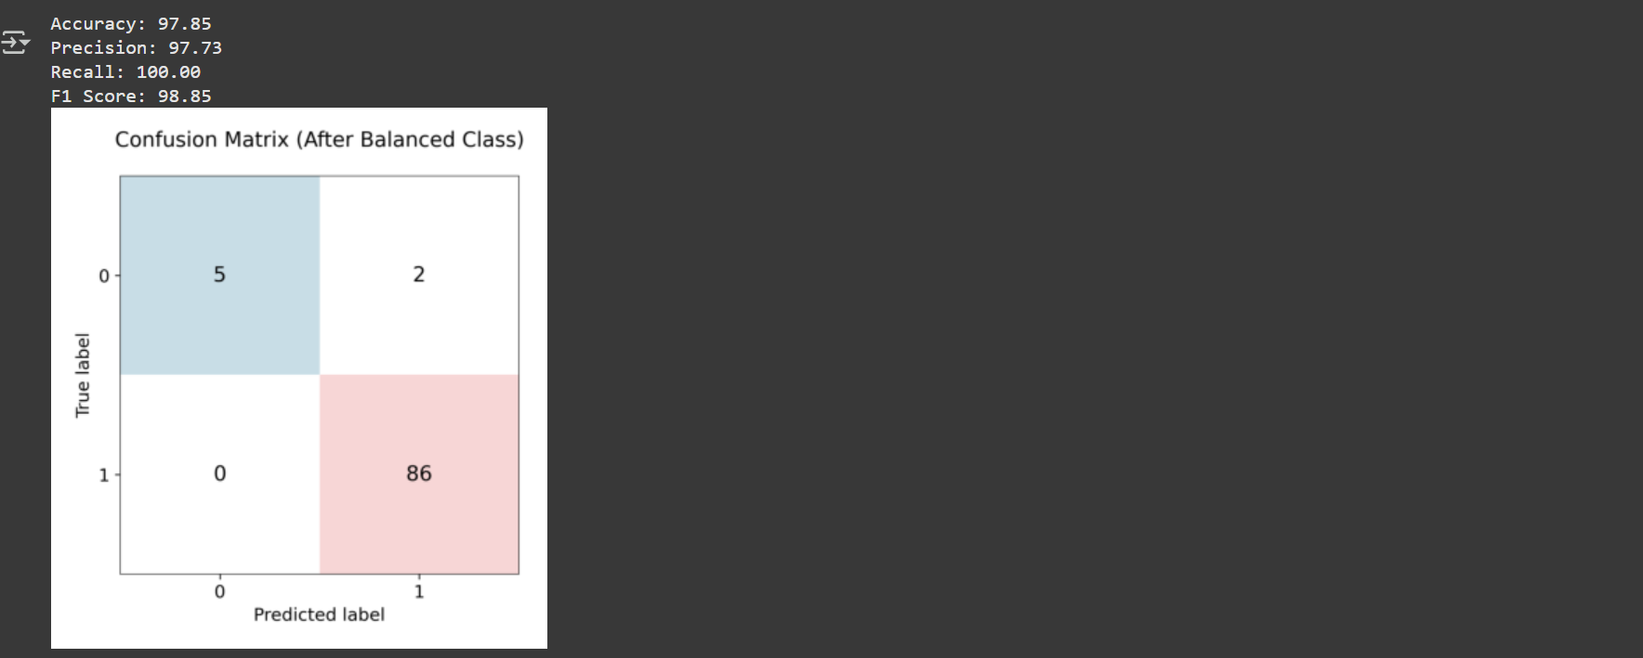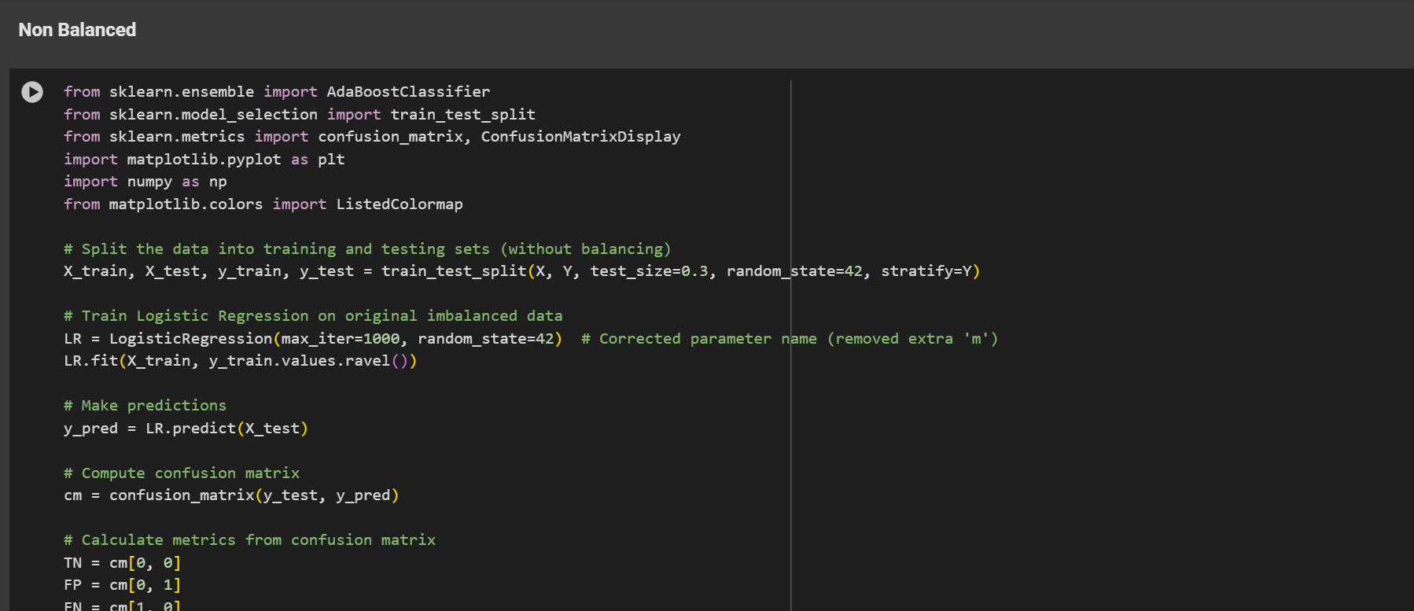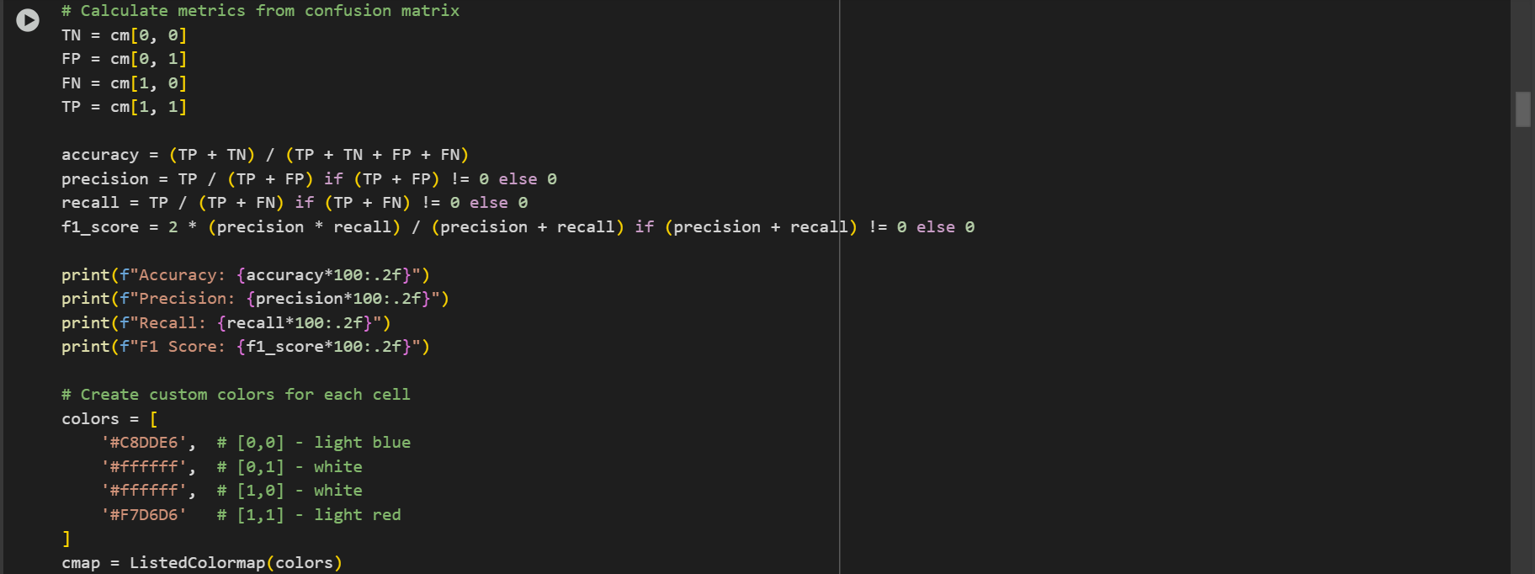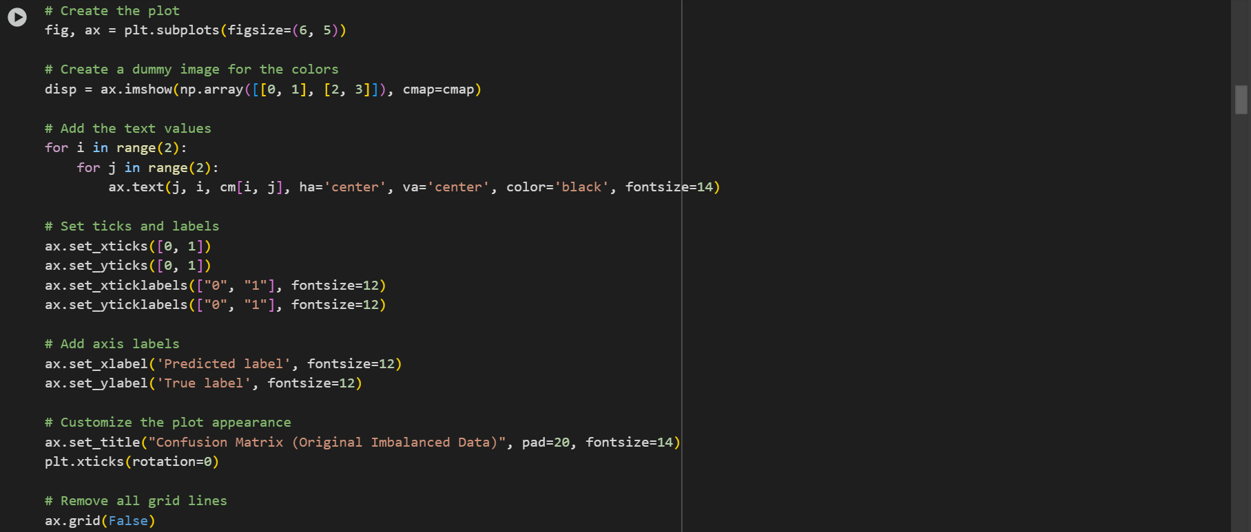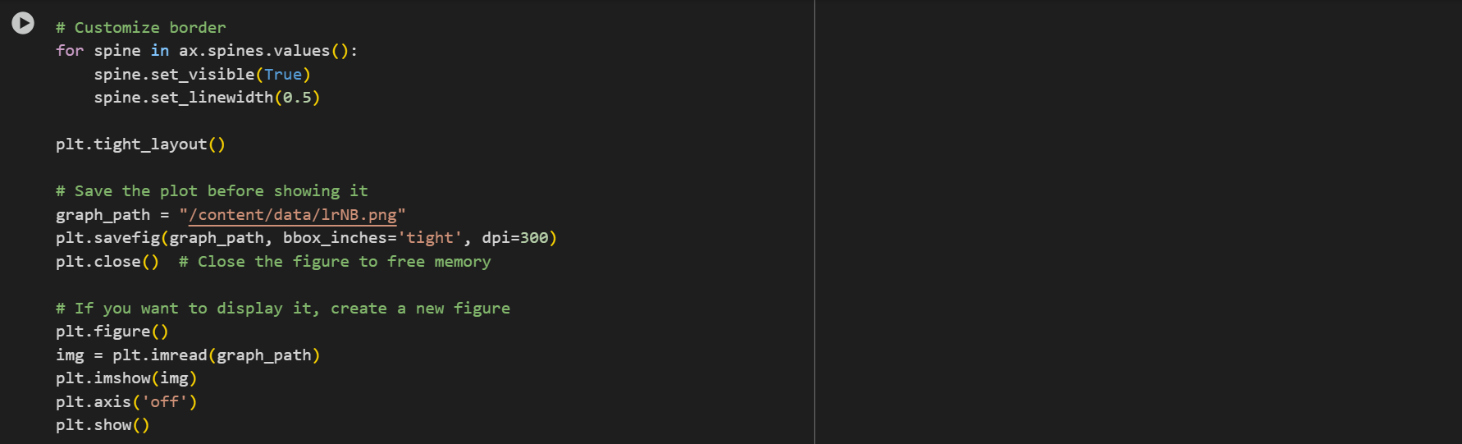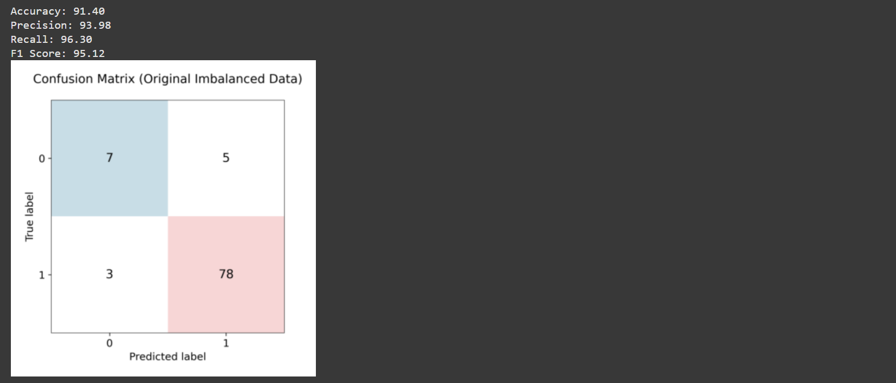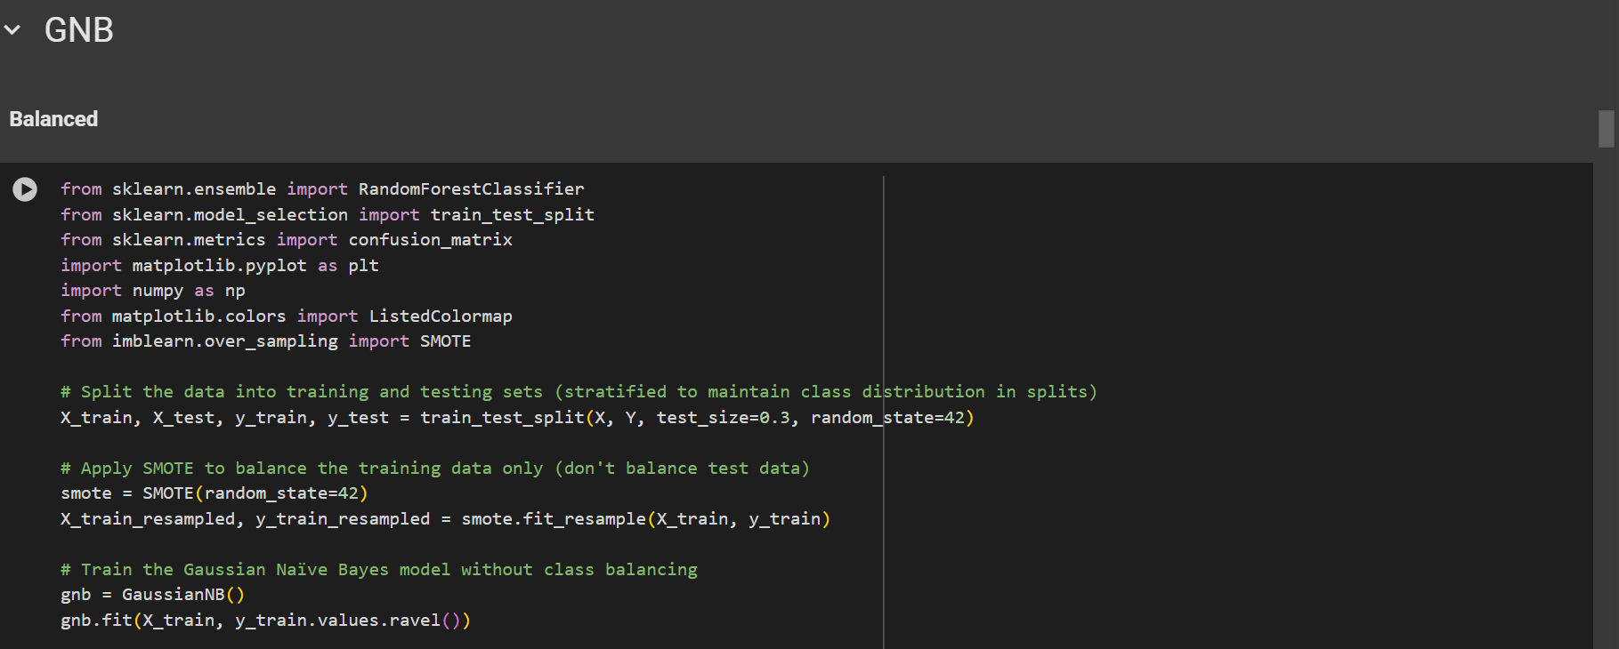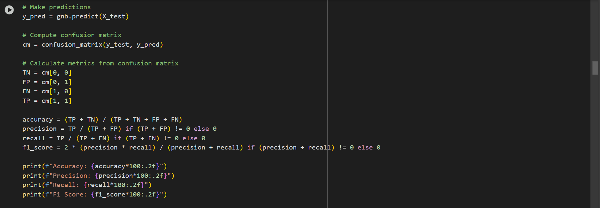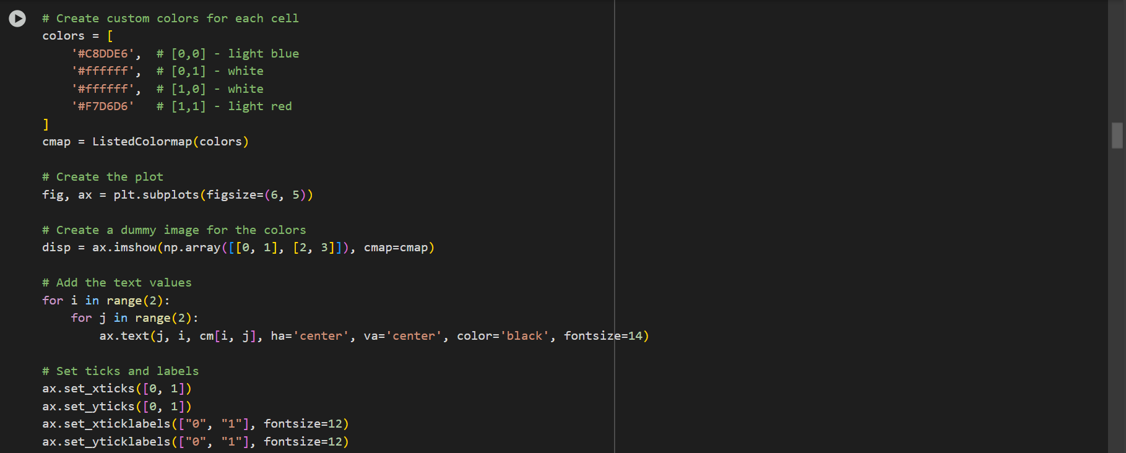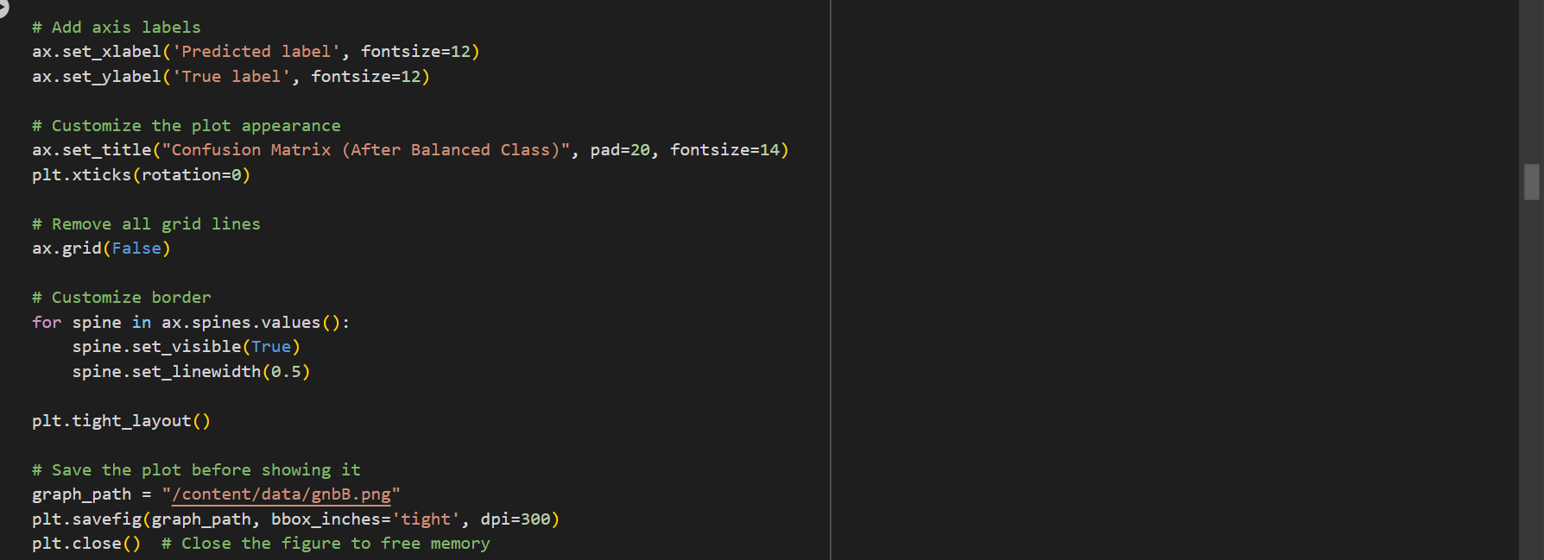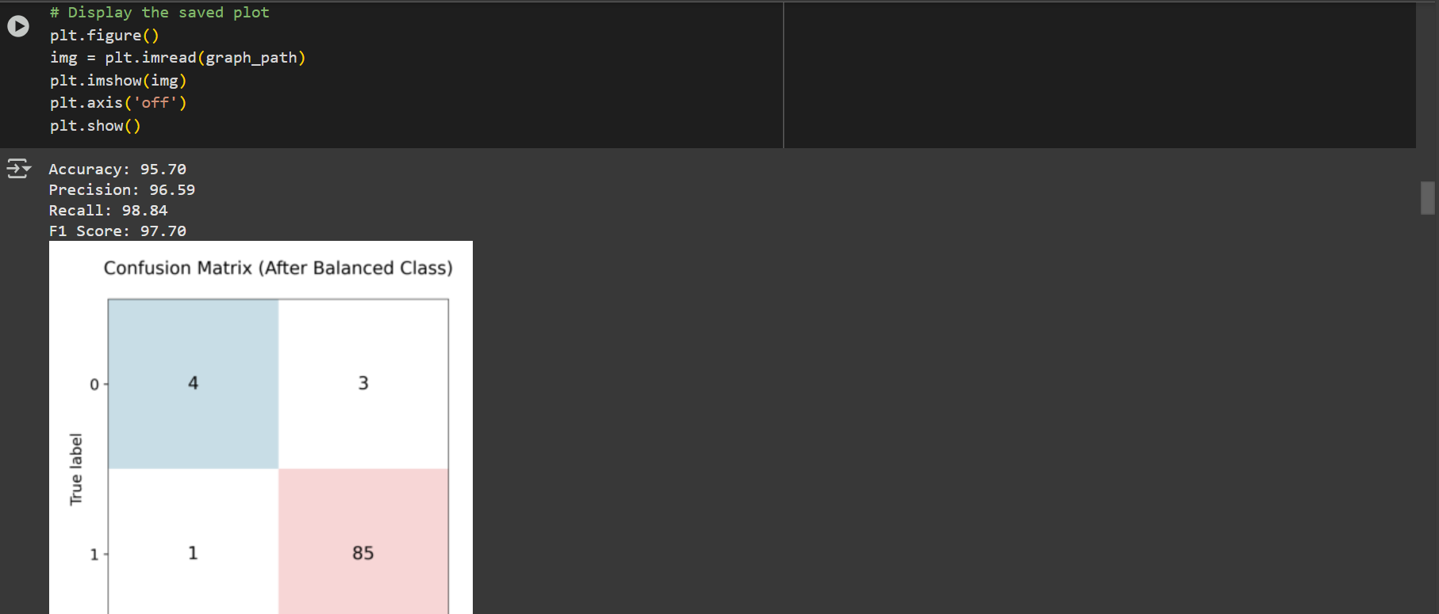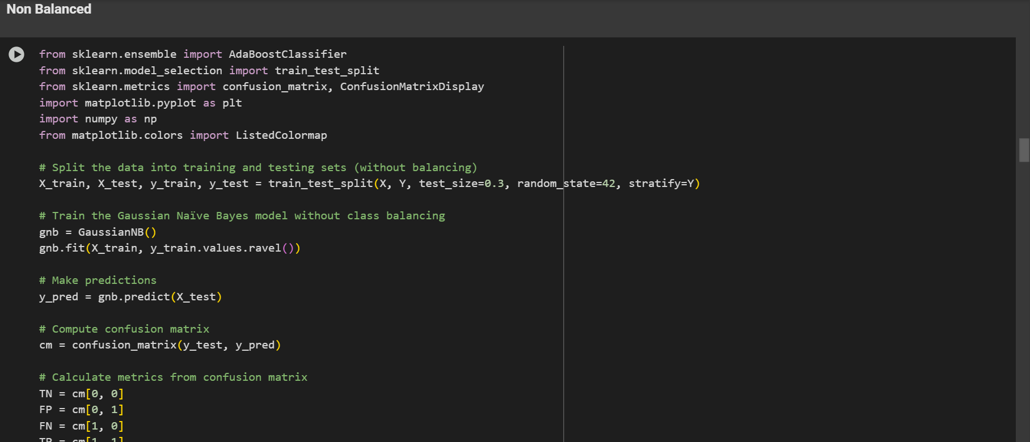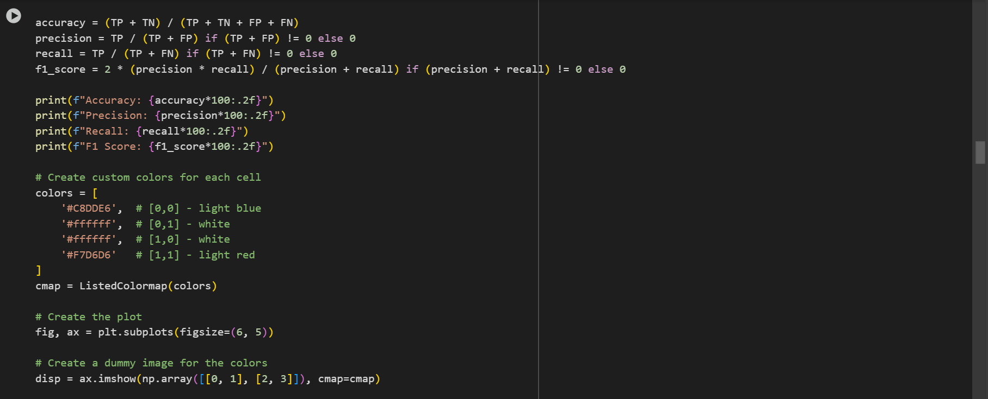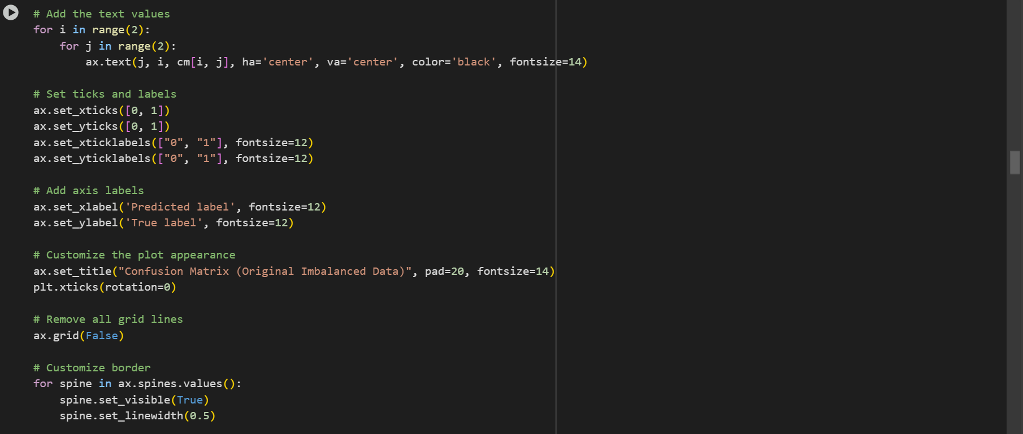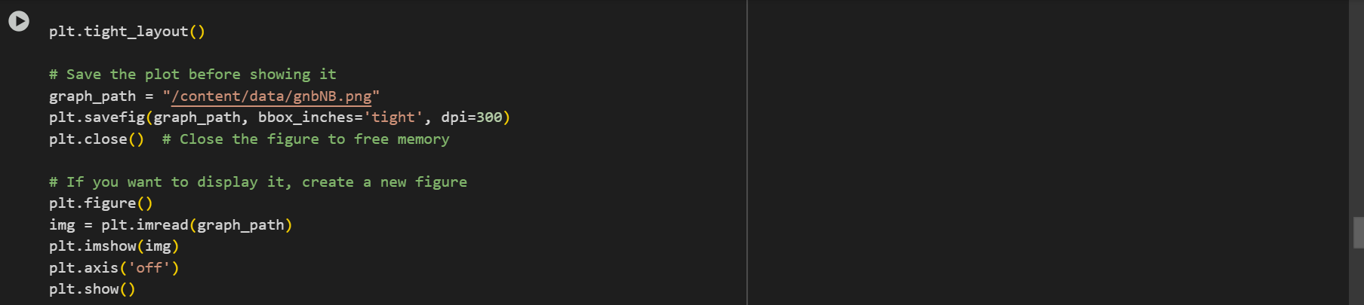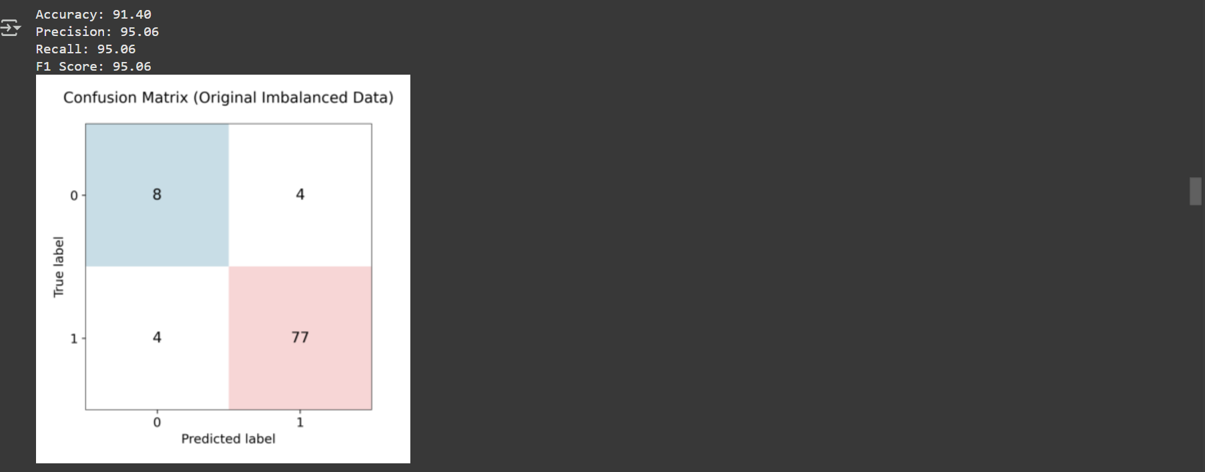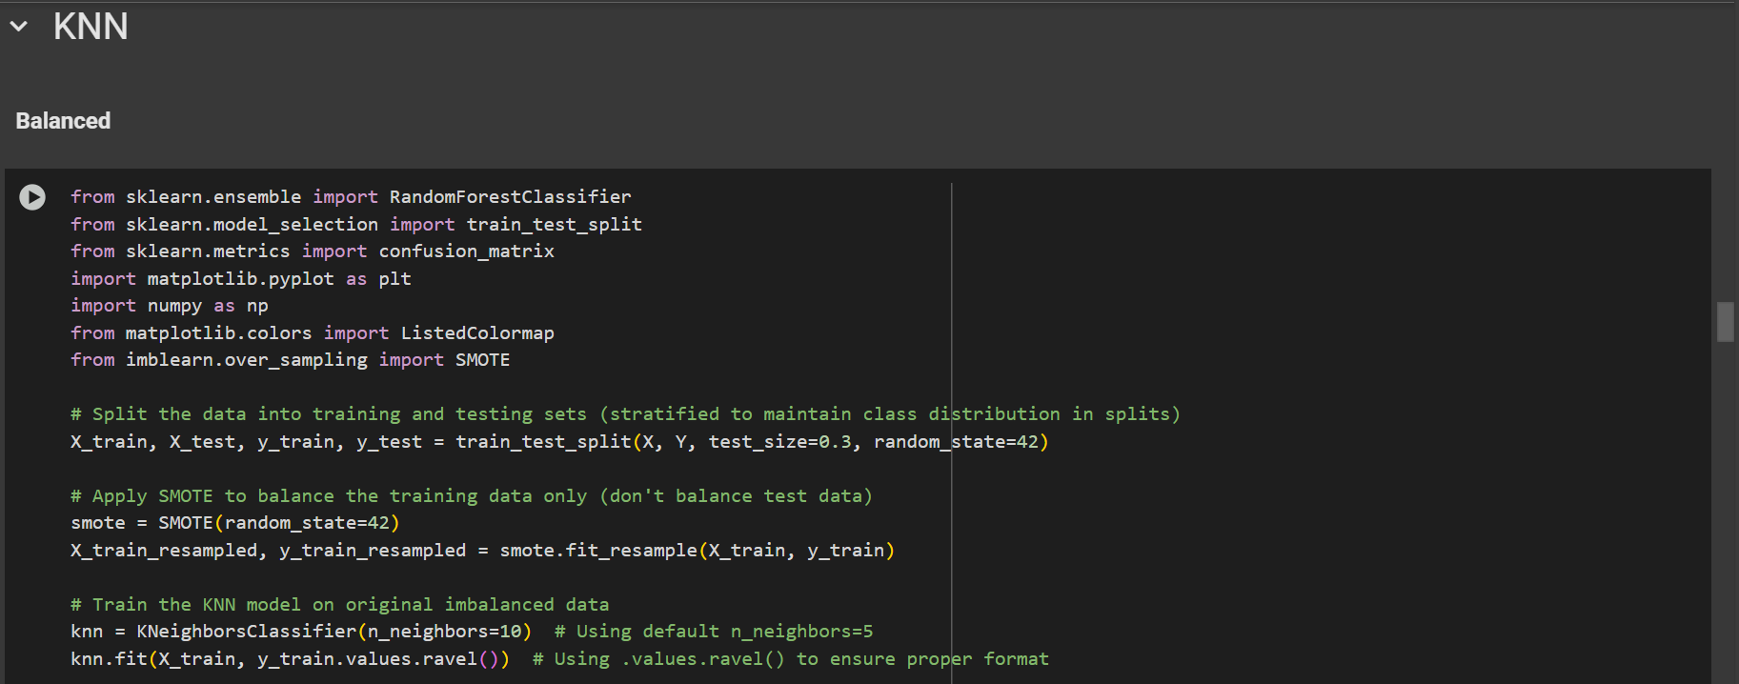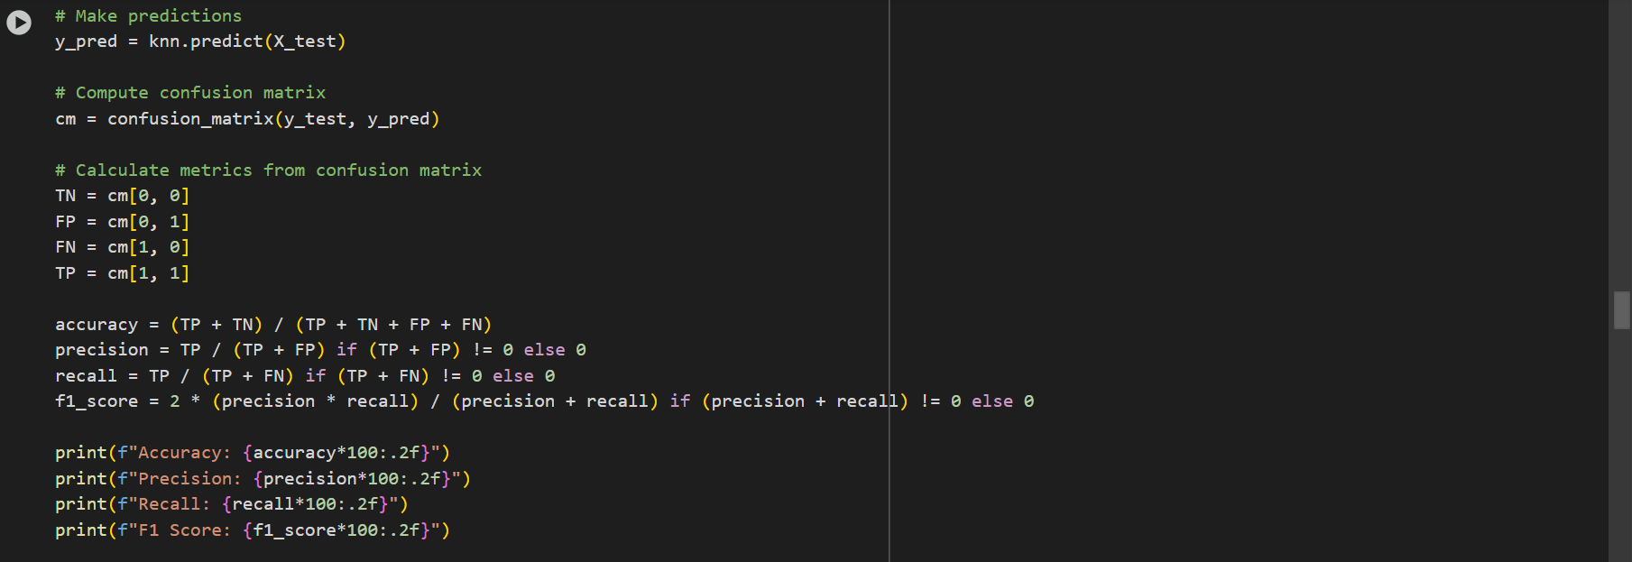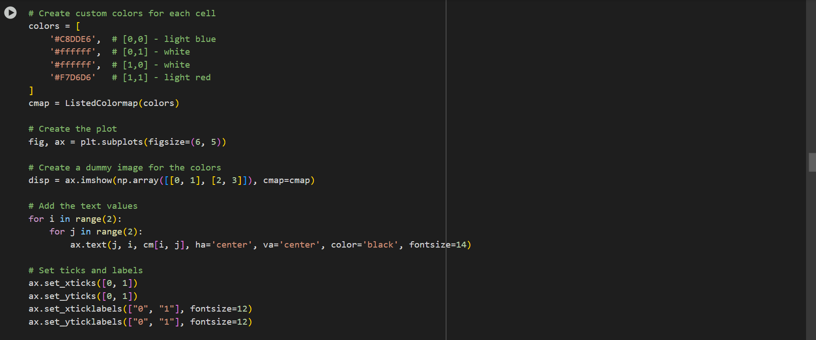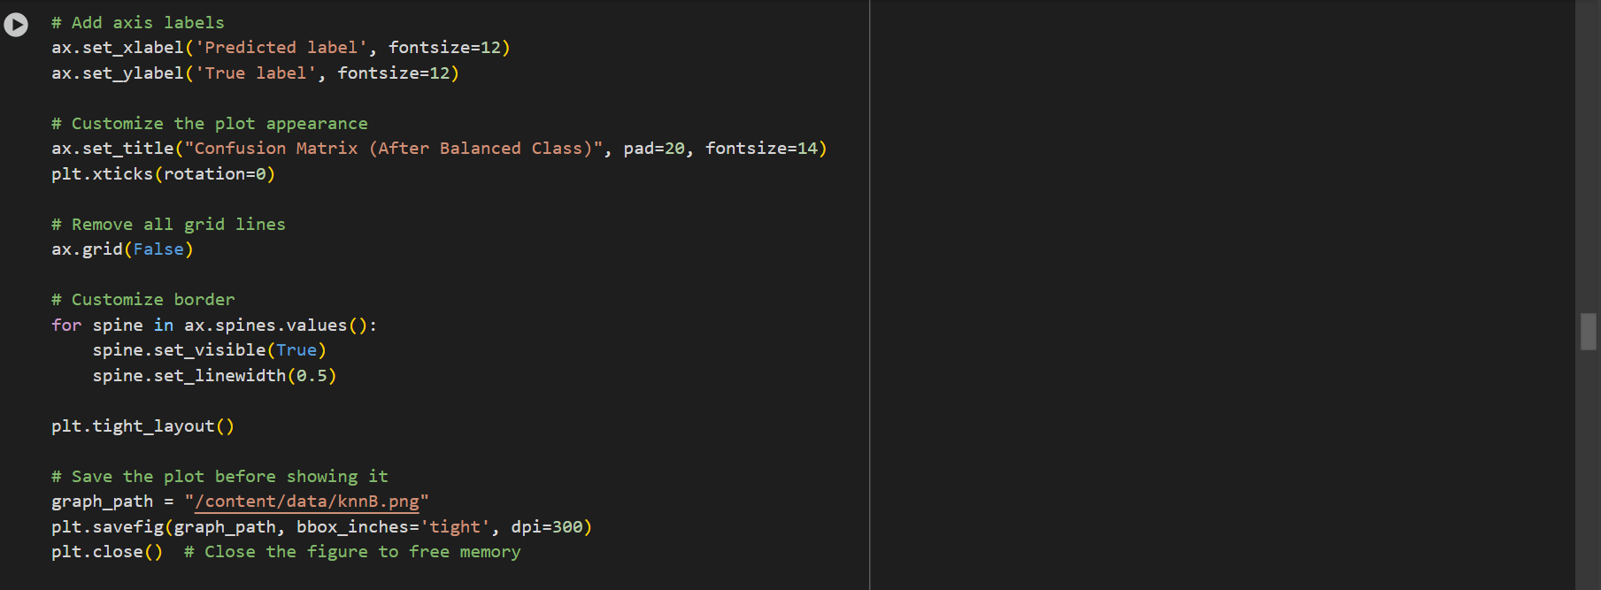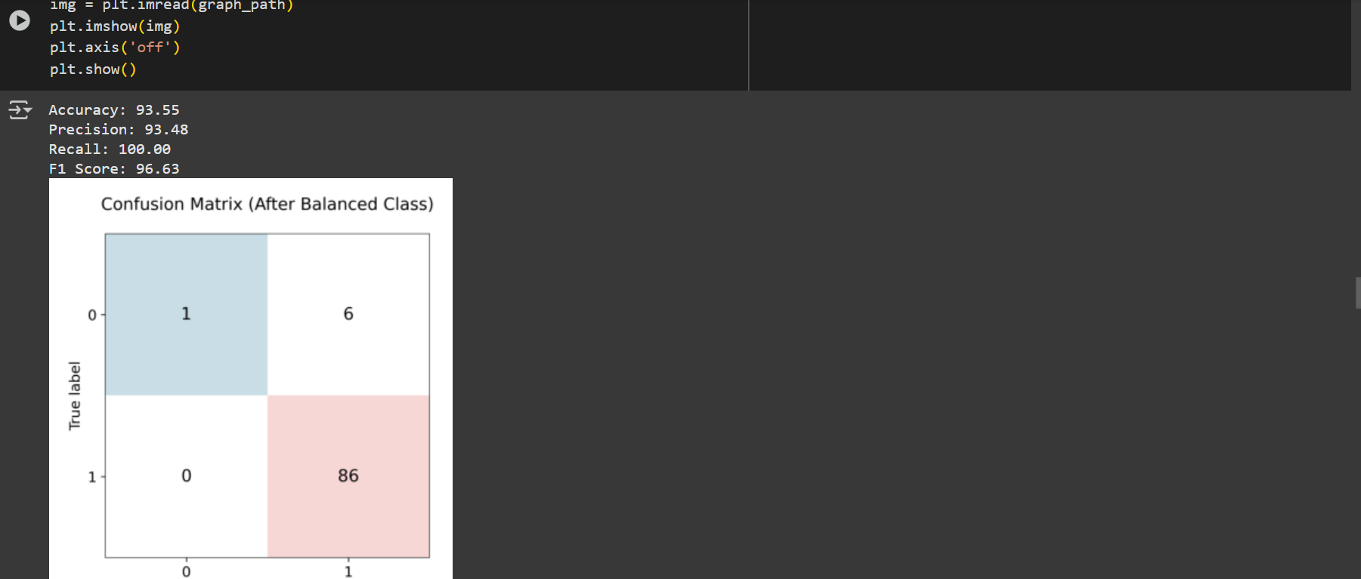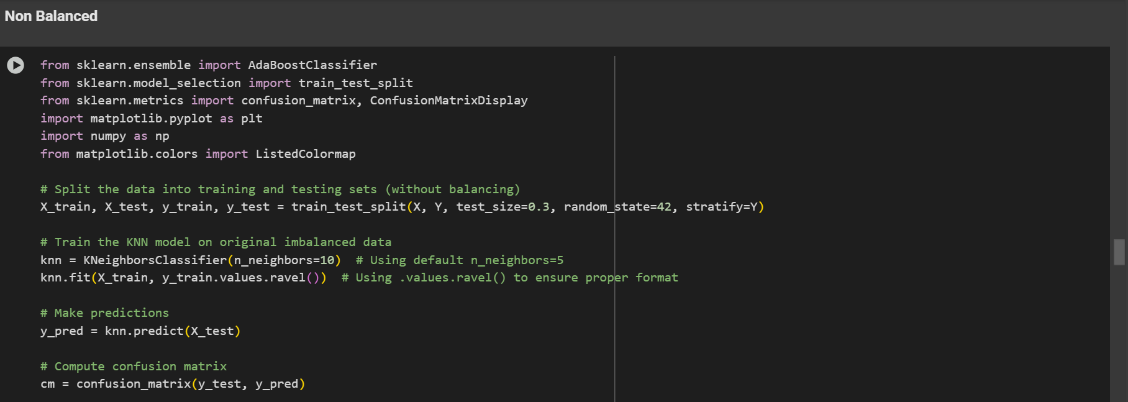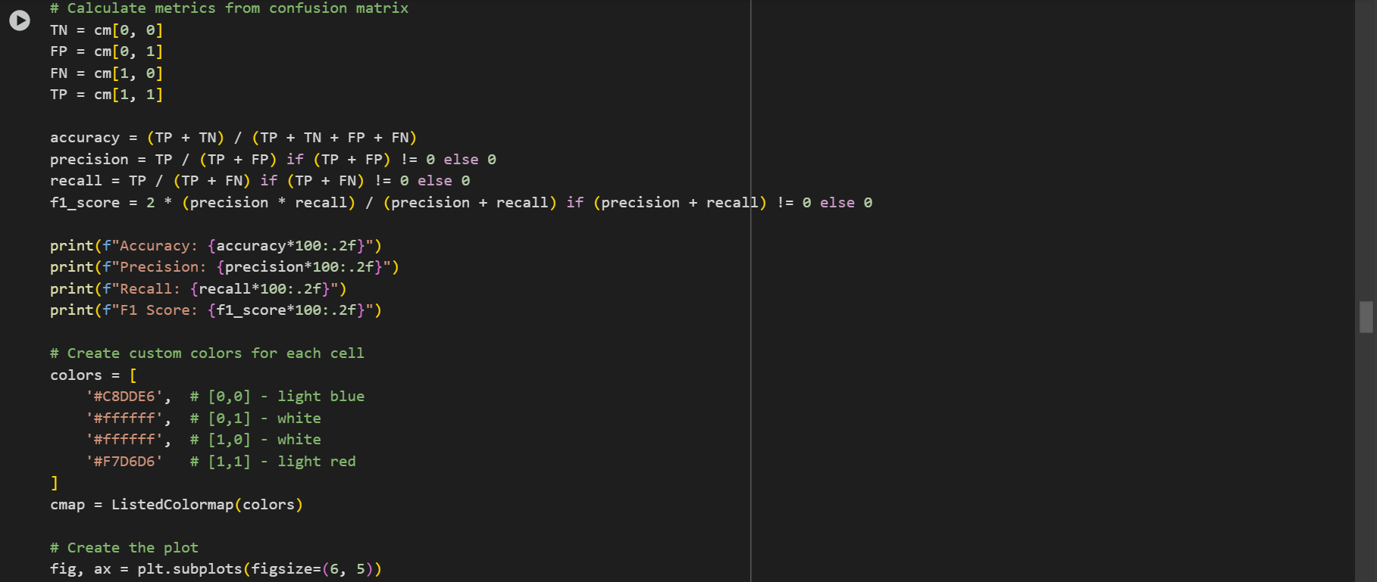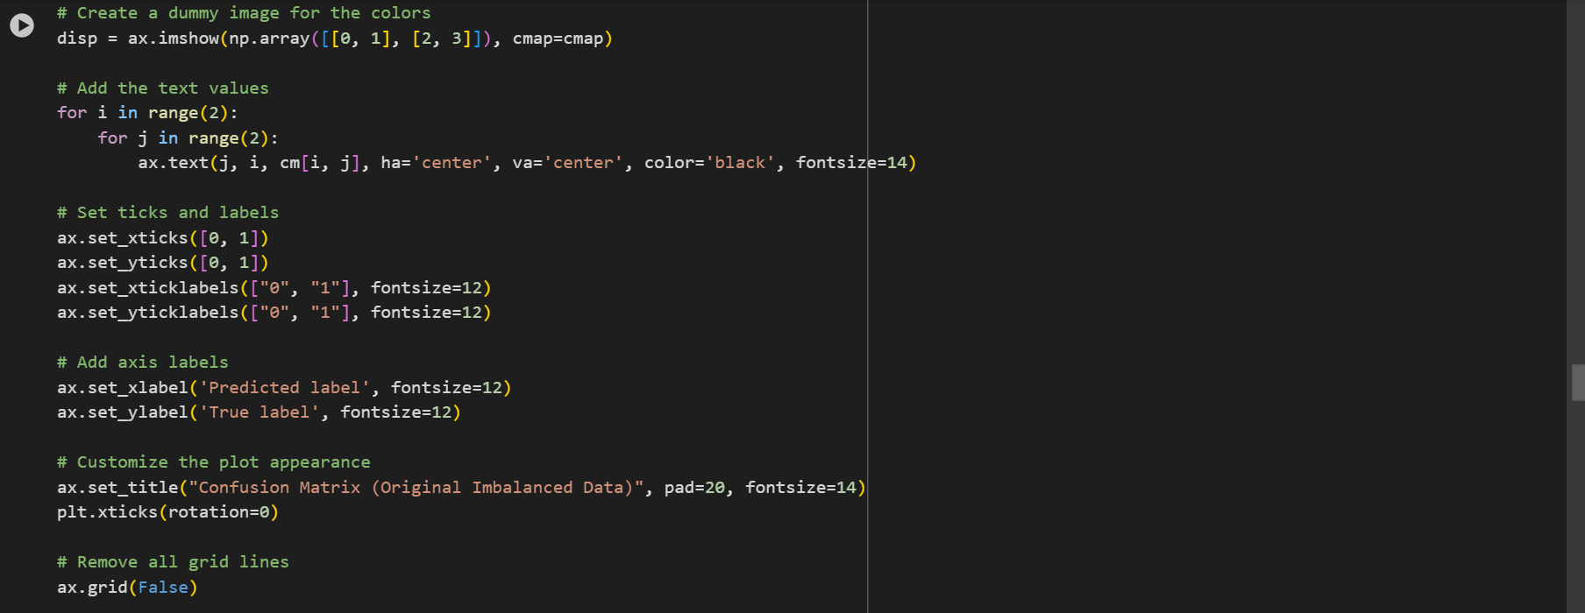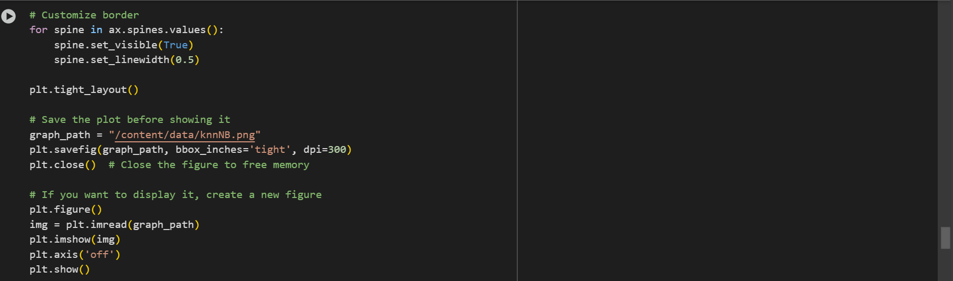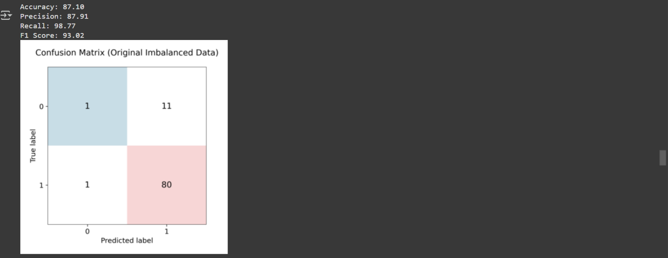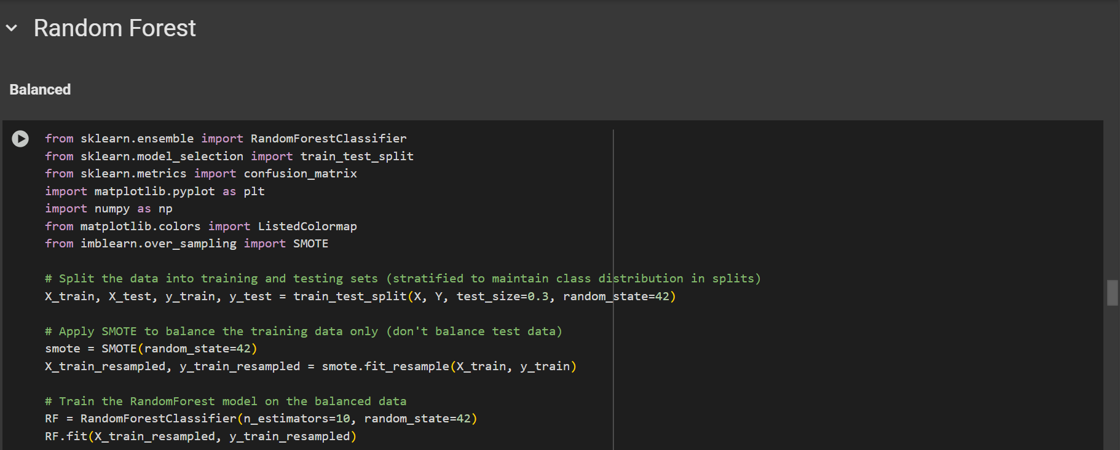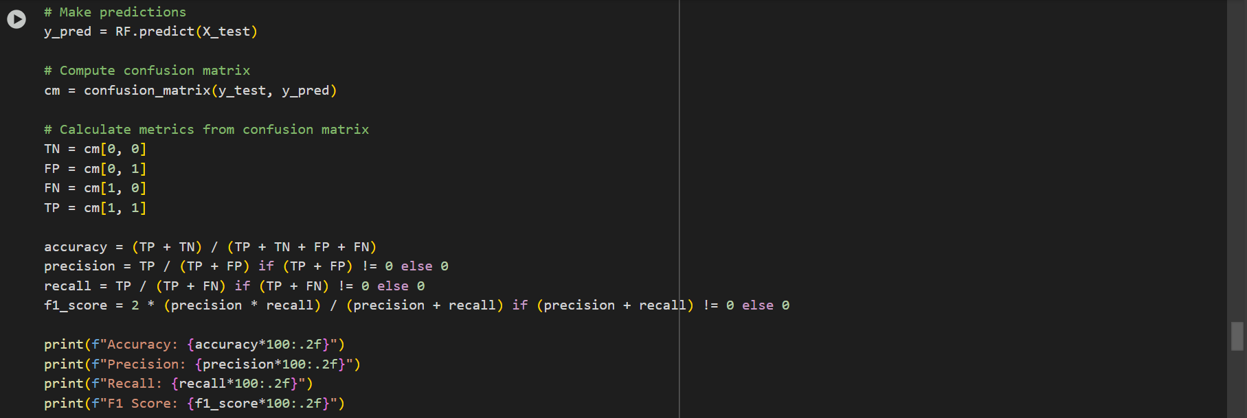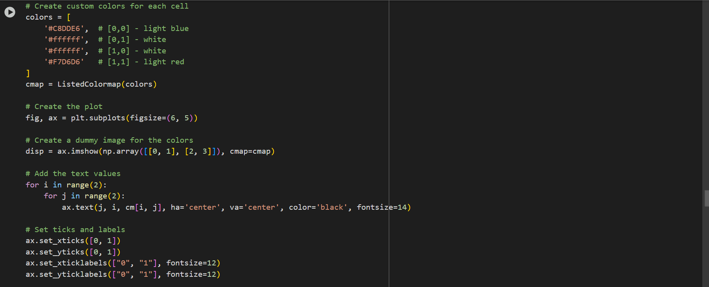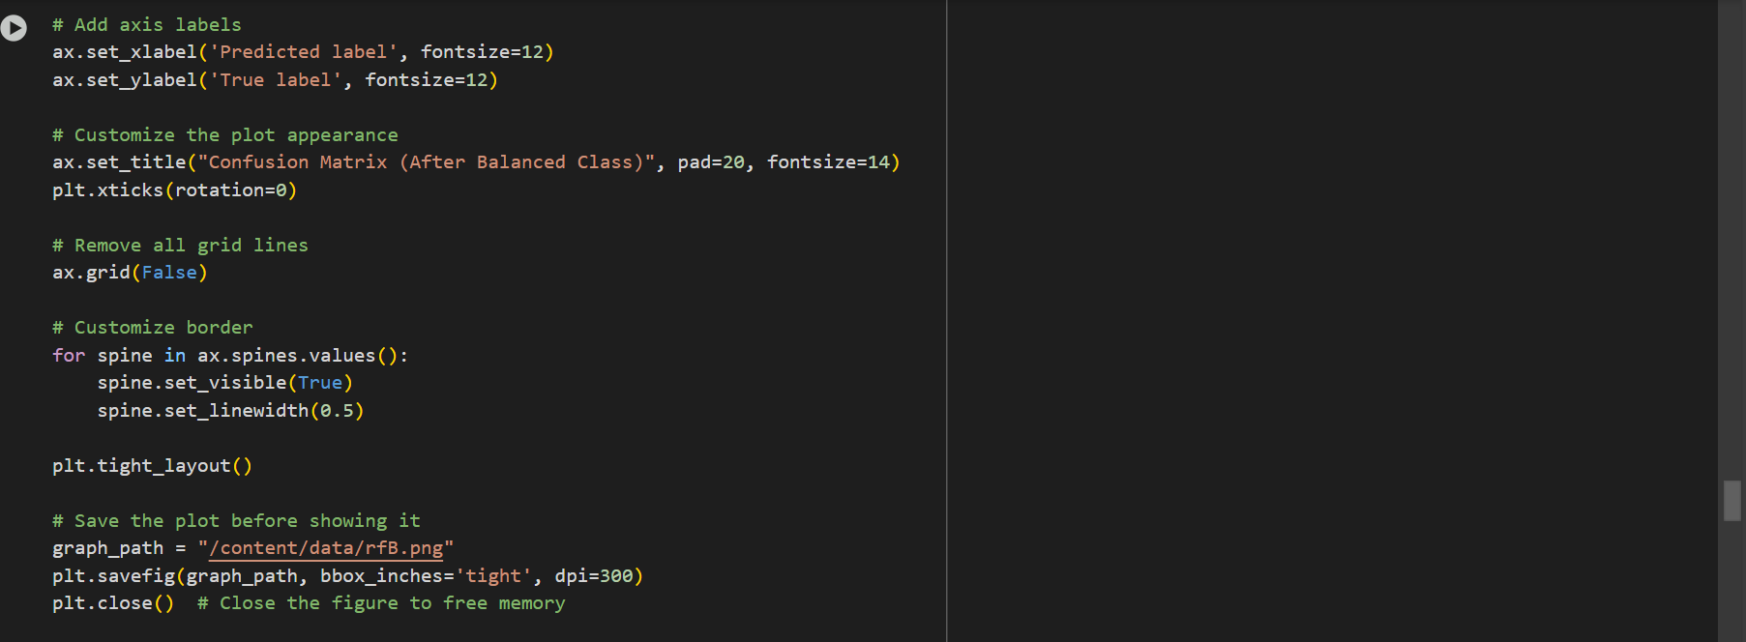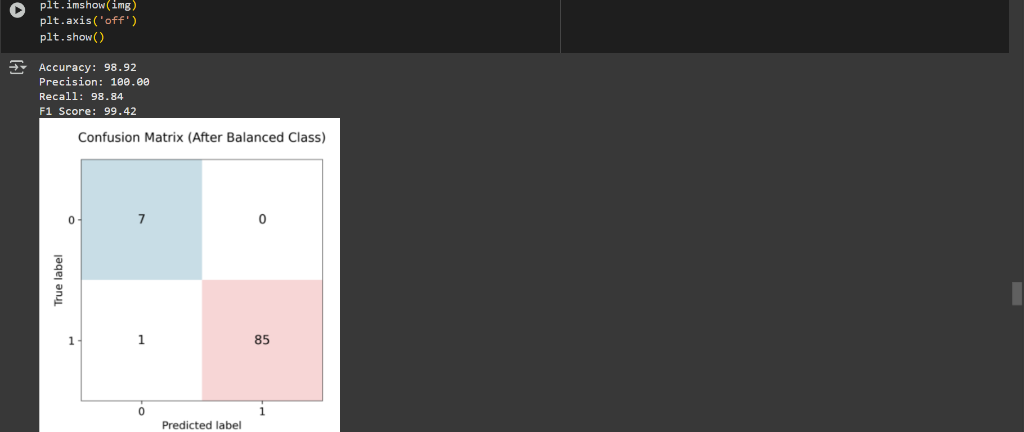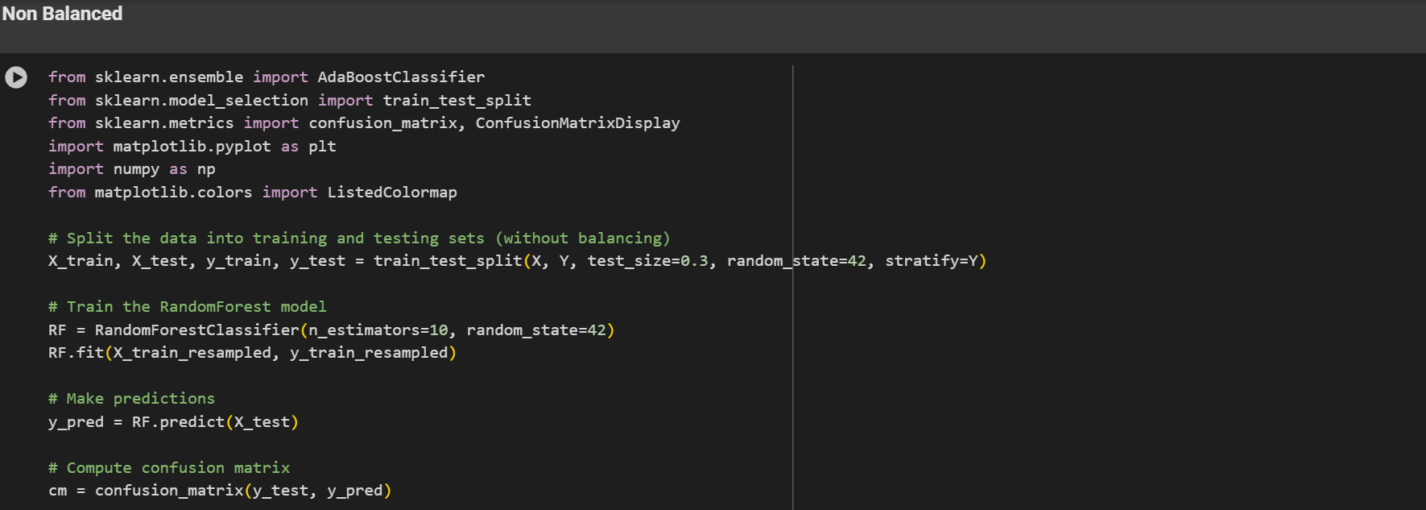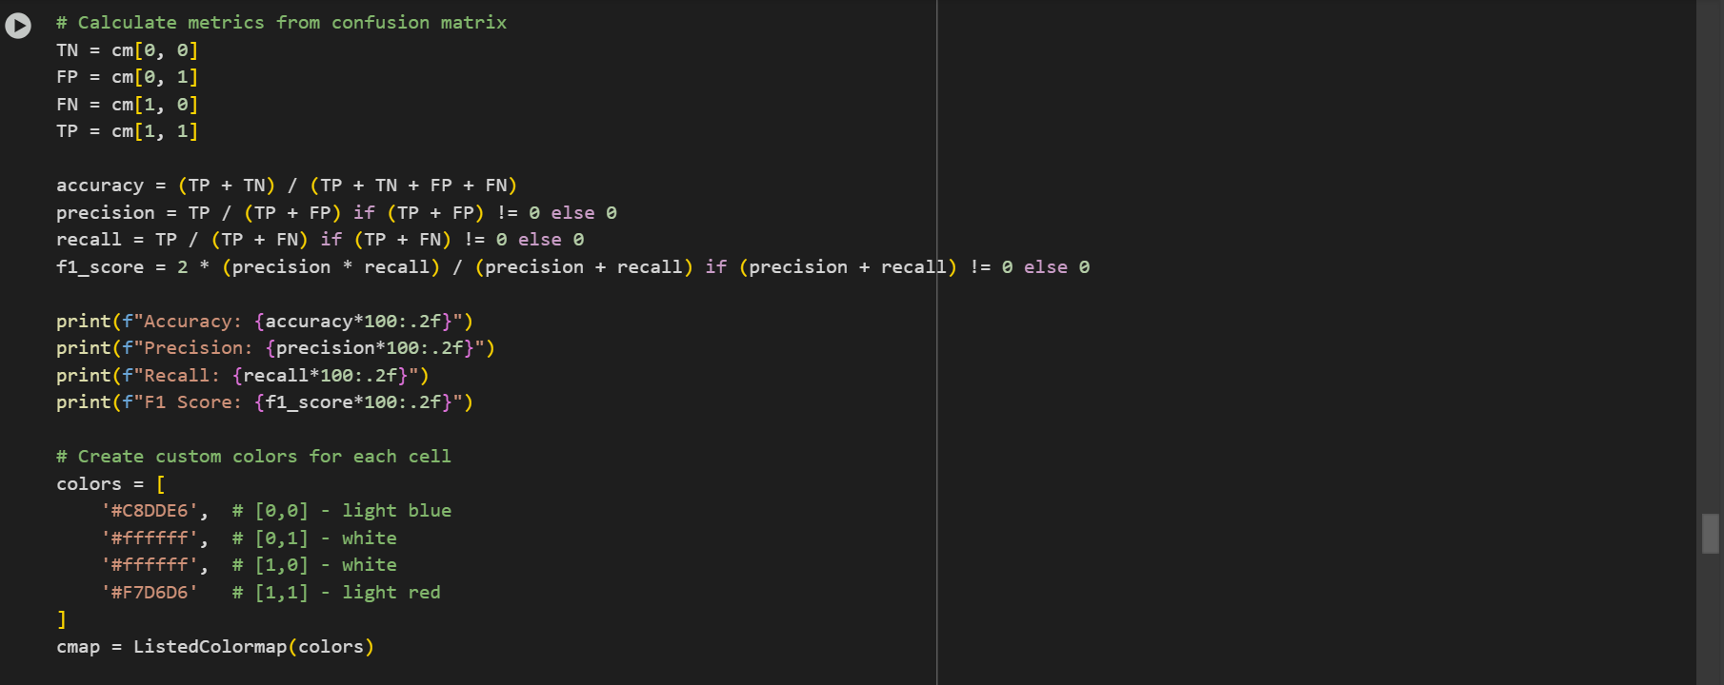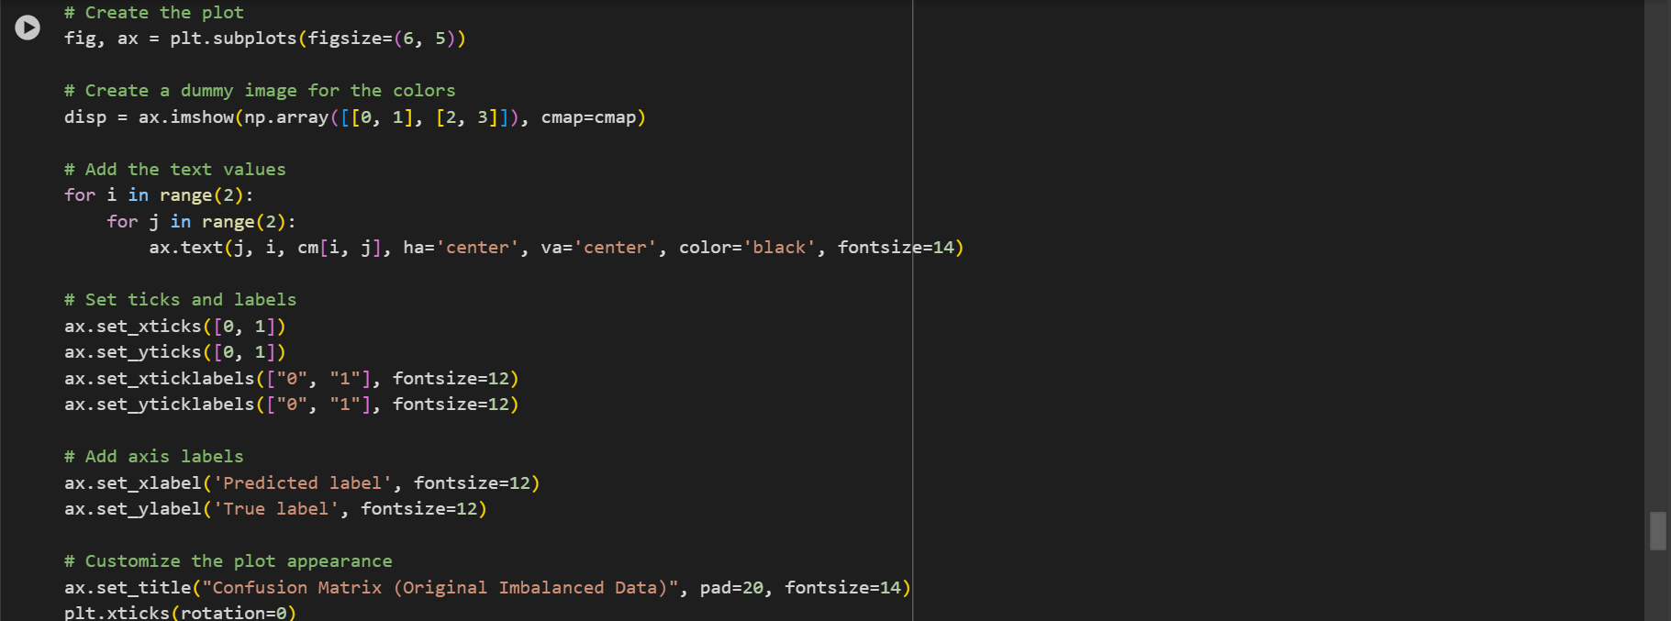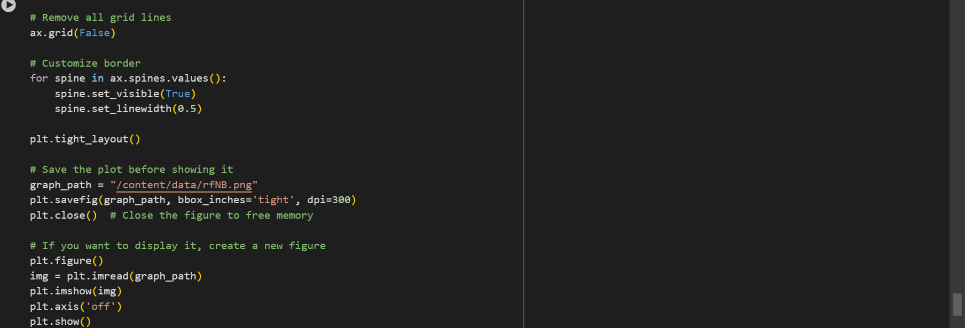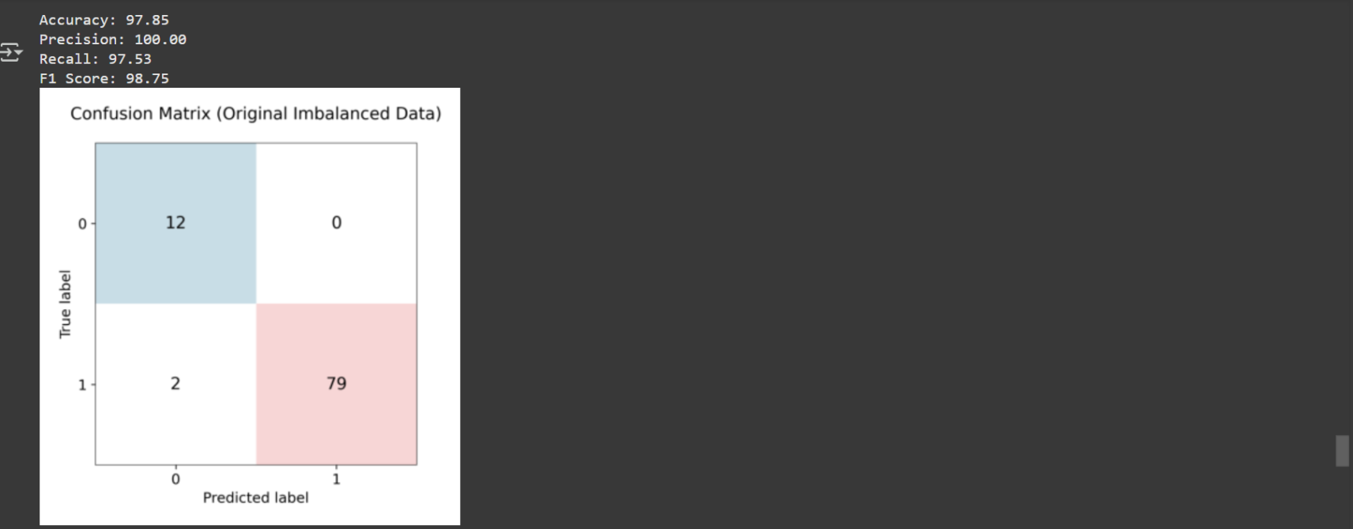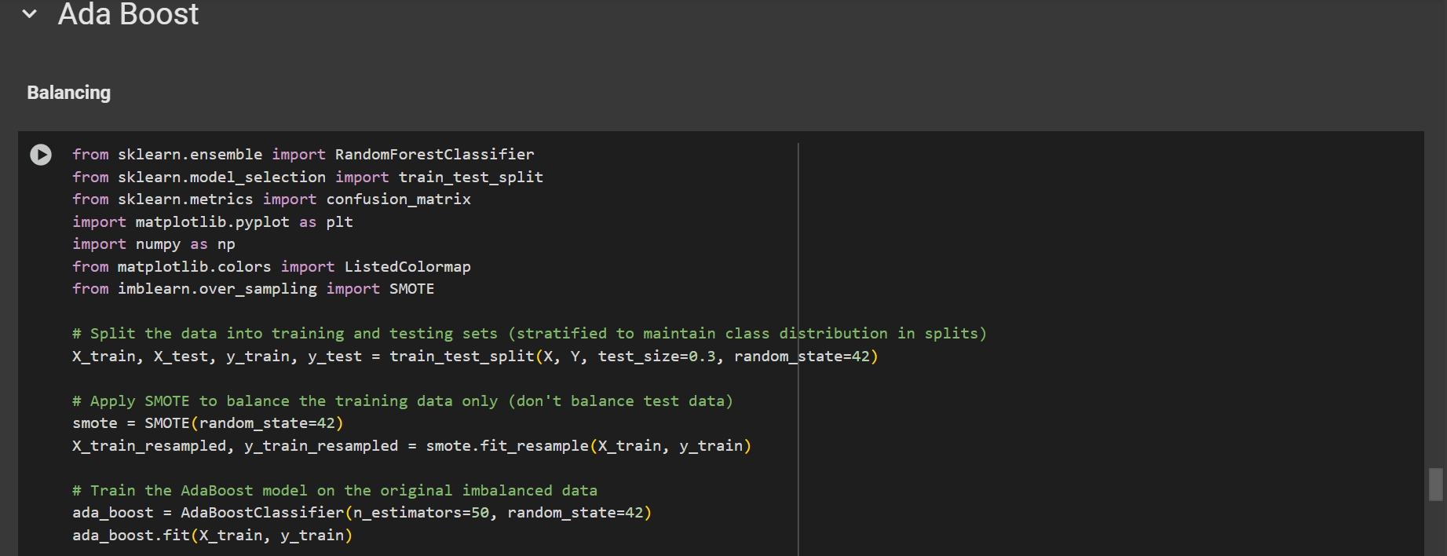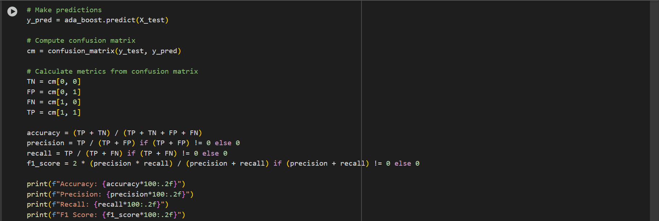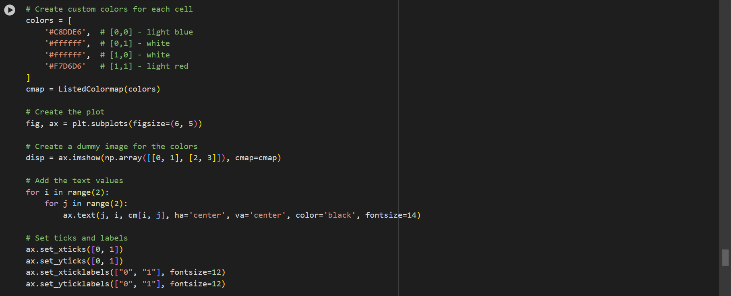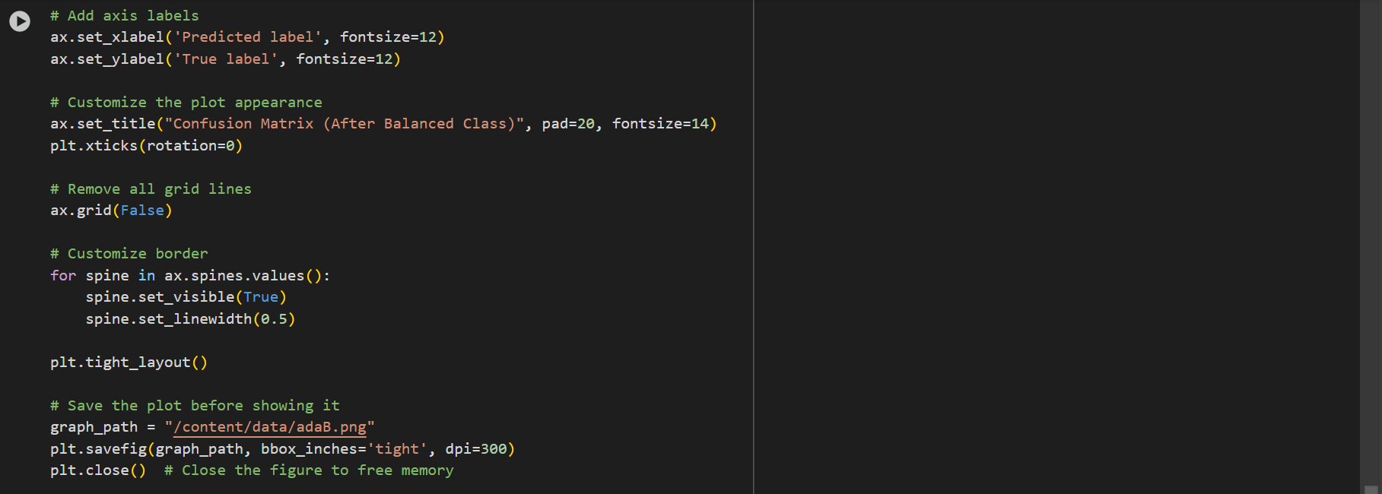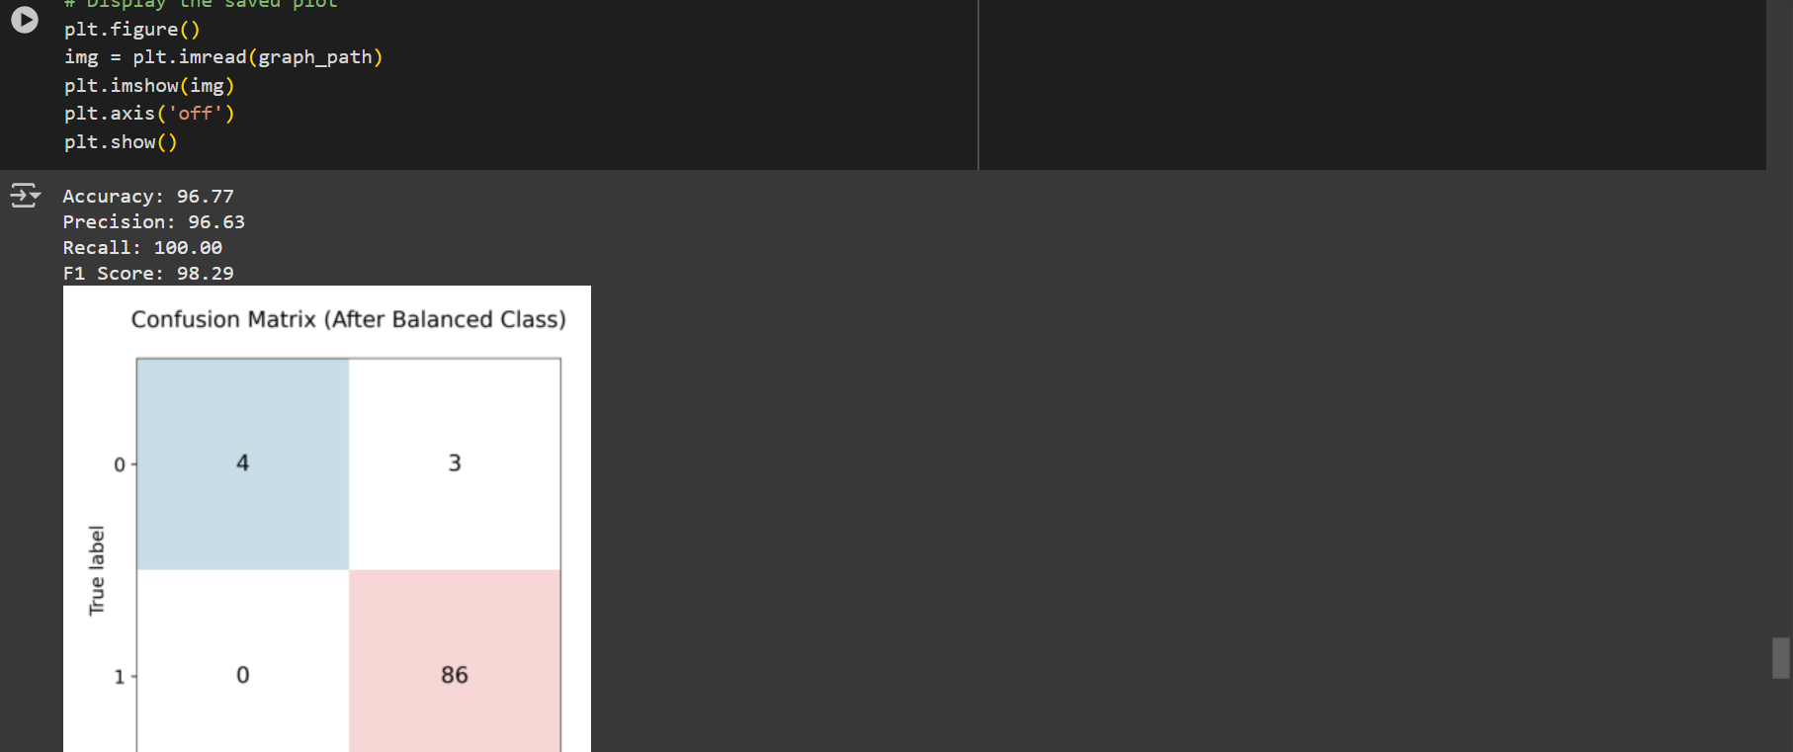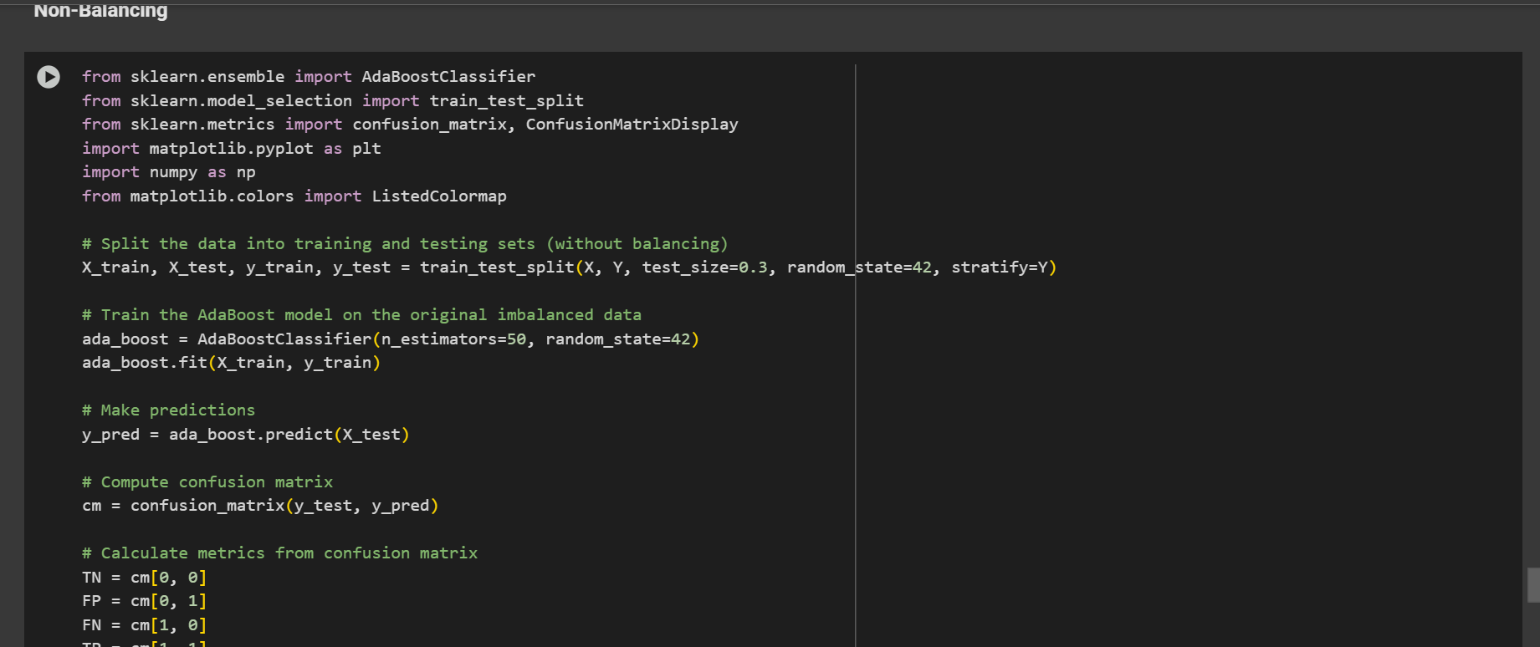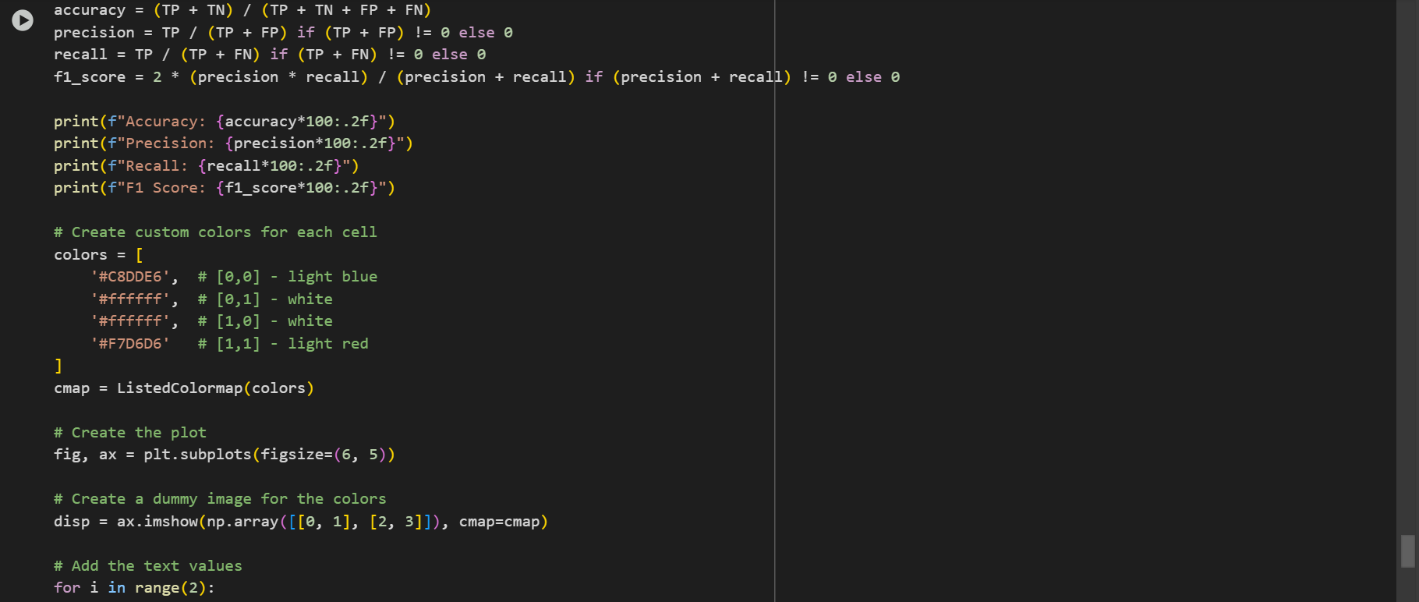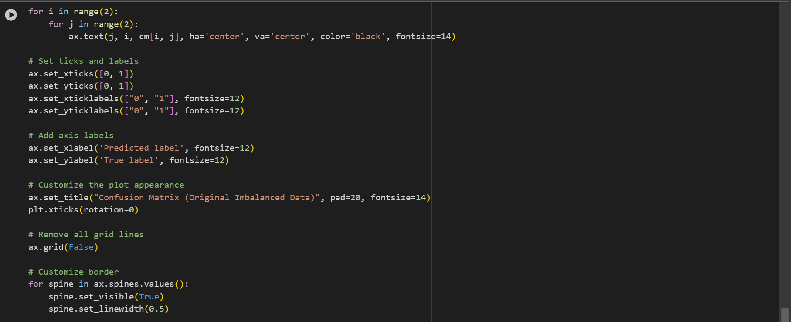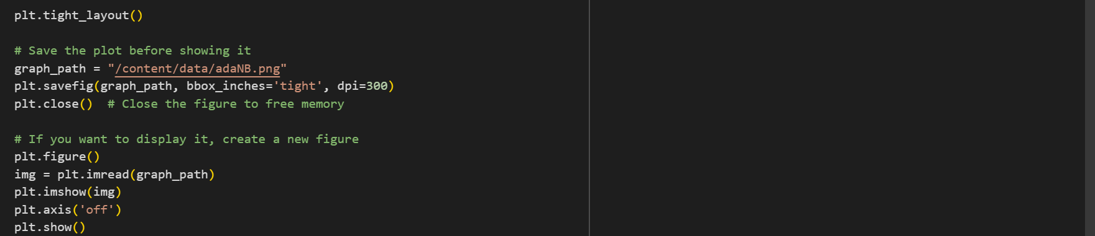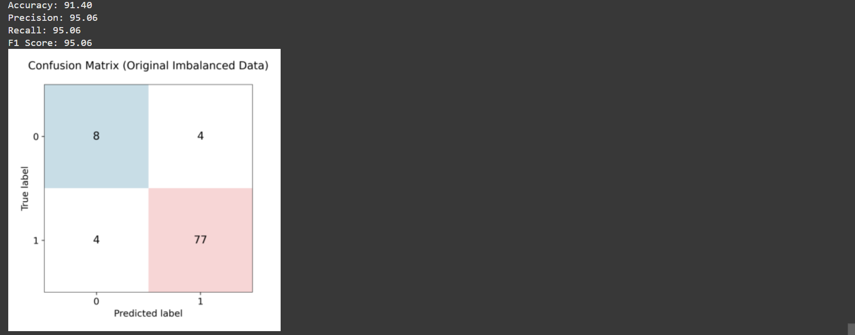

- Limitations (if any)

1. Limited Dataset Size and Diversity
The dataset used (from Kaggle: survey_lung_cancer.csv) is relatively small and lacks diversity in terms of demographics and clinical features. It may not adequately represent the global population, which limits the model’s generalization ability to unseen real-world data.

2. Class Imbalance
The dataset is imbalanced, with a disproportionate number of negative (no cancer) and positive (cancer) samples. Although SMOTE (Synthetic Minority Oversampling Technique) was applied to mitigate this issue, oversampling techniques can sometimes lead to over fitting and generate synthetic examples that do not perfectly represent real patient data.

3. Limited Feature Set
The dataset includes basic attributes such as age, gender, and lifestyle factors (smoking, alcohol consumption), but lacks important clinical features such as CT scan results, genetic markers, or histopathological data. These limitations reduce the model’s ability to capture more accurate indicators of lung cancer.

4. Lack of Real-time Validation
The models were evaluated using only the provided dataset and have not been validated on real-time clinical data. Without deployment and testing in a clinical environment, the actual effectiveness and reliability of the system remain unknown.

5. Assumption of Clean and Preprocessed Input
The model assumes that incoming user data will be clean, well-formatted, and complete. In real-world applications, data may contain noise, errors, or missing values that could degrade model performance if not handled properly.

6. Interpretability of Models
Some models used, such as Random Forest and Ada Boost, are ensemble methods and may act like "black boxes," making it difficult to interpret individual predictions. This lack of interpretability can be a barrier in medical fields where decision justification is crucial.

7. Static Model
The current system is trained on a fixed dataset and does not incorporate continuous learning from new data. In the fast-evolving medical field, models must be adaptable and periodically retrained with new patient data to remain effective.

8. Ethical and Legal Considerations Not Addressed
The system does not currently handle ethical concerns, privacy laws (such as HIPAA or GDPR), or explain ability requirements, which are critical in healthcare-related AI applications.

Future Scope

The current system for Lung Cancer Detection using Machine Learning Classifiers provides a solid foundation for early-stage prediction. However, there is significant potential for future enhancement and research to improve its performance, applicability, and clinical reliability.
1. Integration of Medical Imaging Data
2. Expansion of Dataset Size and Diversity
3. Incorporation of Clinical and Genetic Features
4. Real-Time and Adaptive Learning
5. Explainable AI Integration
6. Deployment as a Web or Mobile Application.

Conclusion
The project demonstrates that machine learning classifiers can effectively aid in the early detection of lung cancer. By evaluating models like Logistic Regression, Random Forest, Naive Bayes, KNN, and AdaBoost using accuracy, precision, recall, and F1-score, we identified their strengths and weaknesses. The use of class balancing techniques like SMOTE improved model performance on imbalanced data. Overall, the system shows potential for assisting medical professionals in making faster and more accurate diagnoses.

Bibliography / References
- scikit-learn Documentation: https://scikit-learn.org/stable/
- SMOTE Oversampling Technique: https://imbalanced-learn.org/stable/references/generated/imblearn.over_sampling.SMOTE.html
- Kaggle – Lung Cancer Dataset: https://www.kaggle.com/datasets
- Towards Data Science – Evaluation Metrics Explained: https://towardsdatascience.com
- ResearchGate
- Google Scholar

