Supermarket Sales Performance & Exploratory Analysis

Exploratory Data Analysis using Python | Project Report
Author: Ansh Srivastava
Domain: Data Analytics
Tools: Python, Jupyter Notebook, Pandas, NumPy, Matplotlib, Seaborn
Dataset: Supermarket Sales (1,000 transactions across 3 retail branches)
Deliverables: .ipynb, requirements.txt, README.md, .docx

Executive Summary
This project presents an exploratory data analysis (EDA) of 1,000 supermarket transaction records to uncover core sales drivers, purchasing behaviors, and customer segment profiles. Using Python and its data analytics ecosystem, raw transaction logs were transformed into clear operational insights.

Metric | Value
Total Transactions | 1,000
Total Revenue | $322,966.75
Gross Income | $15,379.37
Units Sold | 5,510
Average Customer Rating | 6.97 / 10
Quantity–Sales Correlation (r) | 0.7055

1. Project Background & Objectives
Supermarkets process high transaction volumes containing detailed points of interaction—branch location, customer type, product categories, prices, volumes, payment channels, and satisfaction ratings. Without structured analysis, identifying geographic efficiency, dominant product categories, and customer patterns remains difficult.

Key Project Objectives:

- Ingest, validate, and clean the retail transaction dataset.
- Calculate core operational and financial KPIs (revenue, gross profit, sales quantity).
- Compare performance across branches (Yangon, Mandalay, Naypyitaw) and product categories.
- Examine customer segment dynamics across membership status, gender, and payment methods.
- Measure the correlation between units purchased and gross ticket value.
- Provide actionable business recommendations based on empirical findings.

Workflow Pipeline:
Raw Dataset > Data Ingestion & Audit > Feature Engineering > Statistical EDA > Visual Analytics > Business Insights

Workflow Diagram:
[Dataset] ➔ [Load & Inspect] ➔ [Clean & Convert] ➔ [EDA & KPIs] ➔ [Visualize] ➔ [Insights]

2. Dataset Profile & Architecture
- Source: Historical transaction dataset spanning January to March 2019.
- Dimensions: 1,000 transaction records across 17 attributes.
- Quality Audit: 0 null or missing values, 0 duplicate records.
- Branches Covered: Branch A (Yangon), Branch B (Mandalay), Branch C (Naypyitaw).

Dataset Profile Summary
Property | Value | Description
Rows | 1,000 | Transaction records
Columns | 17 | Original variables
Period | Jan–Mar 2019 | Historical transaction period
Branches | A, B, C | Three supermarket branches
Cities | Yangon, Mandalay, Naypyitaw | Branch locations

Attribute Breakdown
Attribute | Analytical Role
Branch / City | Store identifier and geographic location
Customer type | Member vs. Normal (loyalty classification)
Gender | Customer gender profile
Product line | Category classification (e.g., Electronic accessories)
Unit price | Price per individual unit
Quantity | Units purchased per transaction
Total | Gross transaction amount including tax
Date / Time | Purchase timestamp for temporal analysis
Payment | Checkout method (Cash, Ewallet, Credit card)
COGS | Cost of goods sold
Gross income | Margin contribution
Rating | Customer experience rating (1 to 10 scale)

3. Key Findings & Exploratory Insights

3.1 Branch & Geographic Revenue Footprint
Revenue is distributed relatively evenly across all three cities, with Branch C in Naypyitaw leading the portfolio:

- Naypyitaw (Branch C): $110,568.71
- Yangon (Branch A): $106,200.37
- Mandalay (Branch B): $106,197.67

Total Sales by Branch
Branch | City | Total Sales
Branch C | Naypyitaw | $110,568.71
Branch A | Yangon | $106,200.37
Branch B | Mandalay | $106,197.67

3.2 Product Line Performance
- Food and beverages is the highest-revenue product line in the dataset.
- Health and beauty recorded the lowest total sales among the six categories.
- Sports and travel, Electronic accessories, and Fashion accessories maintain steady, consistent contributions.

Total Sales by Product Line
Product Line | Total Sales | Share / Contribution
Food and beverages | $56,144.84 | Highest revenue category
Sports and travel | $55,122.83 | Strong steady contributor
Electronic accessories | $54,337.53 | Consistent revenue contributor
Fashion accessories | $54,305.90 | Consistent revenue contributor
Home and lifestyle | $53,861.91 | Steady revenue contributor
Health and beauty | $49,193.74 | Lowest sales volume category

3.3 Consumer Segments & Payment Behavior
- Payment Channels: Cash accounted for the highest overall transaction volume, followed closely by E-wallet payments. Credit card usage trailed both.

Revenue by Payment Method
Payment Method | Total Revenue | Observation
Cash | $112,206.59 | Highest revenue and transaction volume
Ewallet | $109,993.72 | Follows closely behind cash
Credit card | $100,766.44 | Lowest revenue contributor of the three

- Loyalty Membership: Registered members contributed slightly more total revenue than non-members, demonstrating active engagement.

Revenue by Customer Type
Customer Type | Total Revenue | Observation
Member | $164,223.44 | Contributed majority of total revenue
Normal | $158,743.31 | Strong walk-in customer volume

- Gender Split: Female shoppers contributed more total revenue than male shoppers in this observation window.

Revenue by Gender
Gender | Total Revenue | Observation
Female | $167,882.93 | Higher overall revenue contribution
Male | $155,083.82 | Steady contribution trailing female segment

3.4 Basket Dynamics & Satisfaction Ratings
- Basket Size Impact: A strong Pearson correlation of r = 0.7055 demonstrates that quantity purchased is a major linear driver of final transaction value.
- Customer Satisfaction: Overall average rating is 6.97/10. Top-rated departments include Food and beverages (7.11), Fashion accessories (7.03), and Health and beauty (7.00).

Average Customer Ratings by Product Line
Product Line | Average Rating
Food and beverages | 7.11 / 10
Fashion accessories | 7.03 / 10
Health and beauty | 7.00 / 10

4. Strategic Business Recommendations
- Operational Benchmarking: Investigate the drivers behind Branch C's outperformance in Naypyitaw to transfer successful practices to Yangon and Mandalay.
- Safeguard Core Inventory: Maintain stock availability in high-volume, highly-rated categories like Food and beverages to prevent stock-out revenue losses.
- Drive Multi-Unit Basket Size: Given the strong 0.71 correlation between unit volume and ticket size, implement bundle pricing and tiered discounts.
- Convert Walk-in Shoppers: Leverage targeted promotional offers to convert Normal customers into loyalty Members to foster long-term retention.
- Streamline Cash & Digital Wallet Checkout: Optimize checkout lanes and payment processing for Cash and E-wallets to reduce friction during peak hours.

5. Technical Implementation & Execution
Tech Stack:

- Python 3.10+
- Pandas & NumPy for data loading, cleaning, aggregation, and statistics
- Matplotlib & Seaborn for exploratory visual analytics
- Jupyter Notebook for reproducible execution

Technology Stack and Implementation Details
Technology | Role | Why Used
Python | Programming / analysis | Simple and widely used for data analytics
Pandas | Data processing | Loading, cleaning, grouping and aggregation
NumPy | Numerical operations | Numeric calculations and data support
Matplotlib | Visualization | Flexible chart generation
Seaborn | Statistical visualization | Readable statistical charts
Jupyter Notebook | Execution / reporting | Combines code, output and explanation

File Structure:

- Ansh_Srivastava_Supermarket_Sales_Analysis.ipynb
- requirements.txt
- README.md
- outputs/ (generated charts)
- Ansh_Srivastava_Supermarket_Sales_Analysis_ProjectReport.docx

Execution Instructions:

- Ensure Python 3.10+ is installed.
- Install dependencies: pip install -r requirements.txt
- Run jupyter notebook Ansh_Srivastava_Supermarket_Sales_Analysis.ipynb
- Run all cells sequentially to regenerate all tables and figures.

6. Limitations & Future Roadmap
- Historical Scope: Data covers a 3-month period in 2019 without multi-year seasonality.
- Granularity: Lacks SKU-level pricing, promotional markers, and line-item operating costs.

Future Scope:

- Deploy an interactive BI dashboard in Streamlit or Power BI.
- Conduct RFM customer clustering for granular segmentation.
- Implement time-series demand forecasting (e.g. ARIMA / Prophet).
- Build an automated ETL pipeline connecting directly to operational databases.

7. Analytical Bar Charts
The following bar charts provide a visual comparison of the analytical results reported in this study. Values are taken directly from the report's branch, product-line, payment, customer-type, and gender revenue tables.

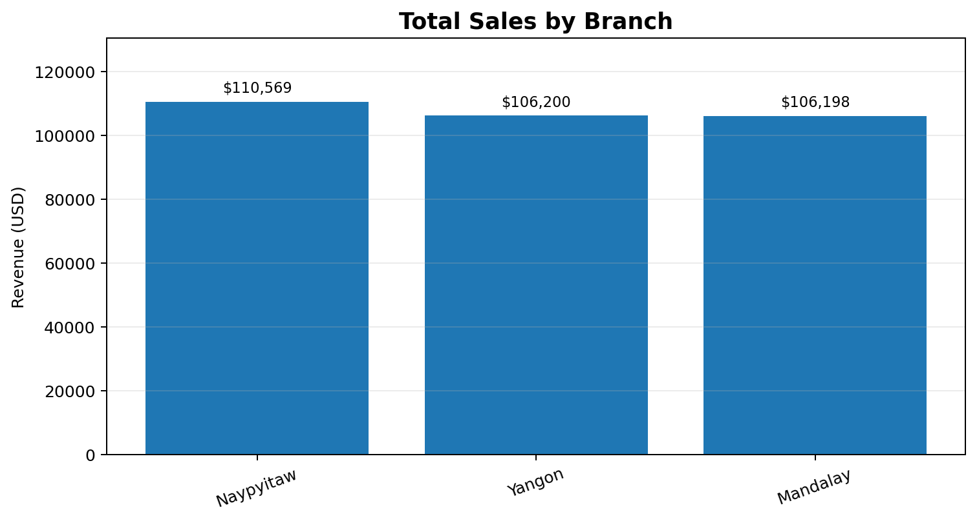
Figure 7.1: Total Sales by Branch. Source: analytical values reported in this project report.

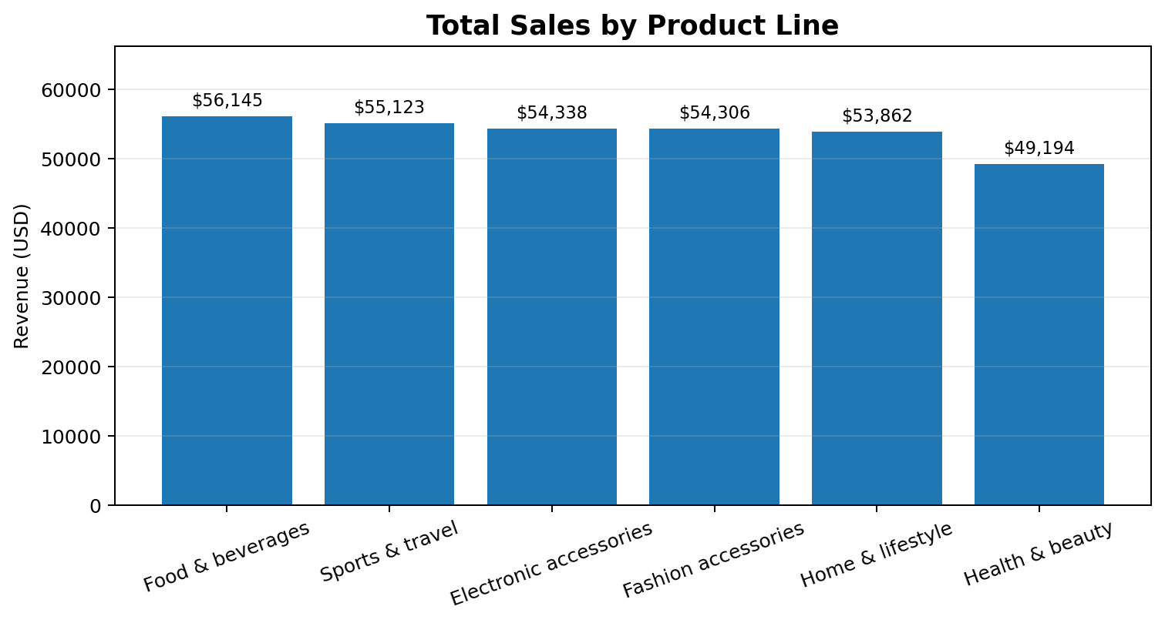
Figure 7.2: Total Sales by Product Line. Source: analytical values reported in this project report.

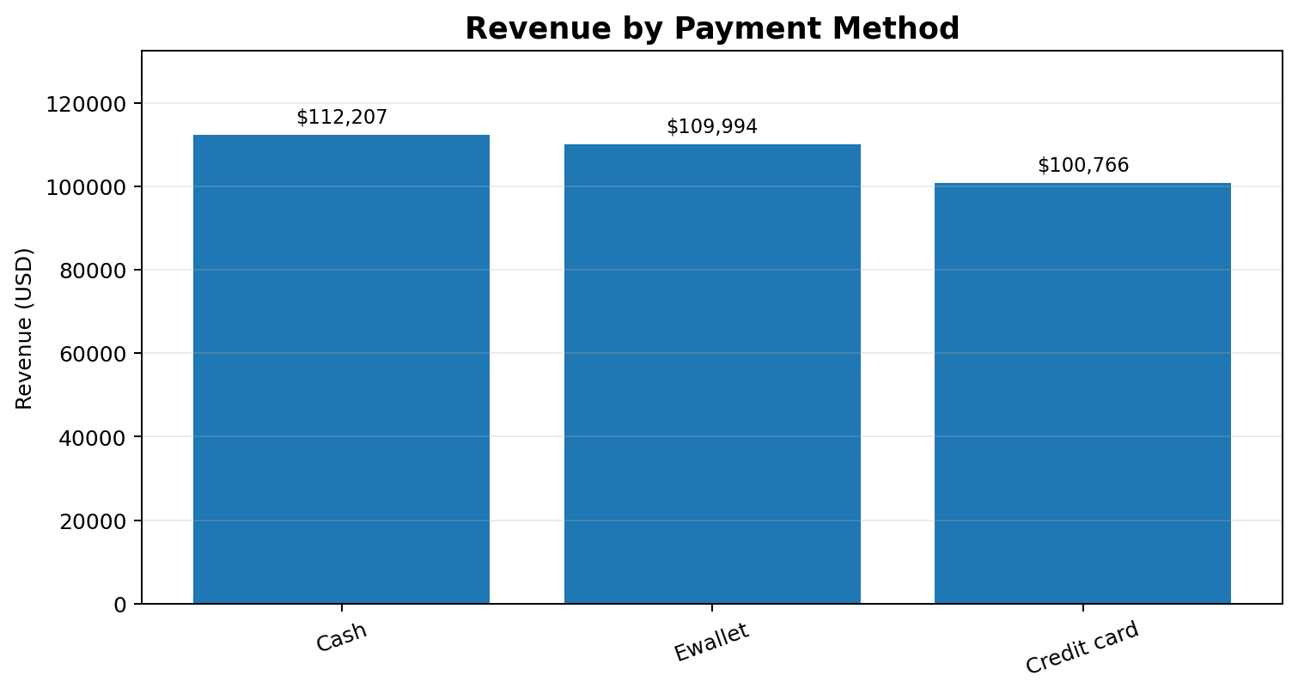
Figure 7.3: Revenue by Payment Method. Source: analytical values reported in this project report.
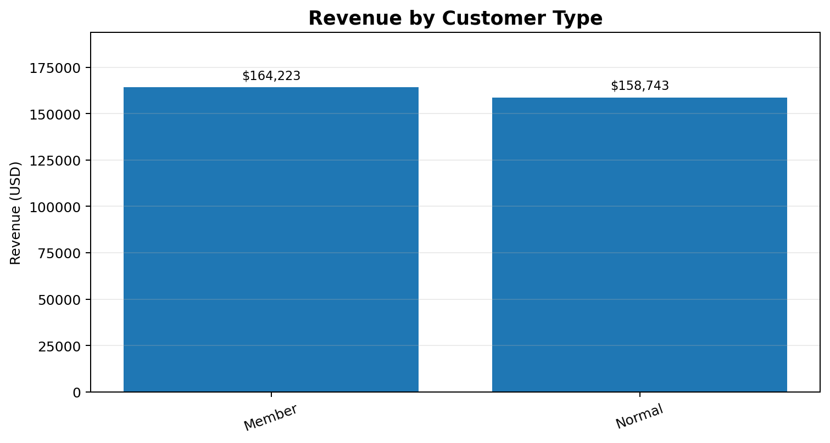
Figure 7.4: Revenue by Customer Type. Source: analytical values reported in this project report.

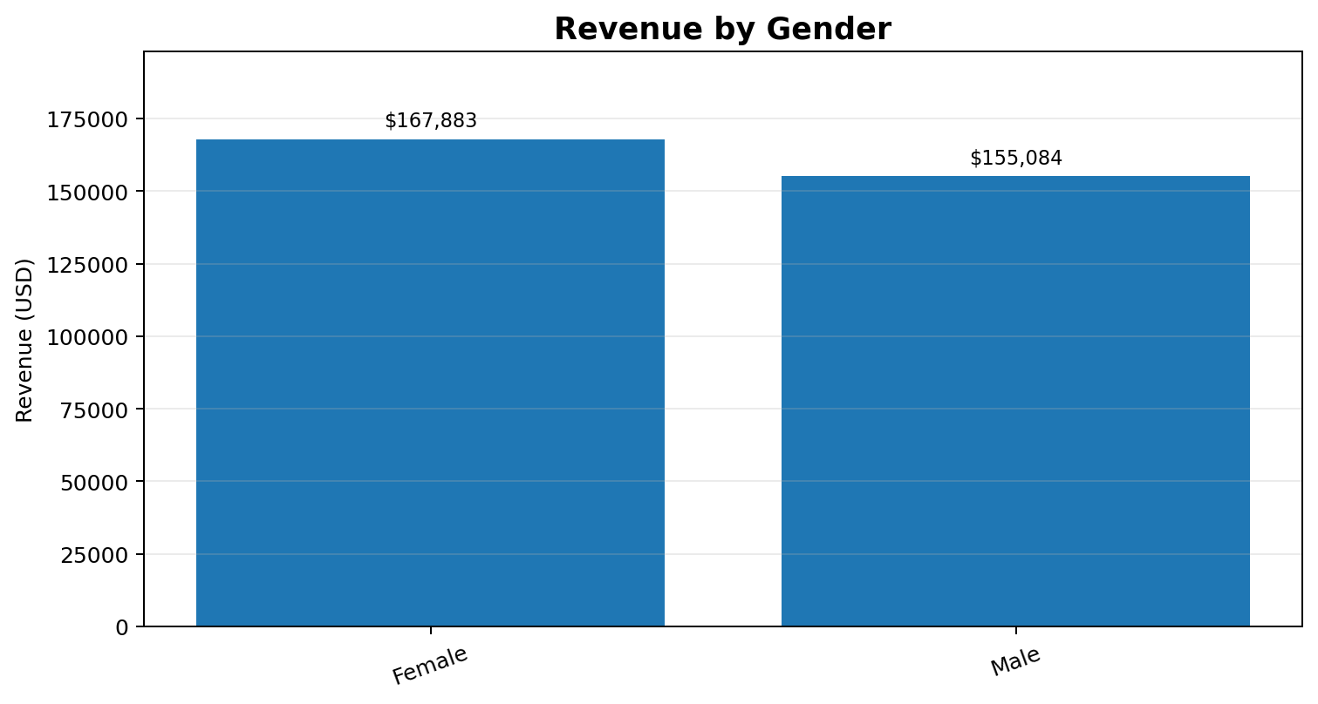
Figure 7.5: Revenue by Gender. Source: analytical values reported in this project report.

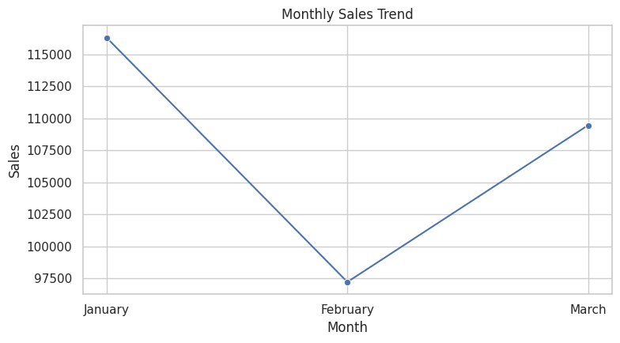
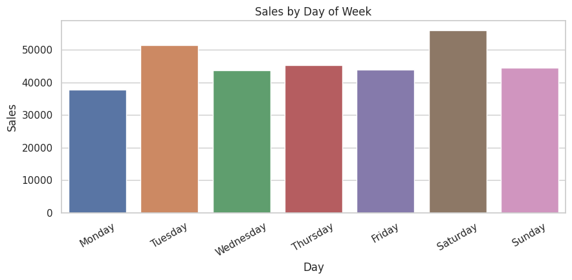
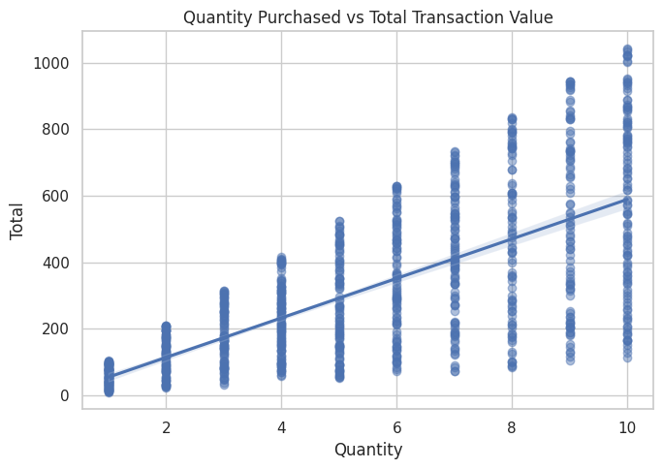
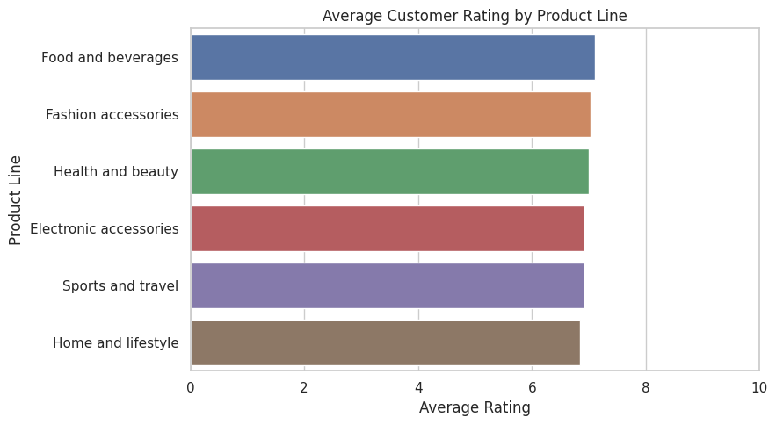
Analytical note: The charts reinforce the report's findings: Naypyitaw has the highest branch revenue; Food and beverages leads product-line revenue; Cash is the largest payment-method revenue contributor; Members contribute slightly more revenue than Normal customers; and Female customers contribute more revenue than Male customers in the analyzed period.

