Outputs-
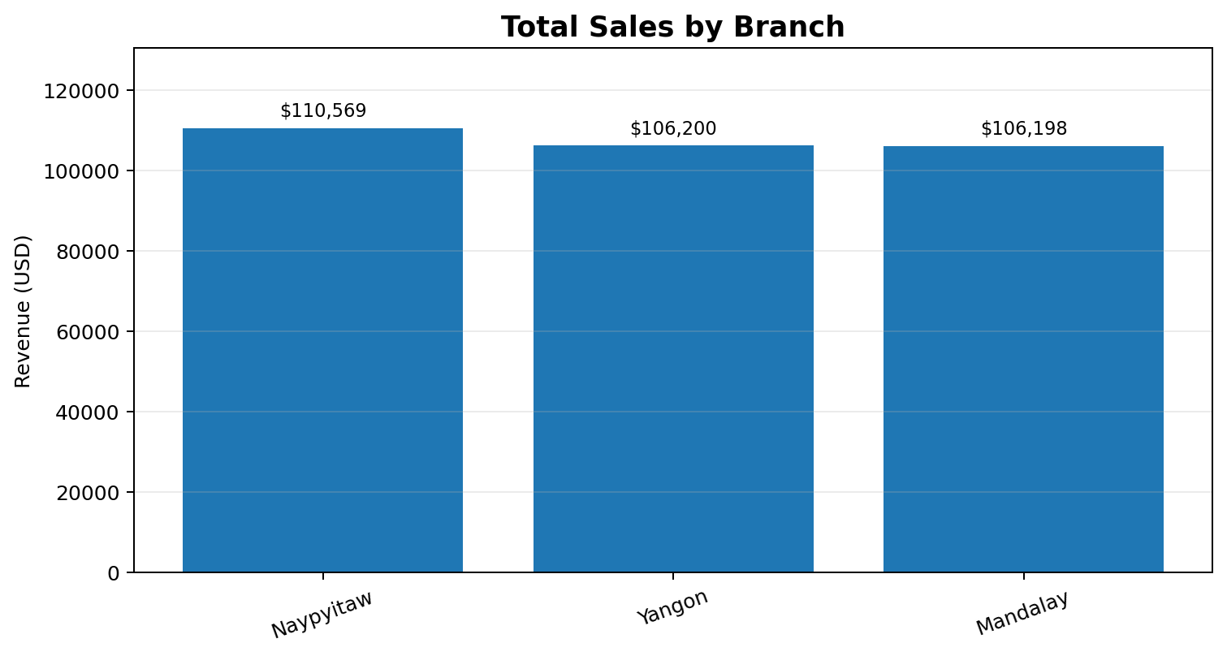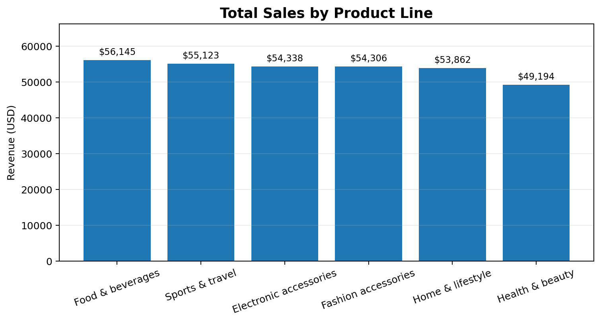

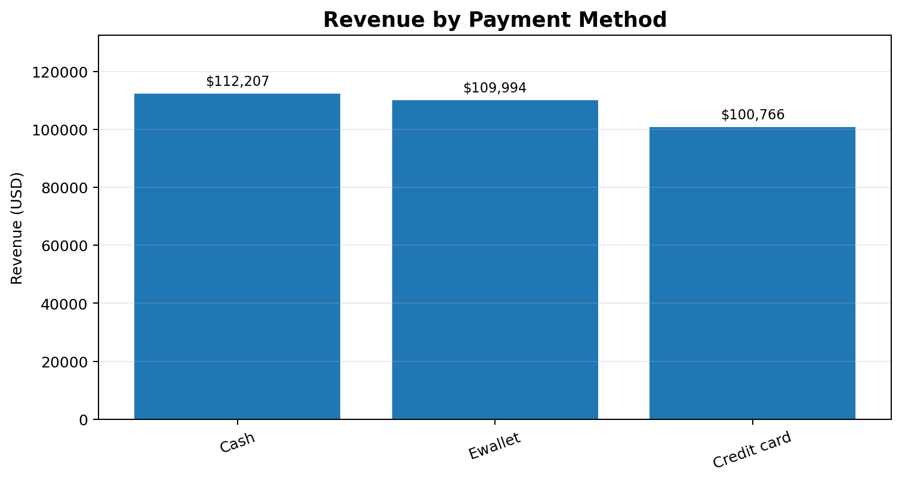
Figure 7.3: Revenue by Payment Method. Source: analytical values reported in this project report.
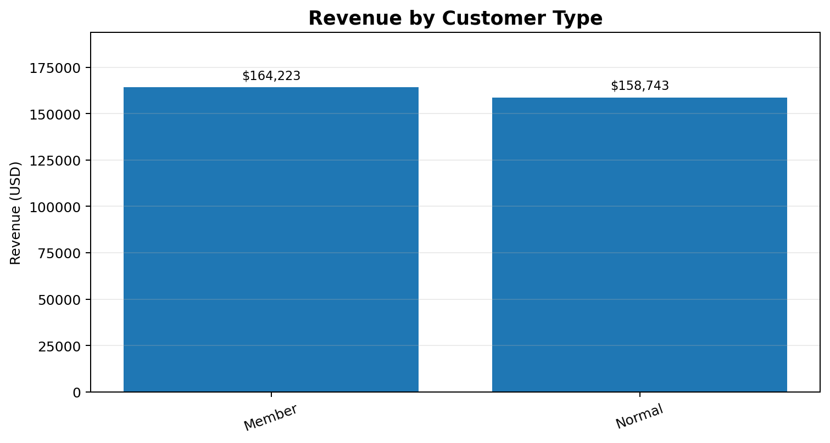
Figure 7.4: Revenue by Customer Type. Source: analytical values reported in this project report.

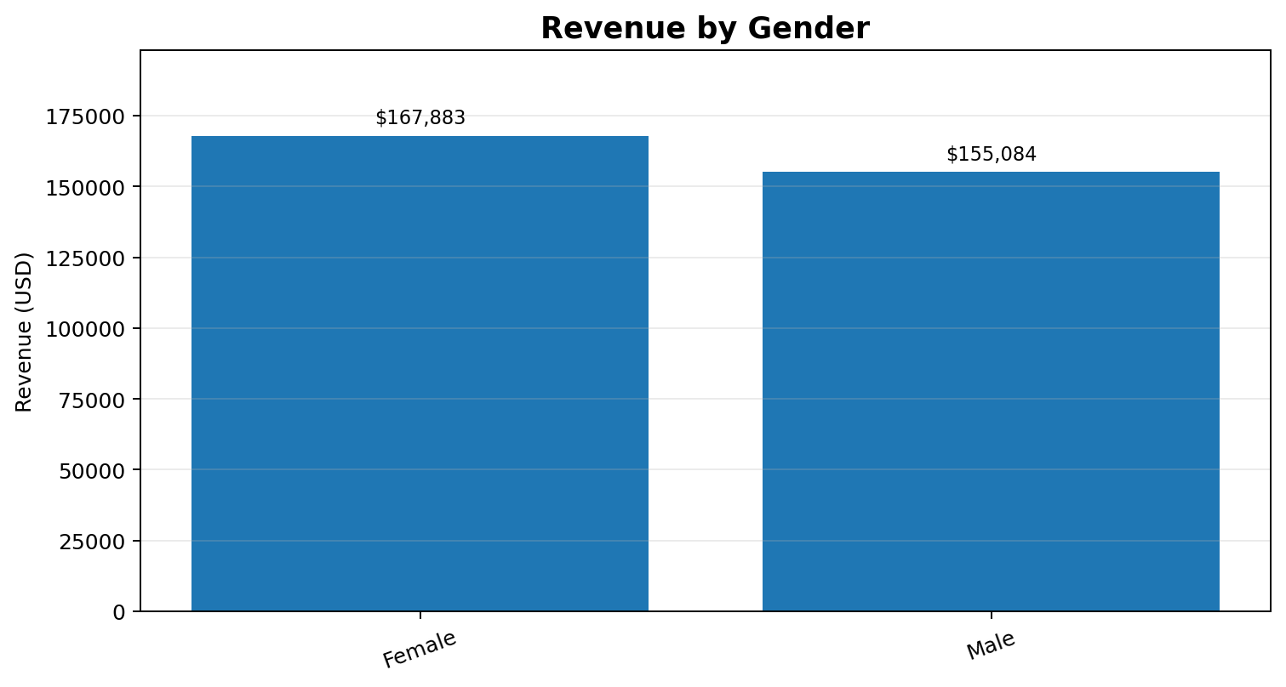
Figure 7.5: Revenue by Gender. Source: analytical values reported in this project report.

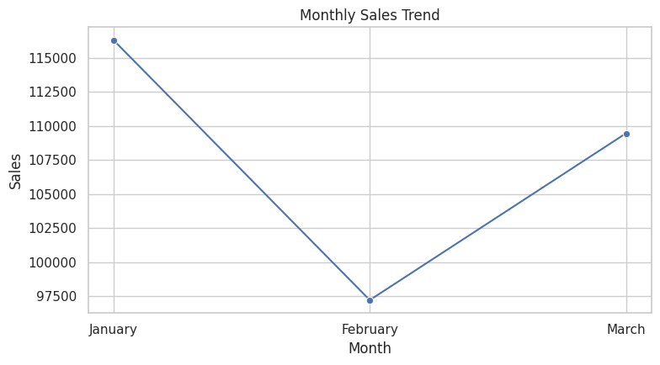
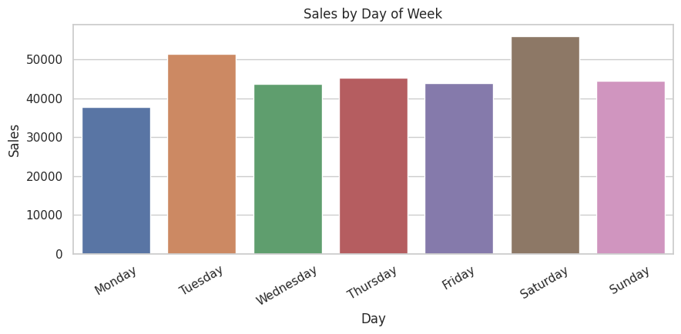
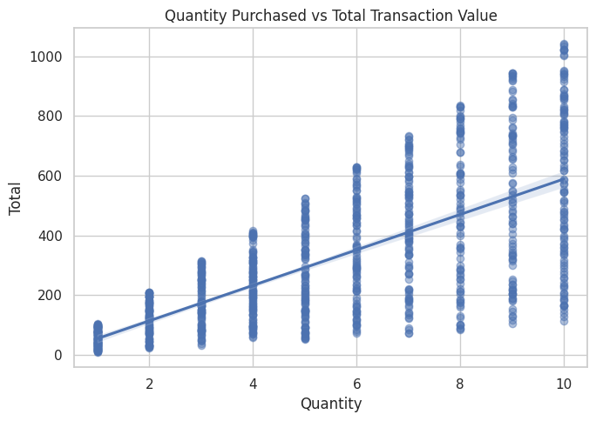
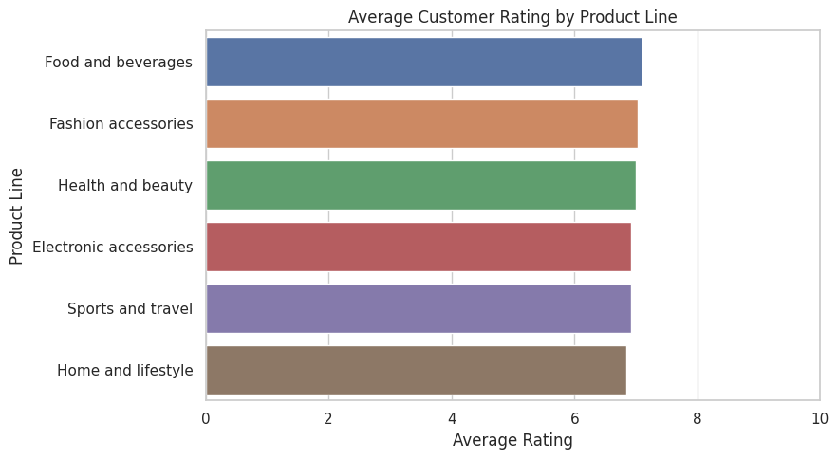
Based on the analytical bar charts in the report, the final conclusions are:
- Branch Performance (Figure 7.1): Revenue is evenly balanced across locations, with Naypyitaw (Branch C) leading at $110,569, followed closely by Yangon ($106,200) and Mandalay ($106,198).
- Product Line Performance (Figure 7.2): Food and beverages generates the highest total sales ($56,145), while Health and beauty ranks lowest ($49,194), with other categories maintaining steady contributions between $53k and $55k.
- Payment Method Breakdown (Figure 7.3): Cash is the top revenue-contributing payment channel ($112,207), trailed closely by E-wallet ($109,994), with Credit card generating the least revenue ($100,766).
- Customer Loyalty Segments (Figure 7.4): Registered Members generate slightly more revenue ($164,223) than non-member Normal shoppers ($158,743).
- Gender Demographics (Figure 7.5): Female shoppers contribute higher overall revenue ($167,883) compared to Male shoppers ($155,084).
- Day-of-Week Sales: Sales peak over the weekend on Saturday (surpassing $50k), with Tuesday also showing strong performance, while Monday exhibits the lowest sales volume.
- Customer Satisfaction by Category: Ratings are remarkably consistent across product lines (hovering around ~7.0/10), led marginally by Food and beverages (7.11) and Fashion accessories (7.03).

