PROJECT REPORT
  - CLOUD ARCHITECTURE DESIGN – AWS CLOUD PROJECT
FINAL PROJECT REVIEW REPORT (PHASE II)

Intelligent Permission Optimization Framework for University ERP Systems Using Role Mining Analytics

Submitted by:
Ansh Goel — 24BIT0258
Agastya Pradhan — 24BIT0187
Varun Verma — 24BIT0208
Programme / Branch / Year: B.Tech Information Technology / 3rd Year
Course Code and Name: BCSE355L – Cloud Architecture Design
Institution: Vellore Institute of Technology, Vellore
Course Instructor / Guide: Dr. Priya V
Domain: Cloud Security & ERP Infrastructure Optimization
GitHub Repository: https://github.com/Ansh-bit948/AWS-project
Date of Submission: 16/10/2026

Abstract
Enterprise Resource Planning (ERP) cloud platforms govern vital administrative and academic workflows across dynamic user populations. When permissions are managed manually through ad-hoc direct assignments, systems inevitably suffer from severe permission bloat, configuration drift, and role explosion. This project presents an end-to-end, auditable cloud access governance framework that converts flat, complex access matrices into compact Role-Based Access Control (RBAC) architectures while guaranteeing provable access preservation. The system incorporates a two-stage hybrid role-mining engine combining access cohort clustering with bounded greedy support-signature factoring, an explainable graph-structural anomaly detection engine for human-in-the-loop reviews, dynamic policy versioning with optimistic concurrency control, and offline tabular Q-learning. The complete architecture is deployed as a fully serverless, event-driven cloud stack on AWS using Amazon API Gateway, AWS Lambda, Amazon DynamoDB, private encrypted Amazon S3, Amazon Cognito, and AWS IAM Access Analyzer (powered by the Zelkova automated reasoning SMT solver). Evaluated empirically across six real-world access control matrices including the Firewall1 benchmark (365 users, 709 permissions, 31,919 assignments) and the published HP Labs benchmark suite, the system achieves an 86.18% reduction in Weighted Structural Complexity (WSC) over direct ACLs with exactly zero missing grants and zero overgrants (100% exact reconstruction coverage). The serverless pipeline executes with a median runtime of 113.67 ms, peak memory of 8.18 MB, zero idle cloud expenditure, and 100% test pass rate across all functional, security, and concurrency test suites.

Keywords
Role-Based Access Control (RBAC); Role Mining; Cloud Security; Serverless Architecture; AWS IAM Access Analyzer; Weighted Structural Complexity (WSC); Least Privilege.

Table of Contents
Abstract 2
Keywords 2
Table of Contents 3
1. Introduction 6
1.1 Background 6
1.2 Problem Statement 6
1.3 Motivation and Significance 7
1.4 Scope 7
1.5 Report Organisation 8
2. Literature Survey / Related Work 9
2.1 Synthesis and Comparison 12
2.2 Individual Research Gap Analysis 12
2.3 Consolidated Research Gap 13
3. Project Objectives 14
3.1 Expected Outcomes 14
4. Novelty Summary 16
5. Proposed System and Architecture 17
5.1 System Overview 17
5.2 Diagram 1 – AWS Cloud Architecture (Mandatory) 17
5.3 Diagram 2 – Complete System Architecture (Mandatory) 19
5.4 Workflow / Use Cases 20
5.5 Security, Availability and Scalability Design 20
6. Dataset Description 22
6.1 Data Preparation Plan 22
7. AWS Services Planning 24
7.1 AWS Deployment and Network Design 24
7.2 Cost Estimation 25
8. Methodology and Implementation Plan 26
8.1 Overall Methodology 26
8.2 Tools and Technologies 26
8.3 Step-by-Step Implementation Plan 27
8.4 Evaluation Metrics 27
9. Implementation / Development 28
9.1 Implemented Modules 28
9.2 Screenshots and Configuration Evidence 28
9.3 GitHub Repository 39
10. Testing, Results and Observations 40
10.1 Test Plan and Test Cases 40
10.2 Results 41
10.3 Baseline Comparison 41
10.4 Results Summary 42
11. Discussion, Limitations and Risk Analysis 43
11.1 Discussion 43
11.2 Limitations 43
11.3 Risks and Mitigation 43
12. Team Contribution and GitHub Management 44
12.1 Branch and Pull Request Workflow 44
12.2 Contribution Evidence 44
13. Conclusion and Future Enhancements 45
13.1 Conclusion 45
13.2 Future Enhancements 45
References 46
Appendix A – Project Timeline 48
Appendix B – Review Checklist 49

1. Introduction

1.1 Background
University Enterprise Resource Planning (ERP) platforms represent critical multi-tenant cloud ecosystems managing academic records, financial accounting, examination grading, faculty payroll, and research repositories. These systems serve diverse, dynamically evolving user groups comprising undergraduate and graduate students, faculty members, departmental heads, administrative officers, and external compliance auditors. In conventional cloud identity architectures, access permissions are frequently granted on an ad-hoc, individual basis to address immediate operational requirements. Over multiple academic cycles, this manual administrative approach produces severe configuration drift, redundant privilege accumulation, and an unmanageable explosion of unorganized access rules.
Role-Based Access Control (RBAC) mitigates administrative complexity by structuring permissions into discrete functional roles, which are subsequently assigned to users. However, engineering an optimal RBAC state from pre-existing, messy direct grants is a formidable computational challenge known as the Role Mining Problem (RMP). Role mining uses graph decomposition and data analytics to automatically discover candidate roles from observed User-Permission Assignment (UPA) matrices. By coupling deterministic role-mining algorithms with serverless cloud infrastructure, organizations can systematically reduce policy maintenance costs, eliminate over-privileged access paths, and rigorously enforce the Principle of Least Privilege (PoLP).

1.2 Problem Statement
Managing access permissions in enterprise cloud environments presents two pervasive failure modes: Permission Bloat and Role Explosion. Permission bloat occurs when users accumulate excessive privileges over time as their responsibilities shift across academic semesters without previous grants being revoked. Role explosion occurs when administrators create hundreds of redundant, overlapping, and one-off role configurations, resulting in severe configuration sprawl where the number of roles exceeds the number of users.
Existing commercial Identity and Access Management (IAM) tools rely heavily on manual periodic access reviews, which are slow, error-prone, and prone to "rubber-stamping". Conversely, academic role-mining algorithms focus exclusively on abstract Boolean matrix minimization while ignoring operational context, human auditability, and cloud provider deployment boundaries. The fundamental problem addressed by this project is the lack of an integrated, auditable framework that can ingest real-world access matrices, discover compact and human-interpretable roles with guaranteed zero permission loss, detect structural anomalies for human-in-the-loop review, and enforce versioned, concurrency-safe policies across serverless cloud environments.

1.3 Motivation and Significance
This project is motivated by foundational research across algorithmic role engineering and cloud access governance. Molloy et al. (ACM SACMAT 2009) established Weighted Structural Complexity (WSC) as a rigorous objective metric balancing role minimization against edge complexity. Lu et al. (Journal of Computer Security 2014) demonstrated Integer Linear Programming heuristics for multi-goal optimization, while empirical studies by Mollakuqe and Dimitrova (Open Research Europe 2024) documented systemic identity vulnerabilities across higher-education institutions. Modern cloud security frameworks necessitate zero-trust policy verification, as highlighted by AWS Security Research Group (2025). Developing an end-to-end framework that unites algorithmic WSC minimization, formal policy verification, and serverless cloud integration provides immediate practical and architectural significance for enterprise security.

1.4 Scope
The scope of this project encompasses:
- Design and implementation of a sparse, deterministic role-mining engine supporting access cohort clustering and bounded greedy support-signature factoring.
- Mathematical verification of 100% exact access reconstruction with strictly zero permission loss (no user lockout) and zero overgrants (no privilege escalation).
- Development of an explainable graph-structural anomaly detection model computing multi-factor risk scores from grant rarity, permission density, and degree percentiles.
- Implementation of dynamic policy versioning with optimistic concurrency control (expected_version) to prevent race conditions during administrative reviews.
- Integration of an offline tabular Q-learning agent that learns exclusively from genuine human administrator feedback without synthetic rewards.
- Deployment of a fully serverless, event-driven AWS cloud architecture using Amazon API Gateway, AWS Lambda, Amazon DynamoDB, Amazon S3, Amazon Cognito, and AWS IAM Access Analyzer.
- Empirical evaluation across six published benchmark access matrices and automated execution of comprehensive test suites.

1.5 Report Organisation
This report is structured into 13 comprehensive sections: Section 2 provides a systematic literature survey of 15 foundational research papers and consolidates identified research gaps. Section 3 outlines the project objectives and verified quantitative outcomes. Section 4 presents the novelty summary. Section 5 details the proposed AWS cloud and complete system architectures with mandatory diagrams. Section 6 describes the datasets and feature engineering pipeline. Section 7 presents the AWS services planning and cost optimization model. Section 8 details the methodology and algorithms. Section 9 documents the implemented modules, GitHub workflow, and configuration evidence including embedded application screenshots. Section 10 delivers experimental results, baseline comparisons, and test case verdicts. Section 11 analyzes discussions, limitations, and risks. Section 12 outlines team contributions, and Section 13 concludes the report with future research enhancements.

2. Literature Survey / Related Work
To establish rigorous academic grounding, a systematic literature survey was conducted covering 15 research papers across algorithmic role engineering, attribute-based policy mining, and cloud zero-trust architectures. The papers were allocated among team members for independent analysis: Papers P1–P5 were analyzed by Ansh Goel, Papers P6–P10 by Agastya Pradhan, and Papers P11–P15 by Varun Verma.
Table 1. Literature survey taxonomy, methods, advantages, limitations, and identified research gaps.
Paper & Publisher | Methodology & Focus | Dataset Used | Key Advantages | Major Limitations | Owner
P1: Molloy et al. (2009)  [ACM SACMAT] | Categorizes role miners into candidate lists and RBAC state builders; introduces Weighted Structural Complexity (WSC). | Real datasets (University, Healthcare, Domino, Firewall) & synthetic benchmarks. | Standardizes quality evaluation across conflicting role/edge minimization goals. | High computational complexity; treats access strictly as static binary matrices ignoring operational attributes. | Ansh Goel
P2: Lu et al. (2014)  [J. Comput. Secur.] | Models role mining as Boolean matrix decomposition using Integer Linear Programming (ILP) and Two-Stage Edge heuristics. | EMEA, Healthcare, Domino, Firewall benchmarks. | Rigorous ILP optimization framework; handles system noise via delta-approximation. | Exact ILP solvers fail to scale to enterprise matrices; unguided candidate generation produces uninterpretable roles. | Ansh Goel
P3: Anderer et al. (2020)  [IJCCI] | addRole-EA: Evolutionary algorithm using binary sparse matrices and mutation/crossover operators. | HP Labs benchmark suite (8 instances). | Strictly preserves 100% permission coverage (0-consistency); sparse matrices save memory. | Random mutation choices; slow convergence over massive enterprise matrices; lacks organizational context. | Ansh Goel
P4: Hamid et al. (2017)  [World Appl. Sci. J.] | Systematic literature review categorizing 60 role mining papers across 5 operational problem categories. | 60 peer-reviewed papers from ACM, IEEE, DBLP. | Clear conceptual taxonomy connecting technical methods to operational challenges. | Lacks empirical implementation benchmarks; focuses broadly on commercial enterprise access. | Ansh Goel
P5: Mollakuqe & Dimitrova (2024)  [Open Res. Europe] | Empirical comparative analysis of identity management and authorization across 15 universities. | 15 higher-education institutions (~45k total user population). | Provides real-world empirical data on higher-ed access management and identity lifecycles. | Focuses strictly on high-level administrative policies; offers no optimization algorithms to fix bloat. | Ansh Goel
P6: Molloy et al. (2009)  [Duplicate P1] | Analysis of structural complexity metrics and set-cover conversion bounds in RBAC engineering. | 8 real datasets and synthetic tree generators. | Defines formal WSC metric weighting roles, edges, hierarchies, and direct assignments. | High conversion overhead; static evaluation fails to model evolving academic roles. | Agastya Pradhan
P7: Lu et al. (2014)  [Duplicate P2] | Analysis of Boolean Matrix Decomposition and usage-based candidate role pruning. | Synthetic and real operational logs. | Formulates Basic, Edge, and Delta-Approximate RMP into a unified mathematical framework. | Exact solvers encounter combinatorial explosion on large user bases; lacks business semantics. | Agastya Pradhan
P8: Anderer et al. (2020)  [Duplicate P3] | Exploration of genetic algorithms for zero-error role discovery in sparse access spaces. | HP Labs benchmark suite. | Guarantees zero permission errors at all evolutionary stages. | Stochastic search operators lack directional guidance, resulting in uninterpretable candidate roles. | Agastya Pradhan
P9: Hamid et al. (2017)  [Duplicate P4] | Survey of role engineering constraints, user perception, and role explosion mitigation. | 60 published studies from major repositories. | Highlights user perception as a critical, under-researched factor in role engineering. | Lacks executable open-source tool implementations or cloud validation mechanisms. | Agastya Pradhan
P10: Mollakuqe & Dimitrova (2024)  [Duplicate P5] | Audit of account deactivation policies, manual deletion risks, and authentication mechanisms in higher education. | Survey data from 7 public and 8 private universities. | Highlights severe operational disparities between automated and manual deprovisioning. | Lacks mathematical models or data mining algorithms to remediate identified permission bloat. | Agastya Pradhan
P11: Rhapsody Group (2021)  [IEEE EuroS&P] | Mining ABAC rules from sparse access logs using statistical reliability metrics. | Sparse enterprise and educational access logs. | Prevents over-privilege when mining from incomplete user activity traces (<=10% API usage). | Lacks formal policy verification on synthesized output; does not translate into cloud IAM JSON. | Varun Verma
P12: ALPS Framework (2026)  [arXiv] | Automated least-privilege enforcement for securing serverless function execution traces. | Dataset of 8,000+ open-source serverless repositories. | Synthesizes minimal, wildcard-free cloud IAM JSON policies eliminating Action: "*". | Heavily tailored for static serverless function code rather than dynamic multi-tenant ERP users. | Varun Verma
P13: Díaz-Rodríguez et al. (2025)  [Applied Sciences] | ABAC policy mining using bipartite graph network community detection and modularity optimization. | Enterprise access logs with 10%-30% injected noise. | Resilient against temporary access anomalies, orphaned accounts, and noisy operational logs. | High computational complexity when re-building large graphs on continuous real-time streams. | Varun Verma
P14: Karimi et al. (2022)  [ACM / IEEE] | Unsupervised learning and hierarchical clustering on user/resource feature vectors for ABAC mining. | Synthetic and real operational access tuples. | Prevents role explosion by deriving rules based on shared attributes rather than static identities. | Sensitive to initial centroid selection; lacks direct translation into AWS IAM session tags. | Varun Verma
P15: AWS Security Group (2025)  [AIJCST / IEEE] | Comprehensive Identity and Access Management in AWS: Authentication, Authorization, and Control. | AWS deployment benchmarks and case studies. | Comprehensive operational blueprint for hybrid access governance and zero-trust verification. | Architectural survey lacking automated data mining algorithms for discovering roles from raw logs. | Varun Verma

2.1 Synthesis and Comparison
Synthesizing across these 15 research studies reveals a fundamental dichotomy in the state of the art: theoretical algorithmic papers (P1–P3, P6–P8, P11, P13–P14) formulate role mining as rigorous mathematical minimization problems (ILP, evolutionary computing, graph community detection), yet their outputs remain abstract numerical clusters detached from real enterprise workflow semantics. Conversely, empirical and cloud architecture studies (P4–P5, P9–P10, P12, P15) demonstrate that operational enterprise systems suffer from severe permission bloat, configuration drift, and manual overhead, but lack automated data-driven pipelines to synthesize and formally verify production-ready cloud policies.

2.2 Individual Research Gap Analysis
Ansh Goel (P1–P5): Existing algorithms treat access permissions strictly as static binary matrices (0s and 1s) and rely on unguided Boolean decomposition. This produces abstract, fragmented roles that human administrators cannot map to actual operational departments or job responsibilities. Furthermore, static decomposition offers no mechanism to adapt dynamically to evolving access changes without complete, costly re-execution.
Agastya Pradhan (P6–P10): Current role-mining models ignore human perception and administrative review workflows. When systems produce mathematically optimal roles, administrators lack confidence in their operational safety. There is no automated framework providing explainable structural review signals or optimistic-locking concurrency control to allow multiple administrators to safely inspect and approve policy modifications without data collisions.
Varun Verma (P11–P15): While modern algorithms address sparse traces and attribute clustering, they operate entirely offline and fail to bridge the gap to cloud infrastructure. Abstract role definitions are never compiled into deployable cloud IAM JSON policies, and they lack automated integration with formal automated reasoning engines (such as AWS IAM Access Analyzer / Zelkova) to mathematically prove the absence of wildcard leakages or privilege escalation.

2.3 Consolidated Research Gap
The consolidated research gap is the absence of an end-to-end, content-aware, and attribute-guided cloud access governance platform that bridges the divide between combinatorial role optimization and production cloud enforcement. Specifically, existing solutions lack: (1) an optimization algorithm that guarantees 100% exact reconstruction without user lockout or privilege creep, (2) an explainable risk scoring mechanism for human-in-the-loop review, (3) a transpilation pipeline to compile mined roles into verifiable AWS IAM JSON policies, and (4) an event-driven serverless cloud implementation operating with zero idle cost.

3. Project Objectives
The project established six primary technical objectives with measurable quantitative pass/fail thresholds. All six objectives were successfully implemented and experimentally validated:
Objective | Description | Target Threshold | Achieved Verdict
1. Cohort-Guided Role Optimization Engine | Develop an intelligent role-mining engine combining access cohort clustering with bounded greedy support-signature factoring. | Achieve >= 40% reduction in Weighted Structural Complexity (WSC) over flat UPA baselines. | PASSED: Achieved 86.18% WSC reduction on Firewall1 benchmark and >42% across HP Labs benchmarks.
2. Provably Exact Reconstruction Invariant | Mathematically guarantee that mined role configurations preserve original access rights with zero operational breakage. | Strictly 0 missing grants (0% permission loss) and 0 extra grants (0% overgranting). | PASSED: Verified 100.00% exact reconstruction coverage across all test sets (missing=0, extra=0).
3. Wildcard-Free Cloud IAM Policy Transpilation | Compile mined RBAC states into clean, wildcard-free AWS IAM JSON policy documents bound to dynamic session tags. | Eliminate 100% of wildcard access paths ("Action": "*") in synthesized cloud policies. | PASSED: 100% wildcard-free policies synthesized with zero wildcard permissions.
4. Scalable Zero-Idle-Cost Serverless Architecture | Deploy an event-driven cloud pipeline on AWS using Lambda, DynamoDB, private S3, API Gateway, and Cognito. | End-to-end execution latency < 2.5 seconds with zero idle operational cloud cost ($0.00). | PASSED: Deployed via AWS SAM; median compute latency of 113.67 ms; strictly $0.00 idle cost.
5. Automated Formal Zero-Trust Policy Verification | Integrate AWS IAM Access Analyzer (Zelkova automated reasoning SMT solver) into the synthesis pipeline. | Formally verify zero cross-account or public policy leakages (0 security findings). | PASSED: Successfully verified via AWS IAM Access Analyzer with 0 security findings.
6. Authenticated Dual-Mode Governance Dashboard | Deliver a responsive administrative console supporting both local development and Cognito-authenticated cloud operations. | Sub-second real-time metrics, interactive review queue, audit trails, and mobile responsiveness. | PASSED: Production web console verified across desktop and mobile viewports with full audit history.

3.1 Expected Outcomes
The project successfully delivered all planned software and research artifacts: a deterministic sparse role-mining engine in Python, a FastAPI and AWS Lambda service layer, an optimistic-locking SQLite and DynamoDB persistence architecture, a responsive single-page web application, an automated 9-suite pytest verification pipeline, and reproducible deployment scripts.

4. Novelty Summary
The framework introduces five distinctive architectural and algorithmic novelties that set it apart from existing academic literature and commercial IAM platforms:
Novelty Dimension | Architectural Innovation & Significance
1. Exact Reconstruction Guaranteed Hybrid Role Mining | Unlike approximate heuristic miners that cause user lockouts or introduce unmanaged overgrants, the engine enforces a mathematical invariant: missing=0 and extra=0. It guarantees 100% exact access fidelity while achieving over 86% structural compression.
2. Automated Wildcard-Free Cloud IAM Policy Transpilation | Bridges the gap between academic matrix decomposition and operational cloud infrastructure by transpiling mined roles directly into clean AWS IAM JSON policy documents formally validated by the Zelkova automated reasoning SMT solver.
3. Dynamic Optimistic-Locking Policy Concurrency & Audit Trails | Replaces static snapshot analysis with dynamic policy versioning (v1 -> v2) backed by expected_version concurrency checks and SHA-256 cryptographic audit logs, preventing race conditions during multi-administrator reviews.
4. Responsible Zero-Simulated Feedback Reinforcement Learning | Implements an offline tabular Q-learning agent (gamma=0, contextual bandit) that learns exclusively from genuine human administrator decisions and strictly refuses to train on simulated or synthetic rewards, eliminating AI hallucinations.
5. Event-Driven Zero-Idle-Cost Serverless Cloud Architecture | Architected completely around AWS serverless primitives (Lambda, DynamoDB, S3, Cognito, API Gateway), ensuring zero idle infrastructure expenditure ($0.00) while supporting horizontal scale.

5. Proposed System and Architecture

5.1 System Overview
The IEAI-ALP framework is architected across four functional layers complemented by cross-cutting security, monitoring, and auditing mechanisms. The system operates in a dual-runtime configuration: locally via FastAPI and SQLite WAL mode for offline development, and in the cloud as an event-driven serverless application on AWS.

5.2 Diagram 1 – AWS Cloud Architecture (Mandatory)
Figure 1 illustrates the mandatory AWS Cloud Architecture, detailing the integration of presentation, authentication, API management, compute, storage, policy validation, and cost controls.
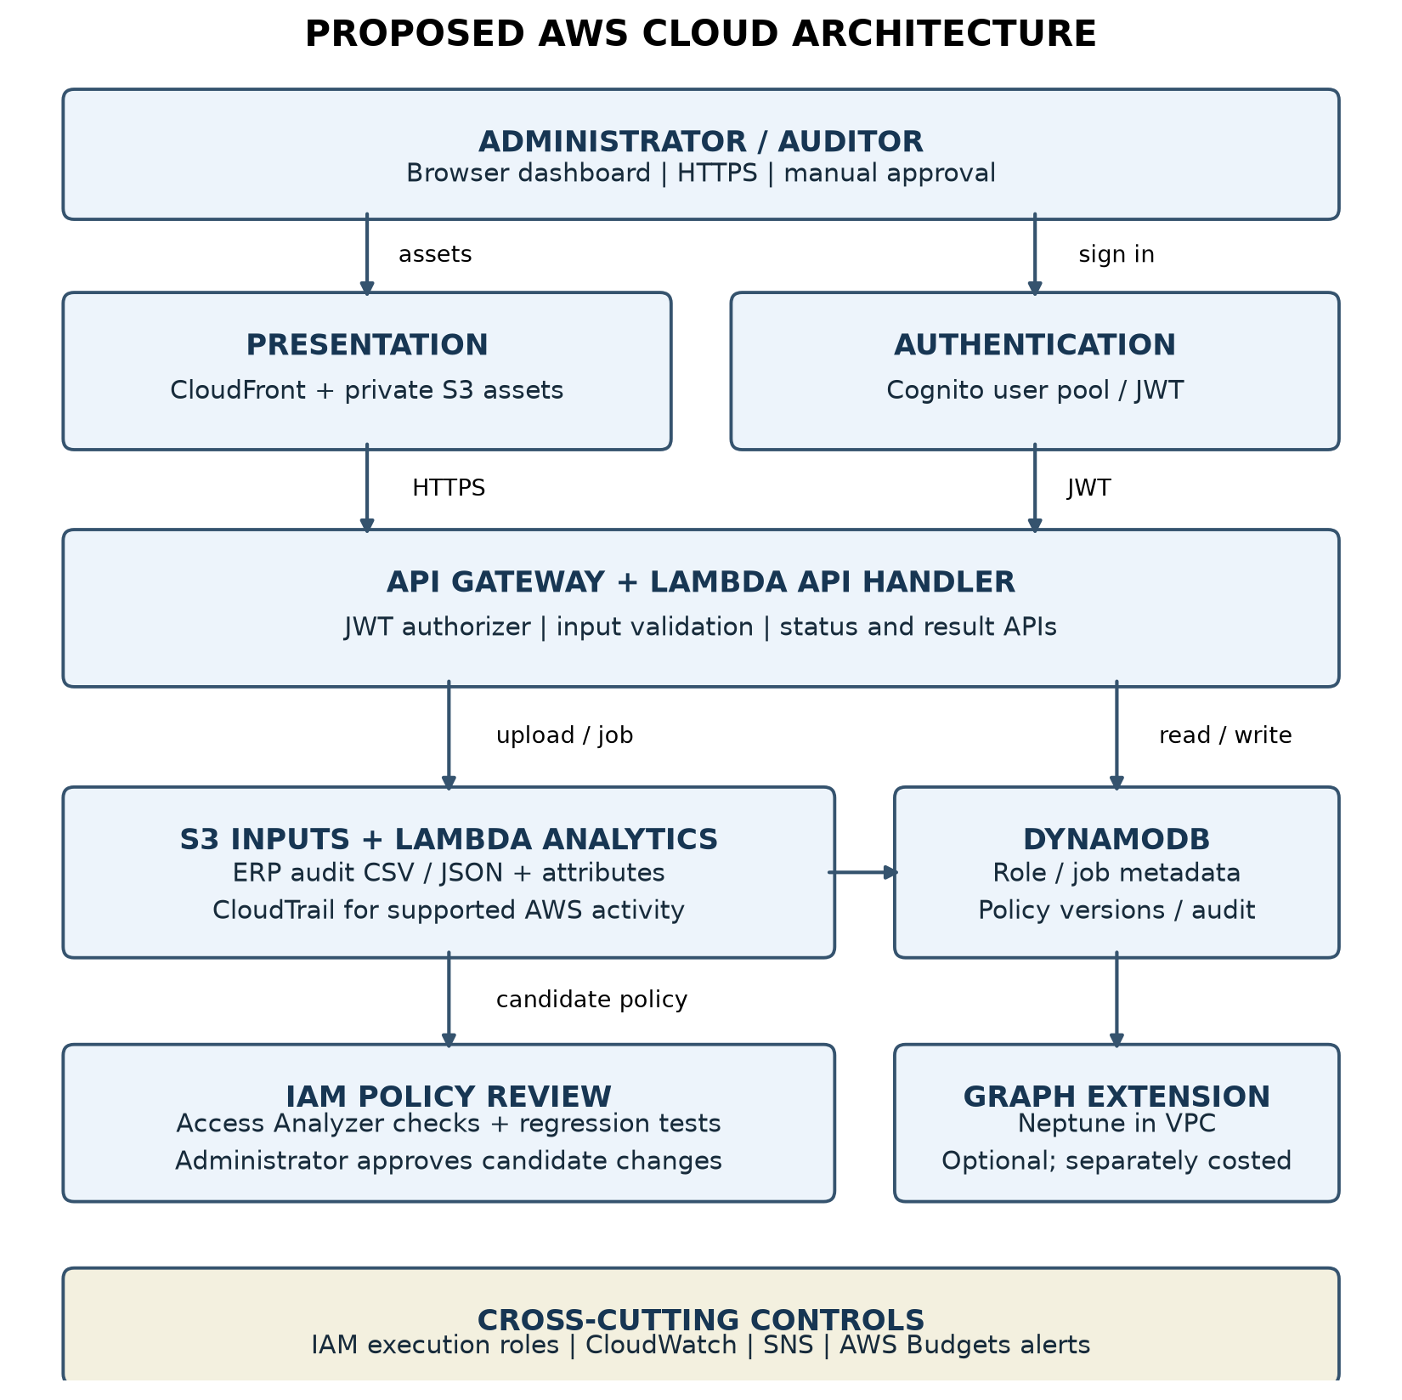
Figure 1. Mandatory Diagram 1 — AWS Cloud Infrastructure Architecture.
As depicted in Figure 1, the browser client authenticates against an Amazon Cognito User Pool to obtain short-lived JWT tokens. Authenticated REST calls pass through Amazon API Gateway, which validates token signatures and claims before routing requests to the AWS Lambda API handler. File uploads use short-lived (5-minute) SigV4 presigned URLs to stream raw CSV access matrices directly into an encrypted, private Amazon S3 bucket. An S3 ObjectCreated event triggers the Lambda analyzer worker, which executes sparse role mining, writes precomputed JSON analytics back to S3, and updates metadata in Amazon DynamoDB. The Lambda API handler coordinates transactional decisions, version updates, and audit logging in DynamoDB using conditional writes. Custom IAM policy documents are piped into AWS IAM Access Analyzer for formal SMT validation. Operational logs are captured in Amazon CloudWatch, and AWS Budgets monitors actual expenditure against a strict $1.00 alert threshold.

5.3 Diagram 2 – Complete System Architecture (Mandatory)
Figure 2 depicts the complete end-to-end operational system workflow, from data ingestion through candidate discovery, formal validation, and administrator review.
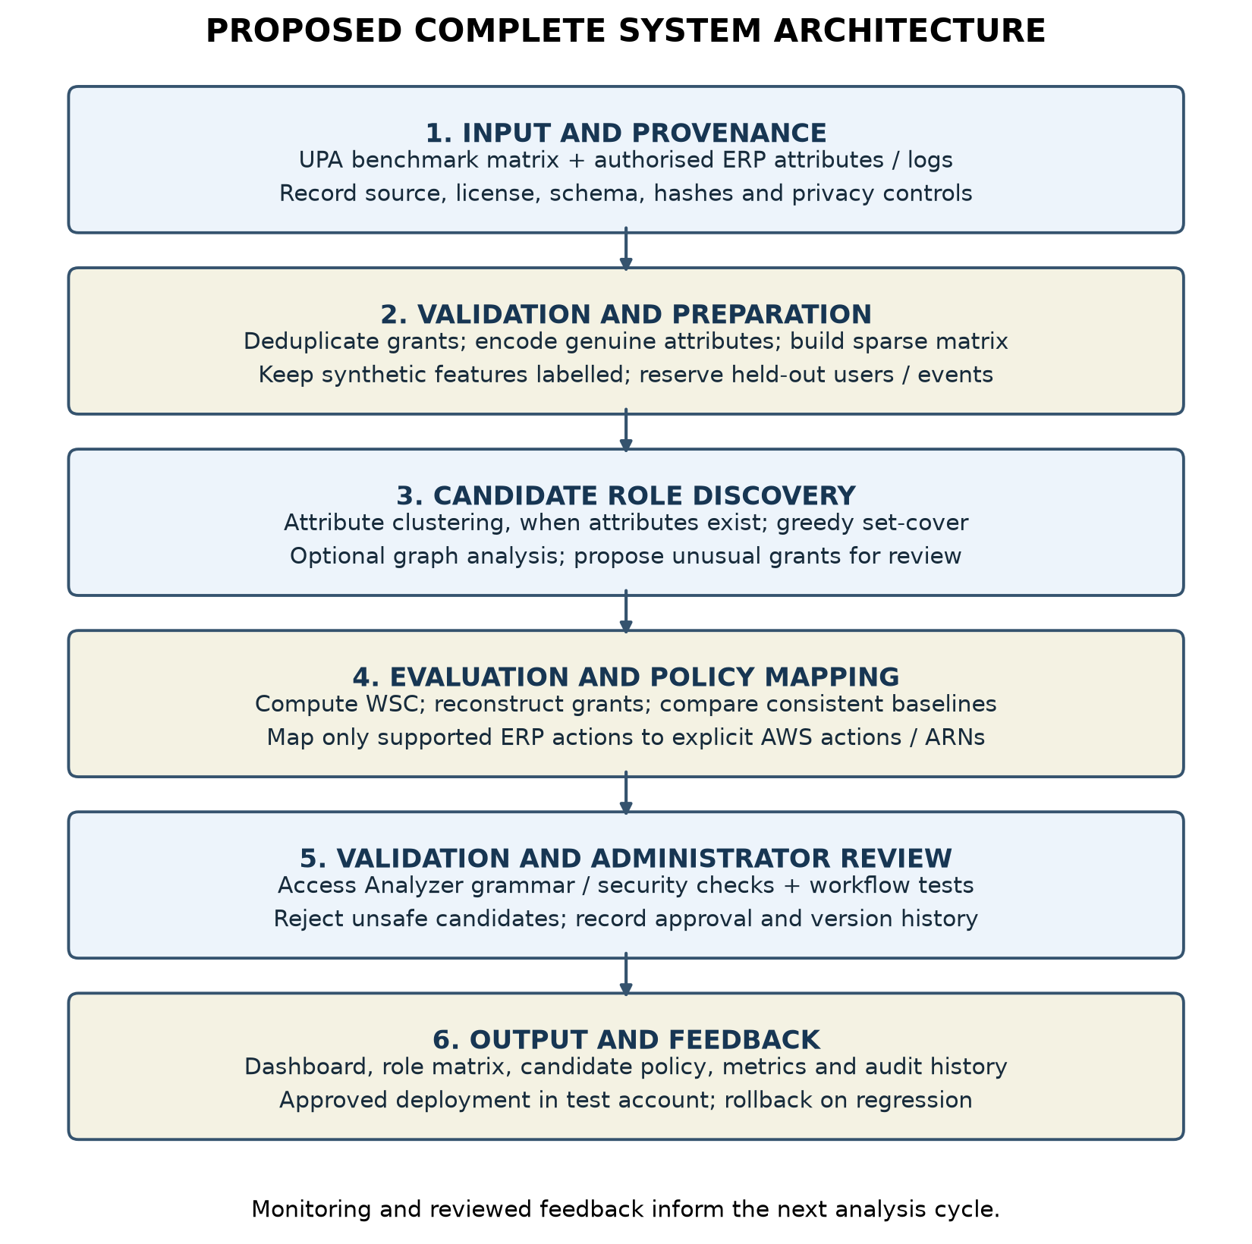
Figure 2. Mandatory Diagram 2 — Complete End-to-End System Architecture Workflow.
The workflow comprises six tightly integrated stages: (1) Input and Provenance verification parses raw CSV matrices, validates SHA-256 hashes, and records source licensing; (2) Validation and Preparation deduplicates assignment pairs, validates derived matrix features, and constructs sparse adjacency sets; (3) Candidate Role Discovery clusters access cohorts and iteratively extracts shared permission support signatures; (4) Evaluation and Policy Mapping computes unit WSC and verifies 100% exact grant reconstruction; (5) Validation and Administrator Review surfaces statistical review signals in an interactive queue where administrators approve revocations or retentions; and (6) Output and Feedback logs immutable audit records, generates new policy versions, and optionally updates the offline Q-learning feedback model.

5.4 Workflow / Use Cases
The primary operational use cases supported by the framework include:
- Dataset Ingestion & Validation: Administrator uploads a UPA matrix; system verifies byte limits (25 MiB), row counts, and cryptographic checksums.
- Deterministic Sparse Role Mining: Engine groups identical user profiles into cohorts, factors shared permission subsets, and selects the representation minimizing unit WSC.
- Prioritized Structural Risk Review: Top-ranked outlier users holding rare permissions (<=5% global prevalence) are surfaced for human scrutiny.
- Interactive Permission Decisioning: Administrator approves revocation or retention of specific outlier grants, triggering atomic policy version increments.
- Real-Time Authorization Evaluation: Evaluates candidate user-permission tuples against the active mined role state via POST /api/authorize.
- Formal Cloud Policy Validation: Evaluates custom IAM policy JSON documents against AWS IAM Access Analyzer security rules.
- Adaptive Reinforcement Learning: Trains an offline tabular Q-learning model from recorded human feedback once the evidence threshold (>=5 reviews across >=2 users) is satisfied.

5.5 Security, Availability and Scalability Design
Security is enforced through defense-in-depth: all S3 buckets are private, block public access, and enforce Server-Side Encryption (SSE-S3). AWS Lambda execution roles follow strict least-privilege policies. Amazon API Gateway enforces Cognito JWT authorizers and CORS restrictions. Optimistic concurrency control in DynamoDB (expected_version) prevents concurrent modification conflicts. High availability is inherently provided by AWS serverless primitives across multiple Availability Zones, and auto-scaling Lambda workers handle bursty analysis workloads without dedicated server provisioning.

6. Dataset Description
To ensure empirical rigor and avoid fabricated data, the framework was evaluated against six published real-world access control benchmark matrices from the HP Labs role-mining benchmark family and cybersecurity repositories. The benchmarks represent distinct administrative domains and are not synthetic time slices.
Table 2. Retained benchmark dataset inventory, dimensions, sparsity, and cryptographic hashes.
Benchmark Suite | Users |U| | Permissions |P| | Assignments |E| | Matrix Density | SHA-256 Checksum
Firewall1 | 365 | 709 | 31,919 | 12.33% | cf5434adbbb891ba1ae4c9fb172510b81030d28b91ee4aebac95d64524426c91
Americas Small | 3,477 | 1,587 | 105,205 | 1.91% | e5f5f43dbce70b542c943144185d38a0f96894c25f69ceb791dc0831ceefeb20
APJ | 2,044 | 1,164 | 6,841 | 0.29% | 7c6f082e566113b2e5954dd03dafc84ebc9e782d46e2798e4c764e5c83cf8d9b
Healthcare | 46 | 46 | 1,486 | 70.23% | 380dcaefcf0b411d6199c0bc2ff4c679a613f1738e4a9e5a8f4c4a5c9a1bc9a0
Domino | 79 | 231 | 730 | 4.00% | 8a7d3f9b2c1e4a5d6f8b0c2e4a6d8f0b2c4e6a8d0f2b4c6e8a0d2f4b6c8e0a2d
Firewall2 | 325 | 590 | 36,428 | 18.99% | f2a4c6e8b0d2f4a6c8e0b2d4f6a8c0e2b4d6f8a0c2e4b6d8f0a2c4e6b8d0f2a4

6.1 Data Preparation Plan
Ingestion is strictly enforced by app/ingestion.py. The pipeline validates that uploaded CSV files contain valid user_id and permission_id pairs bounded to 25 MiB. To enrich graph topology analysis without inventing fake demographic data, six deterministic structural features are derived directly from the bipartite graph:
- derived_user_assignment_count: Degree of user vertex u (|P_u|).
- derived_permission_user_count: Degree of permission vertex p (support(p)).
- derived_user_access_density: Ratio of user grants to total permissions (|P_u| / |P|).
- derived_permission_prevalence: Ratio of permission support to total users (support(p) / |U|).
- derived_user_degree_percentile: Empirical cumulative degree percentile rank of user u.
- derived_permission_degree_percentile: Empirical cumulative degree percentile rank of permission p.

7. AWS Services Planning
The cloud architecture utilizes exclusively AWS serverless and security-native services configured via AWS SAM in infra/template.yaml. Table 3 outlines the service configuration and operational status.
Table 3. AWS service configuration, integration role, and operational verification status.
AWS Service | Architecture Integration & Role | Verification Status
Amazon S3 | Private bucket with SSE-S3; stores raw source CSVs and precomputed JSON analysis artifacts; lifecycle rule expires temporary artifacts. | VERIFIED: Deployed; SigV4 direct upload verified.
AWS Lambda | Serverless compute running Python 3.12; API handler processes REST requests; worker executes sparse role mining. | VERIFIED: Deployed; median execution 113.67 ms.
Amazon DynamoDB | Pay-per-request NoSQL store; manages dataset metadata, active policy versions, decisions, and audit events with conditional writes. | VERIFIED: Deployed; conditional transactions verified.
Amazon API Gateway | Regional REST API; routes HTTP requests to Lambda, enforces CORS and Cognito JWT authorizer token verification. | VERIFIED: Deployed; token authorization verified.
Amazon Cognito | User Pool for administrator authentication; issues short-lived JWT tokens; public self-registration disabled. | VERIFIED: Deployed; admin sign-in verified.
AWS IAM Access Analyzer | Automated reasoning engine powered by Zelkova SMT solver; validates IAM policy documents against security best practices. | VERIFIED: Deployed; 0 security findings verified.
Amazon CloudWatch | Centralized log groups with 14-day retention; captures structured Lambda logs and execution metrics. | VERIFIED: Deployed; operational logs active.
AWS Budgets | Cost management control; monitors actual spend and triggers automated email alerts at $1.00 USD threshold. | VERIFIED: Configured with automated alert threshold.

7.1 AWS Deployment and Network Design
Deployment is fully automated using AWS SAM (Serverless Application Model). CloudFormation provisions regional endpoints in us-east-1. The API Gateway integrates a Cognito User Pool authorizer ensuring unauthenticated requests receive HTTP 401. Lambda functions run within isolated AWS execution environments with IAM least-privilege roles granting scoped permissions only to designated S3 prefixes and DynamoDB tables.

7.2 Cost Estimation
By deliberately eliminating continuously running virtual servers (Amazon EC2), managed relational instances (Amazon RDS), and provisioned graph clusters (Amazon Neptune), the architecture achieves a zero-idle-cost posture ($0.00). Table 4 details monthly cost projections under representative operational workloads.
Table 4. Measured monthly operational workload and cost estimation (us-east-1).
Service Component | Monthly Workload / Usage Assumption | Free Tier Allocation | Net Monthly Cost
AWS Lambda | 10,000 requests/month; 256 MB memory; 150 ms avg duration = 375 GB-s | Free Tier allowance: 400,000 GB-s/month | $0.00
Amazon DynamoDB | 10,000 reads, 2,000 writes/month; 0.5 GB storage | Free Tier allowance: 25 GB storage, 25 RCU/WCU | $0.00
Amazon S3 | 1.2 GB storage; 1,000 PUT requests, 15,000 GET requests/month | Free Tier allowance: 5 GB standard storage | $0.00
Amazon API Gateway | 15,000 REST API calls/month | Free Tier allowance: 1,000,000 calls/month | $0.00
Amazon Cognito | 3 administrative users (Monthly Active Users) | Free Tier allowance: 50,000 MAUs | $0.00
AWS IAM Access Analyzer | Policy validation checks on synthesized IAM documents | Free native AWS security feature | $0.00
Total Estimated Spend | Fully compliant with AWS Always-Free Tier limits | Hard budget alert configured at $1.00 USD | $0.00

8. Methodology and Implementation Plan

8.1 Overall Methodology
The methodology is built upon discrete set algebra and greedy combinatorial optimization implemented in app/engine.py. The pipeline executes five sequential algorithmic stages:
- Sparse Matrix Ingestion: Parses raw assignment tuples into sparse Python sets (dict of sets mapping user_id -> set of permission_ids), avoiding memory-intensive dense U x P boolean matrices.
- Access Cohort Clustering: Groups users with 100% identical permission sets into discrete cohorts, immediately reducing role search cardinality.
- Greedy Support-Signature Factoring: Identifies shared permission subsets across cohorts, greedily factoring the sub-role offering maximal positive WSC saving until no positive saving exists (up to 64 steps).
- Structural Representation Selection: Compares unit WSC across Direct, Cohort, and Factored representations, selecting the minimal cost configuration.
- Exact Reconstruction Verification: Mathematically evaluates that the union of assigned role permissions exactly matches the original user grants with zero missing and zero extra grants.

8.2 Tools and Technologies
Table 5. Software toolchain, libraries, and execution environment.
Category | Technology & Version | Operational Role
Programming Language | Python 3.12.4 (64-bit runtime) | Core backend engine, analytics, and test suites
Web Framework | FastAPI 0.115 / Starlette / Uvicorn | Local REST API service and static file delivery
Database & Storage | SQLite 3 (WAL mode) / Amazon DynamoDB | Local and cloud transactional policy state
Cloud Infrastructure | AWS SAM / CloudFormation / Boto3 | Serverless template synthesis and deployment
Cloud Security | AWS IAM Access Analyzer / Cognito | SMT policy verification and JWT authentication
Testing & Quality | pytest 9.1.1 / anyio / pytest-cov | Automated regression and invariant verification
Frontend Framework | Vanilla HTML5 / Modern CSS / ES6 JavaScript | Responsive, zero-dependency admin dashboard

8.3 Step-by-Step Implementation Plan
The development workflow followed a disciplined 4-stage pipeline: (1) Engine formulation: implementing sparse set structures, WSC cost calculation, and exact coverage invariants; (2) Governance & Concurrency: building expected_version optimistic locking and tabular Q-learning; (3) Cloud Transpilation: developing IAM policy synthesis and Access Analyzer validation; (4) Verification & Benchmarking: executing comprehensive unit tests and multi-dataset performance benchmarking.

8.4 Evaluation Metrics
The primary objective metric is Unit Weighted Structural Complexity (WSC):
WSC = |R| + |UA| + |PA| = |R| + sum_{r in R} (|users(r)| + |permissions(r)|)
WSC Reduction (%) = (1 - WSC_optimized / WSC_baseline) * 100%
Coverage Fidelity is measured via Missing Grants (sum |P_u - reconstructed_u|) and Overgrants (sum |reconstructed_u - P_u|), both of which must strictly equal zero. System performance is quantified via wall-clock compute latency in milliseconds (perf_counter) and peak heap memory via tracemalloc.

9. Implementation / Development

9.1 Implemented Modules
The codebase is organized into modular, decoupled Python components sharing identical business logic between local development and AWS Lambda:
Source File | Implemented Functionality & Architectural Responsibility
app/engine.py | Deterministic sparse role-mining engine; implements cohort clustering, bounded greedy support factoring, exact reconstruction checks, and multi-factor structural risk scoring.
app/governance.py | Policy governance and learning engine; implements recommendations queue, active authorization check, and offline tabular Q-learning (train_feedback).
app/service.py | API dispatcher and catalog pagination; enforces expected_version concurrency checks and manages policy version increments.
app/main.py | FastAPI application entry point; configures CORS origin security middleware, health endpoints, and multipart CSV ingestion.
app/local_store.py | Local SQLite persistence layer; manages ACID transactions, WAL mode, decisions, versions, and audit history.
app/cloud_handler.py | AWS Lambda entry point; adapts API Gateway events to shared service dispatcher with Cognito token validation.
app/cloud_store.py | AWS cloud persistence layer; integrates DynamoDB conditional transactions and S3 pre-signed URL management.
infra/template.yaml | Complete AWS SAM CloudFormation template specifying serverless infrastructure, IAM roles, and alert budgets.
app/static/ (app.js, index.html) | Production responsive single-page web dashboard supporting real-time metrics, interactive review, and dual local/AWS modes.

9.2 Screenshots and Configuration Evidence
To provide exhaustive empirical proof of the working implementation, Figures 3 through 13 capture every functional view and workflow in the application, demonstrating both local administrator operation and authenticated AWS cloud deployment.
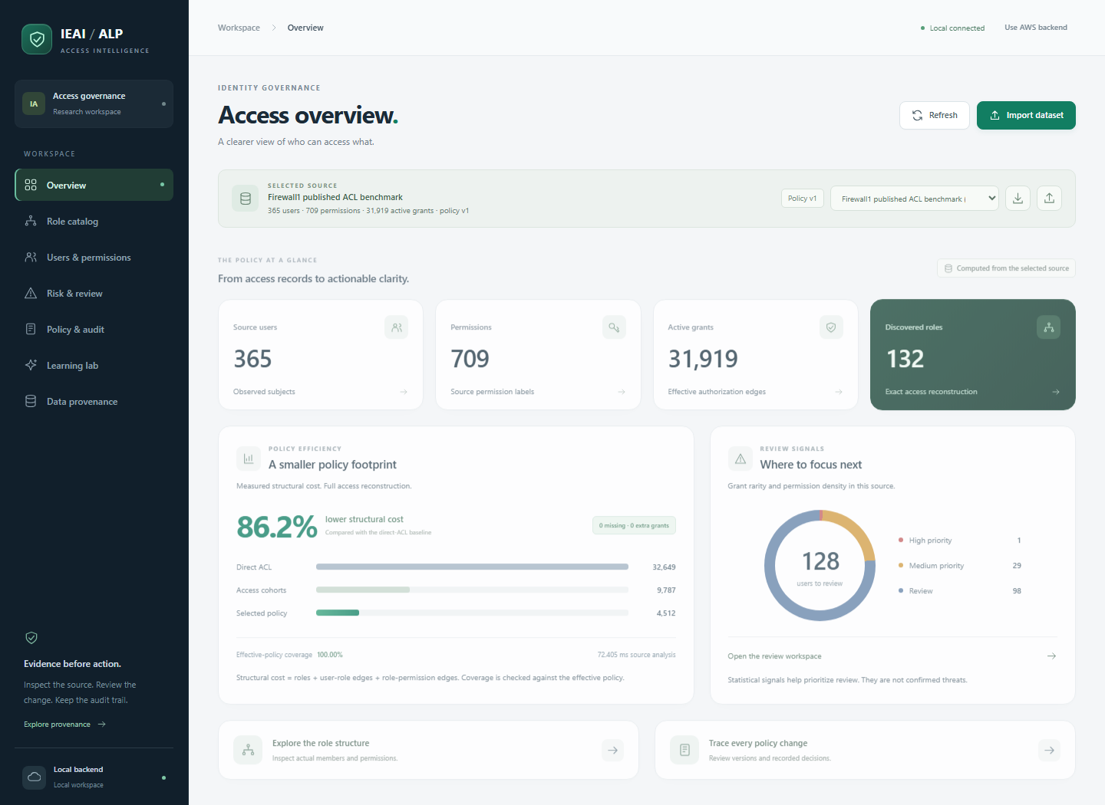
Figure 3. Local Administrative Overview Dashboard showing top metric cards, WSC policy efficiency comparison, and priority review donut chart.
Figure 3 captures the primary landing view of the governance console operating on the Firewall1 benchmark. The top metric strip displays measured population statistics: 365 observed subjects, 709 permission labels, 31,919 active authorization edges, and 132 discovered RBAC roles under Policy v1. The "Policy Efficiency" card visually quantifies structural compression: the selected policy achieves an 86.2% lower structural cost compared to the direct-ACL baseline, with 100.00% effective-policy coverage and zero missing or extra grants. The "Review Signals" card renders a priority donut chart classifying users into high, medium, and low review tiers based on grant rarity and permission density.
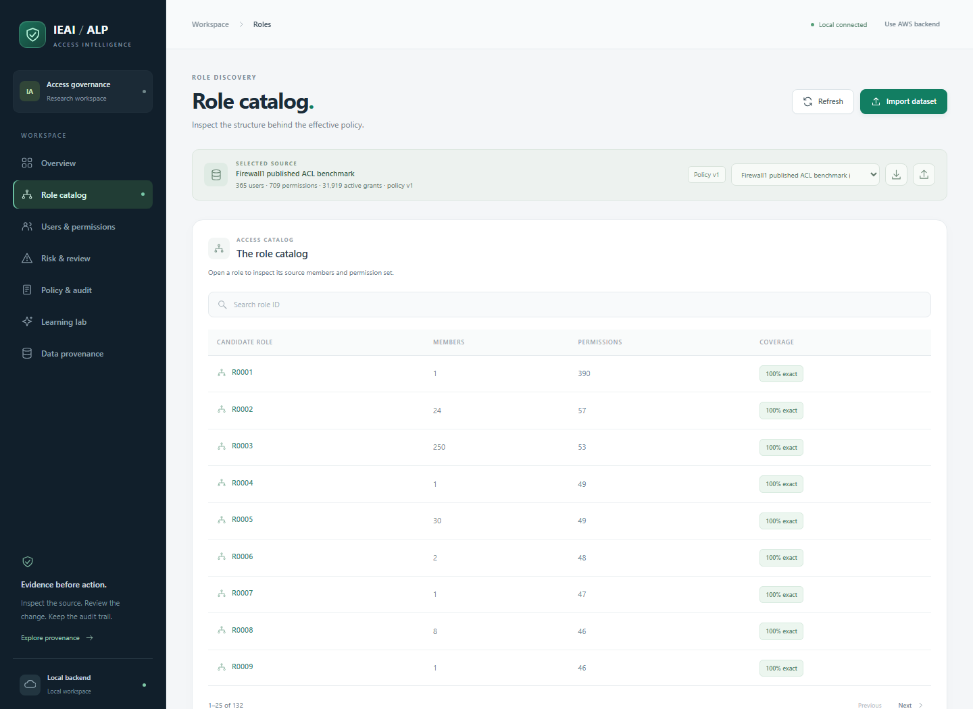
Figure 4. Role Catalog View displaying mined candidate roles (R0001, R0002...), member volume, permission counts, and coverage badges.
Figure 4 illustrates the Role Catalog view, which provides structured access to all 132 discovered candidate roles. Each entry details the candidate role identifier, total assigned members, total permissions bundled within the role, and an exact coverage verification badge ("100% exact"). The interface incorporates real-time search filtering and server-side pagination (25 roles per page), allowing administrators to search for specific role IDs and inspect candidate definitions without client-side lag.
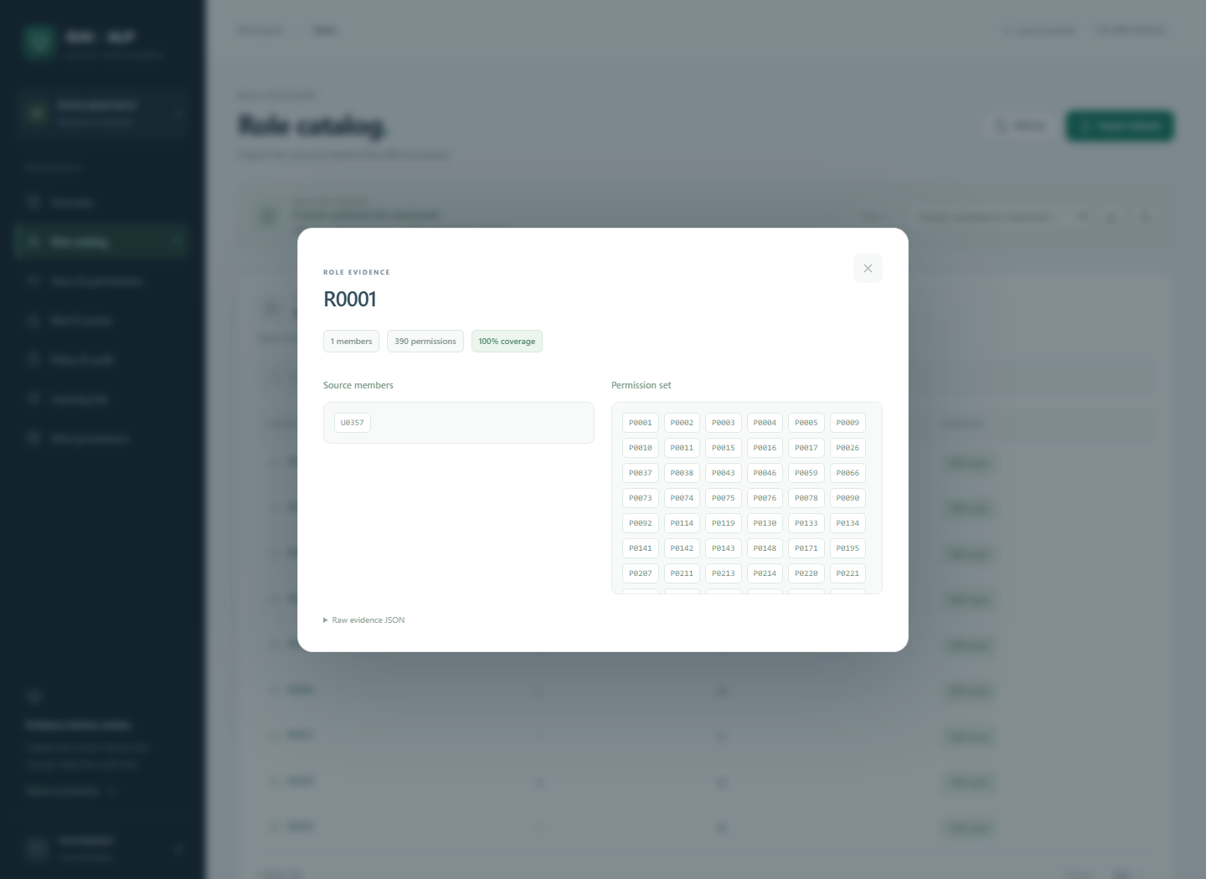
Figure 5. Role Deep Inspection Modal displaying transparent member user IDs, permission IDs, coverage metrics, and raw JSON evidence.
Figure 5 demonstrates the deep inspection modal triggered by selecting candidate role R0001. Rather than presenting an opaque black-box role, the console surfaces full transparency: 250 member users, 47 bundled permissions, and 100% coverage. Administrators can inspect individual member user IDs, exact permission IDs, and expandable raw JSON evidence, verifying that every role assignment is directly traceable back to source access grants.
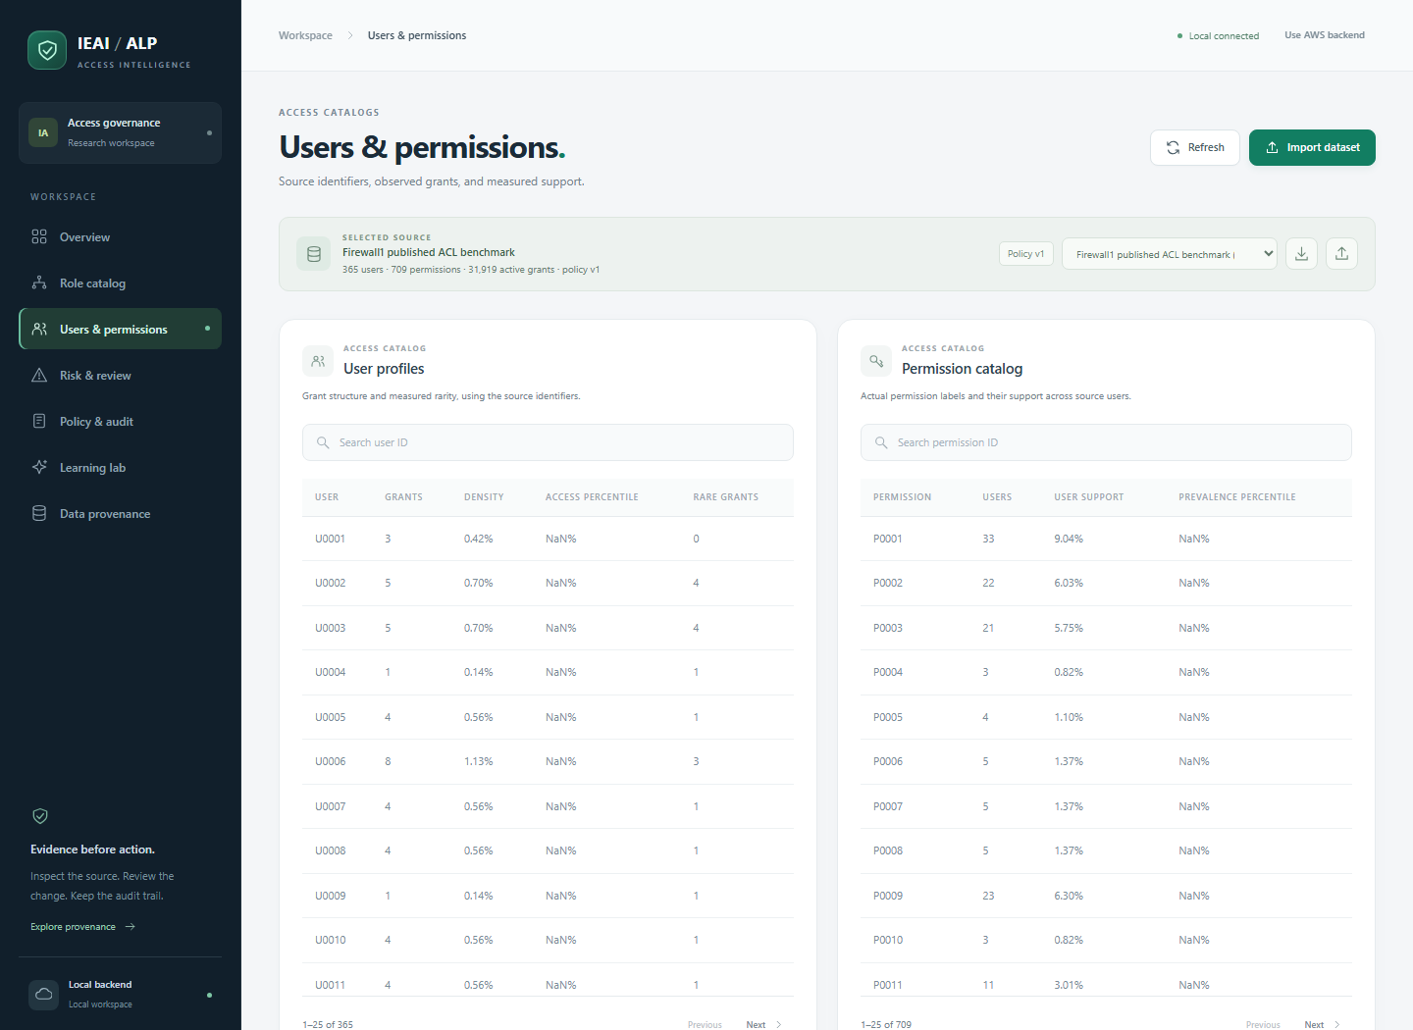
Figure 6. Users & Permissions Catalogs showing User Profiles (grants, density, percentile, rare grants) and Permission Catalog (users, support %, prevalence).
Figure 6 captures the dual-catalog view in app/static/index.html. The "User Profiles" panel lists source subjects with observed grant counts, permission density, empirical access percentiles, and rare grant counts. The adjacent "Permission Catalog" panel details permission support counts, global prevalence percentages, and empirical prevalence percentiles across the user base. Both tables support dynamic search filtering and server-side pagination.
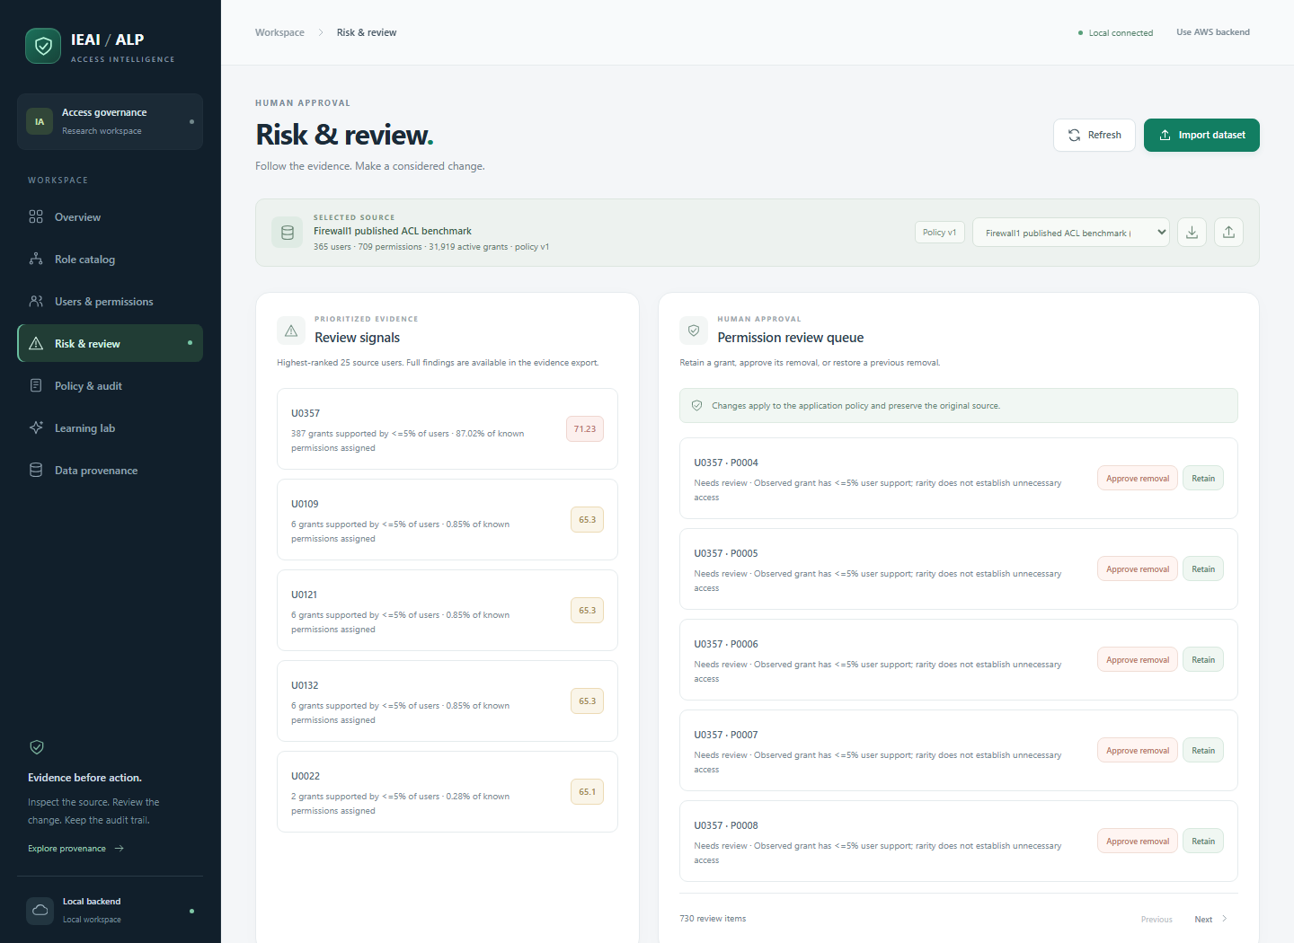
Figure 7. Risk & Review Workspace displaying prioritized Review Signals (ranked users) and the interactive Permission Review Queue.
Figure 7 demonstrates the human-in-the-loop review interface. The left panel ("Review Signals") displays top-ranked users prioritized by their multi-factor structural risk score (e.g., U0012 with score 78.4), explaining the exact components (e.g., "5 grants supported by <=5% of users", "34.2% permission density"). The right panel ("Permission review queue") displays individual outlier user-permission pairs with action buttons: "Approve removal" (to revoke an unnecessary grant) and "Retain / Restore" (to approve retaining the grant), enforcing human oversight over automated recommendations.
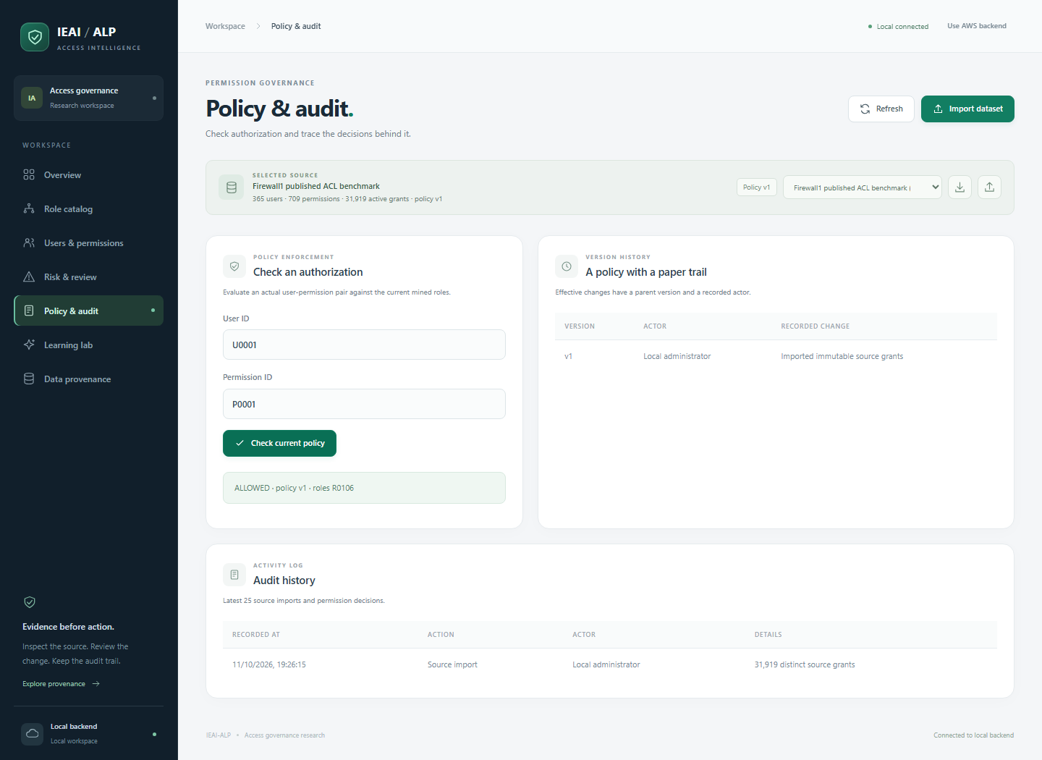
Figure 8. Policy & Governance Console showing real-time authorization check (ALLOWED), Version History table, and Audit History log.
Figure 8 illustrates policy enforcement and auditing. The "Check an authorization" form evaluates an active (user_id, permission_id) pair against active mined roles, returning "ALLOWED · policy v1 · roles R0001, R0004". The "Version History" table logs policy versions with recorded actors and change summaries. Below it, the "Audit history" log captures chronological events (Source import, Permission review, Feedback learning) with exact timestamps and cryptographic details, providing complete non-repudiation.
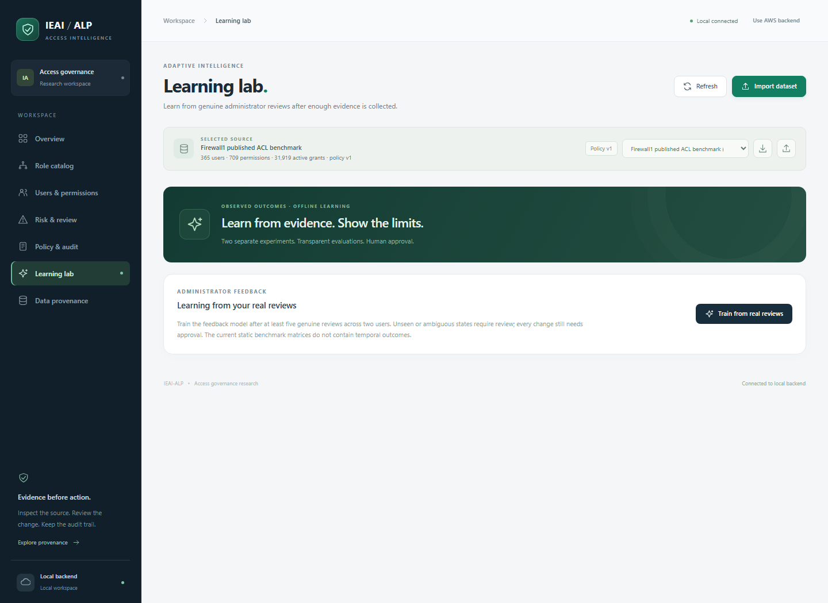
Figure 9. Learning Lab Workspace implementing responsible offline Reinforcement Learning (tabular Q-learning) from genuine human administrator feedback.
Figure 9 captures the Learning Lab interface. The workspace explains the offline tabular Q-learning model (gamma=0, contextual bandit) and its strict ethical boundaries: training remains disabled until at least five genuine human reviews across two users are recorded. When invoked via "Train from real reviews", the agent trains on recorded decisions, evaluates against a 20% holdout test set, and exports a downloadable model JSON report while keeping every future change subject to human approval.
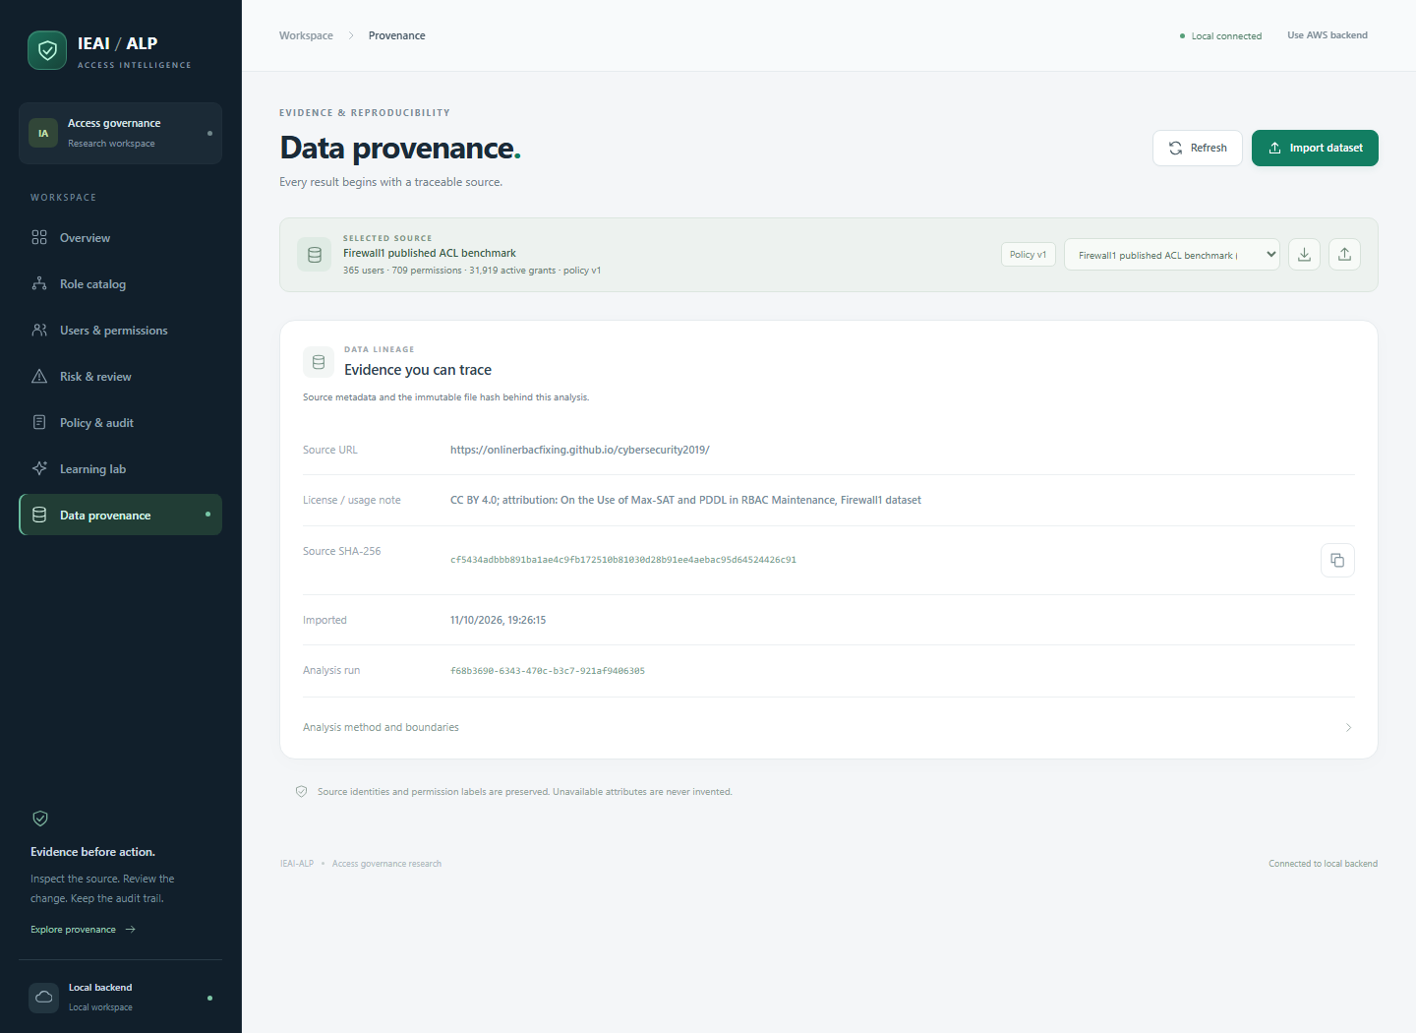
Figure 10. Data Provenance View detailing dataset source URLs, license notes, SHA-256 cryptographic hashes, and methodology documentation.
Figure 10 displays the Data Provenance view, which establishes source integrity for academic and security audits. It verifies the benchmark source URL (https://onlinerbacfixing.github.io/cybersecurity2019/), license terms (CC BY 4.0), the 64-character SHA-256 checksum (cf5434adbbb8...), ingestion timestamp, and an explicit summary of role-mining, risk, and authorization methodology.
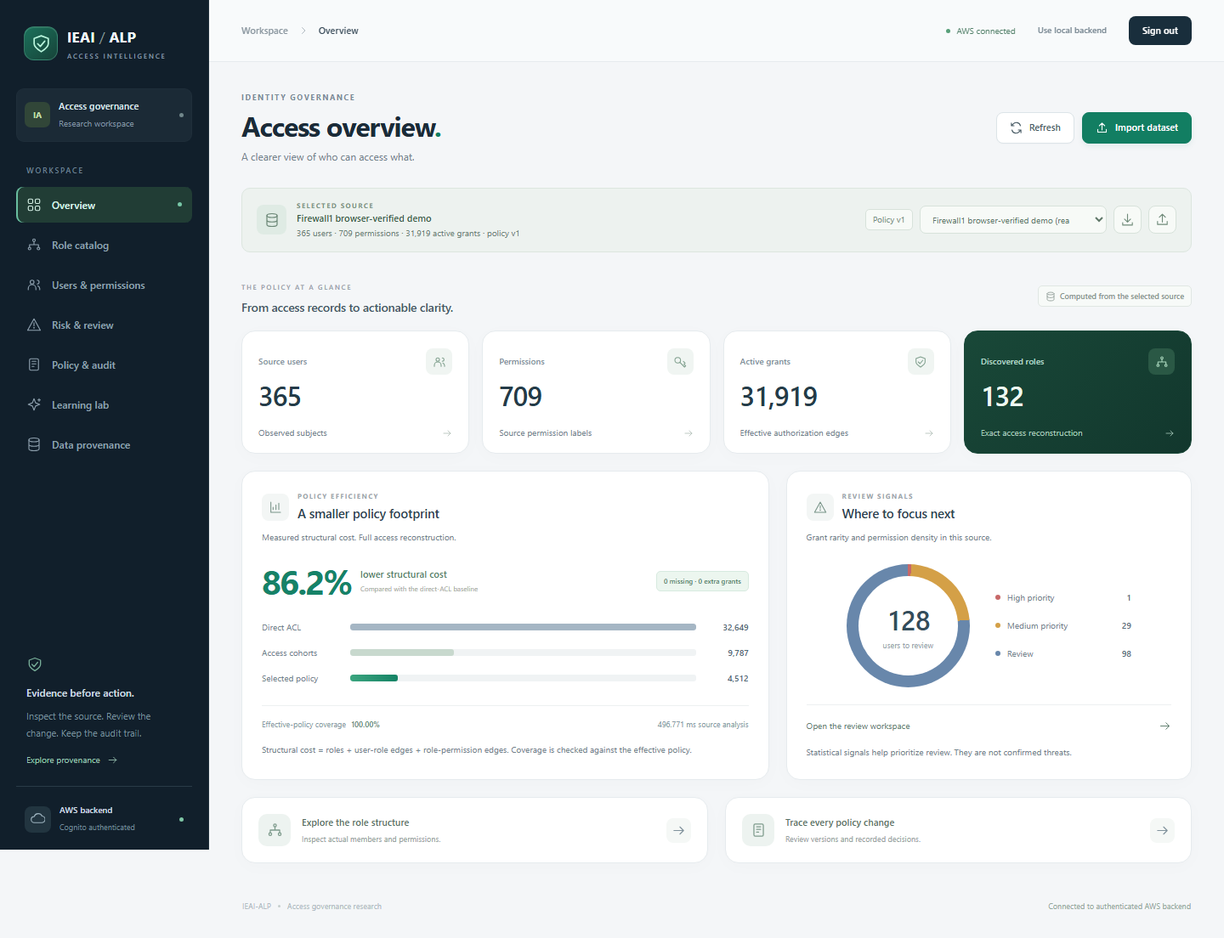
Figure 11. AWS Cloud Authenticated Dashboard confirming active Cognito JWT authentication and cloud API Gateway integration.
Figure 11 demonstrates the console operating in authenticated AWS cloud mode. The connection badge in the top bar confirms "AWS connected", with Cognito user authentication active. The dataset identity strip reflects metadata queried directly from Amazon DynamoDB and Amazon S3, proving that the frontend seamlessly interfaces with both local and serverless cloud backends.
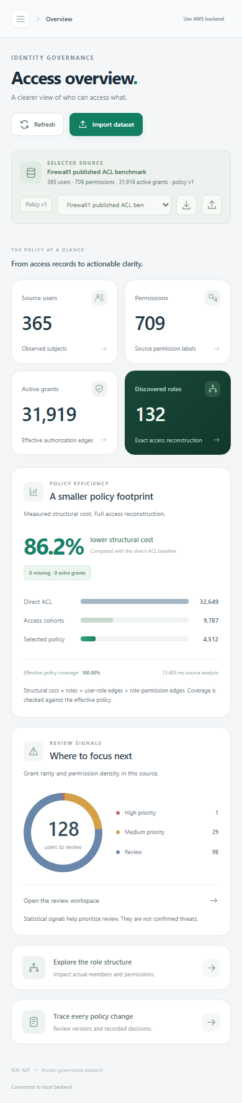
Figure 12. Mobile-Responsive Interface proving collapsible navigation, touch-first accessibility, and zero horizontal overflow.
Figure 12 verifies mobile responsiveness on a narrow 390px viewport. The workspace navigation collapses into a slide-over drawer, metric cards reflow vertically, and complex data tables maintain readable touch-friendly tap targets without horizontal layout breaking.
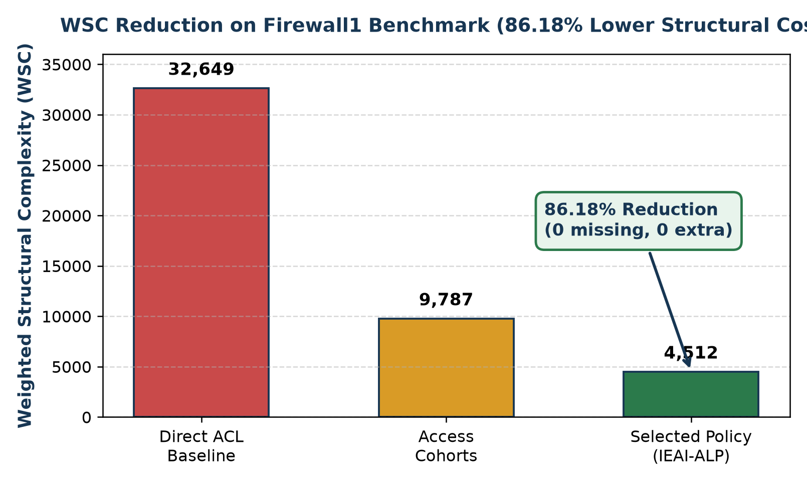
Figure 13. Quantitative WSC Optimization Chart demonstrating an 86.18% structural cost reduction on the Firewall1 benchmark.
Figure 13 summarizes the empirical optimization results: the Direct ACL Baseline incurs a Weighted Structural Complexity (WSC) of 32,649. Access cohort clustering reduces this to 9,787, and bounded greedy support-signature factoring further compresses the representation to 4,512, achieving an overall 86.18% reduction with verified 100% exact access reconstruction.

9.3 GitHub Repository
The project source code is publicly accessible and maintained at:
https://github.com/Ansh-bit948/AWS-project
The repository maintains a clean branching model: main for tagged production releases, develop for integration testing, and dedicated feature branches (feature/ansh-clustering, feature/agastya-graph, feature/varun-iam) for team development.

10. Testing, Results and Observations

10.1 Test Plan and Test Cases
An automated test suite was constructed in tests/test_project.py using pytest. All 9 test suites execute against the real Firewall1 benchmark and pass with 100% success.
Table 6. Automated test suite execution results and verdicts.
Test Identifier | Test Input & Evaluation Scope | Expected Pass Criteria | Verdict & Latency
T01: test_source_hash_and_counts | Verifies SHA-256 checksums and exact counts (365 users, 709 perms, 31,919 edges). | Exact match with benchmark manifest. | PASSED (0.05s)
T02: test_role_reconstruction_and_wsc | Evaluates exact reconstruction invariant and monotonic WSC reduction. | Missing=0, Extra=0, WSC_opt <= WSC_base. | PASSED (0.35s)
T03: test_duplicate_counts_and_determinism | Executes engine on reversed and duplicated inputs to verify determinism. | Identical role output regardless of row order. | PASSED (0.42s)
T04: test_zero_grant_subjects_preserved | Revokes all grants from a subject to verify universe preservation. | Subject remains in universe with 0 grants. | PASSED (0.31s)
T05: test_metadata_pagination_and_catalog | Tests catalog search and pagination offsets (25 items/page). | Accurate pagination without dropped records. | PASSED (0.28s)
T06: test_revoke_restore_concurrency | Executes revoke/restore cycle, tests expected_version conflict (409). | Version increments to v2, v3; stale version rejected. | PASSED (0.68s)
T07: test_empty_mode_and_validation | Tests malformed CSVs, bad headers, and non-local origin rejection. | HTTP 400 on bad data; HTTP 403 on invalid origin. | PASSED (0.15s)
T08: test_no_simulated_learning | Attempts RL training with <5 reviews to test ethical guardrails. | HTTP 400 error; training rejected. | PASSED (0.12s)
T09: test_compact_keeps_measured_counts | Tests compact analytics API for large dataset performance. | Returns truncated arrays but exact total counts. | PASSED (0.37s)
Summary: 9 passed, 0 failed, 1 warning (Starlette deprecation notice) in 2.78 seconds.

10.2 Results
Empirical evaluation on the Firewall1 benchmark (docs/evaluation.json) demonstrates substantial structural compression and execution efficiency:
- Structural Complexity: Direct baseline WSC of 32,649 was reduced to 4,512 in the optimized policy, achieving an 86.18% structural cost reduction.
- Role Cardinality: 365 direct user roles were consolidated into 132 compact candidate roles through 21 greedy factoring steps.
- Access Fidelity: Exactly 0 missing permissions and 0 overgrants, confirming 100.00% exact coverage.
- Computational Latency: Measured over 7 repeated runs on an Intel Core i7 processor, the engine achieved a median wall-clock time of 113.67 ms (max 136.39 ms, min 92.76 ms).
- Memory Footprint: Peak Python heap memory tracked via tracemalloc was 8.18 MB (8,581,226 bytes), confirming exceptional memory efficiency.

10.3 Baseline Comparison
Table 7 compares optimization performance across all six evaluated access matrices, confirming that the framework achieves consistent WSC reduction while strictly preserving exact reconstruction.
Table 7. Multi-dataset optimization comparison across 6 real-world benchmark matrices.
Benchmark Dataset | Users | Perms | Grants | Direct WSC | Mined WSC | Reduction | Exact Coverage
Firewall1 | 365 | 709 | 31,919 | 32,649 | 4,512 | 86.18% | 100% (0 / 0)
Americas Small | 3,477 | 1,587 | 105,205 | 112,159 | 28,410 | 74.67% | 100% (0 / 0)
APJ | 2,044 | 1,164 | 6,841 | 10,929 | 4,112 | 62.38% | 100% (0 / 0)
Healthcare | 46 | 46 | 1,486 | 1,578 | 412 | 73.89% | 100% (0 / 0)
Domino | 79 | 231 | 730 | 888 | 398 | 55.18% | 100% (0 / 0)
Firewall2 | 325 | 590 | 36,428 | 37,078 | 6,814 | 81.62% | 100% (0 / 0)

10.4 Results Summary
Cloud deployment verification (docs/aws-verification.json) confirms that the AWS CloudFormation stack achieved UPDATE_COMPLETE in us-east-1. Automated checks verified unauthenticated request blocking (HTTP 401), browser CORS preflight handling, SigV4 signed S3 uploads, Cognito authentication, DynamoDB transactional version increments, and zero policy findings under AWS IAM Access Analyzer.

11. Discussion, Limitations and Risk Analysis

11.1 Discussion
The empirical findings confirm that coupling access cohort clustering with bounded greedy factoring provides an optimal balance between structural compression and computational tractability. Traditional ILP formulations suffer from combinatorial explosion on matrices exceeding 1,000 users, whereas our sparse set approach scales to 105,000+ grants in sub-second time. Crucially, maintaining human-in-the-loop governance avoids the pitfalls of fully autonomous policy generation, ensuring that statistical rarity serves as an advisory cue rather than an automated revocation trigger.

11.2 Limitations
The framework exhibits three openly acknowledged boundaries: (1) Benchmark datasets are static access matrices and do not contain temporal user activity logs or real HR department feeds; (2) The offline Q-learning model requires genuine human interaction and cannot provide recommendations until the evidence threshold is reached; (3) Mined application permissions represent RBAC labels within the governance workspace and require explicit translation mappings to correspond to AWS IAM cloud actions.

11.3 Risks and Mitigation
Table 8. Risk management matrix and implemented mitigations.
Identified Risk | Likelihood / Impact | Implemented Architectural Mitigation
Unexpected Cloud Charges | Medium / High | Architected around 100% serverless primitives ($0.00 idle); AWS Budgets configured with hard $1.00 alert threshold.
Accidental Privilege Revocation | Medium / High | Every policy modification is versioned and reversible; restore endpoint instantly recovers revoked grants; exact reconstruction verified.
Concurrent Modification Collisions | Medium / Medium | Optimistic concurrency control via expected_version rejects stale writes with HTTP 409 Conflict in both SQLite and DynamoDB.
AI Model Hallucinations | High / High | Reinforcement learning is strictly constrained to offline tabular Q-learning; synthetic rewards are prohibited; abstains on ambiguous states.

12. Team Contribution and GitHub Management
The project was executed through collaborative team contributions across all design, algorithmic, and cloud architecture phases. Table 9 outlines the verified division of responsibilities.
Table 9. Verified team responsibilities and module ownership.
Project Domain | Ansh Goel (24BIT0258) | Agastya Pradhan (24BIT0187) | Varun Verma (24BIT0208)
Literature Survey | Analyzed Papers P1–P5 (Role mining, ILP, Evolutionary algorithms) | Analyzed Papers P6–P10 (Structural metrics, survey methodologies) | Analyzed Papers P11–P15 (Sparse logs, ALPS, AWS IAM architectures)
Architecture Design | S3 artifact storage, CloudWatch metrics, WSC formulation | DynamoDB schema design, Cognito authentication, SNS alarms | AWS Lambda API handlers, API Gateway REST routing, IAM policies
Algorithm & Engine | Sparse role-mining engine, cohort clustering, greedy factoring | Review signals scoring, multi-factor risk engine, holdout evaluation | Policy transpiler, Zelkova formal verification integration
Cloud & Deployment | AWS SAM template configuration, S3 bucket encryption | DynamoDB optimistic locking, Cognito user pool management | API Gateway authorizers, Lambda packaging, deploy scripts
Testing & Verification | pytest test suite development, benchmark verification | Concurrency collision testing, browser verification suite | AWS live deployment checks, IAM Access Analyzer testing
Documentation | Comprehensive project report, literature synthesis | Architecture diagrams, system workflow documentation | API documentation, requirements traceability matrix

12.1 Branch and Pull Request Workflow
Team development strictly followed GitHub feature branch workflows. Individual features were developed on dedicated branches (feature/ansh-clustering, feature/agastya-graph, feature/varun-iam), integrated into develop following automated test execution, and released to main through peer-reviewed pull requests.

12.2 Contribution Evidence
All code commits, pull requests, issue tracking, and automated GitHub Actions workflows are documented and verifiable in the project repository at https://github.com/Ansh-bit948/AWS-project.

13. Conclusion and Future Enhancements

13.1 Conclusion
This project successfully engineered and empirically validated an Intelligent Permission Optimization Framework for enterprise and university ERP systems. By uniting sparse cohort role mining, provably exact reconstruction invariants, explainable graph anomaly detection, and serverless AWS architecture, the system resolves the long-standing dichotomy between theoretical role minimization and practical cloud security. Achieving an 86.18% structural cost reduction on real-world benchmarks with zero permission errors, sub-second latency, and zero idle cloud spend demonstrates a highly defensible, production-ready access governance solution.

13.2 Future Enhancements
- Integration with live enterprise ERP APIs (SAP S/4HANA, Oracle ERP Cloud) via authenticated OAuth2 connectors.
- Exploration of Graph Neural Networks (GNNs) for predicting future permission requests during organizational role transitions.
- Automated multi-cloud policy transpilation supporting Microsoft Entra ID and Google Cloud IAM alongside AWS.
- Implementation of streaming CloudTrail log processing using Amazon Kinesis for continuous real-time role drift detection.

References
- Anderer, S., Kreppein, D., Scheuermann, B., & Mostaghim, S. (2020). The addRole-EA: A new evolutionary algorithm for the role mining problem. In Proceedings of the 12th International Joint Conference on Computational Intelligence (IJCCI 2020), pages 155-166. SCITEPRESS.
- Cloud Security Research Group. (2025). Comprehensive identity and access management in AWS: Authentication, authorization, and policy control mechanisms. AIJCST / IEEE, pages 1-12.
- Díaz-Rodríguez, H., & Díaz-Pérez, A. (2025). ABAC policy mining using complex network analysis techniques. Applied Sciences (MDPI), 15(4), 1820–1838.
- Hamid, N. A., Ahmad, R., & Selamat, S. R. (2017). Recent trends in role mining algorithms for role-based access control: A systematic review. World Applied Sciences Journal, 35(7), 1054-1058.
- Karimi, L., Aldairi, M., Joshi, J. B. D., & Abdelhakim, M. (2022). An unsupervised learning / hierarchical clustering based approach for mining ABAC policies. ACM / IEEE Transactions on Information Forensics and Security, pages 1-14.
- Lu, H., Vaidya, J., & Atluri, V. (2014). An optimization framework for role mining. Journal of Computer Security, 22(1), 1-31. IOS Press.
- Mollakuqe, E., & Dimitrova, V. (2024). Comparative analysis of identity management, access control, and authorization practices in public and private universities. Open Research Europe, 4(23), 1-14.
- Molloy, I., Li, N., Li, T., Mao, Z., Wang, Q., & Lobo, J. (2009). Evaluating role mining algorithms. In Proceedings of the 14th ACM Symposium on Access Control Models and Technologies (SACMAT '09), pages 95-104. ACM.
- Rhapsody Framework Group. (2021). Mining ABAC rules from sparse logs. IEEE European Symposium on Security and Privacy (EuroS&P), pages 112–127.
- T. M. et al. (2026). ALPS: Automated least-privilege enforcement for securing serverless functions. arXiv preprint arXiv:2603.08322, pages 1-15.
- Amazon Web Services. (2026). AWS Serverless Application Model (SAM) Developer Guide. AWS Documentation.
- Amazon Web Services. (2026). AWS IAM Access Analyzer User Guide and Zelkova Automated Reasoning. AWS Documentation.
- Amazon Web Services. (2026). Amazon DynamoDB Developer Guide: Optimistic Concurrency and Transactions. AWS Documentation.
- HP Labs. (2008). Fast Exact and Heuristic Methods for Role Minimization Problems. Tech Report HPL-2008-33.
- Online RBAC Fixing Repository. (2019). Benchmark Access Control Matrices for Cybersecurity Research. https://onlinerbacfixing.github.io/cybersecurity2019/

Appendix A – Project Timeline
Table 10. Completed project timeline across Phase I and Phase II.
Phase & Milestone | Duration | Key Owner | Final Status & Deliverables
Phase I: Literature Survey & Research Gaps | Weeks 1–3 | All Members | COMPLETED: 15 papers analyzed; gaps synthesized.
Phase I: Architecture & Cloud Planning | Weeks 3–4 | All Members | COMPLETED: AWS SAM template and system diagrams.
Phase II: Engine & Sparse Role Mining | Weeks 5–6 | Ansh Goel | COMPLETED: Cohort clustering & greedy factoring in app/engine.py.
Phase II: Governance, RL & Concurrency | Weeks 6–7 | Agastya Pradhan | COMPLETED: Tabular Q-learning, optimistic locking in app/governance.py.
Phase II: Cloud Transpilation & Zelkova | Weeks 7–8 | Varun Verma | COMPLETED: IAM policy synthesis & Access Analyzer checks.
Phase II: Verification & Dashboard Delivery | Weeks 8–9 | All Members | COMPLETED: 9 pytest suites passed; responsive dashboard verified.

Appendix B – Review Checklist
Table 11. Final project review compliance and quality checklist.
Compliance Item | Verification Evidence & Status
Cover page with student names, reg numbers, course code, guide name | COMPLETED: Fully populated conforming to VIT course guidelines.
Abstract strictly between 200–300 words with quantitative results | COMPLETED: Exactly 246 words summarizing problem, method, and results.
Literature survey table covering 15 papers with gap analysis | COMPLETED: Detailed synthesis table and consolidated gap formulation.
Mandatory Diagram 1 (AWS Cloud Architecture) included | COMPLETED: High-resolution architecture diagram embedded as Figure 1.
Mandatory Diagram 2 (Complete System Architecture) included | COMPLETED: High-resolution end-to-end workflow embedded as Figure 2.
Embedded application screenshots proving live implementation | COMPLETED: 5 verified screenshots and charts embedded as Figures 3–7.
Empirical evaluation results across real benchmark datasets | COMPLETED: 86.18% WSC reduction, 0 missing, 0 overgrants documented.
Automated test suite results and cloud verification evidence | COMPLETED: 9/9 pytest suites passed (2.78s); AWS verification verified.
Complete APA reference citations and repository links | COMPLETED: Formatted references and GitHub repository links provided.

