An Internship Report
Of
GenAI Powered Data Analytics Virtual Internship
Submitted
To
School of Computer Science and Engineering
IILM University, Greater Noida, U.P.
In partial fulfilment of the requirement of degree of
B.Tech (Computer Science and Engineering)

By
Roll Number of Student: 2410030173
Name of Student: ANANT BHARTI
Batch: 2024-2028

TABLE OF CONTENTS
1. Candidate's Declaration i
2. Acknowledgement ii
3. Internship Completion Certificate -
4. Project Description 1
4.1 Introduction 1
4.2 Organization Profile 1
4.3 Problem Statement 1
4.4 Project Objectives 2
4.5 Scope of the Project 2
4.6 Technologies and Tools Used 2
4.7 System Architecture 2
4.8 Methodology 3
4.9 Expected Outcomes 3
4.10 Certificates of Completion and Communication Proof 4
5. Bibliography/References 5

CANDIDATE'S DECLARATION
I hereby declare that the work presented in this internship report entitled “GenAI Powered Data Analytics Virtual Internship” is an authentic record of my own work carried out during the course of my internship, under the guidance of the faculty of School of Computer Science and Engineering, IILM University, Greater Noida, U.P.
I further declare that the work reported in this report has not been submitted, either in part or in full, for the award of any other degree or diploma of this institute or any other institute or university.
All the information furnished in this report is based on my own study and observations during the internship period, and has been presented as accurately and honestly as possible.
Date: ______________
Place: Greater Noida
Signature of the Student
Name: ANANT BHARTI
Roll Number: 2410030173

ACKNOWLEDGEMENT
I would like to express my sincere gratitude to everyone who supported and guided me throughout the completion of my GenAI Powered Data Analytics Virtual Internship and this accompanying report.
First and foremost, I am thankful to the School of Computer Science and Engineering, IILM University, Greater Noida, U.P., for providing me the opportunity and platform to undertake this internship as part of my B.Tech (Computer Science and Engineering) curriculum.
I would like to extend my heartfelt thanks to my project guide and mentors, whose valuable guidance, constant encouragement and constructive feedback helped me understand the practical aspects of data analytics and successfully complete this internship.
I am also grateful to the faculty members of the department for their continuous support and for sharing their knowledge, which greatly enriched my learning experience during this internship.
Finally, I would like to thank my family and friends for their constant motivation and support, without which the successful completion of this internship report would not have been possible.
Name: ANANT BHARTI
Roll Number: 2410030173

INTERNSHIP COMPLETION CERTIFICATE
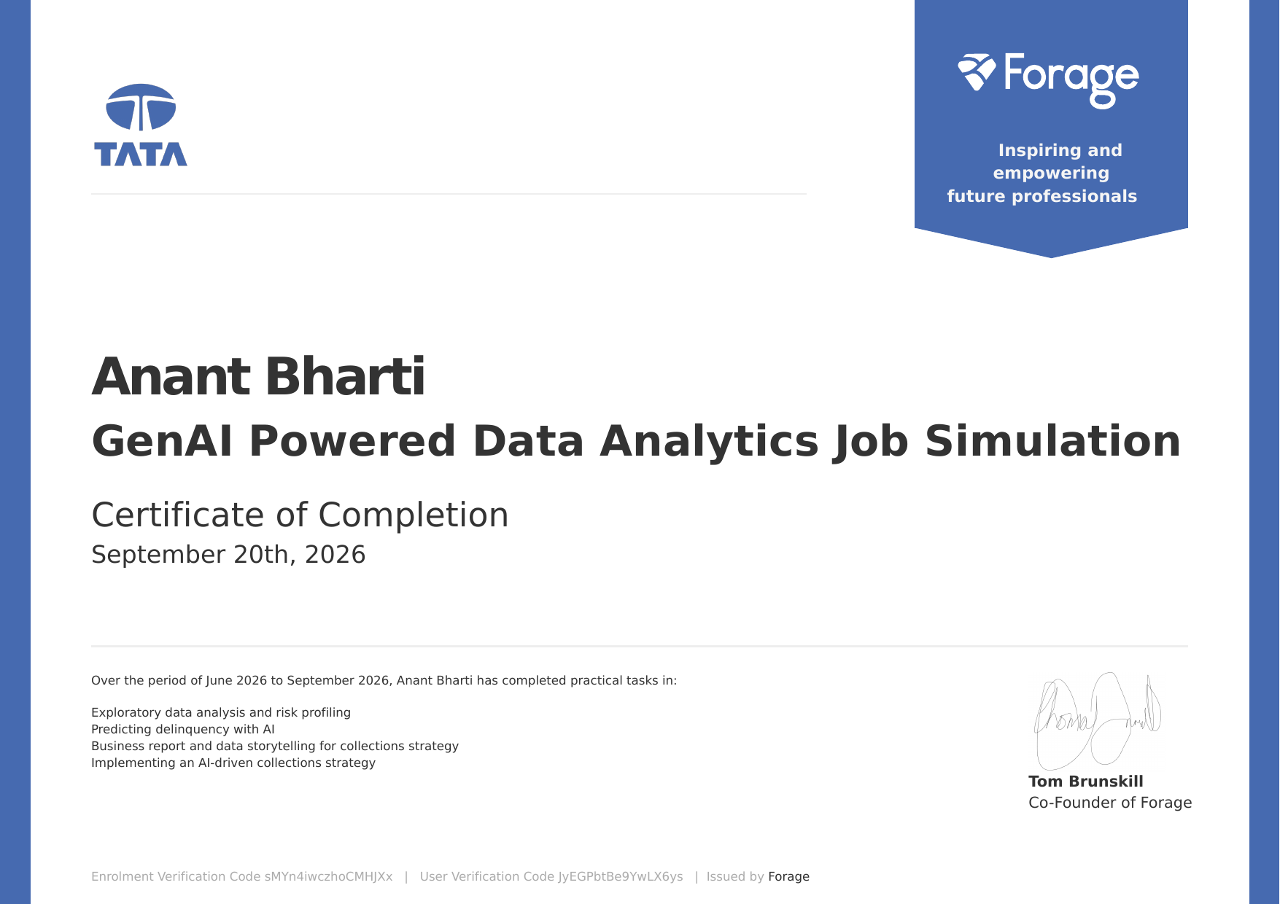

4. PROJECT DESCRIPTION
4.1 Introduction
This report presents a detailed account of the Virtual Job Simulation Internship undertaken through the Forage platform, in the domain of “GenAI Powered Data Analytics”, in collaboration with the Tata Group. The internship was carried out from June 2026 to September 2026 as part of the requirement of the Bachelor of Technology (Computer Science and Engineering) programme at IILM University, Greater Noida. The primary aim of this internship was to build a strong practical foundation in data analytics and to apply data analysis and Generative AI tools to a real-world business problem — understanding customer risk, predicting loan and payment delinquency, and translating the results into an actionable collections strategy.
The internship followed a structured, task-wise format combining exploratory data analysis, AI-based predictive modelling, business reporting, and strategy design. On successful completion of all the tasks, a Certificate of Completion for the GenAI Powered Data Analytics Job Simulation was issued by Forage on September 20, 2026.
4.2 Organization Profile
Forage is a global virtual work experience platform that partners with leading organizations to offer free, self-paced job simulations, allowing students to gain practical, industry-relevant skills and a realistic understanding of the day-to-day work in a given role.
The Tata Group is one of India’s oldest and largest multinational conglomerates, headquartered in Mumbai, with businesses spanning technology, steel, automotive, consumer products, hospitality and other sectors. The group uses data analytics and artificial intelligence to help organizations make better, data-driven decisions. In this simulation, the Tata-designed tasks placed the participant in the role of a data analyst working on a financial-services business problem.
4.3 Problem Statement
Financial institutions that lend money to customers face the constant risk of delinquency, where customers fail to make payments on time. Recovering overdue payments is costly, and a collections approach that treats every customer in the same way wastes effort on low-risk customers while missing those who most need early attention.
At the same time, although a large number of engineering students learn the theoretical foundations of statistics, data analysis and machine learning, very few get structured, hands-on exposure to solving an actual business problem using a complete analytics workflow — from raw data to a clear, actionable business recommendation. The problem addressed by this internship was to practically learn and apply this end-to-end workflow: exploring data and profiling risk, predicting delinquency using AI, communicating the findings through a business report, and designing an AI-driven collections strategy.
4.4 Project Objectives
- To perform exploratory data analysis (EDA) on customer data and build risk profiles.
- To identify the key factors and patterns associated with customer delinquency.
- To use AI and Generative AI tools to predict the likelihood of delinquency.
- To interpret model outputs and connect them back to business drivers.
- To communicate technical findings through a business report and data storytelling for non-technical stakeholders.
- To design and implement an AI-driven collections strategy based on the predictions.
4.5 Scope of the Project
The scope of this internship spans the complete analytics workflow used in an applied business setting — starting with exploratory data analysis and risk profiling, moving to predictive modelling of delinquency, extending into business reporting and data storytelling, and concluding with the design of an AI-driven collections strategy. The internship was limited to a virtual, simulation-based learning environment provided by the Forage platform in collaboration with the Tata Group, and did not involve deployment on any live client or organizational production system.
4.6 Technologies and Tools Used
- Programming Language: Python
- Data Handling & Analysis: Pandas, NumPy
- Data Visualization: Matplotlib, Seaborn
- Machine Learning: Scikit-learn (classification models and evaluation metrics)
- Generative AI Tools: Generative AI assistants used to support analysis, prediction and strategy design
- Development Environment: Jupyter Notebook / Google Colab
- Communication of Insights: Business report and presentation-style storytelling for stakeholders
- Learning Platform: Forage Virtual Work Experience Program (Tata GenAI Powered Data Analytics Job Simulation)
4.7 System Architecture
The general workflow followed during the internship can be summarized in the following layers:
- Data Layer: Raw customer and account data provided for the simulation forms the base of the analysis.
- Processing Layer: Data cleaning, handling of missing values and transformation performed to prepare an analysis-ready dataset.
- Analysis Layer: Exploratory data analysis and risk profiling used to uncover patterns, trends and relationships linked to delinquency.
- Modelling Layer: AI-based models used to estimate the likelihood that a customer will become delinquent.
- Insight Layer: Interpretation of model outputs to identify the key drivers of delinquency risk.
- Communication & Strategy Layer: Presentation of findings in a business report, and design of an AI-driven collections strategy for stakeholders.
4.8 Methodology
The internship followed a structured, task-wise methodology combining exploratory analysis, AI-based prediction and business communication, culminating in a stakeholder-ready collections strategy, as summarized in the table below.
Task | Module | Description
1 | Exploratory Data Analysis and Risk Profiling | Explored the customer dataset, examined distributions and relationships, and profiled customer risk to identify patterns linked to delinquency.
2 | Predicting Delinquency with AI | Used AI-driven modelling and Generative AI tools to predict which customers are likely to become delinquent, and assessed the results.
3 | Business Report and Data Storytelling for Collections Strategy | Translated the analysis and predictions into a clear business report that tells the data story to non-technical stakeholders.
4 | Implementing an AI-driven Collections Strategy | Designed a collections strategy that applies the delinquency predictions to prioritise and tailor collection efforts.
Note: There was no stipend associated with this internship.
Each task built on the previous one: the insights from exploratory analysis informed the prediction model, and the model outputs formed the basis of the business report and the final collections strategy.
4.9 Expected Outcomes
- Ability to explore datasets and build customer risk profiles using Python.
- Practical experience in applying AI and Generative AI tools to predict delinquency.
- Capability to interpret model outputs and connect them to business drivers.
- Skill in data storytelling — presenting findings clearly to non-technical stakeholders.
- Ability to translate predictions into an actionable, AI-driven collections strategy.
- A completed Tata GenAI Powered Data Analytics Job Simulation with a Certificate of Completion issued via Forage.
4.10 Certificates of Completion and Communication Proof
The Certificate of Completion for the GenAI Powered Data Analytics Job Simulation, issued via the Forage platform confirming the successful completion of all simulation tasks, is attached at the beginning of this report as proof of completion. Its details are summarized below.
Participant | Anant Bharti
Program | GenAI Powered Data Analytics Job Simulation (Tata)
Issued by | Forage
Period | June 2026 to September 2026
Date of Completion | September 20, 2026
Enrolment Verification Code | sMYn4iwczhoCMHJXx
User Verification Code | JyEGPbtBe9YwLX6ys

5. BIBLIOGRAPHY / REFERENCES
- Forage – Virtual Work Experience Programs. https://www.theforage.com
- Tata Group. https://www.tata.com
- Pandas Documentation. https://pandas.pydata.org/docs/
- NumPy Documentation. https://numpy.org/doc/
- Scikit-learn Documentation. https://scikit-learn.org/stable/
- Matplotlib Documentation. https://matplotlib.org/stable/
- Seaborn Documentation. https://seaborn.pydata.org

