**Object-Oriented Programming Lab Report**

**Autumn 2023**

**Lab Experiment 1,2,3**

Name: Ansh Garg

Roll no.: R2142220030

Sap_ID: 500105940

B. Tech. CSE spz. Fullstack AI, Semester 2, Batch 3:

Date of experiment: 20-09-2023



School of Computer Science,

University of Petroleum and Energy Studies,

Dehradun

**Experiment 1**

**Assignment-1**

*Write a program to print hello word.*

**Java code:**

// WAP to print hello world.

// Author: Ansh Garg

public class Hello {

    public static void main(String[] args) {

        System.out.println("Hello, World!");

    }

}

**Screenshot of the output:**

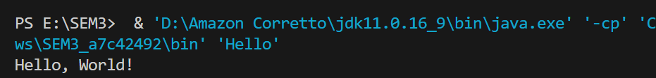

**Assignment-2**

*WAP in Java*

*-> TO perform all arithmetic operations*

**Java Code:**

// WAP in Java

public class arithmetic {

public static void main (String[] args) {

int a=2, b=5;

System.out.printf("Multiply %d\n", a*b);

System.out.printf("Addition %d\n", a+b);

System.out.printf("Subtraction %d\n", a-b);

System.out.printf("Division %d\n", a/b);

System.out.printf("Left shift %d\n", a<<b);

System.out.printf("Right shift %d\n", a>>b);

int ans = a>>b;

System.out.println("Right shift "+ans);

}

**Output:**

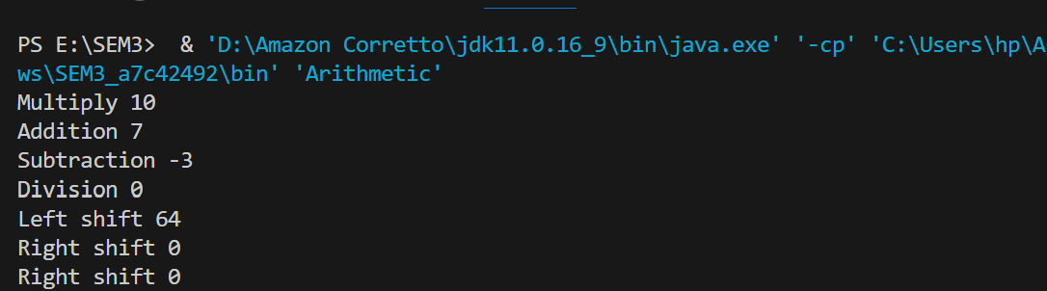

**Assignment-3**

*WAP in Java*

*-> TO perform factorial of number*

**Java Code:**

import java.util.Scanner;

public class Factorial {

    public static void main(String[] args){

        Scanner sc = new Scanner(System.in);

        System.out.println("Enter a number: ");

        int number = sc.nextInt();

        int factorial = 1;

        for(int i = 1; i <= number; i++){

            factorial *= i;

        }

        System.out.println("The factorial of " + number + " is " + factorial);

        sc.close();

    }

}

**Output:**

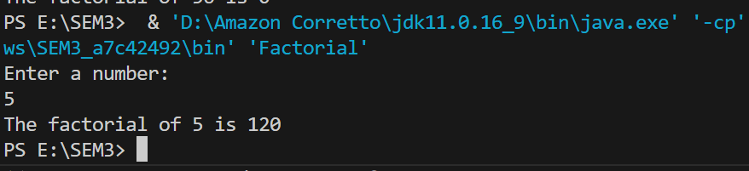

**Assignment-4**

*WAP in Java*

*-> TO find whether the entered number is prime or not*

**Java Code:**

import java.util.Scanner;

public class Prime {

    public static void main(String[] args){

        Scanner sc = new Scanner(System.in);

        System.out.println("Enter a number: ");

        int number = sc.nextInt();

        boolean isPrime = true;

        for(int i = 2; i < number; i++){

            if(number % i == 0){

                isPrime = false;

                break;

            }

        }

        if(isPrime){

            System.out.println(number + " is a prime number.");

        } else {

            System.out.println(number + " is not a prime number.");

        }

    }

}

**Output:**

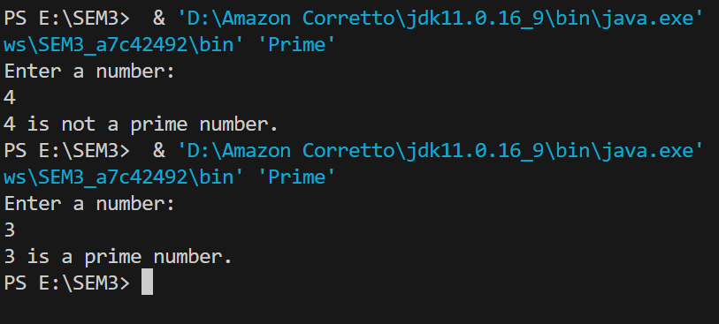

**Experiment-2**

**Assignment-1**

*WAP in Java*

*-> TO print Fibonacci series of a given number*

**Java Code:**

iimport java.util.Scanner;

public class Fibonachi {

    public static void main(String[] args) {

        Scanner sc = new Scanner(System.in);

        System.out.println("Enter number of elements: ");

        int n = sc.nextInt();

        if (n <= 0) {

            System.out.println("Invalid input. Please enter a positive integer.");

            return;

        }

        if (n == 1) {

            System.out.println("1");

            return;

        }

        System.out.println("1: 1");

        int prev = 1;

        int current = 1;

        for (int i = 2; i < n; i++) {

            int next = prev + current;

            if (next % 2 == 0) {

                System.out.println(i + ": " + next + "*");

            } else {

                System.out.println(i + ": " + next);

            }

            prev = current;

            current = next;

        }

    }

}

mport java.util.Scanner;

public class Prime {

    public static void main(String[] args){

        Scanner sc = new Scanner(System.in);

        System.out.println("Enter a number: ");

        int number = sc.nextInt();

        boolean isPrime = true;

        for(int i = 2; i < number; i++){

            if(number % i == 0){

                isPrime = false;

                break;

            }

        }

        if(isPrime){

            System.out.println(number + " is a prime number.");

        } else {

            System.out.println(number + " is not a prime number.");

        }

    }

}

**Output:**

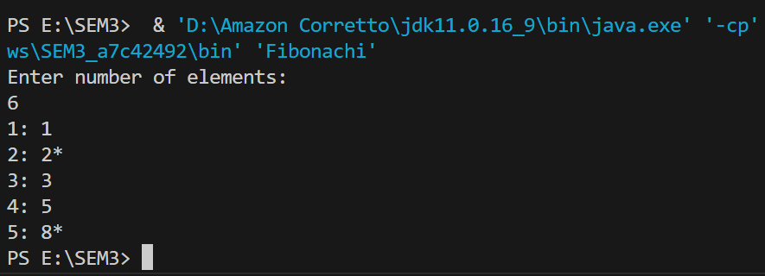

**Experiment-3**

**Assignment-1**

*WAP in Java*

*-> 1)Take user input for 3 students*

*2)Insert Roll no. Name and Display them*

*3)Write seperate functions for insert and display*

*4)Program must have 2 classes*

/**WAP in java

 * Take user input for 3 students

 * insert roll no. name and display them

 * wrute seperate functions for insert and display

 * programm must have 2 classes

 * Name:Ansh Garg

 * Roll No:30

 * SAP ID: 500105940

 */

import java.util.Scanner;

class Student {

    int rollno;

    String name;

    void insert(int r, String n) {

        rollno = r;

        name = n;

    }

    void display() {

        System.out.println(rollno + " " + name);

    }

}

class TestStudent {

    public static void main(String[] args) {

        int num = 3;

        Scanner sc = new Scanner(System.in);

        Student[] arr = new Student[num];

        for (int i = 0; i < num; i++) {

            arr[i] = new Student();

            int j = i + 1;

            System.out.println("Student " + j + " details:");

            System.out.println("Enter Student rollno: ");

            int rollno = sc.nextInt();

            System.out.println("Enter Student name: ");

            String name = sc.next();

            arr[i].insert(rollno, name);

        }

        System.out.println("Student present in the database:");

        for (int i = 0; i < num; i++) {

            arr[i].display();

        }

    }

}

**Output:**

