**Object-Oriented Programming**

**Home Assignment**

**Autumn 2023**

**Home Assignment-1**

Name: Ansh Garg

Roll no.: R2142220030

Sap_ID: 500105940

B. Tech. CSE spz. Fullstack AI, Semester 2, Batch 3:



School of Computer Science,

University of Petroleum and Energy Studies,

Dehradun

**Q-1)** *Describe the difference between shallow and deep cloning.*

1. *Provide an example program implementing both.*
2. *Screenshots of the output.*

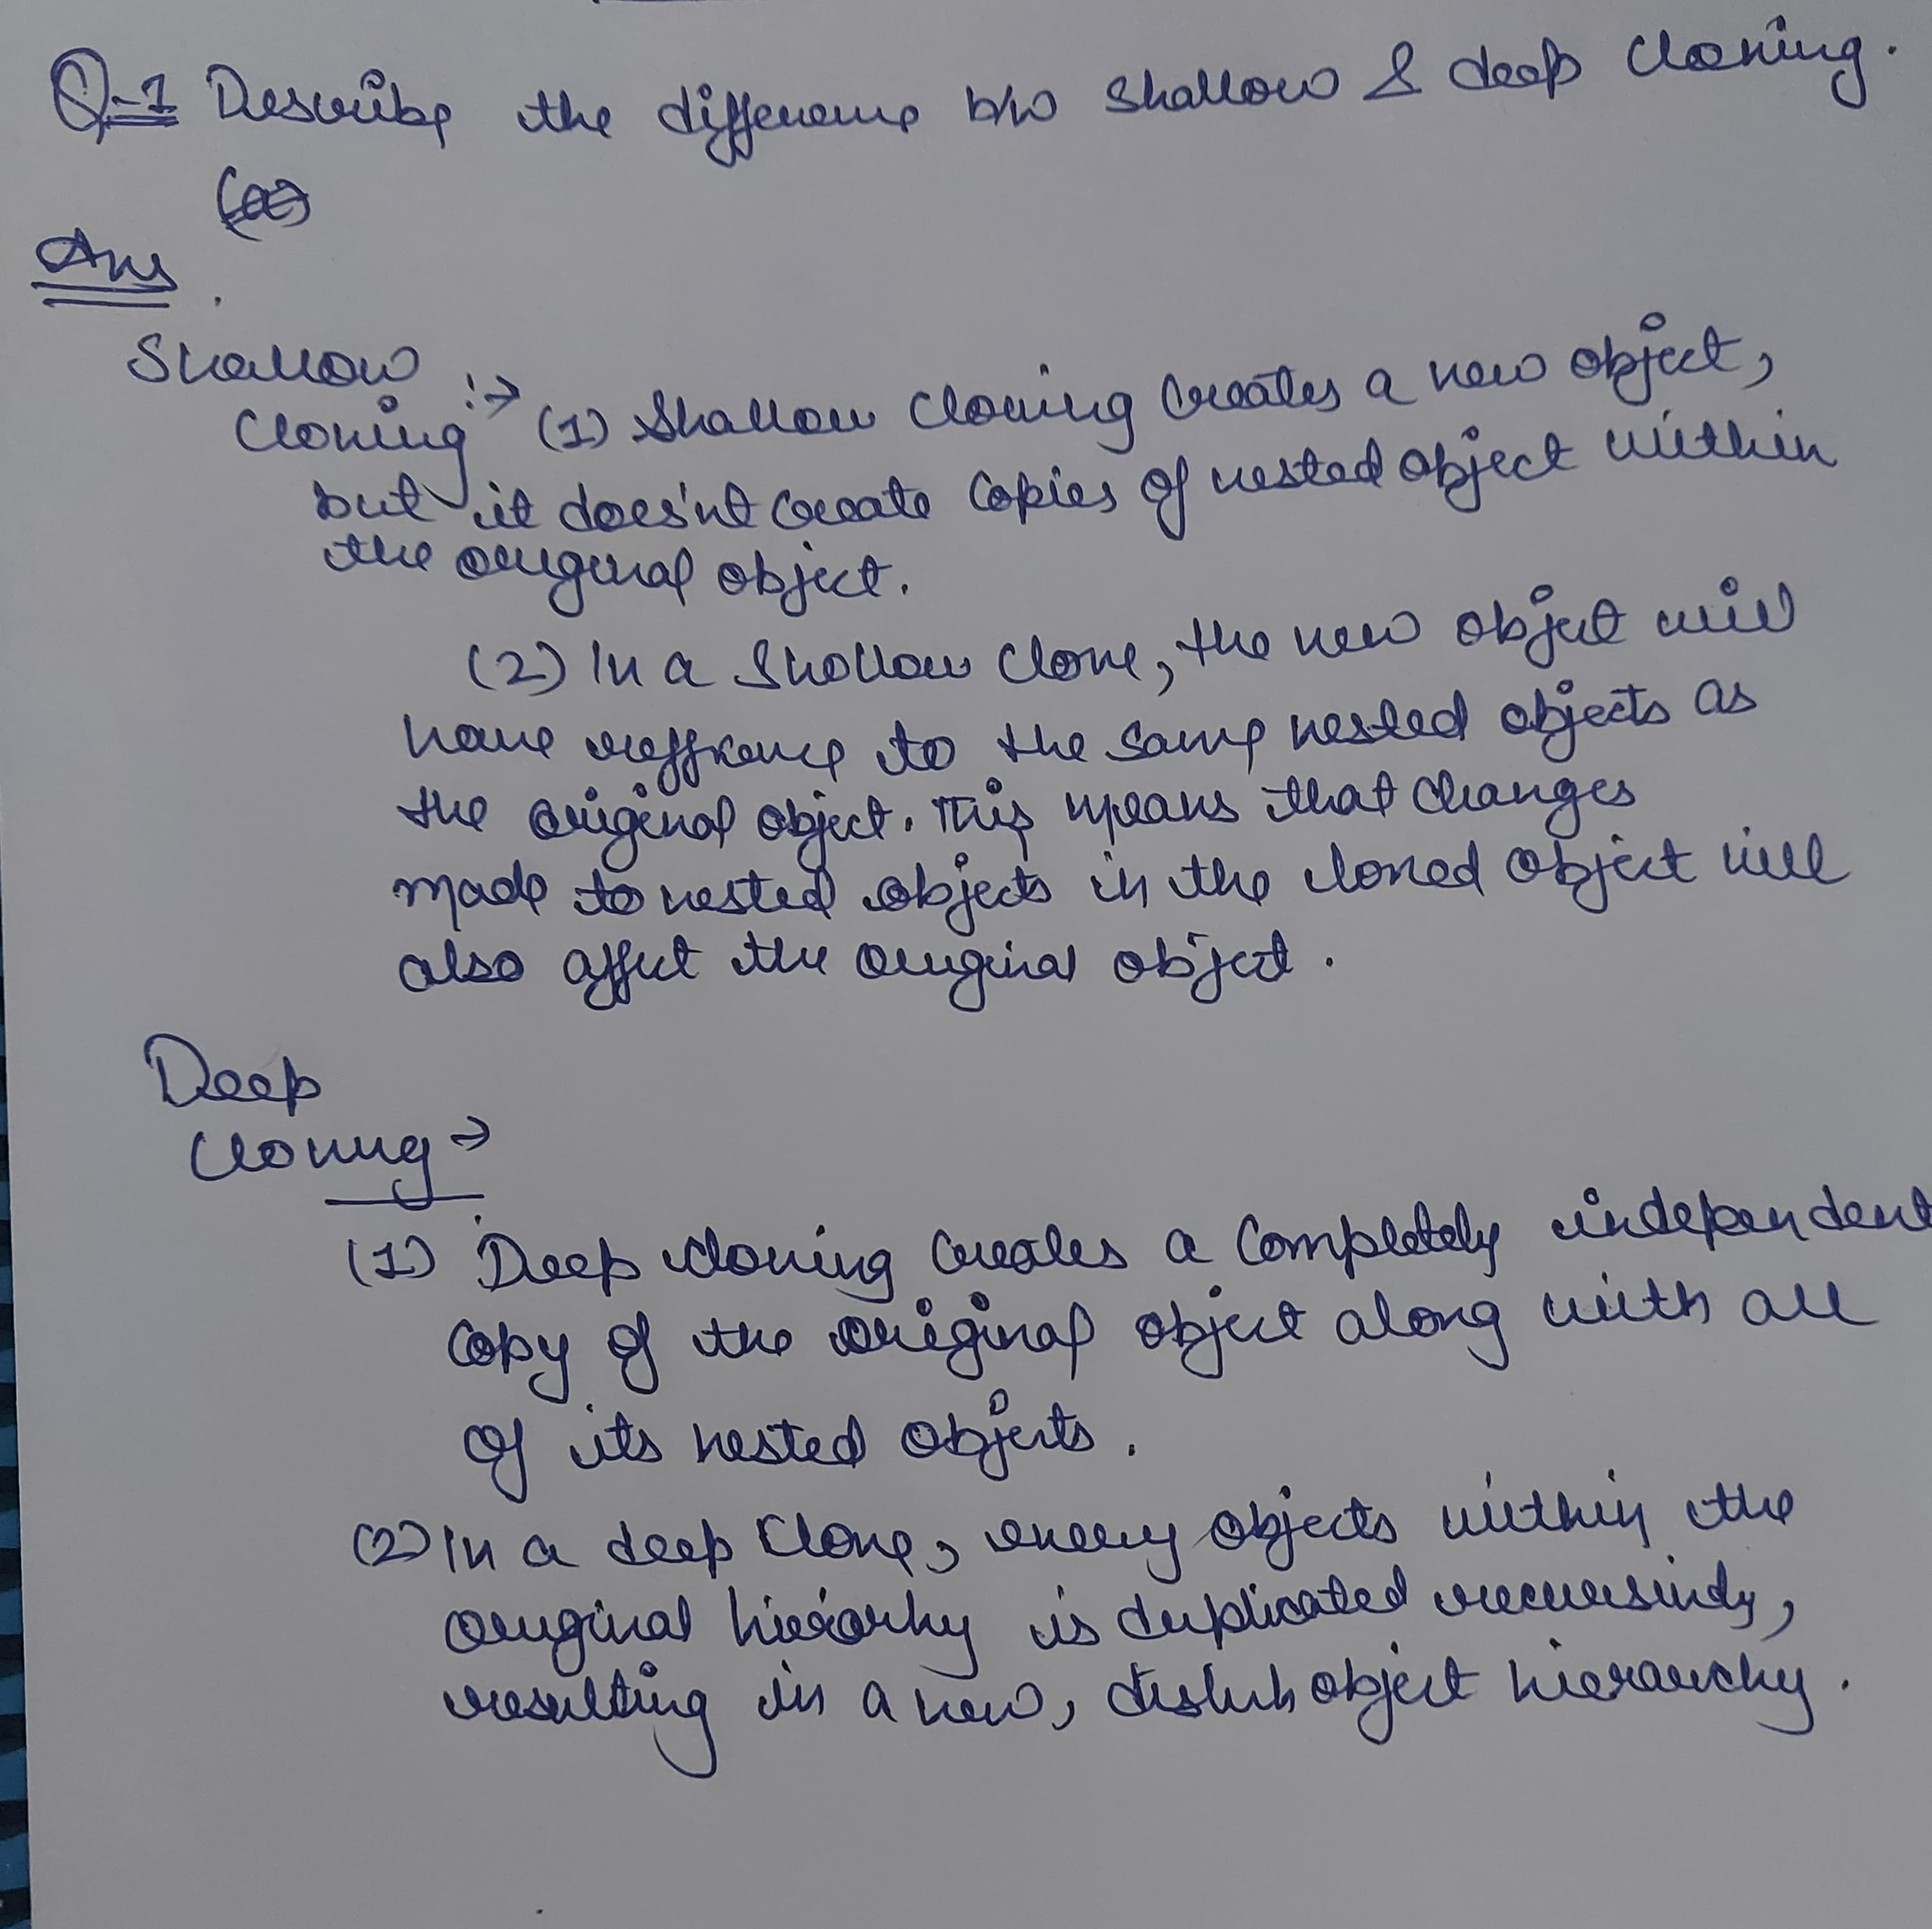

**Java code:**

import java.util.ArrayList;

import java.util.List;

class Person implements Cloneable {

    String name;

    List<String> hobbies;

    public Person(String name, List<String> hobbies) {

        this.name = name;

        this.hobbies = hobbies;

    }

    @Override

    protected Object clone() throws CloneNotSupportedException {

        // Deep copy

        Person clonedPerson = (Person) super.clone();

        clonedPerson.hobbies = new ArrayList<>(this.hobbies);

        return clonedPerson;

    }

}

public class HAssignment {

    public static void main(String[] args) throws CloneNotSupportedException {

        List<String> hobbies = new ArrayList<>();

        hobbies.add("Reading");

        hobbies.add("Swimming");

        Person person1 = new Person("Alice", hobbies);

        Person person2 = (Person) person1.clone();

        person2.hobbies.add("Painting");

        System.out.println("Output for shallow copy:");

        System.out.println("Person 1 Hobbies: " + person1.hobbies);

        System.out.println("Person 2 Hobbies: " + person2.hobbies);

        List<String> hobbiesCopy = new ArrayList<>(person1.hobbies);

        Person person3 = new Person("Bob", hobbiesCopy);

        person3.hobbies.add("Cooking");

        System.out.println("\nOutput for deep copy:");

        System.out.println("\nPerson 1 Hobbies: " + person1.hobbies);

        System.out.println("Person 3 Hobbies: " + person3.hobbies);

    }

}

**Screenshot of the output:**

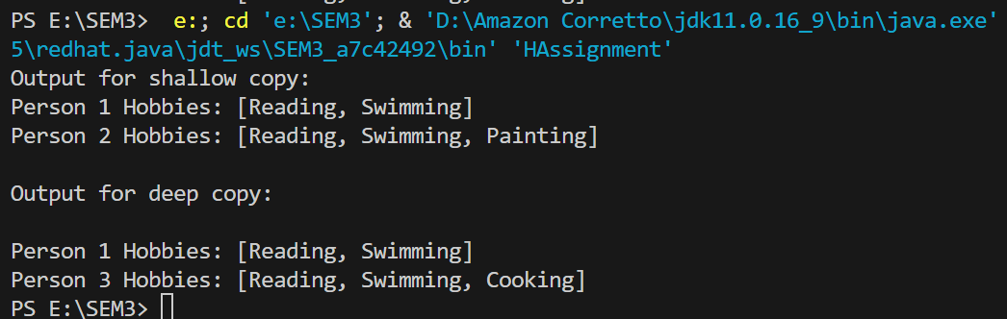

**Q-2)** *Describe the difference between static and final (5+5+5 marks)*

1. *Provide an example program implementing both.*
2. *Screenshots of the output.*

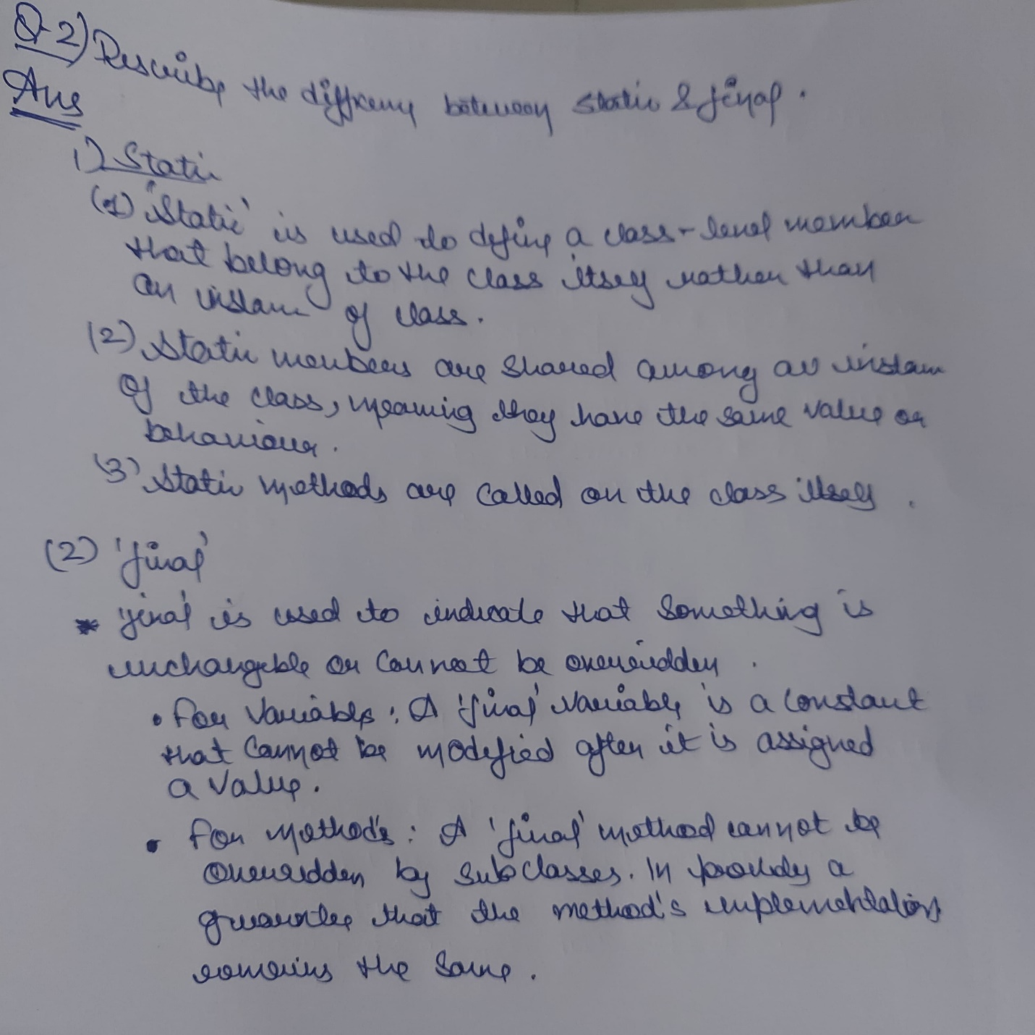

**Java Code:**

public class HAssignment1 {

    static int staticVariable = 10;

    final int finalVariable = 20;

    static void staticMethod() {

        System.out.println("This is a static method.");

    }

    final void finalMethod() {

        System.out.println("This is a final method.");

    }

    public static void main(String[] args) {

        System.out.println("Static Variable: " + HAssignment1.staticVariable);

        HAssignment1.staticMethod();

        HAssignment1 example = new HAssignment1();

        System.out.println("Final Variable: " + example.finalVariable);

        example.finalMethod();

        HAssignment1.staticVariable = 30;

        System.out.println("Modified Static Variable: " + HAssignment1.staticVariable);

        final int modifiedFinalVariable = 40;

        System.out.println("Modified Final Variable: " + modifiedFinalVariable);

    }

}

}

**Screenshot of the output:**

