Changes And Additions
- Directives.g4
  - Property Rule:
    - Added a new rule for property to define a property as an Identifier followed by an = and a value (text, number, or bool).
  - Number Ranges:
    - Introduced a new rule for numberRanges to allow multiple numberRange entries separated by commas.
    - Added a numberRange rule to define a range as two Number values separated by a : and followed by an = and a value.
  - Value Rule:
    - Added a value rule to support String, Number, Column, Bool, BYTE_SIZE, or TIME_DURATION.
  - Ecommand Rule:
    - Introduced a new rule for ecommand to define it as an exclamation mark (!) followed by an Identifier.
  - Config Rule:
    - Added a config rule to define it as an Identifier.
  - Column Rule:
    - Added a column rule to define it as a Column.
- Arguments.java
  - Added a new method:
    - Object valueOrDefault(String string, String string2);
This method allows retrieving a value associated with a given key (string) or returning a default value (string2) if the key does not exist.
- ByteSize.java(Class)
  - Parsing Byte Sizes:
    - Converts a string representation of a byte size (e.g., "10KB", "5MB") into its equivalent value in bytes.
    - Handles various units like B (bytes), KB (kilobytes), MB (megabytes), GB (gigabytes), TB (terabytes), and PB (petabytes).
  - Validation:
    - Ensures the input string contains both numeric and unit parts.
    - Throws an IllegalArgumentException for invalid formats or unsupported units.
  - Token Implementation:
    - Implements the Token interface, providing methods to retrieve the byte size value, type, and JSON representation.
  - Utility Methods:
    - getBytes(): Returns the parsed byte size as a long.
    - toJson(): Converts the byte size to a JSON element.
    - toString(): Returns the original raw value of the byte size.

- TimeDuration.java(Class)
  - Parsing Time Durations:
    - Converts string representations of time durations (e.g., "10ms", "5s", "2m", "1h") into their equivalent values in milliseconds.
    - Handles various time units such as ms (milliseconds), s (seconds), m (minutes), and h (hours).
  - Validation:
    - Ensures the input string is not null or empty.
    - Validates that the input string contains a valid numeric value and a recognized time unit.
    - Throws an IllegalArgumentException for invalid formats or unsupported units.
  - Token Implementation:
    - Implements the Token interface, providing methods to retrieve the duration value, type, and JSON representation.
  - Utility Methods:
    - getMilliseconds(): Returns the parsed duration in milliseconds.
    - toJson(): Converts the duration to a JSON element.
    - toString(): Returns the original raw value of the time duration.
- TokenType.java
  - BYTE_SIZE:
    - Represents a token type for byte sizes in formats like KB, MB, GB, or TB.
  - TIME_DURATION:
    - Represents a token type for time durations in formats like milliseconds, seconds, minutes, or hours.
- Aggregate Directives
  - Aggregation of Byte Sizes and Time Durations:
    - Aggregates values from specified columns for byte sizes and time durations.
    - Supports two aggregation types: total (sum of all values) and average (mean of all values).
  - Unit Conversion:
    - Converts byte sizes into units like bytes, KB, MB, GB, or TB.
    - Converts time durations into units like nanoseconds, milliseconds, seconds, or minutes.
  - Validation:
    - Validates the input size and time units to ensure they are supported.
    - Ensures the specified columns contain numeric values.
  - Customizable Output:
    - Allows specifying target columns for storing the aggregated results.
    - Provides flexibility in choosing the output units for size and time.
  - Error Handling:
    - Throws exceptions for invalid column data or unsupported units.

- ByteSize and Time Duration Test
  - Testing ByteSize Parsing:
    - Validates the conversion of human-readable byte size formats (e.g., "10KB", "1.5MB") into their equivalent values in bytes.
    - Covers edge cases such as zero byte size, uppercase unit letters, and very large sizes (e.g., petabytes).
    - Ensures proper handling of invalid formats and units by expecting exceptions.
  - Testing TimeDuration Parsing:
    - Validates the conversion of human-readable time duration formats (e.g., "5ms", "2.1s", "3m", "1h") into their equivalent values in milliseconds.
    - Covers edge cases such as zero duration, uppercase unit letters, and large durations (e.g., 1000 hours).
    - Ensures proper handling of invalid formats and units by expecting exceptions.

- RecipePipelineExecutor
  - Support for AggregateDirective:
    - Added logic to clear the results list when a directive produces a single aggregated row. This ensures that only the aggregated result is retained in the output.
  - Schema Management Enhancements:
    - Integrated schema management logic to track and update output schemas for each directive when schema management is enabled and an input schema is provided.
    - Added calls to DirectiveOutputSchemaGenerator to add new output fields based on the cumulative rows processed by each directive.

- MapArguments.java
  - Added a new method: valueOrDefault(String name, String defaultValue)
This method retrieves the value of a token by its name. If the token does not exist, it returns the provided default value. It currently supports tokens of type Text and throws an UnsupportedOperationException for unsupported token types.

- RecipteVisitor.java
  - Support for ByteSize and TimeDuration Tokens:
    - Added logic in the visitValue method to handle BYTE_SIZE and TIME_DURATION tokens.
    - These tokens are parsed and added to the RecipeSymbol.Builder as ByteSize and TimeDuration objects, respectively.
  - Enhanced Value Parsing:
    - Updated the visitValue method to throw an IllegalArgumentException for unknown value types, ensuring robust error handling.

- System Directive Registry
  - Added Support for AggregateDirective:
    - Included the namespace "io.cdap.wrangler.directives" in the list of namespaces scanned for directives.
    - This ensures that the AggregateDirective and other directives in the io.cdap.wrangler.directives package are automatically registered in the system directive registry.

- Aggregate Directive Unit Testing
  - testAggregateStats:
    - Tests the AggregateDirective for calculating the total size in MB and total time in seconds.
    - Validates the results for correctness (e.g., 15 MB and 7 seconds for the given input).
  - testAggregateStatsAverage:
    - Tests the AggregateDirective for calculating the average size in MB and average time in seconds.
    - Validates the results for correctness (e.g., 7.5 MB and 3.5 seconds for the given input).
- Added Tests for ByteSize Parsing:
  - testValidByteSizeParsing:
    - Validates correct parsing of valid byte size strings (e.g., "10kb", "1.5MB").
  - testInvalidByteSizeParsing:
    - Ensures an IllegalArgumentException is thrown for invalid byte size strings.
- Added Tests for TimeDuration Parsing:
  - testValidTimeDurationParsing:
    - Validates correct parsing of valid time duration strings (e.g., "5ms", "2.1s").
  - testInvalidTimeDurationParsing:
    - Ensures an IllegalArgumentException is thrown for invalid time duration strings.
- Added Recipe Tests with ByteSize and TimeDuration:
  - testRecipeWithByteSizeAndTimeDuration:
    - Tests a recipe that sets columns with byte size and time duration values.
- Added Tests for Invalid Aggregation:
  - testInvalidByteSizeInAggregate:
    - Ensures a RecipeException is thrown for invalid byte size units in aggregation.
  - testInvalidTimeDurationInAggregate:
    - Ensures a RecipeException is thrown for invalid time duration units in aggregation.
    - Includes additional assertions to validate the exception message for clarity and correctness.
- Added Tests for ByteSize Parsing:
  - testValidByteSizeInRecipe:
    - Validates the correct parsing of valid byte size strings (e.g., "10kb", "1.5MB") into their equivalent values in bytes.
  - testInvalidByteSizeInRecipe:
    - Ensures an IllegalArgumentException is thrown for invalid byte size strings.
- Added Tests for TimeDuration Parsing:
  - testValidTimeDurationInRecipe:
    - Validates the correct parsing of valid time duration strings (e.g., "5ms", "2.1s") into their equivalent values in milliseconds.
  - testInvalidTimeDurationInRecipe:
    - Ensures an IllegalArgumentException is thrown for invalid time duration strings.

Test Execution and Result
1. ByteSize Parsing Tests
- Valid Cases:
  - "10kb" → 10 KB = 10,240 bytes
  - "1.5MB" → 1.5 MB = 1,572,864 bytes
  - "2GB" → 2 GB = 2,147,483,648 bytes
  - "1TB" → 1 TB = 1,099,511,627,776 bytes
  - "0B" → 0 bytes (Zero byte size)
  - "100Kb" → 100 KB = 102,400 bytes (Uppercase 'K' case)
  - "1PB" → 1 PB = 1,125,899,906,842,624 bytes (Very large size)
- Invalid Cases:
  - "10abc" → Throws IllegalArgumentException (Invalid size format)
  - "1000ZZ" → Throws IllegalArgumentException (Invalid unit)


2. TimeDuration Parsing Tests
- Valid Cases:
  - "5ms" → 5 milliseconds
  - "2.1s" → 2.1 seconds = 2,100 milliseconds
  - "3m" → 3 minutes = 180,000 milliseconds
  - "1h" → 1 hour = 3,600,000 milliseconds
  - "0ms" → 0 milliseconds (Zero duration)
  - "0S" → 0 milliseconds (Zero duration with uppercase 'S')
  - "1000h" → 1,000 hours = 3,600,000,000 milliseconds (Large duration)
- Invalid Cases:
  - "5xyz" → Throws IllegalArgumentException (Invalid duration format)
  - "1000xyz" → Throws IllegalArgumentException (Invalid unit)

3. testAggregateStats
- Purpose: Validates the AggregateDirective for calculating the total size in MB and total time in seconds.
- Input:
  - Two rows with the following data:
    - Row 1: data_transfer_size = 10 MB, response_time = 5 seconds
    - Row 2: data_transfer_size = 5 MB, response_time = 2 seconds
- Recipe:
String[] recipe = new String[] {
"#pragma version 2.0;",
"aggregate :data_transfer_size :response_time :total_size_mb :total_time_sec \"MB\" \"seconds\" \"total\""
};

4. testAggregateStatsAverage
- Purpose: Validates the AggregateDirective for calculating the average size in MB and average time in seconds.
- Input:
  - Two rows with the following data:
    - Row 1: data_transfer_size = 10 MB, response_time = 5 seconds
    - Row 2: data_transfer_size = 5 MB, response_time = 2 seconds
- Recipe:
String[] recipeAverage = new String[] {
"#pragma version 2.0;",
"aggregate :data_transfer_size :response_time :avg_size_mb :avg_time_sec \"MB\" \"seconds\" \"average\""
};

- Tests for ByteSize Parsing:
  - testValidByteSizeParsing:
    - Validates the correct parsing of valid byte size strings (e.g., "10kb", "1.5MB") into their equivalent values in bytes.
  - testInvalidByteSizeParsing:
    - Ensures an IllegalArgumentException is thrown for invalid byte size strings.
- Tests for TimeDuration Parsing:
  - testValidTimeDurationParsing:
    - Validates the correct parsing of valid time duration strings (e.g., "5ms", "2.1s") into their equivalent values in milliseconds.
  - testInvalidTimeDurationParsing:
    - Ensures an IllegalArgumentException is thrown for invalid time duration strings.
- Recipe Tests with ByteSize and TimeDuration:
  - testRecipeWithByteSizeAndTimeDuration:
    - Tests a recipe that sets columns with byte size and time duration values.
- Tests for Invalid Aggregation:
  - testInvalidByteSizeInAggregate:
    - Ensures a RecipeException is thrown for invalid byte size units in aggregation.
  - testInvalidTimeDurationInAggregate:
    - Ensures a RecipeException is thrown for invalid time duration units in aggregation.
    - Includes additional assertions to validate the exception message for clarity and correctness.
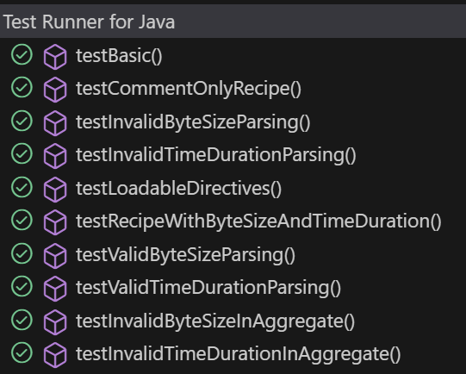
Successful Builds

- mvn clean install -pl wrangler-api -am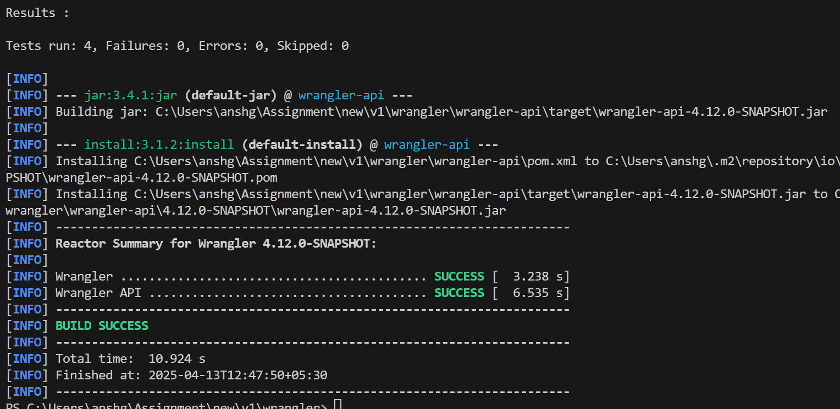
- mvn compile
