WEEK 03 / MACHINE LEARNING

Building and Tuning an AI Model
  - Breast tumour classification using a support vector machine
Technical report | Public dataset | Reproducible experiment
99.12%  Test accuracy | 97.62%  Malignant recall | 98.80%  Malignant F1
Educational model only — not validated for clinical diagnosis or patient-care decisions.

Executive summary
This project develops and evaluates a binary classifier for the Wisconsin Diagnostic Breast Cancer dataset. The task is to distinguish malignant from benign breast-mass cases using 30 numerical measurements derived from cell-nucleus images. A support vector classifier (SVC) was selected because it is suitable for a modest-sized, high-dimensional dataset and can model both linear and nonlinear decision boundaries. The study deliberately treats malignant as the positive class so that precision, recall and F1 address the more safety-sensitive outcome. [1, 2]
The 569 cases were divided into 455 training cases and 114 untouched test cases using a stratified 80/20 split. Standardization was placed inside a pipeline, and a five-fold stratified grid search compared 50 configurations using malignant F1. The selected radial basis function model used C=10, gamma=0.01 and balanced class weights. On the held-out test set it achieved 99.12% accuracy, 100.00% malignant precision, 97.62% malignant recall and 98.80% malignant F1. The confusion matrix contained one false negative and no false positives. These results are encouraging for this particular educational experiment, but neither the small sample nor a single split establishes clinical readiness.

1. Problem definition and data
The predictive problem is supervised binary classification: given measurements calculated from a digitized fine-needle aspirate image, predict whether the associated breast mass is malignant or benign. The copy distributed with scikit-learn contains 569 records, 30 numeric predictors and no missing feature values. The predictors summarize 10 characteristics of cell nuclei, including radius, texture, perimeter, area, smoothness and concavity; the mean, standard error and worst-value summaries produce the 30 columns. They are image-derived measurements, not direct patient histories. The dataset is publicly available through the UCI Machine Learning Repository. [1, 2]
The complete data contain 357 benign and 212 malignant cases, making malignant the minority class. Scikit-learn originally encodes malignant as 0 and benign as 1. The script intentionally reverses that mapping: benign becomes 0 and malignant becomes 1. This is an important implementation detail because the default binary precision, recall and F1 scorers then evaluate malignant cases. Without the reversal, a seemingly good recall could refer to benign rather than malignant cases. The dataset does not require downloading a separate file because scikit-learn includes a local copy.
Partition | Benign (0) | Malignant (1) | Total
All records | 357 | 212 | 569
Training | 285 | 170 | 455
Held-out test | 72 | 42 | 114

The test set contains a 36.84% malignant share, close to the full dataset's 37.26%, because the split is stratified. A hypothetical all-benign classifier would be correct on 72 of the 114 test records, or 63.16%, but would identify no malignant cases. This example shows why overall accuracy alone is insufficient for this task. The model is evaluated as an educational pattern-recognition exercise, not as a replacement for a qualified clinician.

2. Algorithm selection and rationale
A support vector machine seeks a decision boundary that separates classes with a large margin while allowing violations through soft-margin penalties. The scikit-learn SVC implementation provides both linear and kernel-based boundaries. A linear kernel supplies a comparatively simple reference, while the radial basis function (RBF) kernel can represent curved boundaries when the relationship between nuclear measurements and the class is not linearly separable. Its C parameter controls the penalty for margin violations; a larger C can fit the training data more closely, while a smaller C generally imposes stronger regularization. [3]
For an RBF SVC, gamma controls how locally each training example influences the decision surface. Very large gamma can produce an overly intricate boundary, whereas a small value can make the boundary too smooth. Feature scale matters because both margin and kernel distances depend on numerical magnitudes; therefore, standardization is a required part of this model rather than a cosmetic step. SVC is a reasonable choice for 569 observations and 30 continuous features, although this experiment does not prove it is the best possible algorithm for the dataset.
A single decision tree would be easier to inspect, but its splits can be unstable and may require pruning. A neural network could capture complex relationships, but tuning a larger network on only 455 training cases could introduce unnecessary variance and computational work. Logistic regression would be a useful transparent comparator in future work. These alternatives were considered as design trade-offs; they were not experimentally benchmarked here, so no comparative performance claim is made. An RBF SVM also has limited direct interpretability, which is especially important in a healthcare-related problem.

3. Data preparation and leakage control
First, the script loads the bundled dataset and verifies that all feature values are finite. Because the checked dataset contains no missing features, no imputation is fitted. It then performs a stratified train/test split with test_size=0.20 and random_state=42. Stratification preserves the class proportions approximately, and the fixed seed makes this specific partition reproducible. All later model selection uses only the 455 training cases; the 114 test records are set aside until the best configuration has been chosen and refitted.
StandardScaler and SVC are combined in a scikit-learn Pipeline. Within each cross-validation fold the scaler learns means and standard deviations from that fold's training portion only, then transforms its corresponding validation portion using those same parameters. After tuning, a new scaler and SVC are fitted on all 455 training cases. This design prevents validation or test statistics from leaking into training. Scaling the entire dataset before splitting would allow information about the held-out distribution into the model and could make its evaluation misleading. [4]
No feature selection, oversampling or threshold adjustment is performed. This keeps the workflow compact and avoids introducing additional choices that would also have to be learned within cross-validation. The SVC's ordinary decision threshold is zero on its decision-function scale; the decision score is not a calibrated probability. If missing data appeared in another dataset, an appropriate imputer would likewise need to be included inside the pipeline rather than fitted before the split.

4. Training and hyperparameter tuning
The training portion is evaluated with StratifiedKFold using five folds, shuffling and seed 42. Each fold has 91 validation cases, including 34 malignant and 57 benign cases; the other 364 cases train the fold's model. As a reference, the default SVC (RBF kernel, C=1, gamma='scale', no class weighting), with the same scaling pipeline and folds, achieves a mean malignant F1 of 0.9610 with a fold standard deviation of 0.0082. This is a training cross-validation result, not a test-set result.
GridSearchCV then evaluates 50 predefined configurations using mean malignant F1 across the same five training folds. The linear grid combines five C values with two class-weight options, resulting in 10 candidates. The RBF grid combines those C and weight options with four gamma settings, resulting in 40 candidates. That is 250 fold-specific grid fits, followed by one refit of the selected pipeline on all training data; the separate default baseline requires five additional fits. The single-process setting avoids unnecessary parallel-worker overhead on this small dataset. [5]
Kernel | C values | Gamma values | Class weight | Count
Linear | 0.01, 0.1, 1, 10, 100 | Not applicable | None; balanced | 10
RBF | 0.01, 0.1, 1, 10, 100 | scale; 0.001; 0.01; 0.1 | None; balanced | 40

The 'scale' gamma setting is calculated by SVC from the number of features and the variance of the data received by that fit. The balanced option adjusts class-specific penalties inversely to the observed class frequencies in each training fold; it does not create new records. This allows the search to consider whether a larger penalty for mistakes on the minority malignant class improves F1. F1 was chosen to balance malignant precision and recall, although a safety-critical deployment would need an explicitly justified clinical objective rather than this educational optimization target.
The best setting was RBF, C=10, gamma=0.01 and class_weight='balanced'. Its selected mean validation F1 was 0.9730, with fold standard deviation 0.0116. This is about 1.20 percentage points above the default model's mean on the same folds. However, the winning value was selected from 50 candidates using those folds, so it can be optimistic; the increase is not a statistical significance claim. The held-out test set is reserved for assessing the selected model rather than deciding the hyperparameters.
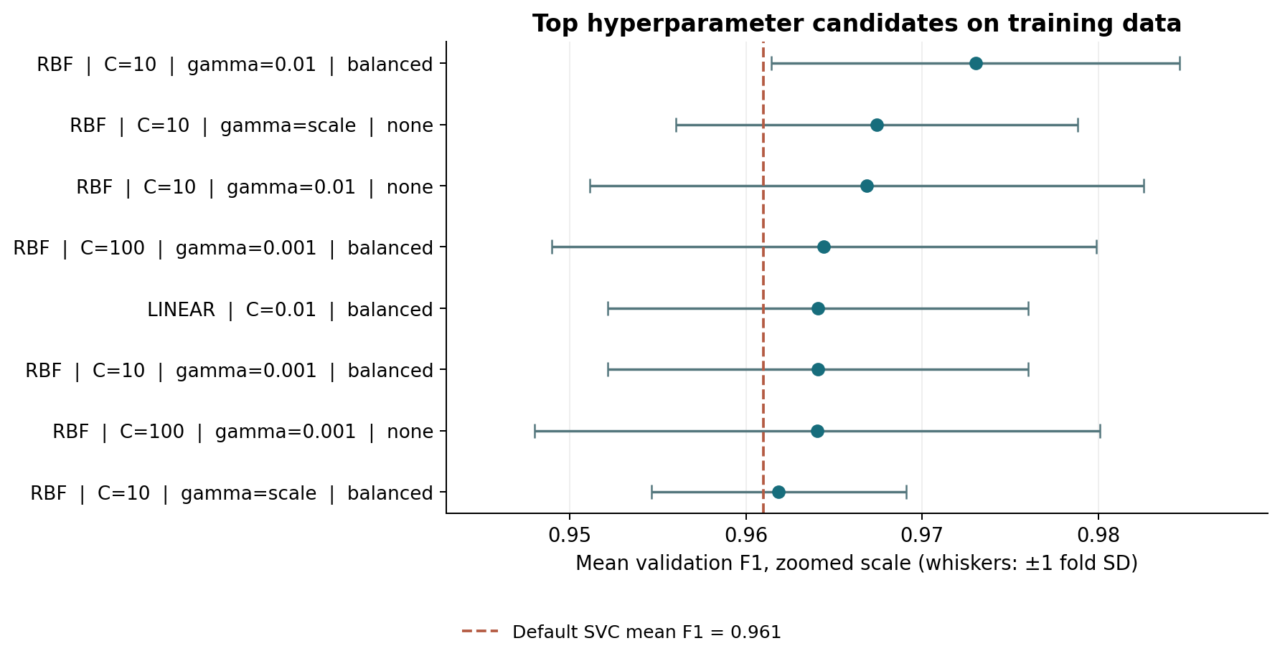
Figure 1. Top candidates on training data. Points are mean validation F1; whiskers show ±1 fold standard deviation, not confidence intervals. The F1 axis is zoomed.

5. Evaluation design and metrics
After the search, the winning pipeline is refitted using the complete training portion. Its predictions are then evaluated on the previously untouched test portion. In the confusion matrix, true positives (TP) are malignant cases correctly predicted malignant; false negatives (FN) are malignant cases predicted benign. True negatives (TN) are benign cases correctly predicted benign; false positives (FP) are benign cases predicted malignant. Rows represent actual classes and columns represent predicted classes.
Accuracy is (TP + TN) / (TP + TN + FP + FN), the fraction of all cases classified correctly. Malignant precision is TP / (TP + FP): among predicted malignant cases, how many are actually malignant? Malignant recall, also called sensitivity, is TP / (TP + FN): among malignant cases, how many are detected? F1 is the harmonic mean 2 × precision × recall / (precision + recall). Specificity is TN / (TN + FP), and balanced accuracy is the mean of sensitivity and specificity. These metrics describe different failure modes and are reported together.
The receiver operating characteristic (ROC) curve plots sensitivity against the false-positive rate at different decision-score thresholds. ROC AUC summarizes how well those scores rank positive cases above negative cases across thresholds; it is not the accuracy at a single threshold. The code obtains this continuous score from decision_function, not from predicted class labels, and does not claim that the scores are calibrated probabilities. No threshold is chosen by inspecting the held-out test set. [6]

6. Results and interpretation
Held-out metric | Result | Interpretation
Accuracy | 99.12% | 113 correct predictions out of 114
Malignant precision | 100.00% | 41 true malignant cases among 41 predicted malignant
Malignant recall | 97.62% | 41 of 42 malignant cases detected
Malignant F1 | 98.80% | Harmonic mean of malignant precision and recall
Benign specificity | 100.00% | 72 of 72 benign cases identified as benign
Balanced accuracy | 98.81% | Average of malignant recall and benign specificity
ROC AUC | 0.9970 | Ranking of malignant versus benign decision scores

For the selected model, the test confusion matrix is TN=72, FP=0, FN=1 and TP=41. The one false negative is a malignant case classified as benign, which illustrates why the errors should not be hidden behind a high overall accuracy. There were no false positives in this sample, so all 41 predicted-malignant cases were malignant. These statements apply only to this holdout and do not imply that the real-world false-positive rate is zero.
The ROC AUC is 0.9970, indicating strong ranking performance on these test cases. Nevertheless, there are only 42 malignant examples in the test set; changing one malignant result changes recall by about 2.38 percentage points. A simple approximate 95% Wilson binomial interval for malignant recall is 87.68% to 99.58%, conditional on its assumptions. This interval does not fix selection bias, non-independence, population shift or the absence of external validation, and it should not be read as a clinical performance guarantee.
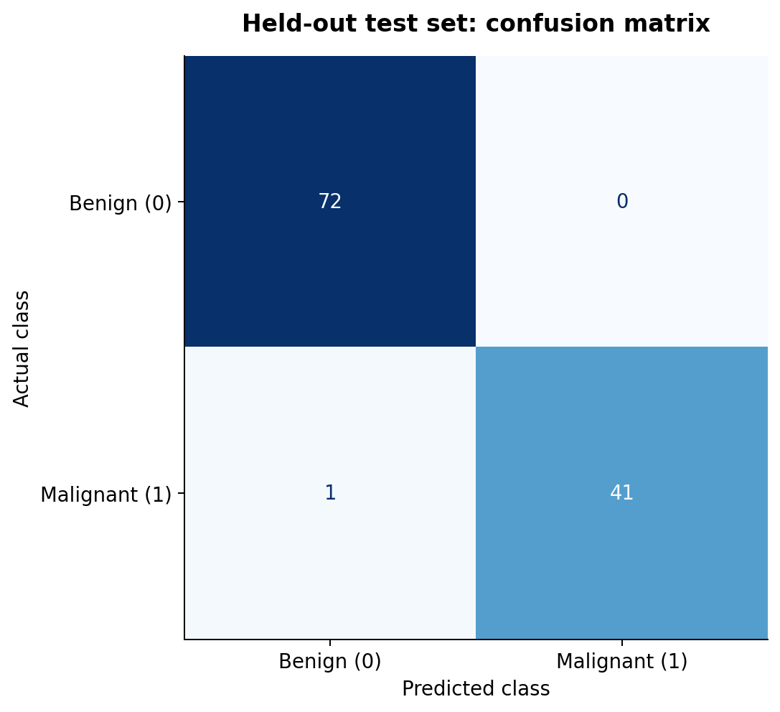
Figure 2. Confusion matrix for the 114 held-out records. Malignant is the positive class (1).
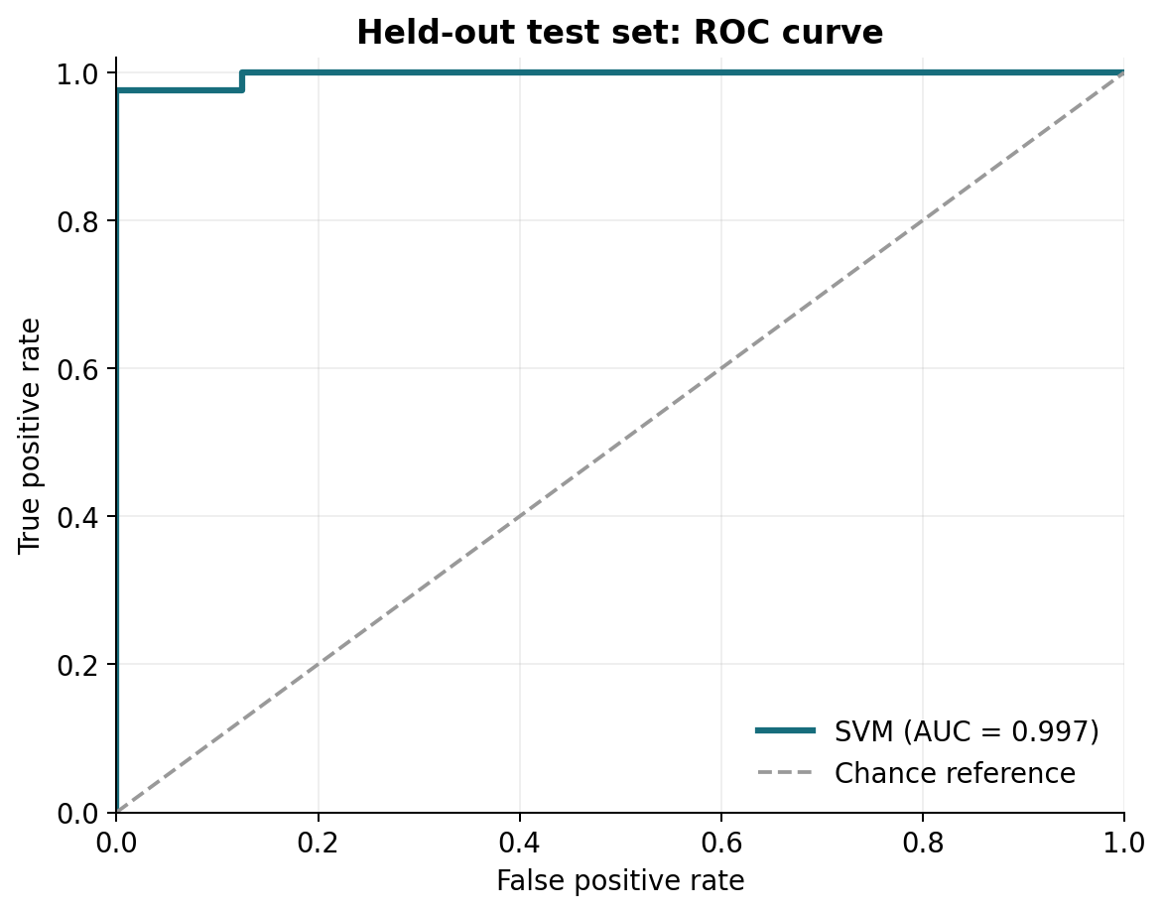
Figure 3. Held-out ROC curve using the SVC decision score. The dashed diagonal is a chance-ranking reference.

7. Tuning challenges and what the results show
The most useful tuning challenge was balancing fit against generalization. For the selected candidate, mean training-fold F1 was 0.9844, compared with mean validation F1 of 0.9730, a gap of approximately 1.13 percentage points. Training scores are normally optimistic because those observations are used to fit the model, so the gap is a diagnostic rather than proof of deployment performance. The fold standard deviation of 0.0116 also demonstrates that scores vary with the validation partition.
More flexible settings did not consistently improve validation performance. For example, the RBF configuration with C=100, gamma='scale' and no class weighting achieved mean training-fold F1 of 1.0000 but mean validation F1 of 0.9532. Its larger train–validation gap is consistent with overfitting on these folds. At the other extreme, the RBF setting C=0.01, gamma='scale' and no class weighting produced mean validation F1 of 0.0000, meaning no malignant true positives were obtained in its validation folds. These observed outcomes show why blindly maximizing C or assuming a default value is optimal would be poor tuning strategies.
The comparison between the selected candidate and the default uses the same training folds, which is useful for a consistent reference. However, it does not remove selection bias: the candidate with the highest cross-validation score is chosen after many comparisons. The test metrics describe only the selected model, not a head-to-head test against every candidate. No baseline test score was computed, and the study does not establish that the observed tuning gain would persist on another sample. Full candidate scores are exported to cv_results.csv for inspection.

8. Limitations, ethics and future improvements
The dataset is relatively small and historical, and the experiment uses one random split from one source. A favorable result can reflect the characteristics of that particular collection or split. The records do not provide sufficient demographic, site or acquisition information in the model features to assess fairness across populations or reliably design a grouped hospital-level split. A repeatable internal split is useful for engineering, but it is not a substitute for prospectively collected, independently sourced cases. Correlation among the 30 image measurements and the limited interpretability of an RBF SVM also complicate explanations of individual decisions.
False negatives and false positives have different consequences. F1 is a convenient symmetric summary of precision and recall, not a clinical utility function; even one missed malignant case matters in the confusion matrix. Any real clinical proposal would require predefined sensitivity and specificity targets, review of errors by domain experts, calibrated probabilities if risk estimates are needed, appropriate consent and privacy protections, and regulatory and workflow assessment. This model must not be used to diagnose patients or make treatment decisions.
A stronger evaluation would use repeated or nested cross-validation on training data, evaluate multiple algorithms under the same leakage-safe protocol, and then confirm the final prespecified approach on a truly independent external test cohort. Where identifiers or site and time information are available, grouping or temporal splitting should prevent related observations from crossing partitions. Uncertainty intervals, subgroup analysis, probability calibration and sensitivity to dataset shift should be assessed before considering deployment. Any decision threshold or cost-sensitive objective must be chosen using training/validation data, not the final test set.

9. Reproducibility and code walkthrough
The accompanying single Python file implements the complete workflow: load and relabel the public data; split it; construct the scaling/SVC pipeline; cross-validate a default baseline; search the hyperparameter grid; refit the best pipeline; evaluate the held-out test set; and write machine-readable metrics, candidate scores and visualizations. Comments identify the purpose of each segment and explain the label encoding, leakage controls, threshold and plot interpretation. No input data file is required. The experiment below was executed twice and produced identical model parameters and metric values under the recorded environment.
python -m pip install numpy scikit-learn matplotlib
python week3_svm_model.py --output-dir results
The output directory contains metrics.json, cv_results.csv, confusion_matrix.png, roc_curve.png and cv_top_candidates.png. metrics.json records the class counts, split, search configuration, selected parameters, confusion counts and library versions; cv_results.csv contains all 50 settings with mean training and validation F1, fold variability and fit time. The recorded environment used Python 3.13.16, NumPy 2.3.5, scikit-learn 1.6.1 and Matplotlib 3.10.9. Fixed seeds make the procedure reproducible, though results can change with library versions or numerical environments.

10. Conclusion
A leakage-safe SVC pipeline, systematically tuned on training folds, produced strong discrimination on one held-out portion of a public dataset. The observed test accuracy was 99.12%, and malignant recall was 97.62%; importantly, the classifier missed one of the 42 malignant cases. The experiment demonstrates how scaling, stratification, explicit class encoding, cross-validation, hyperparameter search and complementary metrics work together. Its main lesson is methodological: strong single-split results should be documented alongside error counts, uncertainty and limitations rather than being treated as evidence of clinical readiness.

References
[1] Wolberg, W., Mangasarian, O., Street, N. and Street, W. Breast Cancer Wisconsin (Diagnostic) [dataset]. UCI Machine Learning Repository, 1995. https://doi.org/10.24432/C5DW2B. Dataset licence: CC BY 4.0.
[2] scikit-learn developers. load_breast_cancer: Breast cancer Wisconsin diagnostic dataset. https://scikit-learn.org/stable/modules/generated/sklearn.datasets.load_breast_cancer.html
[3] scikit-learn developers. SVC: Support vector classification. https://scikit-learn.org/stable/modules/generated/sklearn.svm.SVC.html
[4] scikit-learn developers. Pipeline: sequentially apply transforms and a final estimator. https://scikit-learn.org/stable/modules/generated/sklearn.pipeline.Pipeline.html
[5] scikit-learn developers. GridSearchCV: exhaustive search over specified parameter values. https://scikit-learn.org/stable/modules/generated/sklearn.model_selection.GridSearchCV.html
[6] scikit-learn developers. Model evaluation: scoring and metrics. https://scikit-learn.org/stable/modules/model_evaluation.html

