What we/I have done:

{Programming : “Zeph”, “Interpretation” : [“Zeph”, “Dennis”, [insert name here]], “Slide_prod” : [insert namelist], “Slide_prez”: [insert namelist -> !Zeph]}

1. Motivation
   1. Try to find a dataset that has large datapoint space, and with variety of data variables.
   2. Try to find a dataset that is appropriate[Game sales, Azur Lane group formation]. This needs to be approved by the teaching set, so we decided to just use the preset ones provided in the project paper, to save time and because I do not want to talk to people.
   3. We chose Sales first, since one of our groupmates has an interest in that. But we quickly determined that it is not enough for us. Especially upon doing data analysis between the variables. The results will be incredibly mundane.
   4. The next choice after that is Cardiovascular Disease. Lots of datapoints(>10000) and lots of variables. And hence we stuck with it.
2. Data collection :: Direct from Kaggle

#https://www.kaggle.com/code/bhargavi35/starter-cardiovascular-disease-dataset-d2fc2521-9

* 1. Data has quite a bit of anomalies, it is not the best dataset. It has 70,000 datapoints before trimming.
  2. Download data into workspace.
  3. Comma-Separated File(CSV), where the values are actually comma separated(ex. 34;54;180;…). Hence, I needed to get rid of the ; delimiters. Fortunately, this is very easy to do due to Pandas.
  4. Import data into Jupyter Notebook(I use vscode because I do not like localhost_website) using Pandas’ read_csv method. Do datapull.read(n = some x) for reading x values to double check successful porting.

1. Data preparation I
   1. I do info(), and most importantly value_counts() for numericals to see what we are dealing with.
   2. I assume we look at cardiovascular disease first, since this is what the data was for originally. Also, I don’t care about anything else.
   3. There is an ID column. I do some selective(I used iterated primes(2 * 2, 3 * 5, 7 * 11, 13 * (next p),…, (p_n * p_n+1)..) because I have that function on hand) and see that ID is literally patient ID and has no bearing on probability of having cardiovascular disease. Makes sense in real life too. So, I throw it away.
   4. Next, I translate [0, 1] ranged data to binaries, to prevent downstream clashes with the math.
   5. Next, I standardise ‘age’ and ‘height’ to proper values of years and meter/res.
   6. Using the guide from the Kaggle page, I map [1, 2] for gender to proper gender terms [‘male’, ‘female’], then map [1, 2, 3] to the relevant states [‘norm’, ‘abvnorm’ , ‘wellabvnorm’]. Again, make my life easier, and be more clearer in data presentation for me and to the viewer. Tier I data preparation is now ready.
2. Data analysis I
   1. I start with categorical variables first.
   2. Info(), describe() whatnot. Get a basic feel of the categorical data first.
   3. Do your favourite catplot.
   4. Plot one against another with heatmap to see what influences what. You see some very generic and obvious trends.

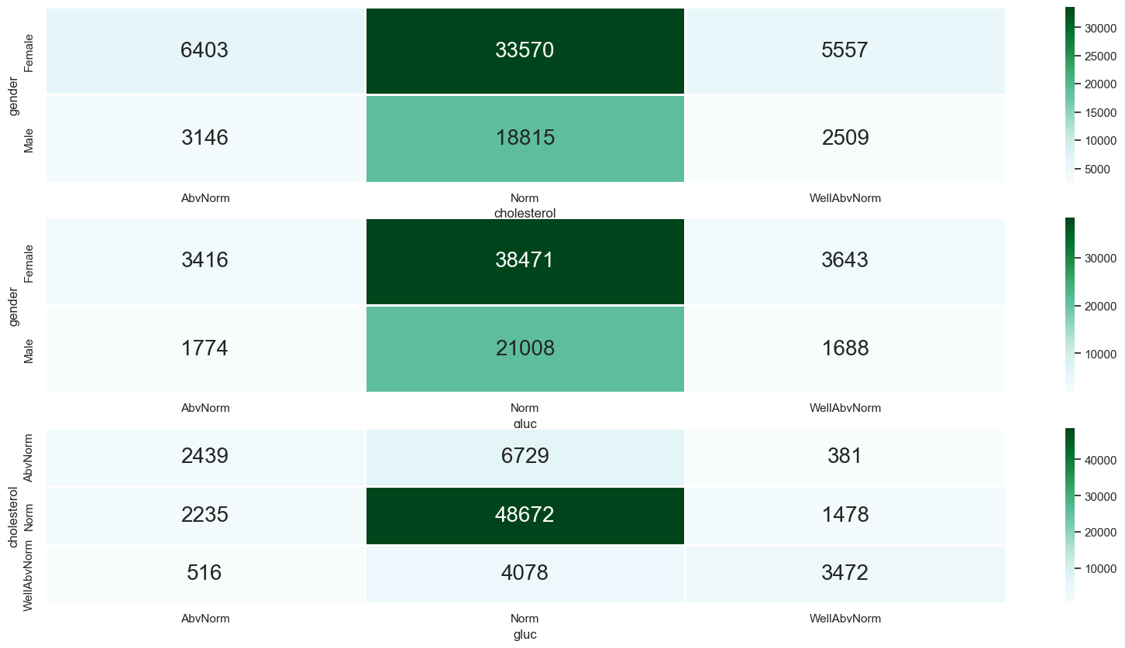

* 1. Then I deal with the True/False stuff. Here, I get a feel of how much proportion of the dataspace is True and False for each binary variable there is.

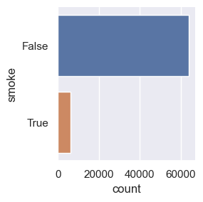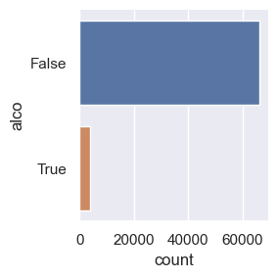

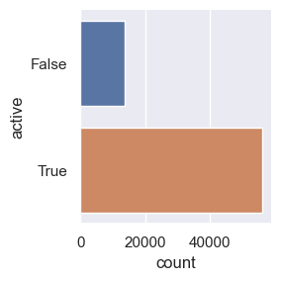

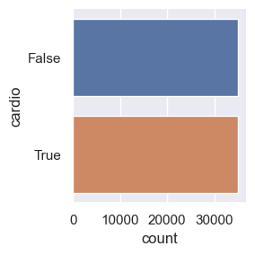

* 1. Here we see that relatively small percentage of people smoke and drink alcohol. A large proportion of people exercise. But cardio seems to be distributed 50-50 among the test subjects. This tells me that either (a) I messed up on data analysis[high probability], (b) The datapoints on binary variables is not enough(for example, “what do they mean by ‘being active?’”), or (c) Those three variables do not contribute to cardio probability, in which case I will throw it away.

1. Data preparation II
   1. [[Out of project exploration, ignore. What:: class structure investigation, do some more slicing of data with deleted functions and investigations], convert binaries to 0 or 100, preparation for <? extends <?>>]
   2. Next, I pull out numericals(age, height, weight, ap_hi and ap_lo) and combine them with the ‘cardio’ [0 or 100] series, in preparation for seeing how the two relate. I ignore the categoricals.
   3. Running tentative data analysis revealed a massive issue with ap_hi and ap_lo. They range from [-11000, 16000] over. Given ap_hi and ap_lo represents systolic and diastolic blood pressures respectively, this data range does not make sense. I double check by printing individual value_counts() to a txt file and confirm the completely absurd values.
   4. I then filter out rows with absurd values, throwing away a total of over 1.3K datapoints. But that is no matter, I have over 68.5K datapoints left. Now, learning my lesson, I ran value_counts() for every variable, and determine that alles fehr gut.
2. Data analysis II
   1. Now I do plotting of the boxplot, histplot and violinplot. Some data are not continuous, but that is expected.

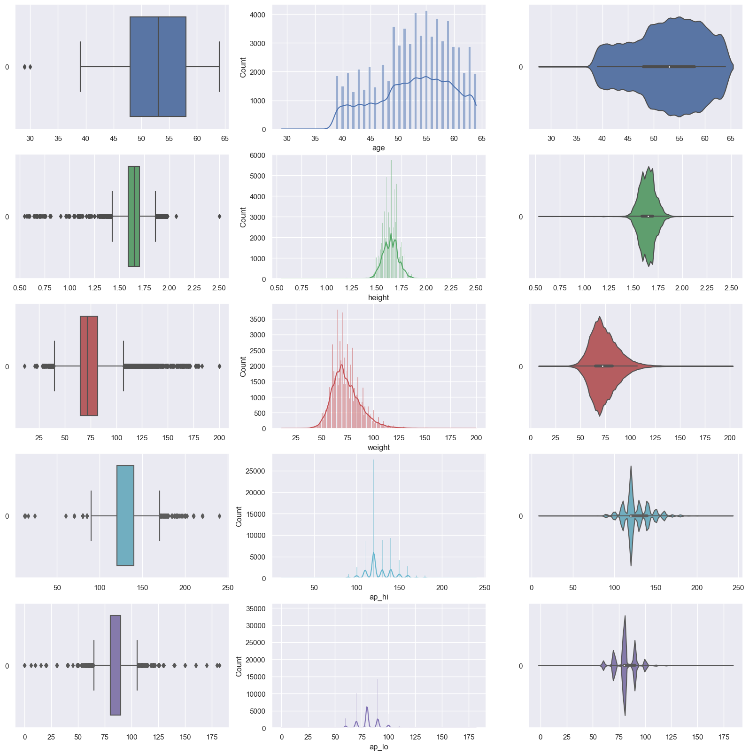

* 1. For now, this is how the distribution would look like.
  2. I split the individual numericals to False/True cardiovascular disease groups and do a boxplot again.

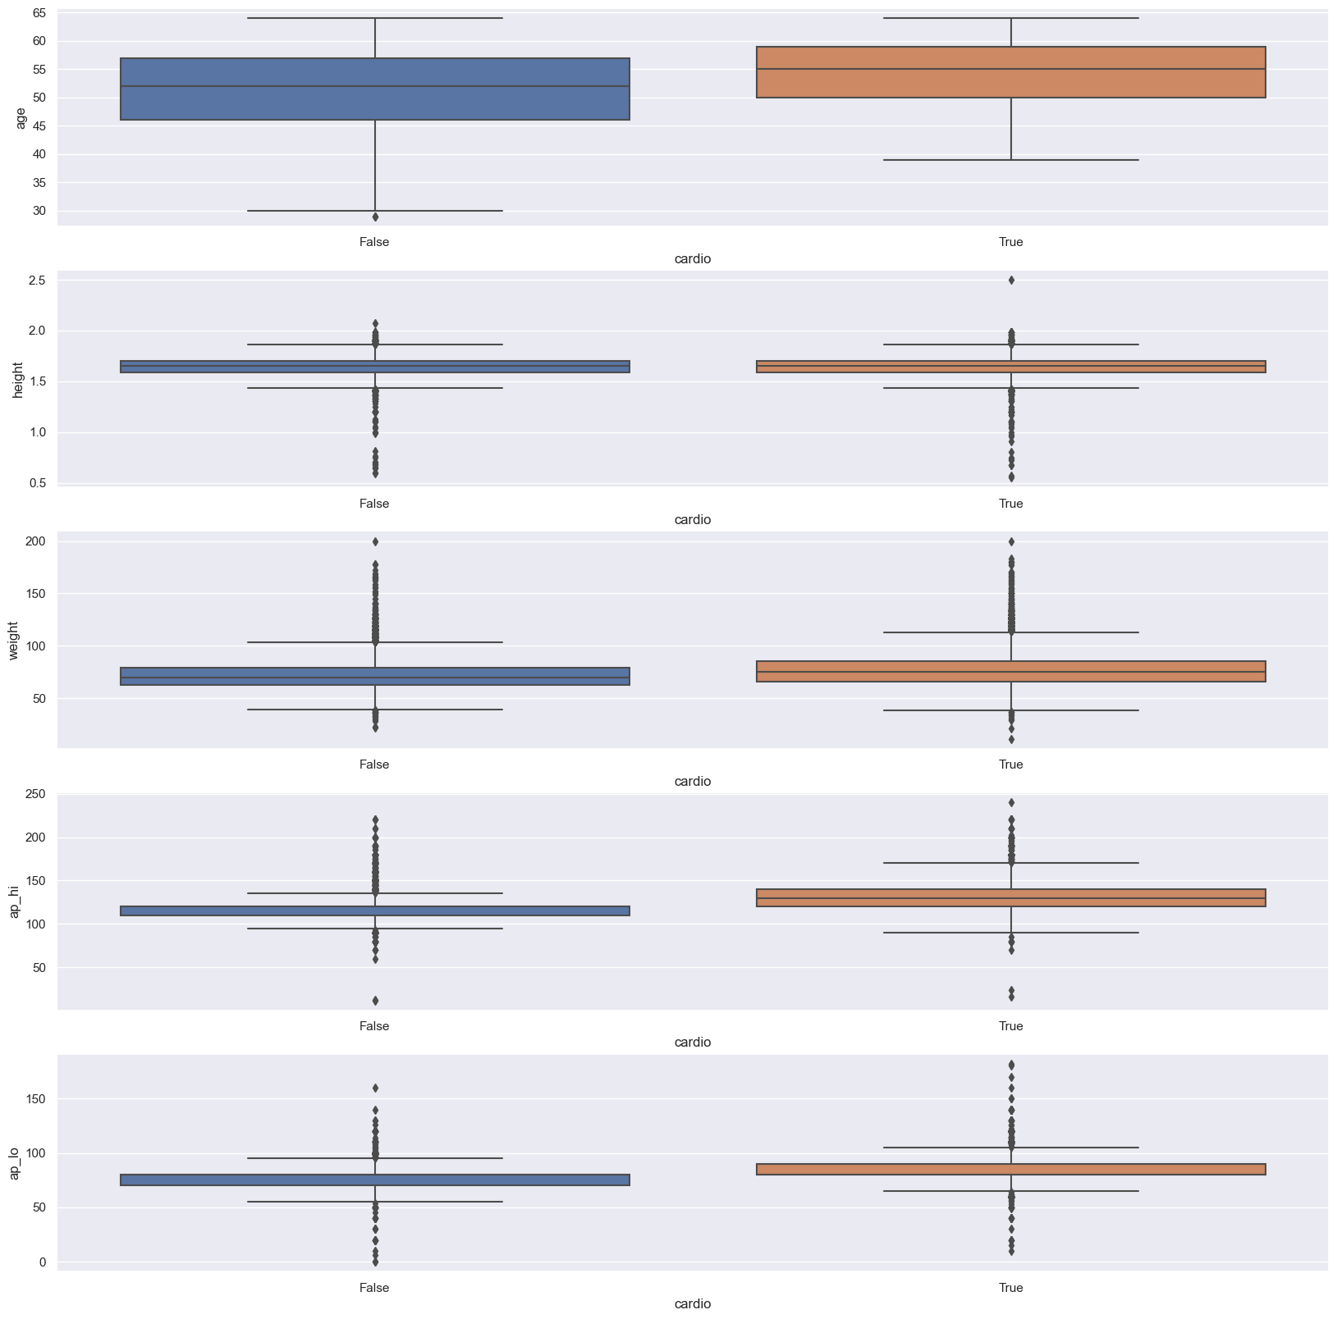

* 1. I conjecture ‘height’ has nothing to do with the probability of having cardiovascular disease[from the boxplots]. And so, I do up another function to calculate whether that is the case or not based on the data description for each variable, comparing between False/True values.
  2. And the former showed that I was right. Height has a high chance of not playing a role. And hence, I will throw away ‘height’.
  3. …[work in progress]

1. Formulating an issue
   1. We decide to focus on cardiovascular disease due to the following reasons: <Mainly interest reasons>
      1. That is what the dataset was for at the start.
      2. Smoke, alco and active seem to be quite skewed, and we are honestly not interested in it.
      3. Gluc, Cholesterol seem interesting, but we currently believe Cardio is our biggest ticket. These will be tested in the future however.
      4. Investigating the correlation between the numerical variables seem useless, and even if it shows something interesting that is not what we are interested in.
      5. Cardiovascular disease prediction is the obvious outcome for this dataset.
2. Deciding on final approach to problem
   1. Linear Discriminant Model => f(variables) = P(cardiovascular disease).