DevOps Assignment Submission
Name: Ansh Parikh
GitHub Repository Link: https://github.com/Ansh13032005/Tutedude-Devops-1

Part 1: GitHub Repository Setup & Flask Project
Goal: Create a GitHub repository, clone it, create a branch named Tutedude, add a Flask project, and merge it into main.
Explanation:
I cloned the remote repository to my local machine, created a new branch called Tutedude, and added app.py containing a basic Flask application with a /api route. Finally, I committed the file and merged the Tutedude branch back into main.
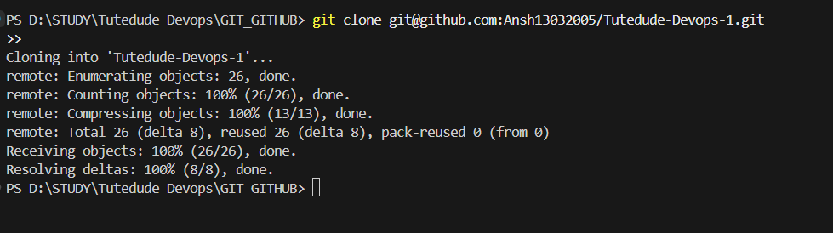

Part 2: Branch Updates
Goal: Create a new branch Tutedude_new, update the /api JSON content, and merge the branch into main.
Explanation:
I created a branch called Tutedude_new and modified the JSON response in the /api route. I then staged, committed the changes, and merged them back into the main branch.
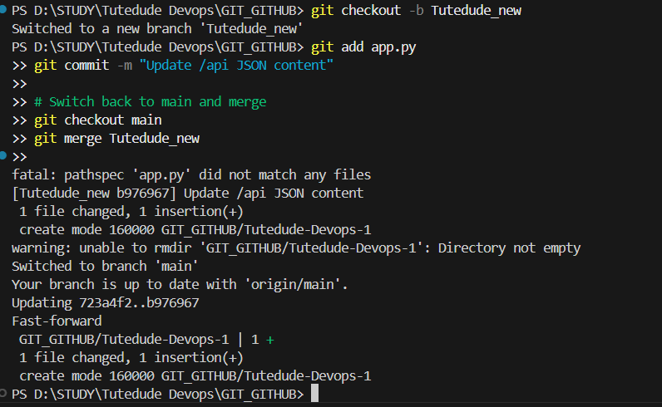

Part 3: Parallel Feature Development (master_1 & master_2)
Goal: Create branches master_1 (frontend) and master_2 (backend), perform parallel development, and merge both into main while resolving conflicts.
Explanation:
I branched master_1 and master_2 simultaneously from main. In master_1, I created a To-Do HTML form. In master_2, I added a /submittodoitem backend route connected to MongoDB. When merging both into main, I resolved a merge conflict in app.py manually.
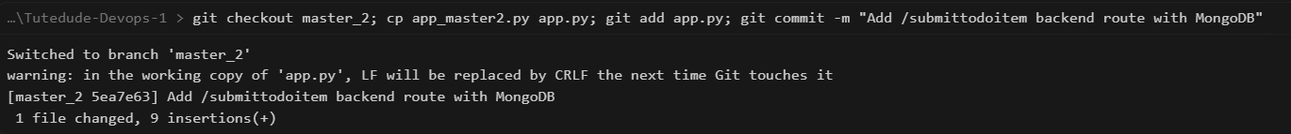
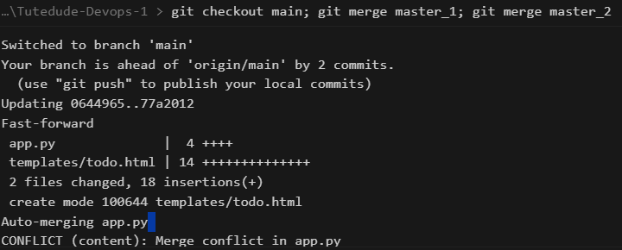

Part 4: Form Enhancements, Git Reset, and Rebase
Goal: Add ID, UUID, and Hash fields to the To-Do form sequentially in master_1, merge to main, perform a soft reset in main, re-commit, and rebase main onto master_1.
Explanation:
In master_1, I added the Item ID, Item UUID, and Item Hash fields to the To-Do form, making separate commits. After merging master_1 into main, I performed a git reset --soft back to the Item ID commit, re-committed the remaining changes as a single commit, and finally used git rebase to sync the rewritten history back into master_1.
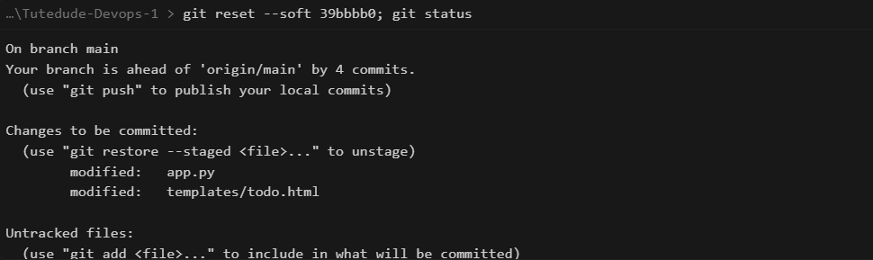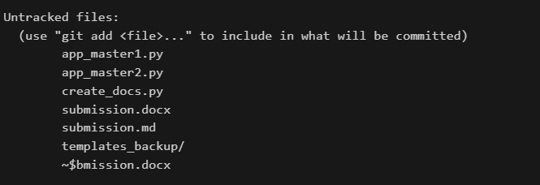

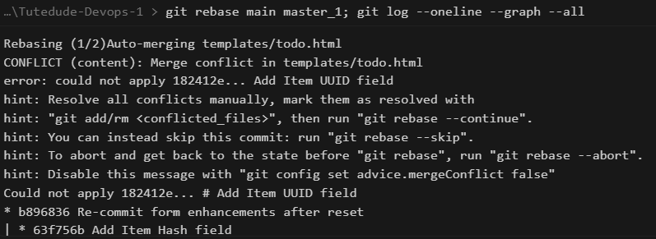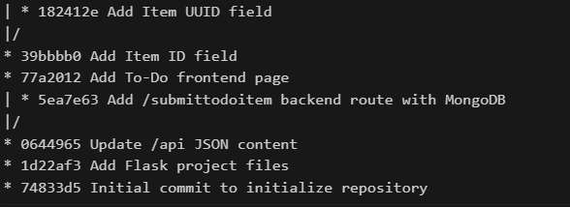

Final Push
All branches and commit histories were pushed to the remote GitHub repository.

