

School of Computer Science Engineering and Information Systems

Fall Semester 2026-2027

Department of Software and Systems Engineering

SWE3004 - Software Design and Development Project

Review -2

HELIXQL (Text to SQL)

22MIS0499 – Ansh Vohra
Under the Guidance of
Sweta Bhattacharya
Associate Professor
SCORE

Guide Signature with date
Sweta Bhattacharya

Internal Examiner -1 Internal Examiner-2
Signature Signature

ABSTRACT:

Getting quick access to data insights is crucial for modern businesses, but waiting for data analysts to write complex SQL queries often creates operational bottlenecks. Using Artificial Intelligence to translate regular English questions into database queries solves this delay, but it introduces severe risks. Most existing systems either pass real, private company data rows to cloud AI networks to provide database context, or they run AI-generated code directly on live servers without checking it first. While these current tools are flexible and easy to prototype, they risk leaking confidential corporate records and leave databases completely vulnerable to accidental data deletion or server crashes caused by AI code typos and hallucinations.
To solve these security and privacy challenges, we propose HelixQL, a secure, multi-tier system that splits the data processing pipeline into two isolated zones. A native desktop application handles database connections safely within the company's internal enterprise firewall, while a secure cloud gateway interfaces with Google Gemini. Instead of exposing real corporate records, HelixQL scans the database structure locally and builds an isolated context containing only empty schema blueprints. Before any query is allowed to execute, a built-in safety controller programmatically analyzes the code structure to guarantee it is strictly read-only. Furthermore, if the AI makes a translation mistake, a stateful self- healing loop automatically traps the runtime error and instructs the AI to fix the query behind the scenes up to three times without disrupting the user. This approach provides absolute data privacy since real database records never cross network perimeters or leave the local machine. Dangerous data-mutating operations are permanently blocked before opening a live network socket, and the system can calculate performance execution costs in under 1 millisecond without adding any server overhead. By blending local schema isolation with structural syntax tracking, HelixQL delivers a resilient, human-readable data assistant that protects sensitive enterprise infrastructure.

Keywords: Large Language Models (LLMs), Retrieval Augmented Generation
(RAG), Abstract Syntax Tree (AST) Validation, Data Privacy and Security, Self-Healing Loops, Electron Framework

- INTRODUCTION:
The increasing adoption of relational databases in modern organizations has created a growing need for efficient and accessible methods of retrieving useful information from large volumes of structured data. Traditionally, users with limited knowledge of SQL depend on database administrators or data analysts to convert their requirements into SQL queries, which can make the process time-consuming and inefficient. Recent advancements in Large Language Models (LLMs) have enabled Natural Language to SQL (Text-to-SQL) systems that allow users to express database queries using ordinary human language. However, deploying such systems in enterprise environments introduces important challenges related to data privacy, query reliability, and database security. Providing sensitive database information to cloud-based language models may expose confidential records, while directly executing AI-generated SQL can result in incorrect or potentially harmful operations. HelixQL is proposed as a secure Text-to-SQL system that addresses these concerns by separating natural-language processing from local database execution. The system extracts only the required database schema locally and provides this structural information to the language model without transmitting actual database records. The generated SQL is then programmatically validated using an Abstract Syntax Tree (AST) based security mechanism before execution. In addition, HelixQL incorporates an error-feedback mechanism that allows incorrect queries to be automatically refined. Through this approach, the system aims to provide a practical natural-language database interface while maintaining data privacy and protecting the underlying database from unsafe queries.

- PROBLEM STATEMENT:
Existing Natural Language to SQL systems allow users to retrieve database information using natural language, but their integration with cloud-based Large Language Models can introduce significant privacy and security risks. Sending actual enterprise database records or excessive schema information to external AI services may expose confidential information. Furthermore, automatically generated SQL can contain syntactic errors, incorrect table or column references, or potentially destructive operations.
Therefore, there is a need for a Text-to-SQL system that can generate SQL from natural language while keeping actual database records within the organization's local environment, programmatically validating generated SQL before execution, and automatically correcting runtime errors without exposing sensitive data.

- OBJECTIVES:
- To develop a natural-language interface for querying relational databases.
- To generate SQL queries from natural-language user requests using an LLM.
- To provide database context to the LLM using schema-only metadata without transmitting actual database records.
- To validate generated SQL queries before execution.
- To prevent destructive database operations by enforcing a read-only query policy.
- To implement an automated error-feedback and self-correction mechanism for incorrect SQL queries.

- SCOPE OF THE PROJECT:
HelixQL is proposed as a secure Natural Language to SQL system that enables users to interact with relational databases using ordinary English queries. The system separates the database environment from the cloud-based AI processing layer to protect sensitive enterprise data. When a user enters a natural language query, the desktop application locally analyzes the database structure and identifies the relevant tables and their schema information. Only the required structural metadata, without actual database records, is sent to the FastAPI-based cloud gateway. The gateway provides this schema context along with the user's query to the Large Language Model, which generates the corresponding SQL statement. The generated SQL is then analyzed using SQLGlot to verify that it follows the system's read-only policy and does not contain destructive operations. After successful validation, the query is returned to the local application, where it is first checked using the database's EXPLAIN mechanism and then executed against the local database. If an error occurs during validation or execution, the error information is used to refine the generated query through a limited self-correction loop. Finally, the retrieved database results and execution information are presented to the user through the desktop interface. This approach allows HelixQL to provide natural-language database access while keeping actual enterprise data within the local environment.

- PROPOSED SYSTEM:
HelixQL is proposed as a secure Natural Language to SQL system that enables users to interact with relational databases using ordinary English queries. The system separates the database environment from the cloud-based AI processing layer to protect sensitive enterprise data. When a user enters a natural language query, the desktop application locally analyzes the database structure and identifies the relevant tables and their schema information. Only the required structural metadata, without actual database records, is sent to the FastAPI-based cloud gateway. The gateway provides this schema context along with the user's query to the Large Language Model, which generates the corresponding SQL statement. The generated SQL is then analyzed using SQLGlot to verify that it follows the system's read-only policy and does not contain destructive operations. After successful validation, the query is returned to the local application, where it is first checked using the database's EXPLAIN mechanism and then executed against the local database. If an error occurs during validation or execution, the error information is used to refine the generated query through a limited self-correction loop. Finally, the retrieved database results and execution information are presented to the user through the desktop interface. This approach allows HelixQL to provide natural-language database access while keeping actual enterprise data within the local environment.

- LITERATURE SURVEY:

S.NO | TITLE | MERITS | DEMERITS
1 | Next-generation Database Interfaces: A Survey of LLM-based Text-to-SQL | Provides a comprehensive survey of recent LLM-based Text-to-SQL methods, database interfaces and major research challenges. It gives a broad understanding of how LLMs are being used to convert natural-language questions into SQL. | As a survey, it mainly analyzes existing approaches rather than proposing a complete implementation. Enterprise-level privacy protection and secure local execution are not the primary focus.
2 | TACO: A Benchmark for Open-Domain Text-to-SQL with Ambiguous and Cross-Database Queries | Introduces a benchmark designed to evaluate Text-to-SQL systems on ambiguous and cross-database queries. It helps evaluate system performance in more challenging and realistic query scenarios. | The work is primarily focused on benchmarking and evaluation. It does not provide an end-to-end mechanism for protecting enterprise data or preventing unsafe SQL execution.
3 | Semantic Captioning: Benchmark Dataset and Graph-Aware Few-Shot In-Context Learning for SQL2Text | Uses graph-aware information and few-shot in-context learning to improve the semantic relationship between SQL and natural language. The work highlights the importance of structural information in database-related language tasks. | The primary task is SQL-to-text rather than Natural Language-to-SQL generation. Therefore, it does not directly address secure SQL generation and database execution.
4 | Enhanced Schema Linking with Large Language Models via Self-Verification and Value Hints | Improves schema linking by using LLM-based self-verification and value hints to identify relevant database elements. Better schema linking can help an LLM generate more accurate SQL queries. | Additional contextual information is required for schema linking. The approach does not primarily address the problem of preventing sensitive database information from reaching external AI services.
5 | Text-to-SQL Meets the Real-World | Studies the challenges involved in applying Text-to-SQL systems to real-world databases instead of relying only on benchmark datasets. It provides useful insights into practical deployment issues and limitations. | The study identifies practical challenges but does not provide a complete architecture combining privacy isolation, query validation and local execution.
6 | LitE-SQL: A Lightweight and Efficient Text-to-SQL Framework with Vector-based Schema Linking and Execution-Guided Self-Correction | Uses a vector-based schema retriever and execution-guided self-correction to improve Text-to-SQL generation. It also demonstrates that lightweight models can achieve strong performance while being more practical for privacy-sensitive and resource-constrained environments. | The approach requires model training and an execution-guided learning process. Although it considers privacy-sensitive deployment, it does not implement HelixQL's specific separation between cloud-based SQL generation and local database execution.
7 | DIN-SQL: Decomposed In-context Learning of Text-to-SQL with Self-Correction | Decomposes Text-to-SQL generation into multiple stages and incorporates self-correction to improve SQL generation. This demonstrates that breaking complex SQL generation into smaller reasoning steps can improve reliability. | The approach relies strongly on LLM reasoning and prompting. It does not provide a dedicated programmatic security layer for blocking destructive SQL operations before execution.
8 | READ-SQL: A Reasoning Path Decomposer and Corrector for Self-Correction | Uses reasoning-path decomposition and correction to improve the reliability of generated SQL. It demonstrates the usefulness of structured reasoning and correction for handling generation errors. | Additional reasoning and correction stages can increase processing complexity. The approach does not specifically address database privacy or isolation of actual enterprise records from the LLM.
9 | LLM-Based SQL Generation: Prompting, Self-Refinement, and Adaptive Weighted Majority Voting | Investigates prompting, self-refinement and candidate selection techniques for improving LLM-based SQL generation. Iterative refinement can help reduce errors in generated queries. | Generating and evaluating multiple candidates can increase token usage and computational cost. The approach focuses on generation quality rather than providing a dedicated database security mechanism.
10 | SQLStructEval: Structural Evaluation of LLM Text-to-SQL Generation | Introduces structural evaluation using canonical Abstract Syntax Tree representations to analyze the reliability of generated SQL. It shows that structurally different SQL queries may be produced for the same input even when execution results are correct. | The work primarily focuses on evaluating structural reliability rather than providing a complete Text-to-SQL execution system. It does not itself provide authentication, privacy isolation or protection against destructive database operations.
11 | RAT-SQL: Relation-Aware Schema Encoding and Linking for Text-to-SQL Parsers | Introduces relation-aware schema encoding and schema linking to better represent relationships between tables, columns and database elements. This improves the model's ability to generate SQL for complex database schemas. | It relies on a specialized model architecture and training process. Its primary objective is Text-to-SQL accuracy rather than privacy-preserving deployment or runtime query security.
12 | PICARD: Parsing Incrementally for Constrained Auto-Regressive Decoding from Language Models | Introduces constrained decoding during SQL generation to prevent invalid tokens and syntactically incorrect SQL structures. This improves the reliability of generated queries by enforcing constraints during decoding. | It mainly addresses syntactic validity and does not guarantee that a generated query is semantically correct or safe. It also does not address enterprise data privacy or local execution.
13 | Text-to-SQL Empowered by Large Language Models: A Benchmark Evaluation | Systematically evaluates different prompting strategies for LLM-based Text-to-SQL, including question representation, example selection and organization. The proposed DAIL-SQL demonstrates strong execution accuracy while also considering token efficiency. | The study primarily focuses on improving LLM prompting and generation efficiency. Generated SQL can still contain incorrect schema references, and the work does not provide a dedicated security layer for database execution.
14 | C3: Zero-shot Text-to-SQL with ChatGPT | Demonstrates the ability of general-purpose LLMs to perform Text-to-SQL without task-specific training by using appropriate prompts and contextual information. It highlights the potential of LLMs as natural-language database interfaces. | Zero-shot generation can still produce incorrect SQL for complex database schemas. It does not provide a dedicated mechanism for preventing unsafe queries or keeping enterprise data isolated from the LLM.
15 | Evaluating the Text-to-SQL Capabilities of Large Language Models | Provides an early systematic evaluation of the ability of large language models to perform Text-to-SQL. It identifies both the potential and limitations of LLMs for generating database queries. | The work primarily evaluates model capabilities rather than designing a production-oriented system. Database privacy, structural security validation and local execution are not its main focus.
[6.1] FINDINGS IN LITERATURE SURVEY:
The literature indicates that recent Text-to-SQL systems have significantly improved SQL generation through large language models, schema linking, retrieval-based context selection and self-correction mechanisms. However, many approaches primarily focus on generation accuracy rather than protecting enterprise database information during the generation process. Existing approaches may also rely on extensive schema information or execution feedback and may not enforce a strict programmatic read-only policy before database execution. Therefore, a gap exists for a Text-to-SQL architecture that combines schema-only context transmission, local database execution, structural SQL validation and bounded self-correction. HelixQL addresses this gap by separating AI-based translation from local data execution.
[7. ] METHEDOLOGY:
The methodology of HelixQL focuses on developing a secure and privacy-preserving Natural Language to SQL pipeline by separating database operations from cloud-based language model processing. Initially, the user provides the database connection details through the desktop application, and the system establishes a local connection with the target relational database. The application retrieves the database structure and creates a schema representation containing information such as tables, columns, and their relationships. When the user submits a natural language query, the system identifies the relevant schema information required to understand the query and prepares an isolated context containing only the required structural metadata. Actual database records are not included in this context.
The selected schema information and the user's natural language request are then transmitted securely to the FastAPI gateway, where the Large Language Model generates the corresponding SQL query. The generated query is passed through an SQLGlot-based Abstract Syntax Tree validation process before it is returned for execution. The validator examines the structure of the generated SQL and ensures that the query follows the read-only policy by allowing SELECT operations and rejecting destructive operations such as DROP, DELETE, UPDATE, INSERT, and ALTER. This programmatic validation acts as a security layer between the AI-generated output and the target database.
After the SQL query passes validation, the desktop application performs an EXPLAIN operation against the local database to verify the query and obtain execution-plan information before retrieving the actual records. If the query produces a database error, the system captures the error information and sends the failed SQL query along with the error details back to the gateway for correction. This self-correction process is limited to a maximum of three attempts to prevent indefinite execution loops. Once a valid query is obtained, the SELECT statement is executed locally and the resulting records and performance information are presented through the application interface.
[8.] SOFTWARE REQUIREMENTS:
Functional Requirements
- User registration/login
- Email verification
- API token generation
- Database connection configuration
- Schema extraction
- Natural-language input
- SQL generation
- SQL validation
- EXPLAIN execution
- Query execution
- Error handling
- Self-correction
- Result visualization
- Query usage tracking

Non-functional Requirements
- Security
- Privacy
- Reliability
- Low latency
- Scalability
- Maintainability
- Cross-platform compatibility
- Fault tolerance
- Deterministic SQL generation
[9.] SYSTEM ARCHITECTURE:
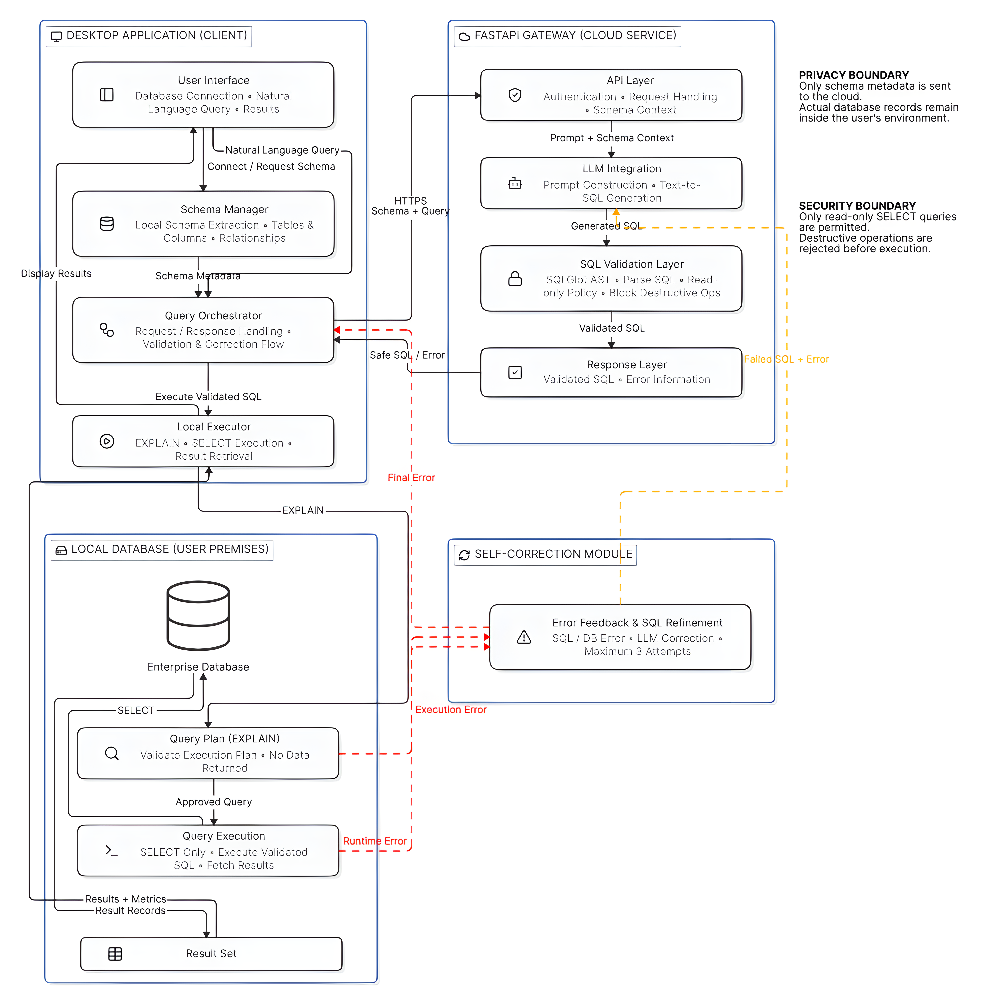

Fig. 9.1 System Architecture

[10]. UML DIAGRAMS:

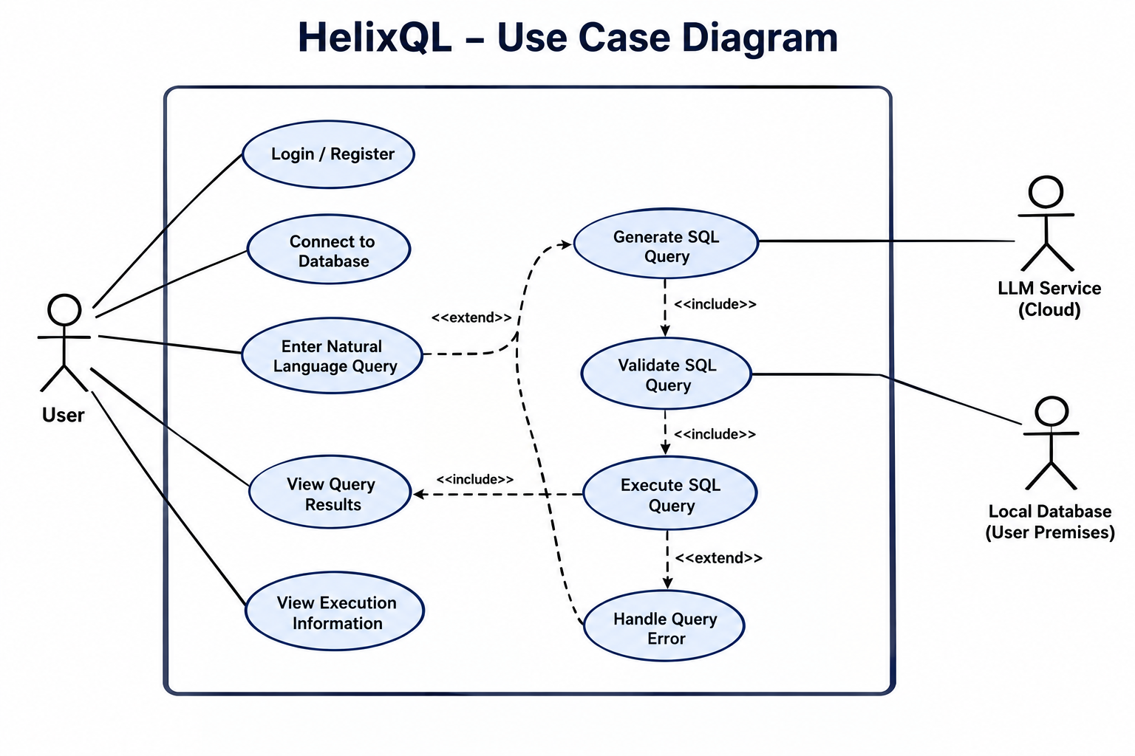
Use Case Diagram:

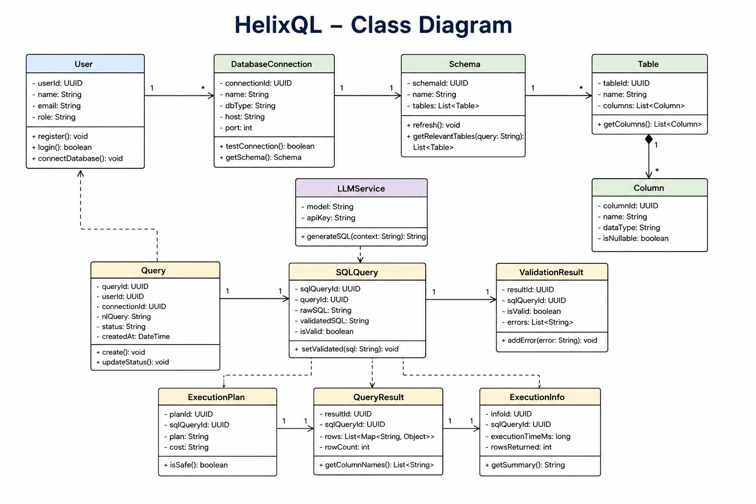
Class Diagram:

Sequence Diagram:

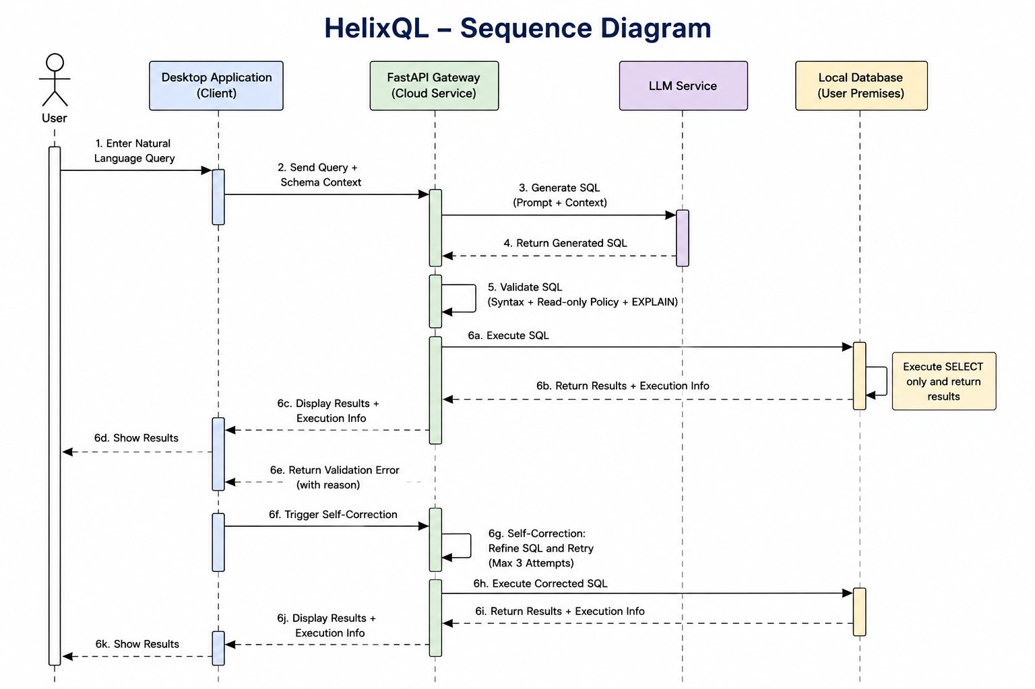

Activity Diagram:
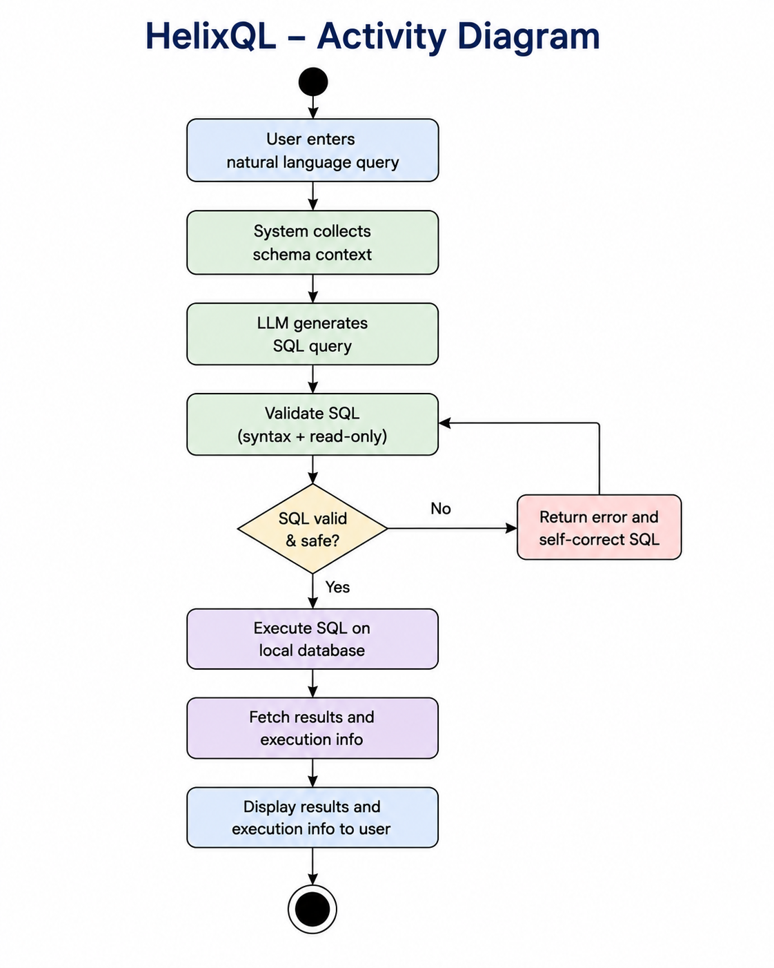

[11] IMPLEMENTATION:

11.1. PROJECT PLAN

HelixQL was built in 5 phases. The work followed the three-tier design: first the foundations, then each tier on its own, then integration, then hardening.

Phase 1: Requirements and Architecture:

Wrote the product specification, covering functional requirements FR-1 to FR-4.
Designed the three-tier architecture:
Control Plane (Next.js + MongoDB): accounts, email verification, API token issuance, subscriptions and usage metering.
Server Gateway (Python FastAPI): turns English questions into SQL and enforces the security guardrail.
Desktop Client (Electron + React): runs inside the customer's firewall and is the only tier that touches real data.
Defined the privacy boundary. The gateway receives only the English question plus empty CREATE TABLE structures. It never receives credentials or result rows.

Phase 2: Core Development:

Control Plane: registration, email verification, login, API token minting, monthly usage limits and rate limiting.
Server Gateway: the /v1/translate endpoint, the LLM integration, and the SQLGlot AST guardrail with its lists of forbidden nodes and functions.
Desktop Client: native MySQL and PostgreSQL drivers, schema discovery, schema pruning and DDL building, and the query pipeline (translate → validate → EXPLAIN → execute).
Self-correction loop: when a query fails, the database error goes back to the model for a repair attempt, up to a fixed limit.

Phase 3: Retrieval and UX Improvements:

RAG-based schema linking through the /v1/embed and /v1/link-schema endpoints, so only the tables relevant to a question are sent to the gateway.
UI work on readability and consistency: the diagnostics pane shows the generated SQL, the EXPLAIN plan, stage timings and the tables that were sent.

Phase 4: Deployment and Distribution:

Docker build for the gateway and a deployment config (deploy.yaml).
A GitHub Actions release workflow that builds the desktop installers, plus a download API on the Control Plane. Not yet deployed over AWS, as of now just sample deployment

Phase 5: Refinement and Stabilisation

Case-insensitive text matching in generated SQL filters.
TypeScript and module-resolution cleanup in the Vite client.
Regression testing and documentation.

11.2 SAMPLE CODE

(a) AST Security Guardrail:

import sqlglot

BLOCKED = {"Insert", "Update", "Delete", "Drop", "Alter", "Create", "Grant"}
BLOCKED_FUNCTIONS = {"SLEEP", "LOAD_FILE", "PG_SLEEP"}

def is_safe(sql):
statements = sqlglot.parse(sql)

# Only one statement allowed
if len(statements) != 1:
return False

query = statements[0]

# Must be a SELECT
if query.key != "select":
return False

# Check every part of the query tree
for node in query.walk():
if type(node).__name__ in BLOCKED:
return False
if node.key == "anonymous" and node.name.upper() in BLOCKED_FUNCTIONS:
return False

return True

(b) Translate Endpoint:

@app.post("/translate")
def translate(question, schema, user):
if user.queries_used >= user.monthly_limit:
return error("Monthly limit reached")

user.queries_used += 1
sql = llm.generate_sql(question, schema)

if not is_safe(sql):
return error("Unsafe query blocked")

return {"sql": sql}

11.3 TESTING STRATEGIES

Testing works at several levels. Each level targets one of the system's core promises: correctness, security and privacy.

I. Unit Testing
Each tier has its own automated unit test suite:

Tier | Framework | Tests | Focus
Server Gateway | pytest | 84 | Guardrail, authentication, metering, LLM retry, output parsing, schema linking, text matching
Control Plane | Vitest | 27 | Password hashing, token issuance, usage limits, rate limiting, auth service
Desktop Client | Vitest | 18 | Schema pruning (RAG), DDL generation
II. Security Testing (Adversarial Test Cases)
The guardrail is tested against a catalogue of attack patterns. All of them must be rejected:

Direct mutations (DROP, DELETE, UPDATE, INSERT, TRUNCATE, ALTER, GRANT)
Stacked statements (SELECT 1; DROP TABLE users)
Mutations hidden inside CTEs and subqueries
File-system access (LOAD_FILE, pg_read_file, SELECT ... INTO)
Denial-of-service functions (SLEEP, BENCHMARK, pg_sleep)
Writes that look like reads (nextval, SELECT ... FOR UPDATE)
Session control (SET, USE)
A matching list of valid SELECT queries (joins, aggregates, subqueries) must pass, which guards against false positives.

III. Integration Testing

Gateway ↔ Control Plane: the client is tested for token validation, usage increments and failure handling (for example, the Control Plane being unavailable).
The translate route is tested end-to-end with a mocked LLM, covering fresh translations, repair attempts, the attempt limit, and the rule that repairs are not metered.
LLM provider tests cover configuration validation and retries for both Gemini and Groq.

IV. Configuration Validation
scripts/dev.sh checks the configuration before startup. For example, it verifies that the shared internal secrets on the gateway and the Control Plane match exactly, which prevents a whole class of hard-to-diagnose failures.

Running the Tests:

cd server-gateway && ./venv/bin/python -m pytest
cd control-plane && npm test
cd client-desktop && npm test
11.3 SAMPLE SCREEN SHOTS

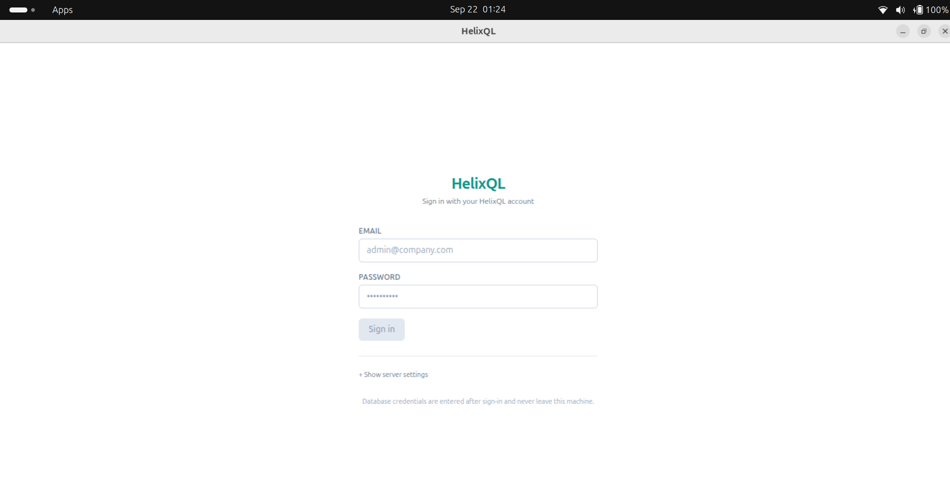
Authentication Page:
Home page (user have to connect to DB):

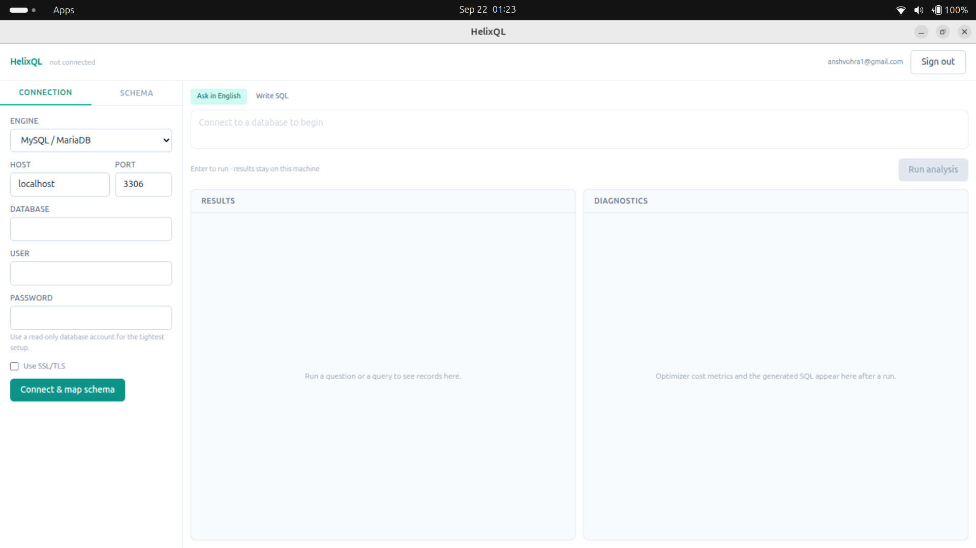
Query Page (here user can enter query in regular english and can see generated query and its response as well):

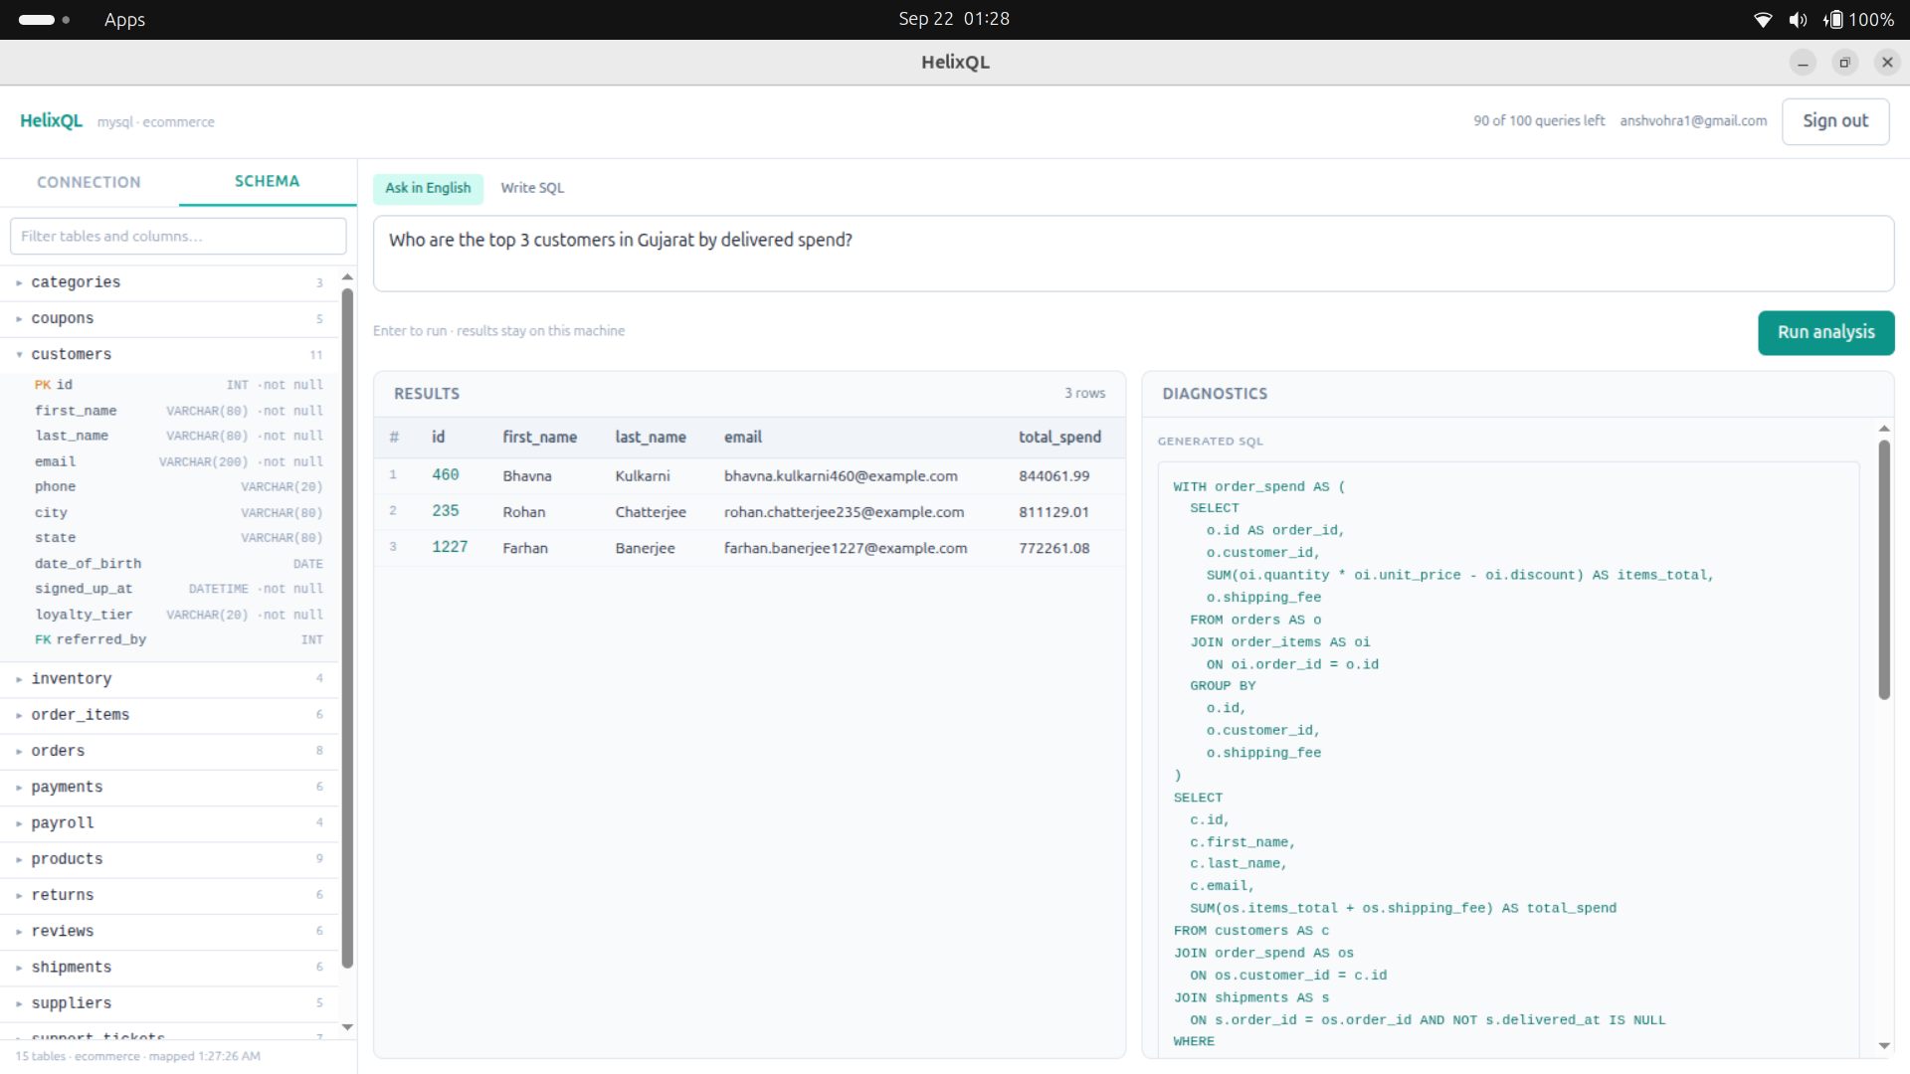
[12] SUMMARY:

HelixQL is a secure Text-to-SQL system designed to simplify database querying through natural language while maintaining data privacy and database security. The proposed system allows users to enter business-related questions in English and converts them into SQL queries using a Large Language Model. To protect sensitive information, HelixQL processes the actual database locally and sends only the required schema metadata to the cloud-based language model. The generated SQL query is further checked using SQLGlot-based AST validation to ensure that only safe, read-only operations are permitted. Before execution, the query is also verified using the database EXPLAIN mechanism. If an error occurs during validation or execution, the system uses an automated self-correction mechanism to refine the generated query and retry it within a limited number of attempts. Thus, HelixQL combines natural language processing, schema-based retrieval, SQL validation, local database execution, and self-correction to provide a practical and secure interface for accessing database information.

REFERENCES:

1) Hong, Z., Yuan, Z., Zhang, Q., Chen, H., Dong, J., Huang, F., & Huang, X. (2025).
Next-generation database interfaces: A survey of llm-based text-to-sql. IEEE
Transactions on Knowledge and Data Engineering.

2) Deng, C., Fan, J., Luo, Y., Xue, Q., Fan, M., Zhang, Y., ... & Du, X. (2026). TACO:
A Benchmark for Open-Domain Text-to-SQL with Ambiguous and Cross-Database
Queries. arXiv preprint arXiv:2606.14201.

3) Al-Lawati, A., Lucas, J., & Mitra, P. (2025, January). Semantic captioning:
benchmark dataset and graph-aware few-shot in-context learning for SQL2Text. In
Proceedings of the 31st International Conference on Computational Linguistics (pp.
8026-8042).

4) Ma, L., Wei, D., Li, X., Wen, F., & Zhang, H. (2026). Enhanced Schema Linking
with Large Language Models via Self-Verification and Value Hints. Big Data and
Cognitive Computing, 10(4), 104.

5) Nascimento, E., García, G. M., Feijó, L., Victorio, W., Izquierdo, Y. T., de Oliveira,
A. R., ... & Casanova, M. A. (2024). Text-to-SQL Meets the Real-World. In ICEIS
(1) (pp. 61-72).

6) Piao, S., Lee, J., & Park, S. (2026, March). LitE-SQL: A Lightweight and Efficient
Text-to-SQL Framework with Vector-based Schema Linking and Execution-Guided
Self-Correction. In Findings of the Association for Computational Linguistics: EACL
2026 (pp. 3593-3608).

7) Pourreza, M., & Rafiei, D. (2023). Din-sql: Decomposed in-context learning of text-
to-sql with self-correction. Advances in neural information processing systems, 36,
36339-36348.

8) Yang, H., Wang, K., & Zhou, X. (2025). READ-SQL: A reasoning path decomposer
and corrector for self-correction. OpenReview / International Conference on Learning
Representations.

9) Yang, Y. J., Chang, H. F., & Chen, P. A. (2026). LLM-Based SQL Generation:
Prompting, Self-Refinement, and Adaptive Weighted Majority Voting. arXiv preprint
arXiv:2601.17942.

10) Zhou, Y., Zhang, F., Guo, Z., Chen, Y., Zhang, H., Nakov, P., & Xie, Z. (2026).
Sqlstructeval: Structural evaluation of llm text-to-sql generation. arXiv preprint
arXiv:2604.06736.

11) Rajkumar, N., Li, R., Kalyan, A., Liang, P., & Manning, C. D. (2022). Evaluating the text-to-SQL capabilities of large language models. arXiv preprint arXiv:2204.00498.

12) Gao, D., Wang, H., Li, Y., Sun, X., Yu, Y., & Wang, J. (2023). Text-to-SQL empowered by large language models: A benchmark evaluation. arXiv preprint arXiv:2308.15363.

13) Sun, Y., Chen, Q., Wang, J., & others. (2023). RESDSQL: Decoupling schema linking and skeleton parsing for text-to-SQL. Proceedings of the AAAI Conference on Artificial Intelligence, 37(11), 13574–13582.

14) Li, J., Hui, B., Qu, G., Yang, J., Li, B., Li, B., Wang, B., Qin, B., Geng, R., Huo, N., Zhou, X., Chen, X., Li, G., Chang, J., Yang, Z., Zhang, Z., & others. (2023). Can LLM already serve as a database interface? A big bench for large-scale database grounded text-to-SQLs. Advances in Neural Information Processing Systems, 36.

15) Gao, Y., Fang, L., Wang, Y., & others. (2024). Retrieval-augmented generation for text-to-SQL: A survey and evaluation. arXiv preprint.

