Practical 4

Part A
1) | 1. Password strength (PasswordChecker.java + Driver.java)  (a) In PasswordChecker, check four rules — length ≥ 8, contains an uppercase letter,  contains a digit, contains a special character — using regex (e.g. “.*[A-Z].*”) or  String methods.  (b) Write strength(String pw) that counts how many rules pass and returns “Weak” (0–1), “Medium” (2–3) or “Strong” (4).  (c) In Driver.main: test several passwords; for each, print which rules passed and thefinal label.  Expected output: “abc” → Weak; “Abcd1234!” → Strong.
 | PasswordChecker.java
Code | package Pprb.Q1;  public class PasswordChecker{  public static boolean minlenght(String pw){  return pw.length()>=8;  }  public static boolean uppercase(String pw){  return pw.matches(".*[A-Z].*");  }  public static boolean digit(String pw){  return pw.matches(".*[0-9].*");  }  public static boolean specialcharacter(String pw){  return pw.matches(".*[^a-zA-Z0-9].*");  }  public static String strength(String pw){  int c=0;  if(minlenght(pw)){  c++;  }  if(uppercase(pw)){  c++;  }  if(digit(pw)){  c++;  }  if(specialcharacter(pw)){  c++;  }  if(c<=1){  return "Weak";  }  else if(c<=3){  return "Medium";  }  else{  return "Strong";  }  }  }
 | Driver.java
Code | package Pprb.Q1;  public class Driver{  public static void main(String[] args) {  String[] passwords = {"abc", "abcdefgh","Abcdefgh",  "Abcd1234","Abcd1234!"};  for(String s:passwords){  System.out.println(s);  System.out.println("Lenght >=8:" + PasswordChecker.minlenght(s));  System.out.println("Uppercase:" + PasswordChecker.uppercase(s));  System.out.println("Digit:" + PasswordChecker.digit(s));  System.out.println("Special Character" + PasswordChecker.specialcharacter(s));  System.out.println("Strength:" + PasswordChecker.strength(s));  }  }  }
Output | 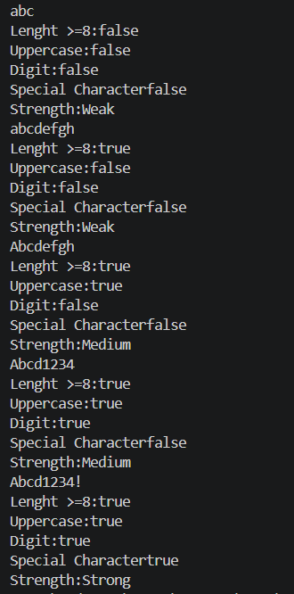
2) | AIM: Chat-log filter (ChatFilter.java + Driver.java)  (a) In Driver.main, define a String[] of log lines like “10:05 alice Hello there” (include  one malformed line with fewer than 3 parts).  (b) Read a keyword from the user.  (c) For each line, split into time/user/message with split(“ ”, 3); skip lines that do nothave 3 parts.  (d) If the message contains the keyword (case-insensitive), increment a counter and append “time user: message” to a StringBuilder.  (e) Print “Matches: N” and the built report.  Expected output: keyword “hello” over 3 lines (1 malformed) → “Matches: 1” and the matching line.
 | ChatFilter.java
Code | package Pprb.Q2;  public class ChatFilter {  public static String filter(String[] logs, String keyword) {  int matches = 0;  StringBuilder report = new StringBuilder();  for (String line : logs) {  String[] parts = line.split(" ", 3);  if (parts.length < 3) {  continue;  }  String time = parts[0];  String user = parts[1];  String message = parts[2];  if (message.toLowerCase().contains(keyword.toLowerCase())) {  matches++;  report.append(time)  .append(" ")  .append(user)  .append(": ")  .append(message)  .append("\n");  }  }  return "Matches: " + matches + "\n" + report;  }  }
 | Driver.java
package Pprb.Q2;
import java.util.Scanner;

public class Driver {

public static void main(String[] args) {

String[] logs = {
"10:05 alice Hello there",
"10:06 bob How are you?",
"10:07 charlie Good morning",
"malformed"
};

Scanner sc = new Scanner(System.in);

System.out.print("Enter keyword: ");
String keyword = sc.nextLine();

String result = ChatFilter.filter(logs, keyword);

System.out.println(result);

sc.close();
}
}

Output | 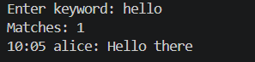
Q3) | AIM: Template filler (TemplateFiller.java +Driver.java)  (a) In Driver.main, define a template like “Dear {name}, order {id} ships {date}.” And two parallel arrays: names {“name”, “id”} and values {“Riya”, “A07”} (note {date} is not supplied).  (b) Compile a Pattern for \{(\w+)\} and get a Matcher on the template.  (c) Walk the matches with a StringBuilder: for each {placeholder}, look up its value in the names array and replace with the value, or with “[?]” if not found.  (d) Print the filled template.  Expected output: the unsupplied {date} becomes [?].)
 | TemplateFiller.java
Code | package Pprb.Q3;  import java.util.regex.Matcher;  import java.util.regex.Pattern;  public class TemplateFiller {  public static String fillTemplate(String template, String[] keys, String[] values) {  Pattern pattern = Pattern.compile("\\{(\\w+)\\}");  Matcher matcher = pattern.matcher(template);  StringBuilder result = new StringBuilder();  while (matcher.find()) {  String placeholderKey = matcher.group(1);  String replacement = "[?]";  for (int i = 0; i < keys.length; i++) {  if (keys[i].equals(placeholderKey)) {  replacement = values[i];  break;  }  }  matcher.appendReplacement(result, Matcher.quoteReplacement(replacement));  }  matcher.appendTail(result);  return result.toString();  }  }
 | Driver.java
Code | package Pprb.Q3;  import java.util.*;  public class Driver {  public static void main(String[] args) {  String template = "Dear {name}, order {id} ships {date}.";  String[] names = {"name", "id"};  String[] values = {"Ansh", "A02"};  String filledTemplate = TemplateFiller.fillTemplate(template, names, values);  System.out.println(filledTemplate);  }  }
Output

