Practical 1

Part A
1)
Code | import java.util.*;  public class VendingMachine {  enum Coin {  ONE, TWO, FIVE, TEN  }  public static void main(String[] args) {  int snack_price = 15;  int total = 0;  Scanner s = new Scanner(System.in);  System.out.println("Snack price is" + snack_price);  while (total < snack_price) {  System.out.print("Enter coin:");  String input = s.next().toUpperCase();  try {  Coin c = Coin.valueOf(input);  int value = 0;  switch (c) {  case ONE:  value = 1;  break;  case TWO:  value = 2;  break;  case FIVE:  value = 5;  break;  case TEN:  value = 10;  break;  }  total += value;  System.out.println("Total:" + total);  } catch (IllegalArgumentException e) {  System.out.println("Invalid coin");  }  }  s.close();  }  }
Output | 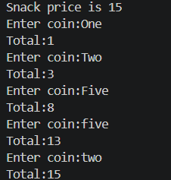
2)
Code | import java.util.*;  public class TollBooth {  record Vehicle(String number, String type){};  public static void main(String[] args){  int total=0;  int bike=0;  int car=0;  int truck=0;  Scanner s=new Scanner(System.in);  while(true){  System.out.print("Enter type:");  String type=s.nextLine().toLowerCase();  if(type.equalsIgnoreCase("done")){  break;  }  System.out.println("Enter vehical number:");  String no=s.nextLine();  Vehicle v=new Vehicle(no, type);  int toll=0;  switch (type) {  case "car":  toll=50;  car++;  break;  case "bike":  toll=20;  bike++;  break;  case "truck":  toll=150;  truck++;  break;  default:  break;  }  total+=toll;  System.out.println("Total toll:"+total);  }  String m=(bike>=car & bike>=truck)?"bike":(car>=truck)?"car":"truck";  System.out.println("Most type with highest count:"+m);  }  }
Output | 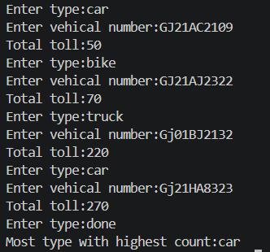
Q3)
Code | import java.util.*;  public class RPSLS{  enum Move{  ROCK,  PAPER,  SCISSORS,  LIZARD,  SPOCK  }  public static int winner (Move player,Move computer){  if(player==computer){  return 0;  }  switch(player){  case ROCK:  if (computer == Move.SCISSORS || computer == Move.LIZARD)  return 1;  else  return -1;  case PAPER:  if (computer == Move.ROCK || computer == Move.SPOCK)  return 1;  else  return -1;  case SCISSORS:  if (computer == Move.PAPER || computer == Move.LIZARD)  return 1;  else  return -1;  case LIZARD:  if (computer == Move.PAPER || computer == Move.SPOCK)  return 1;  else  return -1;  case SPOCK:  if (computer == Move.ROCK || computer == Move.SCISSORS)  return 1;  else  return -1;  }  return 0;  }  public static void main(String [] args){  Scanner s=new Scanner(System.in);  Random r=new Random();  int player_score=0,computer_score=0;  for(int i=1;i<=5;i++){  System.out.println("Round "+ i);  System.out.print("Enter your move(rock,scissors,paper,lizard,spock):");  String input=s.nextLine().toUpperCase();  Move player;  if (input.equals("ROCK")) {  player = Move.ROCK;  } else if (input.equals("PAPER")) {  player = Move.PAPER;  } else if (input.equals("SCISSORS")) {  player = Move.SCISSORS;  } else if (input.equals("LIZARD")) {  player = Move.LIZARD;  } else if (input.equals("SPOCK")) {  player = Move.SPOCK;  }  else{  System.out.println("Invalid Move!");  i--;  continue;  }  Move computer = Move.values()[r.nextInt(5)];  System.out.println("Player Move : " + player);  System.out.println("Computer Move : " + computer);  int result=winner(player, computer);  if(result==1){  System.out.println("You win this round");  player_score++;  }  else if(result==-1){  System.out.println("Computer win this round");  computer_score++;  }  else{  System.out.println("It is Tie");  }  }  System.out.println("\nFinal Score");  System.out.println("Player:" + player_score);  System.out.println("Computer:" + computer_score);  if(player_score>computer_score){  System.out.println("You win the game");  }  else if(computer_score>player_score){  System.out.println("Computer win the game");  }  else{  System.out.println("Match draw");  }  s.close();  }  }
Output | 