Practical 9

Part A
1) | Thread-pool runner: with a fixed pool of 3 (ExecutorService), submit about 10 Runnable  tasks that print their id and sleep briefly; shut down and await completion, observing the  few threads being reused.
Code | import java.util.concurrent.*;  public class ThreadPoolRunner{  public static void main(String[] args)throws InterruptedException{  ExecutorService executor=Executors.newFixedThreadPool(3);  for(int i=1;i<=10;i++){  int id=i;  executor.submit(()->{  System.out.println("Task "+id+" running on "+Thread.currentThread().getName());  try{  Thread.sleep(500);  }catch(InterruptedException e){  Thread.currentThread().interrupt();  }  });  }  executor.shutdown();  executor.awaitTermination(1,TimeUnit.MINUTES);  System.out.println("All tasks completed");  }  }
Output | 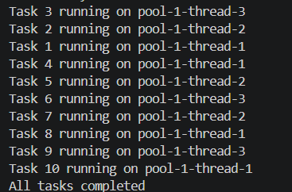
2) | Producer–consumer: one thread adds numbers to a small shared buffer and another  removes them, coordinated with wait()/notify(); produce and consume a fixed number of  items in order with none lost.
Code | class Buffer{  int[] data=new int[3];  int count=0;  int in=0;  int out=0;  synchronized void produce(int value)throws InterruptedException{  while(count==data.length){  wait();  }  data[in]=value;  in=(in+1)%data.length;  count++;  System.out.println("Produced: "+value);  notify();  }  synchronized int consume()throws InterruptedException{  while(count==0){  wait();  }  int value=data[out];  out=(out+1)%data.length;  count--;  System.out.println("Consumed: "+value);  notify();  return value;  }  }  public class ProducerConsumer{  public static void main(String[] args)throws InterruptedException{  Buffer buffer=new Buffer();  int total=10;  Thread producer=new Thread(()->{  try{  for(int i=1;i<=total;i++){  buffer.produce(i);  }  }catch(InterruptedException e){  Thread.currentThread().interrupt();  }  });  Thread consumer=new Thread(()->{  try{  for(int i=1;i<=total;i++){  buffer.consume();  }  }catch(InterruptedException e){  Thread.currentThread().interrupt();  }  });  producer.start();  consumer.start();  producer.join();  consumer.join();  System.out.println("All items processed");  }  }
Output | 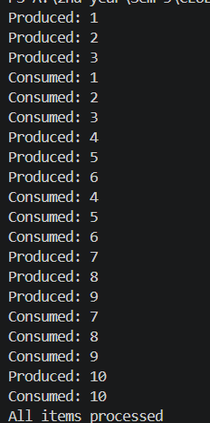
Q3) | Reproduce a deadlock between two threads that lock  two objects in opposite order, then remove it with a consistent lock order. Choose the  scenario yourself.
Code | class DeadlockDemo{  static final Object lock1=new Object();  static final Object lock2=new Object();  static void createDeadlock(){  Thread t1=new Thread(()->{  synchronized(lock1){  System.out.println("Thread 1 locked lock1");  try{  Thread.sleep(100);  }catch(InterruptedException e){  Thread.currentThread().interrupt();  }  synchronized(lock2){  System.out.println("Thread 1 locked lock2");  }  }  });  Thread t2=new Thread(()->{  synchronized(lock2){  System.out.println("Thread 2 locked lock2");  try{  Thread.sleep(100);  }catch(InterruptedException e){  Thread.currentThread().interrupt();  }  synchronized(lock1){  System.out.println("Thread 2 locked lock1");  }  }  });  t1.start();  t2.start();  }  static void avoidDeadlock(){  Thread t1=new Thread(()->{  synchronized(lock1){  System.out.println("Thread 1 locked lock1");  synchronized(lock2){  System.out.println("Thread 1 locked lock2");  }  }  });  Thread t2=new Thread(()->{  synchronized(lock1){  System.out.println("Thread 2 locked lock1");  synchronized(lock2){  System.out.println("Thread 2 locked lock2");  }  }  });  t1.start();  t2.start();  try{  t1.join();  t2.join();  }catch(InterruptedException e){  Thread.currentThread().interrupt();  }  }  public static void main(String[] args){  System.out.println("Deadlock demonstration:");  createDeadlock();  try{  Thread.sleep(1000);  }catch(InterruptedException e){  Thread.currentThread().interrupt();  }  System.out.println("Deadlock demonstration may leave threads blocked.");  System.out.println("Run avoidDeadlock() separately to test the solution.");  }  }
Output | 