Practical 14

Part A
1) | Assemble and test: build a tiny layered app (a model, a service using an ArrayList, and a  menu main), then write two or three JUnit @Test methods checking that adding increases  the count and an invalid action throws — practice before testing MiniBank.
 | Student.java
Code | public class Student{  private int id;  private String name;  public Student(int id,String name){  if(id<=0||name==null||name.trim().isEmpty()){  throw new IllegalArgumentException("Invalid student");  }  this.id=id;  this.name=name;  }  public int getId(){  return id;  }  public String getName(){  return name;  }  }
 | StudentService.java
Code | import java.util.ArrayList;  public class StudentService{  private ArrayList<Student> students=new ArrayList<>();  public void addStudent(Student s){  if(s==null){  throw new IllegalArgumentException("Student cannot be null");  }  for(Student student:students){  if(student.getId()==s.getId()){  throw new IllegalArgumentException("Student already exists");  }  }  students.add(s);  }  public int getCount(){  return students.size();  }  public ArrayList<Student> getStudents(){  return new ArrayList<>(students);  }  }
 | Main.java
Code | import java.util.Scanner;  public class Main{  public static void main(String[] args){  Scanner sc=new Scanner(System.in);  StudentService service=new StudentService();  while(true){  System.out.println("1.Add Student");  System.out.println("2.View Count");  System.out.println("3.Exit");  System.out.print("Enter choice: ");  int choice=sc.nextInt();  sc.nextLine();  switch(choice){  case 1:  System.out.print("Enter ID: ");  int id=sc.nextInt();  sc.nextLine();  System.out.print("Enter Name: ");  String name=sc.nextLine();  try{  service.addStudent(new Student(id,name));  System.out.println("Student added successfully");  }catch(IllegalArgumentException e){  System.out.println(e.getMessage());  }  break;  case 2:  System.out.println("Total Students: "+service.getCount());  break;  case 3:  sc.close();  return;  default:  System.out.println("Invalid choice");  }  }  }  }
Output | 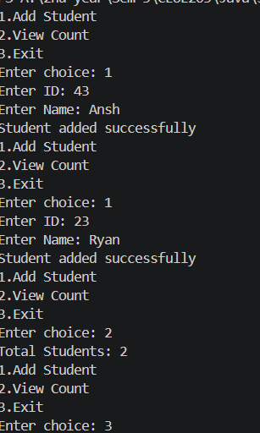
Q2) | Organise that app into packages, build a runnable JAR,  and add a test that saves and reloads its data unchanged.
 | 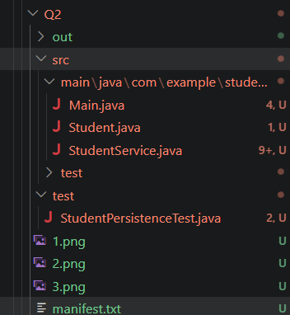
 | StudentPersistenceTest.java
Code | package Lab-14.Pprb.Q2.test;  public class StudentPersistenceTest {  }  Manifest.txt
Code | Main-Class: com.example.studentapp.Main
Output | 