Practical 2

Part A
1) | AIM: Smart thermostat  (a) Create class Thermostat with private String location, private int temperature, private static final int MIN=16 and MAX=30, and private static int activeCount=0.  (b) Constructor(location, startTemp): store location; set temperature to startTemp if it is within MIN..MAX else 22; increment activeCount.  (c) Constructor(location): chain with this(location, 22).  (d) raise(): if temperature < MAX add 1, else print “Already at maximum (30)”.  (e) lower(): if temperature > MIN subtract 1, else print “Already at minimum (16)”.  (f) Add getTemperature() (no setter) and static getActiveCount().  (g) In main: create two thermostats, call raise() 10 times then lower() 20 times in loops (printing the temperature each time), then print getActiveCount(). Expected output: temperature rises to 30 then “Already at maximum”, falls to 16 then “Already at minimum”, count 2.
Code | import java.util.*;  public class Thermostat {  private String location;  private int temperature;  private static int MIN=16;  private static int MAX=30;  private static int activeCount=0;  public Thermostat(String l,int t){  if(t>MIN || t<MAX){  temperature=t;  }  else{  temperature=22;  }  activeCount++;  this.location=l;  }  public Thermostat(String l){  this(l,22);  }  public void raise(){  if(temperature<MAX){  temperature+=1;  }  else{  System.out.println("Already at maximum(30)");  }  }  public void lower(){  if(temperature>MIN){  temperature--;  }  else{  System.out.println("Already at minimum(16)");  }  }  public int getTemperature(){  return temperature;  }  public static int getActiveCount(){  return activeCount;  }  public static void main(String[] args){  Scanner s1 = new Scanner(System.in);  int temp = s1.nextInt();  Thermostat t1 = new Thermostat("room");  Thermostat t2 = new Thermostat("hall", temp);  for(int i=0;i<10;i++){  t1.raise();  t2.raise();  System.out.println("Temp from t1 = "+t1.getTemperature()+" Temp from t2 = "+t2.getTemperature());  }  for(int j=0;j<20;j++){  t1.lower();  t2.lower();  System.out.println("Temp from t1 = "+t1.getTemperature()+" Temp from t2 = "+t2.getTemperature());  }  System.out.println(getActiveCount());  // int temp;  // Scanner s=new Scanner(System.in);  // System.out.print("Enter temperature:");  // temp= s.nextInt();  // String loc;  // System.out.print("Enter loaction:");  // loc=s.next();  // Thermostat t1=new Thermostat(loc,temp);  // String l2;  // System.out.print("Enter loaction:");  // l2=s.next();  // Thermostat t2=new Thermostat(l2);  // s.close();  // for(int i=0;i<10;i++){  // int te=t1.getTemperature();  // t1.raise();  // System.out.println("Temperature:"+te);  // }  // for(int i=0;i<20;i++){  // int te=t1.getTemperature();  // t2.lower();  // System.out.println("Temperature:"+te);  // }  // System.out.println("Active count:"+ Thermostat.getActiveCount());  }  }
Output | 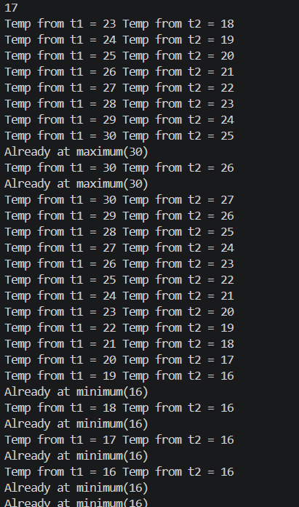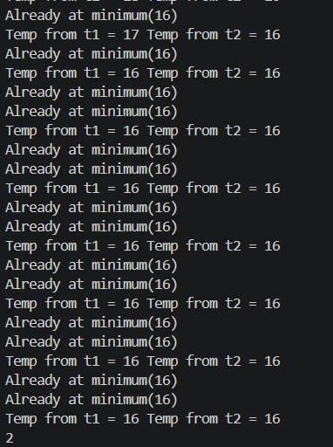
2) | AIM:Cinema show  (a) Create class CinemaShow with private String title, private int seatsAvailable, private final int capacity, and private static int totalBooked=0. (b) Constructor(title, capacity): set both and seatsAvailable = capacity. Constructor(title): chain with this(title, 100).  (c) book(int n): if n ≤ seatsAvailable, reduce seatsAvailable by n, add n to totalBooked, return true; else return false unchanged.  (d) cancel(int n): increase seatsAvailable by n but never above capacity.  (e) Add getSeatsAvailable() and static getTotalBooked().  (f) In main: run a sequence of book and cancel calls, printing the result and seats after each, then print getTotalBooked(). Expected output: booking more than available prints false and leaves seats unchanged; totalBooked equals the successful bookings
Code | import java.util.*;  public class CinemaShow {  private String title;  private int seatsAvailable;  private final int capacity;  private static int totalBooked=0;  public CinemaShow(String t,int c){  title=t;  capacity=c;  seatsAvailable=capacity;  }  public CinemaShow(String t){  this(t,100);  }  public boolean book (int n){  if(n<=seatsAvailable){  seatsAvailable-=n;  totalBooked+=n;  return true;  }  else{  return false;  }  }  public void cancel(int n){  seatsAvailable+=n;  if(seatsAvailable>capacity){  seatsAvailable=capacity;  }  }  public int getSeatsAvailable(){  return seatsAvailable;  }  public static int getTotalBooked(){  return totalBooked;  }  public static void main(String[] args){  Scanner s= new Scanner(System.in);  int cap;  System.out.print("Enter capcaity of cinema:");  cap=s.nextInt();  s.nextLine();  String t;  System.out.print("Enter movie:");  t=s.nextLine();  CinemaShow c= new CinemaShow(t,cap);  while (true){  System.out.println("1. Book ticket");  System.out.println("2. Cancel ticket");  System.out.println("3. Show Available Seats");  System.out.println("4. Exit");  System.out.print("Enter your choice:");  int choice=s.nextInt();  switch ((choice)) {  case 1:  System.out.print("Enter number of tickets:");  int ti=s.nextInt();  boolean result = c.book(ti);  System.out.println("Booking Successful:" + result);  System.out.println("Seats Available:" + c.getSeatsAvailable());  break;  case 2:  System.out.print("Enter number of tickets to cancel:");  int cancel = s.nextInt();  c.cancel(cancel);  System.out.println("Seats Available:" + c.getSeatsAvailable());  break;  case 3:  System.out.println("Seats Available:" + c.getSeatsAvailable());  break;  case 4:  System.out.println("Total Successful Bookings: " + CinemaShow.getTotalBooked());  s.close();  return;  default:  System.out.println("Invalid Choice!");  }  }  }  }
Output | 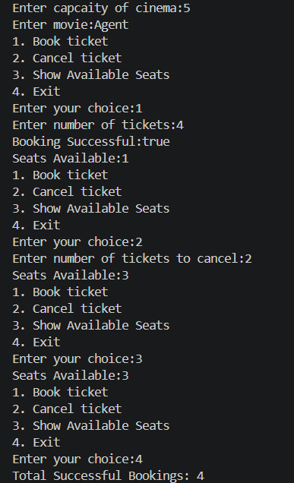
Q3) | AIM: Parking lot  (a) Create class ParkingLot with private int twoWheelers and fourWheelers, private final int twoCap and fourCap, and private static long revenue=0.  (b) park(String type): for “two”, if twoWheelers < twoCap increment and add 20 to revenue; for “four”, if fourWheelers < fourCap increment and add 40; otherwise print “Full” and reject.  (c) leave(String type): decrement the matching count but never below 0.  (d) In main: simulate a sequence of park/leave events, printing each outcome, then print final occupancy and revenue. Expected output: parking into a full section is refused; revenue = 20×(two parked) + 40×(four parked).
Code | import java.util.*;  public class ParkingLot {  private int twoWheelers;  private int fourWheelers;  private final int twoCap;  private final int fourCap;  private static long revenue=0;  public ParkingLot(int twoCap, int fourCap) {  this.twoCap = twoCap;  this.fourCap = fourCap;  twoWheelers = 0;  fourWheelers = 0;  }  public void park(String type){  switch (type.toUpperCase()) {  case "TWO":  if(twoWheelers<twoCap){  twoWheelers++;  revenue+=20;  }  else{  System.out.println("FULL");  }  break;  case "FOUR":  if(fourWheelers<fourCap){  fourWheelers++;  revenue+=40;  }  else{  System.out.println("FULL");  }  break;  default:  System.out.println("Invalid type");  }  }  public void leave(String t){  switch (t.toUpperCase()) {  case "TWO":  if(twoWheelers>0){  twoWheelers--;  }  else{  System.out.println("Empty");  }  break;  case "FOUR":  if(fourWheelers>0){  fourWheelers--;  }  else{  System.out.println("Empty");  }  break;  default:  System.out.println("Invalid type");  }  }  public int getTwoWheelers() {  return twoWheelers;  }  public int getFourWheelers() {  return fourWheelers;  }  public static long getRevenue() {  return revenue;  }  public static void main(String[] args){  Scanner s=new Scanner(System.in);  System.out.print("Enter two-wheeler capacity:");  int two = s.nextInt();  System.out.print("Enter four-wheeler capacity:");  int four = s.nextInt();  ParkingLot p= new ParkingLot(two, four);  while(true){  System.out.println("1. Park Vehicle");  System.out.println("2. Leave Vehicle");  System.out.println("3. Show Status");  System.out.println("4. Exit");  System.out.print("Enter choice: ");  int choice = s.nextInt();  switch (choice) {  case 1:  System.out.print("Enter vehicle type: ");  String type = s.next();  p.park(type);  System.out.println("Two-Wheelers:" + p.getTwoWheelers());  System.out.println("Four-Wheelers:" + p.getFourWheelers());  break;  case 2:  System.out.print("Enter vehicle type: ");  String ty = s.next();  p.leave(ty);  System.out.println("Two-Wheelers:" + p.getTwoWheelers());  System.out.println("Four-Wheelers:" + p.getFourWheelers());  break;  case 3:  System.out.println("Two-Wheelers:" + p.getTwoWheelers());  System.out.println("Four-Wheelers:" + p.getFourWheelers());  System.out.println("Revenue: Rs. " + ParkingLot.getRevenue());  break;  case 4:  System.out.println("Final Occupancy");  System.out.println("Two-Wheelers :" + p.getTwoWheelers());  System.out.println("Four-Wheelers:" + p.getFourWheelers());  System.out.println("Total Revenue:Rs. " + ParkingLot.getRevenue());  s.close();  default:  System.out.println("Invalid Choice");  }  }  }  }
Output | 