**Citi Code Challenge 2022**

*Approach Paper*

**College Name:** Vishwakarma Institute of Technology, Pune

**Team Name**: MastCoders

# **Overview**

## Describe your understanding on problem statement

We have to implement a pair trading strategy in our product which will pair two highly corelated stocks or commodities which will most likely give us maximum profits. Implementing a strategy which will give appropriate stack rank for different pairs based on profits or their correlation. Strategy implemented should give us signals when to long which stock of the pair and when to short it.

## Team members

Ansh Jaiswal(***Team Leader)***

Sanskar Jain

Shrutika Nandurkar

Samiksha Hiran

# **High Level Solution Approach**

## Describe Solution

As we know we should not depend on one indicator while trading in stock market so our strategy is to study two indicators i.e. **Relative Strength** and **Supertrend** and to combine them somehow to achieve desired results.

**Relative Strength:** Relative strength is a strategy used in momentum investing and in identifying value stocks. It focuses on investing in stocks or other investments that have performed well relative to the market as a whole or to a relevant benchmark. For example, a relative strength investor might select technology companies that have outperformed the Nasdaq Composite Index, or stocks that are outperforming the S&P 500 index.

**Calculation of RS:**

*RS*=average loss/average gain​

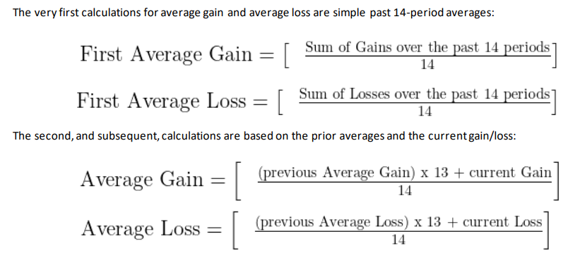

**Super Trend:** A Super Trend is a trend following indicator similar to moving averages. It is plotted on price and the current trend can simply be determined by its placement vis-a-vis price. It is a very simple indicator and is constructed with the help of just two parameters- period and multiplier.

When we construct the Supertrend indicator strategy, the default parameters are 10 for Average True Range (ATR) and 3 for its multiplier. The average true range (ATR) plays a key role in ‘Supertrend’ as the indicator uses ATR to compute its value and it signals the degree of price volatility.

**Calculation of supertrend:**

BASIC UPPER BAND = (HIGH + LOW)/2 + Multiplier* ATR

BASIC LOWER BAND = (HIGH + LOW)/2 – Multiplier* ATR

FINAL UPPER BAND = IF (Current BASIC UPPERBAND< Previous FINAL UPPER BAND) and (Previous close < Previous FINAL LOWER BAND)) THEN (Current BASIC LOWER BAND) ELSE Previous FINAL LOWER BAND)

FINAL LOWER BAND = IF ((current BASIC LOWER BAND > Previous FINAL LOWER BAND) and (Previous Close < Previous FINAL LOWER BAND)) THEN (Current BASIC LOWER BAND) ELSE Previous FINAL LOWER BAND)

SUPER TREND = IF (Current Close <= Current FINAL UPPER BAND) THEN current

FINAL UPPER BAND ELSE Current FINAL LOWERBAND

**Calculation of Average True Range:**

[(Prior ATR * 13) + Current TR] / 14

Here, 14 indicates a period. Therefore, the derivation of ATR is by multiplying the

previous ATR with 13. Furthermore, add the latest TR and divide it by Period.

**Sample Model:**

In this strategy, we have taken the ratio of pair trading stocks.

For example, we will be taking stock from the same industry i.e., Infosys and TCS as they are usually highly corelated.

The graphs shown is from Apr to Dec 2021

Arrows show Supertrend (above arrow) and Relative strength(below arrow).

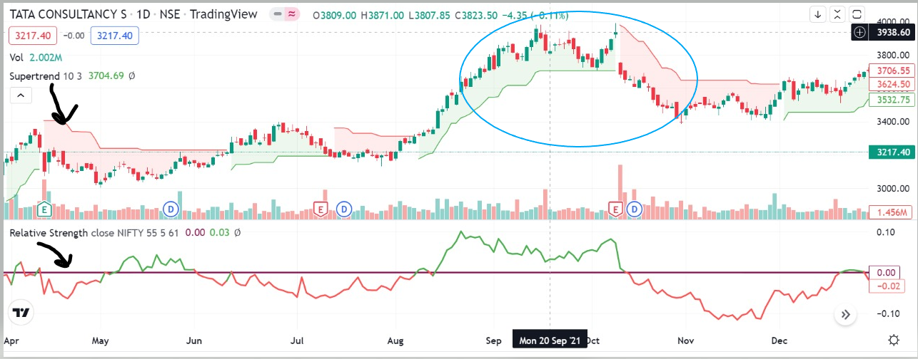

**Fig1:TCS**

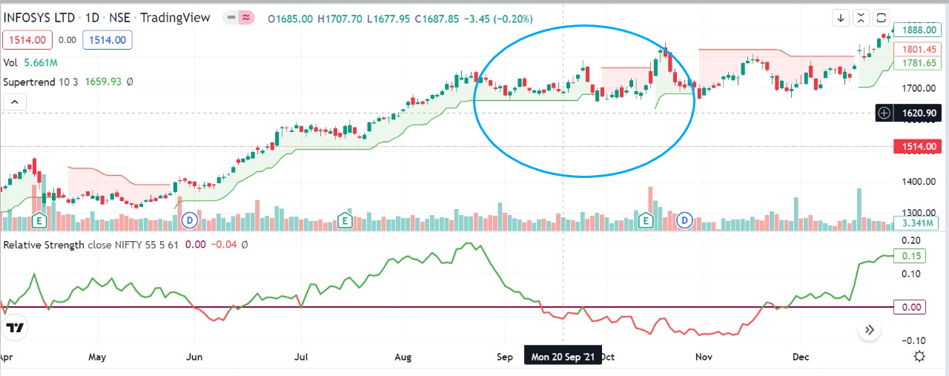

**Fig2: Infosys**

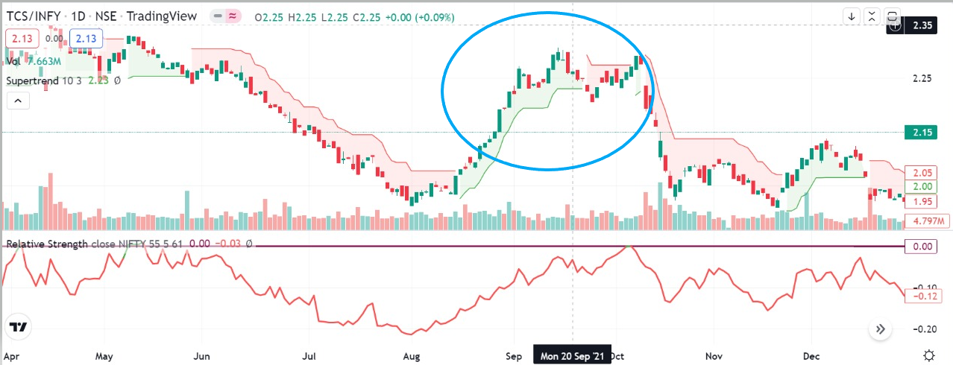

**Fig3:TCS(Stock 1)/Infosys(Stock 2)**

**ENTRY:** If Stock 1’s RS > Stock 2’s RS and supertrend for the ratio is bullish:

Long for stock 1,short for stock 2.

If Stock 1’s RS < Stock 2’s RS and supertrend for the ratio is bearish:

Long for stock 2,short for stock 1.

**EXIT:** 5% stop loss or 5% profit or 5 days.

As you can see in fig1,in the period August to September(period highlighted by blue oval in fig),TCS overperformed(as compared to nifty) as per Relative Strength and in fig2, Infosys underperformed in same period.Also, super trend shows an uptrend (as shown in fig 3) which means we can take a trade and go long on TCS and short on Infosys.

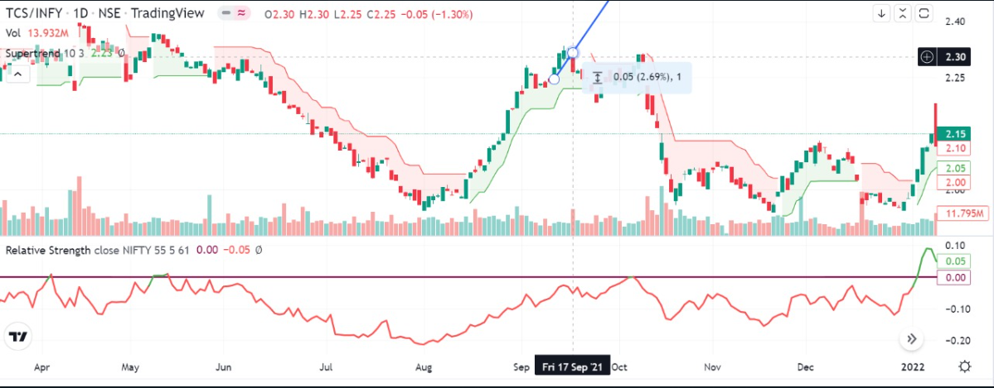

Fig 4(Exit strategy)

For example if we take a long trade on 13 Sept and exit it on 17 sept i.e. after 5 days we make a profit of 2.69%(as shown in fig 4.).We did this because as per our strategy 5 day criteria hit first before 5% stoploss or 5% profit.

## High Level Architecture

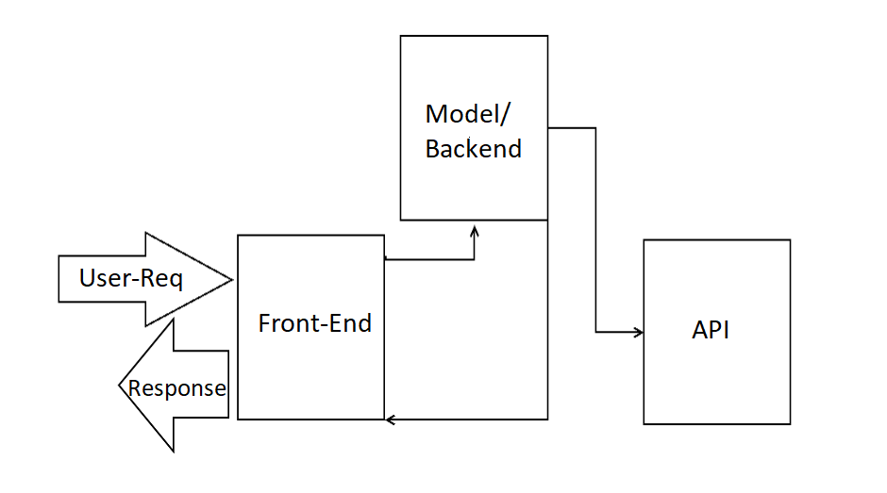

**Fig 5.Architecture**

# **Impact**

## Product Approach

## This product is based on stock market which is very volatile and can have many strategies and have to deal with large data. So, first we have to study different strategies and have to come up with a suitable one which can potentially give us maximum profits. Then, transforming our ideas into code and back testing our strategy on different pairs to see if it works well or not. After getting desired results we would develop an interface with reliable backend and beautiful frontend, which will be our product.

## Business Impact

Unlike different trading techniques such as option trading (which can be risky) pair trading is generally risk-neutral strategy but there are some things which are somewhat challenging. For example, Pairs trading rely on the securities having a high statistical correlation. Most of the traders require a correlation of at least 0.80 which is challenging to recognize. So, our approach can assist the respective business to find such pairs, compare different pairs and maximize their profits.

# **Non-functional Requirements**

## Scalability The solution will be highly capable in handling advanced system inputs on a large scale.

## Throughput The output of the solution will take approximately around 4-5 seconds for input size less or equal to 10^4 and may take a little bit more unit of time for a larger input.

## Security Though the historical data is available freely over the internet but the solution or product will ensure adequate amount of security for the input been taken from a particular user and keeping it safe in case of any malware attack.

## Entitlement The solution will provides absolute right to the user to use the product in any legal way possible.

## Cloud Deployment The current solution can lag any cloud deployment as such but can be incorporated if traffic is higher than expected or cannot be handled.

## Test Automation Testing of the data would be done in an automated fashion which would a part of our backend.