A Report on Major project

PsycheWriter: Crafting Text with Brain Waves

*SUBMITTED IN PARTIAL FULFILLMENT OF THE REQUIREMENTS FOR THE DEGREE OF*

#### BACHELOR OF TECHNOLOGY IN

**COMPUTER ENGINEERING OF**

**VISHWAKARMA INSTITUTE OF TECHNOLOGY**

## Savitribai Phule Pune University

*BY*

**Samiksha Hiran (12010919)**

**Ansh Jaiswal (12010298)**

**Sanskar Jain (12010868)**

*UNDER THE GUIDANCE OF*

Prof. Saraswati Patil



DEPARTMENT OF COMPUTER ENGINEERING

##### BANSILAL RAMNATH AGARWAL CHARITABLE TRUST’S

VISHWAKARMA INSTITUTE OF TECHNOLOGY

(An Autonomous Institute affiliated to Savitribai Phule Pune University)

PUNE - 411037

2023 - 2024

**BANSILAL RAMNATH AGARWAL CHARITABLE TRUST’S**

## VISHWAKARMA INSTITUTE OF TECHNOLOGY

**(An Autonomous Institute affiliated to Savitribai Phule Pune University)**

## PUNE – 411037



**CERTIFICATE**

This is to certify that the Major Project titled **PhycheWriter: Crafting Text with Brain Waves** submitted by **Samiksha Hiran (12010919), Ansh Jaiswal (12010298)** and **Sanskar Jain (12010868)** is in partial fulfillment for the award of Degree of Bachelor of Technology in Computer Engineering of Vishwakarma Institute of Technology, Savitribai Phule Pune University. This project report is a record of bonafide work carried out by them under my guidance during the academic year 2023-24.

**Guide Head of Computer Department Dr. Jyoti Kanjalkar Prof. Dr. S. R. Shinde** Dept. of Computer Engg. Vishwakarma Institute of Technology,.

#### Sign of External Examiner Date

Bansilal Ramnath Agarwal Charitable Trust’s

**Vishwakarma Institute of Technology, Pune-37**

**Department Of Computer Engineering**

## PROJECT SYNOPSIS

Group No: CS-35 Group Members:

|  |  |  |  |  |
| --- | --- | --- | --- | --- |
| **Roll No** | **Name** | **Class** | **Contact No** | **Email-ID** |
| 17 | Samiksha Hiran | B. Tech | 8180911889 | [samiksha.hiran20@vit.edu](mailto:samiksha.hiran20@vit.edu) |
| 27 | Sanskar Jain | B. Tech | 9021620156 | [sanskar.jain20@vit.edu](mailto:sanskar.jain20@vit.edu) |
| 28 | Ansh Jaiswal | B. Tech | 8669073789 | [ansh.jaiswal20@vit.edu](mailto:%20ansh.jaiswal20@vit.edu) |

Academic Year : 2023-24

Project Title : PsycheWriter: Crafting Text with Brain Waves

Project Area : BCI

Sponsor Company : -NA

Company Address : -NA

Internal Guide : Dr. Jyoti Kanjalkar

Name of the External Guide:

Contact No:

**Signature of Internal Guide**

## ACKNOWLEDGEMENT

##### It gives us great satisfaction to be able to present this project on PsycheWriter: Crafting Text with Brain Waves. We would like to express our deep gratitude towards our project guide Prof. Saraswati Patil, for all the guidance and the co-operation, without whom this project would have been an uphill task. We would also like to thank Prof. Dr. Sandip Shinde for his invaluable guidance on how to robustly secure the web application.

Samiksha Hiran

Sanskar Jain

Ansh Jaiswal

**INDEX**

|  |  |  |
| --- | --- | --- |
| **Sr.no.** | **Table of contents** | **Pg. no** |
| 1 | Software Project Synopsis | 6 |
| 2 | Feasibility Status Report | 8 |
| 3 | Use Case Analysis Document | 12 |
| 4 | Software Requirements Specification | 15 |
| 5 | Software Project Plan | 18 |
| 6 | Software Implementation Document | 20 |
| 7 | Conclusion | 31 |
| 8 | References | 32 |

|  |  |  |
| --- | --- | --- |
| **Sr. no.** | **List of figures** | **Pg. no** |
| 1 | Flow Diagram for architecture is displayed. | 22 |
| 2 | Slack Development | 23 |
| 3 | Jupyter Notebook Development | 24 |
| 4 | VS Code | 24 |
| 5 | CNN Accuracy | 25 |
| 6 | RNN loss | 25 |
| 7 | XG Boost Accuracy | 25 |
| 8. | Front End of web application | 26 |

# Software Project Synopsis



#### Approvals Signature Block

|  |  |  |
| --- | --- | --- |
| **Project Responsibility** | **Signature** | **Date** |
| *Project Guide (Internal)* |  |  |
| *Project Guide (External)* |  |  |
| *Documentation Leader* |  |  |

**1. CONTEXT**

The 21st century saw the advent of BCI (Brain Computer Interface) which completely transformed the way people can communicate. Creating a "PsycheWriter" that crafts text with brain waves is an ambitious and cutting-edge endeavor at the intersection of neuroscience, technology, and writing. This concept envisions a system or device that allows individuals to compose text or communicate by directly translating their brain activity into written words.

**2. PROBLEM**

Creating a technology like PsycheWriter, which crafts text with brain waves, has the potential to address several significant problems and challenges, primarily related to accessibility and communication for individuals with disabilities. PsycheWriter can provide a means of communication for individuals with severe physical disabilities, such as quadriplegia, who may have limited or no use of their limbs. It allows them to express their thoughts, needs, and desires independently. It empowers them to engage in social interactions, make decisions, and express their creativity. The development of technologies like PsycheWriter aligns with the broader goal of making technology and communication more inclusive and accessible for people of all abilities.

**3. SOLUTION**

The proposed approach will provide an overview along with functionalities, challenges and its impact on the society. Additionally, we will discuss potential applications beyond text composition, offering a glimpse into the future of human-machine collaboration empowered by BCI technology. This project aims to shed light on the capabilities and potential of PsycheWriter, illustrating the exciting journey at the interaction of neuroscience, natural language processing, and human-computer interaction.

# Feasibility Study Report



#### Approvals Signature Block

|  |  |  |
| --- | --- | --- |
| **Project Responsibility** | **Signature** | **Date** |
| *Project Guide (Internal)* |  |  |
| *Project Guide (External)* |  |  |
| *Documentation Leader* |  |  |

1. **PURPOSE**

The purpose of creating PsycheWriter, a technology that crafts text with brain waves, is to empower individuals with severe physical disabilities, such as quadriplegia or locked-in syndrome, by providing them with a direct and efficient means of communication and creative expression. By translating their brain activity into written words, PsycheWriter aims to enhance the quality of life, independence, and dignity of these individuals, reducing their dependence on caregivers and traditional assistive devices. It addresses a critical need for inclusive and accessible technology, bridging the communication gap and enabling these individuals to participate more fully in social interactions, make decisions, and engage in creative pursuits, ultimately improving their overall well-being.

1. **CURRENT SYSTEMS AND PROCESSES**

With the ever-increasing developments in the field of BCI the data users hoard has significantly gone up leading to the growth in this industry. the development of practical "PsycheWriter" systems using brain waves for text generation was still in the research and prototyping phase, with limited commercial applications. These systems typically relied on electroencephalography (EEG) to capture brain signals, and machine learning algorithms to interpret those signals for text input. Users would undergo training to establish connections between their thoughts and specific commands, such as selecting letters or words. The accuracy and speed of these systems varied, and they often required improvements to be widely accessible.

1. **SYSTEM OBJECTIVES**

The primary objective of a "PsycheWriter" system, utilizing brain waves for text generation, is to provide individuals, particularly those with severe physical disabilities, a direct and efficient means of communication and creative expression. By translating their brain activity into written words, the objective is to enhance their quality of life, independence, and dignity, reducing their dependence on caregivers and traditional assistive devices. Additionally, PsycheWriter aims to promote inclusivity and accessibility in technology, allowing individuals to engage more fully in social interactions, make decisions, and pursue creative endeavors, ultimately improving their overall well-being and enabling them to participate more actively in society.

1. **ISSUES** 
   1. Signal Accuracy: EEG signals can be noisy and subject to interference, affecting the accuracy of interpreting brain activity for text generation.
   2. Limited Vocabulary: The system's vocabulary may be limited, which can be restrictive for users, especially when expressing complex thoughts.
   3. User Comfort: EEG caps or electrodes can be uncomfortable to wear for extended periods, affecting user experience.
   4. Cost and Accessibility: Advanced EEG equipment can be expensive, limiting accessibility for some users.
2. **ASSUMPTIONS AND CONSTRAINTS**

###### Assumptions

* 1. The user should have all the physical devices – EEG headset and its output waves for the implementation to work.
  2. All the users must have a good internet connection.

###### Constraints

1. Typing may not be as fast as traditional typing due to processing of the EEG wave.
2. Outputs may not be 100% accurate.
3. **ALTERNATIVES**

There are several alternative keyboard input methods designed to accommodate individuals with

different needs or preferences. Some of these alternative keyboards include:

1. Braille Keyboards: Braille keyboards are designed for individuals with visual impairments. These keyboards typically have small, raised pins or keys that correspond to Braille characters. Users can type by pressing combinations of these pins to form Braille text.
2. Virtual Keyboards: Virtual keyboards are software-based keyboards that can be displayed on a computer screen or touchscreen device. Users can type by tapping on the virtual keys with a mouse, touchscreen, or other input devices. These keyboards can be customized for different layouts and languages.
3. On-Screen Keyboards: On-screen keyboards are typically part of the operating system and can be controlled with a mouse, touch, or other input methods. They are helpful for people with mobility impairments who may have difficulty using physical keyboards.
4. Sound-Based Keyboards: Sound-based keyboards use sound as input. Users create sounds or clicks, and the system interprets the timing and pitch of these sounds to determine which keys are being pressed. This technology is often used in speech recognition software.
5. Gesture-Based Keyboards: Gesture-based keyboards allow users to input text or commands through hand or body movements. Devices like the Microsoft Kinect or Leap Motion use gestures for input.
6. Eye-Tracking Keyboards: Eye-tracking technology enables users to control a virtual keyboard by moving their eyes and fixating on specific keys or characters. It's a valuable option for individuals with severe mobility impairments.
7. Stenographic Keyboards: Stenographic keyboards are specialized keyboards used by court reporters and stenographers to transcribe spoken words at high speeds. They use shorthand and a unique key layout for rapid text entry.
8. Chorded Keyboards: Chorded keyboards require users to press combinations of keys (chords) to generate characters. These compact keyboards are often used in specialized applications like wearable technology or assistive devices.
9. Predictive Text and Auto-Correct: Predictive text and auto-correct software can assist users in typing by suggesting words or correcting errors as they type. This is particularly useful for touchscreen devices and people with mobility or dexterity challenges.

These alternative keyboard methods can enhance accessibility and provide solutions for individuals with different needs and preferences. The choice of keyboard method depends on the user's specific requirements and abilities.

# Use Case Analysis Document



#### Approvals Signature Block

|  |  |  |
| --- | --- | --- |
| **Project Responsibility** | **Signature** | **Date** |
| *Project Guide (Internal)* |  |  |
| *Project Guide (External)* |  |  |
| *Documentation Leader* |  |  |

**USE CASE TEMPLATE**

|  |  |  |
| --- | --- | --- |
| USE CASE | To facilitate communication through brain waves, enabling direct and efficient exchange of thoughts and emotions between individuals. | |
| **Goal** | The goal of a psyche writer is to enhance and streamline communication by translating and transmitting thoughts directly through brain waves, fostering a deeper and more immediate understanding between individuals. | |
| **Purpose** | 1. Enhanced Non-Verbal Communication: A psyche writer enables individuals to convey thoughts, emotions, and complex ideas directly through brain waves, bypassing the limitations of verbal language and enhancing the depth and nuance of non-verbal communication. 2. Accessible Communication for Diverse Abilities: It serves as an inclusive communication tool, providing a means of expression for individuals with communication challenges or disabilities, fostering a more inclusive society by allowing diverse individuals to connect on a profound level through their shared thoughts and emotions. | |
| **Preconditions** | The precondition of a psyche writer for communication through brain waves is a comprehensive understanding of the neural patterns and signals associated with specific thoughts and emotions. This goes along with the hardware needed to detect the brain waves. | |
| **Success Condition** | The success condition of a psyche writer lies in its ability to accurately and reliably transmit the intended thoughts and emotions between individuals via brain waves, fostering clear and meaningful communication. | |
| **Failed Condition** | The failed condition of a psyche writer is the inability to accurately interpret or transmit brain waves, leading to miscommunication or distortion of thoughts and emotions between individuals. | |
| **Primary Actors** | EEG  Interface  SPU (Signal processing units) | |
| **Trigger** | The trigger for a psyche writer facilitating communication through brain waves typically involves a mental command or focused intention from the user, activating the device to interpret and transmit their thoughts. | |
| **DESCRIPTION** | **Step** | **Basic Course of Action** |
|  | 1 | Interface Development. |
|  | 2 | Signal Processing and communication protocol. |
|  | 3 | User Training. |
|  | 4 | Testing and Calibration and Regulatory Compliance. |
|  | 5 | Continuous Improvement. |

# Software Requirements Specification



#### Approvals Signature Block

|  |  |  |
| --- | --- | --- |
| **Project Responsibility** | **Signature** | **Date** |
| *Project Guide (Internal)* |  |  |
| *Project Guide (External)* |  |  |
| *Documentation Leader* |  |  |

**1. SCOPE**

The goal of a psyche writer for communication through brain waves is to establish a direct and efficient means of exchanging thoughts, emotions, and information between individuals, bypassing traditional forms of communication. By harnessing advanced brain-computer interface technology, the aim is to enable a seamless and intuitive connection that transcends linguistic and cultural barriers, fostering a deeper and more immediate understanding between users.

The scope of a psyche writer encompasses:

1. Mind-to-Mind Communication:

- Enabling individuals to communicate directly through their thoughts and emotions, enhancing the richness and nuance of interpersonal interaction.

2. Accessibility:

- Providing a means of communication for individuals with physical disabilities or communication disorders, offering them an alternative and inclusive way to express themselves.

3. Cross-Cultural Communication:

- Facilitating communication without language barriers, allowing people from different linguistic backgrounds to connect more intimately.

4. Expressive Communication:

- Allowing users to convey complex emotions, ideas, and concepts with greater precision and depth than traditional verbal or written communication.

5. Cognitive Collaboration:

- Supporting collaborative endeavors by enabling the exchange of ideas at a cognitive level, potentially enhancing creativity and problem-solving.

6. Therapeutic Applications:

- Exploring therapeutic applications, such as aiding individuals with mental health conditions or providing a platform for emotional expression and support.

7. Augmented Communication:

- Augmenting existing communication methods, providing an additional layer of communication that complements spoken or written words.

8. Privacy and Security:

- Addressing the ethical implications of mind-to-mind communication by implementing robust privacy and security measures to protect users' mental privacy.

9. Research and Development:

- Serving as a platform for ongoing research in neuroscience, human-computer interaction, and related fields to continually improve the technology and expand its capabilities.

10. Human-Machine Integration:

- Exploring the integration of the psyche writer with other technologies, such as artificial intelligence, to create synergies that enhance the overall communication experience.

The scope is broad, encompassing both personal and societal aspects, with potential implications for how we understand, connect, and communicate as human beings.

**2. REQUIREMENTS**

In the context of a BCI keyboard implementation, the availability of physical devices such as EEG headsets and a reliable internet connection is crucial for a successful user experience. Here's why these elements are essential:

1. EEG Headset: Data Acquisition: EEG headsets are used to capture the user's brainwave activity, which is a fundamental aspect of BCI technology. Without an EEG headset, the system cannot collect the necessary neural data required for brain-computer communication. User-Specific Data: Each user's brain activity is unique. The EEG headset is personalized to the individual, allowing the system to learn and recognize their specific brainwave patterns and intentions. Without the headset, the system would lack this critical user-specific data. Control Input: The EEG headset enables the user to convey their intentions and commands through their brain activity. It acts as the bridge between the user's thoughts and the BCI keyboard, making it a core component of the technology.
2. Good Internet Connection: Data Transmission: BCI keyboards often require the EEG data to be transmitted from the headset to a remote server or processing unit for analysis. This data transfer relies on a stable and high-speed internet connection to ensure real-time or near-real-time communication. Remote Processing: Some BCI systems leverage cloud-based processing, where the EEG data is sent to a remote server for analysis and then returned to control the keyboard. A reliable internet connection is essential for the seamless functioning of such systems. Latency Reduction: Low latency is crucial for a responsive user experience. A strong internet connection helps minimize delays between the user's brain signals and the system's response, which is especially important for tasks like typing on a BCI keyboard.
3. ClientApplication- The client application, written in Flask provides the main User Interface for the user to access the brain computer interaction keyboard.

# Software Project Plan



#### Approvals Signature Block

|  |  |  |
| --- | --- | --- |
| **Project Responsibility** | **Signature** | **Date** |
| *Project Guide (Internal)* |  |  |
| *Project Guide (External)* |  |  |
| *Documentation Leader* |  |  |

**1. OVERVIEW**

We adopted the Agile methodology of Software development to complete the project. We planned a sprint of 1 week. At the end of each week, we reviewed and merged all the code written during the sprint and also panned the tasks for the next week.

**2. PROJECT GOALS**

|  |  |  |
| --- | --- | --- |
| **Project Goal** | **Priority** | **Comment/Description/Reference** |
| **Business Goals:** |  |  |
| Build the solution | 2 | Help all the people who is dumb and deaf to communicate without any hesitation and difficulties. |
| **Technological Goals:** |  |  |
| Development and consideration of all signals. | 1 | To have a fully tested and working system we need to train the system very efficiently. |
| Develop frontend UI | 1 | Develop the Interface UI |

# System Implementation Document



#### Approvals Signature Block

|  |  |  |
| --- | --- | --- |
| **Project Responsibility** | **Signature** | **Date** |
| *Project Guide (Internal)* |  |  |
| *Project Guide (External)* |  |  |
| *Documentation Leader* |  |  |

**1. IMPLEMENTATION**

**DATASET**

The Emotiv dataset typically refers to a collection of electroencephalography (EEG) data recorded using Emotiv EEG headsets. The Emotiv dataset can vary depending on the specific research or project it was collected for. Typically, such a dataset would include EEG recordings from multiple channels/electrodes on the scalp, capturing brain activity signals. These datasets might be used for tasks such as brain-computer interface development.

The label of actions:

up:1

down: 2

left:3

right:4

middle: 5

eye close: 6

Our approach leverages the strengths of CNNs and RNNs for spatial and temporal feature extraction, an autoencoder for feature adaptation, and XGBoost for accurate classification. This comprehensive pipeline enables us to effectively process EEG data, highlighting relevant information and improving the accuracy of directional classification.

1. Data Collection and Preparation:

We begin with a dataset consisting of EEG waves, each accompanied by a directional label, signifying the intended movement or state. This dataset named S1nolabel6 serves as the foundation for our machine learning model. The S1nolabel6 dataset consists of EEG (Electroencephalography) wave recordings collected from 64 channels. Each row of the dataset represents a single EEG recording session, and there are a total of 65 columns in each row. The dataset captured brain activity while performing specific directional tasks, such as moving left, right, up, down, or eyes closed. These directional labels are provided in the 65th column of the dataset such as 1 for left,2 for down and so on.

2. Model Architecture: Our machine learning model is designed with a sophisticated architecture to effectively capture both spatial and temporal information in the EEG data.

 Spatial Feature Extraction with CNN: We employ a Convolutional Neural Network (CNN) as the first component of our model. The CNN is specifically designed for spatial feature extraction. It scans the EEG data, identifying patterns and features in different spatial locations. This allows it to discern spatial nuances in the input data.

 Temporal Feature Extraction with RNN: Simultaneously, we employ a Recurrent Neural Network (RNN) to capture temporal dependencies within the EEG data. The RNN processes the data sequentially, recognizing patterns and relationships over time. This temporal analysis is critical in understanding the dynamic nature of EEG signals.

3. Parallel Processing and Stacking:

The CNN and RNN operate in parallel, ensuring that spatial and temporal features are extracted concurrently. The outputs from these two networks are then stacked together, forming a multi-dimensional representation of the EEG data.

5. Feature Adaptation with Autoencoder Layer:

To further enhance the integration of spatial and temporal features, we introduce an autoencoder layer. This layer serves as a feature adaptation method, mapping the stacked features into a new, correlated feature space. By leveraging the power of autoencoders, we can reduce noise, enhance important patterns, and create a more informative representation that fuses spatial and temporal information effectively.

6. Fusion of Information:

The adapted feature space combines spatial and temporal information in a manner that highlights relevant patterns and relationships within the EEG data. This fusion is crucial for obtaining a comprehensive understanding of the underlying neural activity.

7. Direction Classification with XGBoost:

Finally, we employ the XGBoost algorithm for the task of direction classification. XGBoost is well-suited for this task, as it can handle complex, high-dimensional feature spaces and make accurate predictions. It takes the fused features from the previous step as input and performs the classification task, accurately determining the intended direction or state based on the enriched feature representation.

###### Flow Diagram

The flow for the architecture is displayed in Figure 1.0 below.

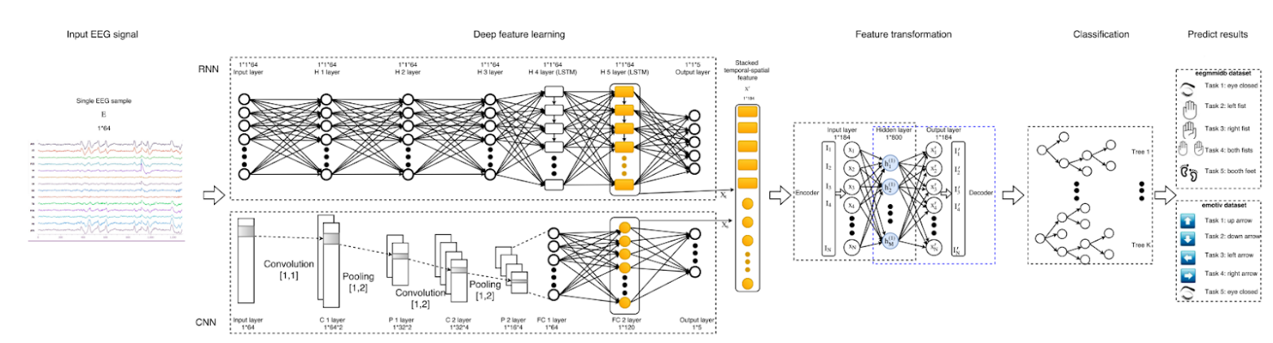

Figure 1.0

**2. DEVELOPMENT**

We adopted the Agile methodology of Software development to complete the project. We planned a sprint for 1 week. At the end of each week, we reviewed and merged all the code written during the sprint and planned the tasks for the next week. We used Jupyter Notebook, VSCode and Slack to manage the source code for backend and frontend.

SLACK

Slack is a popular team collaboration and communication platform that is designed to streamline workplace communication and make it more efficient. It was first launched in 2013 and has since become a widely used tool for businesses, organizations, and teams of all sizes. Slack offers a range of features and capabilities that help teams work together, share information, and stay connected in both real-time and asynchronously*.*

Figure 2.0

Jupyter Notebook

Jupyter Notebook is widely used in the fields of data science, machine learning, scientific research, education, and more. It provides a versatile and user-friendly environment for combining code, data, visualizations, and explanatory text in a single document, making it an essential tool for those who work with data and want to communicate their findings effectively.

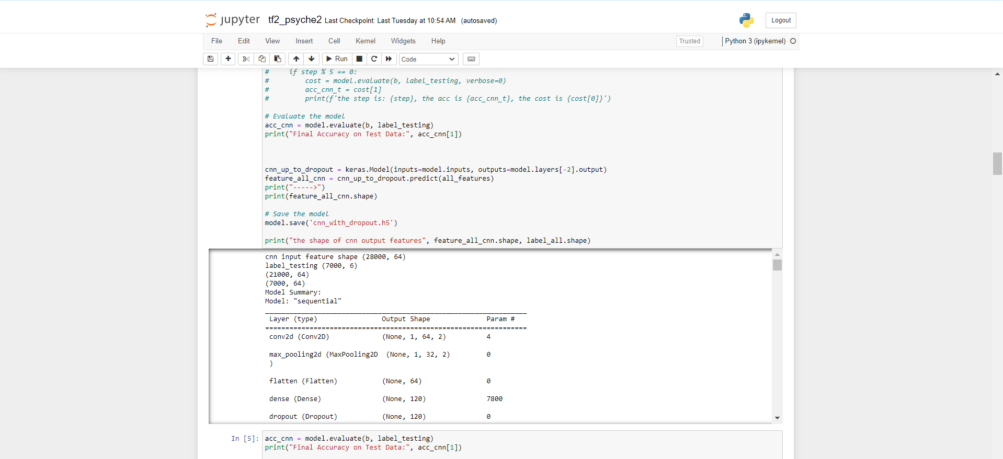

Figure 3.0

VScode

Visual Studio Code, often abbreviated as VS Code, is a free and open-source code editor developed by Microsoft. It has gained immense popularity among developers and is widely used for software development across various programming languages. VS Code is known for its robust set of features and extensions, which make it a powerful and versatile code editor.

*Figure 4.0*

**3. RESULTS**

Firstly, talking about our machine learning architecture, we have 3 models: CNN, RNN, Autoencoder and then for classification we have used XGBoost.

The accuracy of CNN on 1500 epochs is around 68.8% which you can see below.



*Figure 5.0: CNN Accuracy*

The training loss for RNN model reduced from 3.17 to 0.32 which was ran for 500 epochs.

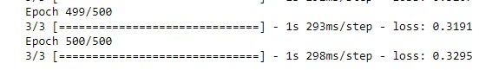

*Figure 6.0: RNN Loss*

Finally, accuracy for XGBoost model is around 93.2%.

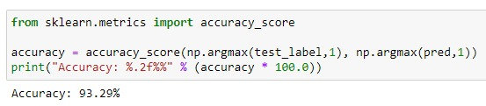

*Figure 7.0: XGBoost Accuracy*

Now if we talk about the frontend, see figure 8.0 .Here we have represented keyboard in terms of three different directions in which if the user wants to type a he would think left in his mind and his EEG signal wave data would be fetched and given in the text box for further processing by our model to split the left string more further and so on.

Figure 8.0: Front end of the web application.

**Comparative Results**

The results of this comparative study serve as a valuable resource for understanding the strengths and weaknesses of our approach in relation to a similar methodology, contributing to the ongoing discourse in the field.

We employed Long Short-Term Memory (LSTM) networks, while the comparative approach utilized Recurrent Neural Networks (RNN). LSTM, being an advanced variant of RNN, is renowned for its ability to capture and retain long-range dependencies in sequential data. In contrast, traditional RNNs may struggle with learning and preserving information over extended sequences due to the vanishing gradient problem.

On 55% training data:

|  |  |  |  |
| --- | --- | --- | --- |
| **Sr no.** | **Model Architecture** | **Key Differences** | **Final Accuracy** |
| 1 | CNN+RNN, AE, XGB | RNN is used for temporal features | ~87% |
| 2 | CNN+RNN and LSTM, AE, XGB | LSTM used to prevent vanishing gradient | ~94% |

Table 1.0:Comparative Results

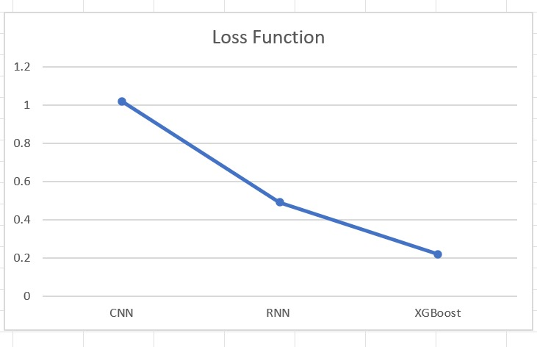

Fig 9.0:Graph of loss

As you can see in the Fig 9.0 ,the loss for CNN is 1.02,For RNN/LSTM is 0.49 and of XGB is 0.22 which shows that combining the two models lead to good results.

UML Diagrams:  
1.**Use Case Diagram**: A Use Case Diagram in Unified Modeling Language (UML) is a graphical representation of a system's functionality as seen by its users (actors). It consists of actors, use cases, and their relationships. Actors are entities external to the system that interact with it, while use cases represent the specific functionalities or tasks the system provides. Lines connecting actors and use cases show the relationships and interactions between them. Use case diagrams are helpful in visualizing the overall functionality of a system and understanding how users interact with it.

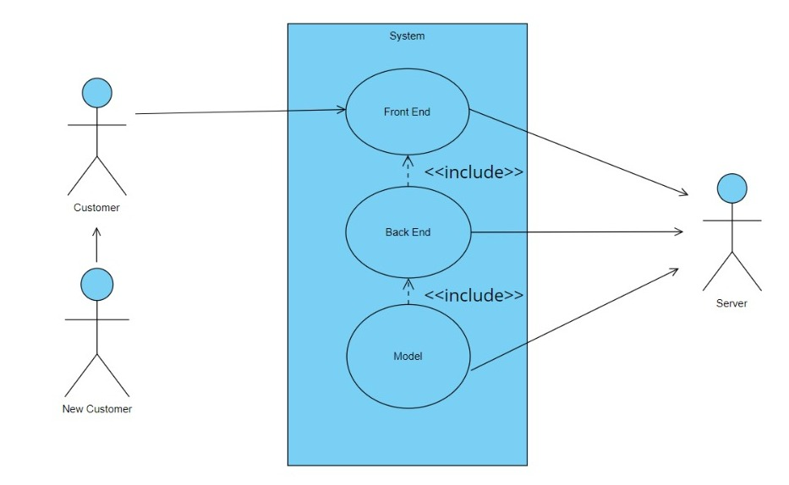

Fig 10.0 Use Case Diagram

2**.Sequence Diagram:** A Sequence Diagram in UML is a dynamic modeling diagram that shows interactions among objects arranged in a time sequence. It illustrates the flow of messages or interactions between different objects or components of a system over time. The vertical axis represents time, and horizontal arrows indicate the order of messages exchanged between objects. Sequence diagrams help visualize the dynamic behavior of a system, showing the order in which interactions occur and the messages exchanged. They are particularly useful for understanding the logic of complex scenarios and the timing of interactions between different components in a system.

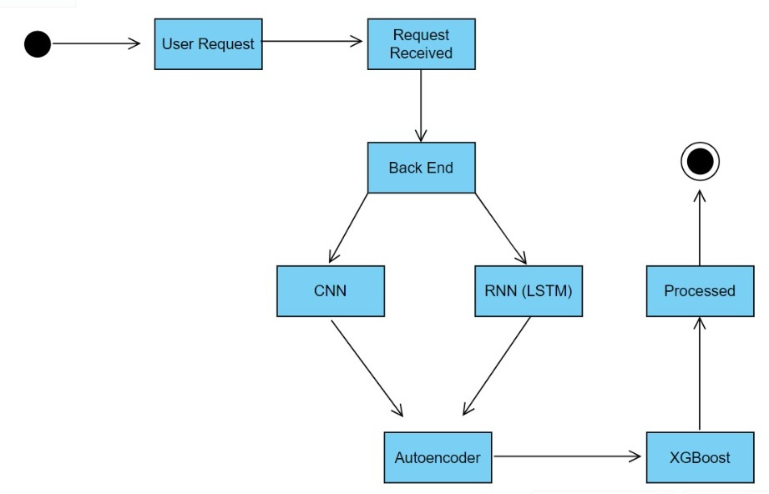

Fig 11.0 Sequence Diagram

**4. CHALLENGES AND POSSIBLE SOLUTIONS**

While the concept of a "psyche writer" for communication through brain waves presents exciting possibilities, several challenges exist that need to be addressed for the current system outlined in the paper. These challenges span technical, ethical, and practical considerations:

1. Accuracy and Interpretation:

- Challenge: Accurately interpreting and translating complex brain wave patterns into meaningful communication poses a significant challenge. Variability in individual brain activity and the nuanced nature of thoughts and emotions make precise interpretation difficult.

- Solution: Continuous improvement of signal processing algorithms and machine learning models to enhance accuracy. Collaboration with neuroscientists for a deeper understanding of brain signals.

2. User Variability and Training:

- Challenge: Users may exhibit diverse brain patterns, and individual training requirements can vary. Ensuring effective user training to control and express thoughts through the psyche writer is crucial for optimal performance.

- Solution: Develop personalized training programs, leveraging adaptive learning techniques to accommodate individual differences. Provide ongoing user support and feedback mechanisms.

3. Privacy and Security Concerns:

- Challenge: Communicating through brain waves raises significant privacy concerns, as thoughts are inherently personal. Ensuring the security of transmitted information and obtaining informed consent from users is paramount.

- Solution: Implement robust encryption methods, stringent access controls, and transparent user consent processes. Collaborate with experts in privacy and ethics to establish industry standards.

4. Ethical Implications:

- Challenge: The potential misuse of mind-to-mind communication technology raises ethical questions, including unauthorized access to thoughts and potential psychological impacts.

- Solution: Establish clear ethical guidelines and regulations. Conduct thorough risk assessments and involve ethicists in the development process. Prioritize user autonomy and consent.

5. Interference and Environmental Factors:

- Challenge: External factors, such as environmental noise or interference, may affect the reliability of brain wave signals. Ensuring the system's robustness in real-world scenarios is crucial.

- Solution: Implement noise reduction algorithms and conduct rigorous testing in diverse environments. Develop adaptive systems that can compensate for variations in signal quality.

6. Integration with Existing Communication Methods:

- Challenge: Integrating the psyche writer into existing communication methods seamlessly can be challenging. Coordinating between traditional communication and the novel brain wave-based system is essential for widespread adoption.

- Solution: Design user-friendly interfaces that complement existing communication tools. Conduct usability studies and obtain user feedback for iterative improvements.

7. Long-Term Effects and Psychological Considerations:

- Challenge: The potential long-term psychological effects of using a psyche writer for communication are not well understood. Ensuring user well-being and mental health is a critical concern.

- Solution: Collaborate with psychologists and mental health professionals for ongoing research. Implement features for monitoring and promoting user well-being, and provide resources for mental health support.

8. Regulatory Approval and Standardization:

- Challenge: Obtaining regulatory approval for a technology that directly interfaces with the human brain is a complex process. Lack of standardized protocols can hinder widespread adoption.

- Solution: Work closely with regulatory bodies to establish safety and efficacy standards. Collaborate with industry stakeholders to create standardized protocols for brain-computer interface technologies.

Addressing these challenges requires a multidisciplinary approach, involving experts in neuroscience, ethics, privacy, and technology. The development of a psyche writer demands a careful balance between technological innovation and responsible deployment to ensure the positive impact of this groundbreaking communication technology.

**5. FUTURE SCOPE**

The future scope for a system like the psyche writer, designed for communication through brain waves, is vast and holds exciting possibilities. While the concept is currently in its infancy, advancements in neuroscience, technology, and human-computer interaction suggest several potential avenues for future development and improvement:

1. **Enhanced Precision and Speed:**

- Future iterations of the psyche writer can strive for increased precision and speed in interpreting and transmitting brain wave patterns. This could lead to more fluid and instantaneous communication, making the technology even more practical and user-friendly.

2. **Expanded Vocabulary and Complexity:**

- Researchers may work towards expanding the vocabulary and complexity of communicated thoughts and emotions. This could involve decoding more nuanced aspects of cognition, allowing for a richer and more detailed exchange of information.

3. **Neuroadaptive Interfaces:**

- Developments in neuroadaptive interfaces could enable the psyche writer to adapt to individual users over time. This could involve learning and understanding the unique brain patterns of each user, leading to a more personalized and efficient communication experience.

4. **Integration with Augmented Reality (AR) and Virtual Reality (VR):**

- Integrating the psyche writer with AR and VR technologies could create immersive communication experiences. Users might be able to share not only thoughts and emotions but also visual and auditory perceptions, leading to a more holistic form of remote interaction.

5. **Brain-Machine Collaboration:**

- Explore possibilities for collaborative efforts between the human brain and artificial intelligence. This could involve leveraging the psyche writer to work in tandem with AI systems, enhancing problem-solving capabilities, creativity, and cognitive tasks.

6. **Medical and Therapeutic Applications:**

- Further exploration of medical and therapeutic applications could be a promising avenue. The psyche writer might be used as a tool for individuals with conditions such as locked-in syndrome, enabling them to communicate and interact with the external world.

7. **Ethical and Privacy Considerations:**

- As the technology advances, there will be an increased need to address ethical concerns and privacy considerations. Future developments should prioritize robust security measures to protect users' mental privacy and ensure responsible use of the technology.

8. **User Accessibility:**

- Future iterations should focus on enhancing user accessibility, making the technology available to a broader range of individuals, including those with disabilities. This could involve developing more user-friendly interfaces and addressing potential barriers to adoption.

9. **Regulatory Frameworks:**

- With the advancement of the psyche writer, there will likely be a need for the establishment of clear regulatory frameworks to govern its use. This includes guidelines on data security, consent, and ethical considerations.

10. **Global Collaboration and Standards:**

- Given the potential societal impact of mind-to-mind communication, future developments should involve global collaboration among researchers, policymakers, and ethicists to establish standards and guidelines for the responsible development and deployment of such technology.

In summary, the future scope for the psyche writer is not only about technological advancements but also about addressing ethical, privacy, and societal implications. As the technology matures, it holds the promise of transforming the way we communicate and interact, ushering in a new era of direct and profound connection between individuals.

### CONCLUSION

In conclusion, the development and application of a psyche writer for communication through brain waves represent a groundbreaking frontier in the realm of human interaction. This innovative technology strives to transcend traditional modes of communication, offering a direct and nuanced exchange of thoughts and emotions between individuals. The intricate blend of neuroscience, brain-computer interface development, and user interface design paves the way for a future where language barriers may fade, and individuals can connect on a profound cognitive level. As we navigate the ethical considerations and technical challenges, the scope of the psyche writer extends from enhancing accessibility for those with communication disorders to fostering cross-cultural understanding. The potential impact on fields ranging from personal relationships to therapeutic applications underscores the transformative power of this technology, pointing towards a future where the boundaries of human connection are redefined through the language of brain waves.

### REFERENCES

# [1] Brain-Computer Interfacing: A method to detect pain signals in the brain of a patient under operation

<https://ieeexplore.ieee.org/document/9641628>

[2] Wireless Brain Machine Interface (BMI) System (Review & Concept)

# <https://ieeexplore.ieee.org/document/9213773>

[3] Brain Computer Interaction (BCI): A Way to Interact with Brain Waves.

# <https://insights2techinfo.com/brain-computer-interaction-bci-a-way-to-interact-with-brain-waves/>

[4] Progress in Brain Computer Interface: Challenges and Opportunities.

<https://www.frontiersin.org/articles/10.3389/fnsys.2021.578875/full>

[5] New research finds deep-sleep brain waves predict blood sugar control. (Recent Study)

<https://news.berkeley.edu/2023/07/07/new-research-finds-deep-sleep-brain-waves-predict-blood-sugar-control>

# [6] The brain wave equation: a model for the EEG

# <https://www.sciencedirect.com/science/article/abs/pii/0025556474900200>

# [7] Towards non-invasive EEG-based arm/hand-control in users with spinal cord injury.

# <https://ieeexplore.ieee.org/document/7858160>

# [8] A study on non-invasive brainwave optimization.

# <https://ieeexplore.ieee.org/document/7284214>

[9] Brainwave Cloud Classroom Training Program in Elderly People.

<https://ieeexplore.ieee.org/document/8619997>

[10] Transforming Brain waves into words with AI (Blog)

<https://developer.nvidia.com/blog/transforming-brain-waves-into-words-with-ai/>

[11] Scientists recorded a Pink Floyd song from patient’s brain waves. (Recent Application)

<https://fortune.com/well/2023/08/15/researchers-recorded-pink-floyd-song-from-brain-waves-machine-interface-eeg/>

[12] New Stanford technology allows people who lost speaking ability to talk through brain waves. (Recent Application)

<https://abc7news.com/stanford-university-medicine-als-research-new-speech-technology-communicating-through-brainwaves/13691517/>

[13] This implant turns brain waves into words. (IEEE Spectrum Speech)

<https://spectrum.ieee.org/brain-computer-interface-speech>