Ansh Gupta
102003752
COE3
Cyber Sec Lab Eval

Question 1

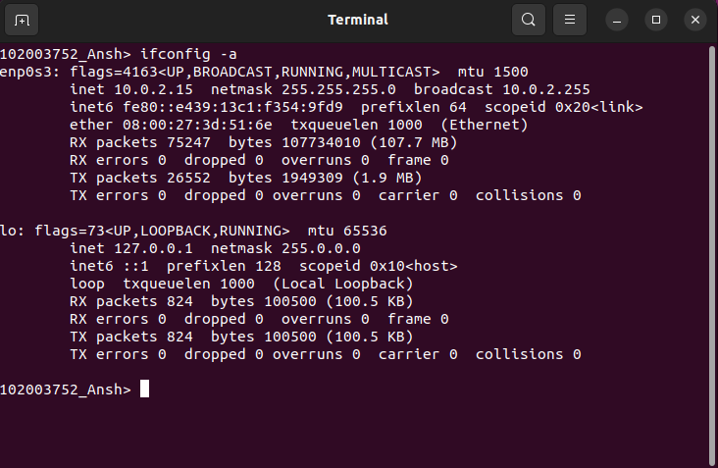
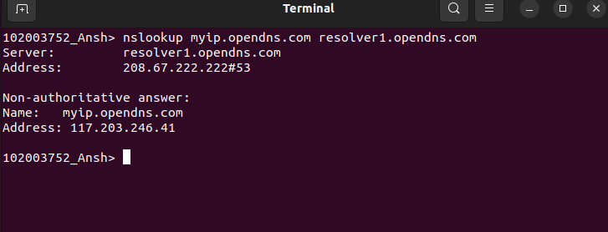

Question 2

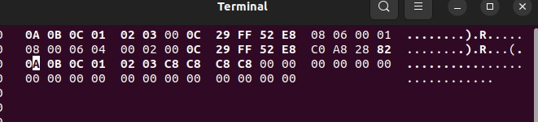

Question 3 TASK1 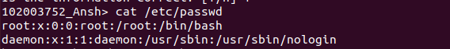 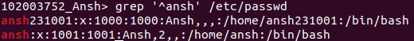 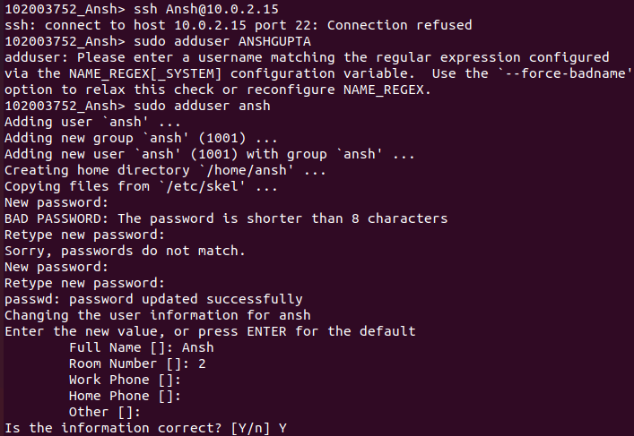 TASK 2 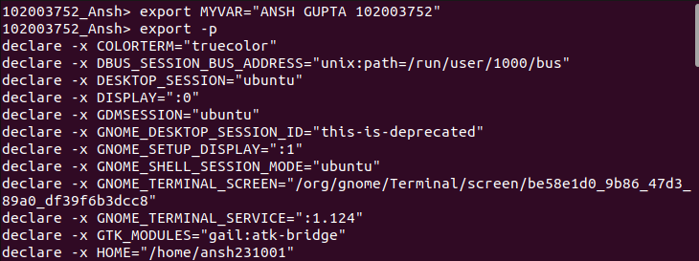 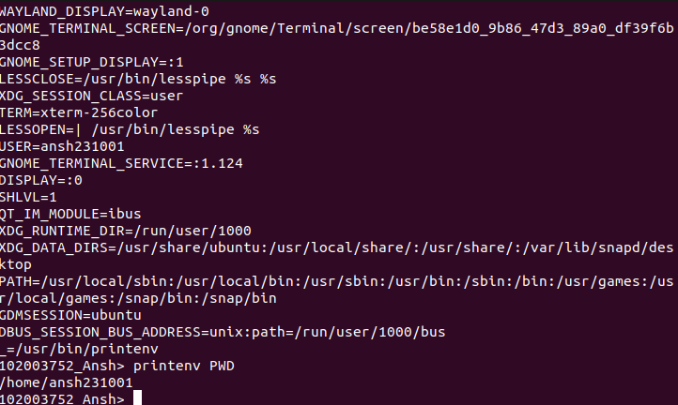 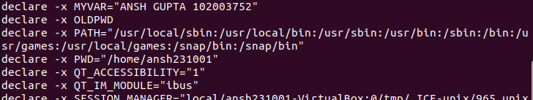 TASK 3 Observation: Since function will be called when childPid = 0, the child process will show it's output. The output is shown as an output of another process(the child process), i.e., it shows in the next command line. If we store it in a text file, we see a list of all our environment variables with their values. 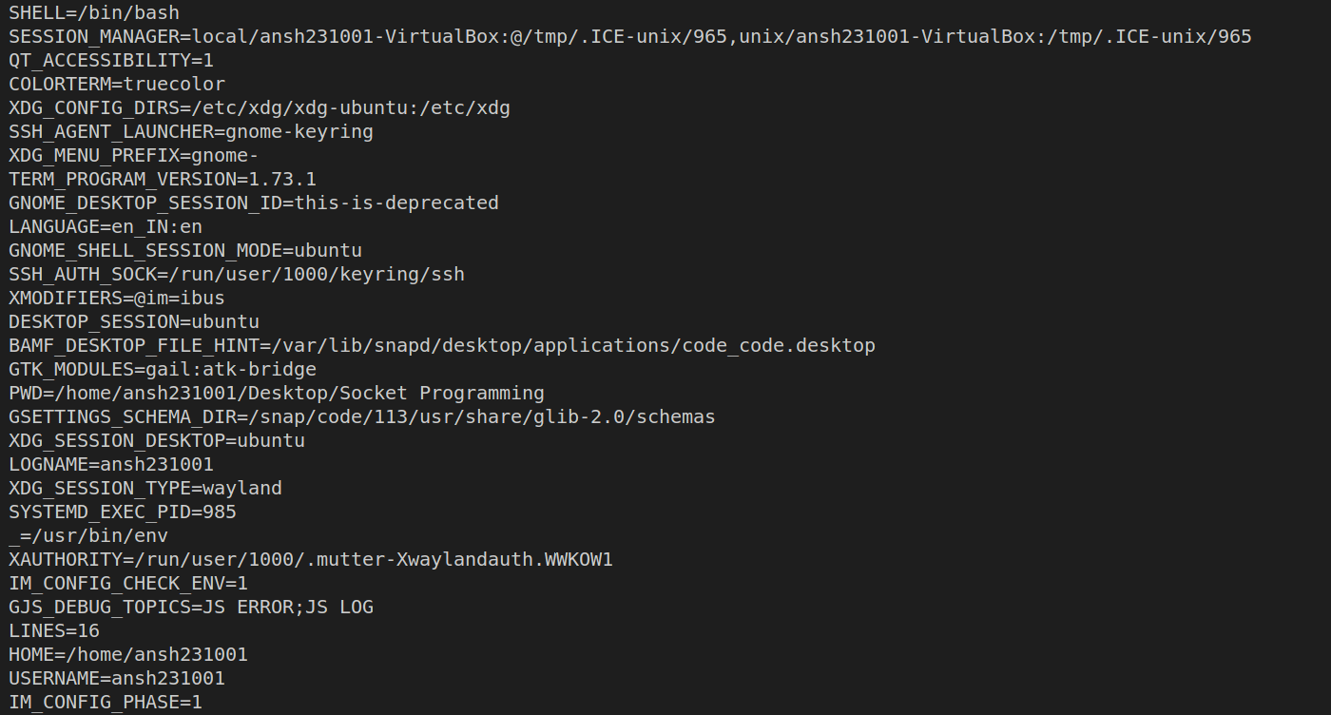 Observation 2: Now, after commenting the child's function call and uncommenting the default, we see that the parent processes' default will be called since the value of childPid will be non zero in the parent process. So, we'll see the output in the same command line. Storing the output in the file, we see the list of environment variables again. When we see the diff between the two files, we see that they are the same. So, the only difference is between the process that calls the function. Question 3 TASK 4 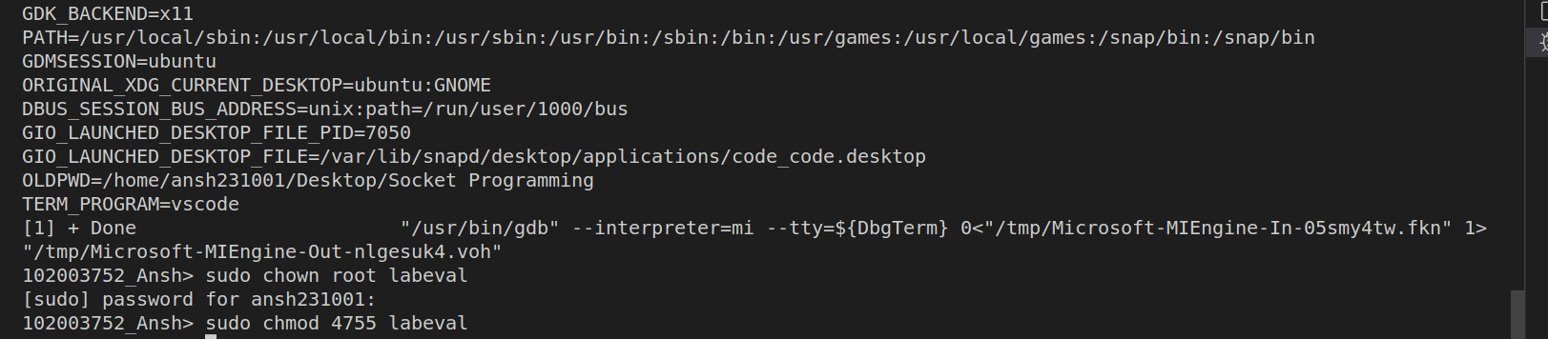 Observation We will get the value what we set for PATH, LD_LIBRARY_PATH and the user defined variable. Explanation We are changing the owership permission of the file to root. So that the file is now under the user root. If any non-root user tries to access the file, a new process will be forked with root permission and the file will be executed under root permission in that process. Next, we are trying to set the environmental variable using export command. The export command sets the environmental variable for all the processes in the system. 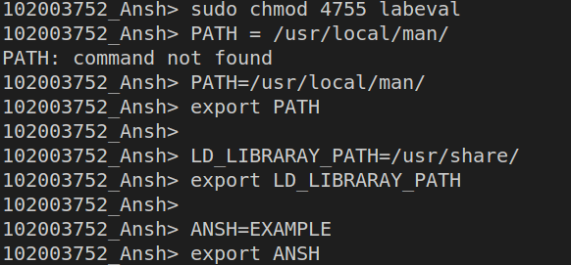 So even the root users will be accessing the new environmental variables set using the export command. That is why we are getting the value what we have set. 