Analysis of the Graphs

# For 1-1 Interaction below/equal to 12 Epsilon(1-2 Interaction):-

We have fixed the epsilon for 1-1 interaction to 10 so we are not observing any significant changes by changing the Epsilon value for 1-2 interaction as the LJ Potential for 1-1 Interaction is higher as compared to 1-2 Interaction. So the Coordination Sphere for 1-1 will remain Unaffected.

# For 1-1 Interaction above 12 Epsilon(1-2 Interaction):-

Now When we Increase the epsilon value for 1-2 Interaction above 12 we will observe a significant decrease in the first Peak value. This is because above 12 epsilon 1-2 Potential overcomes the 1-1 Potential so there will be sharp decrease in the coordination sphere for Nanoparticle as it will be surrounded by Lj particle rather than the Nanoparticle.

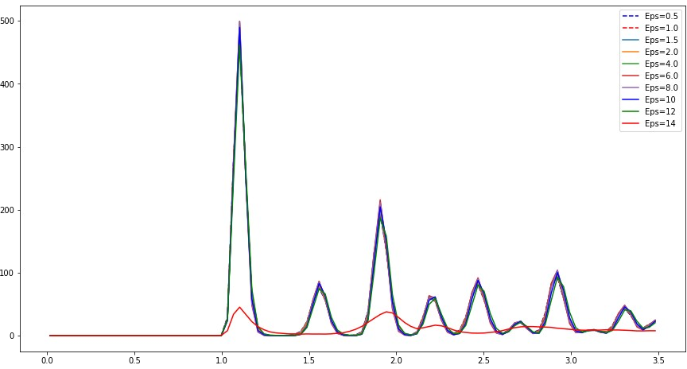

# For 1-2 Interaction below 12 Epsilon(1-2 Interaction):-

As we are increasing the epsilon value for 1-2 Interaction we will observe an increase in the first peak value since increasing the epsilon for 1-2 Interaction will increase the potential between them leading to increase number of Lj particle around nanoparticle / Small Increase in the Coordination Sphere for 1-2.

# For 1-2 Interaction above 12 Epsilon(1-2 Interaction):-

When we increase the epsilon value for 1-2 Interaction above 12 we will observe a significant increase in the first peak value. This is because above 12 Epsilon 1-2 Potential overcomes the 1-1 potential so this time there will be sharp increase in the number of LJ particle around nanoparticle which lead to large increase in the coordination sphere for 1-2 Interaction

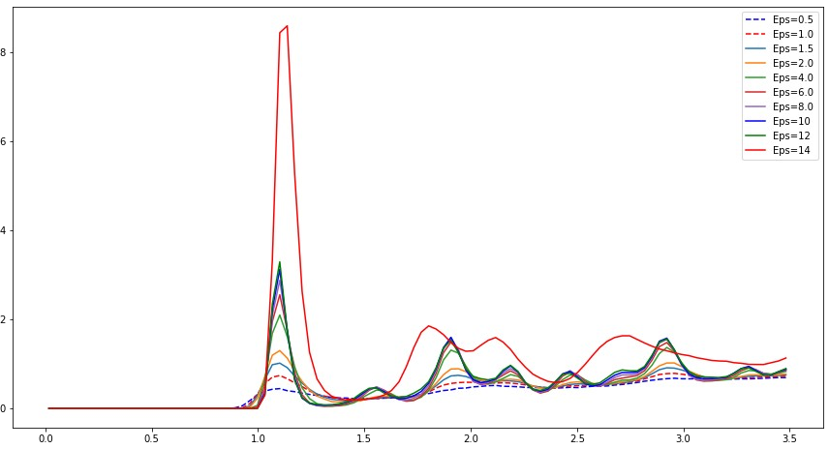

# For 2-2 Interaction:-

We will not observe a significant changes in the graph above/below epsilon equal to 12. This is because in our arrangement We have created one sphere of nanoparticle and outside it we have distributed Lj particle. So if 1-2 Potential increases, the Lj particle starts entering into the sphere but the coordination sphere for 2-2 will remain unaffected.

