LAB 5

Problem 1 — Customer Email Search
Find customer9000@example.com.
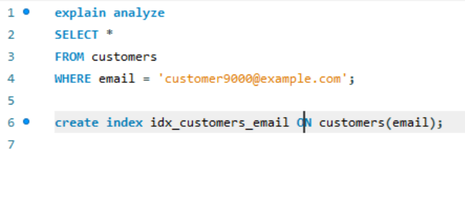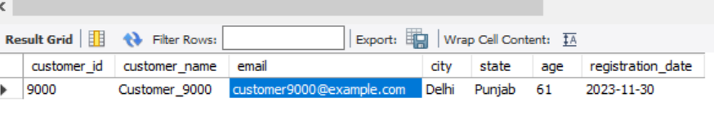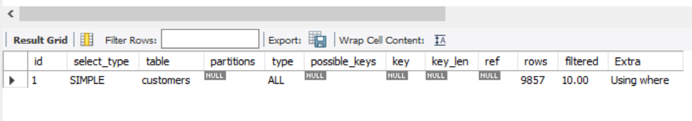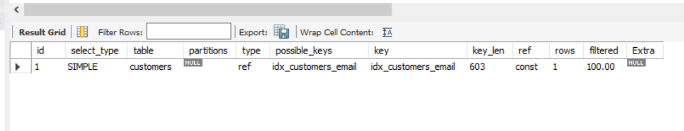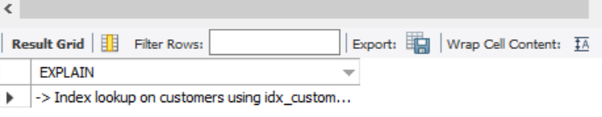

Problem 2 Problem 2 — Customers by City
Search customers from Mumbai.
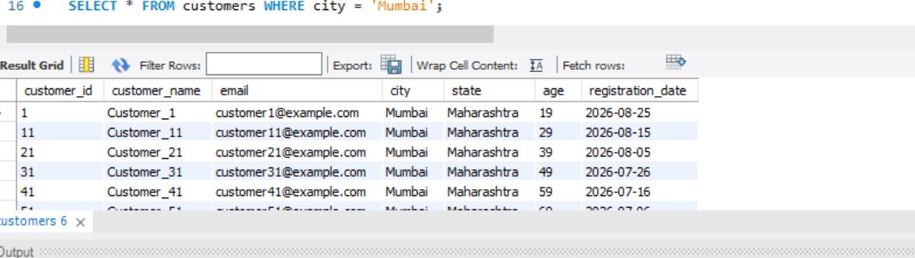

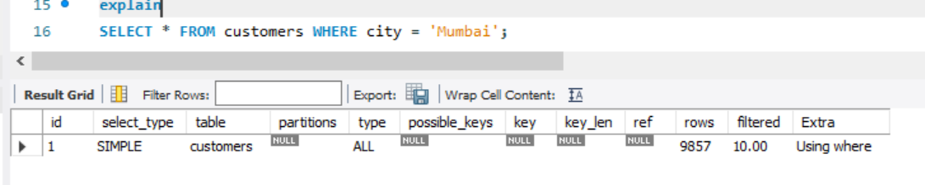
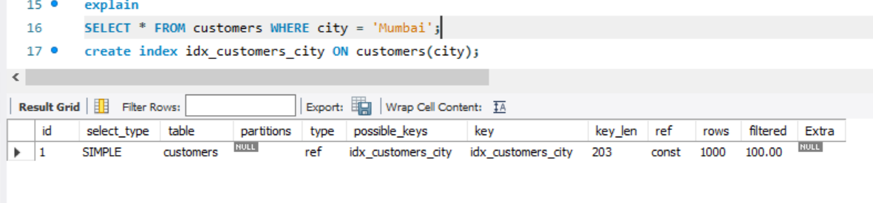
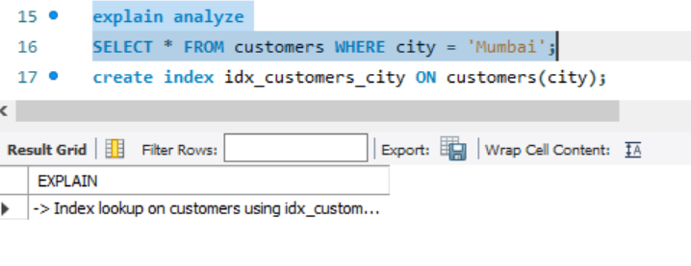

Problem 3 - Orders by Customer
Find all orders for customer 5000.
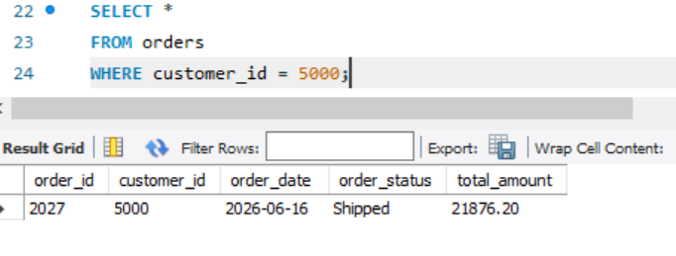
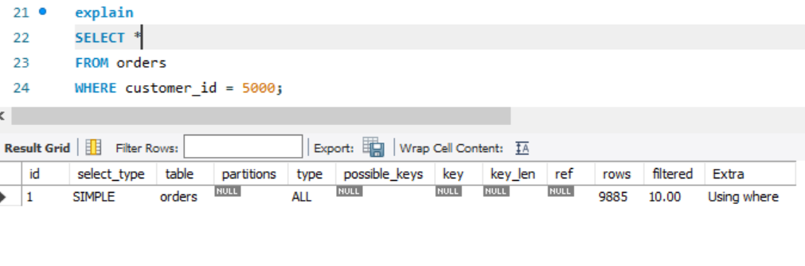
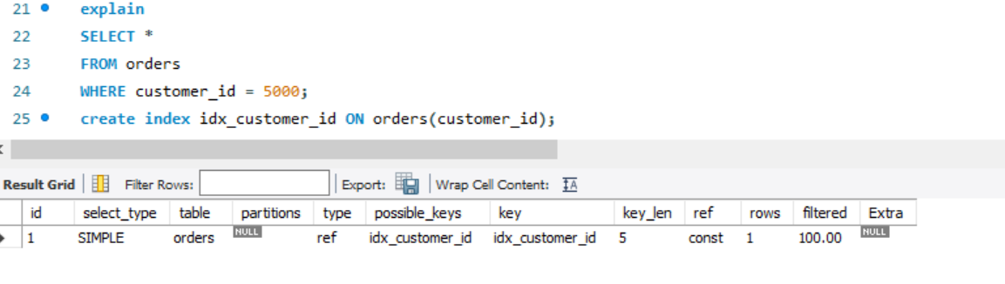
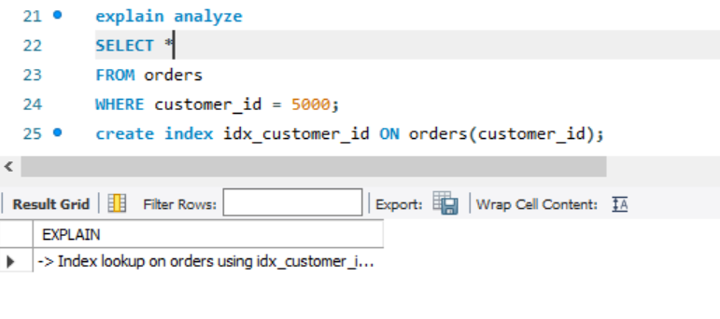

Problem 4 — Orders by Customer and Status
Find delivered orders for customer 5000.

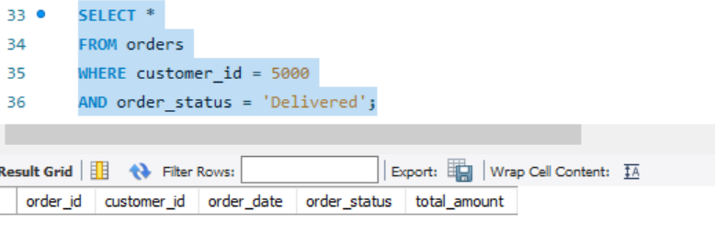

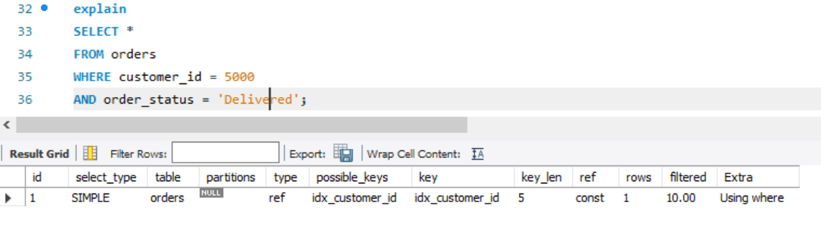

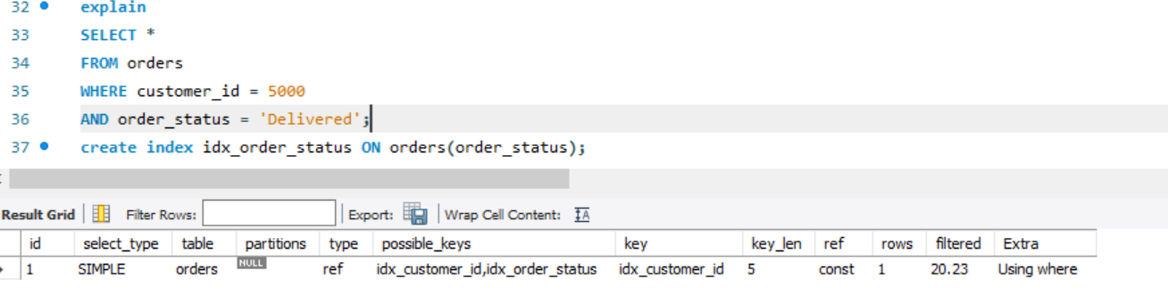

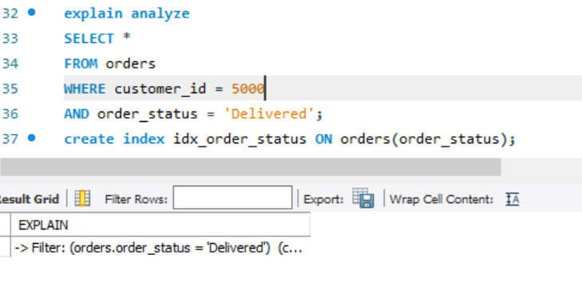

Problem 5 — Orders by Date Range
Find orders between January 1, 2026 and June 30, 2026.

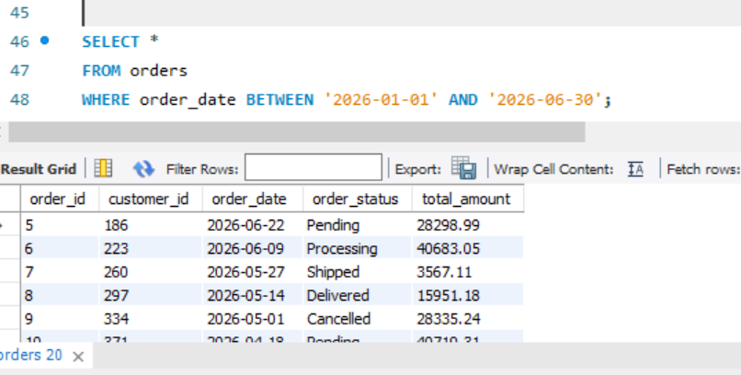

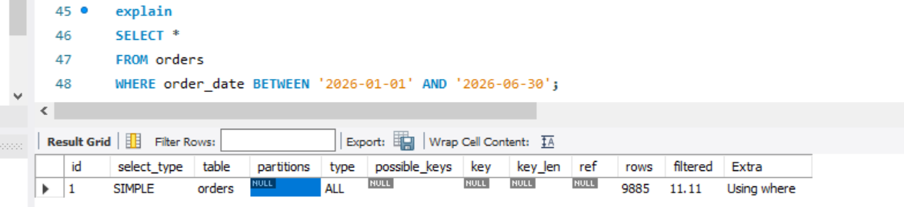

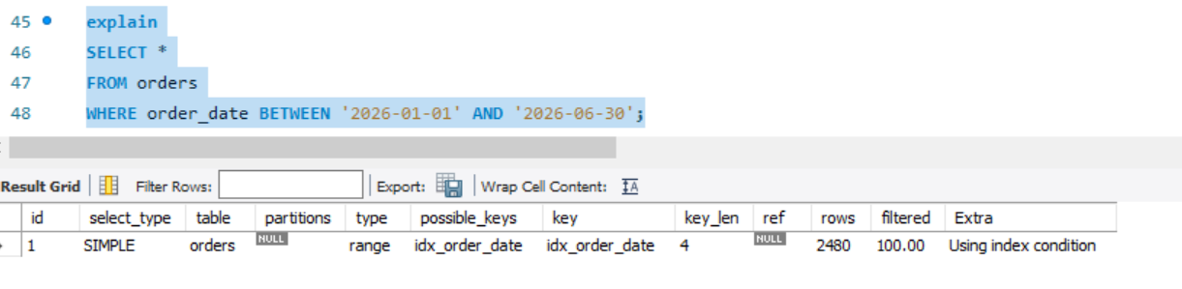

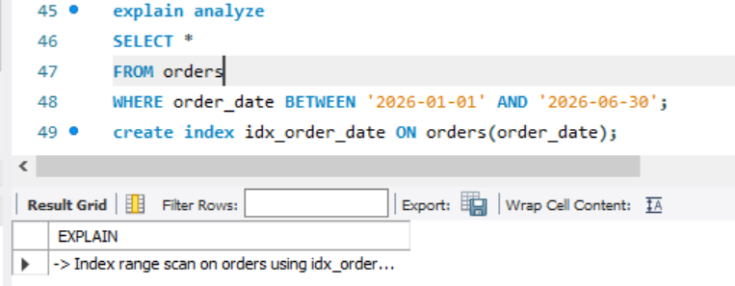

Problem 6 — Expensive Products
Find products costing more than ₹75,000.
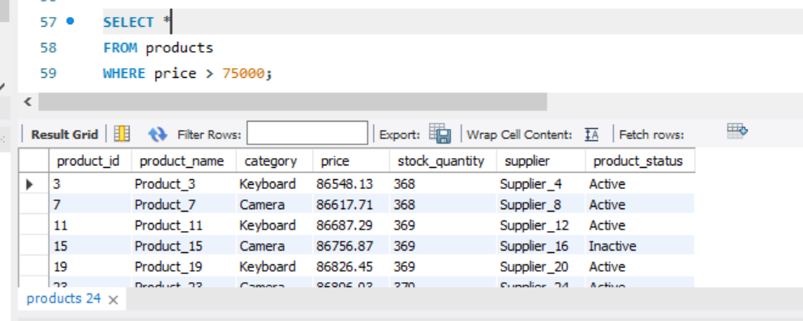

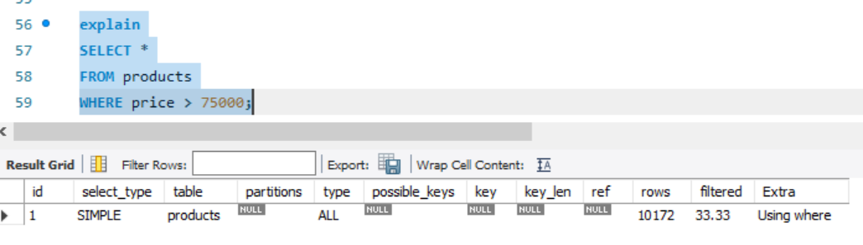
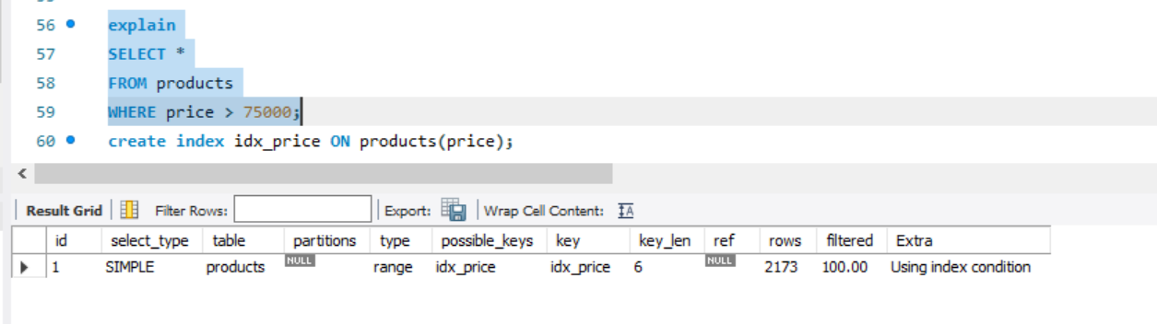

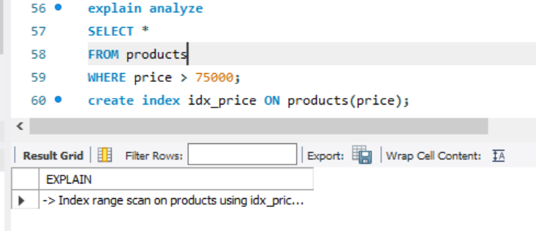

Problem 7 — Category + Price
Find laptops costing more than ₹50,000.

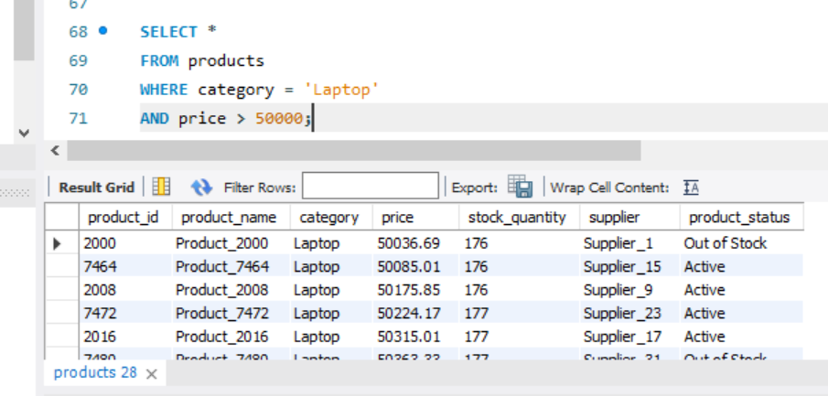

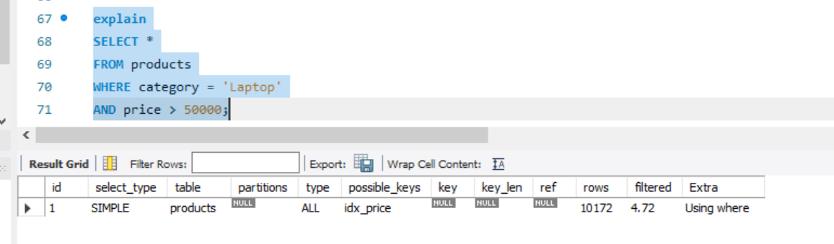

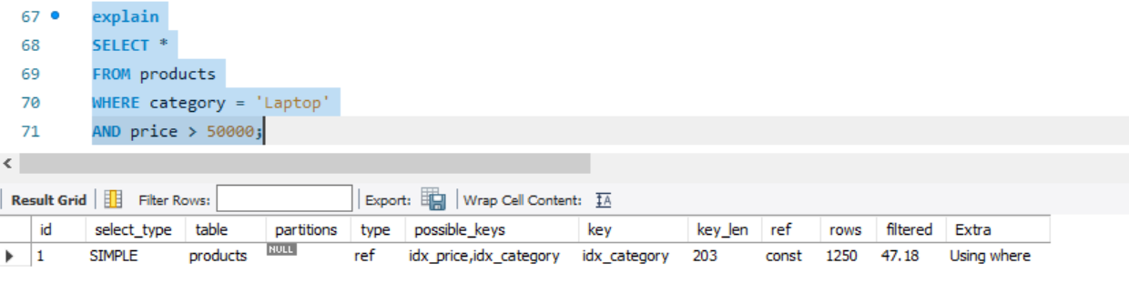

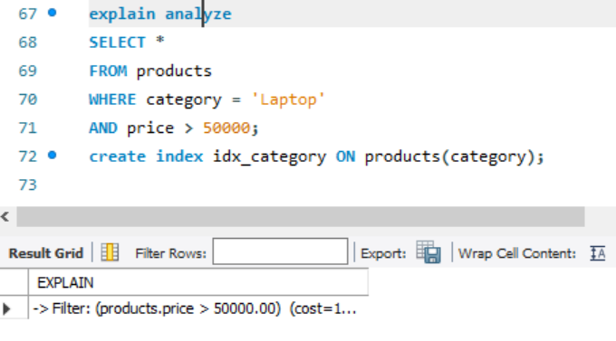

Problem 8 — Prefix Search
Search emails beginning with customer90.

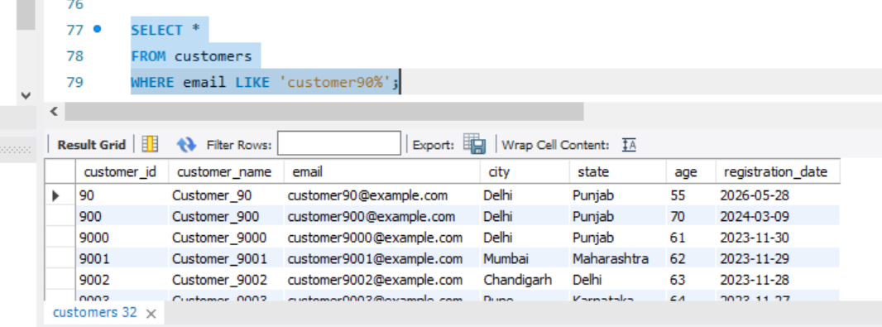

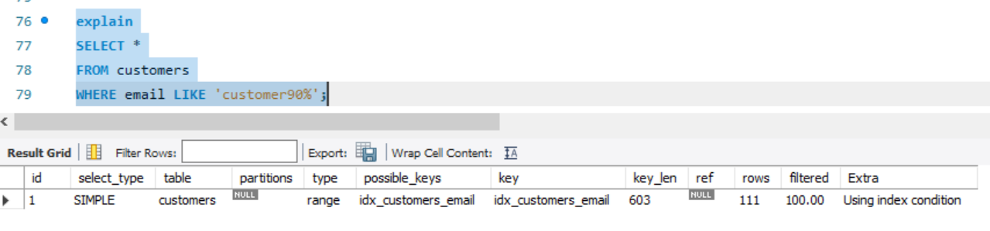

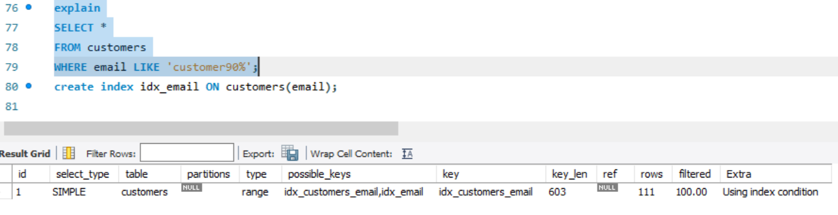
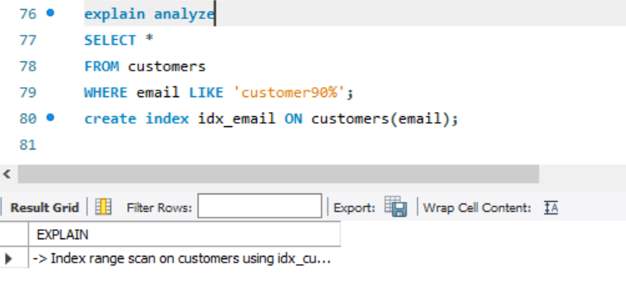

Problem 9 — Leading Wildcard
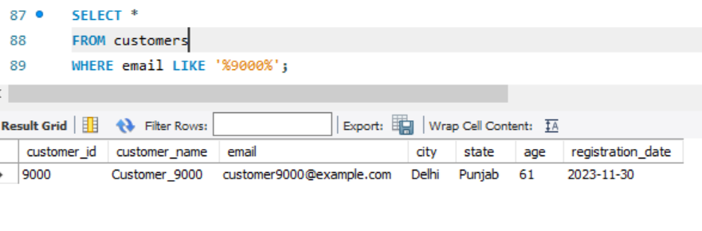
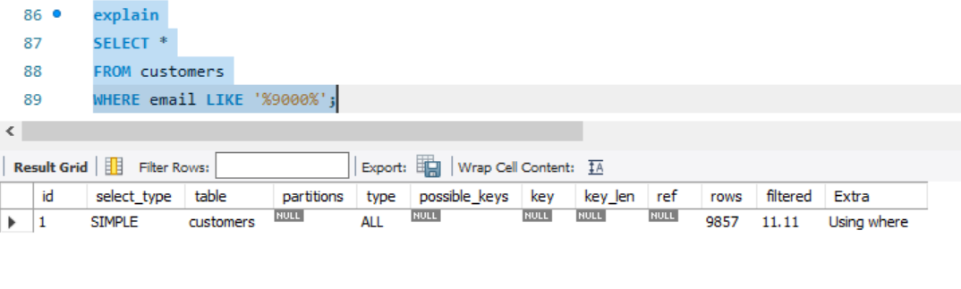
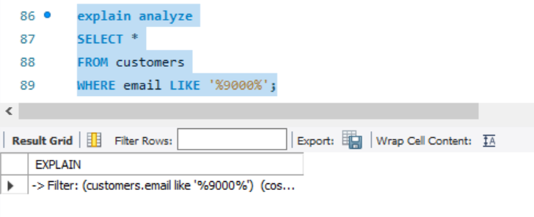

Problem 10 — ORDER BY
Find the latest 20 registered customers.
