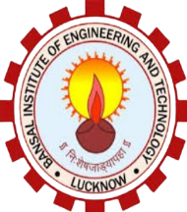

Bansal Institute of Engineering &Technology

**Project**

**On**

**Mira Virtual Assistant**

