

A
Assesment Report
on
“Predict Online Learning Completion”
submitted as partial fulfillment for the award of
BACHELOR OF TECHNOLOGY
DEGREE
SESSION 2024-25
in
Computer Science Engineering (Artificial Intelligence)
By
Ansh Tandon (202401100300053)

Under the supervision of
“Mr. Bikki Gupta”

KIET Group of Institutions, Ghaziabad
Affiliated to
Dr. A.P.J. Abdul Kalam Technical University, Lucknow
(Formerly UPTU)
May, 2025

Predict Online Learning Completion

Introduction:
In today’s era of digital education, online learning platforms have become a major mode of knowledge delivery. However, student retention and course completion remain a challenge. This project aims to predict whether a student will complete an online course or not, based on features like time spent, login frequency, quiz performance, etc. This can help educational platforms improve student engagement strategies.

Methodology:

We followed a typical machine learning pipeline for this task:
- Data Loading: Imported the dataset from Colab.
- Exploratory Data Analysis (EDA): Visualized and summarized the dataset.
- Data Preprocessing:
  - Dropped missing values
  - Encoded categorical columns
  - Scaled numerical features
- Modeling:
  - Used Random Forest Classifier for binary classification (completed or not)
- Evaluation:
  - Evaluated with confusion matrix, accuracy, and classification report
  - Visualized feature importance to understand which attributes influence completion the most

Code:
import pandas as pd
import numpy as np
import matplotlib.pyplot as plt
import seaborn as sns

from sklearn.model_selection import train_test_split
from sklearn.preprocessing import LabelEncoder, StandardScaler
from sklearn.ensemble import RandomForestClassifier
from sklearn.metrics import classification_report, confusion_matrix, accuracy_score

# Load dataset
df = pd.read_csv('/mnt/data/online_learning.csv')

# Explore
print(df.head())
print(df.info())
print(df.describe())

# Visualize target
sns.countplot(x='completed', data=df)
plt.title('Course Completion Count')
plt.show()

# Handle missing values
df = df.dropna()

# Encode categorical columns
label_encoders = {}
for col in df.select_dtypes(include='object').columns:
le = LabelEncoder()
df[col] = le.fit_transform(df[col])
label_encoders[col] = le

# Feature and target
X = df.drop('completed', axis=1)
y = df['completed']

# Normalize features
scaler = StandardScaler()
X_scaled = scaler.fit_transform(X)

# Train-test split
X_train, X_test, y_train, y_test = train_test_split(X_scaled, y, test_size=0.2, random_state=42)

# Train model
model = RandomForestClassifier(n_estimators=100, random_state=42)
model.fit(X_train, y_train)

# Predictions
y_pred = model.predict(X_test)

# Evaluation
print(classification_report(y_test, y_pred))
print("Accuracy:", accuracy_score(y_test, y_pred))

# Confusion Matrix
sns.heatmap(confusion_matrix(y_test, y_pred), annot=True, fmt='d', cmap='Blues')
plt.title('Confusion Matrix')
plt.show()

# Feature importance
importances = model.feature_importances_
indices = np.argsort(importances)[::-1]
sns.barplot(x=importances[indices], y=X.columns[indices])
plt.title('Feature Importance')
plt.show()

Output:

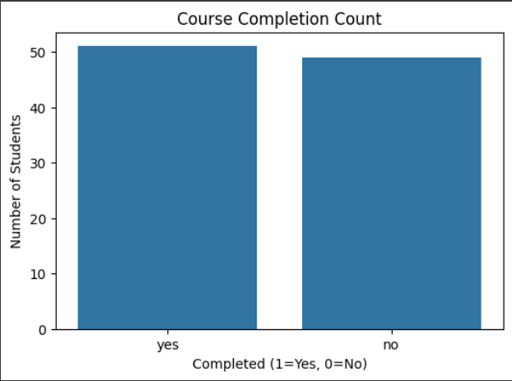

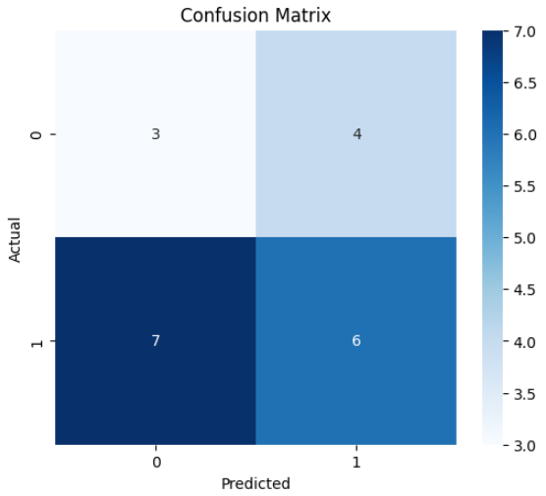
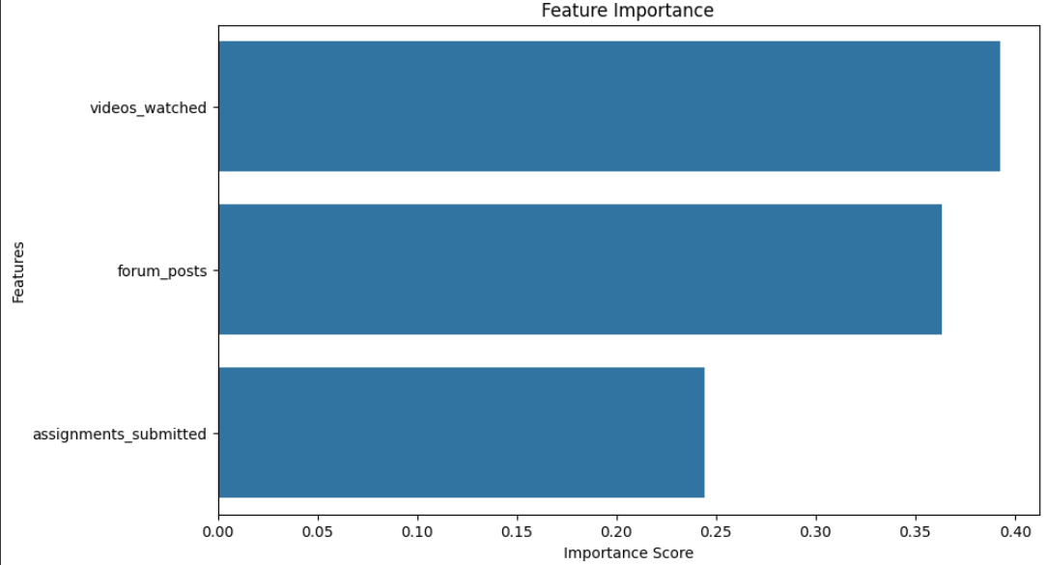

References/Credits
- Dataset: Uploaded CSV file online_learning.csv (source provided by instructor)
- Tools Used: Python, Pandas, Scikit-learn, Seaborn, Matplotlib
- Platform: Google Colab

