Detailed Diagnostic Report (DDR)
# **Detailed Diagnostic Report (DDR)**
**Property Address:** [Not Available]
**Customer Name:** [Not Available]
**Inspection Date:** 27.09.2022
**Inspected By:** Krushna & Mahesh
**Property Type:** Flat (11 Floors)
**Property Age:** [Not Available]
**Previous Structural Audit:** No
**Previous Repair Work:** No
---
## **1. Property Issue Summary**
The inspection revealed **dampness, tile hollowness, plumbing leaks, and external wall cracks** across multiple areas of **Flat No. 103** and **Flat No. 203**. Key concerns include:
- **Dampness at skirting levels** in the hall, bedrooms, and kitchen.
- **Tile hollowness and gaps** in bathrooms (common and master bedroom).
- **Seepage in parking area ceiling** below Flat No. 103.
- **External wall cracks** near the master bedroom.
- **Plumbing issues** (concealed leaks, damaged Nahani traps, loose joints).
- **Thermal anomalies** (temperature variations indicating moisture or insulation issues).
**Overall Inspection Score:** **85.71%** (1 flagged item: **External Wall**).
---
## **2. Area-wise Observations**

Figure: Observation from Page 1

Figure: Observation from Page 2

Figure: Observation from Page 3
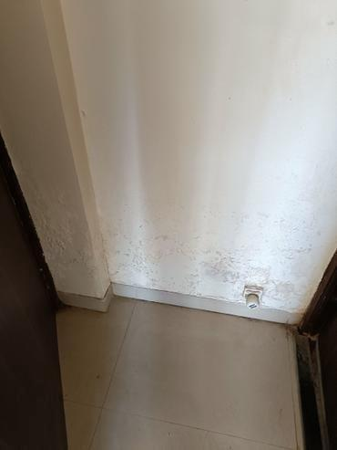
Figure: Observation from Page 3
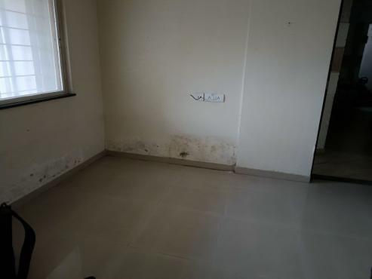
Figure: Observation from Page 3
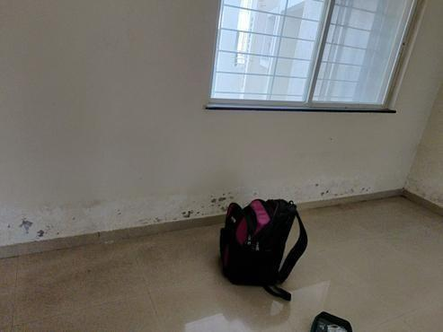
Figure: Observation from Page 3
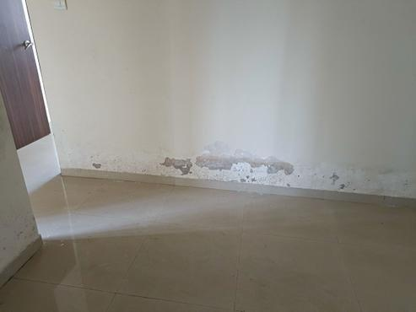
Figure: Observation from Page 3
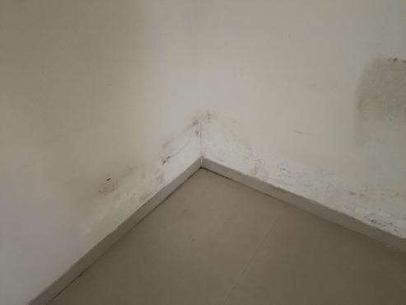
Figure: Observation from Page 3
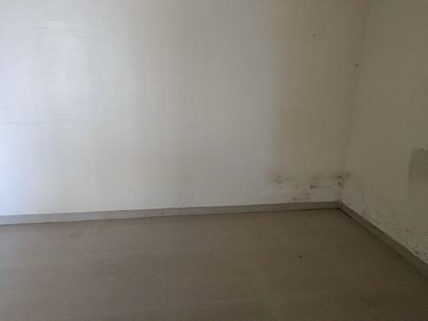
Figure: Observation from Page 3
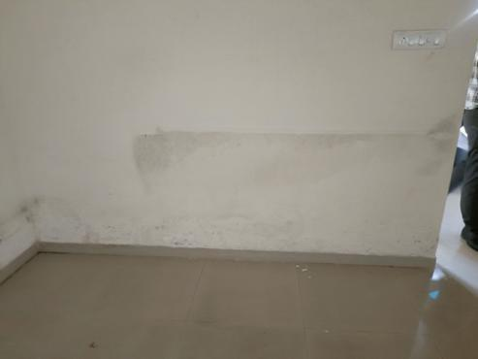
Figure: Observation from Page 3
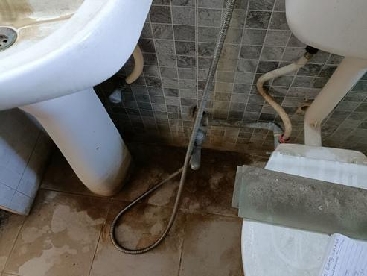
Figure: Observation from Page 3
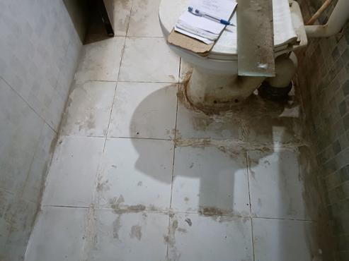
Figure: Observation from Page 3
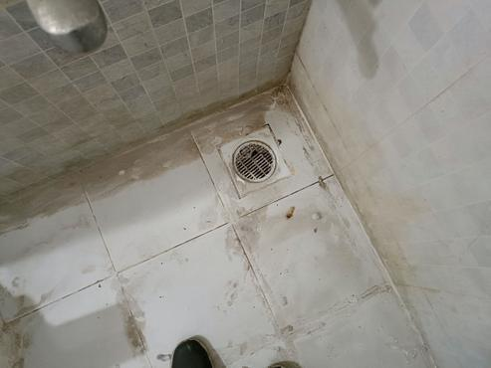
Figure: Observation from Page 3
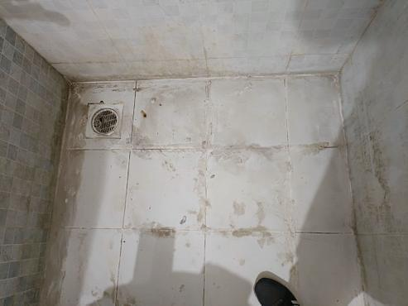
Figure: Observation from Page 3
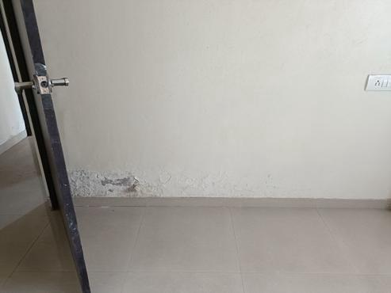
Figure: Observation from Page 3
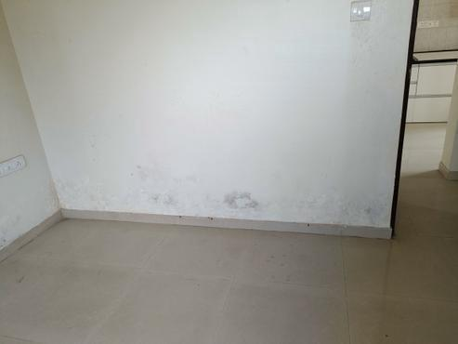
Figure: Observation from Page 3
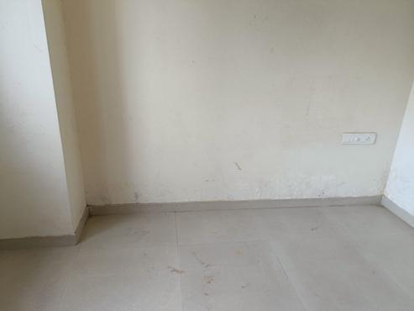
Figure: Observation from Page 3

Figure: Observation from Page 4
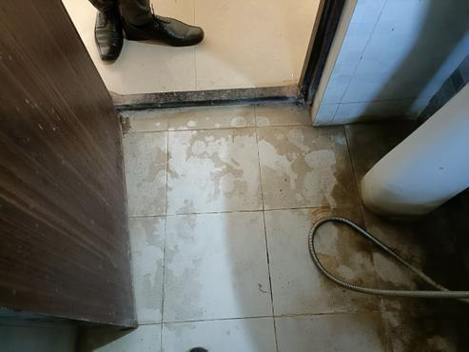
Figure: Observation from Page 4

Figure: Observation from Page 4

Figure: Observation from Page 4

Figure: Observation from Page 4

Figure: Observation from Page 4
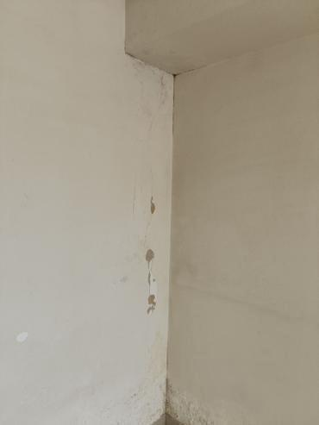
Figure: Observation from Page 4
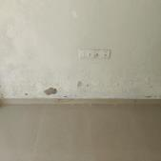
Figure: Observation from Page 4
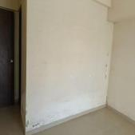
Figure: Observation from Page 4
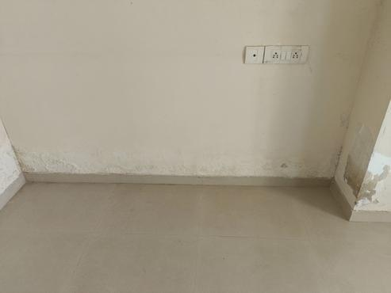
Figure: Observation from Page 4
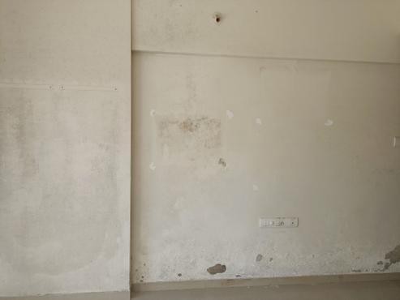
Figure: Observation from Page 4
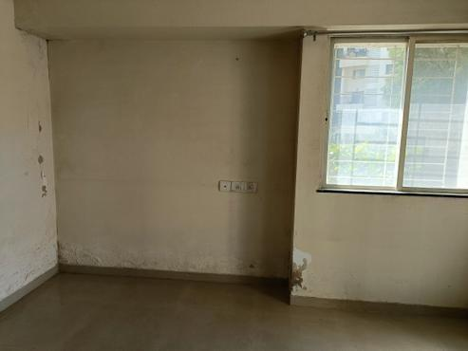
Figure: Observation from Page 4
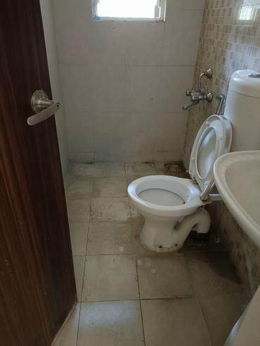
Figure: Observation from Page 4
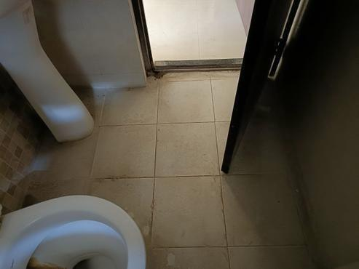
Figure: Observation from Page 4
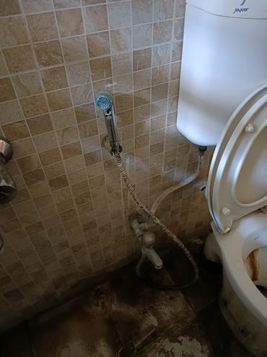
Figure: Observation from Page 4
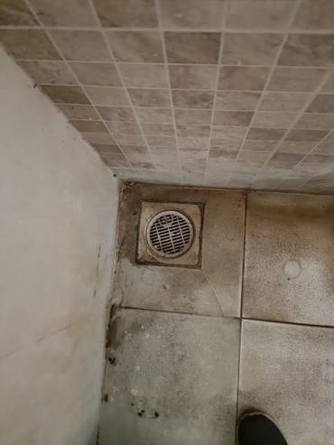
Figure: Observation from Page 4
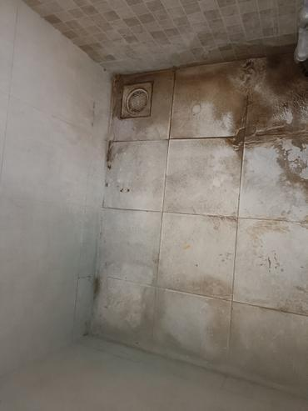
Figure: Observation from Page 4
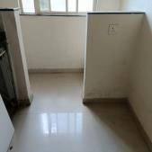
Figure: Observation from Page 4
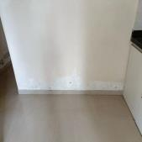
Figure: Observation from Page 4

Figure: Observation from Page 5

Figure: Observation from Page 5

Figure: Observation from Page 5

Figure: Observation from Page 5

Figure: Observation from Page 5

Figure: Observation from Page 5

Figure: Observation from Page 5

Figure: Observation from Page 5

Figure: Observation from Page 5

Figure: Observation from Page 5
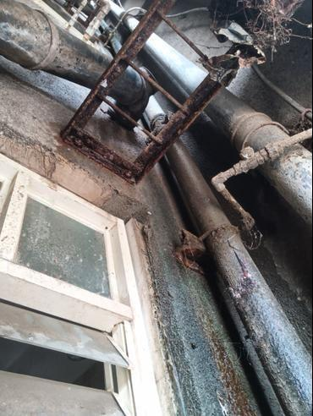
Figure: Observation from Page 5
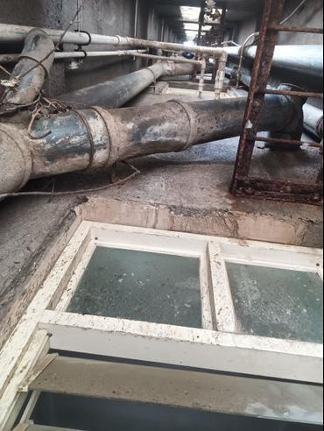
Figure: Observation from Page 5
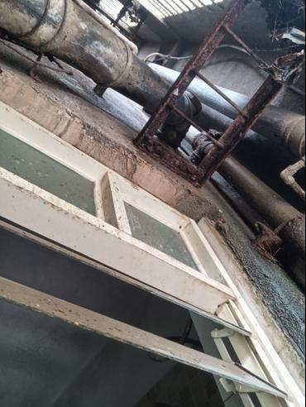
Figure: Observation from Page 5
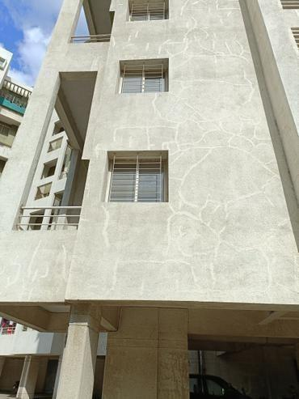
Figure: Observation from Page 5
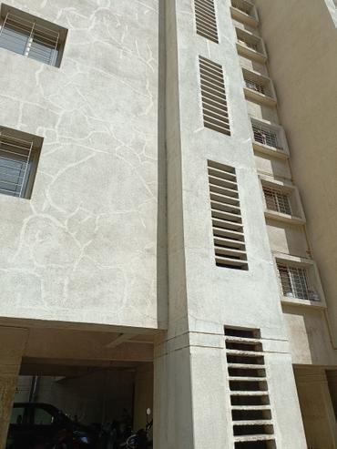
Figure: Observation from Page 5
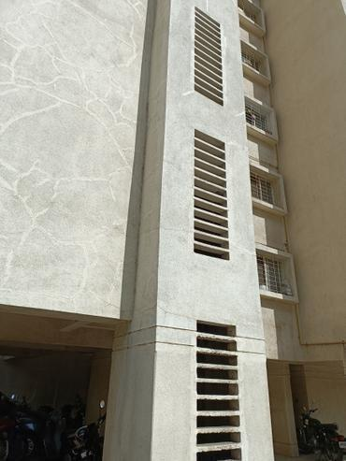
Figure: Observation from Page 5
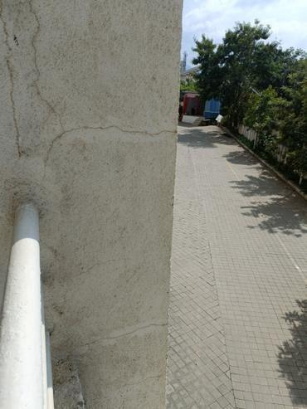
Figure: Observation from Page 5

Figure: Observation from Page 6
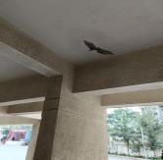
Figure: Observation from Page 6
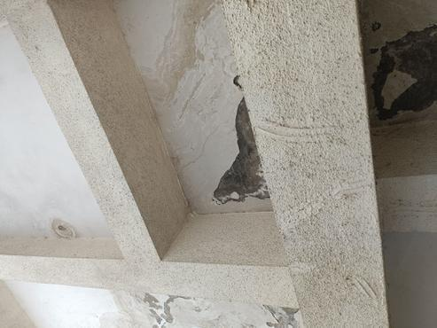
Figure: Observation from Page 6
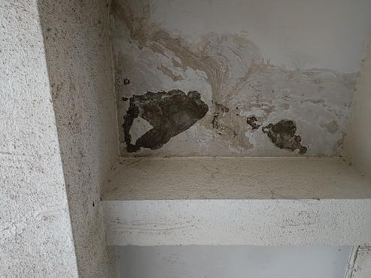
Figure: Observation from Page 6
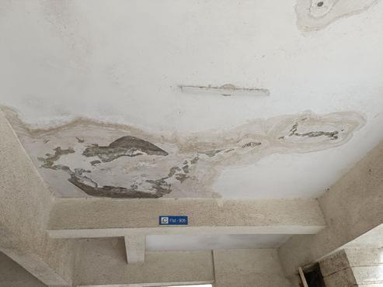
Figure: Observation from Page 6

Figure: Observation from Page 6

Figure: Observation from Page 6

Figure: Observation from Page 6

Figure: Observation from Page 6

Figure: Observation from Page 6
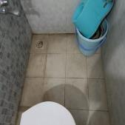
Figure: Observation from Page 6
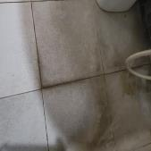
Figure: Observation from Page 6
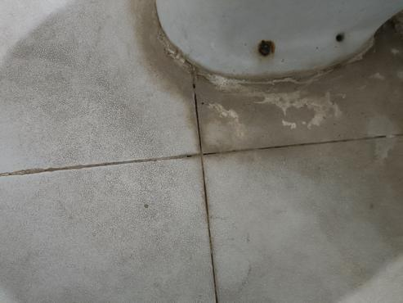
Figure: Observation from Page 6
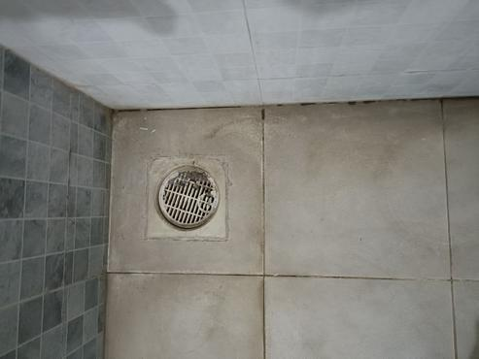
Figure: Observation from Page 6
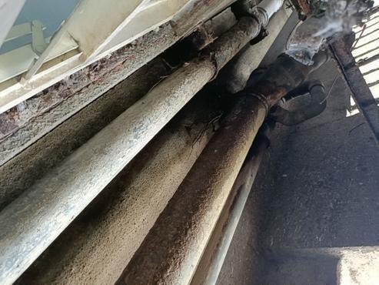
Figure: Observation from Page 6
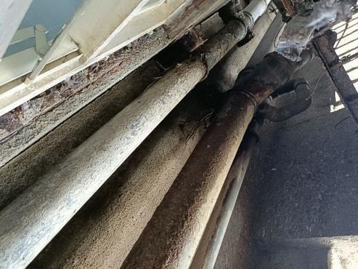
Figure: Observation from Page 6
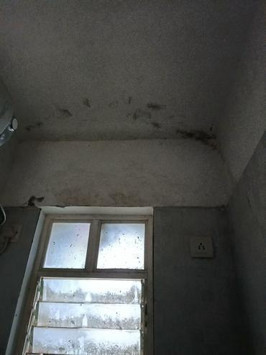
Figure: Observation from Page 6

Figure: Observation from Page 7

Figure: Observation from Page 8

Figure: Observation from Page 9
Figure: Observation from Page 9

Figure: Observation from Page 10

Figure: Observation from Page 11

Figure: Observation from Page 11

Figure: Observation from Page 11

Figure: Observation from Page 11

Figure: Observation from Page 11

Figure: Observation from Page 11

Figure: Observation from Page 11

Figure: Observation from Page 12

Figure: Observation from Page 12

Figure: Observation from Page 12

Figure: Observation from Page 12

Figure: Observation from Page 12

Figure: Observation from Page 12

Figure: Observation from Page 12

Figure: Observation from Page 13

Figure: Observation from Page 13

Figure: Observation from Page 13

Figure: Observation from Page 13

Figure: Observation from Page 13

Figure: Observation from Page 13

Figure: Observation from Page 13

Figure: Observation from Page 13

Figure: Observation from Page 14

Figure: Observation from Page 14

Figure: Observation from Page 14

Figure: Observation from Page 14

Figure: Observation from Page 14

Figure: Observation from Page 15

Figure: Observation from Page 15

Figure: Observation from Page 15

Figure: Observation from Page 15

Figure: Observation from Page 15

Figure: Observation from Page 15

Figure: Observation from Page 15

Figure: Observation from Page 16

Figure: Observation from Page 16

Figure: Observation from Page 16

Figure: Observation from Page 17

Figure: Observation from Page 17

Figure: Observation from Page 17

Figure: Observation from Page 17

Figure: Observation from Page 17

Figure: Observation from Page 17

Figure: Observation from Page 17

Figure: Observation from Page 18

Figure: Observation from Page 18

Figure: Observation from Page 18

Figure: Observation from Page 19

Figure: Observation from Page 19

Figure: Observation from Page 19

Figure: Observation from Page 19

Figure: Observation from Page 19

Figure: Observation from Page 19

Figure: Observation from Page 19

Figure: Observation from Page 20

Figure: Observation from Page 20

Figure: Observation from Page 20

Figure: Observation from Page 20

Figure: Observation from Page 20
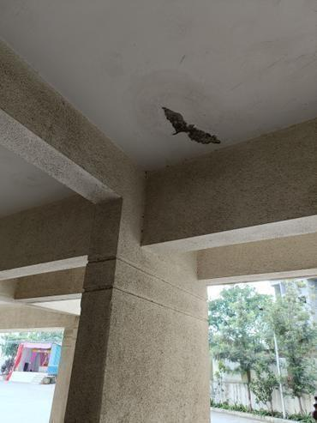
Figure: Observation from Page 20

Figure: Observation from Page 20

Figure: Observation from Page 21

Figure: Observation from Page 21

Figure: Observation from Page 21

Figure: Observation from Page 22

Figure: Observation from Page 22

Figure: Observation from Page 22

Figure: Observation from Page 22

Figure: Observation from Page 22

Figure: Observation from Page 22

Figure: Observation from Page 22

Figure: Observation from Page 23

Figure: Observation from Page 23

Figure: Observation from Page 23

Figure: Observation from Page 23

Figure: Observation from Page 23

Figure: Observation from Page 1

Figure: Observation from Page 1

Figure: Observation from Page 1
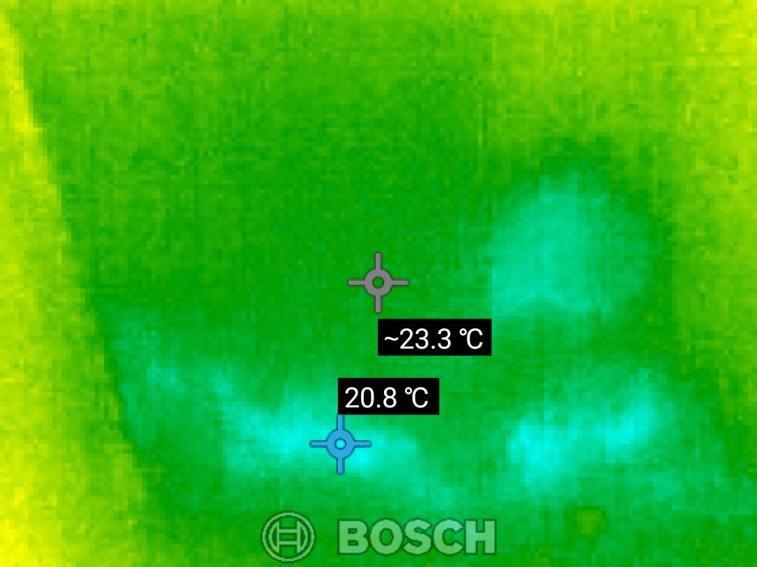
Figure: Observation from Page 1
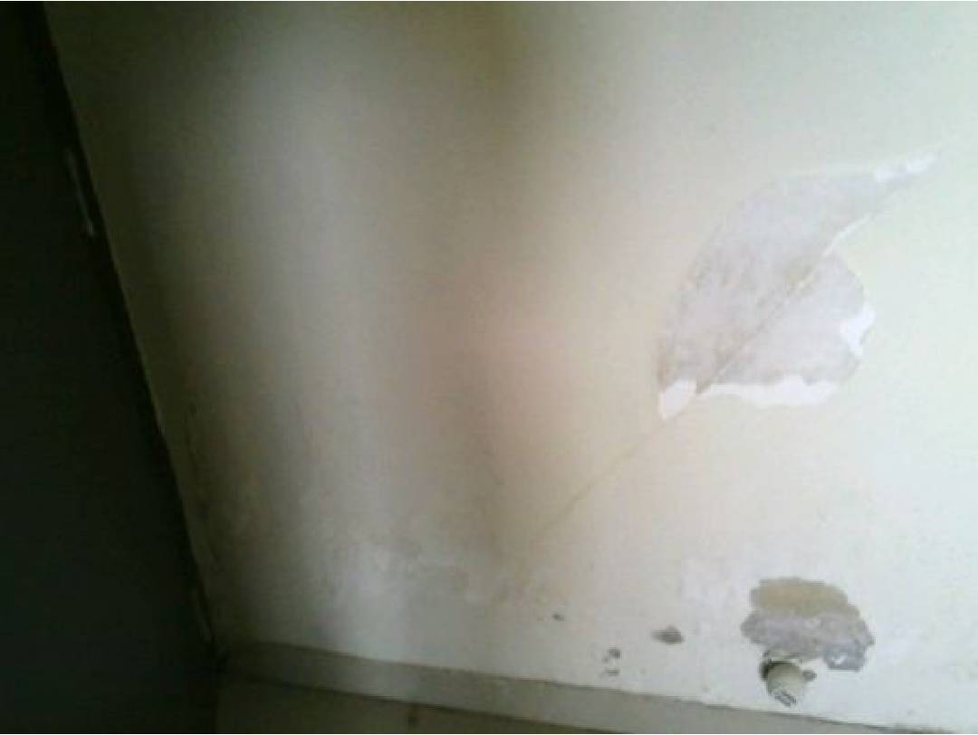
Figure: Observation from Page 1
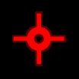
Figure: Observation from Page 1

Figure: Observation from Page 1

Figure: Observation from Page 1

Figure: Observation from Page 1
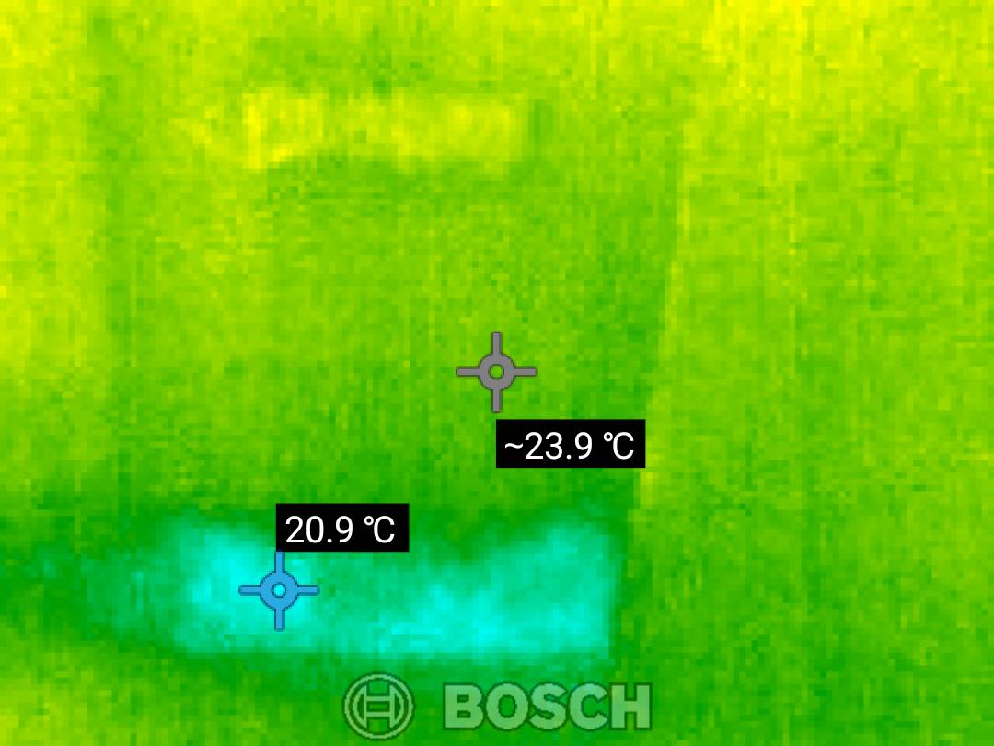
Figure: Observation from Page 1
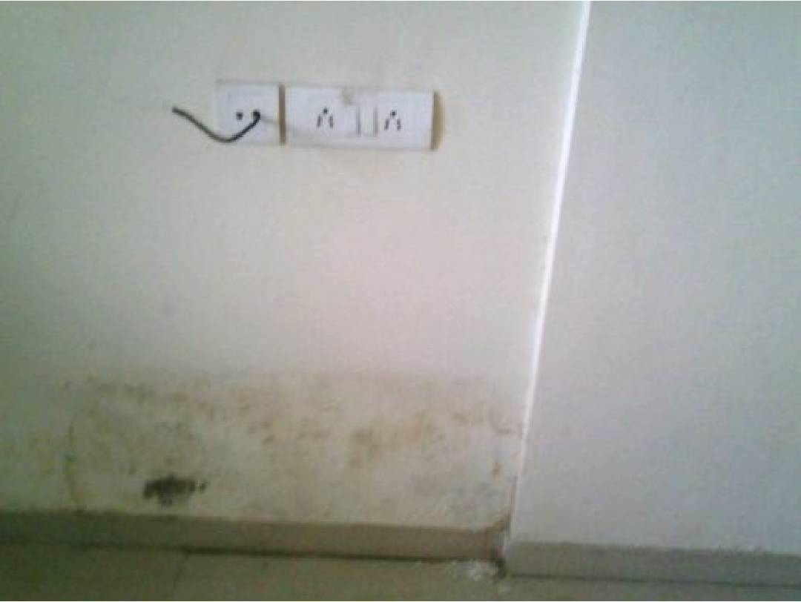
Figure: Observation from Page 1

Figure: Observation from Page 1

Figure: Observation from Page 1

Figure: Observation from Page 1

Figure: Observation from Page 1
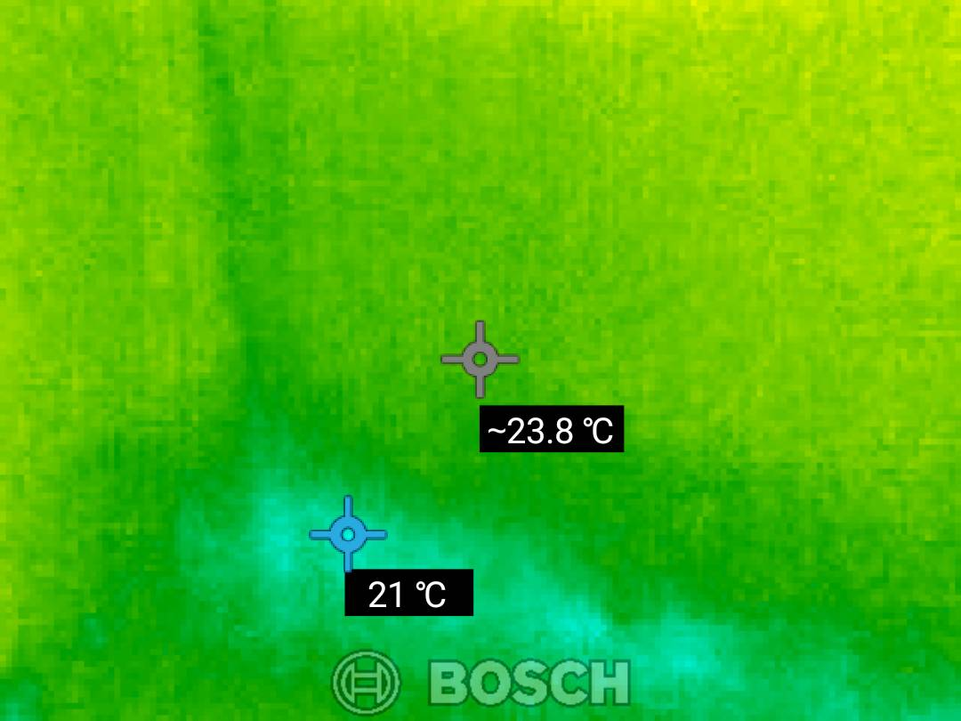
Figure: Observation from Page 1
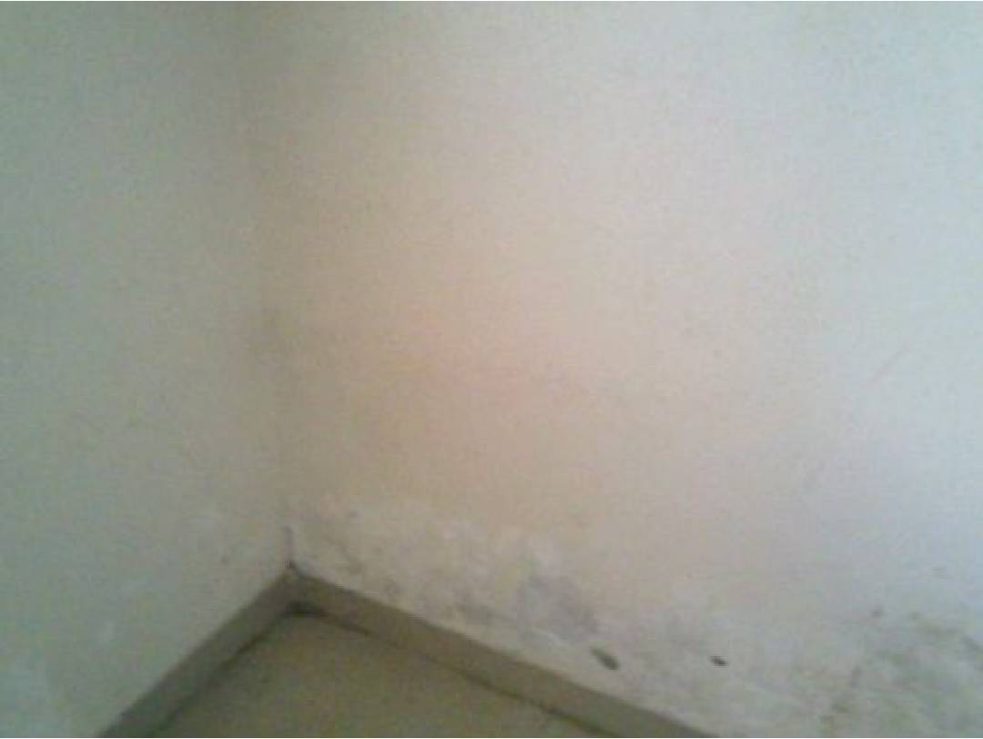
Figure: Observation from Page 1

Figure: Observation from Page 1

Figure: Observation from Page 1

Figure: Observation from Page 1

Figure: Observation from Page 1
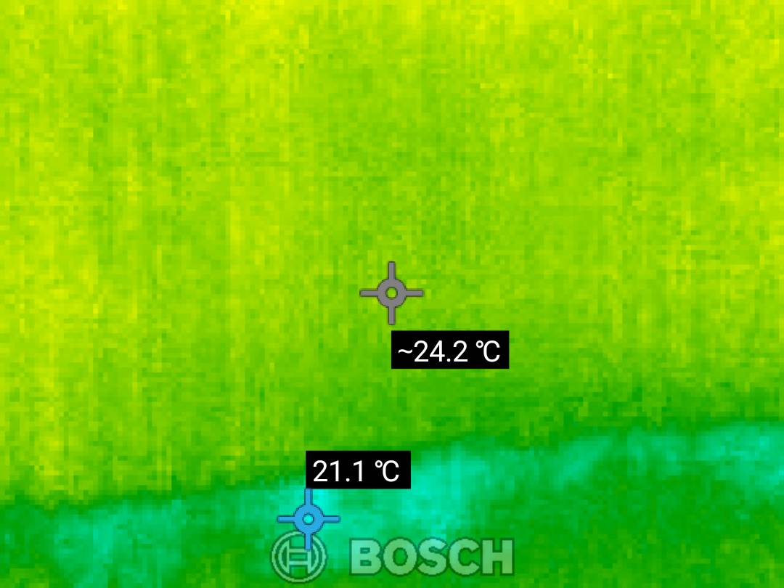
Figure: Observation from Page 1
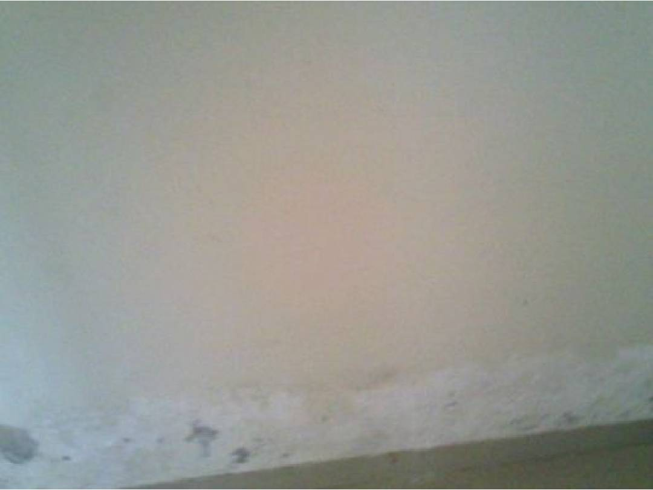
Figure: Observation from Page 1

Figure: Observation from Page 1

Figure: Observation from Page 1

Figure: Observation from Page 1

Figure: Observation from Page 1
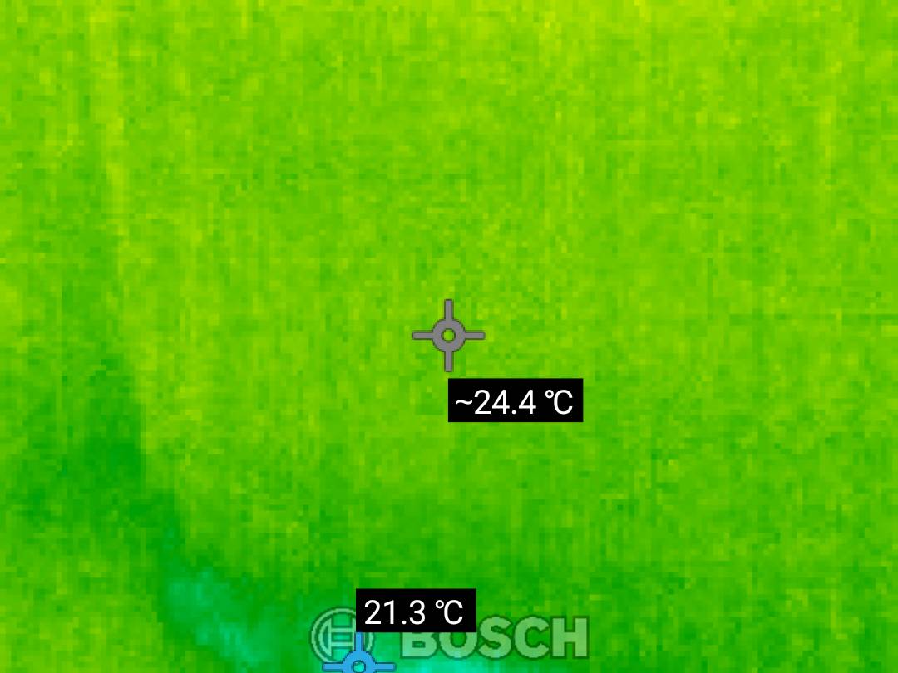
Figure: Observation from Page 1
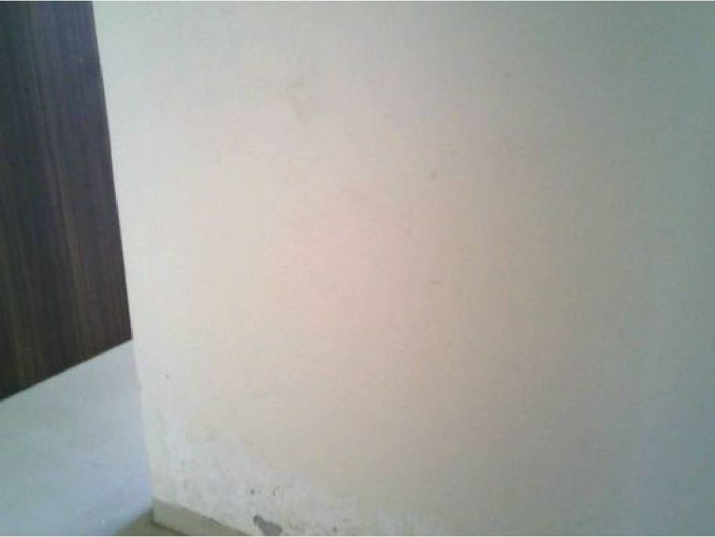
Figure: Observation from Page 1

Figure: Observation from Page 1

Figure: Observation from Page 1

Figure: Observation from Page 1

Figure: Observation from Page 1
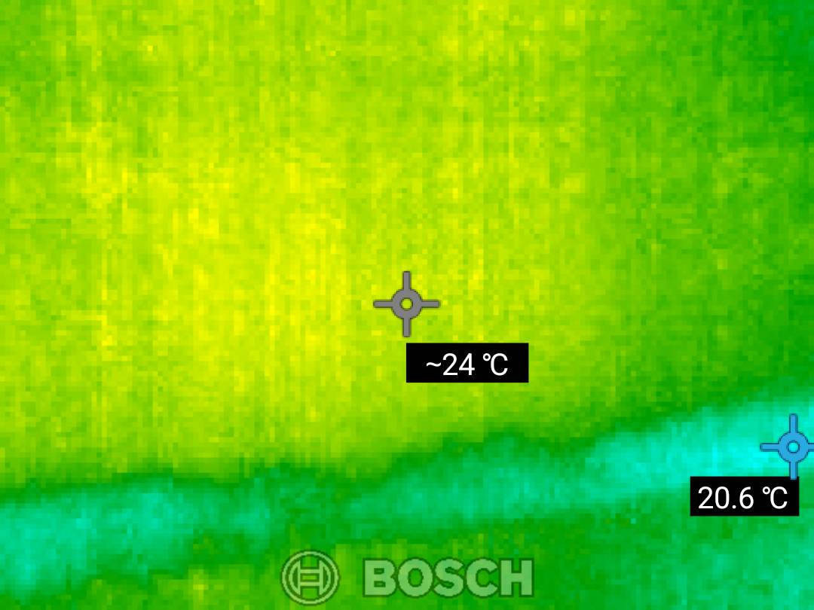
Figure: Observation from Page 1
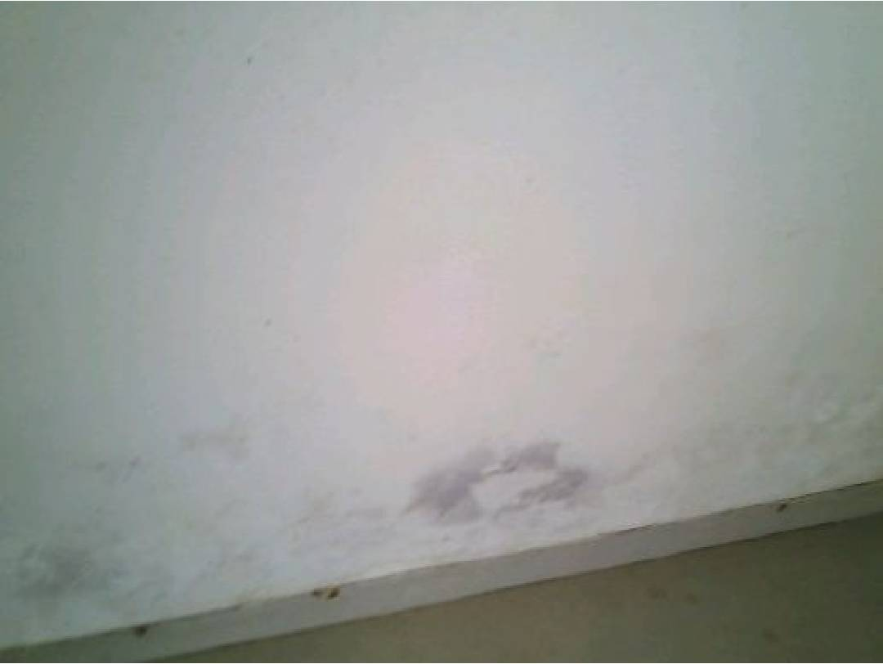
Figure: Observation from Page 1

Figure: Observation from Page 1

Figure: Observation from Page 1

Figure: Observation from Page 1

Figure: Observation from Page 1
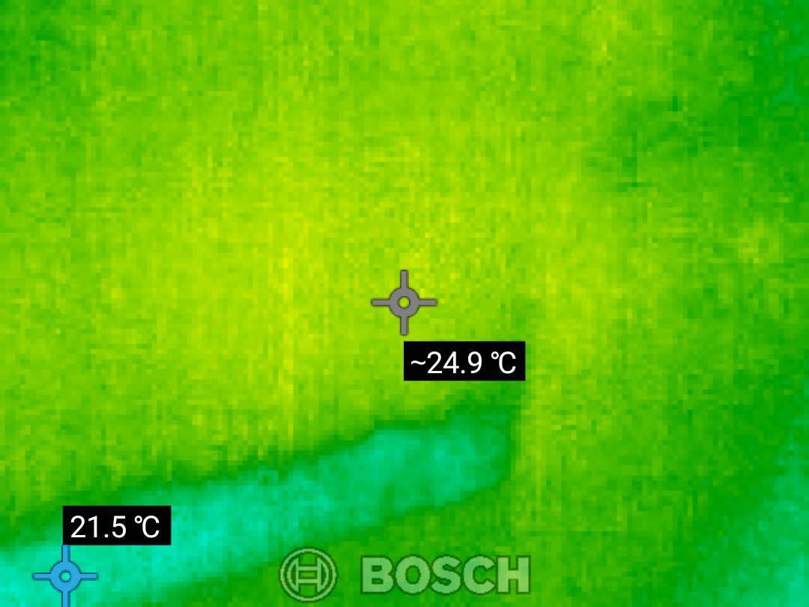
Figure: Observation from Page 1
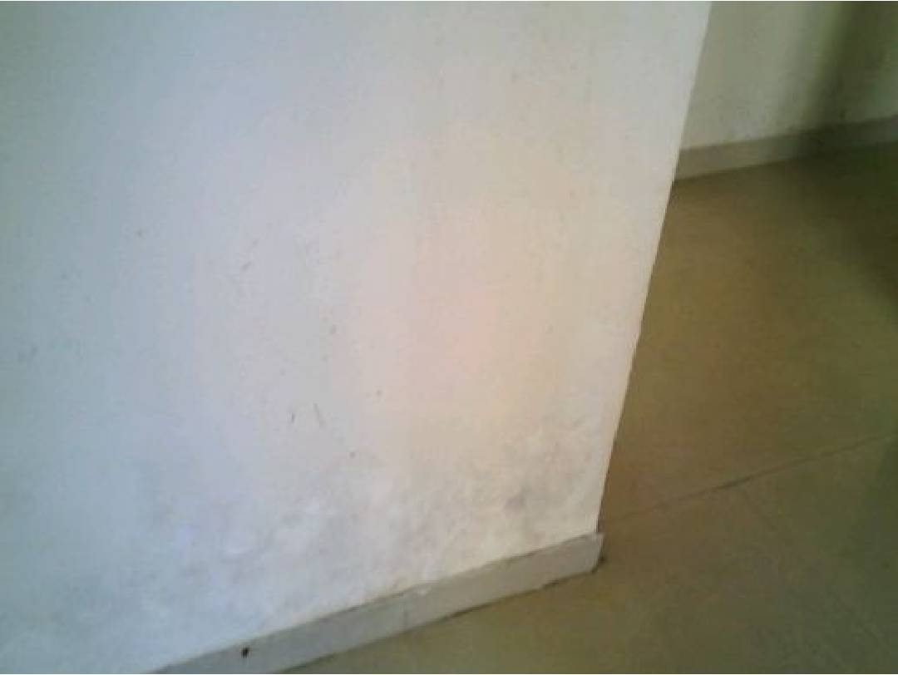
Figure: Observation from Page 1

Figure: Observation from Page 1

Figure: Observation from Page 1

Figure: Observation from Page 1

Figure: Observation from Page 1
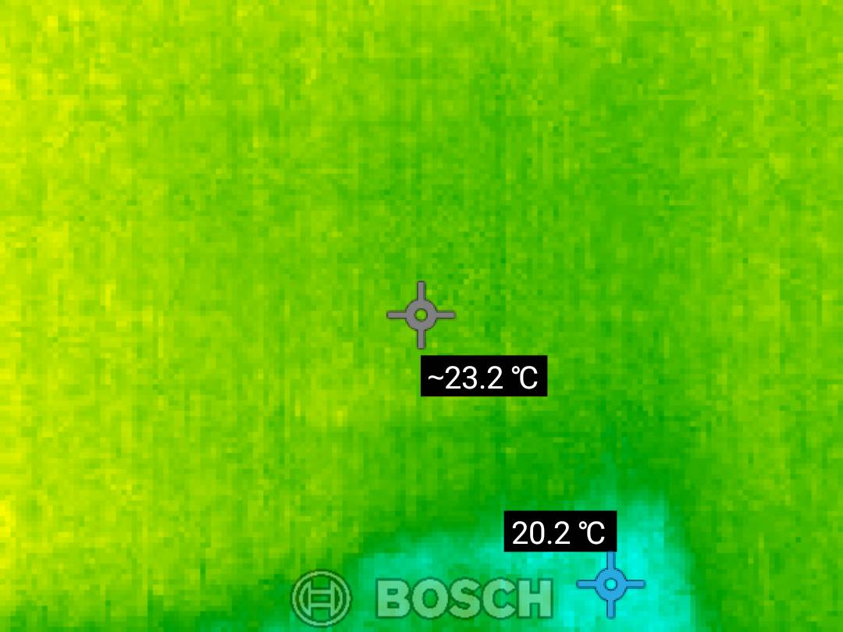
Figure: Observation from Page 1
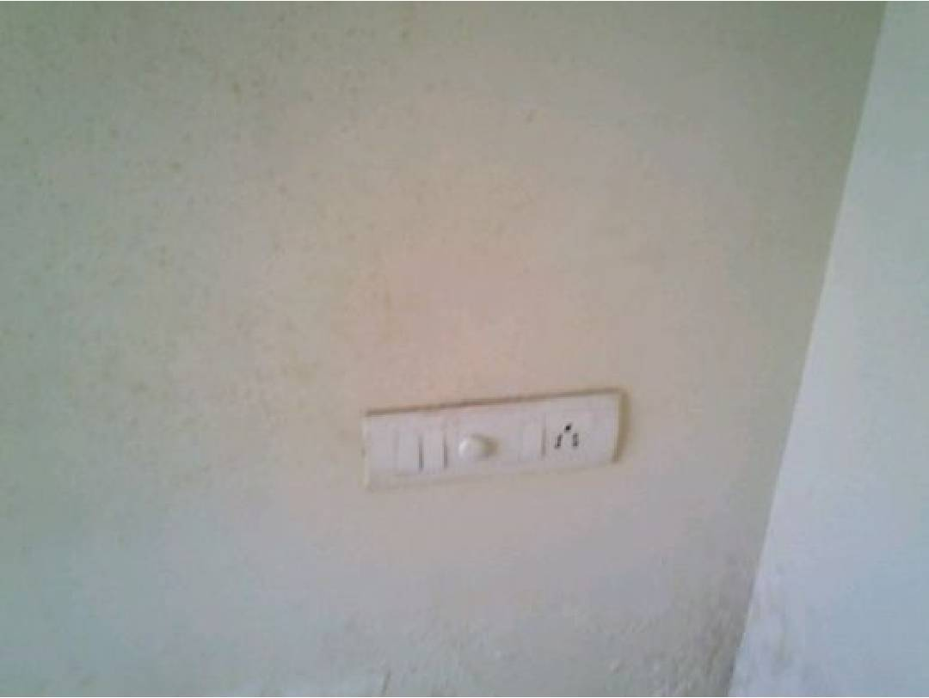
Figure: Observation from Page 1

Figure: Observation from Page 1

Figure: Observation from Page 1

Figure: Observation from Page 1

Figure: Observation from Page 1
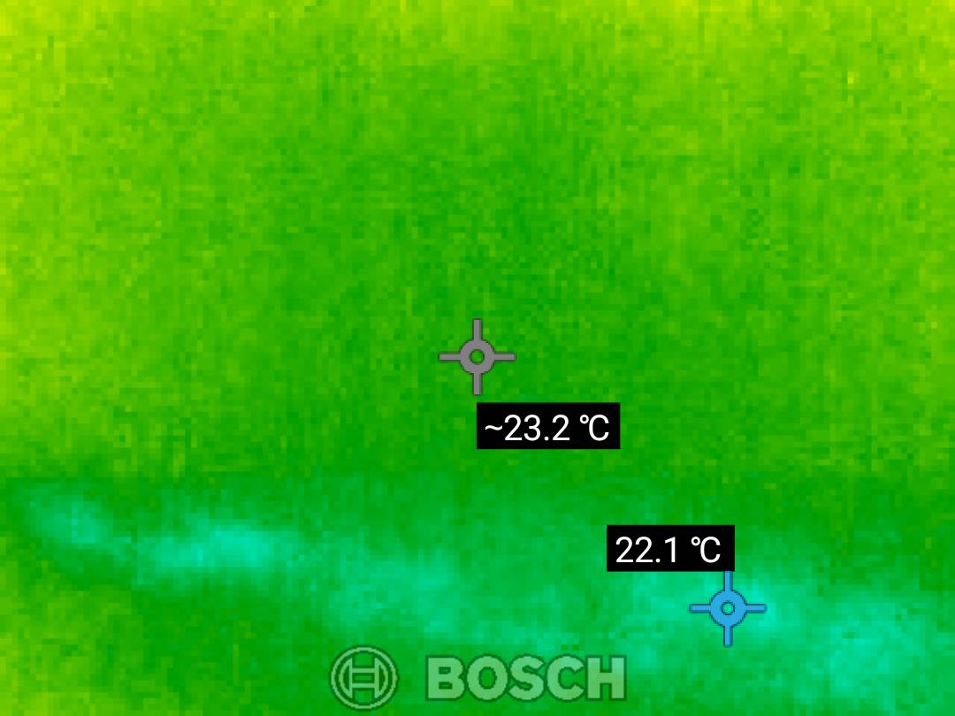
Figure: Observation from Page 1
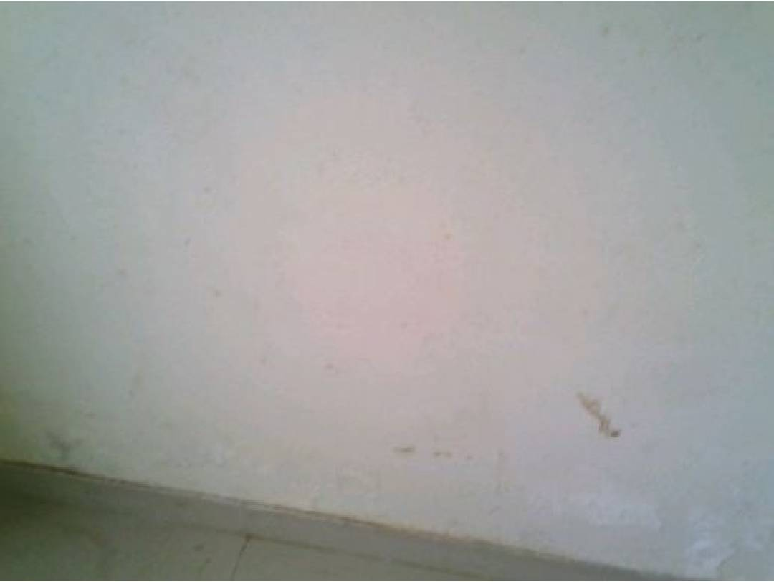
Figure: Observation from Page 1

Figure: Observation from Page 1

Figure: Observation from Page 1

Figure: Observation from Page 1

Figure: Observation from Page 1
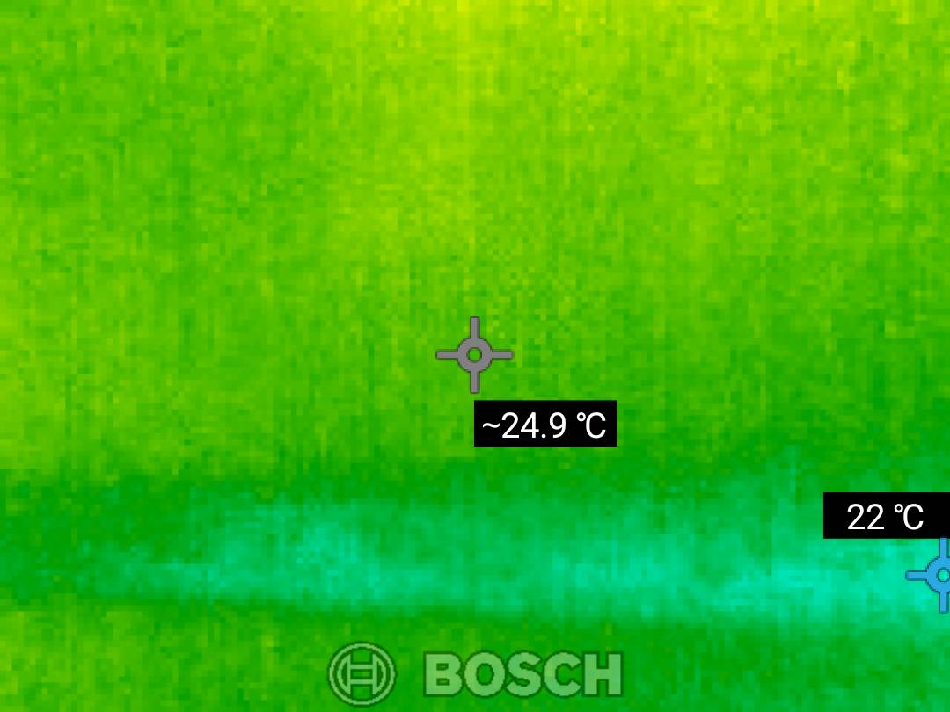
Figure: Observation from Page 1
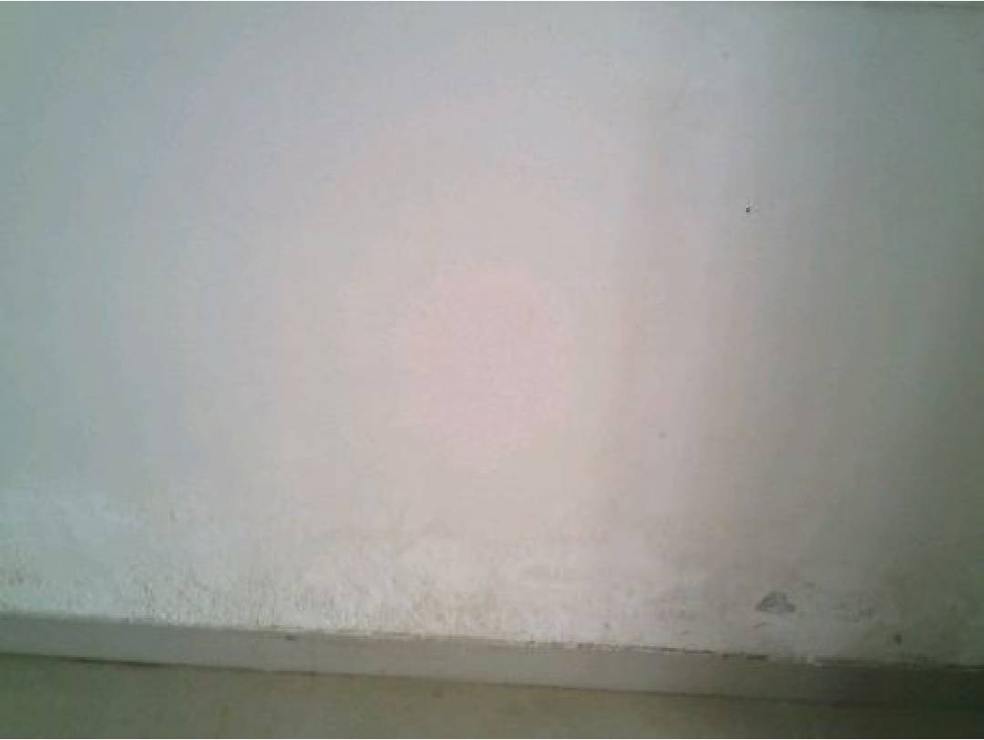
Figure: Observation from Page 1

Figure: Observation from Page 1

Figure: Observation from Page 1

Figure: Observation from Page 1

Figure: Observation from Page 1
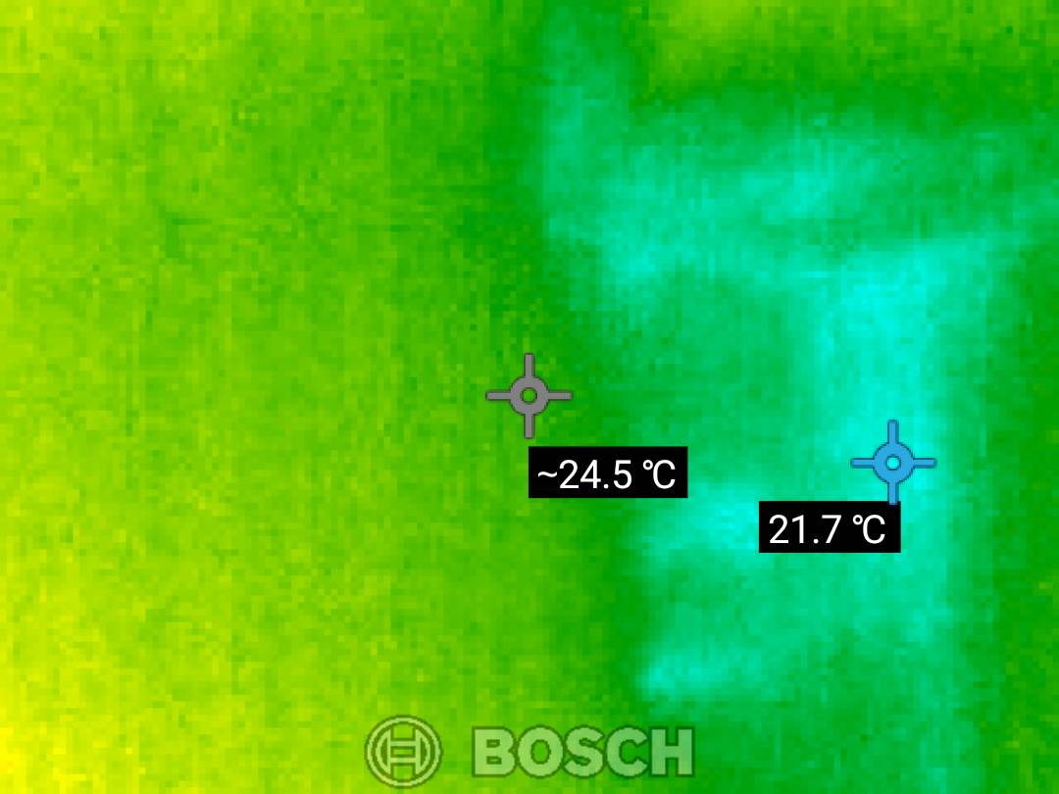
Figure: Observation from Page 1
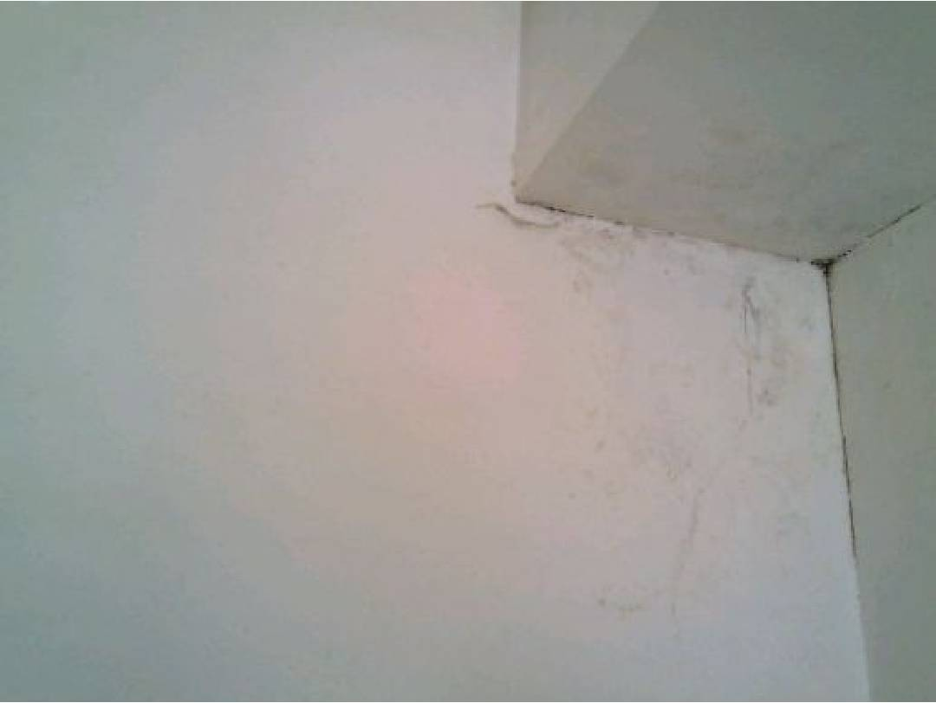
Figure: Observation from Page 1

Figure: Observation from Page 1

Figure: Observation from Page 1

Figure: Observation from Page 1

Figure: Observation from Page 1
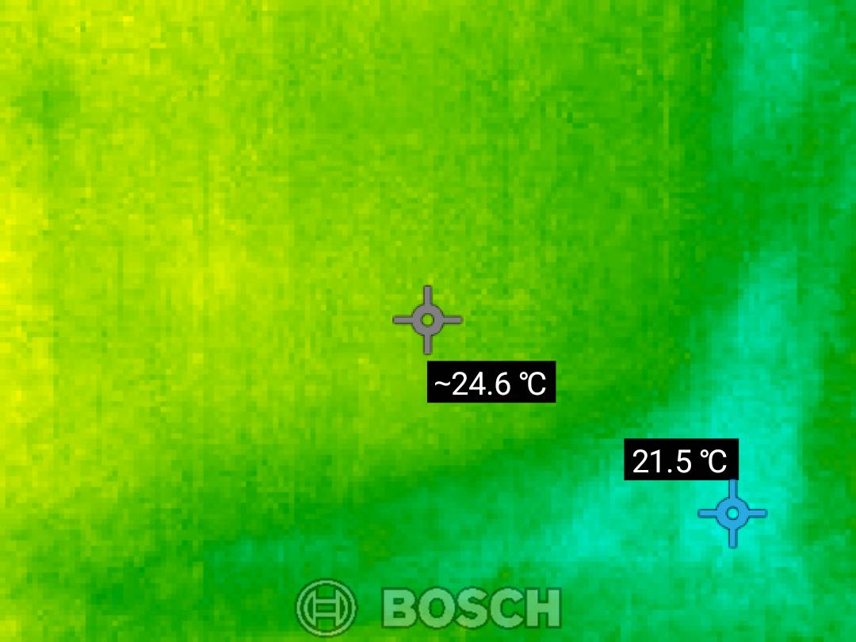
Figure: Observation from Page 1
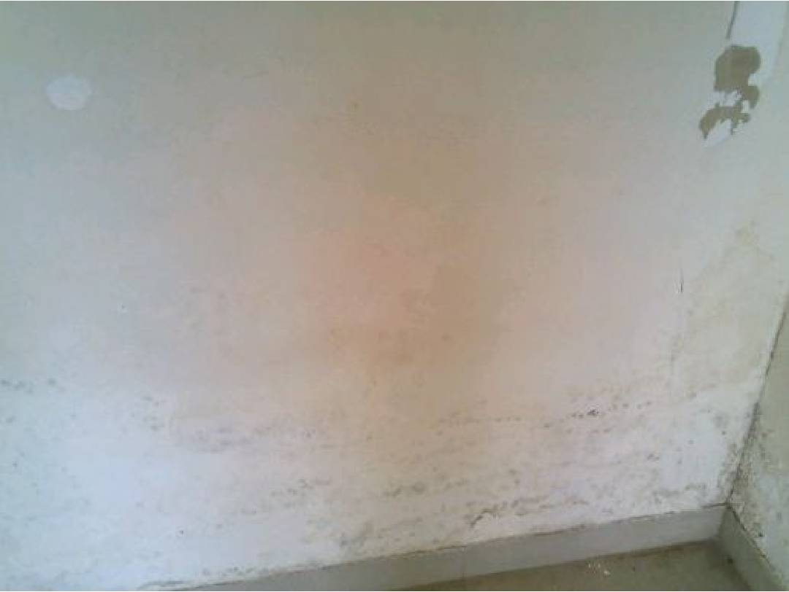
Figure: Observation from Page 1

Figure: Observation from Page 1

Figure: Observation from Page 1

Figure: Observation from Page 1

Figure: Observation from Page 1
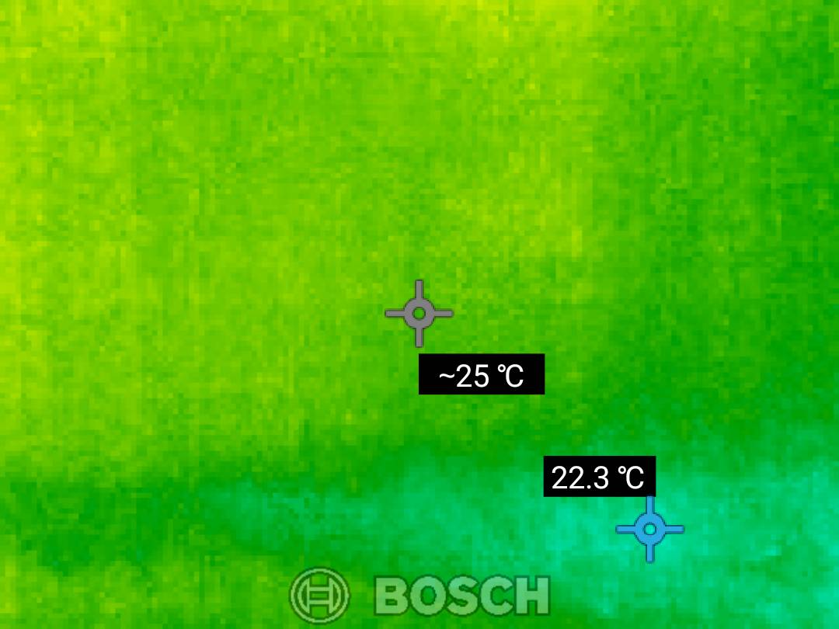
Figure: Observation from Page 1
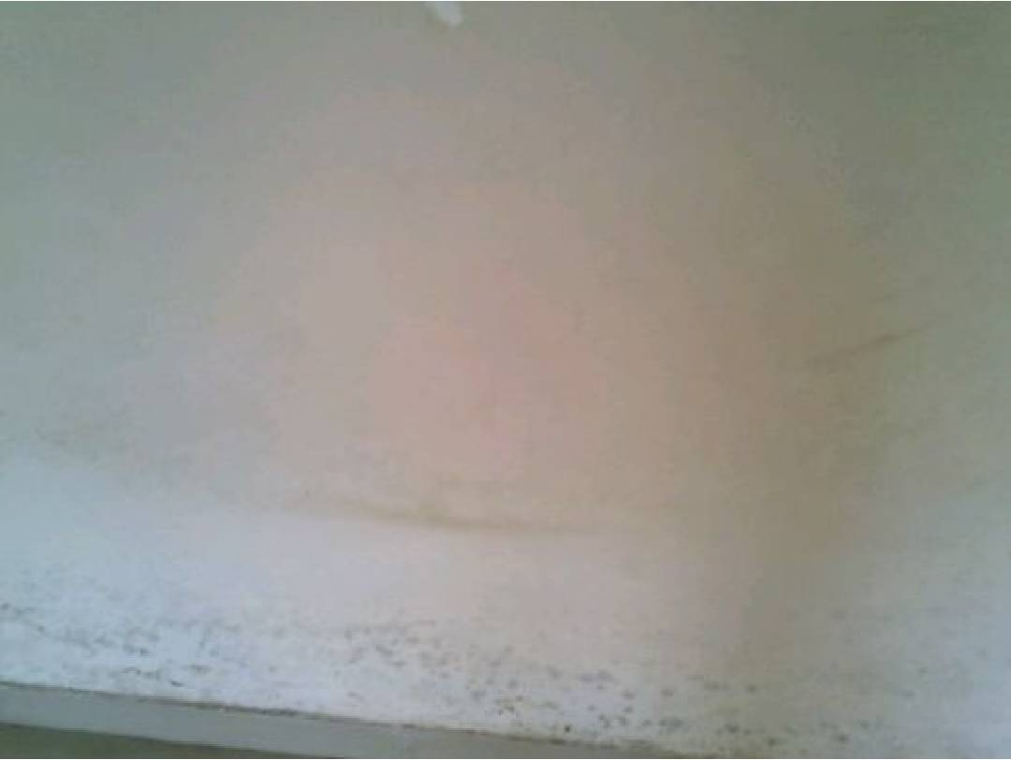
Figure: Observation from Page 1

Figure: Observation from Page 1

Figure: Observation from Page 1

Figure: Observation from Page 1

Figure: Observation from Page 1

Figure: Observation from Page 1

Figure: Observation from Page 1

Figure: Observation from Page 1

Figure: Observation from Page 1

Figure: Observation from Page 1

Figure: Observation from Page 1
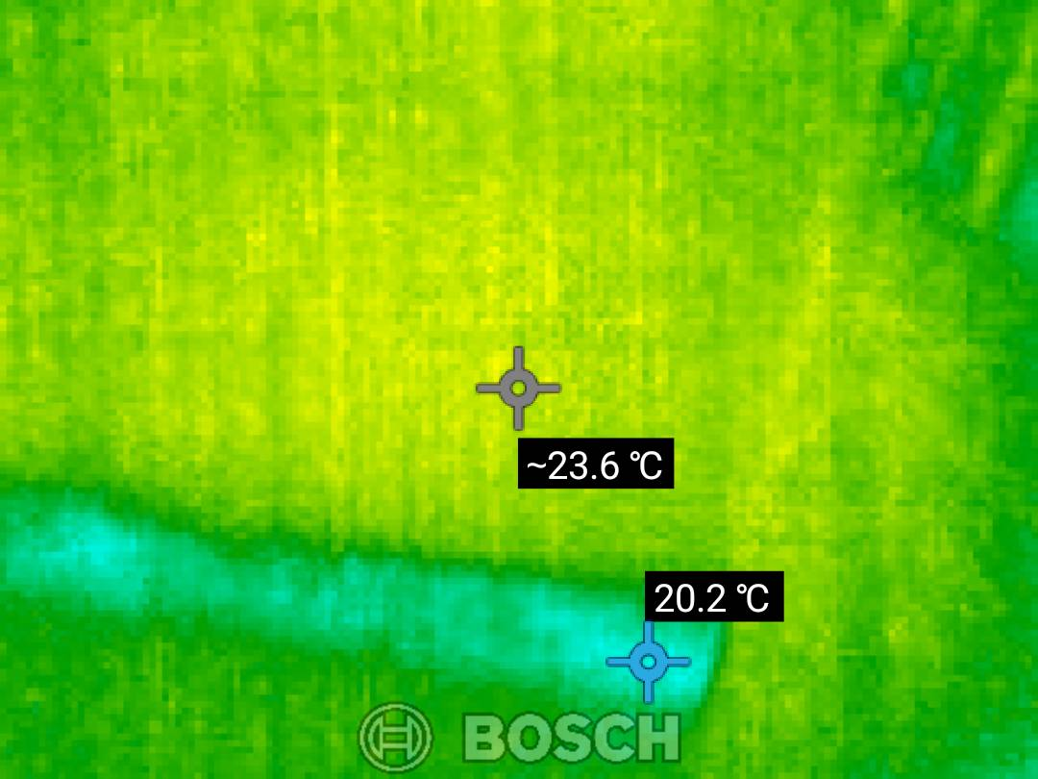
Figure: Observation from Page 1
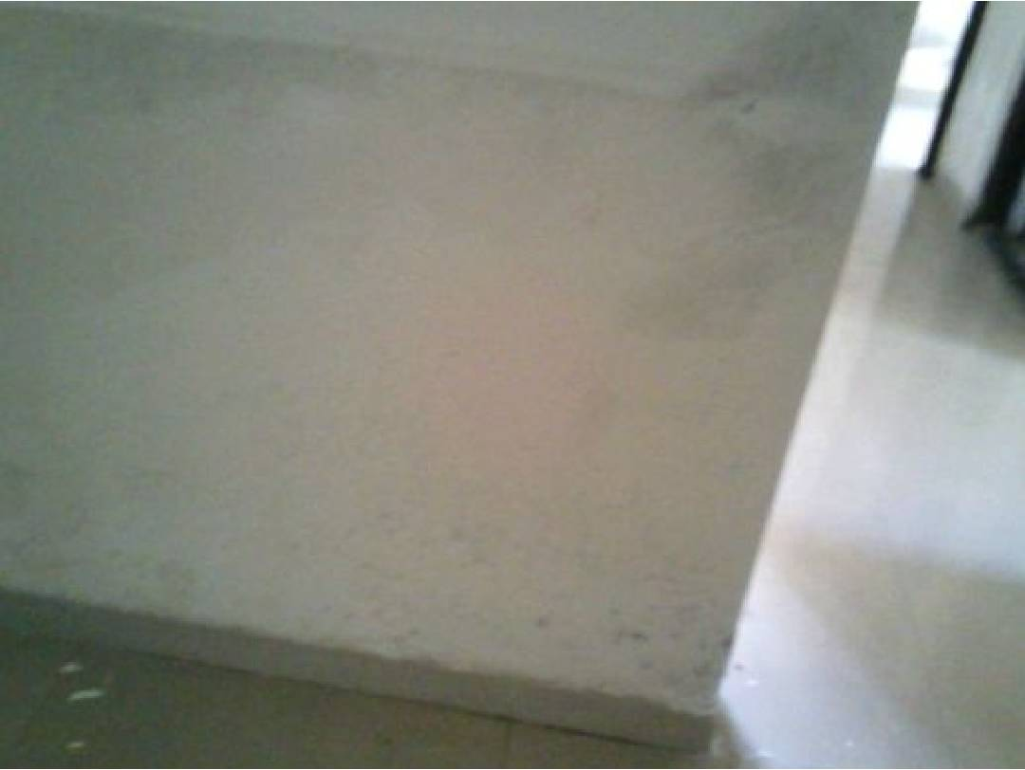
Figure: Observation from Page 1

Figure: Observation from Page 1
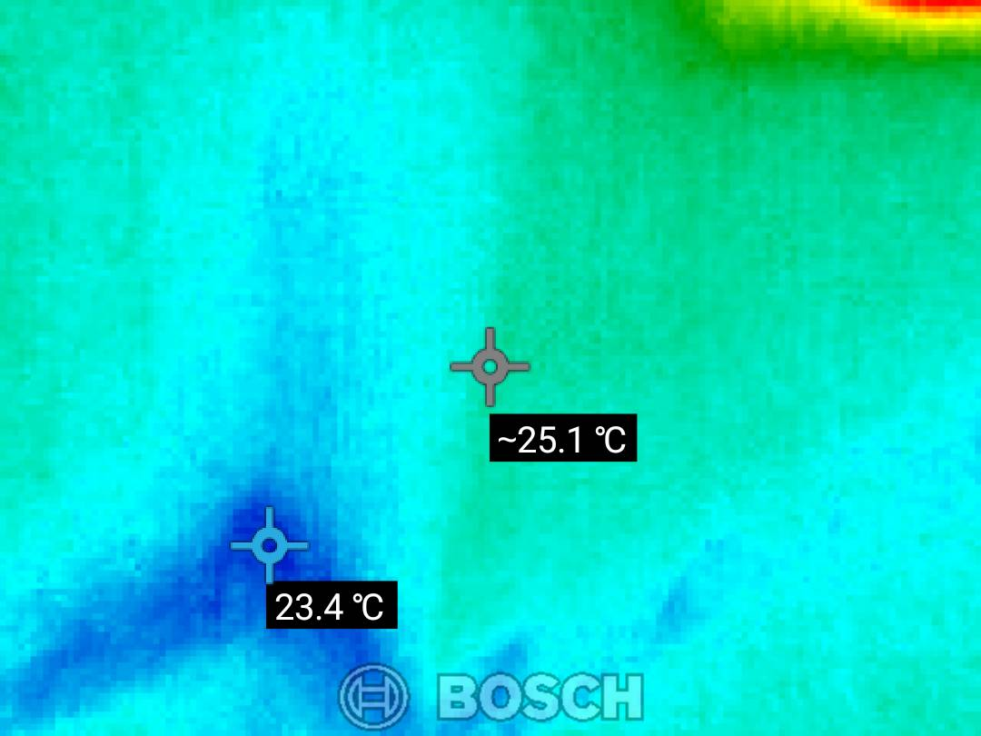
Figure: Observation from Page 1

Figure: Observation from Page 1

Figure: Observation from Page 1

Figure: Observation from Page 1
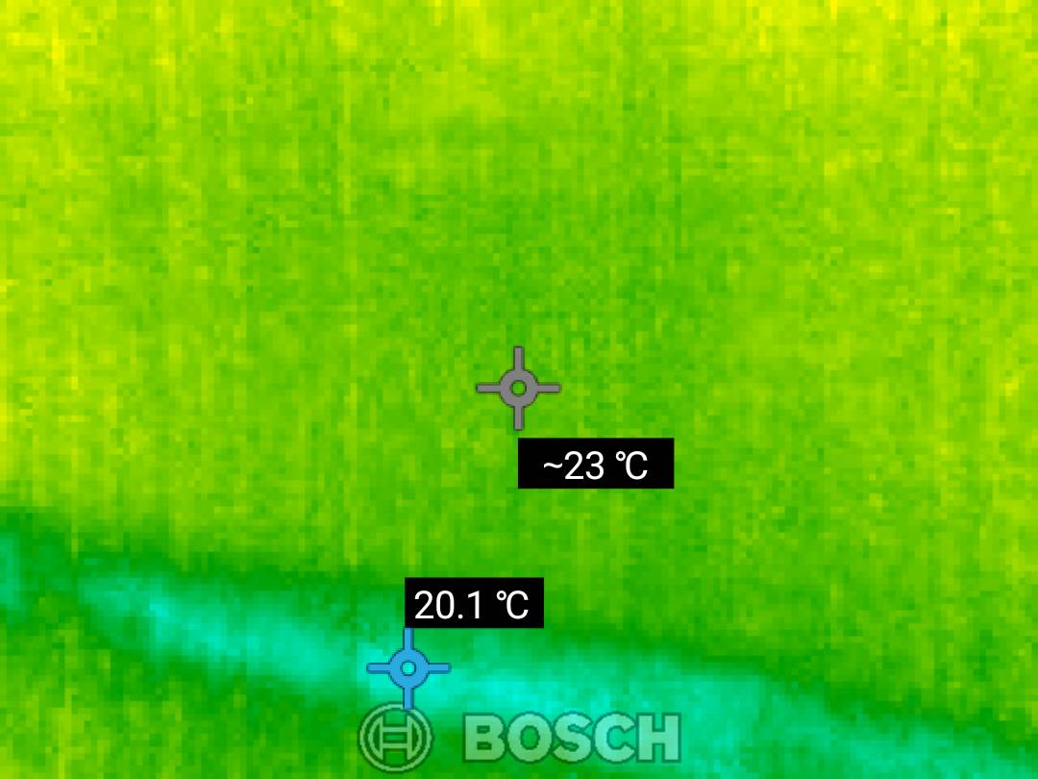
Figure: Observation from Page 1
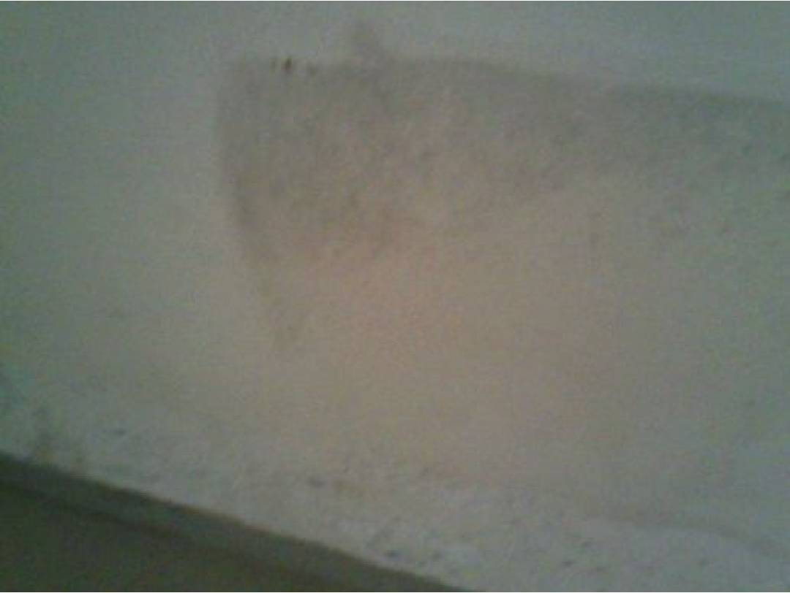
Figure: Observation from Page 1

Figure: Observation from Page 1
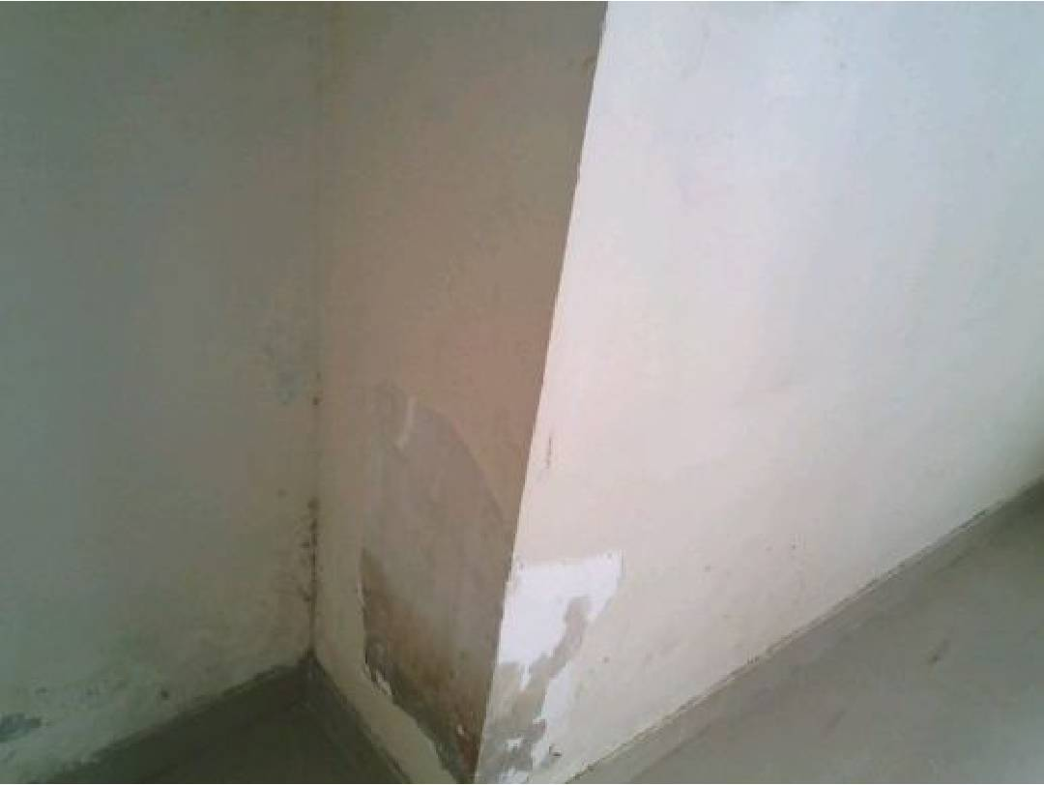
Figure: Observation from Page 1

Figure: Observation from Page 1

Figure: Observation from Page 1

Figure: Observation from Page 1
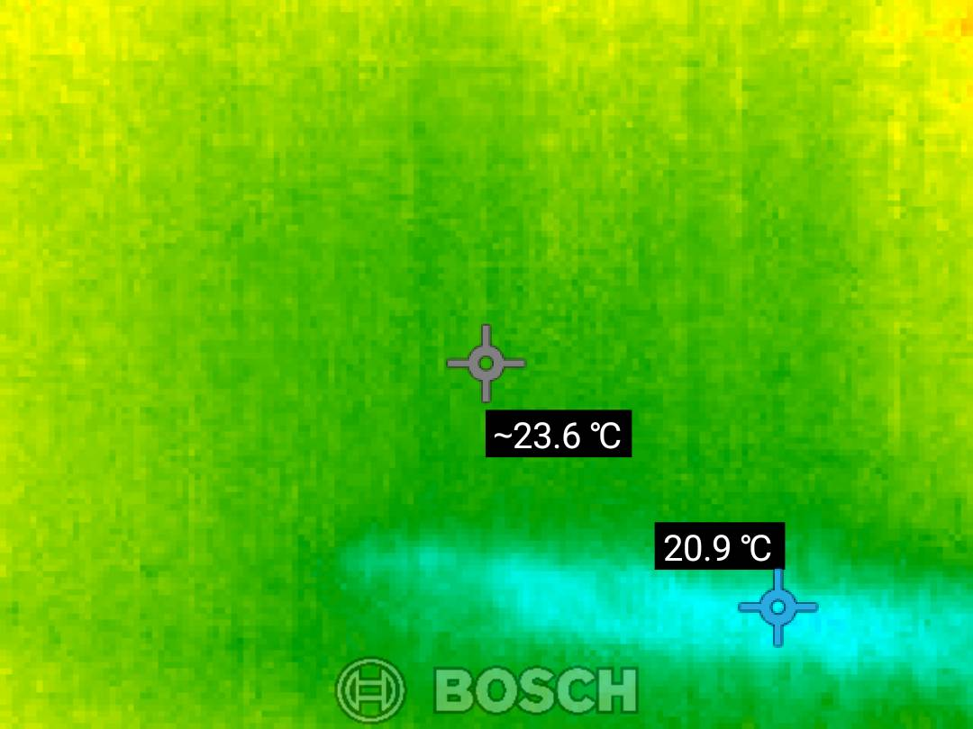
Figure: Observation from Page 1
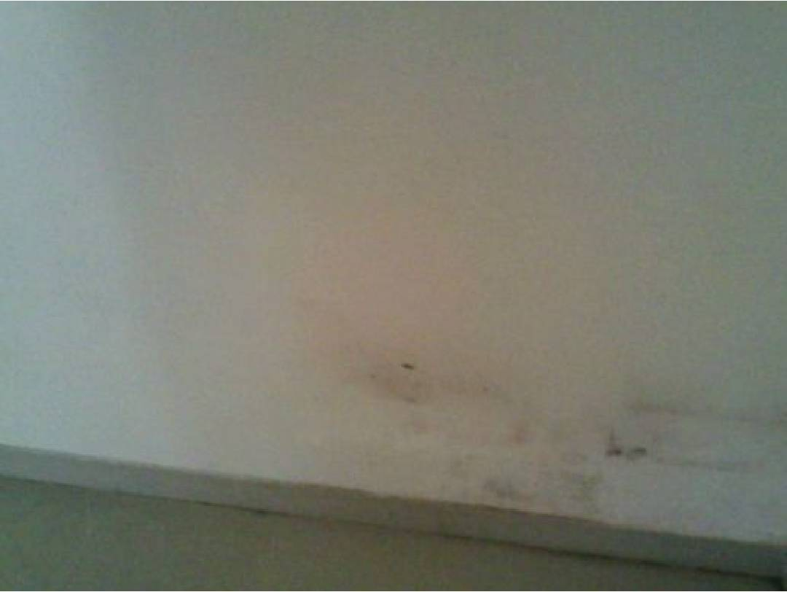
Figure: Observation from Page 1

Figure: Observation from Page 1

Figure: Observation from Page 1

Figure: Observation from Page 1

Figure: Observation from Page 1
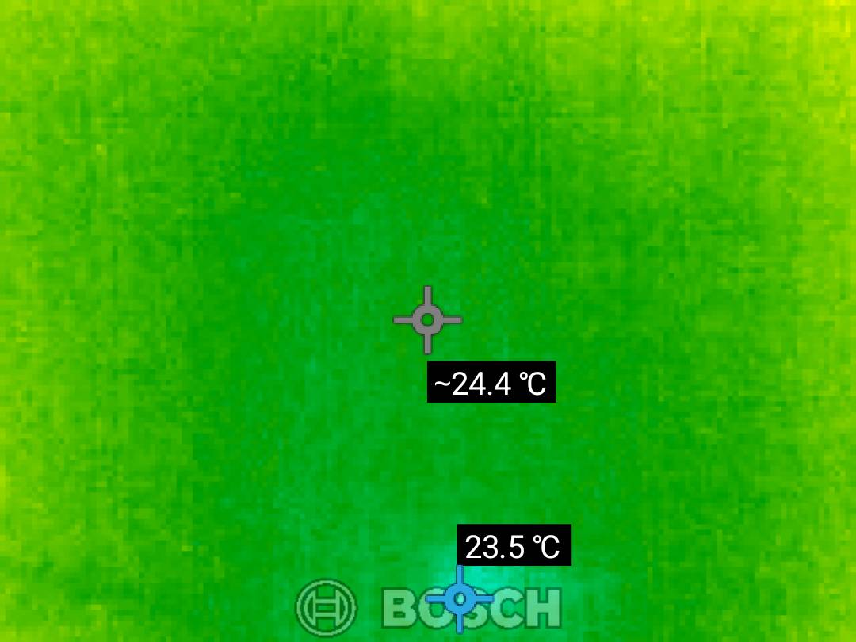
Figure: Observation from Page 1
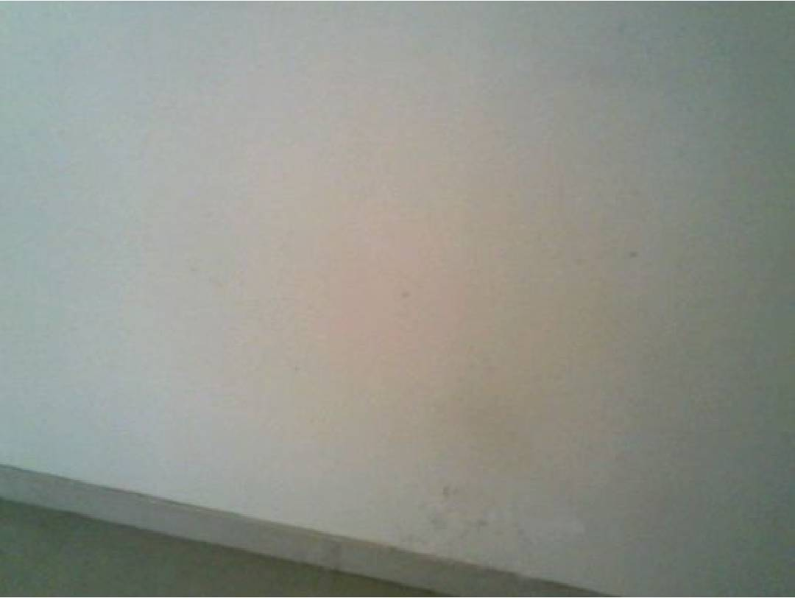
Figure: Observation from Page 1

Figure: Observation from Page 1

Figure: Observation from Page 1

Figure: Observation from Page 1

Figure: Observation from Page 1

Figure: Observation from Page 1
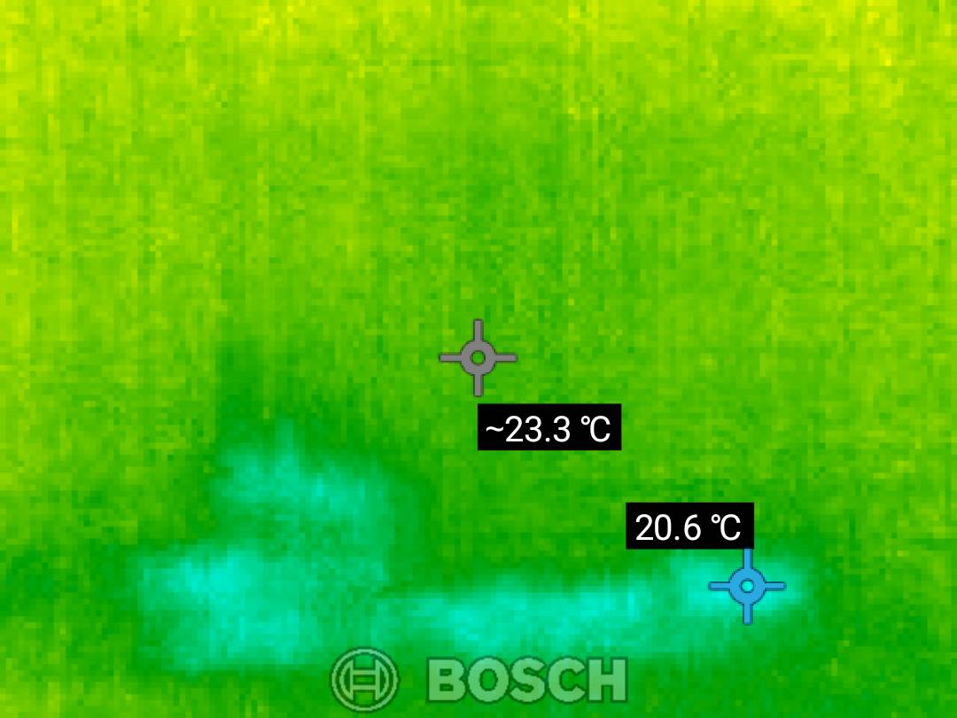
Figure: Observation from Page 1
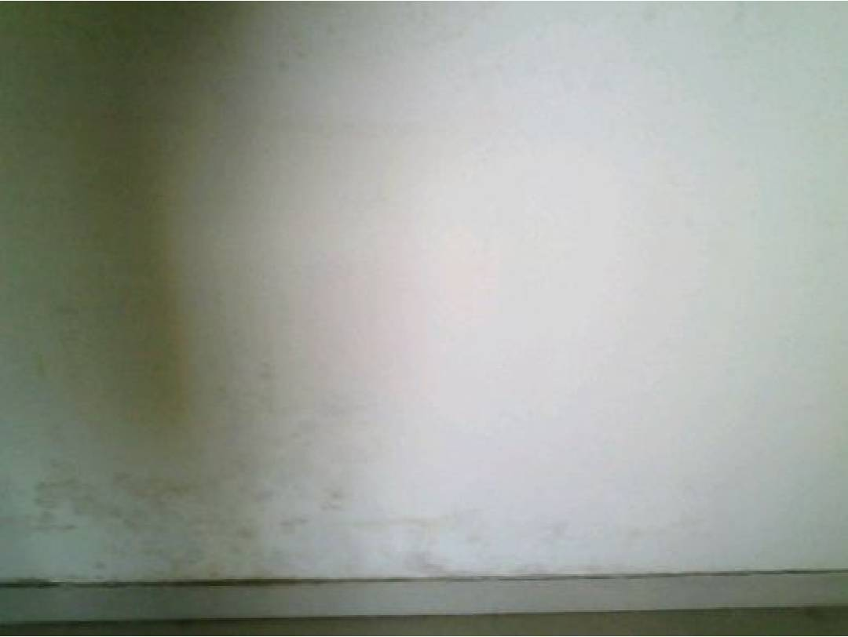
Figure: Observation from Page 1

Figure: Observation from Page 1

Figure: Observation from Page 1

Figure: Observation from Page 1

Figure: Observation from Page 1
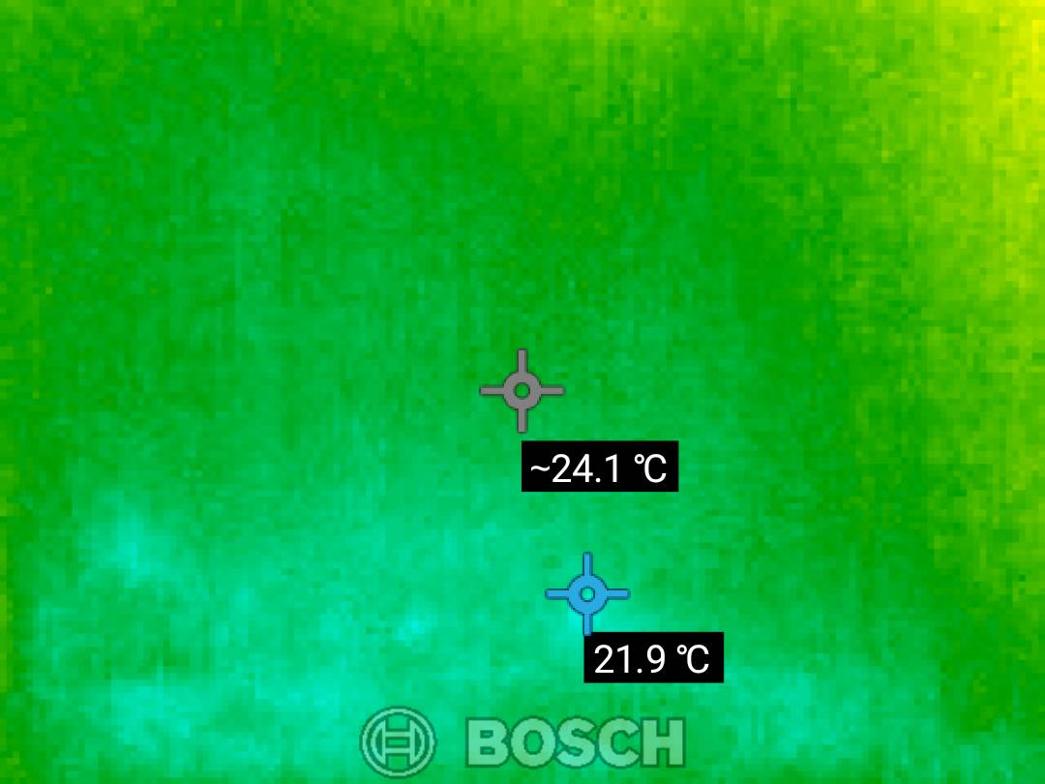
Figure: Observation from Page 1
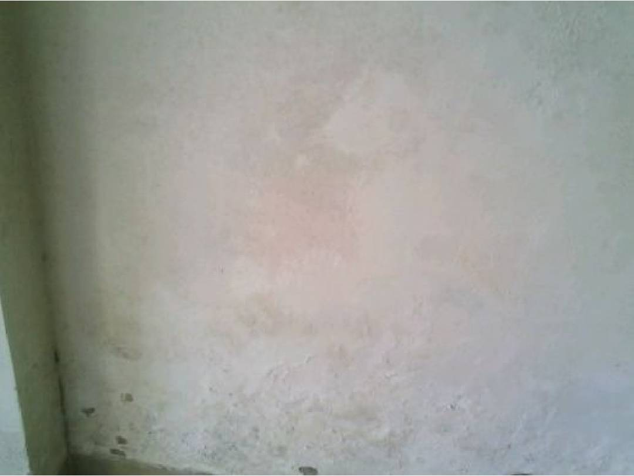
Figure: Observation from Page 1

Figure: Observation from Page 1

Figure: Observation from Page 1

Figure: Observation from Page 1

Figure: Observation from Page 1

Figure: Observation from Page 1
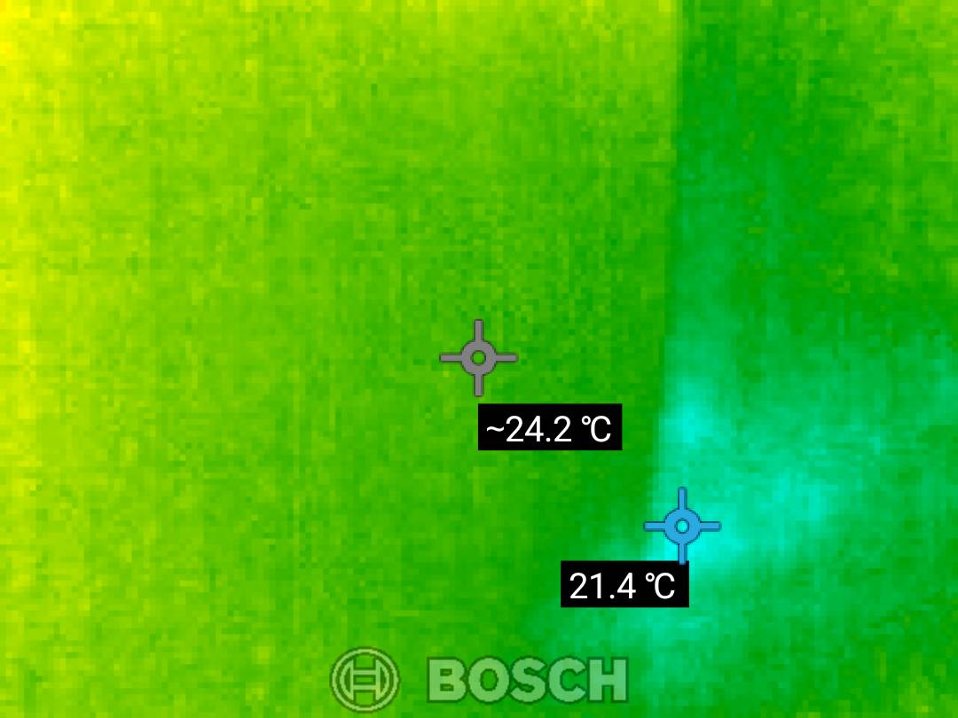
Figure: Observation from Page 1
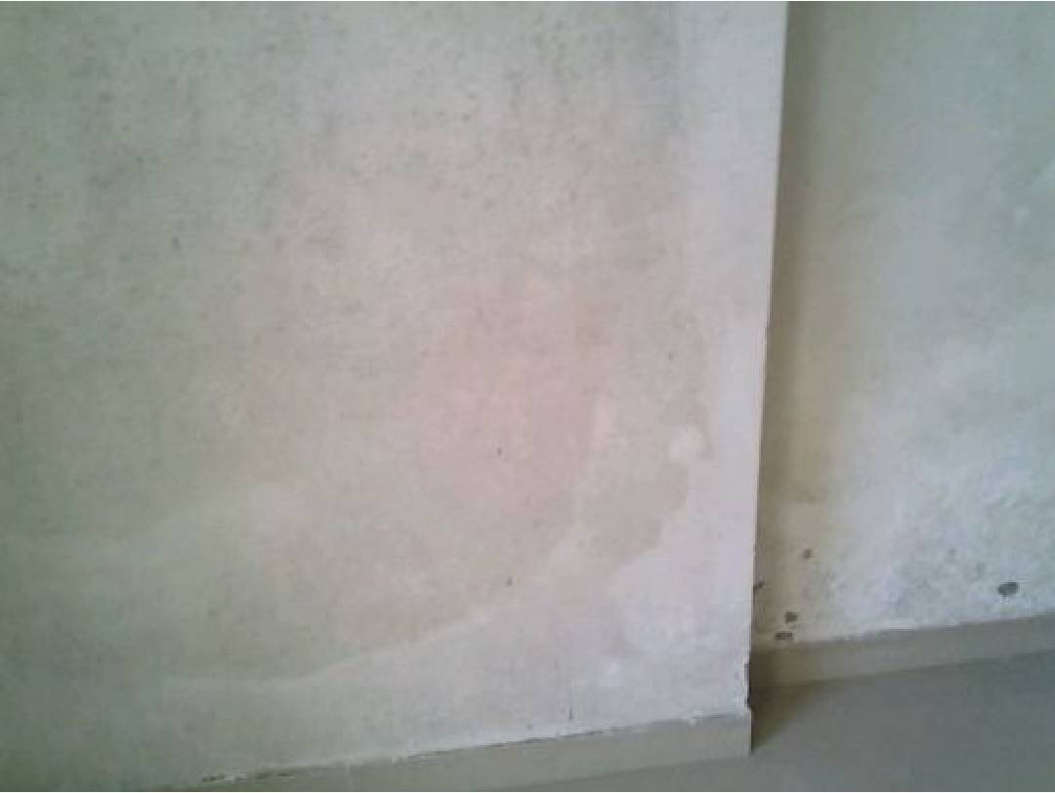
Figure: Observation from Page 1

Figure: Observation from Page 1

Figure: Observation from Page 1

Figure: Observation from Page 1

Figure: Observation from Page 1
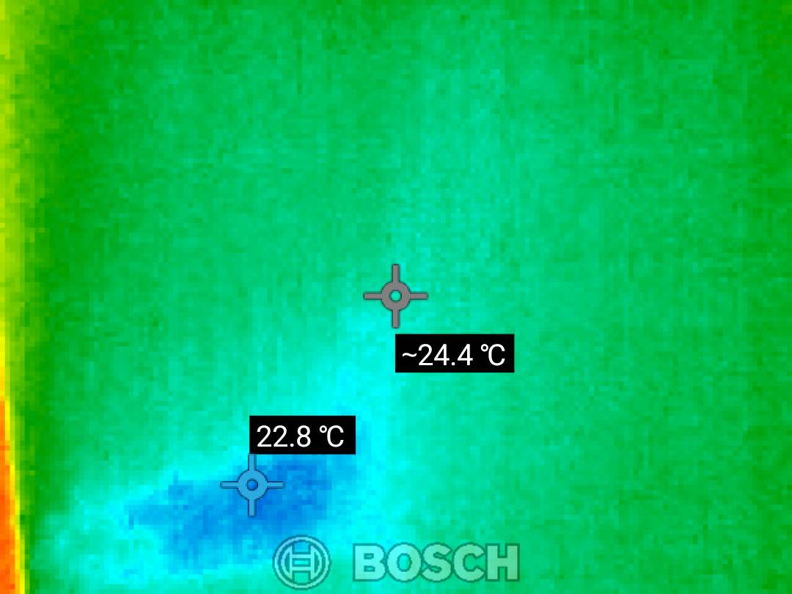
Figure: Observation from Page 1
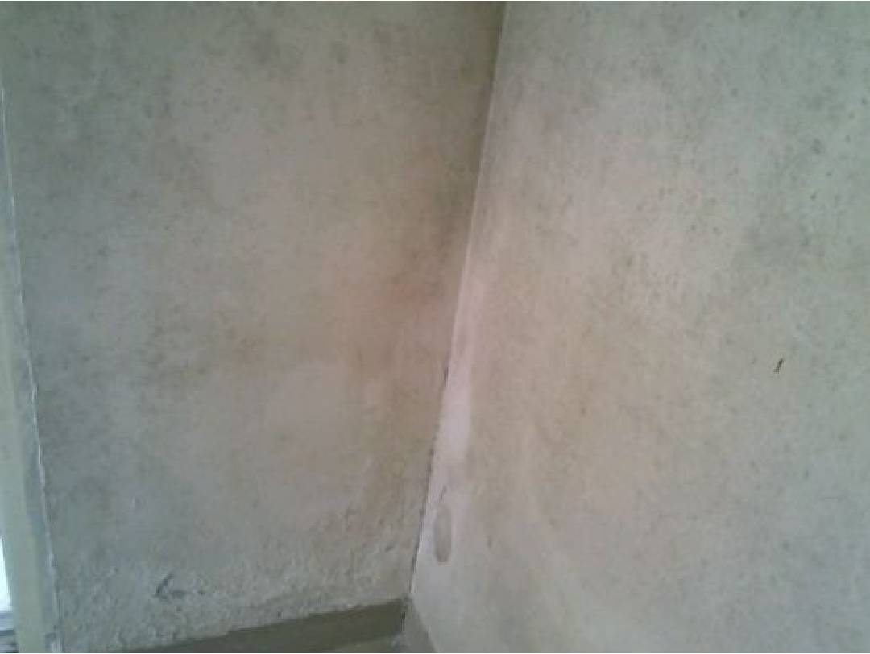
Figure: Observation from Page 1

Figure: Observation from Page 1

Figure: Observation from Page 1

Figure: Observation from Page 1

Figure: Observation from Page 1

Figure: Observation from Page 1

Figure: Observation from Page 1
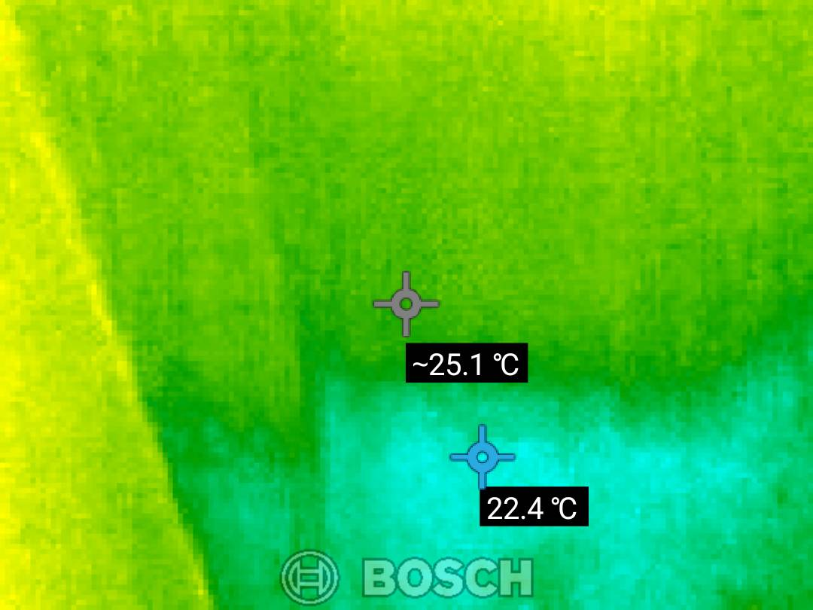
Figure: Observation from Page 1
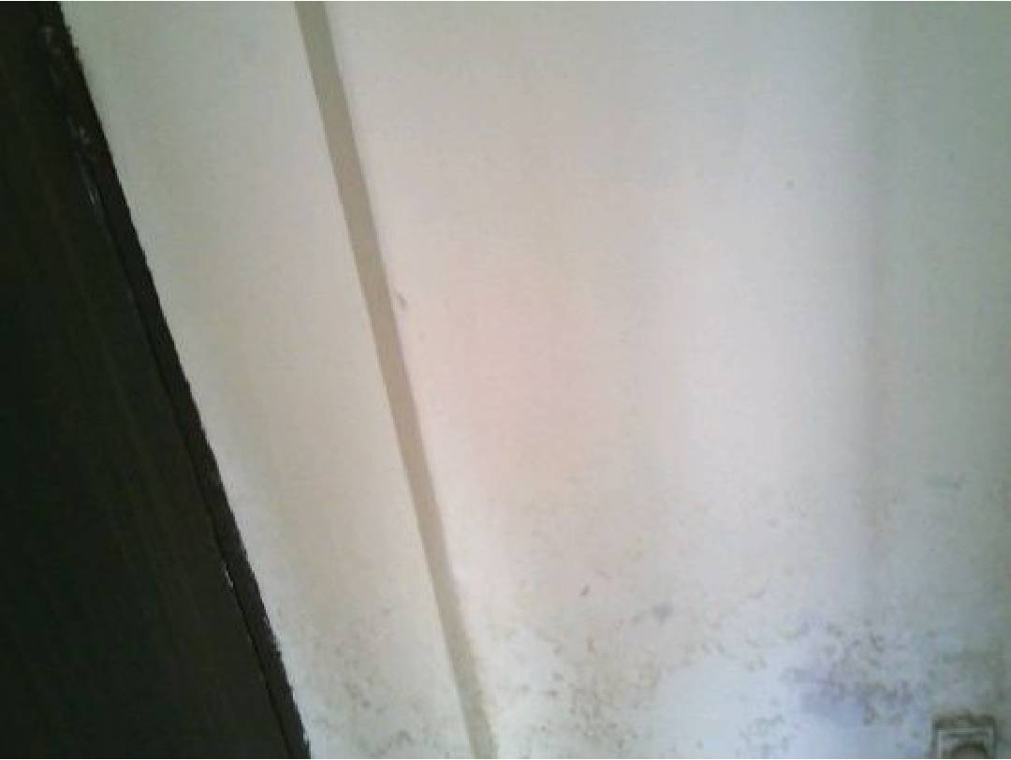
Figure: Observation from Page 1

Figure: Observation from Page 1

Figure: Observation from Page 1

Figure: Observation from Page 1

Figure: Observation from Page 1
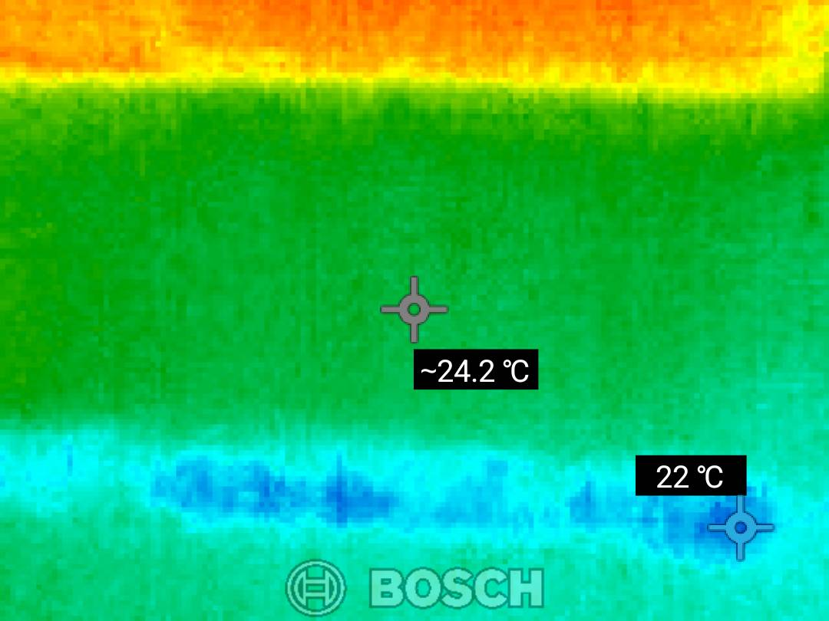
Figure: Observation from Page 1
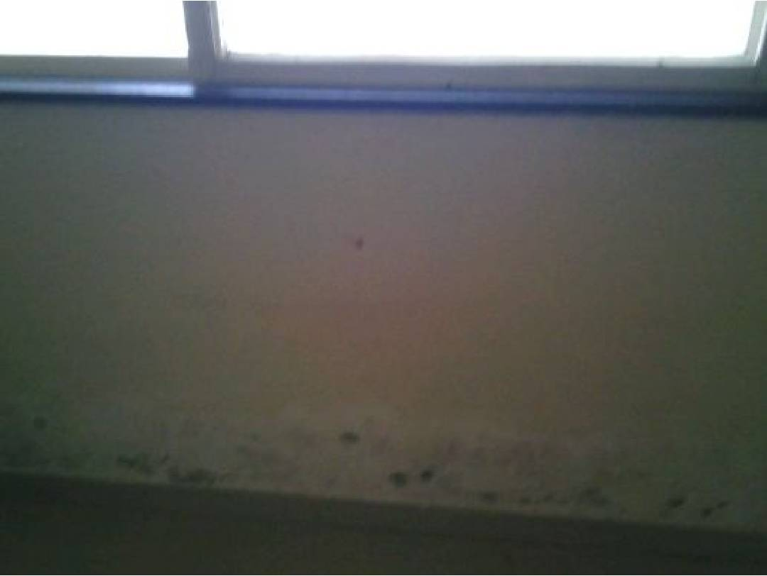
Figure: Observation from Page 1

Figure: Observation from Page 1

Figure: Observation from Page 1

Figure: Observation from Page 1

Figure: Observation from Page 1
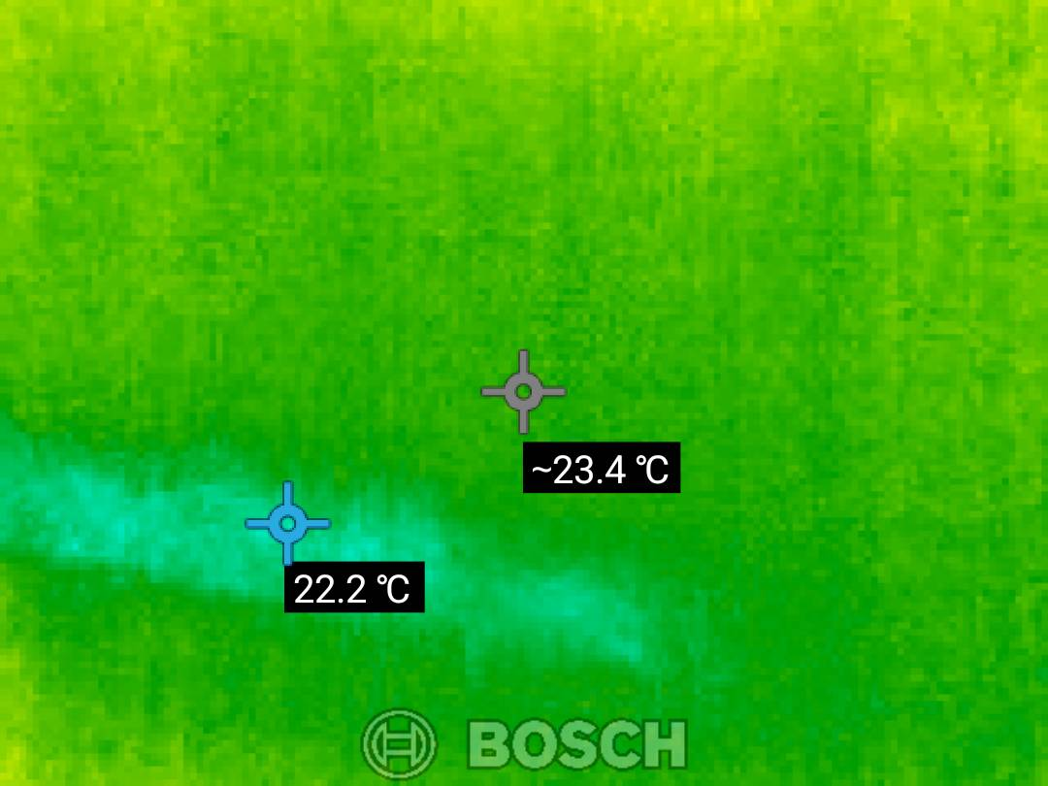
Figure: Observation from Page 1
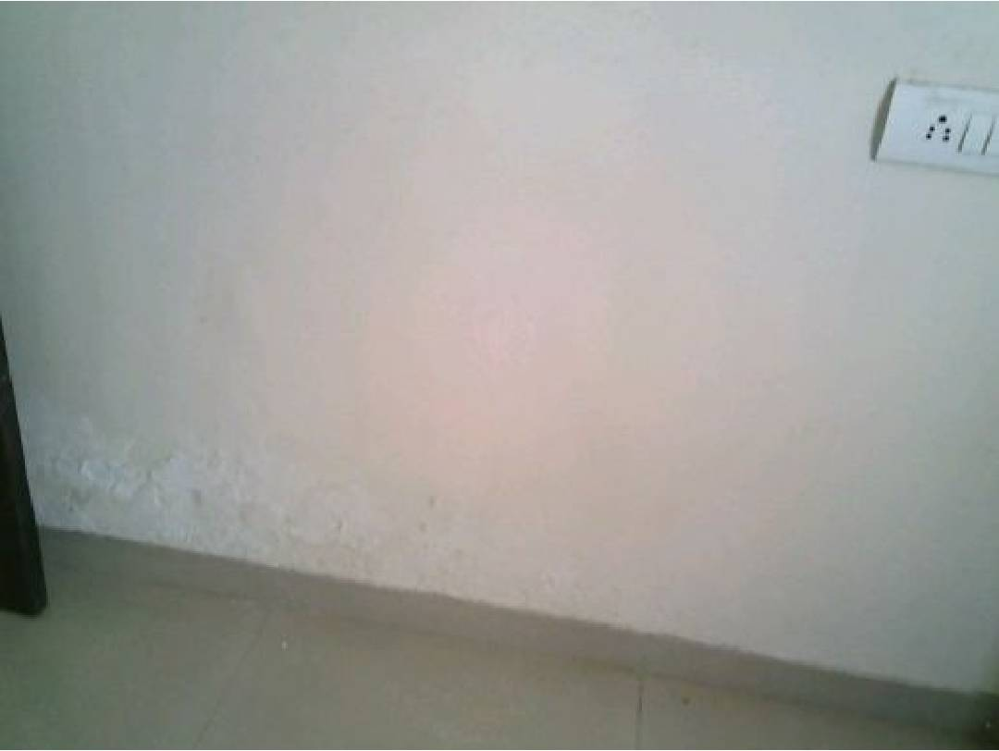
Figure: Observation from Page 1

Figure: Observation from Page 1

Figure: Observation from Page 1

Figure: Observation from Page 1

Figure: Observation from Page 1
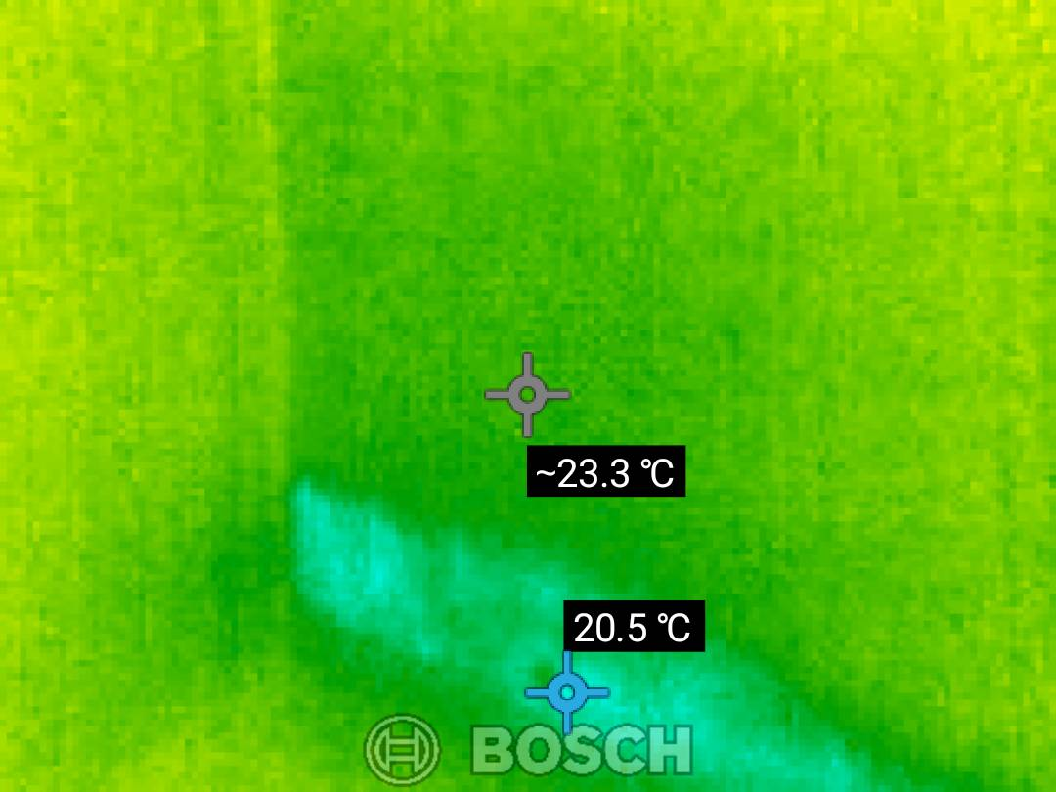
Figure: Observation from Page 1
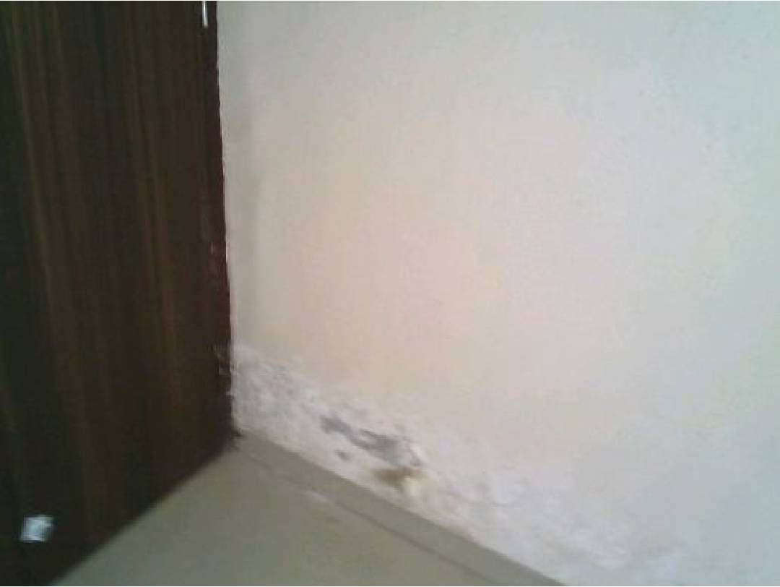
Figure: Observation from Page 1

Figure: Observation from Page 1

Figure: Observation from Page 1

Figure: Observation from Page 1

Figure: Observation from Page 1
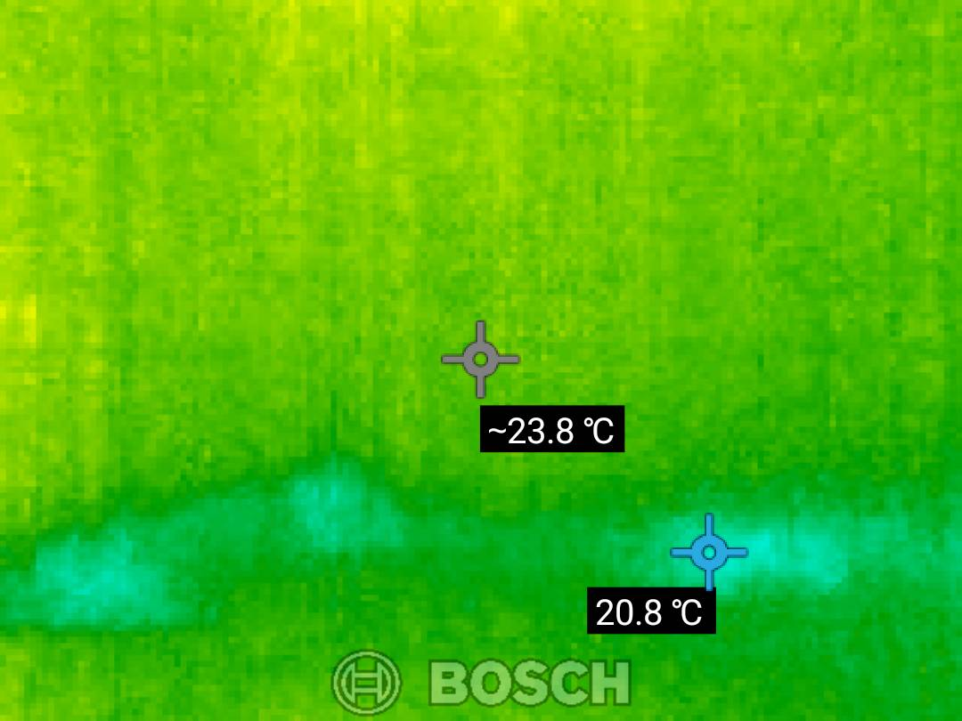
Figure: Observation from Page 1
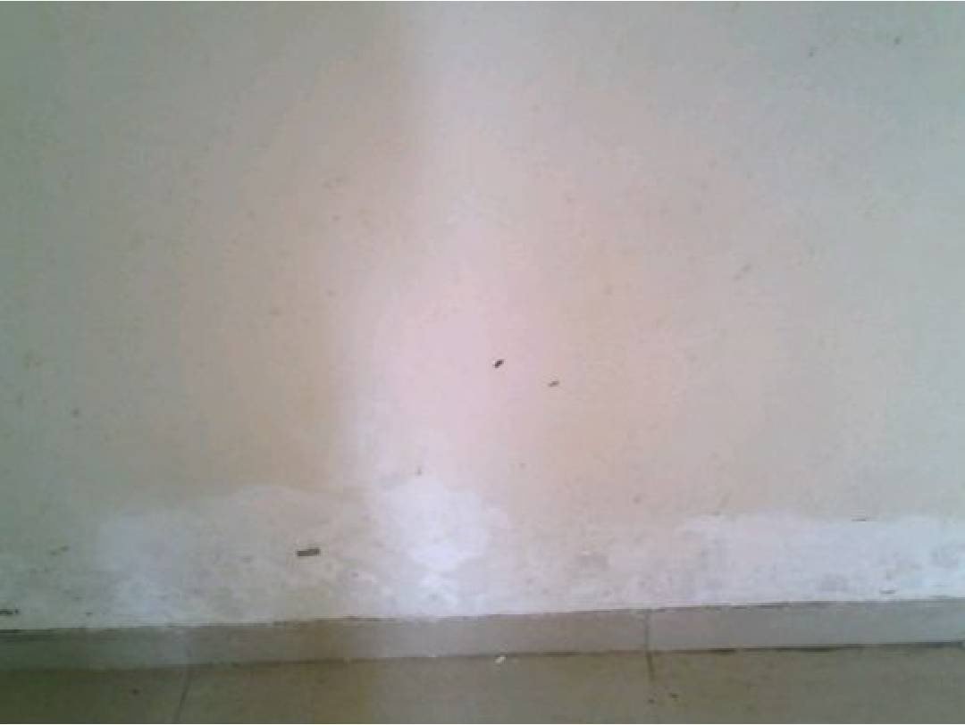
Figure: Observation from Page 1

Figure: Observation from Page 1

Figure: Observation from Page 1

Figure: Observation from Page 1

Figure: Observation from Page 1
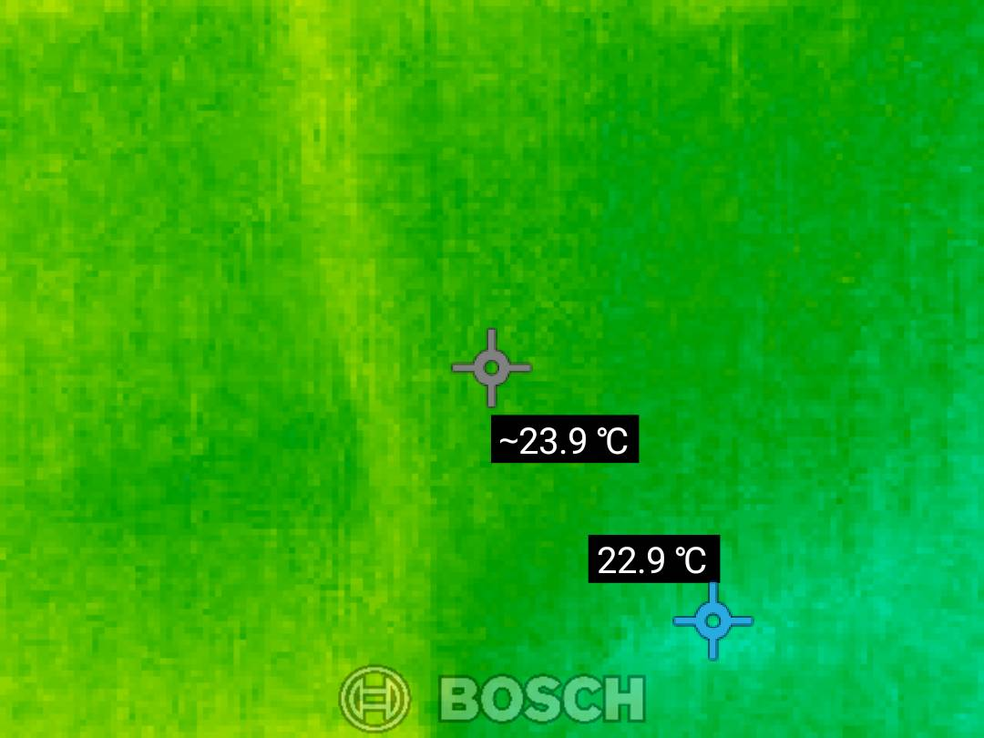
Figure: Observation from Page 1
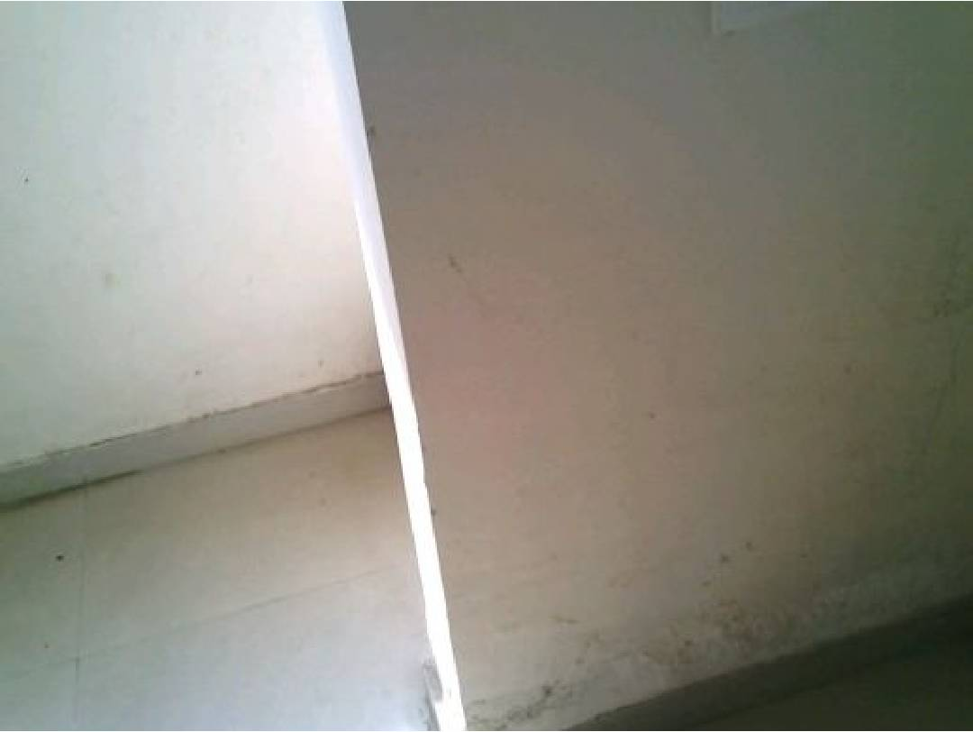
Figure: Observation from Page 1

Figure: Observation from Page 1

Figure: Observation from Page 1

Figure: Observation from Page 1

Figure: Observation from Page 1
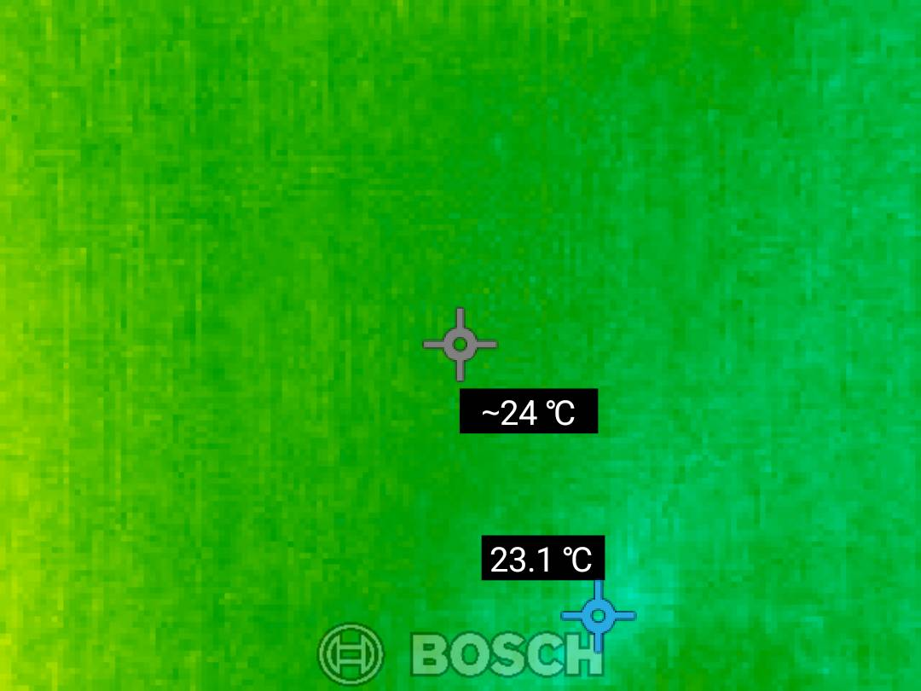
Figure: Observation from Page 1
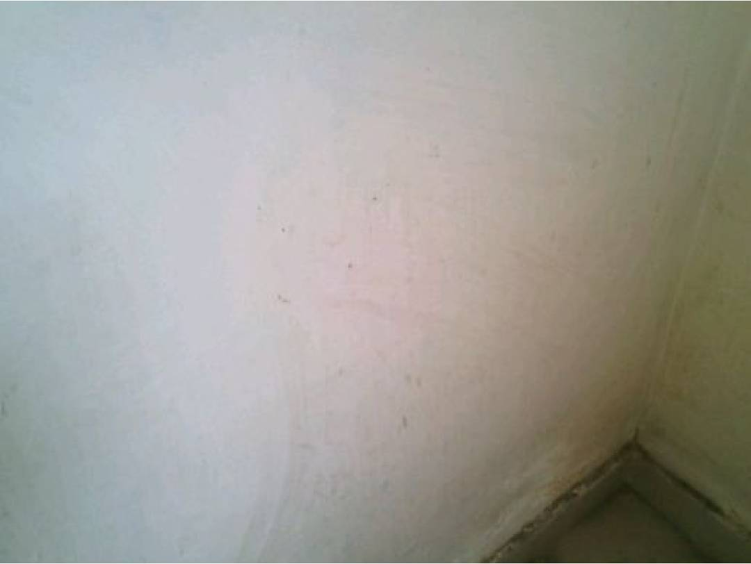
Figure: Observation from Page 1

Figure: Observation from Page 1

Figure: Observation from Page 2

Figure: Observation from Page 2

Figure: Observation from Page 2

Figure: Observation from Page 2

Figure: Observation from Page 2

Figure: Observation from Page 2

Figure: Observation from Page 2

Figure: Observation from Page 2

Figure: Observation from Page 2

Figure: Observation from Page 2

Figure: Observation from Page 2

Figure: Observation from Page 2

Figure: Observation from Page 2

Figure: Observation from Page 2

Figure: Observation from Page 2

Figure: Observation from Page 2

Figure: Observation from Page 2

Figure: Observation from Page 2

Figure: Observation from Page 2

Figure: Observation from Page 2

Figure: Observation from Page 2

Figure: Observation from Page 2

Figure: Observation from Page 2

Figure: Observation from Page 2

Figure: Observation from Page 2

Figure: Observation from Page 2

Figure: Observation from Page 2

Figure: Observation from Page 2

Figure: Observation from Page 2

Figure: Observation from Page 2

Figure: Observation from Page 2

Figure: Observation from Page 2

Figure: Observation from Page 2

Figure: Observation from Page 2

Figure: Observation from Page 2

Figure: Observation from Page 2

Figure: Observation from Page 2

Figure: Observation from Page 2

Figure: Observation from Page 2

Figure: Observation from Page 2

Figure: Observation from Page 2

Figure: Observation from Page 2

Figure: Observation from Page 2

Figure: Observation from Page 2

Figure: Observation from Page 2

Figure: Observation from Page 2

Figure: Observation from Page 2

Figure: Observation from Page 2

Figure: Observation from Page 2

Figure: Observation from Page 2

Figure: Observation from Page 2

Figure: Observation from Page 2

Figure: Observation from Page 2

Figure: Observation from Page 2

Figure: Observation from Page 2

Figure: Observation from Page 2

Figure: Observation from Page 2

Figure: Observation from Page 2

Figure: Observation from Page 2

Figure: Observation from Page 2

Figure: Observation from Page 2

Figure: Observation from Page 2

Figure: Observation from Page 2

Figure: Observation from Page 2

Figure: Observation from Page 2

Figure: Observation from Page 2

Figure: Observation from Page 2

Figure: Observation from Page 2

Figure: Observation from Page 2

Figure: Observation from Page 2

Figure: Observation from Page 2

Figure: Observation from Page 2

Figure: Observation from Page 2

Figure: Observation from Page 2

Figure: Observation from Page 2

Figure: Observation from Page 2

Figure: Observation from Page 2

Figure: Observation from Page 2

Figure: Observation from Page 2

Figure: Observation from Page 2

Figure: Observation from Page 2

Figure: Observation from Page 2

Figure: Observation from Page 2

Figure: Observation from Page 2

Figure: Observation from Page 2

Figure: Observation from Page 2

Figure: Observation from Page 2

Figure: Observation from Page 2

Figure: Observation from Page 2

Figure: Observation from Page 2

Figure: Observation from Page 2

Figure: Observation from Page 2

Figure: Observation from Page 2

Figure: Observation from Page 2

Figure: Observation from Page 2

Figure: Observation from Page 2

Figure: Observation from Page 2

Figure: Observation from Page 2

Figure: Observation from Page 2

Figure: Observation from Page 2

Figure: Observation from Page 2

Figure: Observation from Page 2

Figure: Observation from Page 2

Figure: Observation from Page 2

Figure: Observation from Page 2

Figure: Observation from Page 2

Figure: Observation from Page 2

Figure: Observation from Page 2

Figure: Observation from Page 2

Figure: Observation from Page 2

Figure: Observation from Page 2

Figure: Observation from Page 2

Figure: Observation from Page 2

Figure: Observation from Page 2

Figure: Observation from Page 2

Figure: Observation from Page 2

Figure: Observation from Page 2

Figure: Observation from Page 2

Figure: Observation from Page 2

Figure: Observation from Page 2

Figure: Observation from Page 2

Figure: Observation from Page 2

Figure: Observation from Page 2

Figure: Observation from Page 2

Figure: Observation from Page 2

Figure: Observation from Page 2

Figure: Observation from Page 2

Figure: Observation from Page 2

Figure: Observation from Page 2

Figure: Observation from Page 2

Figure: Observation from Page 2

Figure: Observation from Page 2

Figure: Observation from Page 2

Figure: Observation from Page 2

Figure: Observation from Page 2

Figure: Observation from Page 2

Figure: Observation from Page 2

Figure: Observation from Page 2

Figure: Observation from Page 2

Figure: Observation from Page 2

Figure: Observation from Page 2

Figure: Observation from Page 2

Figure: Observation from Page 2

Figure: Observation from Page 2

Figure: Observation from Page 2

Figure: Observation from Page 2

Figure: Observation from Page 2

Figure: Observation from Page 2

Figure: Observation from Page 2

Figure: Observation from Page 2

Figure: Observation from Page 2

Figure: Observation from Page 2

Figure: Observation from Page 2

Figure: Observation from Page 2

Figure: Observation from Page 2

Figure: Observation from Page 2

Figure: Observation from Page 2

Figure: Observation from Page 2

Figure: Observation from Page 2

Figure: Observation from Page 2

Figure: Observation from Page 2

Figure: Observation from Page 2

Figure: Observation from Page 2

Figure: Observation from Page 2

Figure: Observation from Page 2

Figure: Observation from Page 2

Figure: Observation from Page 2

Figure: Observation from Page 2

Figure: Observation from Page 2

Figure: Observation from Page 2

Figure: Observation from Page 2

Figure: Observation from Page 2

Figure: Observation from Page 2

Figure: Observation from Page 2

Figure: Observation from Page 2

Figure: Observation from Page 2

Figure: Observation from Page 2

Figure: Observation from Page 2

Figure: Observation from Page 2

Figure: Observation from Page 2

Figure: Observation from Page 3

Figure: Observation from Page 3

Figure: Observation from Page 3

Figure: Observation from Page 3

Figure: Observation from Page 3

Figure: Observation from Page 3

Figure: Observation from Page 3

Figure: Observation from Page 3

Figure: Observation from Page 3

Figure: Observation from Page 3

Figure: Observation from Page 3

Figure: Observation from Page 3

Figure: Observation from Page 3

Figure: Observation from Page 3

Figure: Observation from Page 3

Figure: Observation from Page 3

Figure: Observation from Page 3

Figure: Observation from Page 3

Figure: Observation from Page 3

Figure: Observation from Page 3

Figure: Observation from Page 3

Figure: Observation from Page 3

Figure: Observation from Page 3

Figure: Observation from Page 3

Figure: Observation from Page 3

Figure: Observation from Page 3

Figure: Observation from Page 3

Figure: Observation from Page 3

Figure: Observation from Page 3

Figure: Observation from Page 3

Figure: Observation from Page 3

Figure: Observation from Page 3

Figure: Observation from Page 3

Figure: Observation from Page 3

Figure: Observation from Page 3

Figure: Observation from Page 3

Figure: Observation from Page 3

Figure: Observation from Page 3

Figure: Observation from Page 3

Figure: Observation from Page 3

Figure: Observation from Page 3

Figure: Observation from Page 3

Figure: Observation from Page 3

Figure: Observation from Page 3

Figure: Observation from Page 3

Figure: Observation from Page 3

Figure: Observation from Page 3

Figure: Observation from Page 3

Figure: Observation from Page 3

Figure: Observation from Page 3

Figure: Observation from Page 3

Figure: Observation from Page 3

Figure: Observation from Page 3

Figure: Observation from Page 3

Figure: Observation from Page 3

Figure: Observation from Page 3

Figure: Observation from Page 3

Figure: Observation from Page 3

Figure: Observation from Page 3

Figure: Observation from Page 3

Figure: Observation from Page 3

Figure: Observation from Page 3

Figure: Observation from Page 3

Figure: Observation from Page 3

Figure: Observation from Page 3

Figure: Observation from Page 3

Figure: Observation from Page 3

Figure: Observation from Page 3

Figure: Observation from Page 3

Figure: Observation from Page 3

Figure: Observation from Page 3

Figure: Observation from Page 3

Figure: Observation from Page 3

Figure: Observation from Page 3

Figure: Observation from Page 3

Figure: Observation from Page 3

Figure: Observation from Page 3

Figure: Observation from Page 3

Figure: Observation from Page 3

Figure: Observation from Page 3

Figure: Observation from Page 3

Figure: Observation from Page 3

Figure: Observation from Page 3

Figure: Observation from Page 3

Figure: Observation from Page 3

Figure: Observation from Page 3

Figure: Observation from Page 3

Figure: Observation from Page 3

Figure: Observation from Page 3

Figure: Observation from Page 3

Figure: Observation from Page 3

Figure: Observation from Page 3

Figure: Observation from Page 3

Figure: Observation from Page 3

Figure: Observation from Page 3

Figure: Observation from Page 3

Figure: Observation from Page 3

Figure: Observation from Page 3

Figure: Observation from Page 3

Figure: Observation from Page 3

Figure: Observation from Page 3

Figure: Observation from Page 3

Figure: Observation from Page 3

Figure: Observation from Page 3

Figure: Observation from Page 3

Figure: Observation from Page 3

Figure: Observation from Page 3

Figure: Observation from Page 3

Figure: Observation from Page 3

Figure: Observation from Page 3

Figure: Observation from Page 3

Figure: Observation from Page 3

Figure: Observation from Page 3

Figure: Observation from Page 3

Figure: Observation from Page 3

Figure: Observation from Page 3

Figure: Observation from Page 3

Figure: Observation from Page 3

Figure: Observation from Page 3

Figure: Observation from Page 3

Figure: Observation from Page 3

Figure: Observation from Page 3

Figure: Observation from Page 3

Figure: Observation from Page 3

Figure: Observation from Page 3

Figure: Observation from Page 3

Figure: Observation from Page 3

Figure: Observation from Page 3

Figure: Observation from Page 3

Figure: Observation from Page 3

Figure: Observation from Page 3

Figure: Observation from Page 3

Figure: Observation from Page 3

Figure: Observation from Page 3

Figure: Observation from Page 3

Figure: Observation from Page 3

Figure: Observation from Page 3

Figure: Observation from Page 3

Figure: Observation from Page 3

Figure: Observation from Page 3

Figure: Observation from Page 3

Figure: Observation from Page 3

Figure: Observation from Page 3

Figure: Observation from Page 3

Figure: Observation from Page 3

Figure: Observation from Page 3

Figure: Observation from Page 3

Figure: Observation from Page 3

Figure: Observation from Page 3

Figure: Observation from Page 3

Figure: Observation from Page 3

Figure: Observation from Page 3

Figure: Observation from Page 3

Figure: Observation from Page 3

Figure: Observation from Page 3

Figure: Observation from Page 3

Figure: Observation from Page 3

Figure: Observation from Page 3

Figure: Observation from Page 3

Figure: Observation from Page 3

Figure: Observation from Page 3

Figure: Observation from Page 3

Figure: Observation from Page 3

Figure: Observation from Page 3

Figure: Observation from Page 3

Figure: Observation from Page 3

Figure: Observation from Page 3

Figure: Observation from Page 3

Figure: Observation from Page 3

Figure: Observation from Page 3

Figure: Observation from Page 3

Figure: Observation from Page 3

Figure: Observation from Page 3

Figure: Observation from Page 3

Figure: Observation from Page 3

Figure: Observation from Page 3

Figure: Observation from Page 3

Figure: Observation from Page 3

Figure: Observation from Page 3

Figure: Observation from Page 3

Figure: Observation from Page 4

Figure: Observation from Page 4

Figure: Observation from Page 4

Figure: Observation from Page 4

Figure: Observation from Page 4

Figure: Observation from Page 4

Figure: Observation from Page 4

Figure: Observation from Page 4

Figure: Observation from Page 4

Figure: Observation from Page 4

Figure: Observation from Page 4

Figure: Observation from Page 4

Figure: Observation from Page 4

Figure: Observation from Page 4

Figure: Observation from Page 4

Figure: Observation from Page 4

Figure: Observation from Page 4

Figure: Observation from Page 4

Figure: Observation from Page 4

Figure: Observation from Page 4

Figure: Observation from Page 4

Figure: Observation from Page 4

Figure: Observation from Page 4

Figure: Observation from Page 4

Figure: Observation from Page 4

Figure: Observation from Page 4

Figure: Observation from Page 4

Figure: Observation from Page 4

Figure: Observation from Page 4

Figure: Observation from Page 4

Figure: Observation from Page 4

Figure: Observation from Page 4

Figure: Observation from Page 4

Figure: Observation from Page 4

Figure: Observation from Page 4

Figure: Observation from Page 4

Figure: Observation from Page 4

Figure: Observation from Page 4

Figure: Observation from Page 4

Figure: Observation from Page 4

Figure: Observation from Page 4

Figure: Observation from Page 4

Figure: Observation from Page 4

Figure: Observation from Page 4

Figure: Observation from Page 4

Figure: Observation from Page 4

Figure: Observation from Page 4

Figure: Observation from Page 4

Figure: Observation from Page 4

Figure: Observation from Page 4

Figure: Observation from Page 4

Figure: Observation from Page 4

Figure: Observation from Page 4

Figure: Observation from Page 4

Figure: Observation from Page 4

Figure: Observation from Page 4

Figure: Observation from Page 4

Figure: Observation from Page 4

Figure: Observation from Page 4

Figure: Observation from Page 4

Figure: Observation from Page 4

Figure: Observation from Page 4

Figure: Observation from Page 4

Figure: Observation from Page 4

Figure: Observation from Page 4

Figure: Observation from Page 4

Figure: Observation from Page 4

Figure: Observation from Page 4

Figure: Observation from Page 4

Figure: Observation from Page 4

Figure: Observation from Page 4

Figure: Observation from Page 4

Figure: Observation from Page 4

Figure: Observation from Page 4

Figure: Observation from Page 4

Figure: Observation from Page 4

Figure: Observation from Page 4

Figure: Observation from Page 4

Figure: Observation from Page 4

Figure: Observation from Page 4

Figure: Observation from Page 4

Figure: Observation from Page 4

Figure: Observation from Page 4

Figure: Observation from Page 4

Figure: Observation from Page 4

Figure: Observation from Page 4

Figure: Observation from Page 4

Figure: Observation from Page 4

Figure: Observation from Page 4

Figure: Observation from Page 4

Figure: Observation from Page 4

Figure: Observation from Page 4

Figure: Observation from Page 4

Figure: Observation from Page 4

Figure: Observation from Page 4

Figure: Observation from Page 4

Figure: Observation from Page 4

Figure: Observation from Page 4

Figure: Observation from Page 4

Figure: Observation from Page 4

Figure: Observation from Page 4

Figure: Observation from Page 4

Figure: Observation from Page 4

Figure: Observation from Page 4

Figure: Observation from Page 4

Figure: Observation from Page 4

Figure: Observation from Page 4

Figure: Observation from Page 4

Figure: Observation from Page 4

Figure: Observation from Page 4

Figure: Observation from Page 4

Figure: Observation from Page 4

Figure: Observation from Page 4

Figure: Observation from Page 4

Figure: Observation from Page 4

Figure: Observation from Page 4

Figure: Observation from Page 4

Figure: Observation from Page 4

Figure: Observation from Page 4

Figure: Observation from Page 4

Figure: Observation from Page 4

Figure: Observation from Page 4

Figure: Observation from Page 4

Figure: Observation from Page 4

Figure: Observation from Page 4

Figure: Observation from Page 4

Figure: Observation from Page 4

Figure: Observation from Page 4

Figure: Observation from Page 4

Figure: Observation from Page 4

Figure: Observation from Page 4

Figure: Observation from Page 4

Figure: Observation from Page 4

Figure: Observation from Page 4

Figure: Observation from Page 4

Figure: Observation from Page 4

Figure: Observation from Page 4

Figure: Observation from Page 4

Figure: Observation from Page 4

Figure: Observation from Page 4

Figure: Observation from Page 4

Figure: Observation from Page 4

Figure: Observation from Page 4

Figure: Observation from Page 4

Figure: Observation from Page 4

Figure: Observation from Page 4

Figure: Observation from Page 4

Figure: Observation from Page 4

Figure: Observation from Page 4

Figure: Observation from Page 4

Figure: Observation from Page 4

Figure: Observation from Page 4

Figure: Observation from Page 4

Figure: Observation from Page 4

Figure: Observation from Page 4

Figure: Observation from Page 4

Figure: Observation from Page 4

Figure: Observation from Page 4

Figure: Observation from Page 4

Figure: Observation from Page 4

Figure: Observation from Page 4

Figure: Observation from Page 4

Figure: Observation from Page 4

Figure: Observation from Page 4

Figure: Observation from Page 4

Figure: Observation from Page 4

Figure: Observation from Page 4

Figure: Observation from Page 4

Figure: Observation from Page 4

Figure: Observation from Page 4

Figure: Observation from Page 4

Figure: Observation from Page 4

Figure: Observation from Page 4

Figure: Observation from Page 4

Figure: Observation from Page 4

Figure: Observation from Page 4

Figure: Observation from Page 4

Figure: Observation from Page 4

Figure: Observation from Page 4

Figure: Observation from Page 4

Figure: Observation from Page 5

Figure: Observation from Page 5

Figure: Observation from Page 5

Figure: Observation from Page 5

Figure: Observation from Page 5

Figure: Observation from Page 5

Figure: Observation from Page 5

Figure: Observation from Page 5

Figure: Observation from Page 5

Figure: Observation from Page 5

Figure: Observation from Page 5

Figure: Observation from Page 5

Figure: Observation from Page 5

Figure: Observation from Page 5

Figure: Observation from Page 5

Figure: Observation from Page 5

Figure: Observation from Page 5

Figure: Observation from Page 5

Figure: Observation from Page 5

Figure: Observation from Page 5

Figure: Observation from Page 5

Figure: Observation from Page 5

Figure: Observation from Page 5

Figure: Observation from Page 5

Figure: Observation from Page 5

Figure: Observation from Page 5

Figure: Observation from Page 5

Figure: Observation from Page 5

Figure: Observation from Page 5

Figure: Observation from Page 5

Figure: Observation from Page 5

Figure: Observation from Page 5

Figure: Observation from Page 5

Figure: Observation from Page 5

Figure: Observation from Page 5

Figure: Observation from Page 5

Figure: Observation from Page 5

Figure: Observation from Page 5

Figure: Observation from Page 5

Figure: Observation from Page 5

Figure: Observation from Page 5

Figure: Observation from Page 5

Figure: Observation from Page 5

Figure: Observation from Page 5

Figure: Observation from Page 5

Figure: Observation from Page 5

Figure: Observation from Page 5

Figure: Observation from Page 5

Figure: Observation from Page 5

Figure: Observation from Page 5

Figure: Observation from Page 5

Figure: Observation from Page 5

Figure: Observation from Page 5

Figure: Observation from Page 5

Figure: Observation from Page 5

Figure: Observation from Page 5

Figure: Observation from Page 5

Figure: Observation from Page 5

Figure: Observation from Page 5

Figure: Observation from Page 5

Figure: Observation from Page 5

Figure: Observation from Page 5

Figure: Observation from Page 5

Figure: Observation from Page 5

Figure: Observation from Page 5

Figure: Observation from Page 5

Figure: Observation from Page 5

Figure: Observation from Page 5

Figure: Observation from Page 5

Figure: Observation from Page 5

Figure: Observation from Page 5

Figure: Observation from Page 5

Figure: Observation from Page 5

Figure: Observation from Page 5

Figure: Observation from Page 5

Figure: Observation from Page 5

Figure: Observation from Page 5

Figure: Observation from Page 5

Figure: Observation from Page 5

Figure: Observation from Page 5

Figure: Observation from Page 5

Figure: Observation from Page 5

Figure: Observation from Page 5

Figure: Observation from Page 5

Figure: Observation from Page 5

Figure: Observation from Page 5

Figure: Observation from Page 5

Figure: Observation from Page 5

Figure: Observation from Page 5

Figure: Observation from Page 5

Figure: Observation from Page 5

Figure: Observation from Page 5

Figure: Observation from Page 5

Figure: Observation from Page 5

Figure: Observation from Page 5

Figure: Observation from Page 5

Figure: Observation from Page 5

Figure: Observation from Page 5

Figure: Observation from Page 5

Figure: Observation from Page 5

Figure: Observation from Page 5

Figure: Observation from Page 5

Figure: Observation from Page 5

Figure: Observation from Page 5

Figure: Observation from Page 5

Figure: Observation from Page 5

Figure: Observation from Page 5

Figure: Observation from Page 5

Figure: Observation from Page 5

Figure: Observation from Page 5

Figure: Observation from Page 5

Figure: Observation from Page 5

Figure: Observation from Page 5

Figure: Observation from Page 5

Figure: Observation from Page 5

Figure: Observation from Page 5

Figure: Observation from Page 5

Figure: Observation from Page 5

Figure: Observation from Page 5

Figure: Observation from Page 5

Figure: Observation from Page 5

Figure: Observation from Page 5

Figure: Observation from Page 5

Figure: Observation from Page 5

Figure: Observation from Page 5

Figure: Observation from Page 5

Figure: Observation from Page 5

Figure: Observation from Page 5

Figure: Observation from Page 5

Figure: Observation from Page 5

Figure: Observation from Page 5

Figure: Observation from Page 5

Figure: Observation from Page 5

Figure: Observation from Page 5

Figure: Observation from Page 5

Figure: Observation from Page 5

Figure: Observation from Page 5

Figure: Observation from Page 5

Figure: Observation from Page 5

Figure: Observation from Page 5

Figure: Observation from Page 5

Figure: Observation from Page 5

Figure: Observation from Page 5

Figure: Observation from Page 5

Figure: Observation from Page 5

Figure: Observation from Page 5

Figure: Observation from Page 5

Figure: Observation from Page 5

Figure: Observation from Page 5

Figure: Observation from Page 5

Figure: Observation from Page 5

Figure: Observation from Page 5

Figure: Observation from Page 5

Figure: Observation from Page 5

Figure: Observation from Page 5

Figure: Observation from Page 5

Figure: Observation from Page 5

Figure: Observation from Page 5

Figure: Observation from Page 5

Figure: Observation from Page 5

Figure: Observation from Page 5

Figure: Observation from Page 5

Figure: Observation from Page 5

Figure: Observation from Page 5

Figure: Observation from Page 5

Figure: Observation from Page 5

Figure: Observation from Page 5

Figure: Observation from Page 5

Figure: Observation from Page 5

Figure: Observation from Page 5

Figure: Observation from Page 5

Figure: Observation from Page 5

Figure: Observation from Page 5

Figure: Observation from Page 5

Figure: Observation from Page 5

Figure: Observation from Page 5

Figure: Observation from Page 5

Figure: Observation from Page 5

Figure: Observation from Page 5

Figure: Observation from Page 5

Figure: Observation from Page 6

Figure: Observation from Page 6

Figure: Observation from Page 6

Figure: Observation from Page 6

Figure: Observation from Page 6

Figure: Observation from Page 6

Figure: Observation from Page 6

Figure: Observation from Page 6

Figure: Observation from Page 6

Figure: Observation from Page 6

Figure: Observation from Page 6

Figure: Observation from Page 6

Figure: Observation from Page 6

Figure: Observation from Page 6

Figure: Observation from Page 6

Figure: Observation from Page 6

Figure: Observation from Page 6

Figure: Observation from Page 6

Figure: Observation from Page 6

Figure: Observation from Page 6

Figure: Observation from Page 6

Figure: Observation from Page 6

Figure: Observation from Page 6

Figure: Observation from Page 6

Figure: Observation from Page 6

Figure: Observation from Page 6

Figure: Observation from Page 6

Figure: Observation from Page 6

Figure: Observation from Page 6

Figure: Observation from Page 6

Figure: Observation from Page 6

Figure: Observation from Page 6

Figure: Observation from Page 6

Figure: Observation from Page 6

Figure: Observation from Page 6

Figure: Observation from Page 6

Figure: Observation from Page 6

Figure: Observation from Page 6

Figure: Observation from Page 6

Figure: Observation from Page 6

Figure: Observation from Page 6

Figure: Observation from Page 6

Figure: Observation from Page 6

Figure: Observation from Page 6

Figure: Observation from Page 6

Figure: Observation from Page 6

Figure: Observation from Page 6

Figure: Observation from Page 6

Figure: Observation from Page 6

Figure: Observation from Page 6

Figure: Observation from Page 6

Figure: Observation from Page 6

Figure: Observation from Page 6

Figure: Observation from Page 6

Figure: Observation from Page 6

Figure: Observation from Page 6

Figure: Observation from Page 6

Figure: Observation from Page 6

Figure: Observation from Page 6

Figure: Observation from Page 6

Figure: Observation from Page 6

Figure: Observation from Page 6

Figure: Observation from Page 6

Figure: Observation from Page 6

Figure: Observation from Page 6

Figure: Observation from Page 6

Figure: Observation from Page 6

Figure: Observation from Page 6

Figure: Observation from Page 6

Figure: Observation from Page 6

Figure: Observation from Page 6

Figure: Observation from Page 6

Figure: Observation from Page 6

Figure: Observation from Page 6

Figure: Observation from Page 6

Figure: Observation from Page 6

Figure: Observation from Page 6

Figure: Observation from Page 6

Figure: Observation from Page 6

Figure: Observation from Page 6

Figure: Observation from Page 6

Figure: Observation from Page 6

Figure: Observation from Page 6

Figure: Observation from Page 6

Figure: Observation from Page 6

Figure: Observation from Page 6

Figure: Observation from Page 6

Figure: Observation from Page 6

Figure: Observation from Page 6

Figure: Observation from Page 6

Figure: Observation from Page 6

Figure: Observation from Page 6

Figure: Observation from Page 6

Figure: Observation from Page 6

Figure: Observation from Page 6

Figure: Observation from Page 6

Figure: Observation from Page 6

Figure: Observation from Page 6

Figure: Observation from Page 6

Figure: Observation from Page 6

Figure: Observation from Page 6

Figure: Observation from Page 6

Figure: Observation from Page 6

Figure: Observation from Page 6

Figure: Observation from Page 6

Figure: Observation from Page 6

Figure: Observation from Page 6

Figure: Observation from Page 6

Figure: Observation from Page 6

Figure: Observation from Page 6

Figure: Observation from Page 6

Figure: Observation from Page 6

Figure: Observation from Page 6

Figure: Observation from Page 6

Figure: Observation from Page 6

Figure: Observation from Page 6

Figure: Observation from Page 6

Figure: Observation from Page 6

Figure: Observation from Page 6

Figure: Observation from Page 6

Figure: Observation from Page 6

Figure: Observation from Page 6

Figure: Observation from Page 6

Figure: Observation from Page 6

Figure: Observation from Page 6

Figure: Observation from Page 6

Figure: Observation from Page 6

Figure: Observation from Page 6

Figure: Observation from Page 6

Figure: Observation from Page 6

Figure: Observation from Page 6

Figure: Observation from Page 6

Figure: Observation from Page 6

Figure: Observation from Page 6

Figure: Observation from Page 6

Figure: Observation from Page 6

Figure: Observation from Page 6

Figure: Observation from Page 6

Figure: Observation from Page 6

Figure: Observation from Page 6

Figure: Observation from Page 6

Figure: Observation from Page 6

Figure: Observation from Page 6

Figure: Observation from Page 6

Figure: Observation from Page 6

Figure: Observation from Page 6

Figure: Observation from Page 6

Figure: Observation from Page 6

Figure: Observation from Page 6

Figure: Observation from Page 6

Figure: Observation from Page 6

Figure: Observation from Page 6

Figure: Observation from Page 6

Figure: Observation from Page 6

Figure: Observation from Page 6

Figure: Observation from Page 6

Figure: Observation from Page 6

Figure: Observation from Page 6

Figure: Observation from Page 6

Figure: Observation from Page 6

Figure: Observation from Page 6

Figure: Observation from Page 6

Figure: Observation from Page 6

Figure: Observation from Page 6

Figure: Observation from Page 6

Figure: Observation from Page 6

Figure: Observation from Page 6

Figure: Observation from Page 6

Figure: Observation from Page 6

Figure: Observation from Page 6

Figure: Observation from Page 6

Figure: Observation from Page 6

Figure: Observation from Page 6

Figure: Observation from Page 6

Figure: Observation from Page 6

Figure: Observation from Page 6

Figure: Observation from Page 6

Figure: Observation from Page 6

Figure: Observation from Page 6

Figure: Observation from Page 6

Figure: Observation from Page 7

Figure: Observation from Page 7

Figure: Observation from Page 7

Figure: Observation from Page 7

Figure: Observation from Page 7

Figure: Observation from Page 7

Figure: Observation from Page 7

Figure: Observation from Page 7

Figure: Observation from Page 7

Figure: Observation from Page 7

Figure: Observation from Page 7

Figure: Observation from Page 7

Figure: Observation from Page 7

Figure: Observation from Page 7

Figure: Observation from Page 7

Figure: Observation from Page 7

Figure: Observation from Page 7

Figure: Observation from Page 7

Figure: Observation from Page 7

Figure: Observation from Page 7

Figure: Observation from Page 7

Figure: Observation from Page 7

Figure: Observation from Page 7

Figure: Observation from Page 7

Figure: Observation from Page 7

Figure: Observation from Page 7

Figure: Observation from Page 7

Figure: Observation from Page 7

Figure: Observation from Page 7

Figure: Observation from Page 7

Figure: Observation from Page 7

Figure: Observation from Page 7

Figure: Observation from Page 7

Figure: Observation from Page 7

Figure: Observation from Page 7

Figure: Observation from Page 7

Figure: Observation from Page 7

Figure: Observation from Page 7

Figure: Observation from Page 7

Figure: Observation from Page 7

Figure: Observation from Page 7

Figure: Observation from Page 7

Figure: Observation from Page 7

Figure: Observation from Page 7

Figure: Observation from Page 7

Figure: Observation from Page 7

Figure: Observation from Page 7

Figure: Observation from Page 7

Figure: Observation from Page 7

Figure: Observation from Page 7

Figure: Observation from Page 7

Figure: Observation from Page 7

Figure: Observation from Page 7

Figure: Observation from Page 7

Figure: Observation from Page 7

Figure: Observation from Page 7

Figure: Observation from Page 7

Figure: Observation from Page 7

Figure: Observation from Page 7

Figure: Observation from Page 7

Figure: Observation from Page 7

Figure: Observation from Page 7

Figure: Observation from Page 7

Figure: Observation from Page 7

Figure: Observation from Page 7

Figure: Observation from Page 7

Figure: Observation from Page 7

Figure: Observation from Page 7

Figure: Observation from Page 7

Figure: Observation from Page 7

Figure: Observation from Page 7

Figure: Observation from Page 7

Figure: Observation from Page 7

Figure: Observation from Page 7

Figure: Observation from Page 7

Figure: Observation from Page 7

Figure: Observation from Page 7

Figure: Observation from Page 7

Figure: Observation from Page 7

Figure: Observation from Page 7

Figure: Observation from Page 7

Figure: Observation from Page 7

Figure: Observation from Page 7

Figure: Observation from Page 7

Figure: Observation from Page 7

Figure: Observation from Page 7

Figure: Observation from Page 7

Figure: Observation from Page 7

Figure: Observation from Page 7

Figure: Observation from Page 7

Figure: Observation from Page 7

Figure: Observation from Page 7

Figure: Observation from Page 7

Figure: Observation from Page 7

Figure: Observation from Page 7

Figure: Observation from Page 7

Figure: Observation from Page 7

Figure: Observation from Page 7

Figure: Observation from Page 7

Figure: Observation from Page 7

Figure: Observation from Page 7

Figure: Observation from Page 7

Figure: Observation from Page 7

Figure: Observation from Page 7

Figure: Observation from Page 7

Figure: Observation from Page 7

Figure: Observation from Page 7

Figure: Observation from Page 7

Figure: Observation from Page 7

Figure: Observation from Page 7

Figure: Observation from Page 7

Figure: Observation from Page 7

Figure: Observation from Page 7

Figure: Observation from Page 7

Figure: Observation from Page 7

Figure: Observation from Page 7

Figure: Observation from Page 7

Figure: Observation from Page 7

Figure: Observation from Page 7

Figure: Observation from Page 7

Figure: Observation from Page 7

Figure: Observation from Page 7

Figure: Observation from Page 7

Figure: Observation from Page 7

Figure: Observation from Page 7

Figure: Observation from Page 7

Figure: Observation from Page 7

Figure: Observation from Page 7

Figure: Observation from Page 7

Figure: Observation from Page 7

Figure: Observation from Page 7

Figure: Observation from Page 7

Figure: Observation from Page 7

Figure: Observation from Page 7

Figure: Observation from Page 7

Figure: Observation from Page 7

Figure: Observation from Page 7

Figure: Observation from Page 7

Figure: Observation from Page 7

Figure: Observation from Page 7

Figure: Observation from Page 7

Figure: Observation from Page 7

Figure: Observation from Page 7

Figure: Observation from Page 7

Figure: Observation from Page 7

Figure: Observation from Page 7

Figure: Observation from Page 7

Figure: Observation from Page 7

Figure: Observation from Page 7

Figure: Observation from Page 7

Figure: Observation from Page 7

Figure: Observation from Page 7

Figure: Observation from Page 7

Figure: Observation from Page 7

Figure: Observation from Page 7

Figure: Observation from Page 7

Figure: Observation from Page 7

Figure: Observation from Page 7

Figure: Observation from Page 7

Figure: Observation from Page 7

Figure: Observation from Page 7

Figure: Observation from Page 7

Figure: Observation from Page 7

Figure: Observation from Page 7

Figure: Observation from Page 7

Figure: Observation from Page 7

Figure: Observation from Page 7

Figure: Observation from Page 7

Figure: Observation from Page 7

Figure: Observation from Page 7

Figure: Observation from Page 7

Figure: Observation from Page 7

Figure: Observation from Page 7

Figure: Observation from Page 7

Figure: Observation from Page 7

Figure: Observation from Page 7

Figure: Observation from Page 7

Figure: Observation from Page 7

Figure: Observation from Page 7

Figure: Observation from Page 7

Figure: Observation from Page 8

Figure: Observation from Page 8

Figure: Observation from Page 8

Figure: Observation from Page 8

Figure: Observation from Page 8

Figure: Observation from Page 8

Figure: Observation from Page 8

Figure: Observation from Page 8

Figure: Observation from Page 8

Figure: Observation from Page 8

Figure: Observation from Page 8

Figure: Observation from Page 8

Figure: Observation from Page 8

Figure: Observation from Page 8

Figure: Observation from Page 8

Figure: Observation from Page 8

Figure: Observation from Page 8

Figure: Observation from Page 8

Figure: Observation from Page 8

Figure: Observation from Page 8

Figure: Observation from Page 8

Figure: Observation from Page 8

Figure: Observation from Page 8

Figure: Observation from Page 8

Figure: Observation from Page 8

Figure: Observation from Page 8

Figure: Observation from Page 8

Figure: Observation from Page 8

Figure: Observation from Page 8

Figure: Observation from Page 8

Figure: Observation from Page 8

Figure: Observation from Page 8

Figure: Observation from Page 8

Figure: Observation from Page 8

Figure: Observation from Page 8

Figure: Observation from Page 8

Figure: Observation from Page 8

Figure: Observation from Page 8

Figure: Observation from Page 8

Figure: Observation from Page 8

Figure: Observation from Page 8

Figure: Observation from Page 8

Figure: Observation from Page 8

Figure: Observation from Page 8

Figure: Observation from Page 8

Figure: Observation from Page 8

Figure: Observation from Page 8

Figure: Observation from Page 8

Figure: Observation from Page 8

Figure: Observation from Page 8

Figure: Observation from Page 8

Figure: Observation from Page 8

Figure: Observation from Page 8

Figure: Observation from Page 8

Figure: Observation from Page 8

Figure: Observation from Page 8

Figure: Observation from Page 8

Figure: Observation from Page 8

Figure: Observation from Page 8

Figure: Observation from Page 8

Figure: Observation from Page 8

Figure: Observation from Page 8

Figure: Observation from Page 8

Figure: Observation from Page 8

Figure: Observation from Page 8

Figure: Observation from Page 8

Figure: Observation from Page 8

Figure: Observation from Page 8

Figure: Observation from Page 8

Figure: Observation from Page 8

Figure: Observation from Page 8

Figure: Observation from Page 8

Figure: Observation from Page 8

Figure: Observation from Page 8

Figure: Observation from Page 8

Figure: Observation from Page 8

Figure: Observation from Page 8

Figure: Observation from Page 8

Figure: Observation from Page 8

Figure: Observation from Page 8

Figure: Observation from Page 8

Figure: Observation from Page 8

Figure: Observation from Page 8

Figure: Observation from Page 8

Figure: Observation from Page 8

Figure: Observation from Page 8

Figure: Observation from Page 8

Figure: Observation from Page 8

Figure: Observation from Page 8

Figure: Observation from Page 8

Figure: Observation from Page 8

Figure: Observation from Page 8

Figure: Observation from Page 8

Figure: Observation from Page 8

Figure: Observation from Page 8

Figure: Observation from Page 8

Figure: Observation from Page 8

Figure: Observation from Page 8

Figure: Observation from Page 8

Figure: Observation from Page 8

Figure: Observation from Page 8

Figure: Observation from Page 8

Figure: Observation from Page 8

Figure: Observation from Page 8

Figure: Observation from Page 8

Figure: Observation from Page 8

Figure: Observation from Page 8

Figure: Observation from Page 8

Figure: Observation from Page 8

Figure: Observation from Page 8

Figure: Observation from Page 8

Figure: Observation from Page 8

Figure: Observation from Page 8

Figure: Observation from Page 8

Figure: Observation from Page 8

Figure: Observation from Page 8

Figure: Observation from Page 8

Figure: Observation from Page 8

Figure: Observation from Page 8

Figure: Observation from Page 8

Figure: Observation from Page 8

Figure: Observation from Page 8

Figure: Observation from Page 8

Figure: Observation from Page 8

Figure: Observation from Page 8

Figure: Observation from Page 8

Figure: Observation from Page 8

Figure: Observation from Page 8

Figure: Observation from Page 8

Figure: Observation from Page 8

Figure: Observation from Page 8

Figure: Observation from Page 8

Figure: Observation from Page 8

Figure: Observation from Page 8

Figure: Observation from Page 8

Figure: Observation from Page 8

Figure: Observation from Page 8

Figure: Observation from Page 8

Figure: Observation from Page 8

Figure: Observation from Page 8

Figure: Observation from Page 8

Figure: Observation from Page 8

Figure: Observation from Page 8

Figure: Observation from Page 8

Figure: Observation from Page 8

Figure: Observation from Page 8

Figure: Observation from Page 8

Figure: Observation from Page 8

Figure: Observation from Page 8

Figure: Observation from Page 8

Figure: Observation from Page 8

Figure: Observation from Page 8

Figure: Observation from Page 8

Figure: Observation from Page 8

Figure: Observation from Page 8

Figure: Observation from Page 8

Figure: Observation from Page 8

Figure: Observation from Page 8

Figure: Observation from Page 8

Figure: Observation from Page 8

Figure: Observation from Page 8

Figure: Observation from Page 8

Figure: Observation from Page 8

Figure: Observation from Page 8

Figure: Observation from Page 8

Figure: Observation from Page 8

Figure: Observation from Page 8

Figure: Observation from Page 8

Figure: Observation from Page 8

Figure: Observation from Page 8

Figure: Observation from Page 8

Figure: Observation from Page 8

Figure: Observation from Page 8

Figure: Observation from Page 8

Figure: Observation from Page 8

Figure: Observation from Page 8

Figure: Observation from Page 8

Figure: Observation from Page 8

Figure: Observation from Page 8

Figure: Observation from Page 8

Figure: Observation from Page 9

Figure: Observation from Page 9

Figure: Observation from Page 9

Figure: Observation from Page 9

Figure: Observation from Page 9

Figure: Observation from Page 9

Figure: Observation from Page 9

Figure: Observation from Page 9

Figure: Observation from Page 9

Figure: Observation from Page 9

Figure: Observation from Page 9

Figure: Observation from Page 9

Figure: Observation from Page 9

Figure: Observation from Page 9

Figure: Observation from Page 9

Figure: Observation from Page 9

Figure: Observation from Page 9

Figure: Observation from Page 9

Figure: Observation from Page 9

Figure: Observation from Page 9

Figure: Observation from Page 9

Figure: Observation from Page 9

Figure: Observation from Page 9

Figure: Observation from Page 9

Figure: Observation from Page 9

Figure: Observation from Page 9

Figure: Observation from Page 9

Figure: Observation from Page 9

Figure: Observation from Page 9

Figure: Observation from Page 9

Figure: Observation from Page 9

Figure: Observation from Page 9

Figure: Observation from Page 9

Figure: Observation from Page 9

Figure: Observation from Page 9

Figure: Observation from Page 9

Figure: Observation from Page 9

Figure: Observation from Page 9

Figure: Observation from Page 9

Figure: Observation from Page 9

Figure: Observation from Page 9

Figure: Observation from Page 9

Figure: Observation from Page 9

Figure: Observation from Page 9

Figure: Observation from Page 9

Figure: Observation from Page 9

Figure: Observation from Page 9

Figure: Observation from Page 9

Figure: Observation from Page 9

Figure: Observation from Page 9

Figure: Observation from Page 9

Figure: Observation from Page 9

Figure: Observation from Page 9

Figure: Observation from Page 9

Figure: Observation from Page 9

Figure: Observation from Page 9

Figure: Observation from Page 9

Figure: Observation from Page 9

Figure: Observation from Page 9

Figure: Observation from Page 9

Figure: Observation from Page 9

Figure: Observation from Page 9

Figure: Observation from Page 9

Figure: Observation from Page 9

Figure: Observation from Page 9

Figure: Observation from Page 9

Figure: Observation from Page 9

Figure: Observation from Page 9

Figure: Observation from Page 9

Figure: Observation from Page 9

Figure: Observation from Page 9

Figure: Observation from Page 9

Figure: Observation from Page 9

Figure: Observation from Page 9

Figure: Observation from Page 9

Figure: Observation from Page 9

Figure: Observation from Page 9

Figure: Observation from Page 9

Figure: Observation from Page 9

Figure: Observation from Page 9

Figure: Observation from Page 9

Figure: Observation from Page 9

Figure: Observation from Page 9

Figure: Observation from Page 9

Figure: Observation from Page 9

Figure: Observation from Page 9

Figure: Observation from Page 9

Figure: Observation from Page 9

Figure: Observation from Page 9

Figure: Observation from Page 9

Figure: Observation from Page 9

Figure: Observation from Page 9

Figure: Observation from Page 9

Figure: Observation from Page 9

Figure: Observation from Page 9

Figure: Observation from Page 9

Figure: Observation from Page 9

Figure: Observation from Page 9

Figure: Observation from Page 9

Figure: Observation from Page 9

Figure: Observation from Page 9

Figure: Observation from Page 9

Figure: Observation from Page 9

Figure: Observation from Page 9

Figure: Observation from Page 9

Figure: Observation from Page 9

Figure: Observation from Page 9

Figure: Observation from Page 9

Figure: Observation from Page 9

Figure: Observation from Page 9

Figure: Observation from Page 9

Figure: Observation from Page 9

Figure: Observation from Page 9

Figure: Observation from Page 9

Figure: Observation from Page 9

Figure: Observation from Page 9

Figure: Observation from Page 9

Figure: Observation from Page 9

Figure: Observation from Page 9

Figure: Observation from Page 9

Figure: Observation from Page 9

Figure: Observation from Page 9

Figure: Observation from Page 9

Figure: Observation from Page 9

Figure: Observation from Page 9

Figure: Observation from Page 9

Figure: Observation from Page 9

Figure: Observation from Page 9

Figure: Observation from Page 9

Figure: Observation from Page 9

Figure: Observation from Page 9

Figure: Observation from Page 9

Figure: Observation from Page 9

Figure: Observation from Page 9

Figure: Observation from Page 9

Figure: Observation from Page 9

Figure: Observation from Page 9

Figure: Observation from Page 9

Figure: Observation from Page 9

Figure: Observation from Page 9

Figure: Observation from Page 9

Figure: Observation from Page 9

Figure: Observation from Page 9

Figure: Observation from Page 9

Figure: Observation from Page 9

Figure: Observation from Page 9

Figure: Observation from Page 9

Figure: Observation from Page 9

Figure: Observation from Page 9

Figure: Observation from Page 9

Figure: Observation from Page 9

Figure: Observation from Page 9

Figure: Observation from Page 9

Figure: Observation from Page 9

Figure: Observation from Page 9

Figure: Observation from Page 9

Figure: Observation from Page 9

Figure: Observation from Page 9

Figure: Observation from Page 9

Figure: Observation from Page 9

Figure: Observation from Page 9

Figure: Observation from Page 9

Figure: Observation from Page 9

Figure: Observation from Page 9

Figure: Observation from Page 9

Figure: Observation from Page 9

Figure: Observation from Page 9

Figure: Observation from Page 9

Figure: Observation from Page 9

Figure: Observation from Page 9

Figure: Observation from Page 9

Figure: Observation from Page 9

Figure: Observation from Page 9

Figure: Observation from Page 9

Figure: Observation from Page 9

Figure: Observation from Page 9

Figure: Observation from Page 9

Figure: Observation from Page 9

Figure: Observation from Page 9

Figure: Observation from Page 9

Figure: Observation from Page 10

Figure: Observation from Page 10

Figure: Observation from Page 10

Figure: Observation from Page 10

Figure: Observation from Page 10

Figure: Observation from Page 10

Figure: Observation from Page 10

Figure: Observation from Page 10

Figure: Observation from Page 10

Figure: Observation from Page 10

Figure: Observation from Page 10

Figure: Observation from Page 10

Figure: Observation from Page 10

Figure: Observation from Page 10

Figure: Observation from Page 10

Figure: Observation from Page 10

Figure: Observation from Page 10

Figure: Observation from Page 10

Figure: Observation from Page 10

Figure: Observation from Page 10

Figure: Observation from Page 10

Figure: Observation from Page 10

Figure: Observation from Page 10

Figure: Observation from Page 10

Figure: Observation from Page 10

Figure: Observation from Page 10

Figure: Observation from Page 10

Figure: Observation from Page 10

Figure: Observation from Page 10

Figure: Observation from Page 10

Figure: Observation from Page 10

Figure: Observation from Page 10

Figure: Observation from Page 10

Figure: Observation from Page 10

Figure: Observation from Page 10

Figure: Observation from Page 10

Figure: Observation from Page 10

Figure: Observation from Page 10

Figure: Observation from Page 10

Figure: Observation from Page 10

Figure: Observation from Page 10

Figure: Observation from Page 10

Figure: Observation from Page 10

Figure: Observation from Page 10

Figure: Observation from Page 10

Figure: Observation from Page 10

Figure: Observation from Page 10

Figure: Observation from Page 10

Figure: Observation from Page 10

Figure: Observation from Page 10

Figure: Observation from Page 10

Figure: Observation from Page 10

Figure: Observation from Page 10

Figure: Observation from Page 10

Figure: Observation from Page 10

Figure: Observation from Page 10

Figure: Observation from Page 10

Figure: Observation from Page 10

Figure: Observation from Page 10

Figure: Observation from Page 10

Figure: Observation from Page 10

Figure: Observation from Page 10

Figure: Observation from Page 10

Figure: Observation from Page 10

Figure: Observation from Page 10

Figure: Observation from Page 10

Figure: Observation from Page 10

Figure: Observation from Page 10

Figure: Observation from Page 10

Figure: Observation from Page 10

Figure: Observation from Page 10

Figure: Observation from Page 10

Figure: Observation from Page 10

Figure: Observation from Page 10

Figure: Observation from Page 10

Figure: Observation from Page 10

Figure: Observation from Page 10

Figure: Observation from Page 10

Figure: Observation from Page 10

Figure: Observation from Page 10

Figure: Observation from Page 10

Figure: Observation from Page 10

Figure: Observation from Page 10

Figure: Observation from Page 10

Figure: Observation from Page 10

Figure: Observation from Page 10

Figure: Observation from Page 10

Figure: Observation from Page 10

Figure: Observation from Page 10

Figure: Observation from Page 10

Figure: Observation from Page 10

Figure: Observation from Page 10

Figure: Observation from Page 10

Figure: Observation from Page 10

Figure: Observation from Page 10

Figure: Observation from Page 10

Figure: Observation from Page 10

Figure: Observation from Page 10

Figure: Observation from Page 10

Figure: Observation from Page 10

Figure: Observation from Page 10

Figure: Observation from Page 10

Figure: Observation from Page 10

Figure: Observation from Page 10

Figure: Observation from Page 10

Figure: Observation from Page 10

Figure: Observation from Page 10

Figure: Observation from Page 10

Figure: Observation from Page 10

Figure: Observation from Page 10

Figure: Observation from Page 10

Figure: Observation from Page 10

Figure: Observation from Page 10

Figure: Observation from Page 10

Figure: Observation from Page 10

Figure: Observation from Page 10

Figure: Observation from Page 10

Figure: Observation from Page 10

Figure: Observation from Page 10

Figure: Observation from Page 10

Figure: Observation from Page 10

Figure: Observation from Page 10

Figure: Observation from Page 10

Figure: Observation from Page 10

Figure: Observation from Page 10

Figure: Observation from Page 10

Figure: Observation from Page 10

Figure: Observation from Page 10

Figure: Observation from Page 10

Figure: Observation from Page 10

Figure: Observation from Page 10

Figure: Observation from Page 10

Figure: Observation from Page 10

Figure: Observation from Page 10

Figure: Observation from Page 10

Figure: Observation from Page 10

Figure: Observation from Page 10

Figure: Observation from Page 10

Figure: Observation from Page 10

Figure: Observation from Page 10

Figure: Observation from Page 10

Figure: Observation from Page 10

Figure: Observation from Page 10

Figure: Observation from Page 10

Figure: Observation from Page 10

Figure: Observation from Page 10

Figure: Observation from Page 10

Figure: Observation from Page 10

Figure: Observation from Page 10

Figure: Observation from Page 10

Figure: Observation from Page 10

Figure: Observation from Page 10

Figure: Observation from Page 10

Figure: Observation from Page 10

Figure: Observation from Page 10

Figure: Observation from Page 10

Figure: Observation from Page 10

Figure: Observation from Page 10

Figure: Observation from Page 10

Figure: Observation from Page 10

Figure: Observation from Page 10

Figure: Observation from Page 10

Figure: Observation from Page 10

Figure: Observation from Page 10

Figure: Observation from Page 10

Figure: Observation from Page 10

Figure: Observation from Page 10

Figure: Observation from Page 10

Figure: Observation from Page 10

Figure: Observation from Page 10

Figure: Observation from Page 10

Figure: Observation from Page 10

Figure: Observation from Page 10

Figure: Observation from Page 10

Figure: Observation from Page 10

Figure: Observation from Page 10

Figure: Observation from Page 10

Figure: Observation from Page 10

Figure: Observation from Page 10

Figure: Observation from Page 10

Figure: Observation from Page 11

Figure: Observation from Page 11

Figure: Observation from Page 11

Figure: Observation from Page 11

Figure: Observation from Page 11

Figure: Observation from Page 11

Figure: Observation from Page 11

Figure: Observation from Page 11

Figure: Observation from Page 11

Figure: Observation from Page 11

Figure: Observation from Page 11

Figure: Observation from Page 11

Figure: Observation from Page 11

Figure: Observation from Page 11

Figure: Observation from Page 11

Figure: Observation from Page 11

Figure: Observation from Page 11

Figure: Observation from Page 11

Figure: Observation from Page 11

Figure: Observation from Page 11

Figure: Observation from Page 11

Figure: Observation from Page 11

Figure: Observation from Page 11

Figure: Observation from Page 11

Figure: Observation from Page 11

Figure: Observation from Page 11

Figure: Observation from Page 11

Figure: Observation from Page 11

Figure: Observation from Page 11

Figure: Observation from Page 11

Figure: Observation from Page 11

Figure: Observation from Page 11

Figure: Observation from Page 11

Figure: Observation from Page 11

Figure: Observation from Page 11

Figure: Observation from Page 11

Figure: Observation from Page 11

Figure: Observation from Page 11

Figure: Observation from Page 11

Figure: Observation from Page 11

Figure: Observation from Page 11

Figure: Observation from Page 11

Figure: Observation from Page 11

Figure: Observation from Page 11

Figure: Observation from Page 11

Figure: Observation from Page 11

Figure: Observation from Page 11

Figure: Observation from Page 11

Figure: Observation from Page 11

Figure: Observation from Page 11

Figure: Observation from Page 11

Figure: Observation from Page 11

Figure: Observation from Page 11

Figure: Observation from Page 11

Figure: Observation from Page 11

Figure: Observation from Page 11

Figure: Observation from Page 11

Figure: Observation from Page 11

Figure: Observation from Page 11

Figure: Observation from Page 11

Figure: Observation from Page 11

Figure: Observation from Page 11

Figure: Observation from Page 11

Figure: Observation from Page 11

Figure: Observation from Page 11

Figure: Observation from Page 11

Figure: Observation from Page 11

Figure: Observation from Page 11

Figure: Observation from Page 11

Figure: Observation from Page 11

Figure: Observation from Page 11

Figure: Observation from Page 11

Figure: Observation from Page 11

Figure: Observation from Page 11

Figure: Observation from Page 11

Figure: Observation from Page 11

Figure: Observation from Page 11

Figure: Observation from Page 11

Figure: Observation from Page 11

Figure: Observation from Page 11

Figure: Observation from Page 11

Figure: Observation from Page 11

Figure: Observation from Page 11

Figure: Observation from Page 11

Figure: Observation from Page 11

Figure: Observation from Page 11

Figure: Observation from Page 11

Figure: Observation from Page 11

Figure: Observation from Page 11

Figure: Observation from Page 11

Figure: Observation from Page 11

Figure: Observation from Page 11

Figure: Observation from Page 11

Figure: Observation from Page 11

Figure: Observation from Page 11

Figure: Observation from Page 11

Figure: Observation from Page 11

Figure: Observation from Page 11

Figure: Observation from Page 11

Figure: Observation from Page 11

Figure: Observation from Page 11

Figure: Observation from Page 11

Figure: Observation from Page 11

Figure: Observation from Page 11

Figure: Observation from Page 11

Figure: Observation from Page 11

Figure: Observation from Page 11

Figure: Observation from Page 11

Figure: Observation from Page 11

Figure: Observation from Page 11

Figure: Observation from Page 11

Figure: Observation from Page 11

Figure: Observation from Page 11

Figure: Observation from Page 11

Figure: Observation from Page 11

Figure: Observation from Page 11

Figure: Observation from Page 11

Figure: Observation from Page 11

Figure: Observation from Page 11

Figure: Observation from Page 11

Figure: Observation from Page 11

Figure: Observation from Page 11

Figure: Observation from Page 11

Figure: Observation from Page 11

Figure: Observation from Page 11

Figure: Observation from Page 11

Figure: Observation from Page 11

Figure: Observation from Page 11

Figure: Observation from Page 11

Figure: Observation from Page 11

Figure: Observation from Page 11

Figure: Observation from Page 11

Figure: Observation from Page 11

Figure: Observation from Page 11

Figure: Observation from Page 11

Figure: Observation from Page 11

Figure: Observation from Page 11

Figure: Observation from Page 11

Figure: Observation from Page 11

Figure: Observation from Page 11

Figure: Observation from Page 11

Figure: Observation from Page 11

Figure: Observation from Page 11

Figure: Observation from Page 11

Figure: Observation from Page 11

Figure: Observation from Page 11

Figure: Observation from Page 11

Figure: Observation from Page 11

Figure: Observation from Page 11

Figure: Observation from Page 11

Figure: Observation from Page 11

Figure: Observation from Page 11

Figure: Observation from Page 11

Figure: Observation from Page 11

Figure: Observation from Page 11

Figure: Observation from Page 11

Figure: Observation from Page 11

Figure: Observation from Page 11

Figure: Observation from Page 11

Figure: Observation from Page 11

Figure: Observation from Page 11

Figure: Observation from Page 11

Figure: Observation from Page 11

Figure: Observation from Page 11

Figure: Observation from Page 11

Figure: Observation from Page 11

Figure: Observation from Page 11

Figure: Observation from Page 11

Figure: Observation from Page 11

Figure: Observation from Page 11

Figure: Observation from Page 11

Figure: Observation from Page 11

Figure: Observation from Page 11

Figure: Observation from Page 11

Figure: Observation from Page 11

Figure: Observation from Page 11

Figure: Observation from Page 11

Figure: Observation from Page 11

Figure: Observation from Page 11

Figure: Observation from Page 11

Figure: Observation from Page 12

Figure: Observation from Page 12

Figure: Observation from Page 12

Figure: Observation from Page 12

Figure: Observation from Page 12

Figure: Observation from Page 12

Figure: Observation from Page 12

Figure: Observation from Page 12

Figure: Observation from Page 12

Figure: Observation from Page 12

Figure: Observation from Page 12

Figure: Observation from Page 12

Figure: Observation from Page 12

Figure: Observation from Page 12

Figure: Observation from Page 12

Figure: Observation from Page 12

Figure: Observation from Page 12

Figure: Observation from Page 12

Figure: Observation from Page 12

Figure: Observation from Page 12

Figure: Observation from Page 12

Figure: Observation from Page 12

Figure: Observation from Page 12

Figure: Observation from Page 12

Figure: Observation from Page 12

Figure: Observation from Page 12

Figure: Observation from Page 12

Figure: Observation from Page 12

Figure: Observation from Page 12

Figure: Observation from Page 12

Figure: Observation from Page 12

Figure: Observation from Page 12

Figure: Observation from Page 12

Figure: Observation from Page 12

Figure: Observation from Page 12

Figure: Observation from Page 12

Figure: Observation from Page 12

Figure: Observation from Page 12

Figure: Observation from Page 12

Figure: Observation from Page 12

Figure: Observation from Page 12

Figure: Observation from Page 12

Figure: Observation from Page 12

Figure: Observation from Page 12

Figure: Observation from Page 12

Figure: Observation from Page 12

Figure: Observation from Page 12

Figure: Observation from Page 12

Figure: Observation from Page 12

Figure: Observation from Page 12

Figure: Observation from Page 12

Figure: Observation from Page 12

Figure: Observation from Page 12

Figure: Observation from Page 12

Figure: Observation from Page 12

Figure: Observation from Page 12

Figure: Observation from Page 12

Figure: Observation from Page 12

Figure: Observation from Page 12

Figure: Observation from Page 12

Figure: Observation from Page 12

Figure: Observation from Page 12

Figure: Observation from Page 12

Figure: Observation from Page 12

Figure: Observation from Page 12

Figure: Observation from Page 12

Figure: Observation from Page 12

Figure: Observation from Page 12

Figure: Observation from Page 12

Figure: Observation from Page 12

Figure: Observation from Page 12

Figure: Observation from Page 12

Figure: Observation from Page 12

Figure: Observation from Page 12

Figure: Observation from Page 12

Figure: Observation from Page 12

Figure: Observation from Page 12

Figure: Observation from Page 12

Figure: Observation from Page 12

Figure: Observation from Page 12

Figure: Observation from Page 12

Figure: Observation from Page 12

Figure: Observation from Page 12

Figure: Observation from Page 12

Figure: Observation from Page 12

Figure: Observation from Page 12

Figure: Observation from Page 12

Figure: Observation from Page 12

Figure: Observation from Page 12

Figure: Observation from Page 12

Figure: Observation from Page 12

Figure: Observation from Page 12

Figure: Observation from Page 12

Figure: Observation from Page 12

Figure: Observation from Page 12

Figure: Observation from Page 12

Figure: Observation from Page 12

Figure: Observation from Page 12

Figure: Observation from Page 12

Figure: Observation from Page 12

Figure: Observation from Page 12

Figure: Observation from Page 12

Figure: Observation from Page 12

Figure: Observation from Page 12

Figure: Observation from Page 12

Figure: Observation from Page 12

Figure: Observation from Page 12

Figure: Observation from Page 12

Figure: Observation from Page 12

Figure: Observation from Page 12

Figure: Observation from Page 12

Figure: Observation from Page 12

Figure: Observation from Page 12

Figure: Observation from Page 12

Figure: Observation from Page 12

Figure: Observation from Page 12

Figure: Observation from Page 12

Figure: Observation from Page 12

Figure: Observation from Page 12

Figure: Observation from Page 12

Figure: Observation from Page 12

Figure: Observation from Page 12

Figure: Observation from Page 12

Figure: Observation from Page 12

Figure: Observation from Page 12

Figure: Observation from Page 12

Figure: Observation from Page 12

Figure: Observation from Page 12

Figure: Observation from Page 12

Figure: Observation from Page 12

Figure: Observation from Page 12

Figure: Observation from Page 12

Figure: Observation from Page 12

Figure: Observation from Page 12

Figure: Observation from Page 12

Figure: Observation from Page 12

Figure: Observation from Page 12

Figure: Observation from Page 12

Figure: Observation from Page 12

Figure: Observation from Page 12

Figure: Observation from Page 12

Figure: Observation from Page 12

Figure: Observation from Page 12

Figure: Observation from Page 12

Figure: Observation from Page 12

Figure: Observation from Page 12

Figure: Observation from Page 12

Figure: Observation from Page 12

Figure: Observation from Page 12

Figure: Observation from Page 12

Figure: Observation from Page 12

Figure: Observation from Page 12

Figure: Observation from Page 12

Figure: Observation from Page 12

Figure: Observation from Page 12

Figure: Observation from Page 12

Figure: Observation from Page 12

Figure: Observation from Page 12

Figure: Observation from Page 12

Figure: Observation from Page 12

Figure: Observation from Page 12

Figure: Observation from Page 12

Figure: Observation from Page 12

Figure: Observation from Page 12

Figure: Observation from Page 12

Figure: Observation from Page 12

Figure: Observation from Page 12

Figure: Observation from Page 12

Figure: Observation from Page 12

Figure: Observation from Page 12

Figure: Observation from Page 12

Figure: Observation from Page 12

Figure: Observation from Page 12

Figure: Observation from Page 12

Figure: Observation from Page 12

Figure: Observation from Page 12

Figure: Observation from Page 12

Figure: Observation from Page 12

Figure: Observation from Page 12

Figure: Observation from Page 12

Figure: Observation from Page 13

Figure: Observation from Page 13

Figure: Observation from Page 13

Figure: Observation from Page 13

Figure: Observation from Page 13

Figure: Observation from Page 13

Figure: Observation from Page 13

Figure: Observation from Page 13

Figure: Observation from Page 13

Figure: Observation from Page 13

Figure: Observation from Page 13

Figure: Observation from Page 13

Figure: Observation from Page 13

Figure: Observation from Page 13

Figure: Observation from Page 13

Figure: Observation from Page 13

Figure: Observation from Page 13

Figure: Observation from Page 13

Figure: Observation from Page 13

Figure: Observation from Page 13

Figure: Observation from Page 13

Figure: Observation from Page 13

Figure: Observation from Page 13

Figure: Observation from Page 13

Figure: Observation from Page 13

Figure: Observation from Page 13

Figure: Observation from Page 13

Figure: Observation from Page 13

Figure: Observation from Page 13

Figure: Observation from Page 13

Figure: Observation from Page 13

Figure: Observation from Page 13

Figure: Observation from Page 13

Figure: Observation from Page 13

Figure: Observation from Page 13

Figure: Observation from Page 13

Figure: Observation from Page 13

Figure: Observation from Page 13

Figure: Observation from Page 13

Figure: Observation from Page 13

Figure: Observation from Page 13

Figure: Observation from Page 13

Figure: Observation from Page 13

Figure: Observation from Page 13

Figure: Observation from Page 13

Figure: Observation from Page 13

Figure: Observation from Page 13

Figure: Observation from Page 13

Figure: Observation from Page 13

Figure: Observation from Page 13

Figure: Observation from Page 13

Figure: Observation from Page 13

Figure: Observation from Page 13

Figure: Observation from Page 13

Figure: Observation from Page 13

Figure: Observation from Page 13

Figure: Observation from Page 13

Figure: Observation from Page 13

Figure: Observation from Page 13

Figure: Observation from Page 13

Figure: Observation from Page 13

Figure: Observation from Page 13

Figure: Observation from Page 13

Figure: Observation from Page 13

Figure: Observation from Page 13

Figure: Observation from Page 13

Figure: Observation from Page 13

Figure: Observation from Page 13

Figure: Observation from Page 13

Figure: Observation from Page 13

Figure: Observation from Page 13

Figure: Observation from Page 13

Figure: Observation from Page 13

Figure: Observation from Page 13

Figure: Observation from Page 13

Figure: Observation from Page 13

Figure: Observation from Page 13

Figure: Observation from Page 13

Figure: Observation from Page 13

Figure: Observation from Page 13

Figure: Observation from Page 13

Figure: Observation from Page 13

Figure: Observation from Page 13

Figure: Observation from Page 13

Figure: Observation from Page 13

Figure: Observation from Page 13

Figure: Observation from Page 13

Figure: Observation from Page 13

Figure: Observation from Page 13

Figure: Observation from Page 13

Figure: Observation from Page 13

Figure: Observation from Page 13

Figure: Observation from Page 13

Figure: Observation from Page 13

Figure: Observation from Page 13

Figure: Observation from Page 13

Figure: Observation from Page 13

Figure: Observation from Page 13

Figure: Observation from Page 13

Figure: Observation from Page 13

Figure: Observation from Page 13

Figure: Observation from Page 13

Figure: Observation from Page 13

Figure: Observation from Page 13

Figure: Observation from Page 13

Figure: Observation from Page 13

Figure: Observation from Page 13

Figure: Observation from Page 13

Figure: Observation from Page 13

Figure: Observation from Page 13

Figure: Observation from Page 13

Figure: Observation from Page 13

Figure: Observation from Page 13

Figure: Observation from Page 13

Figure: Observation from Page 13

Figure: Observation from Page 13

Figure: Observation from Page 13

Figure: Observation from Page 13

Figure: Observation from Page 13

Figure: Observation from Page 13

Figure: Observation from Page 13

Figure: Observation from Page 13

Figure: Observation from Page 13

Figure: Observation from Page 13

Figure: Observation from Page 13

Figure: Observation from Page 13

Figure: Observation from Page 13

Figure: Observation from Page 13

Figure: Observation from Page 13

Figure: Observation from Page 13

Figure: Observation from Page 13

Figure: Observation from Page 13

Figure: Observation from Page 13

Figure: Observation from Page 13

Figure: Observation from Page 13

Figure: Observation from Page 13

Figure: Observation from Page 13

Figure: Observation from Page 13

Figure: Observation from Page 13

Figure: Observation from Page 13

Figure: Observation from Page 13

Figure: Observation from Page 13

Figure: Observation from Page 13

Figure: Observation from Page 13

Figure: Observation from Page 13

Figure: Observation from Page 13

Figure: Observation from Page 13

Figure: Observation from Page 13

Figure: Observation from Page 13

Figure: Observation from Page 13

Figure: Observation from Page 13

Figure: Observation from Page 13

Figure: Observation from Page 13

Figure: Observation from Page 13

Figure: Observation from Page 13

Figure: Observation from Page 13

Figure: Observation from Page 13

Figure: Observation from Page 13

Figure: Observation from Page 13

Figure: Observation from Page 13

Figure: Observation from Page 13

Figure: Observation from Page 13

Figure: Observation from Page 13

Figure: Observation from Page 13

Figure: Observation from Page 13

Figure: Observation from Page 13

Figure: Observation from Page 13

Figure: Observation from Page 13

Figure: Observation from Page 13

Figure: Observation from Page 13

Figure: Observation from Page 13

Figure: Observation from Page 13

Figure: Observation from Page 13

Figure: Observation from Page 13

Figure: Observation from Page 13

Figure: Observation from Page 13

Figure: Observation from Page 13

Figure: Observation from Page 13

Figure: Observation from Page 13

Figure: Observation from Page 13

Figure: Observation from Page 14

Figure: Observation from Page 14

Figure: Observation from Page 14

Figure: Observation from Page 14

Figure: Observation from Page 14

Figure: Observation from Page 14

Figure: Observation from Page 14

Figure: Observation from Page 14

Figure: Observation from Page 14

Figure: Observation from Page 14

Figure: Observation from Page 14

Figure: Observation from Page 14

Figure: Observation from Page 14

Figure: Observation from Page 14

Figure: Observation from Page 14

Figure: Observation from Page 14

Figure: Observation from Page 14

Figure: Observation from Page 14

Figure: Observation from Page 14

Figure: Observation from Page 14

Figure: Observation from Page 14

Figure: Observation from Page 14

Figure: Observation from Page 14

Figure: Observation from Page 14

Figure: Observation from Page 14

Figure: Observation from Page 14

Figure: Observation from Page 14

Figure: Observation from Page 14

Figure: Observation from Page 14

Figure: Observation from Page 14

Figure: Observation from Page 14

Figure: Observation from Page 14

Figure: Observation from Page 14

Figure: Observation from Page 14

Figure: Observation from Page 14

Figure: Observation from Page 14

Figure: Observation from Page 14

Figure: Observation from Page 14

Figure: Observation from Page 14

Figure: Observation from Page 14

Figure: Observation from Page 14

Figure: Observation from Page 14

Figure: Observation from Page 14

Figure: Observation from Page 14

Figure: Observation from Page 14

Figure: Observation from Page 14

Figure: Observation from Page 14

Figure: Observation from Page 14

Figure: Observation from Page 14

Figure: Observation from Page 14

Figure: Observation from Page 14

Figure: Observation from Page 14

Figure: Observation from Page 14

Figure: Observation from Page 14

Figure: Observation from Page 14

Figure: Observation from Page 14

Figure: Observation from Page 14

Figure: Observation from Page 14

Figure: Observation from Page 14

Figure: Observation from Page 14

Figure: Observation from Page 14

Figure: Observation from Page 14

Figure: Observation from Page 14

Figure: Observation from Page 14

Figure: Observation from Page 14

Figure: Observation from Page 14

Figure: Observation from Page 14

Figure: Observation from Page 14

Figure: Observation from Page 14

Figure: Observation from Page 14

Figure: Observation from Page 14

Figure: Observation from Page 14

Figure: Observation from Page 14

Figure: Observation from Page 14

Figure: Observation from Page 14

Figure: Observation from Page 14

Figure: Observation from Page 14

Figure: Observation from Page 14

Figure: Observation from Page 14

Figure: Observation from Page 14

Figure: Observation from Page 14

Figure: Observation from Page 14

Figure: Observation from Page 14

Figure: Observation from Page 14

Figure: Observation from Page 14

Figure: Observation from Page 14

Figure: Observation from Page 14

Figure: Observation from Page 14

Figure: Observation from Page 14

Figure: Observation from Page 14

Figure: Observation from Page 14

Figure: Observation from Page 14

Figure: Observation from Page 14

Figure: Observation from Page 14

Figure: Observation from Page 14

Figure: Observation from Page 14

Figure: Observation from Page 14

Figure: Observation from Page 14

Figure: Observation from Page 14

Figure: Observation from Page 14

Figure: Observation from Page 14

Figure: Observation from Page 14

Figure: Observation from Page 14

Figure: Observation from Page 14

Figure: Observation from Page 14

Figure: Observation from Page 14

Figure: Observation from Page 14

Figure: Observation from Page 14

Figure: Observation from Page 14

Figure: Observation from Page 14

Figure: Observation from Page 14

Figure: Observation from Page 14

Figure: Observation from Page 14

Figure: Observation from Page 14

Figure: Observation from Page 14

Figure: Observation from Page 14

Figure: Observation from Page 14

Figure: Observation from Page 14

Figure: Observation from Page 14

Figure: Observation from Page 14

Figure: Observation from Page 14

Figure: Observation from Page 14

Figure: Observation from Page 14

Figure: Observation from Page 14

Figure: Observation from Page 14

Figure: Observation from Page 14

Figure: Observation from Page 14

Figure: Observation from Page 14

Figure: Observation from Page 14

Figure: Observation from Page 14

Figure: Observation from Page 14

Figure: Observation from Page 14

Figure: Observation from Page 14

Figure: Observation from Page 14

Figure: Observation from Page 14

Figure: Observation from Page 14

Figure: Observation from Page 14

Figure: Observation from Page 14

Figure: Observation from Page 14

Figure: Observation from Page 14

Figure: Observation from Page 14

Figure: Observation from Page 14

Figure: Observation from Page 14

Figure: Observation from Page 14

Figure: Observation from Page 14

Figure: Observation from Page 14

Figure: Observation from Page 14

Figure: Observation from Page 14

Figure: Observation from Page 14

Figure: Observation from Page 14

Figure: Observation from Page 14

Figure: Observation from Page 14

Figure: Observation from Page 14

Figure: Observation from Page 14

Figure: Observation from Page 14

Figure: Observation from Page 14

Figure: Observation from Page 14

Figure: Observation from Page 14

Figure: Observation from Page 14

Figure: Observation from Page 14

Figure: Observation from Page 14

Figure: Observation from Page 14

Figure: Observation from Page 14

Figure: Observation from Page 14

Figure: Observation from Page 14

Figure: Observation from Page 14

Figure: Observation from Page 14

Figure: Observation from Page 14

Figure: Observation from Page 14

Figure: Observation from Page 14

Figure: Observation from Page 14

Figure: Observation from Page 14

Figure: Observation from Page 14

Figure: Observation from Page 14

Figure: Observation from Page 14

Figure: Observation from Page 14

Figure: Observation from Page 14

Figure: Observation from Page 14

Figure: Observation from Page 14

Figure: Observation from Page 14

Figure: Observation from Page 15

Figure: Observation from Page 15

Figure: Observation from Page 15

Figure: Observation from Page 15

Figure: Observation from Page 15

Figure: Observation from Page 15

Figure: Observation from Page 15

Figure: Observation from Page 15

Figure: Observation from Page 15

Figure: Observation from Page 15

Figure: Observation from Page 15

Figure: Observation from Page 15

Figure: Observation from Page 15

Figure: Observation from Page 15

Figure: Observation from Page 15

Figure: Observation from Page 15

Figure: Observation from Page 15

Figure: Observation from Page 15

Figure: Observation from Page 15

Figure: Observation from Page 15

Figure: Observation from Page 15

Figure: Observation from Page 15

Figure: Observation from Page 15

Figure: Observation from Page 15

Figure: Observation from Page 15

Figure: Observation from Page 15

Figure: Observation from Page 15

Figure: Observation from Page 15

Figure: Observation from Page 15

Figure: Observation from Page 15

Figure: Observation from Page 15

Figure: Observation from Page 15

Figure: Observation from Page 15

Figure: Observation from Page 15

Figure: Observation from Page 15

Figure: Observation from Page 15

Figure: Observation from Page 15

Figure: Observation from Page 15

Figure: Observation from Page 15

Figure: Observation from Page 15

Figure: Observation from Page 15

Figure: Observation from Page 15

Figure: Observation from Page 15

Figure: Observation from Page 15

Figure: Observation from Page 15

Figure: Observation from Page 15

Figure: Observation from Page 15

Figure: Observation from Page 15

Figure: Observation from Page 15

Figure: Observation from Page 15

Figure: Observation from Page 15

Figure: Observation from Page 15

Figure: Observation from Page 15

Figure: Observation from Page 15

Figure: Observation from Page 15

Figure: Observation from Page 15

Figure: Observation from Page 15

Figure: Observation from Page 15

Figure: Observation from Page 15

Figure: Observation from Page 15

Figure: Observation from Page 15

Figure: Observation from Page 15

Figure: Observation from Page 15

Figure: Observation from Page 15

Figure: Observation from Page 15

Figure: Observation from Page 15

Figure: Observation from Page 15

Figure: Observation from Page 15

Figure: Observation from Page 15

Figure: Observation from Page 15

Figure: Observation from Page 15

Figure: Observation from Page 15

Figure: Observation from Page 15

Figure: Observation from Page 15

Figure: Observation from Page 15

Figure: Observation from Page 15

Figure: Observation from Page 15

Figure: Observation from Page 15

Figure: Observation from Page 15

Figure: Observation from Page 15

Figure: Observation from Page 15

Figure: Observation from Page 15

Figure: Observation from Page 15

Figure: Observation from Page 15

Figure: Observation from Page 15

Figure: Observation from Page 15

Figure: Observation from Page 15

Figure: Observation from Page 15

Figure: Observation from Page 15

Figure: Observation from Page 15

Figure: Observation from Page 15

Figure: Observation from Page 15

Figure: Observation from Page 15

Figure: Observation from Page 15

Figure: Observation from Page 15

Figure: Observation from Page 15

Figure: Observation from Page 15

Figure: Observation from Page 15

Figure: Observation from Page 15

Figure: Observation from Page 15

Figure: Observation from Page 15

Figure: Observation from Page 15

Figure: Observation from Page 15

Figure: Observation from Page 15

Figure: Observation from Page 15

Figure: Observation from Page 15

Figure: Observation from Page 15

Figure: Observation from Page 15

Figure: Observation from Page 15

Figure: Observation from Page 15

Figure: Observation from Page 15

Figure: Observation from Page 15

Figure: Observation from Page 15

Figure: Observation from Page 15

Figure: Observation from Page 15

Figure: Observation from Page 15

Figure: Observation from Page 15

Figure: Observation from Page 15

Figure: Observation from Page 15

Figure: Observation from Page 15

Figure: Observation from Page 15

Figure: Observation from Page 15

Figure: Observation from Page 15

Figure: Observation from Page 15

Figure: Observation from Page 15

Figure: Observation from Page 15

Figure: Observation from Page 15

Figure: Observation from Page 15

Figure: Observation from Page 15

Figure: Observation from Page 15

Figure: Observation from Page 15

Figure: Observation from Page 15

Figure: Observation from Page 15

Figure: Observation from Page 15

Figure: Observation from Page 15

Figure: Observation from Page 15

Figure: Observation from Page 15

Figure: Observation from Page 15

Figure: Observation from Page 15

Figure: Observation from Page 15

Figure: Observation from Page 15

Figure: Observation from Page 15

Figure: Observation from Page 15

Figure: Observation from Page 15

Figure: Observation from Page 15

Figure: Observation from Page 15

Figure: Observation from Page 15

Figure: Observation from Page 15

Figure: Observation from Page 15

Figure: Observation from Page 15

Figure: Observation from Page 15

Figure: Observation from Page 15

Figure: Observation from Page 15

Figure: Observation from Page 15

Figure: Observation from Page 15

Figure: Observation from Page 15

Figure: Observation from Page 15

Figure: Observation from Page 15

Figure: Observation from Page 15

Figure: Observation from Page 15

Figure: Observation from Page 15

Figure: Observation from Page 15

Figure: Observation from Page 15

Figure: Observation from Page 15

Figure: Observation from Page 15

Figure: Observation from Page 15

Figure: Observation from Page 15

Figure: Observation from Page 15

Figure: Observation from Page 15

Figure: Observation from Page 15

Figure: Observation from Page 15

Figure: Observation from Page 15

Figure: Observation from Page 15

Figure: Observation from Page 15

Figure: Observation from Page 15

Figure: Observation from Page 15

Figure: Observation from Page 15

Figure: Observation from Page 15

Figure: Observation from Page 15

Figure: Observation from Page 15

Figure: Observation from Page 16

Figure: Observation from Page 16

Figure: Observation from Page 16

Figure: Observation from Page 16

Figure: Observation from Page 16

Figure: Observation from Page 16

Figure: Observation from Page 16

Figure: Observation from Page 16

Figure: Observation from Page 16

Figure: Observation from Page 16

Figure: Observation from Page 16

Figure: Observation from Page 16

Figure: Observation from Page 16

Figure: Observation from Page 16

Figure: Observation from Page 16

Figure: Observation from Page 16

Figure: Observation from Page 16

Figure: Observation from Page 16

Figure: Observation from Page 16

Figure: Observation from Page 16

Figure: Observation from Page 16

Figure: Observation from Page 16

Figure: Observation from Page 16

Figure: Observation from Page 16

Figure: Observation from Page 16

Figure: Observation from Page 16

Figure: Observation from Page 16

Figure: Observation from Page 16

Figure: Observation from Page 16

Figure: Observation from Page 16

Figure: Observation from Page 16

Figure: Observation from Page 16

Figure: Observation from Page 16

Figure: Observation from Page 16

Figure: Observation from Page 16

Figure: Observation from Page 16

Figure: Observation from Page 16

Figure: Observation from Page 16

Figure: Observation from Page 16

Figure: Observation from Page 16

Figure: Observation from Page 16

Figure: Observation from Page 16

Figure: Observation from Page 16

Figure: Observation from Page 16

Figure: Observation from Page 16

Figure: Observation from Page 16

Figure: Observation from Page 16

Figure: Observation from Page 16

Figure: Observation from Page 16

Figure: Observation from Page 16

Figure: Observation from Page 16

Figure: Observation from Page 16

Figure: Observation from Page 16

Figure: Observation from Page 16

Figure: Observation from Page 16

Figure: Observation from Page 16

Figure: Observation from Page 16

Figure: Observation from Page 16

Figure: Observation from Page 16

Figure: Observation from Page 16

Figure: Observation from Page 16

Figure: Observation from Page 16

Figure: Observation from Page 16

Figure: Observation from Page 16

Figure: Observation from Page 16

Figure: Observation from Page 16

Figure: Observation from Page 16

Figure: Observation from Page 16

Figure: Observation from Page 16

Figure: Observation from Page 16

Figure: Observation from Page 16

Figure: Observation from Page 16

Figure: Observation from Page 16

Figure: Observation from Page 16

Figure: Observation from Page 16

Figure: Observation from Page 16

Figure: Observation from Page 16

Figure: Observation from Page 16

Figure: Observation from Page 16

Figure: Observation from Page 16

Figure: Observation from Page 16

Figure: Observation from Page 16

Figure: Observation from Page 16

Figure: Observation from Page 16

Figure: Observation from Page 16

Figure: Observation from Page 16

Figure: Observation from Page 16

Figure: Observation from Page 16

Figure: Observation from Page 16

Figure: Observation from Page 16

Figure: Observation from Page 16

Figure: Observation from Page 16

Figure: Observation from Page 16

Figure: Observation from Page 16

Figure: Observation from Page 16

Figure: Observation from Page 16

Figure: Observation from Page 16

Figure: Observation from Page 16

Figure: Observation from Page 16

Figure: Observation from Page 16

Figure: Observation from Page 16

Figure: Observation from Page 16

Figure: Observation from Page 16

Figure: Observation from Page 16

Figure: Observation from Page 16

Figure: Observation from Page 16

Figure: Observation from Page 16

Figure: Observation from Page 16

Figure: Observation from Page 16

Figure: Observation from Page 16

Figure: Observation from Page 16

Figure: Observation from Page 16

Figure: Observation from Page 16

Figure: Observation from Page 16

Figure: Observation from Page 16

Figure: Observation from Page 16

Figure: Observation from Page 16

Figure: Observation from Page 16

Figure: Observation from Page 16

Figure: Observation from Page 16

Figure: Observation from Page 16

Figure: Observation from Page 16

Figure: Observation from Page 16

Figure: Observation from Page 16

Figure: Observation from Page 16

Figure: Observation from Page 16

Figure: Observation from Page 16

Figure: Observation from Page 16

Figure: Observation from Page 16

Figure: Observation from Page 16

Figure: Observation from Page 16

Figure: Observation from Page 16

Figure: Observation from Page 16

Figure: Observation from Page 16

Figure: Observation from Page 16

Figure: Observation from Page 16

Figure: Observation from Page 16

Figure: Observation from Page 16

Figure: Observation from Page 16

Figure: Observation from Page 16

Figure: Observation from Page 16

Figure: Observation from Page 16

Figure: Observation from Page 16

Figure: Observation from Page 16

Figure: Observation from Page 16

Figure: Observation from Page 16

Figure: Observation from Page 16

Figure: Observation from Page 16

Figure: Observation from Page 16

Figure: Observation from Page 16

Figure: Observation from Page 16

Figure: Observation from Page 16

Figure: Observation from Page 16

Figure: Observation from Page 16

Figure: Observation from Page 16

Figure: Observation from Page 16

Figure: Observation from Page 16

Figure: Observation from Page 16

Figure: Observation from Page 16

Figure: Observation from Page 16

Figure: Observation from Page 16

Figure: Observation from Page 16

Figure: Observation from Page 16

Figure: Observation from Page 16

Figure: Observation from Page 16

Figure: Observation from Page 16

Figure: Observation from Page 16

Figure: Observation from Page 16

Figure: Observation from Page 16

Figure: Observation from Page 16

Figure: Observation from Page 16

Figure: Observation from Page 16

Figure: Observation from Page 16

Figure: Observation from Page 16

Figure: Observation from Page 16

Figure: Observation from Page 16

Figure: Observation from Page 16

Figure: Observation from Page 16

Figure: Observation from Page 16

Figure: Observation from Page 16

Figure: Observation from Page 17

Figure: Observation from Page 17

Figure: Observation from Page 17

Figure: Observation from Page 17

Figure: Observation from Page 17

Figure: Observation from Page 17

Figure: Observation from Page 17

Figure: Observation from Page 17

Figure: Observation from Page 17

Figure: Observation from Page 17

Figure: Observation from Page 17

Figure: Observation from Page 17

Figure: Observation from Page 17

Figure: Observation from Page 17

Figure: Observation from Page 17

Figure: Observation from Page 17

Figure: Observation from Page 17

Figure: Observation from Page 17

Figure: Observation from Page 17

Figure: Observation from Page 17

Figure: Observation from Page 17

Figure: Observation from Page 17

Figure: Observation from Page 17

Figure: Observation from Page 17

Figure: Observation from Page 17

Figure: Observation from Page 17

Figure: Observation from Page 17

Figure: Observation from Page 17

Figure: Observation from Page 17

Figure: Observation from Page 17

Figure: Observation from Page 17

Figure: Observation from Page 17

Figure: Observation from Page 17

Figure: Observation from Page 17

Figure: Observation from Page 17

Figure: Observation from Page 17

Figure: Observation from Page 17

Figure: Observation from Page 17

Figure: Observation from Page 17

Figure: Observation from Page 17

Figure: Observation from Page 17

Figure: Observation from Page 17

Figure: Observation from Page 17

Figure: Observation from Page 17

Figure: Observation from Page 17

Figure: Observation from Page 17

Figure: Observation from Page 17

Figure: Observation from Page 17

Figure: Observation from Page 17

Figure: Observation from Page 17

Figure: Observation from Page 17

Figure: Observation from Page 17

Figure: Observation from Page 17

Figure: Observation from Page 17

Figure: Observation from Page 17

Figure: Observation from Page 17

Figure: Observation from Page 17

Figure: Observation from Page 17

Figure: Observation from Page 17

Figure: Observation from Page 17

Figure: Observation from Page 17

Figure: Observation from Page 17

Figure: Observation from Page 17

Figure: Observation from Page 17

Figure: Observation from Page 17

Figure: Observation from Page 17

Figure: Observation from Page 17

Figure: Observation from Page 17

Figure: Observation from Page 17

Figure: Observation from Page 17

Figure: Observation from Page 17

Figure: Observation from Page 17

Figure: Observation from Page 17

Figure: Observation from Page 17

Figure: Observation from Page 17

Figure: Observation from Page 17

Figure: Observation from Page 17

Figure: Observation from Page 17

Figure: Observation from Page 17

Figure: Observation from Page 17

Figure: Observation from Page 17

Figure: Observation from Page 17

Figure: Observation from Page 17

Figure: Observation from Page 17

Figure: Observation from Page 17

Figure: Observation from Page 17

Figure: Observation from Page 17

Figure: Observation from Page 17

Figure: Observation from Page 17

Figure: Observation from Page 17

Figure: Observation from Page 17

Figure: Observation from Page 17

Figure: Observation from Page 17

Figure: Observation from Page 17

Figure: Observation from Page 17

Figure: Observation from Page 17

Figure: Observation from Page 17

Figure: Observation from Page 17

Figure: Observation from Page 17

Figure: Observation from Page 17

Figure: Observation from Page 17

Figure: Observation from Page 17

Figure: Observation from Page 17

Figure: Observation from Page 17

Figure: Observation from Page 17

Figure: Observation from Page 17

Figure: Observation from Page 17

Figure: Observation from Page 17

Figure: Observation from Page 17

Figure: Observation from Page 17

Figure: Observation from Page 17

Figure: Observation from Page 17

Figure: Observation from Page 17

Figure: Observation from Page 17

Figure: Observation from Page 17

Figure: Observation from Page 17

Figure: Observation from Page 17

Figure: Observation from Page 17

Figure: Observation from Page 17

Figure: Observation from Page 17

Figure: Observation from Page 17

Figure: Observation from Page 17

Figure: Observation from Page 17

Figure: Observation from Page 17

Figure: Observation from Page 17

Figure: Observation from Page 17

Figure: Observation from Page 17

Figure: Observation from Page 17

Figure: Observation from Page 17

Figure: Observation from Page 17

Figure: Observation from Page 17

Figure: Observation from Page 17

Figure: Observation from Page 17

Figure: Observation from Page 17

Figure: Observation from Page 17

Figure: Observation from Page 17

Figure: Observation from Page 17

Figure: Observation from Page 17

Figure: Observation from Page 17

Figure: Observation from Page 17

Figure: Observation from Page 17

Figure: Observation from Page 17

Figure: Observation from Page 17

Figure: Observation from Page 17

Figure: Observation from Page 17

Figure: Observation from Page 17

Figure: Observation from Page 17

Figure: Observation from Page 17

Figure: Observation from Page 17

Figure: Observation from Page 17

Figure: Observation from Page 17

Figure: Observation from Page 17

Figure: Observation from Page 17

Figure: Observation from Page 17

Figure: Observation from Page 17

Figure: Observation from Page 17

Figure: Observation from Page 17

Figure: Observation from Page 17

Figure: Observation from Page 17

Figure: Observation from Page 17

Figure: Observation from Page 17

Figure: Observation from Page 17

Figure: Observation from Page 17

Figure: Observation from Page 17

Figure: Observation from Page 17

Figure: Observation from Page 17

Figure: Observation from Page 17

Figure: Observation from Page 17

Figure: Observation from Page 17

Figure: Observation from Page 17

Figure: Observation from Page 17

Figure: Observation from Page 17

Figure: Observation from Page 17

Figure: Observation from Page 17

Figure: Observation from Page 17

Figure: Observation from Page 17

Figure: Observation from Page 17

Figure: Observation from Page 17

Figure: Observation from Page 17

Figure: Observation from Page 17

Figure: Observation from Page 18

Figure: Observation from Page 18

Figure: Observation from Page 18

Figure: Observation from Page 18

Figure: Observation from Page 18

Figure: Observation from Page 18

Figure: Observation from Page 18

Figure: Observation from Page 18

Figure: Observation from Page 18

Figure: Observation from Page 18

Figure: Observation from Page 18

Figure: Observation from Page 18

Figure: Observation from Page 18

Figure: Observation from Page 18

Figure: Observation from Page 18

Figure: Observation from Page 18

Figure: Observation from Page 18

Figure: Observation from Page 18

Figure: Observation from Page 18

Figure: Observation from Page 18

Figure: Observation from Page 18

Figure: Observation from Page 18

Figure: Observation from Page 18

Figure: Observation from Page 18

Figure: Observation from Page 18

Figure: Observation from Page 18

Figure: Observation from Page 18

Figure: Observation from Page 18

Figure: Observation from Page 18

Figure: Observation from Page 18

Figure: Observation from Page 18

Figure: Observation from Page 18

Figure: Observation from Page 18

Figure: Observation from Page 18

Figure: Observation from Page 18

Figure: Observation from Page 18

Figure: Observation from Page 18

Figure: Observation from Page 18

Figure: Observation from Page 18

Figure: Observation from Page 18

Figure: Observation from Page 18

Figure: Observation from Page 18

Figure: Observation from Page 18

Figure: Observation from Page 18

Figure: Observation from Page 18

Figure: Observation from Page 18

Figure: Observation from Page 18

Figure: Observation from Page 18

Figure: Observation from Page 18

Figure: Observation from Page 18

Figure: Observation from Page 18

Figure: Observation from Page 18

Figure: Observation from Page 18

Figure: Observation from Page 18

Figure: Observation from Page 18

Figure: Observation from Page 18

Figure: Observation from Page 18

Figure: Observation from Page 18

Figure: Observation from Page 18

Figure: Observation from Page 18

Figure: Observation from Page 18

Figure: Observation from Page 18

Figure: Observation from Page 18

Figure: Observation from Page 18

Figure: Observation from Page 18

Figure: Observation from Page 18

Figure: Observation from Page 18

Figure: Observation from Page 18

Figure: Observation from Page 18

Figure: Observation from Page 18

Figure: Observation from Page 18

Figure: Observation from Page 18

Figure: Observation from Page 18

Figure: Observation from Page 18

Figure: Observation from Page 18

Figure: Observation from Page 18

Figure: Observation from Page 18

Figure: Observation from Page 18

Figure: Observation from Page 18

Figure: Observation from Page 18

Figure: Observation from Page 18

Figure: Observation from Page 18

Figure: Observation from Page 18

Figure: Observation from Page 18

Figure: Observation from Page 18

Figure: Observation from Page 18

Figure: Observation from Page 18

Figure: Observation from Page 18

Figure: Observation from Page 18

Figure: Observation from Page 18

Figure: Observation from Page 18

Figure: Observation from Page 18

Figure: Observation from Page 18

Figure: Observation from Page 18

Figure: Observation from Page 18

Figure: Observation from Page 18

Figure: Observation from Page 18

Figure: Observation from Page 18

Figure: Observation from Page 18

Figure: Observation from Page 18

Figure: Observation from Page 18

Figure: Observation from Page 18

Figure: Observation from Page 18

Figure: Observation from Page 18

Figure: Observation from Page 18

Figure: Observation from Page 18

Figure: Observation from Page 18

Figure: Observation from Page 18

Figure: Observation from Page 18

Figure: Observation from Page 18

Figure: Observation from Page 18

Figure: Observation from Page 18

Figure: Observation from Page 18

Figure: Observation from Page 18

Figure: Observation from Page 18

Figure: Observation from Page 18

Figure: Observation from Page 18

Figure: Observation from Page 18

Figure: Observation from Page 18

Figure: Observation from Page 18

Figure: Observation from Page 18

Figure: Observation from Page 18

Figure: Observation from Page 18

Figure: Observation from Page 18

Figure: Observation from Page 18

Figure: Observation from Page 18

Figure: Observation from Page 18

Figure: Observation from Page 18

Figure: Observation from Page 18

Figure: Observation from Page 18

Figure: Observation from Page 18

Figure: Observation from Page 18

Figure: Observation from Page 18

Figure: Observation from Page 18

Figure: Observation from Page 18

Figure: Observation from Page 18

Figure: Observation from Page 18

Figure: Observation from Page 18

Figure: Observation from Page 18

Figure: Observation from Page 18

Figure: Observation from Page 18

Figure: Observation from Page 18

Figure: Observation from Page 18

Figure: Observation from Page 18

Figure: Observation from Page 18

Figure: Observation from Page 18

Figure: Observation from Page 18

Figure: Observation from Page 18

Figure: Observation from Page 18

Figure: Observation from Page 18

Figure: Observation from Page 18

Figure: Observation from Page 18

Figure: Observation from Page 18

Figure: Observation from Page 18

Figure: Observation from Page 18

Figure: Observation from Page 18

Figure: Observation from Page 18

Figure: Observation from Page 18

Figure: Observation from Page 18

Figure: Observation from Page 18

Figure: Observation from Page 18

Figure: Observation from Page 18

Figure: Observation from Page 18

Figure: Observation from Page 18

Figure: Observation from Page 18

Figure: Observation from Page 18

Figure: Observation from Page 18

Figure: Observation from Page 18

Figure: Observation from Page 18

Figure: Observation from Page 18

Figure: Observation from Page 18

Figure: Observation from Page 18

Figure: Observation from Page 18

Figure: Observation from Page 18

Figure: Observation from Page 18

Figure: Observation from Page 18

Figure: Observation from Page 18

Figure: Observation from Page 18

Figure: Observation from Page 18

Figure: Observation from Page 18

Figure: Observation from Page 19

Figure: Observation from Page 19

Figure: Observation from Page 19

Figure: Observation from Page 19

Figure: Observation from Page 19

Figure: Observation from Page 19

Figure: Observation from Page 19

Figure: Observation from Page 19

Figure: Observation from Page 19

Figure: Observation from Page 19

Figure: Observation from Page 19

Figure: Observation from Page 19

Figure: Observation from Page 19

Figure: Observation from Page 19

Figure: Observation from Page 19

Figure: Observation from Page 19

Figure: Observation from Page 19

Figure: Observation from Page 19

Figure: Observation from Page 19

Figure: Observation from Page 19

Figure: Observation from Page 19

Figure: Observation from Page 19

Figure: Observation from Page 19

Figure: Observation from Page 19

Figure: Observation from Page 19

Figure: Observation from Page 19

Figure: Observation from Page 19

Figure: Observation from Page 19

Figure: Observation from Page 19

Figure: Observation from Page 19

Figure: Observation from Page 19

Figure: Observation from Page 19

Figure: Observation from Page 19

Figure: Observation from Page 19

Figure: Observation from Page 19

Figure: Observation from Page 19

Figure: Observation from Page 19

Figure: Observation from Page 19

Figure: Observation from Page 19

Figure: Observation from Page 19

Figure: Observation from Page 19

Figure: Observation from Page 19

Figure: Observation from Page 19

Figure: Observation from Page 19

Figure: Observation from Page 19

Figure: Observation from Page 19

Figure: Observation from Page 19

Figure: Observation from Page 19

Figure: Observation from Page 19

Figure: Observation from Page 19

Figure: Observation from Page 19

Figure: Observation from Page 19

Figure: Observation from Page 19

Figure: Observation from Page 19

Figure: Observation from Page 19

Figure: Observation from Page 19

Figure: Observation from Page 19

Figure: Observation from Page 19

Figure: Observation from Page 19

Figure: Observation from Page 19

Figure: Observation from Page 19

Figure: Observation from Page 19

Figure: Observation from Page 19

Figure: Observation from Page 19

Figure: Observation from Page 19

Figure: Observation from Page 19

Figure: Observation from Page 19

Figure: Observation from Page 19

Figure: Observation from Page 19

Figure: Observation from Page 19

Figure: Observation from Page 19

Figure: Observation from Page 19

Figure: Observation from Page 19

Figure: Observation from Page 19

Figure: Observation from Page 19

Figure: Observation from Page 19

Figure: Observation from Page 19

Figure: Observation from Page 19

Figure: Observation from Page 19

Figure: Observation from Page 19

Figure: Observation from Page 19

Figure: Observation from Page 19

Figure: Observation from Page 19

Figure: Observation from Page 19

Figure: Observation from Page 19

Figure: Observation from Page 19

Figure: Observation from Page 19

Figure: Observation from Page 19

Figure: Observation from Page 19

Figure: Observation from Page 19

Figure: Observation from Page 19

Figure: Observation from Page 19

Figure: Observation from Page 19

Figure: Observation from Page 19

Figure: Observation from Page 19

Figure: Observation from Page 19

Figure: Observation from Page 19

Figure: Observation from Page 19

Figure: Observation from Page 19

Figure: Observation from Page 19

Figure: Observation from Page 19

Figure: Observation from Page 19

Figure: Observation from Page 19

Figure: Observation from Page 19

Figure: Observation from Page 19

Figure: Observation from Page 19

Figure: Observation from Page 19

Figure: Observation from Page 19

Figure: Observation from Page 19

Figure: Observation from Page 19

Figure: Observation from Page 19

Figure: Observation from Page 19

Figure: Observation from Page 19

Figure: Observation from Page 19

Figure: Observation from Page 19

Figure: Observation from Page 19

Figure: Observation from Page 19

Figure: Observation from Page 19

Figure: Observation from Page 19

Figure: Observation from Page 19

Figure: Observation from Page 19

Figure: Observation from Page 19

Figure: Observation from Page 19

Figure: Observation from Page 19

Figure: Observation from Page 19

Figure: Observation from Page 19

Figure: Observation from Page 19

Figure: Observation from Page 19

Figure: Observation from Page 19

Figure: Observation from Page 19

Figure: Observation from Page 19

Figure: Observation from Page 19

Figure: Observation from Page 19

Figure: Observation from Page 19

Figure: Observation from Page 19

Figure: Observation from Page 19

Figure: Observation from Page 19

Figure: Observation from Page 19

Figure: Observation from Page 19

Figure: Observation from Page 19

Figure: Observation from Page 19

Figure: Observation from Page 19

Figure: Observation from Page 19

Figure: Observation from Page 19

Figure: Observation from Page 19

Figure: Observation from Page 19

Figure: Observation from Page 19

Figure: Observation from Page 19

Figure: Observation from Page 19

Figure: Observation from Page 19

Figure: Observation from Page 19

Figure: Observation from Page 19

Figure: Observation from Page 19

Figure: Observation from Page 19

Figure: Observation from Page 19

Figure: Observation from Page 19

Figure: Observation from Page 19

Figure: Observation from Page 19

Figure: Observation from Page 19

Figure: Observation from Page 19

Figure: Observation from Page 19

Figure: Observation from Page 19

Figure: Observation from Page 19

Figure: Observation from Page 19

Figure: Observation from Page 19

Figure: Observation from Page 19

Figure: Observation from Page 19

Figure: Observation from Page 19

Figure: Observation from Page 19

Figure: Observation from Page 19

Figure: Observation from Page 19

Figure: Observation from Page 19

Figure: Observation from Page 19

Figure: Observation from Page 19

Figure: Observation from Page 19

Figure: Observation from Page 19

Figure: Observation from Page 19

Figure: Observation from Page 19

Figure: Observation from Page 19

Figure: Observation from Page 19

Figure: Observation from Page 20

Figure: Observation from Page 20

Figure: Observation from Page 20

Figure: Observation from Page 20

Figure: Observation from Page 20

Figure: Observation from Page 20

Figure: Observation from Page 20

Figure: Observation from Page 20

Figure: Observation from Page 20

Figure: Observation from Page 20

Figure: Observation from Page 20

Figure: Observation from Page 20

Figure: Observation from Page 20

Figure: Observation from Page 20

Figure: Observation from Page 20

Figure: Observation from Page 20

Figure: Observation from Page 20

Figure: Observation from Page 20

Figure: Observation from Page 20

Figure: Observation from Page 20

Figure: Observation from Page 20

Figure: Observation from Page 20

Figure: Observation from Page 20

Figure: Observation from Page 20

Figure: Observation from Page 20

Figure: Observation from Page 20

Figure: Observation from Page 20

Figure: Observation from Page 20

Figure: Observation from Page 20

Figure: Observation from Page 20

Figure: Observation from Page 20

Figure: Observation from Page 20

Figure: Observation from Page 20

Figure: Observation from Page 20

Figure: Observation from Page 20

Figure: Observation from Page 20

Figure: Observation from Page 20

Figure: Observation from Page 20

Figure: Observation from Page 20

Figure: Observation from Page 20

Figure: Observation from Page 20

Figure: Observation from Page 20

Figure: Observation from Page 20

Figure: Observation from Page 20

Figure: Observation from Page 20

Figure: Observation from Page 20

Figure: Observation from Page 20

Figure: Observation from Page 20

Figure: Observation from Page 20

Figure: Observation from Page 20

Figure: Observation from Page 20

Figure: Observation from Page 20

Figure: Observation from Page 20

Figure: Observation from Page 20

Figure: Observation from Page 20

Figure: Observation from Page 20

Figure: Observation from Page 20

Figure: Observation from Page 20

Figure: Observation from Page 20

Figure: Observation from Page 20

Figure: Observation from Page 20

Figure: Observation from Page 20

Figure: Observation from Page 20

Figure: Observation from Page 20

Figure: Observation from Page 20

Figure: Observation from Page 20

Figure: Observation from Page 20

Figure: Observation from Page 20

Figure: Observation from Page 20

Figure: Observation from Page 20

Figure: Observation from Page 20

Figure: Observation from Page 20

Figure: Observation from Page 20

Figure: Observation from Page 20

Figure: Observation from Page 20

Figure: Observation from Page 20

Figure: Observation from Page 20

Figure: Observation from Page 20

Figure: Observation from Page 20

Figure: Observation from Page 20

Figure: Observation from Page 20

Figure: Observation from Page 20

Figure: Observation from Page 20

Figure: Observation from Page 20

Figure: Observation from Page 20

Figure: Observation from Page 20

Figure: Observation from Page 20

Figure: Observation from Page 20

Figure: Observation from Page 20

Figure: Observation from Page 20

Figure: Observation from Page 20

Figure: Observation from Page 20

Figure: Observation from Page 20

Figure: Observation from Page 20

Figure: Observation from Page 20

Figure: Observation from Page 20

Figure: Observation from Page 20

Figure: Observation from Page 20

Figure: Observation from Page 20

Figure: Observation from Page 20

Figure: Observation from Page 20

Figure: Observation from Page 20

Figure: Observation from Page 20

Figure: Observation from Page 20

Figure: Observation from Page 20

Figure: Observation from Page 20

Figure: Observation from Page 20

Figure: Observation from Page 20

Figure: Observation from Page 20

Figure: Observation from Page 20

Figure: Observation from Page 20

Figure: Observation from Page 20

Figure: Observation from Page 20

Figure: Observation from Page 20

Figure: Observation from Page 20

Figure: Observation from Page 20

Figure: Observation from Page 20

Figure: Observation from Page 20

Figure: Observation from Page 20

Figure: Observation from Page 20

Figure: Observation from Page 20

Figure: Observation from Page 20

Figure: Observation from Page 20

Figure: Observation from Page 20

Figure: Observation from Page 20

Figure: Observation from Page 20

Figure: Observation from Page 20

Figure: Observation from Page 20

Figure: Observation from Page 20

Figure: Observation from Page 20

Figure: Observation from Page 20

Figure: Observation from Page 20

Figure: Observation from Page 20

Figure: Observation from Page 20

Figure: Observation from Page 20

Figure: Observation from Page 20

Figure: Observation from Page 20

Figure: Observation from Page 20

Figure: Observation from Page 20

Figure: Observation from Page 20

Figure: Observation from Page 20

Figure: Observation from Page 20

Figure: Observation from Page 20

Figure: Observation from Page 20

Figure: Observation from Page 20

Figure: Observation from Page 20

Figure: Observation from Page 20

Figure: Observation from Page 20

Figure: Observation from Page 20

Figure: Observation from Page 20

Figure: Observation from Page 20

Figure: Observation from Page 20

Figure: Observation from Page 20

Figure: Observation from Page 20

Figure: Observation from Page 20

Figure: Observation from Page 20

Figure: Observation from Page 20

Figure: Observation from Page 20

Figure: Observation from Page 20

Figure: Observation from Page 20

Figure: Observation from Page 20

Figure: Observation from Page 20

Figure: Observation from Page 20

Figure: Observation from Page 20

Figure: Observation from Page 20

Figure: Observation from Page 20

Figure: Observation from Page 20

Figure: Observation from Page 20

Figure: Observation from Page 20

Figure: Observation from Page 20

Figure: Observation from Page 20

Figure: Observation from Page 20

Figure: Observation from Page 20

Figure: Observation from Page 20

Figure: Observation from Page 20

Figure: Observation from Page 20

Figure: Observation from Page 20

Figure: Observation from Page 20

Figure: Observation from Page 20

Figure: Observation from Page 20

Figure: Observation from Page 21

Figure: Observation from Page 21

Figure: Observation from Page 21

Figure: Observation from Page 21

Figure: Observation from Page 21

Figure: Observation from Page 21

Figure: Observation from Page 21

Figure: Observation from Page 21

Figure: Observation from Page 21

Figure: Observation from Page 21

Figure: Observation from Page 21

Figure: Observation from Page 21

Figure: Observation from Page 21

Figure: Observation from Page 21

Figure: Observation from Page 21

Figure: Observation from Page 21

Figure: Observation from Page 21

Figure: Observation from Page 21

Figure: Observation from Page 21

Figure: Observation from Page 21

Figure: Observation from Page 21

Figure: Observation from Page 21

Figure: Observation from Page 21

Figure: Observation from Page 21

Figure: Observation from Page 21

Figure: Observation from Page 21

Figure: Observation from Page 21

Figure: Observation from Page 21

Figure: Observation from Page 21

Figure: Observation from Page 21

Figure: Observation from Page 21

Figure: Observation from Page 21

Figure: Observation from Page 21

Figure: Observation from Page 21

Figure: Observation from Page 21

Figure: Observation from Page 21

Figure: Observation from Page 21

Figure: Observation from Page 21

Figure: Observation from Page 21

Figure: Observation from Page 21

Figure: Observation from Page 21

Figure: Observation from Page 21

Figure: Observation from Page 21

Figure: Observation from Page 21

Figure: Observation from Page 21

Figure: Observation from Page 21

Figure: Observation from Page 21

Figure: Observation from Page 21

Figure: Observation from Page 21

Figure: Observation from Page 21

Figure: Observation from Page 21

Figure: Observation from Page 21

Figure: Observation from Page 21

Figure: Observation from Page 21

Figure: Observation from Page 21

Figure: Observation from Page 21

Figure: Observation from Page 21

Figure: Observation from Page 21

Figure: Observation from Page 21

Figure: Observation from Page 21

Figure: Observation from Page 21

Figure: Observation from Page 21

Figure: Observation from Page 21

Figure: Observation from Page 21

Figure: Observation from Page 21

Figure: Observation from Page 21

Figure: Observation from Page 21

Figure: Observation from Page 21

Figure: Observation from Page 21

Figure: Observation from Page 21

Figure: Observation from Page 21

Figure: Observation from Page 21

Figure: Observation from Page 21

Figure: Observation from Page 21

Figure: Observation from Page 21

Figure: Observation from Page 21

Figure: Observation from Page 21

Figure: Observation from Page 21

Figure: Observation from Page 21

Figure: Observation from Page 21

Figure: Observation from Page 21

Figure: Observation from Page 21

Figure: Observation from Page 21

Figure: Observation from Page 21

Figure: Observation from Page 21

Figure: Observation from Page 21

Figure: Observation from Page 21

Figure: Observation from Page 21

Figure: Observation from Page 21

Figure: Observation from Page 21

Figure: Observation from Page 21

Figure: Observation from Page 21

Figure: Observation from Page 21

Figure: Observation from Page 21

Figure: Observation from Page 21

Figure: Observation from Page 21

Figure: Observation from Page 21

Figure: Observation from Page 21

Figure: Observation from Page 21

Figure: Observation from Page 21

Figure: Observation from Page 21

Figure: Observation from Page 21

Figure: Observation from Page 21

Figure: Observation from Page 21

Figure: Observation from Page 21

Figure: Observation from Page 21

Figure: Observation from Page 21

Figure: Observation from Page 21

Figure: Observation from Page 21

Figure: Observation from Page 21

Figure: Observation from Page 21

Figure: Observation from Page 21

Figure: Observation from Page 21

Figure: Observation from Page 21

Figure: Observation from Page 21

Figure: Observation from Page 21

Figure: Observation from Page 21

Figure: Observation from Page 21

Figure: Observation from Page 21

Figure: Observation from Page 21

Figure: Observation from Page 21

Figure: Observation from Page 21

Figure: Observation from Page 21

Figure: Observation from Page 21

Figure: Observation from Page 21

Figure: Observation from Page 21

Figure: Observation from Page 21

Figure: Observation from Page 21

Figure: Observation from Page 21

Figure: Observation from Page 21

Figure: Observation from Page 21

Figure: Observation from Page 21

Figure: Observation from Page 21

Figure: Observation from Page 21

Figure: Observation from Page 21

Figure: Observation from Page 21

Figure: Observation from Page 21

Figure: Observation from Page 21

Figure: Observation from Page 21

Figure: Observation from Page 21

Figure: Observation from Page 21

Figure: Observation from Page 21

Figure: Observation from Page 21

Figure: Observation from Page 21

Figure: Observation from Page 21

Figure: Observation from Page 21

Figure: Observation from Page 21

Figure: Observation from Page 21

Figure: Observation from Page 21

Figure: Observation from Page 21

Figure: Observation from Page 21

Figure: Observation from Page 21

Figure: Observation from Page 21

Figure: Observation from Page 21

Figure: Observation from Page 21

Figure: Observation from Page 21

Figure: Observation from Page 21

Figure: Observation from Page 21

Figure: Observation from Page 21

Figure: Observation from Page 21

Figure: Observation from Page 21

Figure: Observation from Page 21

Figure: Observation from Page 21

Figure: Observation from Page 21

Figure: Observation from Page 21

Figure: Observation from Page 21

Figure: Observation from Page 21

Figure: Observation from Page 21

Figure: Observation from Page 21

Figure: Observation from Page 21

Figure: Observation from Page 21

Figure: Observation from Page 21

Figure: Observation from Page 21

Figure: Observation from Page 21

Figure: Observation from Page 21

Figure: Observation from Page 21

Figure: Observation from Page 21

Figure: Observation from Page 21

Figure: Observation from Page 21

Figure: Observation from Page 21

Figure: Observation from Page 22

Figure: Observation from Page 22

Figure: Observation from Page 22

Figure: Observation from Page 22

Figure: Observation from Page 22

Figure: Observation from Page 22

Figure: Observation from Page 22

Figure: Observation from Page 22

Figure: Observation from Page 22

Figure: Observation from Page 22

Figure: Observation from Page 22

Figure: Observation from Page 22

Figure: Observation from Page 22

Figure: Observation from Page 22

Figure: Observation from Page 22

Figure: Observation from Page 22

Figure: Observation from Page 22

Figure: Observation from Page 22

Figure: Observation from Page 22

Figure: Observation from Page 22

Figure: Observation from Page 22

Figure: Observation from Page 22

Figure: Observation from Page 22

Figure: Observation from Page 22

Figure: Observation from Page 22

Figure: Observation from Page 22

Figure: Observation from Page 22

Figure: Observation from Page 22

Figure: Observation from Page 22

Figure: Observation from Page 22

Figure: Observation from Page 22

Figure: Observation from Page 22

Figure: Observation from Page 22

Figure: Observation from Page 22

Figure: Observation from Page 22

Figure: Observation from Page 22

Figure: Observation from Page 22

Figure: Observation from Page 22

Figure: Observation from Page 22

Figure: Observation from Page 22

Figure: Observation from Page 22

Figure: Observation from Page 22

Figure: Observation from Page 22

Figure: Observation from Page 22

Figure: Observation from Page 22

Figure: Observation from Page 22

Figure: Observation from Page 22

Figure: Observation from Page 22

Figure: Observation from Page 22

Figure: Observation from Page 22

Figure: Observation from Page 22

Figure: Observation from Page 22

Figure: Observation from Page 22

Figure: Observation from Page 22

Figure: Observation from Page 22

Figure: Observation from Page 22

Figure: Observation from Page 22

Figure: Observation from Page 22

Figure: Observation from Page 22

Figure: Observation from Page 22

Figure: Observation from Page 22

Figure: Observation from Page 22

Figure: Observation from Page 22

Figure: Observation from Page 22

Figure: Observation from Page 22

Figure: Observation from Page 22

Figure: Observation from Page 22

Figure: Observation from Page 22

Figure: Observation from Page 22

Figure: Observation from Page 22

Figure: Observation from Page 22

Figure: Observation from Page 22

Figure: Observation from Page 22

Figure: Observation from Page 22

Figure: Observation from Page 22

Figure: Observation from Page 22

Figure: Observation from Page 22

Figure: Observation from Page 22

Figure: Observation from Page 22

Figure: Observation from Page 22

Figure: Observation from Page 22

Figure: Observation from Page 22

Figure: Observation from Page 22

Figure: Observation from Page 22

Figure: Observation from Page 22

Figure: Observation from Page 22

Figure: Observation from Page 22

Figure: Observation from Page 22

Figure: Observation from Page 22

Figure: Observation from Page 22

Figure: Observation from Page 22

Figure: Observation from Page 22

Figure: Observation from Page 22

Figure: Observation from Page 22

Figure: Observation from Page 22

Figure: Observation from Page 22

Figure: Observation from Page 22

Figure: Observation from Page 22

Figure: Observation from Page 22

Figure: Observation from Page 22

Figure: Observation from Page 22

Figure: Observation from Page 22

Figure: Observation from Page 22

Figure: Observation from Page 22

Figure: Observation from Page 22

Figure: Observation from Page 22

Figure: Observation from Page 22

Figure: Observation from Page 22

Figure: Observation from Page 22

Figure: Observation from Page 22

Figure: Observation from Page 22

Figure: Observation from Page 22

Figure: Observation from Page 22

Figure: Observation from Page 22

Figure: Observation from Page 22

Figure: Observation from Page 22

Figure: Observation from Page 22

Figure: Observation from Page 22

Figure: Observation from Page 22

Figure: Observation from Page 22

Figure: Observation from Page 22

Figure: Observation from Page 22

Figure: Observation from Page 22

Figure: Observation from Page 22

Figure: Observation from Page 22

Figure: Observation from Page 22

Figure: Observation from Page 22

Figure: Observation from Page 22

Figure: Observation from Page 22

Figure: Observation from Page 22

Figure: Observation from Page 22

Figure: Observation from Page 22

Figure: Observation from Page 22

Figure: Observation from Page 22

Figure: Observation from Page 22

Figure: Observation from Page 22

Figure: Observation from Page 22

Figure: Observation from Page 22

Figure: Observation from Page 22

Figure: Observation from Page 22

Figure: Observation from Page 22

Figure: Observation from Page 22

Figure: Observation from Page 22

Figure: Observation from Page 22

Figure: Observation from Page 22

Figure: Observation from Page 22

Figure: Observation from Page 22

Figure: Observation from Page 22

Figure: Observation from Page 22

Figure: Observation from Page 22

Figure: Observation from Page 22

Figure: Observation from Page 22

Figure: Observation from Page 22

Figure: Observation from Page 22

Figure: Observation from Page 22

Figure: Observation from Page 22

Figure: Observation from Page 22

Figure: Observation from Page 22

Figure: Observation from Page 22

Figure: Observation from Page 22

Figure: Observation from Page 22

Figure: Observation from Page 22

Figure: Observation from Page 22

Figure: Observation from Page 22

Figure: Observation from Page 22

Figure: Observation from Page 22

Figure: Observation from Page 22

Figure: Observation from Page 22

Figure: Observation from Page 22

Figure: Observation from Page 22

Figure: Observation from Page 22

Figure: Observation from Page 22

Figure: Observation from Page 22

Figure: Observation from Page 22

Figure: Observation from Page 22

Figure: Observation from Page 22

Figure: Observation from Page 22

Figure: Observation from Page 22

Figure: Observation from Page 22

Figure: Observation from Page 22

Figure: Observation from Page 23

Figure: Observation from Page 23

Figure: Observation from Page 23

Figure: Observation from Page 23

Figure: Observation from Page 23

Figure: Observation from Page 23

Figure: Observation from Page 23

Figure: Observation from Page 23

Figure: Observation from Page 23

Figure: Observation from Page 23

Figure: Observation from Page 23

Figure: Observation from Page 23

Figure: Observation from Page 23

Figure: Observation from Page 23

Figure: Observation from Page 23

Figure: Observation from Page 23

Figure: Observation from Page 23

Figure: Observation from Page 23

Figure: Observation from Page 23

Figure: Observation from Page 23

Figure: Observation from Page 23

Figure: Observation from Page 23

Figure: Observation from Page 23

Figure: Observation from Page 23

Figure: Observation from Page 23

Figure: Observation from Page 23

Figure: Observation from Page 23

Figure: Observation from Page 23

Figure: Observation from Page 23

Figure: Observation from Page 23

Figure: Observation from Page 23

Figure: Observation from Page 23

Figure: Observation from Page 23

Figure: Observation from Page 23

Figure: Observation from Page 23

Figure: Observation from Page 23

Figure: Observation from Page 23

Figure: Observation from Page 23

Figure: Observation from Page 23

Figure: Observation from Page 23

Figure: Observation from Page 23

Figure: Observation from Page 23

Figure: Observation from Page 23

Figure: Observation from Page 23

Figure: Observation from Page 23

Figure: Observation from Page 23

Figure: Observation from Page 23

Figure: Observation from Page 23

Figure: Observation from Page 23

Figure: Observation from Page 23

Figure: Observation from Page 23

Figure: Observation from Page 23

Figure: Observation from Page 23

Figure: Observation from Page 23

Figure: Observation from Page 23

Figure: Observation from Page 23

Figure: Observation from Page 23

Figure: Observation from Page 23

Figure: Observation from Page 23

Figure: Observation from Page 23

Figure: Observation from Page 23

Figure: Observation from Page 23

Figure: Observation from Page 23

Figure: Observation from Page 23

Figure: Observation from Page 23

Figure: Observation from Page 23

Figure: Observation from Page 23

Figure: Observation from Page 23

Figure: Observation from Page 23

Figure: Observation from Page 23

Figure: Observation from Page 23

Figure: Observation from Page 23

Figure: Observation from Page 23

Figure: Observation from Page 23

Figure: Observation from Page 23

Figure: Observation from Page 23

Figure: Observation from Page 23

Figure: Observation from Page 23

Figure: Observation from Page 23

Figure: Observation from Page 23

Figure: Observation from Page 23

Figure: Observation from Page 23

Figure: Observation from Page 23

Figure: Observation from Page 23

Figure: Observation from Page 23

Figure: Observation from Page 23

Figure: Observation from Page 23

Figure: Observation from Page 23

Figure: Observation from Page 23

Figure: Observation from Page 23

Figure: Observation from Page 23

Figure: Observation from Page 23

Figure: Observation from Page 23

Figure: Observation from Page 23

Figure: Observation from Page 23

Figure: Observation from Page 23

Figure: Observation from Page 23

Figure: Observation from Page 23

Figure: Observation from Page 23

Figure: Observation from Page 23

Figure: Observation from Page 23

Figure: Observation from Page 23

Figure: Observation from Page 23

Figure: Observation from Page 23

Figure: Observation from Page 23

Figure: Observation from Page 23

Figure: Observation from Page 23

Figure: Observation from Page 23

Figure: Observation from Page 23

Figure: Observation from Page 23

Figure: Observation from Page 23

Figure: Observation from Page 23

Figure: Observation from Page 23

Figure: Observation from Page 23

Figure: Observation from Page 23

Figure: Observation from Page 23

Figure: Observation from Page 23

Figure: Observation from Page 23

Figure: Observation from Page 23

Figure: Observation from Page 23

Figure: Observation from Page 23

Figure: Observation from Page 23

Figure: Observation from Page 23

Figure: Observation from Page 23

Figure: Observation from Page 23

Figure: Observation from Page 23

Figure: Observation from Page 23

Figure: Observation from Page 23

Figure: Observation from Page 23

Figure: Observation from Page 23

Figure: Observation from Page 23

Figure: Observation from Page 23

Figure: Observation from Page 23

Figure: Observation from Page 23

Figure: Observation from Page 23

Figure: Observation from Page 23

Figure: Observation from Page 23

Figure: Observation from Page 23

Figure: Observation from Page 23

Figure: Observation from Page 23

Figure: Observation from Page 23

Figure: Observation from Page 23

Figure: Observation from Page 23

Figure: Observation from Page 23

Figure: Observation from Page 23

Figure: Observation from Page 23

Figure: Observation from Page 23

Figure: Observation from Page 23

Figure: Observation from Page 23

Figure: Observation from Page 23

Figure: Observation from Page 23

Figure: Observation from Page 23

Figure: Observation from Page 23

Figure: Observation from Page 23

Figure: Observation from Page 23

Figure: Observation from Page 23

Figure: Observation from Page 23

Figure: Observation from Page 23

Figure: Observation from Page 23

Figure: Observation from Page 23

Figure: Observation from Page 23

Figure: Observation from Page 23

Figure: Observation from Page 23

Figure: Observation from Page 23

Figure: Observation from Page 23

Figure: Observation from Page 23

Figure: Observation from Page 23

Figure: Observation from Page 23

Figure: Observation from Page 23

Figure: Observation from Page 23

Figure: Observation from Page 23

Figure: Observation from Page 23

Figure: Observation from Page 23

Figure: Observation from Page 23

Figure: Observation from Page 23

Figure: Observation from Page 23

Figure: Observation from Page 23

Figure: Observation from Page 23

Figure: Observation from Page 23

Figure: Observation from Page 23

Figure: Observation from Page 24

Figure: Observation from Page 24

Figure: Observation from Page 24

Figure: Observation from Page 24

Figure: Observation from Page 24

Figure: Observation from Page 24

Figure: Observation from Page 24

Figure: Observation from Page 24

Figure: Observation from Page 24

Figure: Observation from Page 24

Figure: Observation from Page 24

Figure: Observation from Page 24

Figure: Observation from Page 24

Figure: Observation from Page 24

Figure: Observation from Page 24

Figure: Observation from Page 24

Figure: Observation from Page 24

Figure: Observation from Page 24

Figure: Observation from Page 24

Figure: Observation from Page 24

Figure: Observation from Page 24

Figure: Observation from Page 24

Figure: Observation from Page 24

Figure: Observation from Page 24

Figure: Observation from Page 24

Figure: Observation from Page 24

Figure: Observation from Page 24

Figure: Observation from Page 24

Figure: Observation from Page 24

Figure: Observation from Page 24

Figure: Observation from Page 24

Figure: Observation from Page 24

Figure: Observation from Page 24

Figure: Observation from Page 24

Figure: Observation from Page 24

Figure: Observation from Page 24

Figure: Observation from Page 24

Figure: Observation from Page 24

Figure: Observation from Page 24

Figure: Observation from Page 24

Figure: Observation from Page 24

Figure: Observation from Page 24

Figure: Observation from Page 24

Figure: Observation from Page 24

Figure: Observation from Page 24

Figure: Observation from Page 24

Figure: Observation from Page 24

Figure: Observation from Page 24

Figure: Observation from Page 24

Figure: Observation from Page 24

Figure: Observation from Page 24

Figure: Observation from Page 24

Figure: Observation from Page 24

Figure: Observation from Page 24

Figure: Observation from Page 24

Figure: Observation from Page 24

Figure: Observation from Page 24

Figure: Observation from Page 24

Figure: Observation from Page 24

Figure: Observation from Page 24

Figure: Observation from Page 24

Figure: Observation from Page 24

Figure: Observation from Page 24

Figure: Observation from Page 24

Figure: Observation from Page 24

Figure: Observation from Page 24

Figure: Observation from Page 24

Figure: Observation from Page 24

Figure: Observation from Page 24

Figure: Observation from Page 24

Figure: Observation from Page 24

Figure: Observation from Page 24

Figure: Observation from Page 24

Figure: Observation from Page 24

Figure: Observation from Page 24

Figure: Observation from Page 24

Figure: Observation from Page 24

Figure: Observation from Page 24

Figure: Observation from Page 24

Figure: Observation from Page 24

Figure: Observation from Page 24

Figure: Observation from Page 24

Figure: Observation from Page 24

Figure: Observation from Page 24

Figure: Observation from Page 24

Figure: Observation from Page 24

Figure: Observation from Page 24

Figure: Observation from Page 24

Figure: Observation from Page 24

Figure: Observation from Page 24

Figure: Observation from Page 24

Figure: Observation from Page 24

Figure: Observation from Page 24

Figure: Observation from Page 24

Figure: Observation from Page 24

Figure: Observation from Page 24

Figure: Observation from Page 24

Figure: Observation from Page 24

Figure: Observation from Page 24

Figure: Observation from Page 24

Figure: Observation from Page 24

Figure: Observation from Page 24

Figure: Observation from Page 24

Figure: Observation from Page 24

Figure: Observation from Page 24

Figure: Observation from Page 24

Figure: Observation from Page 24

Figure: Observation from Page 24

Figure: Observation from Page 24

Figure: Observation from Page 24

Figure: Observation from Page 24

Figure: Observation from Page 24

Figure: Observation from Page 24

Figure: Observation from Page 24

Figure: Observation from Page 24

Figure: Observation from Page 24

Figure: Observation from Page 24

Figure: Observation from Page 24

Figure: Observation from Page 24

Figure: Observation from Page 24

Figure: Observation from Page 24

Figure: Observation from Page 24

Figure: Observation from Page 24

Figure: Observation from Page 24

Figure: Observation from Page 24

Figure: Observation from Page 24

Figure: Observation from Page 24

Figure: Observation from Page 24

Figure: Observation from Page 24

Figure: Observation from Page 24

Figure: Observation from Page 24

Figure: Observation from Page 24

Figure: Observation from Page 24

Figure: Observation from Page 24

Figure: Observation from Page 24

Figure: Observation from Page 24

Figure: Observation from Page 24

Figure: Observation from Page 24

Figure: Observation from Page 24

Figure: Observation from Page 24

Figure: Observation from Page 24

Figure: Observation from Page 24

Figure: Observation from Page 24

Figure: Observation from Page 24

Figure: Observation from Page 24

Figure: Observation from Page 24

Figure: Observation from Page 24

Figure: Observation from Page 24

Figure: Observation from Page 24

Figure: Observation from Page 24

Figure: Observation from Page 24

Figure: Observation from Page 24

Figure: Observation from Page 24

Figure: Observation from Page 24

Figure: Observation from Page 24

Figure: Observation from Page 24

Figure: Observation from Page 24

Figure: Observation from Page 24

Figure: Observation from Page 24

Figure: Observation from Page 24

Figure: Observation from Page 24

Figure: Observation from Page 24

Figure: Observation from Page 24

Figure: Observation from Page 24

Figure: Observation from Page 24

Figure: Observation from Page 24

Figure: Observation from Page 24

Figure: Observation from Page 24

Figure: Observation from Page 24

Figure: Observation from Page 24

Figure: Observation from Page 24

Figure: Observation from Page 24

Figure: Observation from Page 24

Figure: Observation from Page 24

Figure: Observation from Page 24

Figure: Observation from Page 24

Figure: Observation from Page 24

Figure: Observation from Page 24

Figure: Observation from Page 24

Figure: Observation from Page 24

Figure: Observation from Page 25

Figure: Observation from Page 25

Figure: Observation from Page 25

Figure: Observation from Page 25

Figure: Observation from Page 25

Figure: Observation from Page 25

Figure: Observation from Page 25

Figure: Observation from Page 25

Figure: Observation from Page 25

Figure: Observation from Page 25

Figure: Observation from Page 25

Figure: Observation from Page 25

Figure: Observation from Page 25

Figure: Observation from Page 25

Figure: Observation from Page 25

Figure: Observation from Page 25

Figure: Observation from Page 25

Figure: Observation from Page 25

Figure: Observation from Page 25

Figure: Observation from Page 25

Figure: Observation from Page 25

Figure: Observation from Page 25

Figure: Observation from Page 25

Figure: Observation from Page 25

Figure: Observation from Page 25

Figure: Observation from Page 25

Figure: Observation from Page 25

Figure: Observation from Page 25

Figure: Observation from Page 25

Figure: Observation from Page 25

Figure: Observation from Page 25

Figure: Observation from Page 25

Figure: Observation from Page 25

Figure: Observation from Page 25

Figure: Observation from Page 25

Figure: Observation from Page 25

Figure: Observation from Page 25

Figure: Observation from Page 25

Figure: Observation from Page 25

Figure: Observation from Page 25

Figure: Observation from Page 25

Figure: Observation from Page 25

Figure: Observation from Page 25

Figure: Observation from Page 25

Figure: Observation from Page 25

Figure: Observation from Page 25

Figure: Observation from Page 25

Figure: Observation from Page 25

Figure: Observation from Page 25

Figure: Observation from Page 25

Figure: Observation from Page 25

Figure: Observation from Page 25

Figure: Observation from Page 25

Figure: Observation from Page 25

Figure: Observation from Page 25

Figure: Observation from Page 25

Figure: Observation from Page 25

Figure: Observation from Page 25

Figure: Observation from Page 25

Figure: Observation from Page 25

Figure: Observation from Page 25

Figure: Observation from Page 25

Figure: Observation from Page 25

Figure: Observation from Page 25

Figure: Observation from Page 25

Figure: Observation from Page 25

Figure: Observation from Page 25

Figure: Observation from Page 25

Figure: Observation from Page 25

Figure: Observation from Page 25

Figure: Observation from Page 25

Figure: Observation from Page 25

Figure: Observation from Page 25

Figure: Observation from Page 25

Figure: Observation from Page 25

Figure: Observation from Page 25

Figure: Observation from Page 25

Figure: Observation from Page 25

Figure: Observation from Page 25

Figure: Observation from Page 25

Figure: Observation from Page 25

Figure: Observation from Page 25

Figure: Observation from Page 25

Figure: Observation from Page 25

Figure: Observation from Page 25

Figure: Observation from Page 25

Figure: Observation from Page 25

Figure: Observation from Page 25

Figure: Observation from Page 25

Figure: Observation from Page 25

Figure: Observation from Page 25

Figure: Observation from Page 25

Figure: Observation from Page 25

Figure: Observation from Page 25

Figure: Observation from Page 25

Figure: Observation from Page 25

Figure: Observation from Page 25

Figure: Observation from Page 25

Figure: Observation from Page 25

Figure: Observation from Page 25

Figure: Observation from Page 25

Figure: Observation from Page 25

Figure: Observation from Page 25

Figure: Observation from Page 25

Figure: Observation from Page 25

Figure: Observation from Page 25

Figure: Observation from Page 25

Figure: Observation from Page 25

Figure: Observation from Page 25

Figure: Observation from Page 25

Figure: Observation from Page 25

Figure: Observation from Page 25

Figure: Observation from Page 25

Figure: Observation from Page 25

Figure: Observation from Page 25

Figure: Observation from Page 25

Figure: Observation from Page 25

Figure: Observation from Page 25

Figure: Observation from Page 25

Figure: Observation from Page 25

Figure: Observation from Page 25

Figure: Observation from Page 25

Figure: Observation from Page 25

Figure: Observation from Page 25

Figure: Observation from Page 25

Figure: Observation from Page 25

Figure: Observation from Page 25

Figure: Observation from Page 25

Figure: Observation from Page 25

Figure: Observation from Page 25

Figure: Observation from Page 25

Figure: Observation from Page 25

Figure: Observation from Page 25

Figure: Observation from Page 25

Figure: Observation from Page 25

Figure: Observation from Page 25

Figure: Observation from Page 25

Figure: Observation from Page 25

Figure: Observation from Page 25

Figure: Observation from Page 25

Figure: Observation from Page 25

Figure: Observation from Page 25

Figure: Observation from Page 25

Figure: Observation from Page 25

Figure: Observation from Page 25

Figure: Observation from Page 25

Figure: Observation from Page 25

Figure: Observation from Page 25

Figure: Observation from Page 25

Figure: Observation from Page 25

Figure: Observation from Page 25

Figure: Observation from Page 25

Figure: Observation from Page 25

Figure: Observation from Page 25

Figure: Observation from Page 25

Figure: Observation from Page 25

Figure: Observation from Page 25

Figure: Observation from Page 25

Figure: Observation from Page 25

Figure: Observation from Page 25

Figure: Observation from Page 25

Figure: Observation from Page 25

Figure: Observation from Page 25

Figure: Observation from Page 25

Figure: Observation from Page 25

Figure: Observation from Page 25

Figure: Observation from Page 25

Figure: Observation from Page 25

Figure: Observation from Page 25

Figure: Observation from Page 25

Figure: Observation from Page 25

Figure: Observation from Page 25

Figure: Observation from Page 25

Figure: Observation from Page 25

Figure: Observation from Page 25

Figure: Observation from Page 25

Figure: Observation from Page 25

Figure: Observation from Page 25

Figure: Observation from Page 25

Figure: Observation from Page 25

Figure: Observation from Page 26

Figure: Observation from Page 26

Figure: Observation from Page 26

Figure: Observation from Page 26

Figure: Observation from Page 26

Figure: Observation from Page 26

Figure: Observation from Page 26

Figure: Observation from Page 26

Figure: Observation from Page 26

Figure: Observation from Page 26

Figure: Observation from Page 26

Figure: Observation from Page 26

Figure: Observation from Page 26

Figure: Observation from Page 26

Figure: Observation from Page 26

Figure: Observation from Page 26

Figure: Observation from Page 26

Figure: Observation from Page 26

Figure: Observation from Page 26

Figure: Observation from Page 26

Figure: Observation from Page 26

Figure: Observation from Page 26

Figure: Observation from Page 26

Figure: Observation from Page 26

Figure: Observation from Page 26

Figure: Observation from Page 26

Figure: Observation from Page 26

Figure: Observation from Page 26

Figure: Observation from Page 26

Figure: Observation from Page 26

Figure: Observation from Page 26

Figure: Observation from Page 26

Figure: Observation from Page 26

Figure: Observation from Page 26

Figure: Observation from Page 26

Figure: Observation from Page 26

Figure: Observation from Page 26

Figure: Observation from Page 26

Figure: Observation from Page 26

Figure: Observation from Page 26

Figure: Observation from Page 26

Figure: Observation from Page 26

Figure: Observation from Page 26

Figure: Observation from Page 26

Figure: Observation from Page 26

Figure: Observation from Page 26

Figure: Observation from Page 26

Figure: Observation from Page 26

Figure: Observation from Page 26

Figure: Observation from Page 26

Figure: Observation from Page 26

Figure: Observation from Page 26

Figure: Observation from Page 26

Figure: Observation from Page 26

Figure: Observation from Page 26

Figure: Observation from Page 26

Figure: Observation from Page 26

Figure: Observation from Page 26

Figure: Observation from Page 26

Figure: Observation from Page 26

Figure: Observation from Page 26

Figure: Observation from Page 26

Figure: Observation from Page 26

Figure: Observation from Page 26

Figure: Observation from Page 26

Figure: Observation from Page 26

Figure: Observation from Page 26

Figure: Observation from Page 26

Figure: Observation from Page 26

Figure: Observation from Page 26

Figure: Observation from Page 26

Figure: Observation from Page 26

Figure: Observation from Page 26

Figure: Observation from Page 26

Figure: Observation from Page 26

Figure: Observation from Page 26

Figure: Observation from Page 26

Figure: Observation from Page 26

Figure: Observation from Page 26

Figure: Observation from Page 26

Figure: Observation from Page 26

Figure: Observation from Page 26

Figure: Observation from Page 26

Figure: Observation from Page 26

Figure: Observation from Page 26

Figure: Observation from Page 26

Figure: Observation from Page 26

Figure: Observation from Page 26

Figure: Observation from Page 26

Figure: Observation from Page 26

Figure: Observation from Page 26

Figure: Observation from Page 26

Figure: Observation from Page 26

Figure: Observation from Page 26

Figure: Observation from Page 26

Figure: Observation from Page 26

Figure: Observation from Page 26

Figure: Observation from Page 26

Figure: Observation from Page 26

Figure: Observation from Page 26

Figure: Observation from Page 26

Figure: Observation from Page 26

Figure: Observation from Page 26

Figure: Observation from Page 26

Figure: Observation from Page 26

Figure: Observation from Page 26

Figure: Observation from Page 26

Figure: Observation from Page 26

Figure: Observation from Page 26

Figure: Observation from Page 26

Figure: Observation from Page 26

Figure: Observation from Page 26

Figure: Observation from Page 26

Figure: Observation from Page 26

Figure: Observation from Page 26

Figure: Observation from Page 26

Figure: Observation from Page 26

Figure: Observation from Page 26

Figure: Observation from Page 26

Figure: Observation from Page 26

Figure: Observation from Page 26

Figure: Observation from Page 26

Figure: Observation from Page 26

Figure: Observation from Page 26

Figure: Observation from Page 26

Figure: Observation from Page 26

Figure: Observation from Page 26

Figure: Observation from Page 26

Figure: Observation from Page 26

Figure: Observation from Page 26

Figure: Observation from Page 26

Figure: Observation from Page 26

Figure: Observation from Page 26

Figure: Observation from Page 26

Figure: Observation from Page 26

Figure: Observation from Page 26

Figure: Observation from Page 26

Figure: Observation from Page 26

Figure: Observation from Page 26

Figure: Observation from Page 26

Figure: Observation from Page 26

Figure: Observation from Page 26

Figure: Observation from Page 26

Figure: Observation from Page 26

Figure: Observation from Page 26

Figure: Observation from Page 26

Figure: Observation from Page 26

Figure: Observation from Page 26

Figure: Observation from Page 26

Figure: Observation from Page 26

Figure: Observation from Page 26

Figure: Observation from Page 26

Figure: Observation from Page 26

Figure: Observation from Page 26

Figure: Observation from Page 26

Figure: Observation from Page 26

Figure: Observation from Page 26

Figure: Observation from Page 26

Figure: Observation from Page 26

Figure: Observation from Page 26

Figure: Observation from Page 26

Figure: Observation from Page 26

Figure: Observation from Page 26

Figure: Observation from Page 26

Figure: Observation from Page 26

Figure: Observation from Page 26

Figure: Observation from Page 26

Figure: Observation from Page 26

Figure: Observation from Page 26

Figure: Observation from Page 26

Figure: Observation from Page 26

Figure: Observation from Page 26

Figure: Observation from Page 26

Figure: Observation from Page 26

Figure: Observation from Page 26

Figure: Observation from Page 26

Figure: Observation from Page 26

Figure: Observation from Page 26

Figure: Observation from Page 26

Figure: Observation from Page 26

Figure: Observation from Page 27

Figure: Observation from Page 27

Figure: Observation from Page 27

Figure: Observation from Page 27

Figure: Observation from Page 27

Figure: Observation from Page 27

Figure: Observation from Page 27

Figure: Observation from Page 27

Figure: Observation from Page 27

Figure: Observation from Page 27

Figure: Observation from Page 27

Figure: Observation from Page 27

Figure: Observation from Page 27

Figure: Observation from Page 27

Figure: Observation from Page 27

Figure: Observation from Page 27

Figure: Observation from Page 27

Figure: Observation from Page 27

Figure: Observation from Page 27

Figure: Observation from Page 27

Figure: Observation from Page 27

Figure: Observation from Page 27

Figure: Observation from Page 27

Figure: Observation from Page 27

Figure: Observation from Page 27

Figure: Observation from Page 27

Figure: Observation from Page 27

Figure: Observation from Page 27

Figure: Observation from Page 27

Figure: Observation from Page 27

Figure: Observation from Page 27

Figure: Observation from Page 27

Figure: Observation from Page 27

Figure: Observation from Page 27

Figure: Observation from Page 27

Figure: Observation from Page 27

Figure: Observation from Page 27

Figure: Observation from Page 27

Figure: Observation from Page 27

Figure: Observation from Page 27

Figure: Observation from Page 27

Figure: Observation from Page 27

Figure: Observation from Page 27

Figure: Observation from Page 27

Figure: Observation from Page 27

Figure: Observation from Page 27

Figure: Observation from Page 27

Figure: Observation from Page 27

Figure: Observation from Page 27

Figure: Observation from Page 27

Figure: Observation from Page 27

Figure: Observation from Page 27

Figure: Observation from Page 27

Figure: Observation from Page 27

Figure: Observation from Page 27

Figure: Observation from Page 27

Figure: Observation from Page 27

Figure: Observation from Page 27

Figure: Observation from Page 27

Figure: Observation from Page 27

Figure: Observation from Page 27

Figure: Observation from Page 27

Figure: Observation from Page 27

Figure: Observation from Page 27

Figure: Observation from Page 27

Figure: Observation from Page 27

Figure: Observation from Page 27

Figure: Observation from Page 27

Figure: Observation from Page 27

Figure: Observation from Page 27

Figure: Observation from Page 27

Figure: Observation from Page 27

Figure: Observation from Page 27

Figure: Observation from Page 27

Figure: Observation from Page 27

Figure: Observation from Page 27

Figure: Observation from Page 27

Figure: Observation from Page 27

Figure: Observation from Page 27

Figure: Observation from Page 27

Figure: Observation from Page 27

Figure: Observation from Page 27

Figure: Observation from Page 27

Figure: Observation from Page 27

Figure: Observation from Page 27

Figure: Observation from Page 27

Figure: Observation from Page 27

Figure: Observation from Page 27

Figure: Observation from Page 27

Figure: Observation from Page 27

Figure: Observation from Page 27

Figure: Observation from Page 27

Figure: Observation from Page 27

Figure: Observation from Page 27

Figure: Observation from Page 27

Figure: Observation from Page 27

Figure: Observation from Page 27

Figure: Observation from Page 27

Figure: Observation from Page 27

Figure: Observation from Page 27

Figure: Observation from Page 27

Figure: Observation from Page 27

Figure: Observation from Page 27

Figure: Observation from Page 27

Figure: Observation from Page 27

Figure: Observation from Page 27

Figure: Observation from Page 27

Figure: Observation from Page 27

Figure: Observation from Page 27

Figure: Observation from Page 27

Figure: Observation from Page 27

Figure: Observation from Page 27

Figure: Observation from Page 27

Figure: Observation from Page 27

Figure: Observation from Page 27

Figure: Observation from Page 27

Figure: Observation from Page 27

Figure: Observation from Page 27

Figure: Observation from Page 27

Figure: Observation from Page 27

Figure: Observation from Page 27

Figure: Observation from Page 27

Figure: Observation from Page 27

Figure: Observation from Page 27

Figure: Observation from Page 27

Figure: Observation from Page 27

Figure: Observation from Page 27

Figure: Observation from Page 27

Figure: Observation from Page 27

Figure: Observation from Page 27

Figure: Observation from Page 27

Figure: Observation from Page 27

Figure: Observation from Page 27

Figure: Observation from Page 27

Figure: Observation from Page 27

Figure: Observation from Page 27

Figure: Observation from Page 27

Figure: Observation from Page 27

Figure: Observation from Page 27

Figure: Observation from Page 27

Figure: Observation from Page 27

Figure: Observation from Page 27

Figure: Observation from Page 27

Figure: Observation from Page 27

Figure: Observation from Page 27

Figure: Observation from Page 27

Figure: Observation from Page 27

Figure: Observation from Page 27

Figure: Observation from Page 27

Figure: Observation from Page 27

Figure: Observation from Page 27

Figure: Observation from Page 27

Figure: Observation from Page 27

Figure: Observation from Page 27

Figure: Observation from Page 27

Figure: Observation from Page 27

Figure: Observation from Page 27

Figure: Observation from Page 27

Figure: Observation from Page 27

Figure: Observation from Page 27

Figure: Observation from Page 27

Figure: Observation from Page 27

Figure: Observation from Page 27

Figure: Observation from Page 27

Figure: Observation from Page 27

Figure: Observation from Page 27

Figure: Observation from Page 27

Figure: Observation from Page 27

Figure: Observation from Page 27

Figure: Observation from Page 27

Figure: Observation from Page 27

Figure: Observation from Page 27

Figure: Observation from Page 27

Figure: Observation from Page 27

Figure: Observation from Page 27

Figure: Observation from Page 27

Figure: Observation from Page 27

Figure: Observation from Page 27

Figure: Observation from Page 27

Figure: Observation from Page 27

Figure: Observation from Page 28

Figure: Observation from Page 28

Figure: Observation from Page 28

Figure: Observation from Page 28

Figure: Observation from Page 28

Figure: Observation from Page 28

Figure: Observation from Page 28

Figure: Observation from Page 28

Figure: Observation from Page 28

Figure: Observation from Page 28

Figure: Observation from Page 28

Figure: Observation from Page 28

Figure: Observation from Page 28

Figure: Observation from Page 28

Figure: Observation from Page 28

Figure: Observation from Page 28

Figure: Observation from Page 28

Figure: Observation from Page 28

Figure: Observation from Page 28

Figure: Observation from Page 28

Figure: Observation from Page 28

Figure: Observation from Page 28

Figure: Observation from Page 28

Figure: Observation from Page 28

Figure: Observation from Page 28

Figure: Observation from Page 28

Figure: Observation from Page 28

Figure: Observation from Page 28

Figure: Observation from Page 28

Figure: Observation from Page 28

Figure: Observation from Page 28

Figure: Observation from Page 28

Figure: Observation from Page 28

Figure: Observation from Page 28

Figure: Observation from Page 28

Figure: Observation from Page 28

Figure: Observation from Page 28

Figure: Observation from Page 28

Figure: Observation from Page 28

Figure: Observation from Page 28

Figure: Observation from Page 28

Figure: Observation from Page 28

Figure: Observation from Page 28

Figure: Observation from Page 28

Figure: Observation from Page 28

Figure: Observation from Page 28

Figure: Observation from Page 28

Figure: Observation from Page 28

Figure: Observation from Page 28

Figure: Observation from Page 28

Figure: Observation from Page 28

Figure: Observation from Page 28

Figure: Observation from Page 28

Figure: Observation from Page 28

Figure: Observation from Page 28

Figure: Observation from Page 28

Figure: Observation from Page 28

Figure: Observation from Page 28

Figure: Observation from Page 28

Figure: Observation from Page 28

Figure: Observation from Page 28

Figure: Observation from Page 28

Figure: Observation from Page 28

Figure: Observation from Page 28

Figure: Observation from Page 28

Figure: Observation from Page 28

Figure: Observation from Page 28

Figure: Observation from Page 28

Figure: Observation from Page 28

Figure: Observation from Page 28

Figure: Observation from Page 28

Figure: Observation from Page 28

Figure: Observation from Page 28

Figure: Observation from Page 28

Figure: Observation from Page 28

Figure: Observation from Page 28

Figure: Observation from Page 28

Figure: Observation from Page 28

Figure: Observation from Page 28

Figure: Observation from Page 28

Figure: Observation from Page 28

Figure: Observation from Page 28

Figure: Observation from Page 28

Figure: Observation from Page 28

Figure: Observation from Page 28

Figure: Observation from Page 28

Figure: Observation from Page 28

Figure: Observation from Page 28

Figure: Observation from Page 28

Figure: Observation from Page 28

Figure: Observation from Page 28

Figure: Observation from Page 28

Figure: Observation from Page 28

Figure: Observation from Page 28

Figure: Observation from Page 28

Figure: Observation from Page 28

Figure: Observation from Page 28

Figure: Observation from Page 28

Figure: Observation from Page 28

Figure: Observation from Page 28

Figure: Observation from Page 28

Figure: Observation from Page 28

Figure: Observation from Page 28

Figure: Observation from Page 28

Figure: Observation from Page 28

Figure: Observation from Page 28

Figure: Observation from Page 28

Figure: Observation from Page 28

Figure: Observation from Page 28

Figure: Observation from Page 28

Figure: Observation from Page 28

Figure: Observation from Page 28

Figure: Observation from Page 28

Figure: Observation from Page 28

Figure: Observation from Page 28

Figure: Observation from Page 28

Figure: Observation from Page 28

Figure: Observation from Page 28

Figure: Observation from Page 28

Figure: Observation from Page 28

Figure: Observation from Page 28

Figure: Observation from Page 28

Figure: Observation from Page 28

Figure: Observation from Page 28

Figure: Observation from Page 28

Figure: Observation from Page 28

Figure: Observation from Page 28

Figure: Observation from Page 28

Figure: Observation from Page 28

Figure: Observation from Page 28

Figure: Observation from Page 28

Figure: Observation from Page 28

Figure: Observation from Page 28

Figure: Observation from Page 28

Figure: Observation from Page 28

Figure: Observation from Page 28

Figure: Observation from Page 28

Figure: Observation from Page 28

Figure: Observation from Page 28

Figure: Observation from Page 28

Figure: Observation from Page 28

Figure: Observation from Page 28

Figure: Observation from Page 28

Figure: Observation from Page 28

Figure: Observation from Page 28

Figure: Observation from Page 28

Figure: Observation from Page 28

Figure: Observation from Page 28

Figure: Observation from Page 28

Figure: Observation from Page 28

Figure: Observation from Page 28

Figure: Observation from Page 28

Figure: Observation from Page 28

Figure: Observation from Page 28

Figure: Observation from Page 28

Figure: Observation from Page 28

Figure: Observation from Page 28

Figure: Observation from Page 28

Figure: Observation from Page 28

Figure: Observation from Page 28

Figure: Observation from Page 28

Figure: Observation from Page 28

Figure: Observation from Page 28

Figure: Observation from Page 28

Figure: Observation from Page 28

Figure: Observation from Page 28

Figure: Observation from Page 28

Figure: Observation from Page 28

Figure: Observation from Page 28

Figure: Observation from Page 28

Figure: Observation from Page 28

Figure: Observation from Page 28

Figure: Observation from Page 28

Figure: Observation from Page 28

Figure: Observation from Page 28

Figure: Observation from Page 28

Figure: Observation from Page 28

Figure: Observation from Page 28

Figure: Observation from Page 28

Figure: Observation from Page 28

Figure: Observation from Page 29

Figure: Observation from Page 29

Figure: Observation from Page 29

Figure: Observation from Page 29

Figure: Observation from Page 29

Figure: Observation from Page 29

Figure: Observation from Page 29

Figure: Observation from Page 29

Figure: Observation from Page 29

Figure: Observation from Page 29

Figure: Observation from Page 29

Figure: Observation from Page 29

Figure: Observation from Page 29

Figure: Observation from Page 29

Figure: Observation from Page 29

Figure: Observation from Page 29

Figure: Observation from Page 29

Figure: Observation from Page 29

Figure: Observation from Page 29

Figure: Observation from Page 29

Figure: Observation from Page 29

Figure: Observation from Page 29

Figure: Observation from Page 29

Figure: Observation from Page 29

Figure: Observation from Page 29

Figure: Observation from Page 29

Figure: Observation from Page 29

Figure: Observation from Page 29

Figure: Observation from Page 29

Figure: Observation from Page 29

Figure: Observation from Page 29

Figure: Observation from Page 29

Figure: Observation from Page 29

Figure: Observation from Page 29

Figure: Observation from Page 29

Figure: Observation from Page 29

Figure: Observation from Page 29

Figure: Observation from Page 29

Figure: Observation from Page 29

Figure: Observation from Page 29

Figure: Observation from Page 29

Figure: Observation from Page 29

Figure: Observation from Page 29

Figure: Observation from Page 29

Figure: Observation from Page 29

Figure: Observation from Page 29

Figure: Observation from Page 29

Figure: Observation from Page 29

Figure: Observation from Page 29

Figure: Observation from Page 29

Figure: Observation from Page 29

Figure: Observation from Page 29

Figure: Observation from Page 29

Figure: Observation from Page 29

Figure: Observation from Page 29

Figure: Observation from Page 29

Figure: Observation from Page 29

Figure: Observation from Page 29

Figure: Observation from Page 29

Figure: Observation from Page 29

Figure: Observation from Page 29

Figure: Observation from Page 29

Figure: Observation from Page 29

Figure: Observation from Page 29

Figure: Observation from Page 29

Figure: Observation from Page 29

Figure: Observation from Page 29

Figure: Observation from Page 29

Figure: Observation from Page 29

Figure: Observation from Page 29

Figure: Observation from Page 29

Figure: Observation from Page 29

Figure: Observation from Page 29

Figure: Observation from Page 29

Figure: Observation from Page 29

Figure: Observation from Page 29

Figure: Observation from Page 29

Figure: Observation from Page 29

Figure: Observation from Page 29

Figure: Observation from Page 29

Figure: Observation from Page 29

Figure: Observation from Page 29

Figure: Observation from Page 29

Figure: Observation from Page 29

Figure: Observation from Page 29

Figure: Observation from Page 29

Figure: Observation from Page 29

Figure: Observation from Page 29

Figure: Observation from Page 29

Figure: Observation from Page 29

Figure: Observation from Page 29

Figure: Observation from Page 29

Figure: Observation from Page 29

Figure: Observation from Page 29

Figure: Observation from Page 29

Figure: Observation from Page 29

Figure: Observation from Page 29

Figure: Observation from Page 29

Figure: Observation from Page 29

Figure: Observation from Page 29

Figure: Observation from Page 29

Figure: Observation from Page 29

Figure: Observation from Page 29

Figure: Observation from Page 29

Figure: Observation from Page 29

Figure: Observation from Page 29

Figure: Observation from Page 29

Figure: Observation from Page 29

Figure: Observation from Page 29

Figure: Observation from Page 29

Figure: Observation from Page 29

Figure: Observation from Page 29

Figure: Observation from Page 29

Figure: Observation from Page 29

Figure: Observation from Page 29

Figure: Observation from Page 29

Figure: Observation from Page 29

Figure: Observation from Page 29

Figure: Observation from Page 29

Figure: Observation from Page 29

Figure: Observation from Page 29

Figure: Observation from Page 29

Figure: Observation from Page 29

Figure: Observation from Page 29

Figure: Observation from Page 29

Figure: Observation from Page 29

Figure: Observation from Page 29

Figure: Observation from Page 29

Figure: Observation from Page 29

Figure: Observation from Page 29

Figure: Observation from Page 29

Figure: Observation from Page 29

Figure: Observation from Page 29

Figure: Observation from Page 29

Figure: Observation from Page 29

Figure: Observation from Page 29

Figure: Observation from Page 29

Figure: Observation from Page 29

Figure: Observation from Page 29

Figure: Observation from Page 29

Figure: Observation from Page 29

Figure: Observation from Page 29

Figure: Observation from Page 29

Figure: Observation from Page 29

Figure: Observation from Page 29

Figure: Observation from Page 29

Figure: Observation from Page 29

Figure: Observation from Page 29

Figure: Observation from Page 29

Figure: Observation from Page 29

Figure: Observation from Page 29

Figure: Observation from Page 29

Figure: Observation from Page 29

Figure: Observation from Page 29

Figure: Observation from Page 29

Figure: Observation from Page 29

Figure: Observation from Page 29

Figure: Observation from Page 29

Figure: Observation from Page 29

Figure: Observation from Page 29

Figure: Observation from Page 29

Figure: Observation from Page 29

Figure: Observation from Page 29

Figure: Observation from Page 29

Figure: Observation from Page 29

Figure: Observation from Page 29

Figure: Observation from Page 29

Figure: Observation from Page 29

Figure: Observation from Page 29

Figure: Observation from Page 29

Figure: Observation from Page 29

Figure: Observation from Page 29

Figure: Observation from Page 29

Figure: Observation from Page 29

Figure: Observation from Page 29

Figure: Observation from Page 29

Figure: Observation from Page 29

Figure: Observation from Page 29

Figure: Observation from Page 29

Figure: Observation from Page 29

Figure: Observation from Page 30

Figure: Observation from Page 30

Figure: Observation from Page 30

Figure: Observation from Page 30

Figure: Observation from Page 30

Figure: Observation from Page 30

Figure: Observation from Page 30

Figure: Observation from Page 30

Figure: Observation from Page 30

Figure: Observation from Page 30

Figure: Observation from Page 30

Figure: Observation from Page 30

Figure: Observation from Page 30

Figure: Observation from Page 30

Figure: Observation from Page 30

Figure: Observation from Page 30

Figure: Observation from Page 30

Figure: Observation from Page 30

Figure: Observation from Page 30

Figure: Observation from Page 30

Figure: Observation from Page 30

Figure: Observation from Page 30

Figure: Observation from Page 30

Figure: Observation from Page 30

Figure: Observation from Page 30

Figure: Observation from Page 30

Figure: Observation from Page 30

Figure: Observation from Page 30

Figure: Observation from Page 30

Figure: Observation from Page 30

Figure: Observation from Page 30

Figure: Observation from Page 30

Figure: Observation from Page 30

Figure: Observation from Page 30

Figure: Observation from Page 30

Figure: Observation from Page 30

Figure: Observation from Page 30

Figure: Observation from Page 30

Figure: Observation from Page 30

Figure: Observation from Page 30

Figure: Observation from Page 30

Figure: Observation from Page 30

Figure: Observation from Page 30

Figure: Observation from Page 30

Figure: Observation from Page 30

Figure: Observation from Page 30

Figure: Observation from Page 30

Figure: Observation from Page 30

Figure: Observation from Page 30

Figure: Observation from Page 30

Figure: Observation from Page 30

Figure: Observation from Page 30

Figure: Observation from Page 30

Figure: Observation from Page 30

Figure: Observation from Page 30

Figure: Observation from Page 30

Figure: Observation from Page 30

Figure: Observation from Page 30

Figure: Observation from Page 30

Figure: Observation from Page 30

Figure: Observation from Page 30

Figure: Observation from Page 30

Figure: Observation from Page 30

Figure: Observation from Page 30

Figure: Observation from Page 30

Figure: Observation from Page 30

Figure: Observation from Page 30

Figure: Observation from Page 30

Figure: Observation from Page 30

Figure: Observation from Page 30

Figure: Observation from Page 30

Figure: Observation from Page 30

Figure: Observation from Page 30

Figure: Observation from Page 30

Figure: Observation from Page 30

Figure: Observation from Page 30

Figure: Observation from Page 30

Figure: Observation from Page 30

Figure: Observation from Page 30

Figure: Observation from Page 30

Figure: Observation from Page 30

Figure: Observation from Page 30

Figure: Observation from Page 30

Figure: Observation from Page 30

Figure: Observation from Page 30

Figure: Observation from Page 30

Figure: Observation from Page 30

Figure: Observation from Page 30

Figure: Observation from Page 30

Figure: Observation from Page 30

Figure: Observation from Page 30

Figure: Observation from Page 30

Figure: Observation from Page 30

Figure: Observation from Page 30

Figure: Observation from Page 30

Figure: Observation from Page 30

Figure: Observation from Page 30

Figure: Observation from Page 30

Figure: Observation from Page 30

Figure: Observation from Page 30

Figure: Observation from Page 30

Figure: Observation from Page 30

Figure: Observation from Page 30

Figure: Observation from Page 30

Figure: Observation from Page 30

Figure: Observation from Page 30

Figure: Observation from Page 30

Figure: Observation from Page 30

Figure: Observation from Page 30

Figure: Observation from Page 30

Figure: Observation from Page 30

Figure: Observation from Page 30

Figure: Observation from Page 30

Figure: Observation from Page 30

Figure: Observation from Page 30

Figure: Observation from Page 30

Figure: Observation from Page 30

Figure: Observation from Page 30

Figure: Observation from Page 30

Figure: Observation from Page 30

Figure: Observation from Page 30

Figure: Observation from Page 30

Figure: Observation from Page 30

Figure: Observation from Page 30

Figure: Observation from Page 30

Figure: Observation from Page 30

Figure: Observation from Page 30

Figure: Observation from Page 30

Figure: Observation from Page 30

Figure: Observation from Page 30

Figure: Observation from Page 30

Figure: Observation from Page 30

Figure: Observation from Page 30

Figure: Observation from Page 30

Figure: Observation from Page 30

Figure: Observation from Page 30

Figure: Observation from Page 30

Figure: Observation from Page 30

Figure: Observation from Page 30

Figure: Observation from Page 30

Figure: Observation from Page 30

Figure: Observation from Page 30

Figure: Observation from Page 30

Figure: Observation from Page 30

Figure: Observation from Page 30

Figure: Observation from Page 30

Figure: Observation from Page 30

Figure: Observation from Page 30

Figure: Observation from Page 30

Figure: Observation from Page 30

Figure: Observation from Page 30

Figure: Observation from Page 30

Figure: Observation from Page 30

Figure: Observation from Page 30

Figure: Observation from Page 30

Figure: Observation from Page 30

Figure: Observation from Page 30

Figure: Observation from Page 30

Figure: Observation from Page 30

Figure: Observation from Page 30

Figure: Observation from Page 30

Figure: Observation from Page 30

Figure: Observation from Page 30

Figure: Observation from Page 30

Figure: Observation from Page 30

Figure: Observation from Page 30

Figure: Observation from Page 30

Figure: Observation from Page 30

Figure: Observation from Page 30

Figure: Observation from Page 30

Figure: Observation from Page 30

Figure: Observation from Page 30

Figure: Observation from Page 30

Figure: Observation from Page 30

Figure: Observation from Page 30

Figure: Observation from Page 30

Figure: Observation from Page 30

Figure: Observation from Page 30

Figure: Observation from Page 30

Figure: Observation from Page 30
**A. Dampness Issues**
| **Area** | **Observation** | **Photos** |
|------------------------|-------------------------------------------------------------------------------|---------------------|
| **Hall** | Dampness at skirting level. | 1–7 |
| **Common Bedroom** | Dampness at skirting level. | 20–25 |
| **Master Bedroom** | Dampness at skirting level + wall dampness/efflorescence. | 38–41 |
| **Kitchen** | Dampness at skirting level. | 31–32 |
| **Common Bathroom** | Mild dampness on ceiling. | 58 |
| **Parking Area** | Seepage on ceiling below Flat No. 103. | 49–52 |
**B. Tile & Plumbing Issues**
| **Area** | **Observation** | **Photos** |
|------------------------|-------------------------------------------------------------------------------|---------------------|
| **Common Bathroom** | - Tile hollowness & gaps in joints. <br> - Plumbing issues (loose joints, rust). | 8–11, 53–57 |
| **Master Bedroom Bathroom** | Tile hollowness & gaps in joints. | 26–30 |
| **Flat No. 203** | Open tile joints in common & master bedroom bathrooms. | 59–64 |
**C. External Wall & Structural Issues**
| **Observation** | **Photos** |
|-------------------------------------------------------------------------------|---------------------|
| Cracks on external wall near master bedroom. | 42–48 |
| Algae/fungus growth on external wall (moderate). | [Not explicitly shown] |
| Moderate cracks in RCC columns/beams (no corrosion or spalling observed). | [Not explicitly shown] |
**D. Thermal Imaging Findings**
Thermal images indicate **temperature variations (20.1°C to 28.8°C)**, suggesting:
- **Moisture retention** in damp areas (higher temperatures).
- **Possible insulation gaps** or **leakage paths** (cold spots near 20–22°C).
*(Note: Thermal images correlate with dampness observations but do not provide standalone proof of structural defects.)*
---
## **3. Probable Root Causes**
| **Issue** | **Likely Causes** |
|-------------------------|---------------------------------------------------------------------------------|
| **Dampness at skirting** | - **Concealed plumbing leaks** (confirmed in WC checklist). <br> - **Poor waterproofing** at wall-floor junctions. <br> - **Capillary action** from external moisture. |
| **Tile hollowness/gaps** | - **Improper tile adhesive application** (hollow sound on tapping). <br> - **Water seepage** weakening bond. <br> - **Plumbing leaks** (e.g., Nahani trap damage). |
| **External wall cracks** | - **Thermal expansion/contraction** (moderate cracks). <br> - **Settlement of building** (if cracks are diagonal/step-patterned). <br> - **Water ingress** exacerbating cracks. |
| **Parking seepage** | - **Leakage from upper floor bathrooms** (Flat No. 103). <br> - **Damaged waterproofing** in slab. |
| **Plumbing issues** | - **Corroded/loose joints** (flush tank, shower, washbasin). <br> - **Cracked Nahani traps** (confirmed in checklist). <br> - **Poor grouting** around pipes. |
---
## **4. Severity Assessment**
| **Issue** | **Severity** | **Reasoning** |
|-------------------------|-------------|-----------------------------------------------------------------------------|
| **Dampness (skirting/walls)** | **High** | - **Active leaks** (all-time leakage per checklist). <br> - **Structural risk** (efflorescence weakens plaster). <br> - **Health risk** (mold growth potential). |
| **Tile hollowness/gaps** | **Medium** | - **Not an immediate structural risk** but indicates poor workmanship. <br> - **Water ingress** can worsen over time. |
| **External wall cracks** | **Medium** | - **Moderate cracks** (no spalling/corrosion). <br> - **Monitor for progression** (could worsen with water ingress). |
| **Parking seepage** | **High** | - **Active leakage** from upper floor. <br> - **Risk of slab deterioration** if unaddressed. |
| **Plumbing leaks** | **High** | - **Concealed leaks** (hard to detect, high damage potential). <br> - **Water wastage** and **mold risk**. |
**Overall Risk:** **High** (due to active leaks and structural dampness).
---
## **5. Recommended Actions**
**Immediate (0–3 Months)**
✅ **Plumbing Repairs:**
- **Locate and fix concealed leaks** (use moisture meters or thermal imaging).
- **Replace damaged Nahani traps** and **re-grout pipe openings**.
- **Tighten/replace loose plumbing joints** (flush tank, shower, washbasin).
✅ **Dampness Mitigation:**
- **Inject waterproofing chemicals** at skirting levels (e.g., epoxy or polyurethane grouts).
- **Apply anti-damp paint** (e.g., Dr. Fixit Dampguard) on affected walls.
- **Improve ventilation** in bathrooms to reduce humidity.
✅ **Tile Repairs:**
- **Remove hollow tiles** and **re-lay with proper adhesive** (e.g., tile mortar with polymer additives).
- **Re-grout tile joints** with **waterproof grout** (e.g., epoxy-based).
**Short-Term (3–6 Months)**
🔹 **External Wall:**
- **Seal cracks** with **elastic sealant** (e.g., Sikaflex) to prevent water ingress.
- **Apply waterproof coating** (e.g., acrylic or silicone-based) on external walls.
- **Clean algae/fungus** with **biocide solution** (e.g., sodium hypochlorite).
🔹 **Structural Check:**
- **Engage a structural engineer** to assess:
- **Crack patterns** (if diagonal/step-patterned, may indicate settlement).
- **RCC beam/column condition** (if cracks worsen).
**Long-Term (6–12 Months)**
🔧 **Preventive Measures:**
- **Install leak detection sensors** in bathrooms/kitchen.
- **Upgrade waterproofing** during next repainting cycle.
- **Regular maintenance** (check plumbing joints, grout condition every 6 months).
---
## **6. Additional Notes**
- **No previous structural audit/repairs** were conducted, increasing the risk of undetected issues.
- **Thermal images** support dampness findings but **should be cross-verified with moisture meters**.
- **Flat No. 203** has **open tile joints**, which may lead to similar issues if unaddressed.
- **Bird droppings/vegetation** on external walls (if present) can accelerate deterioration.
---
## **7. Missing or Unclear Information**
| **Information** | **Status** | **Impact** |
|-------------------------|---------------------|---------------------------------------------------------------------------|
| Property age | Not Available | Affects assessment of **settlement-related cracks**. |
| Floor plan | Not Available | Limits **leak source tracing** (e.g., bathroom above parking seepage). |
| Type of paint used | Not Sure | Important for **repainting recommendations**. |
| Window sealant condition | N/A | Could contribute to **external wall dampness**. |
| Expansion joint details | N/A | Needed to assess **structural movement risks**. |
| Photos of RCC cracks | Not Explicitly Shown | Required for **severity assessment of structural issues**. |
---
**Final Recommendation**
**Prioritize plumbing repairs and damp-proofing** to prevent further damage. **Monitor external cracks** and **consult a structural engineer** if they widen. **Schedule a follow-up inspection in 3 months** to assess repair effectiveness.
**Prepared by:** [Your Name/Company]
**Date:** [Insert Date]
**Contact:** [Your Contact Information]

