Practical-14
Admin Dashboard with Role-Based Access Control, Dynamic Menu, and Audit Log
Theory :
- Are dashboard values loaded dynamically from the database?
Answer: Yes, dashboard values are fetched dynamically from the database.
2. Is access restricted to admin users?
Answer: Yes, only authorized admin users can access the admin dashboard.
3. Are role-based menus working?
Answer: Yes, menus are displayed according to the user's role and permissions.
4. Are important admin actions recorded in audit_logs?
Answer: Yes, important admin actions are recorded in the audit_logs table for tracking and monitoring.

Result:

1)admin rights management
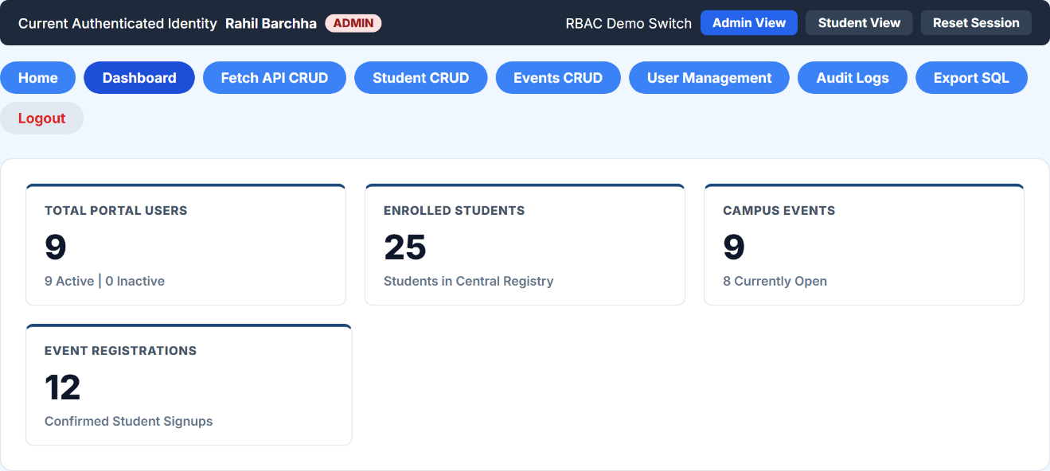
2) data analytics for events and summary
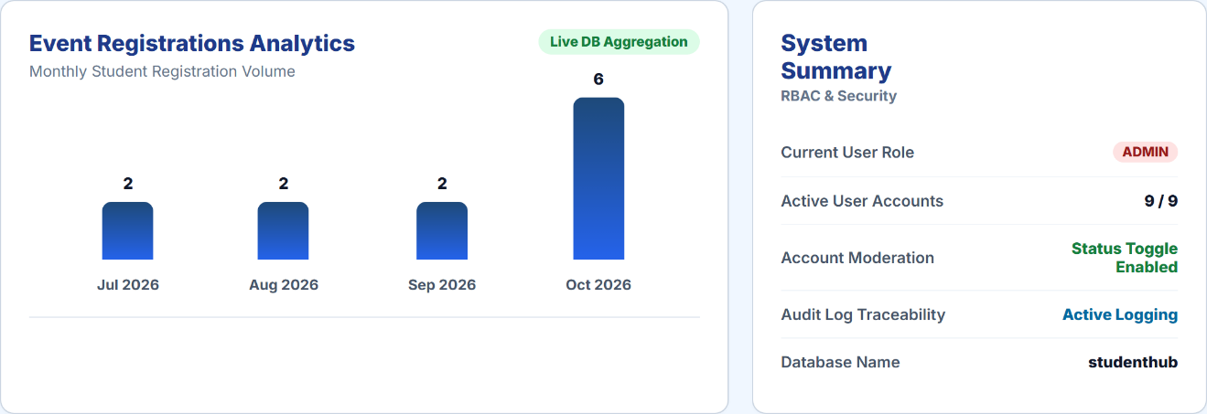
3)student account management via admin account
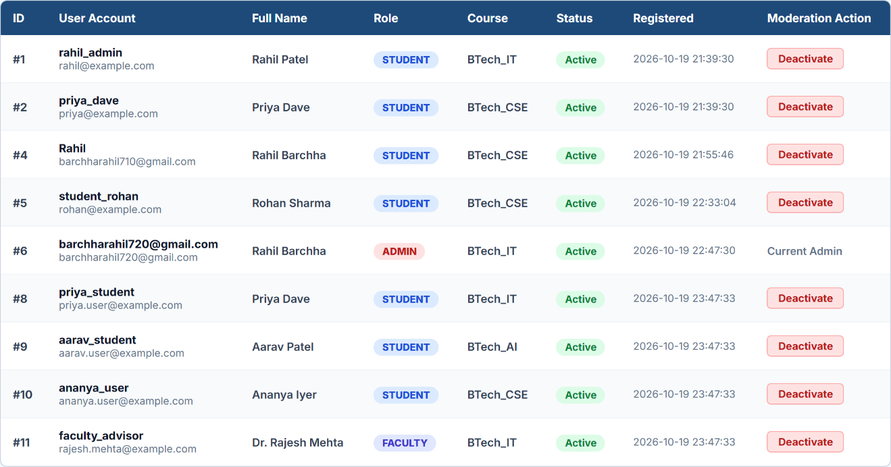

4)audit logs
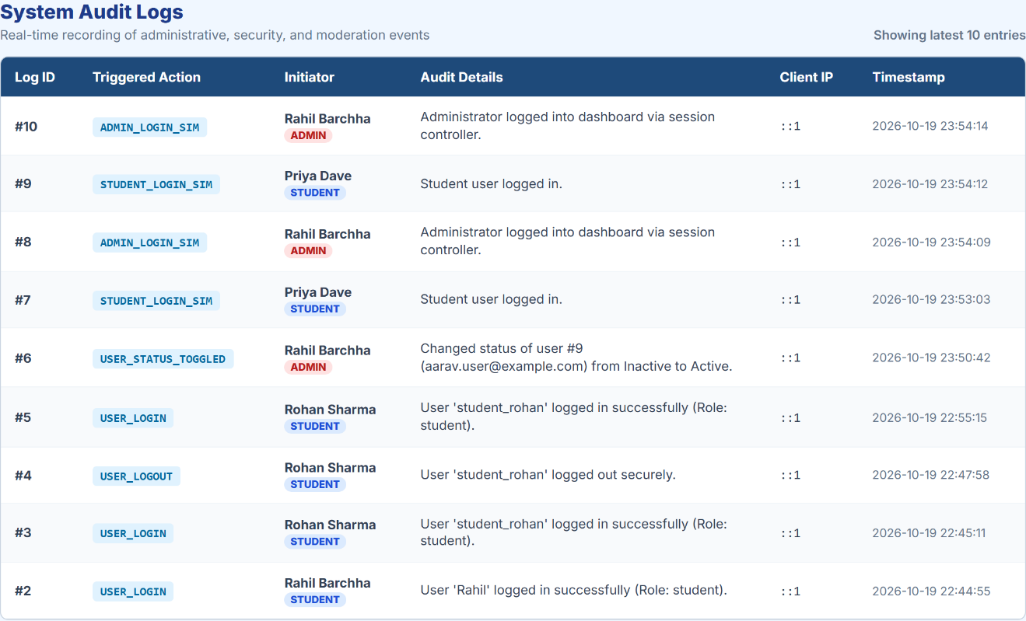

Git Hub Repository Link:
https://github.com/AnshDabhi-26/Student-Hub/tree/7e4112985c5e391a913405d1f5be23f853d6a792/Practical-14
Challenges Faced: I faced difficulties in fetching dashboard statistics dynamically from the database. I struggled with implementing role-based access control and displaying menus according to user roles. I also faced challenges in recording important admin activities in the audit_logs table.
Learning Outcome: I learned to create an admin dashboard with dynamic statistics and latest registration details. I understood how to restrict dashboard access to admins and display role-based menus. I also learned how to maintain audit logs to track important administrative activities.

