Practical - 1
Practical Title: Project Initiation, Requirement Analysis, Sitemap, Wireframe, and GitHub Setup

Problem Definition: Initiate the semester-long StudentHub portal by identifying the problem scope, user roles, key modules, navigation flow, and minimum 10 pages. Create a sitemap, low-fidelity wireframe, project folder structure, README file, and GitHub repository.

- Theory

- What is URL and parts of URL?
Answer: URL is Uniform Resource Locator , which is a unique link/address of anything like website or webpage . The following are the parts of URL :- scheme , domain , subdomain , top level domain , port , path , query string and fragment.

- How does HTML file process in web browser?
Answer: A web browser processes an HTML file through a sequence called the Critical Rendering Path, transforming raw code into a visual webpage.

3. How will page navigation flow managed among all HTML pages?
Answer: Page navigation flow among HTML pages is managed in three primary ways:-
Hyperlink , browser history , javascript routing .

4. How will GitHub commits be maintained after each practical?
Answer: GitHub commits are typically maintained after each practical by making self-contained commits for logical milestones and pushing them to a remote repository.

- Implementation

In this practical, the foundational structure of the StudentHub Portal was implemented using HTML5. The following key elements and tags were utilized:-

Basic HTML Skeleton:- Used <!DOCTYPE html>, <html>, <head>, and <body> to structure all 10 web pages.

Navigation:- Implemented a consistent global navigation bar across all pages using <nav>, unordered lists <ul>, and list items <li> with anchor tags <a> for links.

Forms & Input:- Created user authentication and contact pages (login.html, register.html, contact.html) using the <form> tag along with various <input> types (text, email, password) and <button> elements.

Content Organization :- Used semantic tags like ( <header> ,<footer> ,<main> ) and <div> container sto organize the dashboard

Sitemap Generation:- Created a sitemap.xml file using standard XML tags like <urlset>, <url>, <loc>, and <priority> to define the structure and navigation

- Evidence of Work (Screenshots)
Description: wireframe image of login page

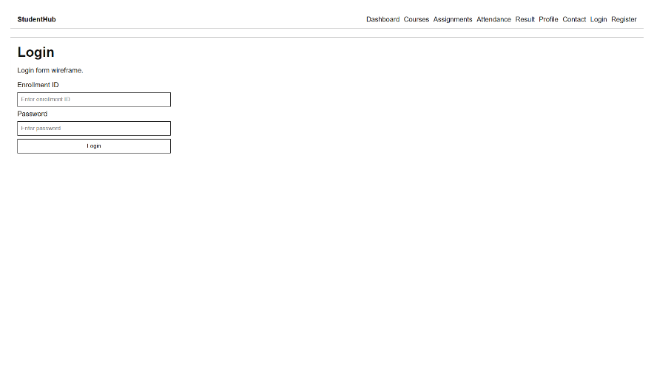

Figure 1.1

Description: wireframe image of index page

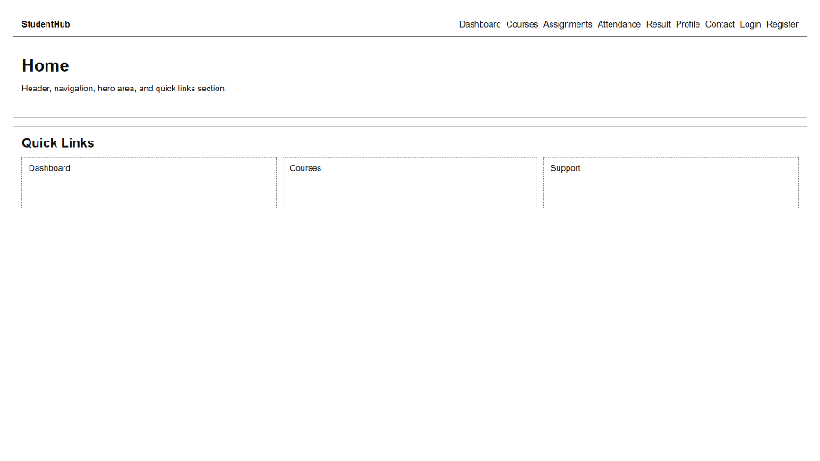

Figure 1.2

Description: wireframe image of assignment page
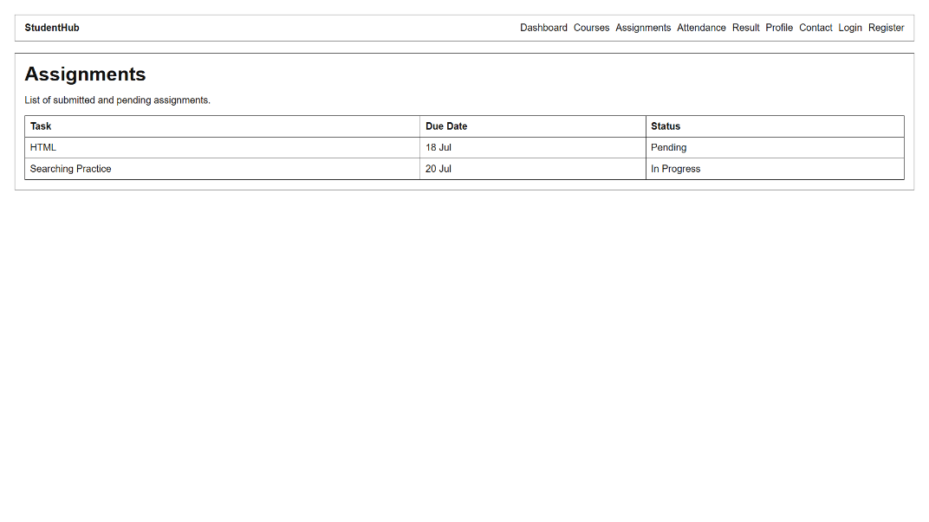
Figure 1.3

Description: wireframe image of attendance page
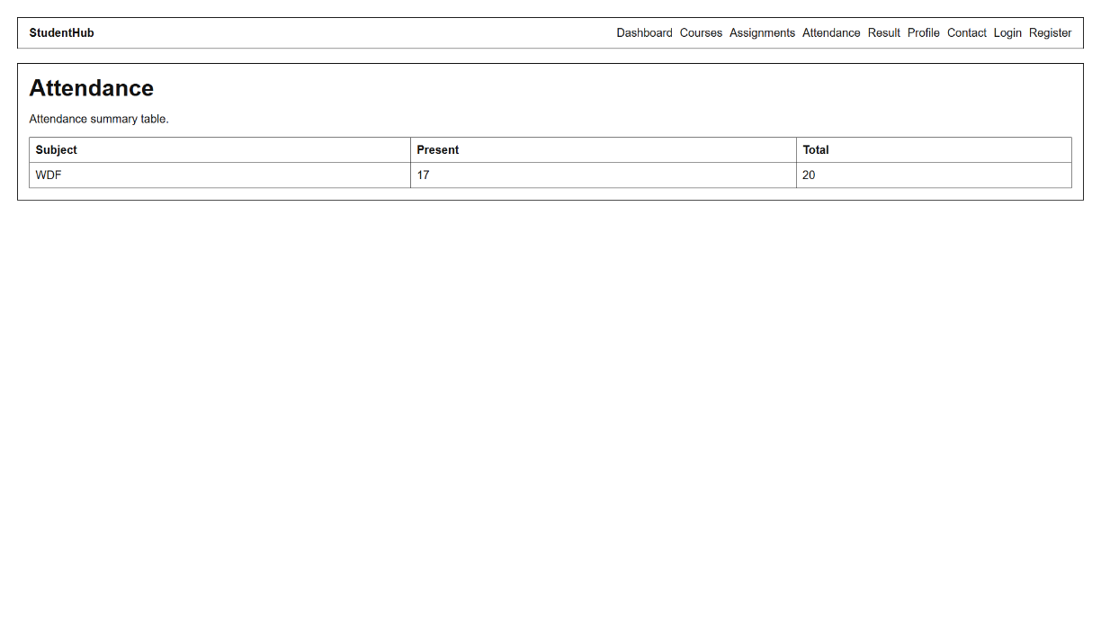
Figure 1.4

Description: wireframe image of contact page
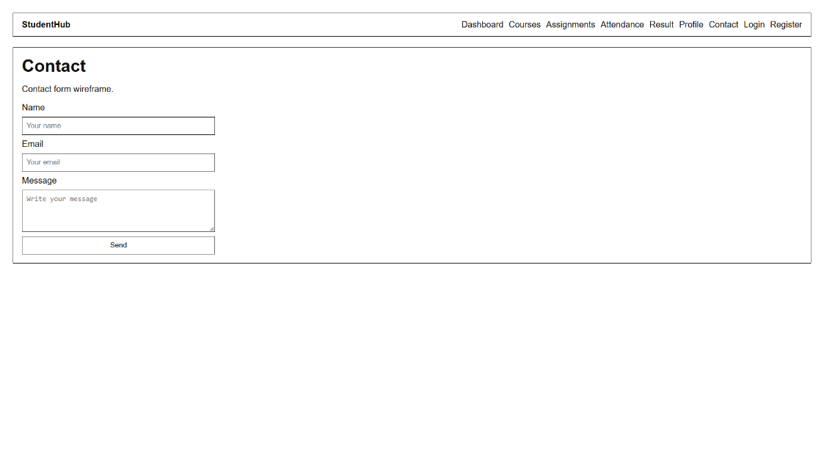
Figure 1.5

Description: wireframe image of courses page
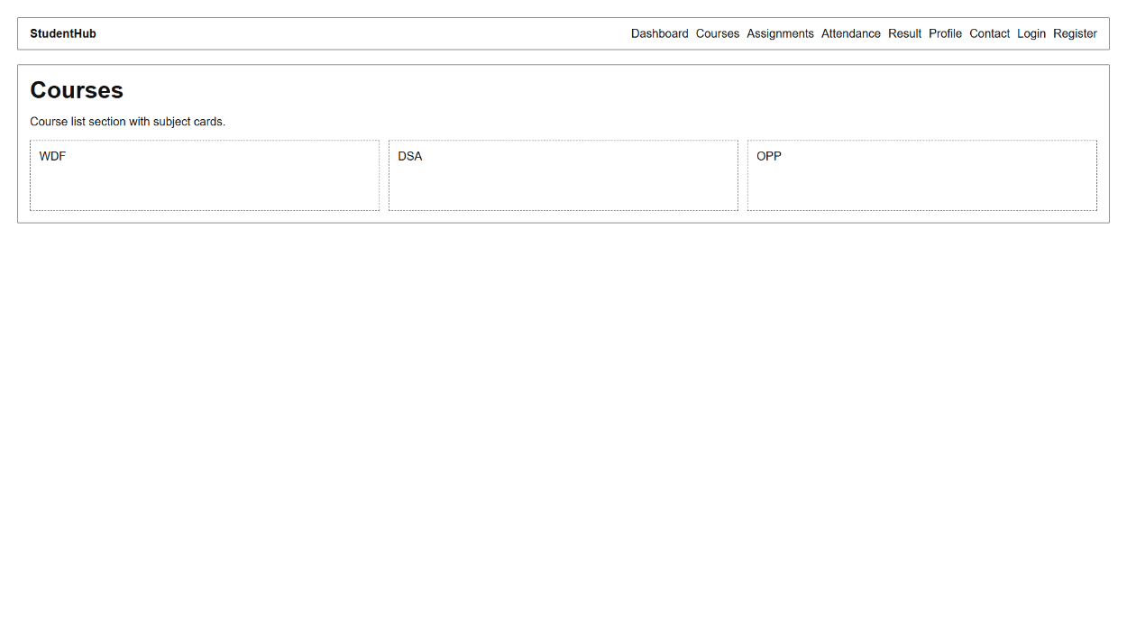
Figure 1.6

Description: wireframe image of dashboard page
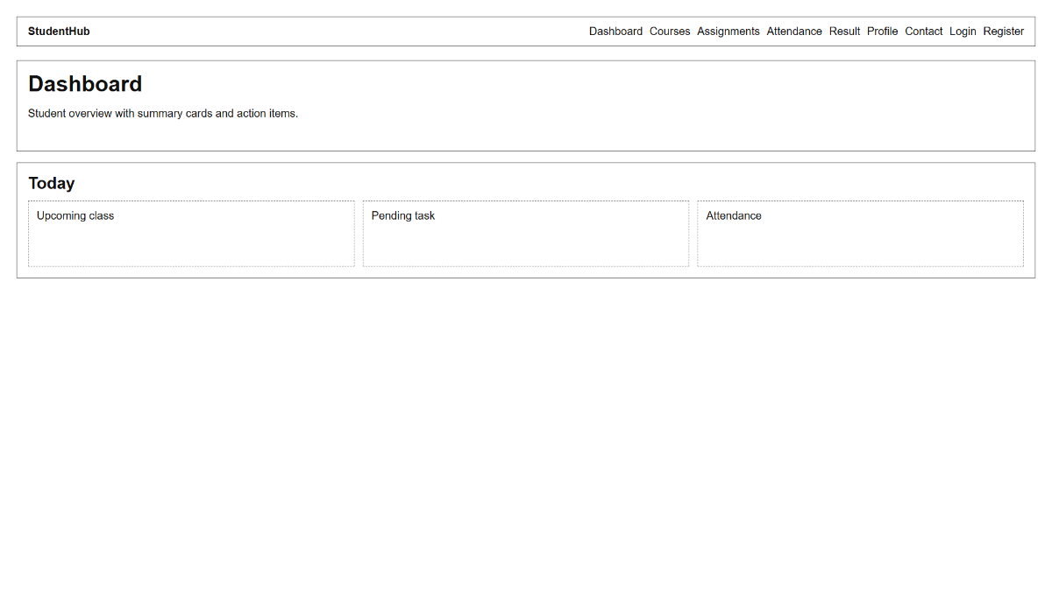
Figure 1.7

Description: wireframe image of profile page
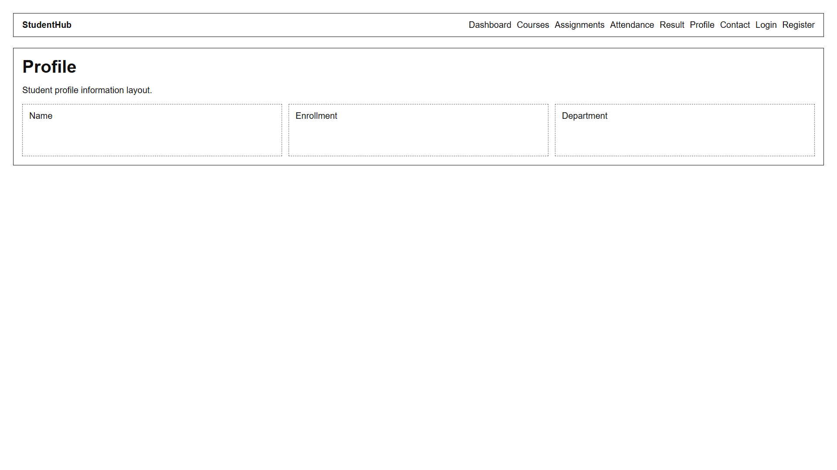
Figure 1.8

Description: wireframe image of register page
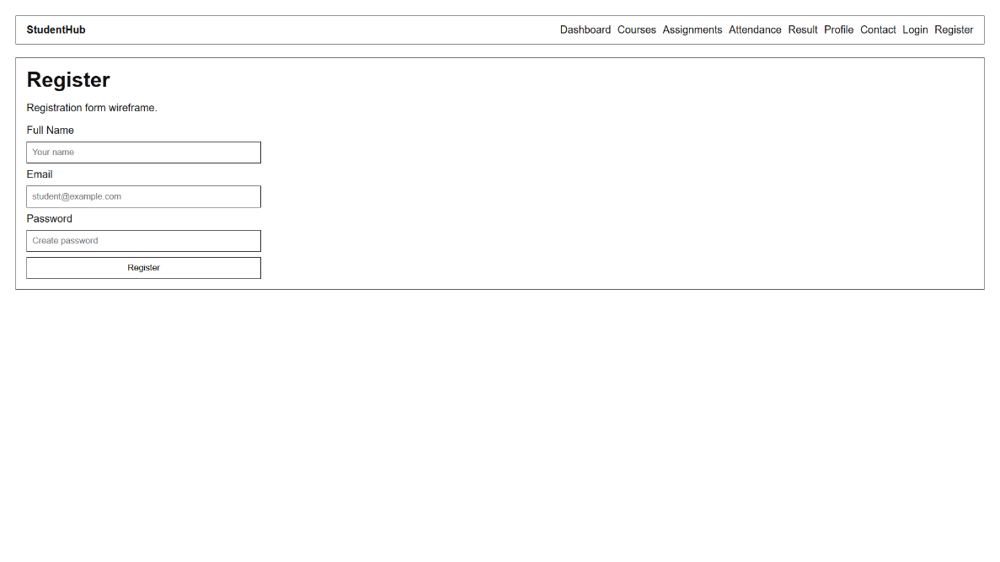
Figure 1.9

Description: wireframe image of result page
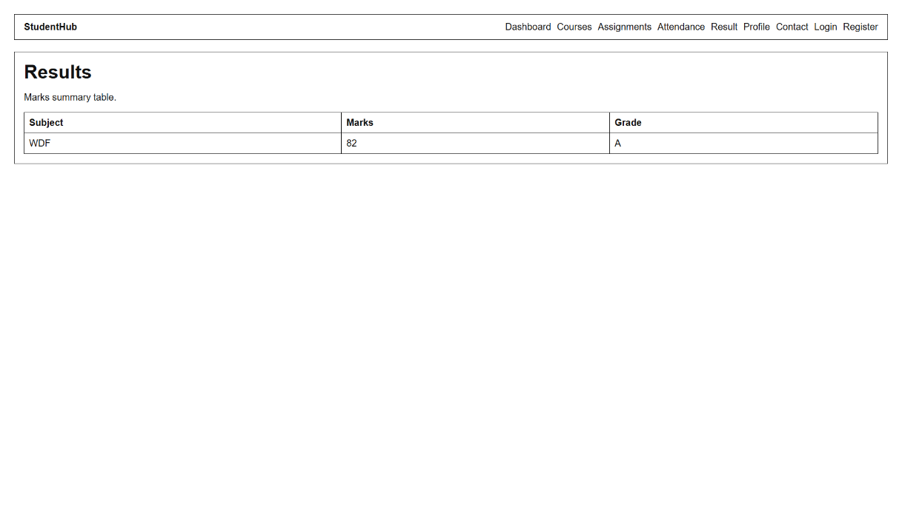
Figure 1.10

- GitHub Repository Link:
- https://github.com/AnshDabhi-26/Student-Hub/tree/main/Practical-1
- Challenges Faced:
During Practical 1, the primary challenge was translating the broad idea of a StudentHub into specific, actionable requirements without overcomplicating the initial project scope. Designing the wireframes in Draw.io presented difficulties in planning how to clearly display complex data, like the dashboard summaries and course tables, on a single screen. It was also challenging to ensure that the global navigation and UI layouts remained perfectly consistent across all 10 distinct page designs during the wireframing phase. When creating the sitemap, I had to adapt to the strict syntax rules of XML, ensuring all <url>, <loc>, and <priority> tags were accurately nested and closed properly. Finally, deciding on a logical folder architecture (CSS, JS, IMAGES, PAGES) was tricky but necessary to ensure the project remains organized during future coding phases.

- Learning Outcomes:

Gained hands-on experience structuring a multi-page web application using standard HTML5 tags and semantic elements.

Learned how to implement global navigation and link multiple HTML files together across different directories.
Mastered the process of organizing a clean project architecture with dedicated folders for CSS, JS, and HTML pages.
Developed an understanding of how to build structural layouts for forms, tables, and dashboards using pure HTML.
Learned how to write and format a sitemap.xml file to define the website's hierarchy for search engines.

Faculty Remarks:

