Practical - 3
Practical Title: Responsive UI Design using CSS Grid, Flexbox, and Bootstrap/Tailwind

Problem Definition: Design responsive layouts for Home, About, Registration, Dashboard, and Events pages using CSS Grid and Flexbox. Optional to use CSS framework such as Bootstrap or Tailwind. Ensure mobile-first responsiveness.

Theory

How does the layout adapt for mobile, tablet, and desktop screens?
Answer :
The layout adapts fluidly. Instead of strict media queries, it uses responsive CSS properties like flex-wrap: wrap and min-width: 180px (seen in .feature-box). This allows elements to automatically stack on mobile/tablet screens and sit side-by-side on desktop screens.

Which layout technique is used and why?
Answer :
CSS Flexbox (display: flex;) is the primary layout technique used (specifically for .features and form containers). It is used because it provides a modern, efficient way to align elements, distribute space, and handle dynamic wrapping without relying on complex and outdated float rules.

Are typography, spacing, colors, and contrast readable?
Answer :
Yes. Typography uses clean, modern fonts (Segoe UI, Arial). Spacing is consistent (e.g., padding: 24px, gap: 15px). The color palette uses a warm, earthy theme (browns on beige), providing excellent contrast and high readability between the dark text (##3f83ff
) and light backgrounds (#ffffff).

4. Is the framework used consistently without unnecessary inline CSS?
Answer :
Yes, perfectly. Pure CSS3 is used consistently via a single external stylesheet (../CSS/script.css). A scan of all HTML files in Practical 3 confirms there is zero inline CSS (no style="..." attributes used anywhere), ensuring a clean separation of structure and design.

Implementation

This practical focused on UI design and project organization.

The flat file structure was reorganized into a professional architecture using CSS, JS,
and PAGES directories.

A central script.css stylesheet was created and linked to all pages, utilizing advanced CSS techniques like linear gradients, box shadows, Flexbox layouts, and hover effects to transform the raw HTML into a polished, modern interface.

Evidence of Work (Screenshots)

Description: home page of student hub portal

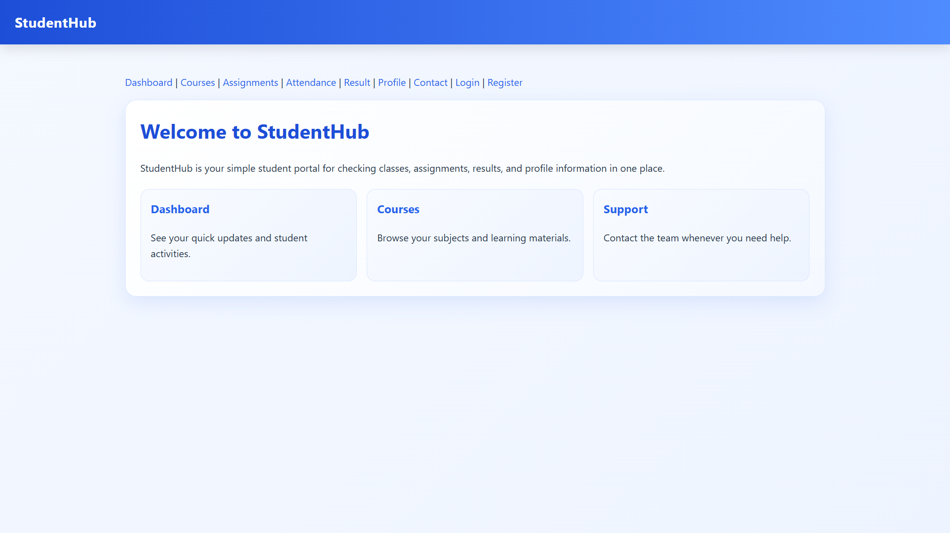

Figure 3.1

Description: login page

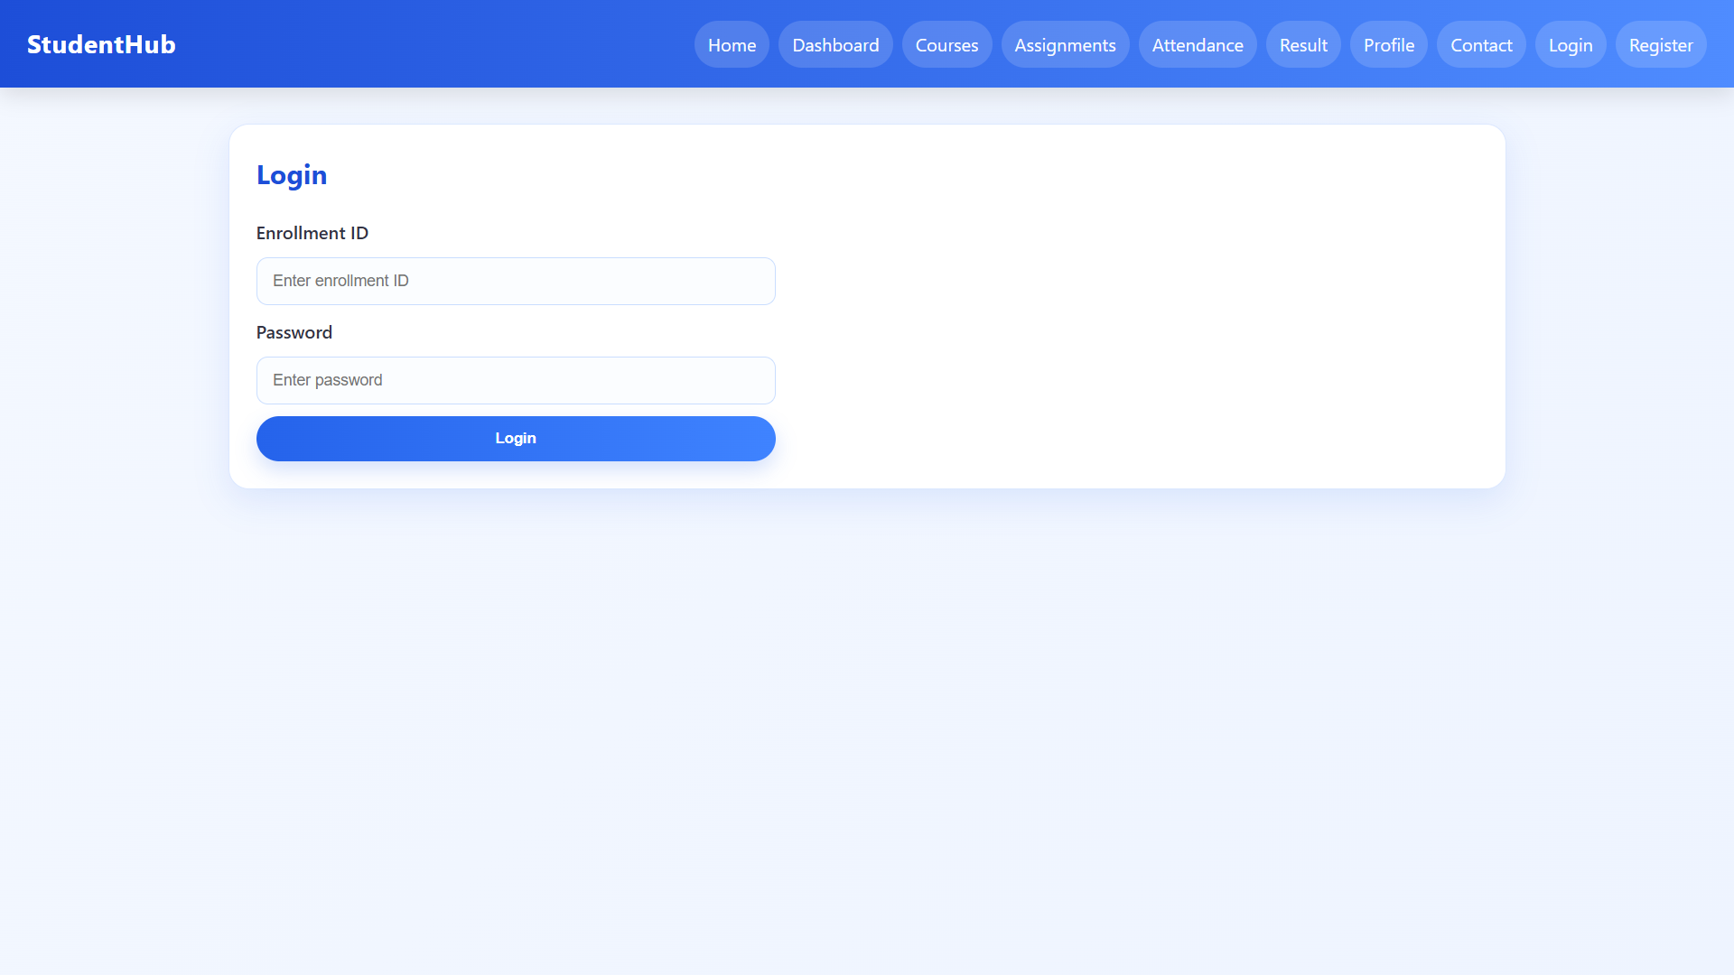

Figure 3.2

Description: register page

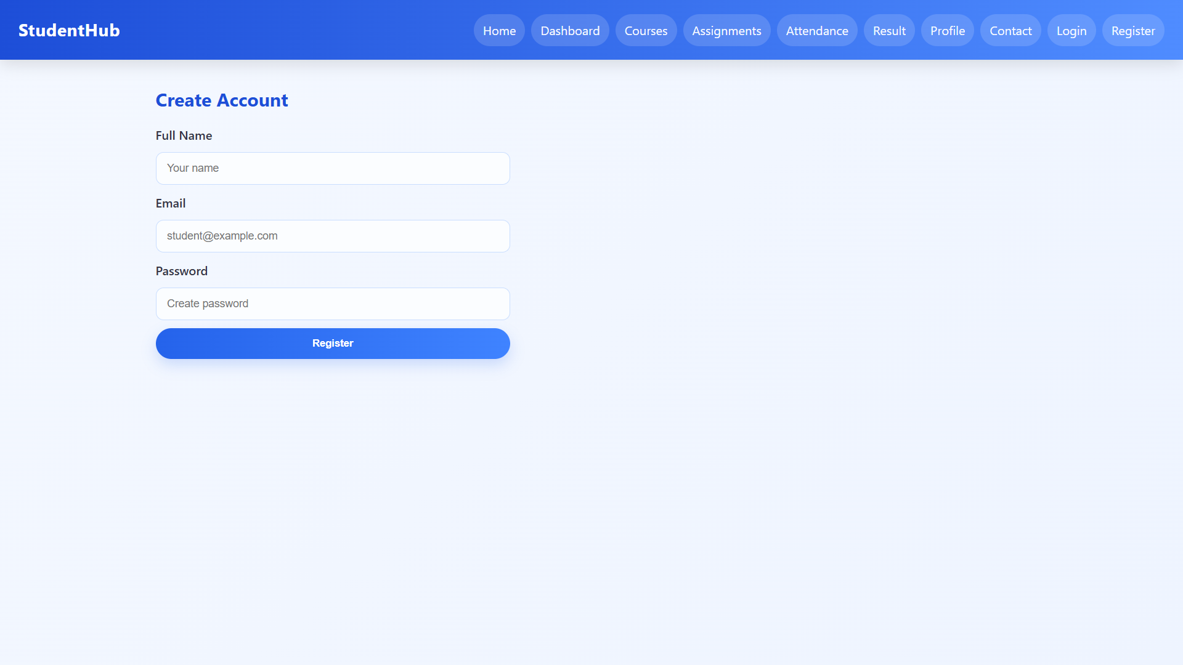

Figure 3.3

Description: profile page

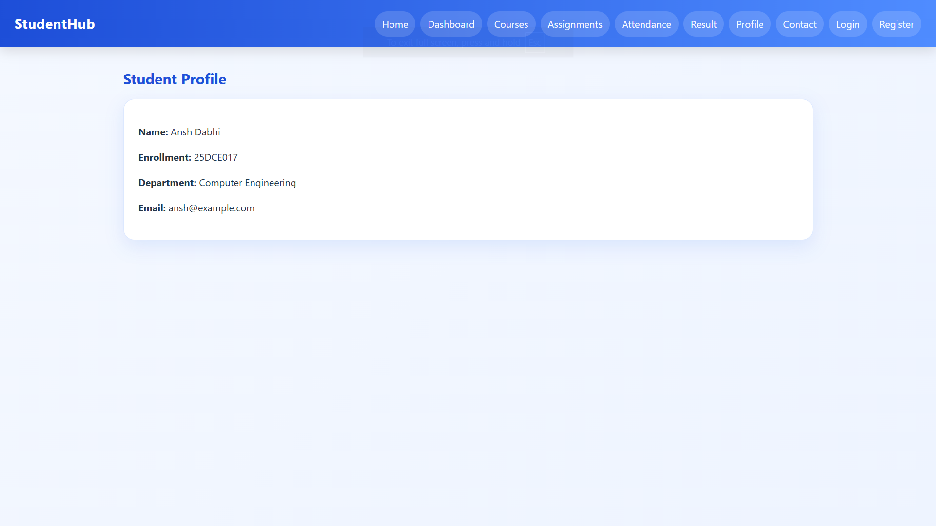

Figure 3.4

Description: contact page

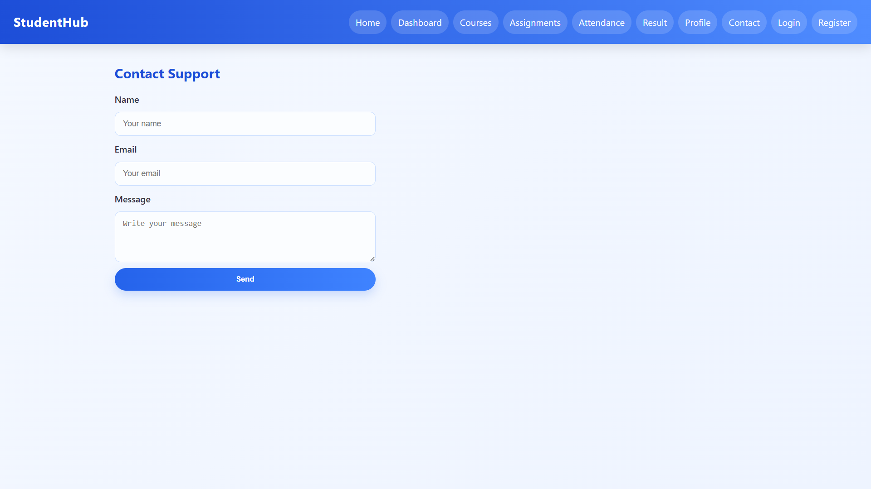
Figure 3.5

Description: result page

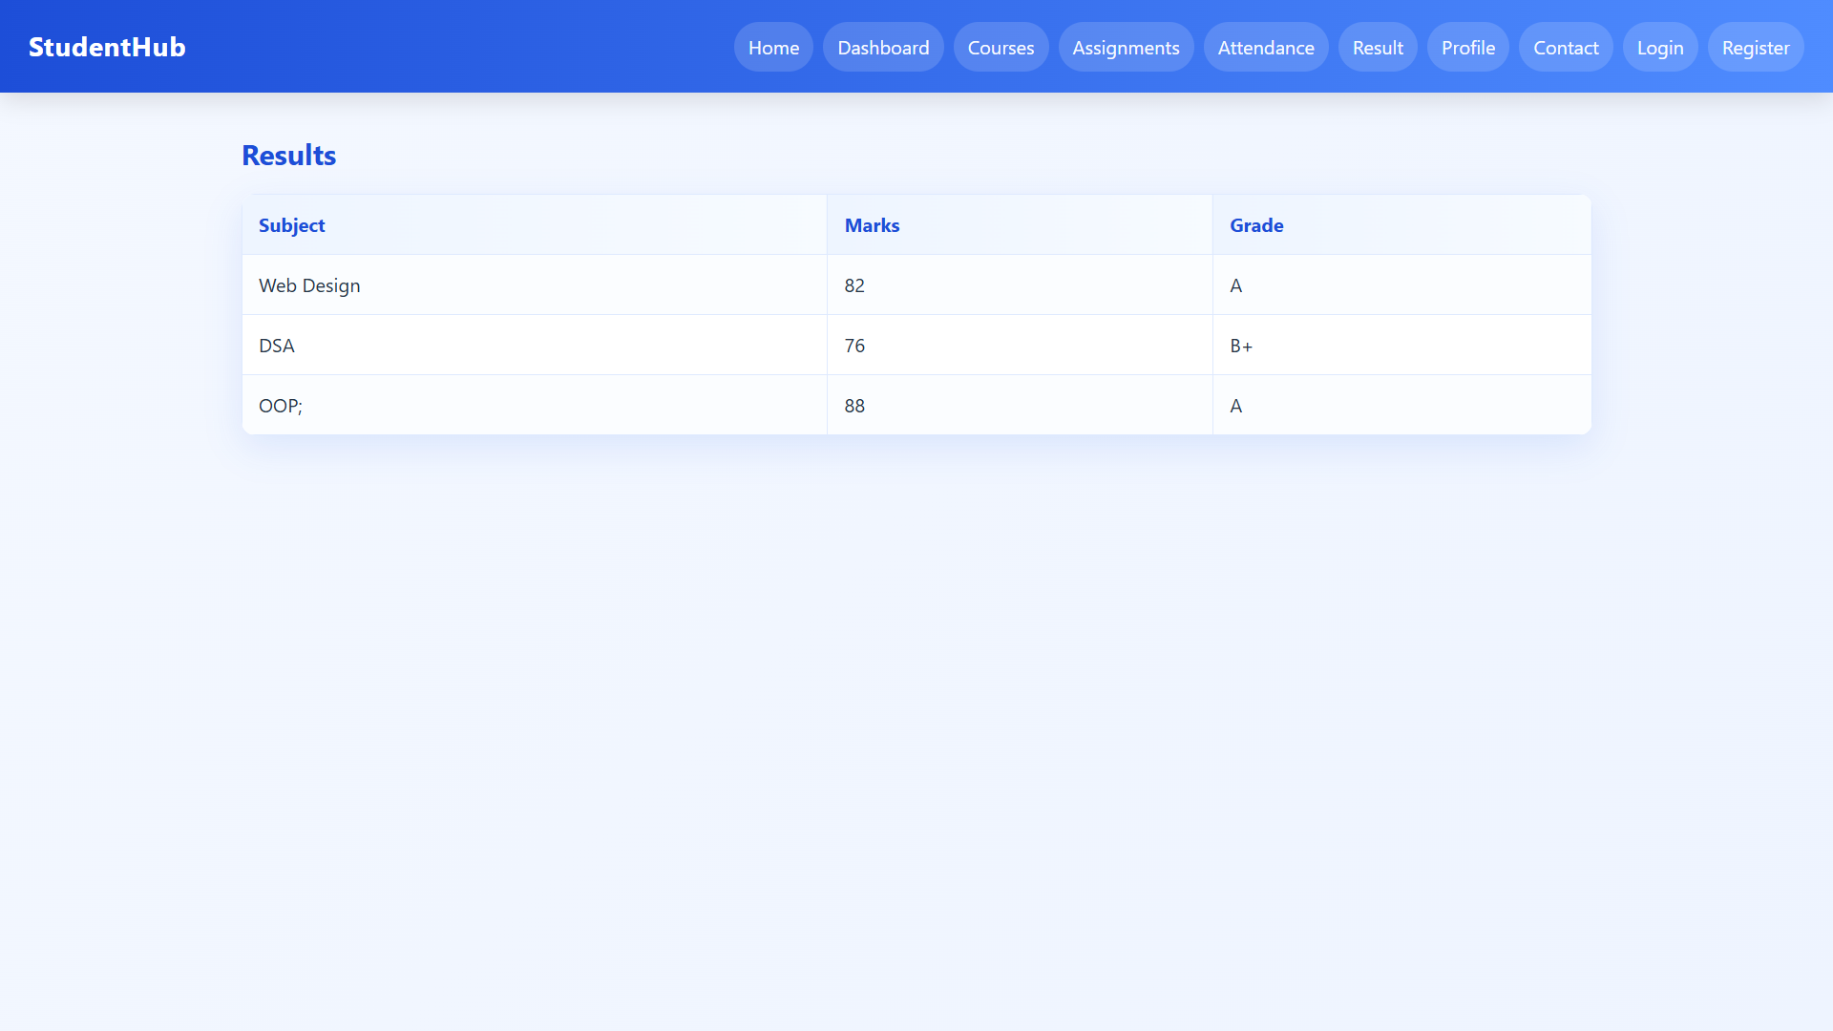

Figure 3.6
Description: attendance page

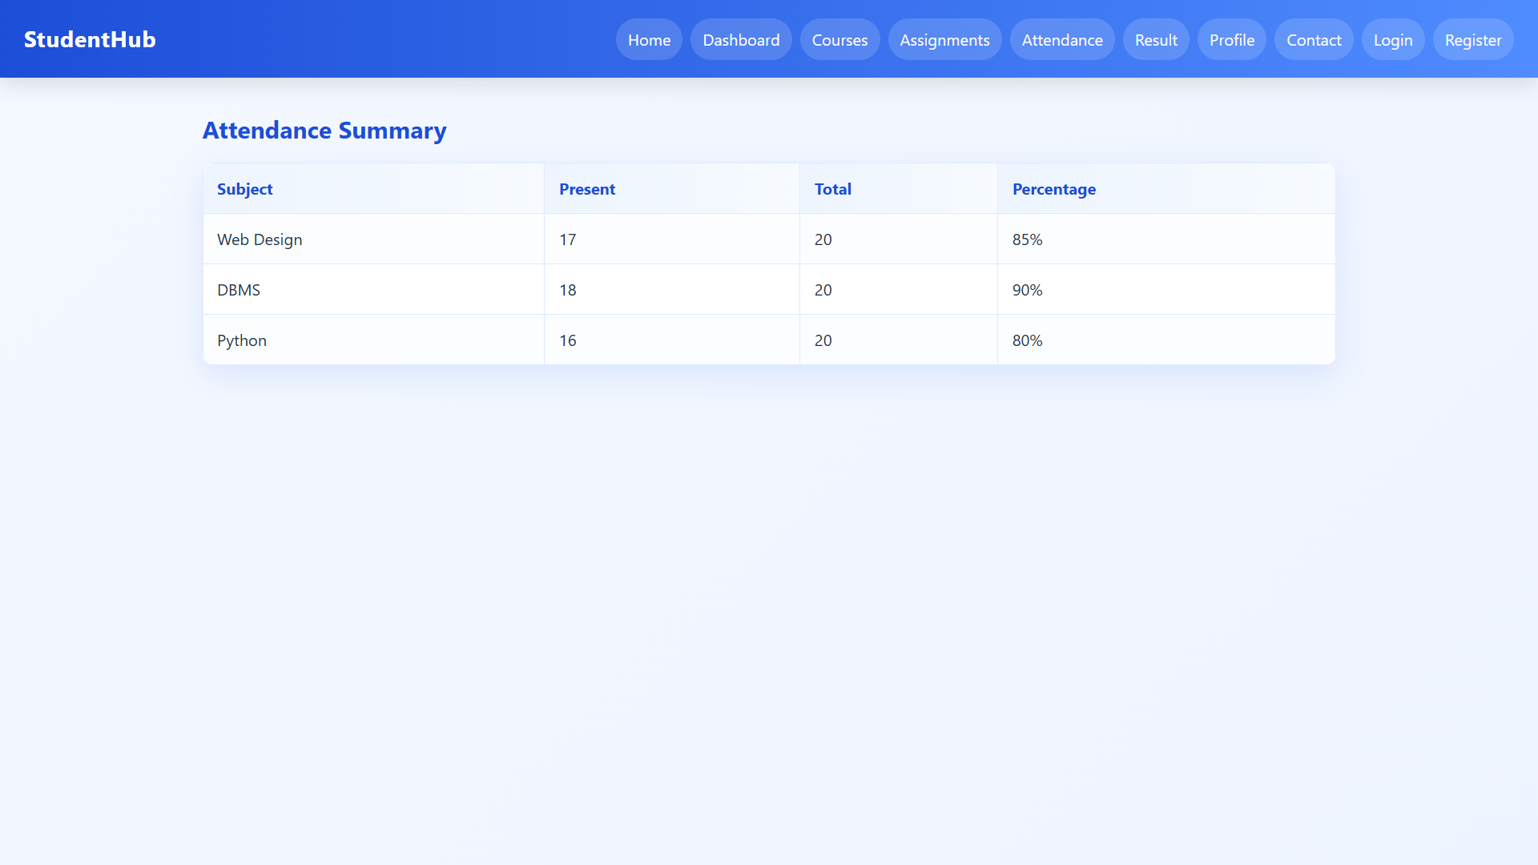

Figure 3.7
Description: assignment page

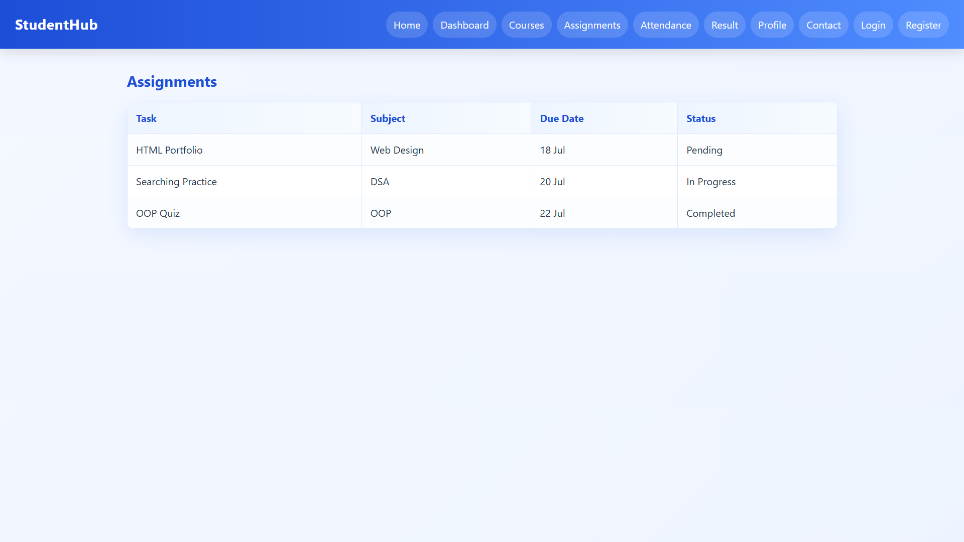

Figure 3.8

Description: courses page

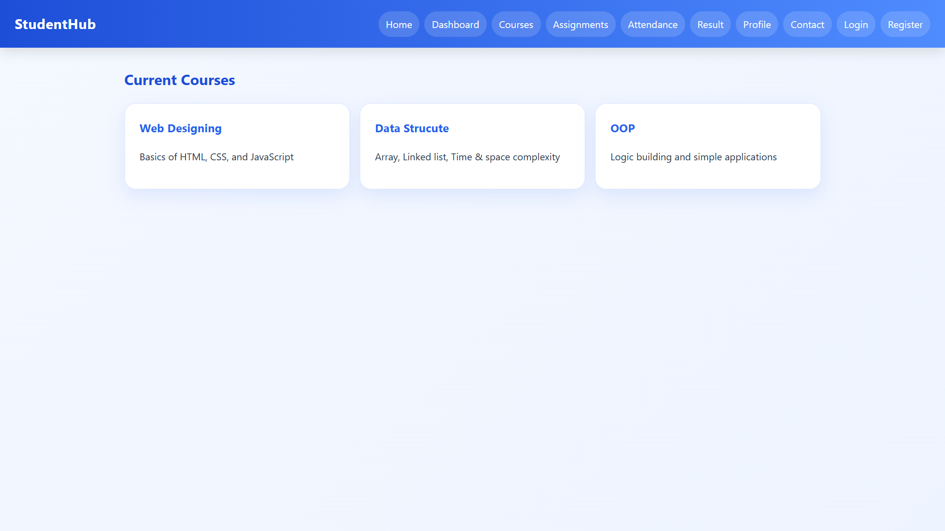
Figure 3.9

Description: dashboard page

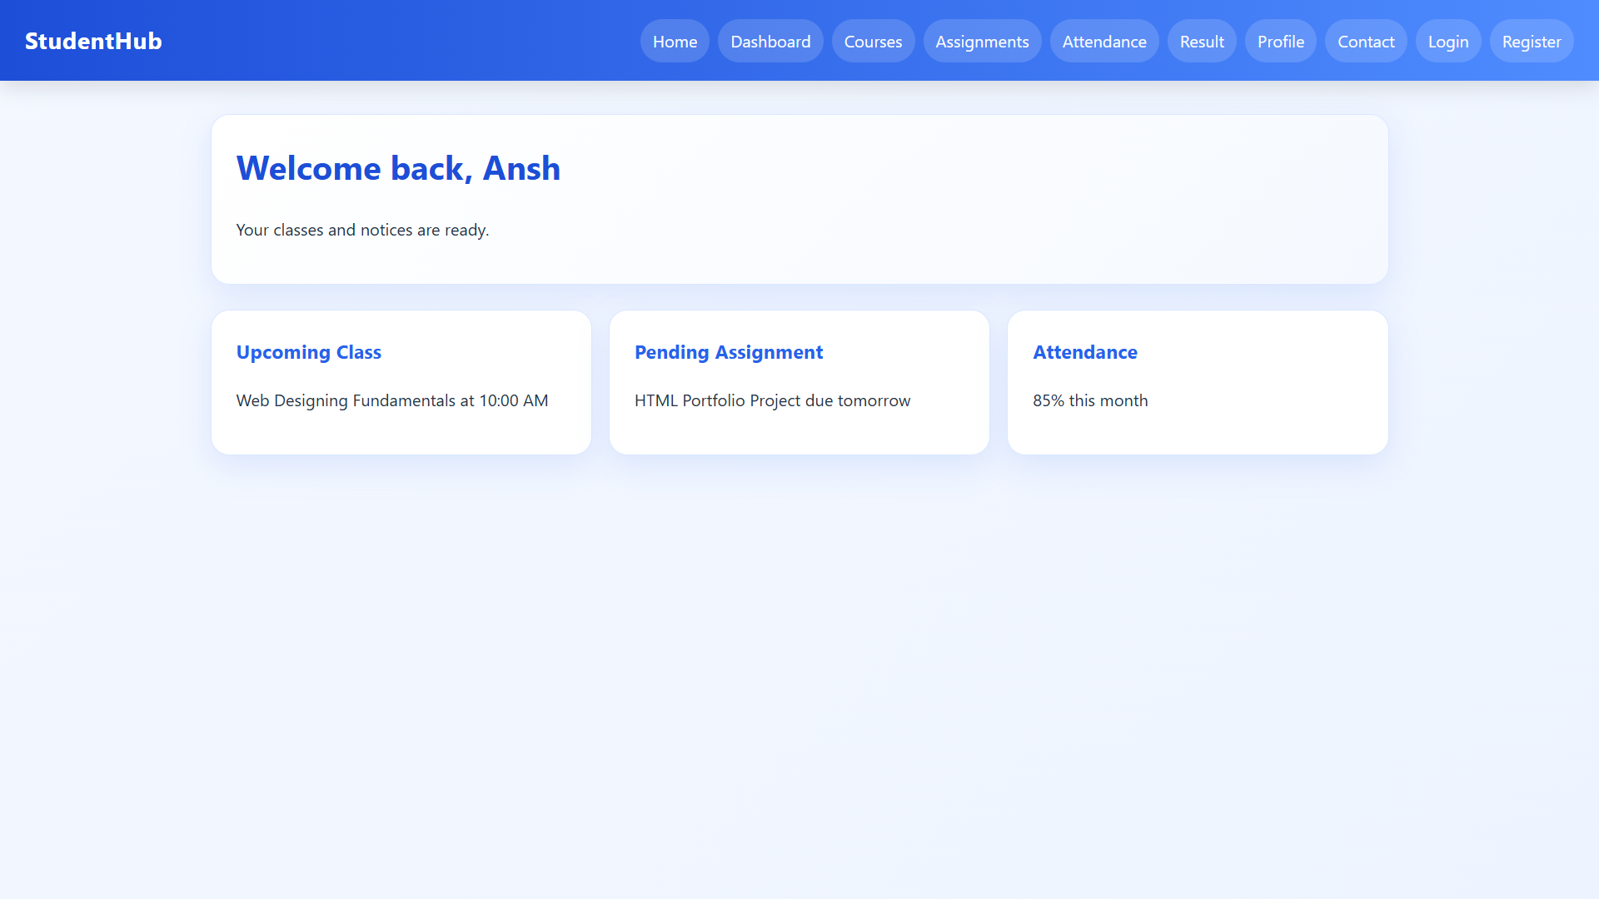

Figure 3.10

GitHub Repository Link:

https://github.com/AnshDabhi-26/Student-Hub/tree/main/Practical-3

Challenges Faced:

In Practical 3, moving the raw HTML into a structured directory architecture (PAGES, CSS, JS) broke all existing file links, which was challenging to fix by updating every ../ relative path.

When writing script.css, applying Flexbox to the feature boxes and form containers was tricky, getting the items to align and wrap correctly required constant tweaking.

Additionally, implementing consistent styling for tables and navigation bars across all pages meant I had to rely heavily on CSS classes and global rules, which was a significant shift in thinking.

Finally, debugging conflicting CSS rules where styles accidentally overrode each other took considerable time.

Learning Outcomes:

Learned to structure a web project professionally using dedicated directories.

Gained experience applying aesthetic properties like gradients, shadows.

Learned how to resolve relative path issues when linking external stylesheets.

Understood the importance of a single global stylesheet for maintaining UI
consistency.

Faculty Remarks:

