Practical-6
Rendering External JSON Data using Fetch API, Search and Filter

Theory
1. How is JSON fetched, parsed, and rendered?
Answer: JSON is fetched using the Fetch API. First, JavaScript uses fetch() to get the JSON file. Then the response is converted into JavaScript data using .json(). After parsing, the data is used to create HTML elements and display the information on the webpage.
So, the basic process is:
Fetch JSON → Parse JSON → Use Data → Render on Webpage

2. Which array methods are used for search, filter, sort, and pagination?
Answer: For searching, filtering, sorting, and pagination, different JavaScript array methods are used.
- Search: find() or findIndex()
- Filter: filter()
- Sort: sort()
- Pagination: slice()
These methods help to easily manage and display JSON data on the webpage.

3. How are loading and error states handled?
Answer: A loading message is shown while fetching data. If fetching is successful, the data is displayed. If an error occurs, an error message is shown using catch().

4. How is modularity maintained in JavaScript files?
Answer: Modularity is maintained by dividing JavaScript code into separate files and functions, where each file handles a specific task.

Result:

Evidence of Work (Screenshots)

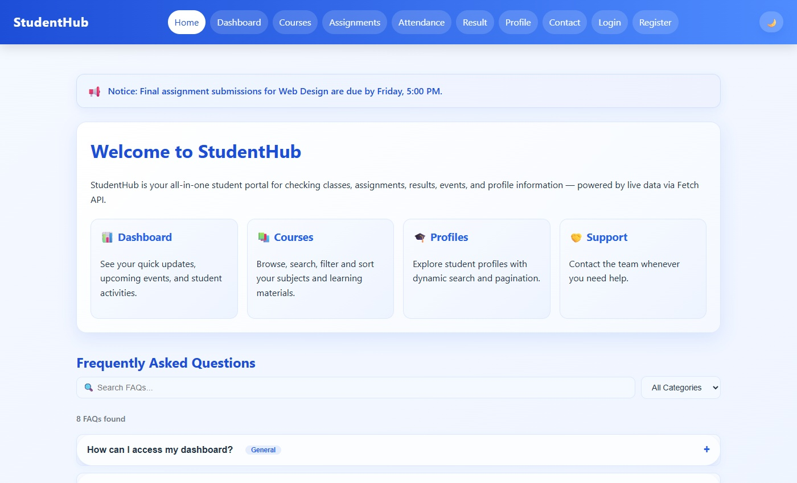
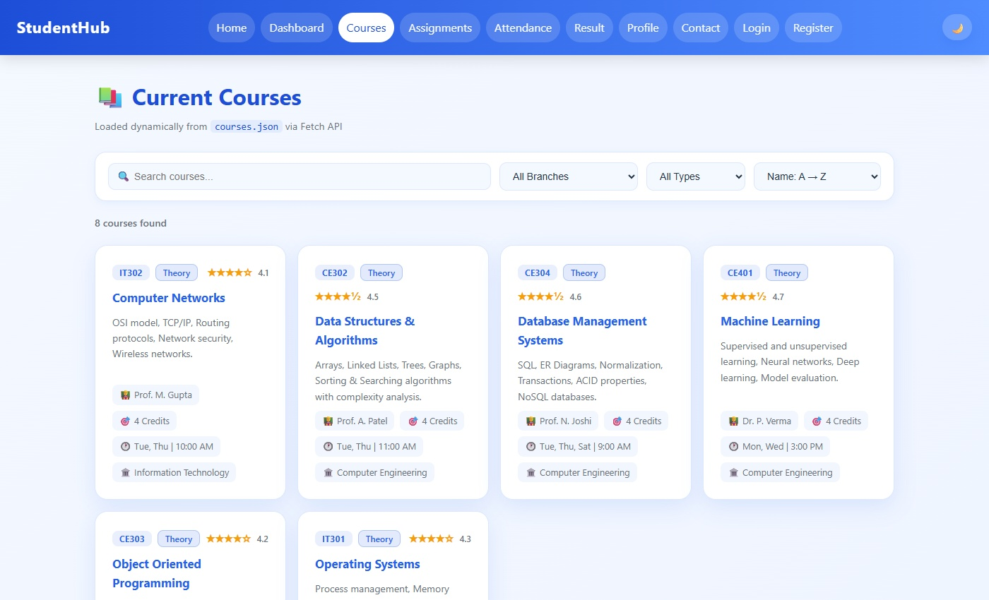
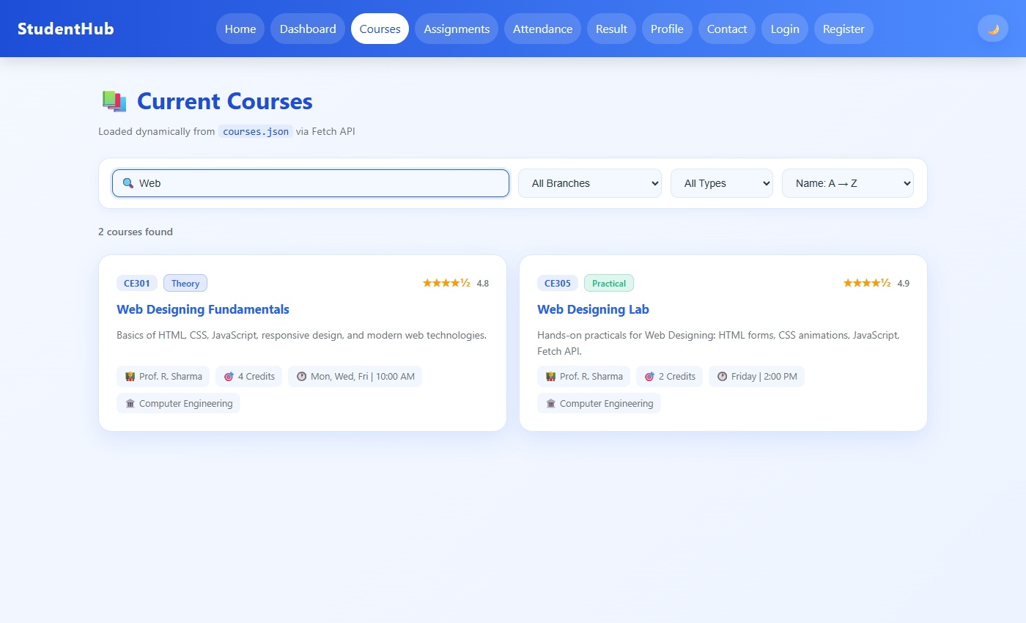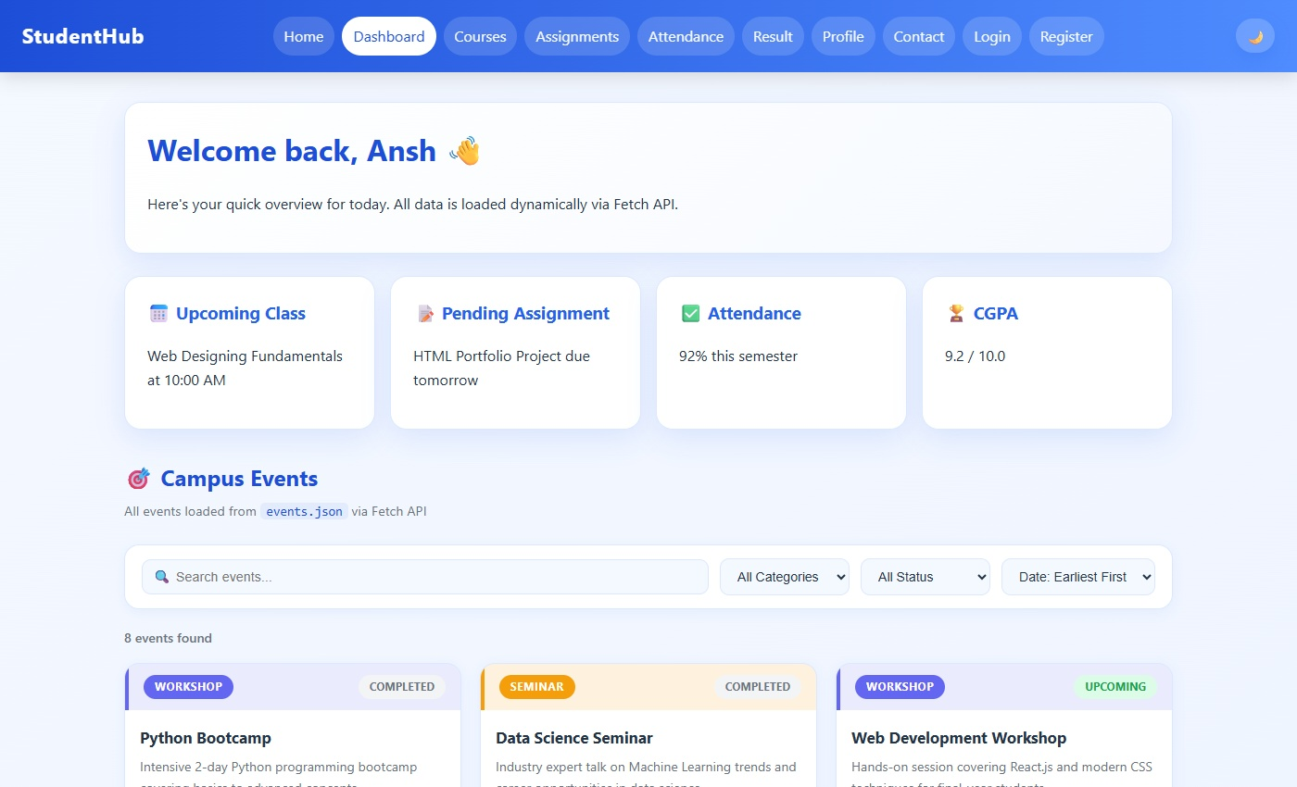
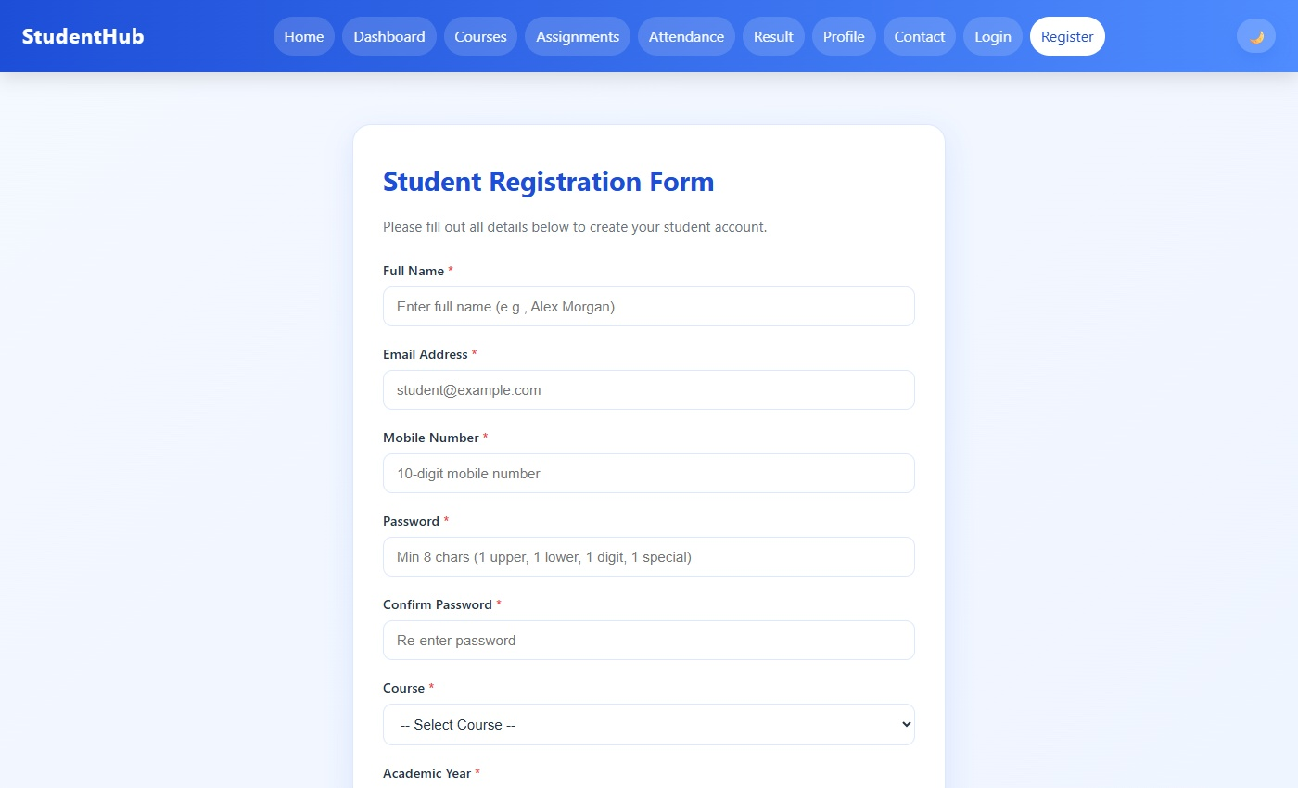
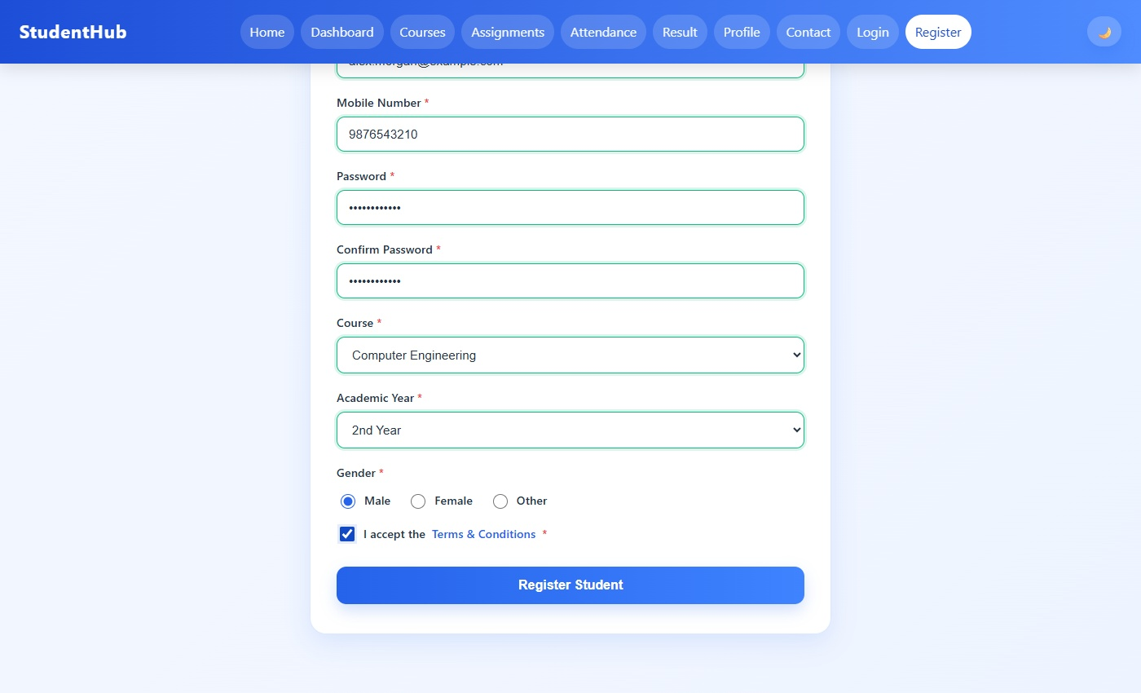

GitHub Repository Link:
https://github.com/AnshDabhi-26/Student-Hub/tree/1c68e096f3a0f60f221afb87c86e52d364689023/Practical-6

Challenges Faced:

- I faced some difficulty in fetching and reading the JSON data correctly.
- It was a difficult to apply search, filter, and sorting together.like how to update html code and how to apply search operation and fetching.
- I faced problems while implementing pagination for the data.
- Handling loading and error messages was also a challenge.
- Managing the JavaScript code in different files was sometimes confusing.also wrote javascript for this is also difficult .

C.Learning Outcome:-

I learned how to fetch and display JSON data using Fetch API.
I also learned search, filter, sorting, and pagination using JavaScript.
I understood how to handle loading and error states.

Faculty Remarks:

