Practical-8
MySQL Schema Design, ER Model, PDO Connectivity, and Prepared Statements
Theory
1. Is the schema normalized properly?
Answer: Yes. The database is divided into separate tables like students, events, and registrations. This avoids repeating the same data and keeps the database organized.

2. Are primary keys and foreign keys correctly defined?
Answer: Yes. Each table has a primary key to uniquely identify each record. Foreign keys connect related tables, such as student_id and event_id in the registrations table.

3. Is the database connection handled securely?
Answer: Yes, reasonably. The connection details are kept in a separate db.php file, and the code uses prepared statements when inserting data.

Result:
- DATABASE STORED IN TABULAR FORM
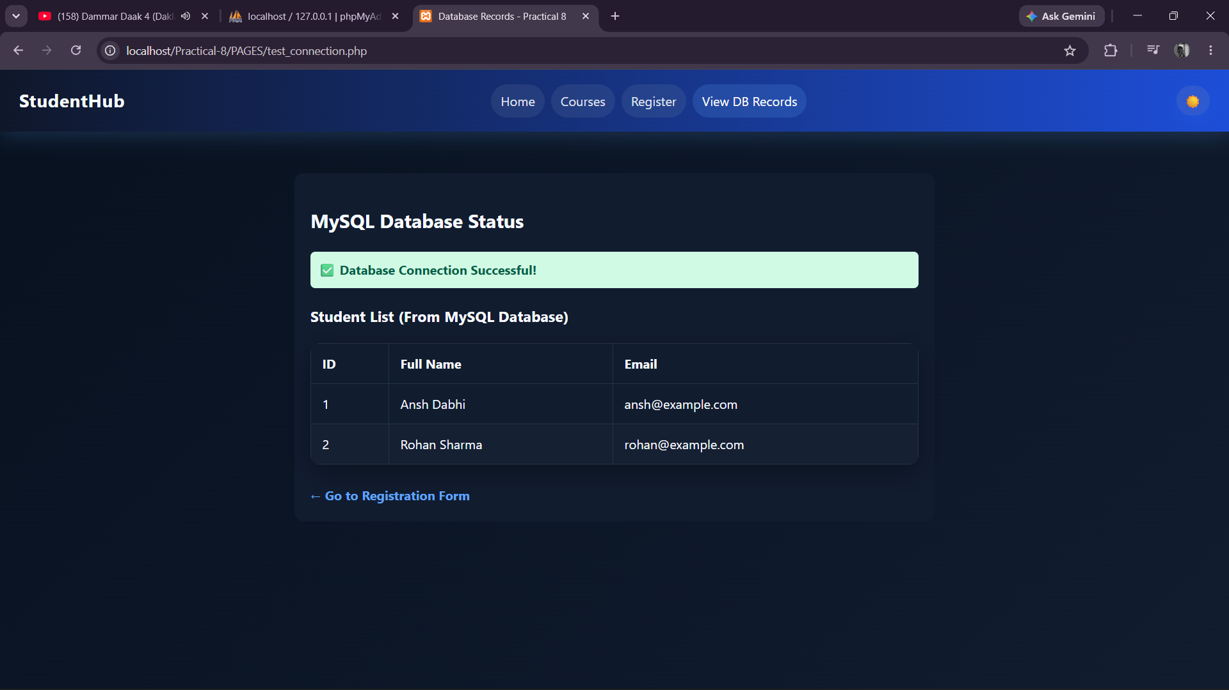

2)Register form
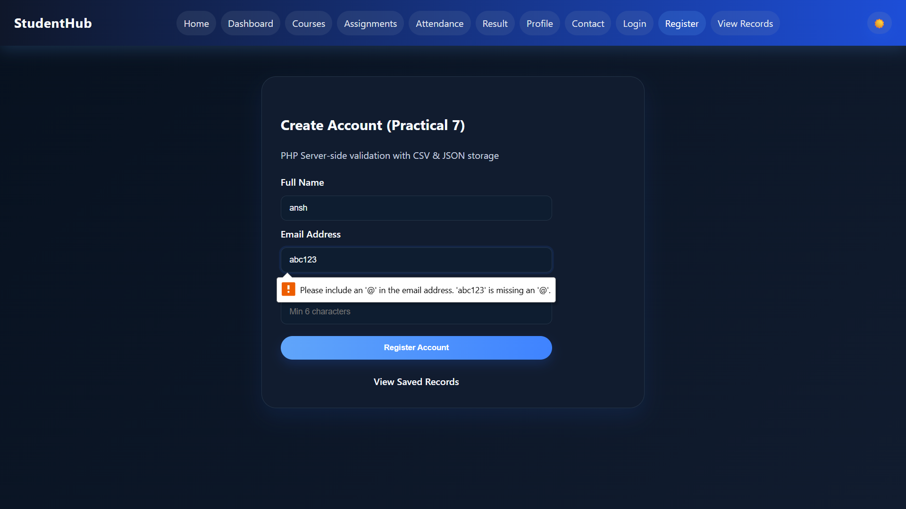

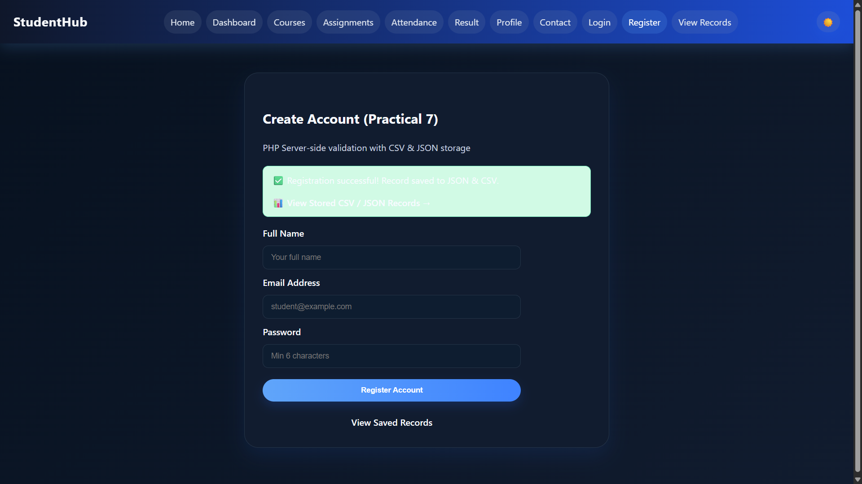

GitHub Repository:
https://github.com/AnshDabhi-26/Student-Hub/tree/98e733b56f34380b12a1d087bf47cb2679baa07a/Practical-8

Challenges Faced:

I did not know much about MYSQL at the beginning.
I had difficulty understanding PHP syntax. And How to connect with MYSQL.
I was confused about how to connect my HTML pages with MYSQL.
I did not know how to run my project using the XAMPP server. Also How to Make Table in XAMMP Server also diificult for beginner .
I faced errors while connecting the HTML form with the PHP file. And MYSQL.

C.Learning Outcome:-

Learned to design a normalized MySQL database, connect PHP with MySQL, and use primary/foreign keys and prepared statements securely.

