REPORT
ANSH PRAKASH
2016CS10367

1(a)
Learning rate 0.1
Stopping criteria:when change is cost function is less than some epsilon
On Normalised data
Theta :
[[0.99653652]
[0.00134037]]
1(b)
learning rate=0.1
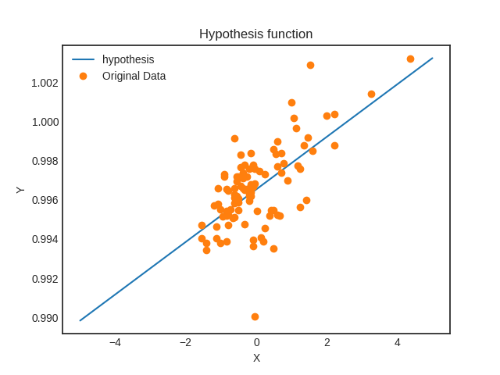

1(c)

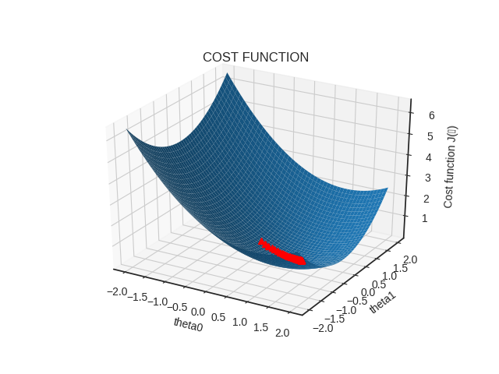
1(d)
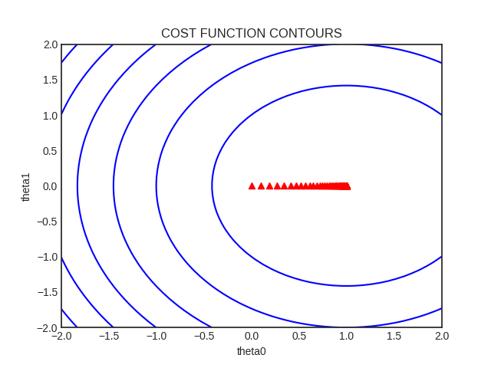
1(e)
for learning_rate=0.1
graphs are above
learing_rate=0.5
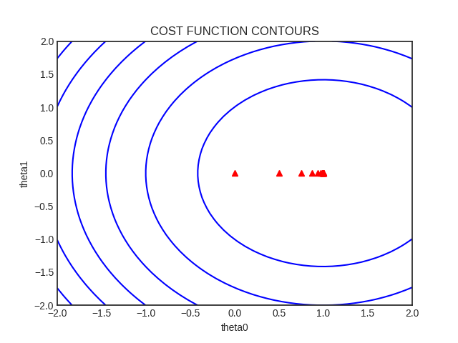
learning_rate=0.9
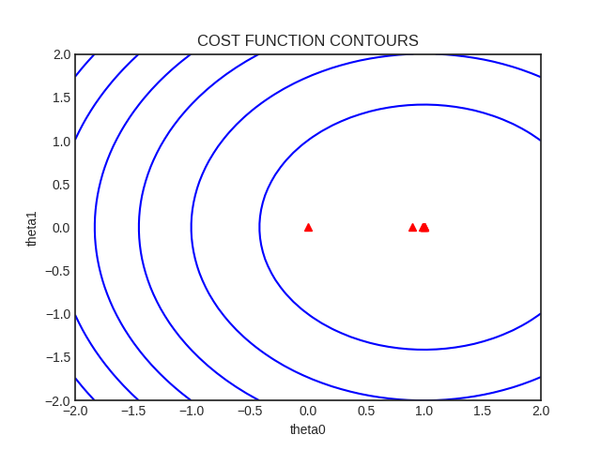
learning_rate=1.3
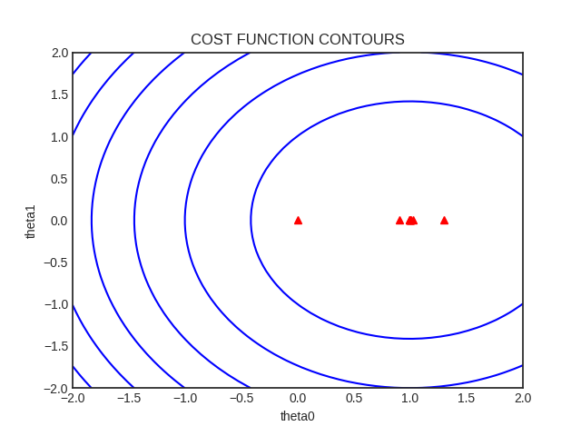
learning_rate=1.7
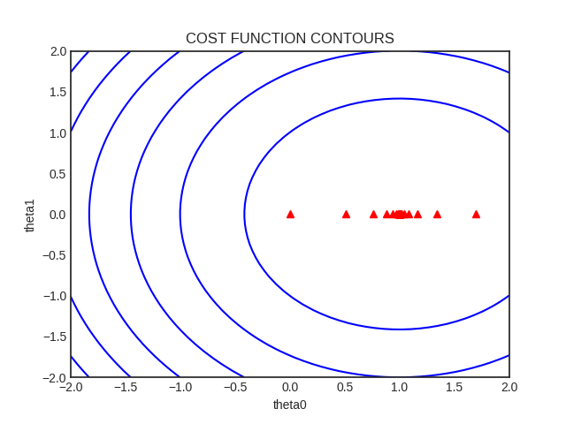
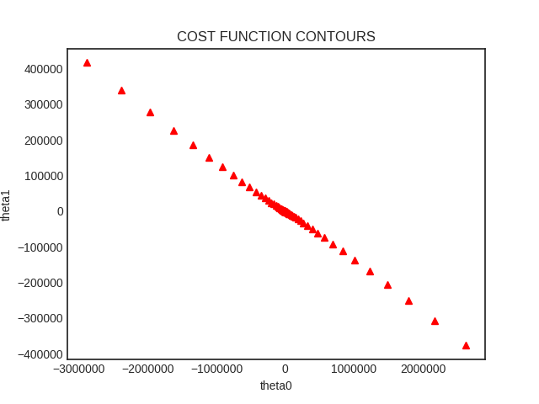
learning_rate=2.5
Observations:
for 2.1 or greater gradient descent doesn’t converge
for greater than 0.9 and less than 2.1 it converges after jumping over the minima many times

2(a)

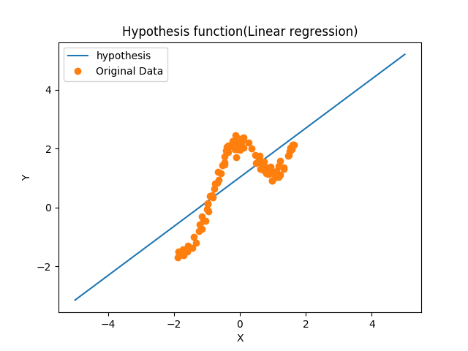

2(b)
tau=0.8
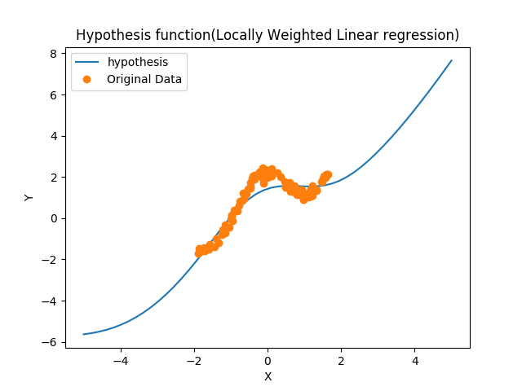
2(c)
tau=0.1
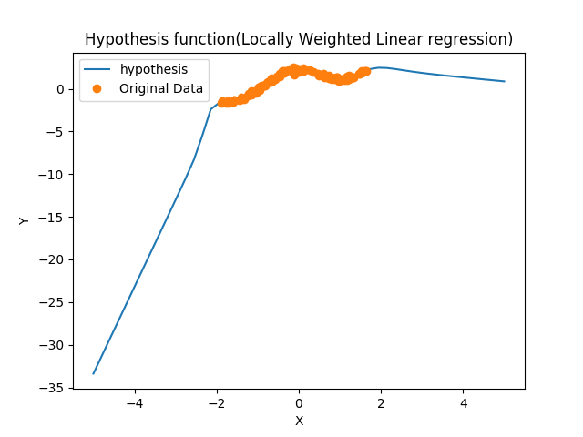
tau=0.3
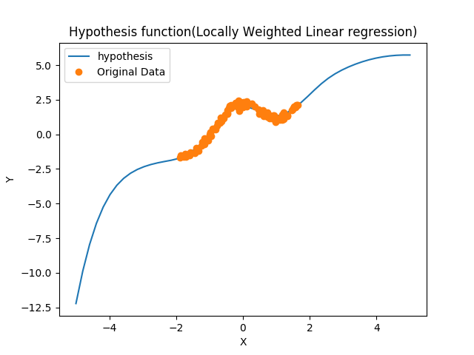
tau=2
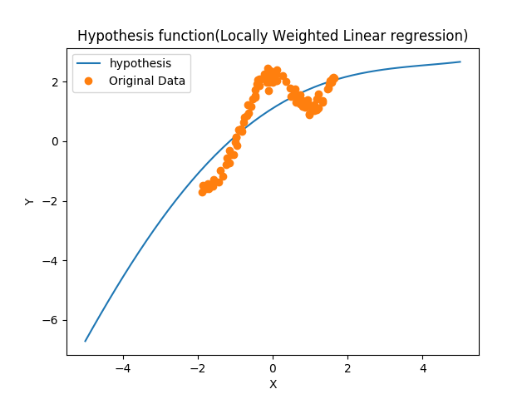
tau=10
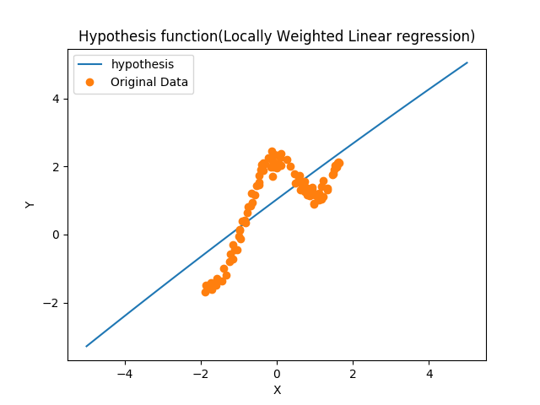
Observation:
for very small values of tau the hypothesis over fit the point i.e till 0.3 for our case
for larger value of tau ,it becomes similar to linear regression.

3(a)[ 0.4012307 , 2.60817385, -2.7452371 ]
3(b)
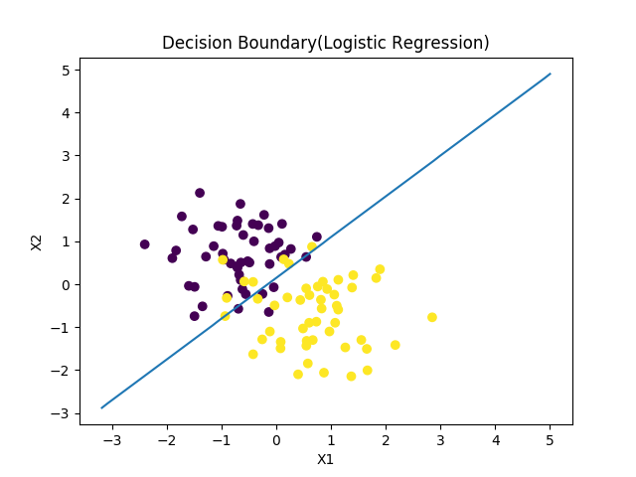
4(a)
myu0= [[137.46 366.62]]
myu1= [[ 98.38 429.66]]
E(covarience)=
[[ 287.482 -26.748]
[ -26.748 1123.25 ]]

4(b)
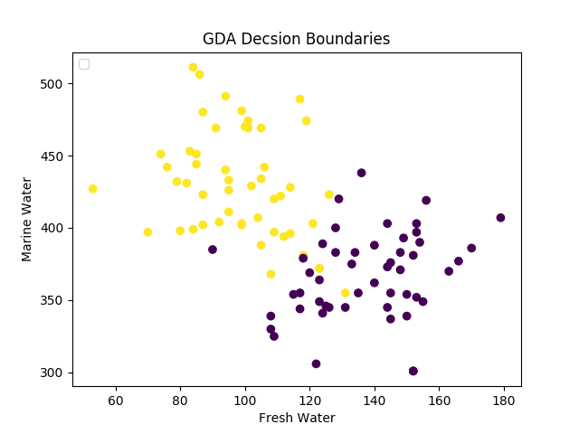
4(c)
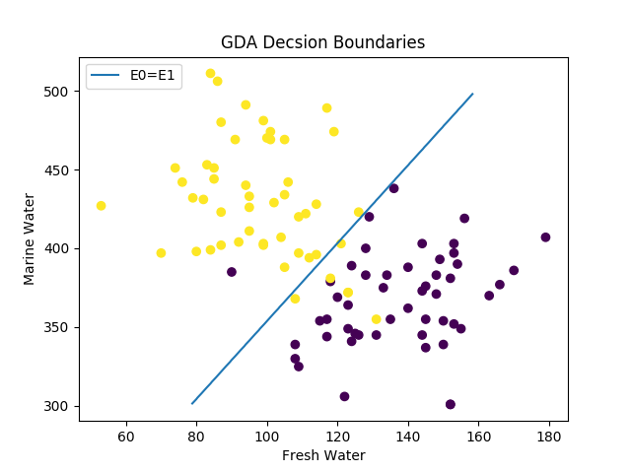
4(e)
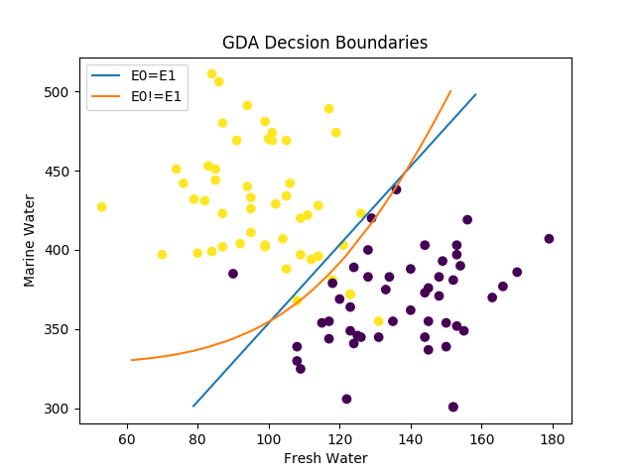
4(d)
myu0= [[137.46 366.62]]
myu1= [[ 98.38 429.66]]
E0
[[319.5684 130.8348]
[130.8348 875.3956]]
E1
[[ 255.3956 -184.3308]
[-184.3308 1371.1044]]

4(f)
The the assumption of E0=E1 is less general so, the second graph is more general.
The an also fit data in which one class is separate the a class which is fitting in between them.

