REPORT
ANSH PRAKASH
2016CS10367
SEQ VS P_THREAD
Y-Axis=Time(s)
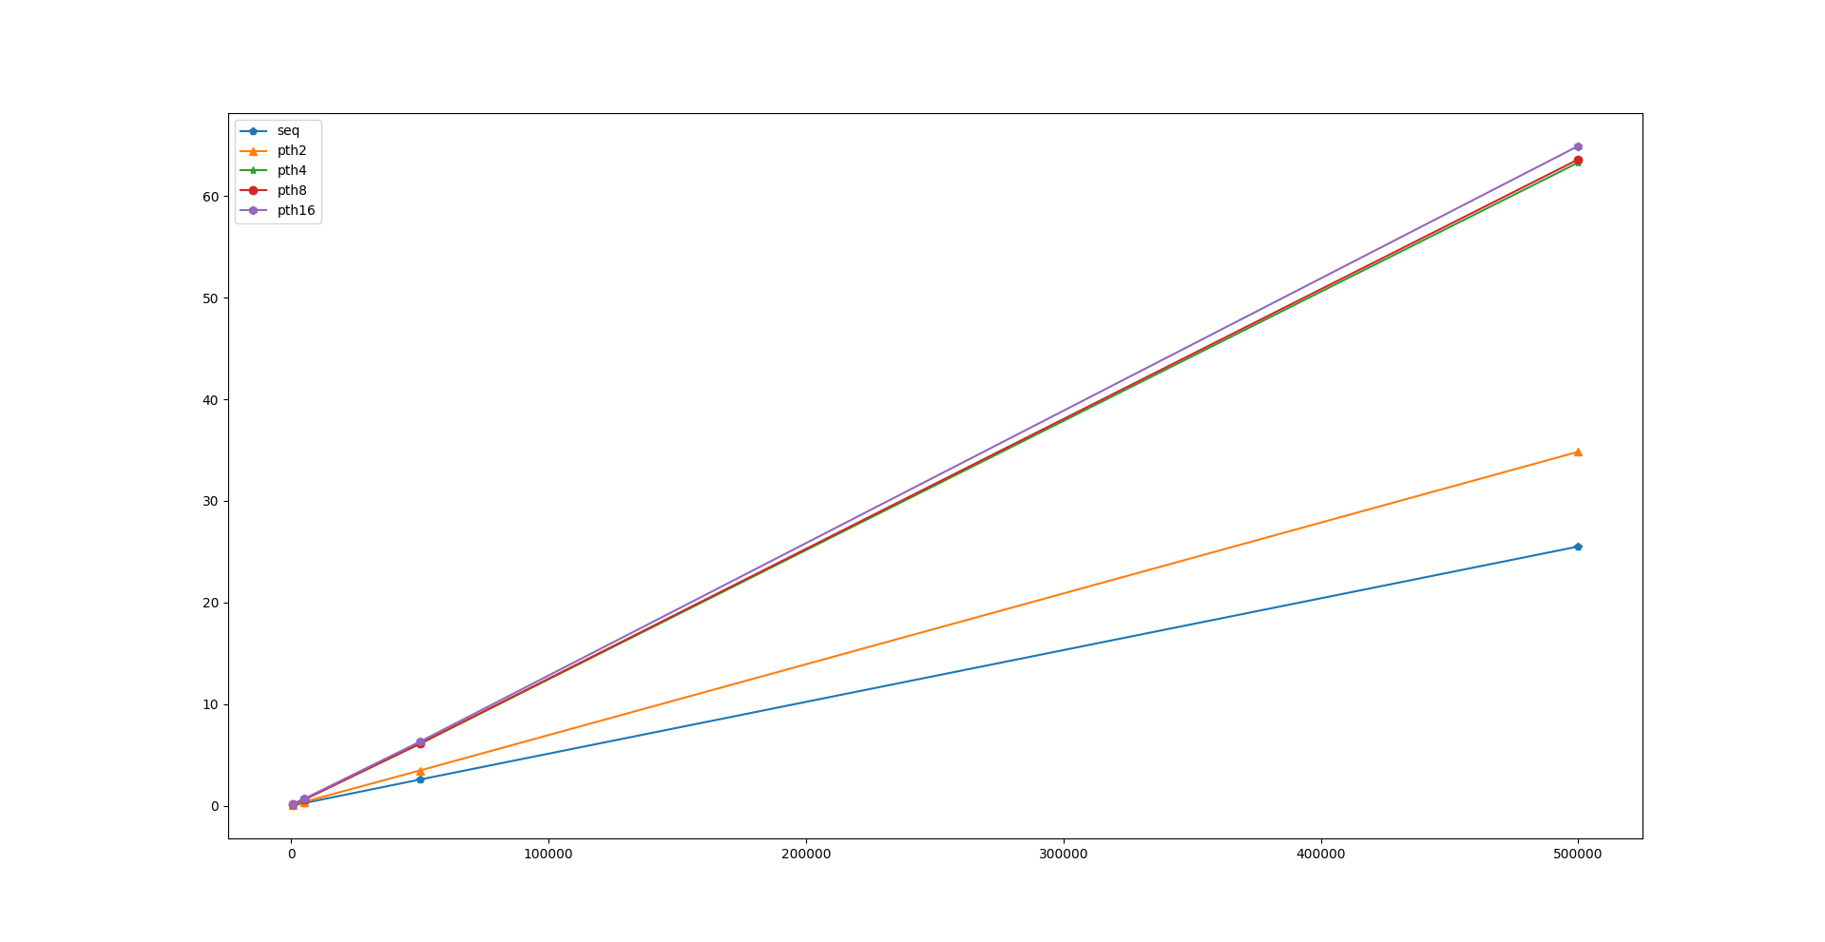
X-axis=Data_size

SEQ VS OMP
Y-Axis=Time(s)
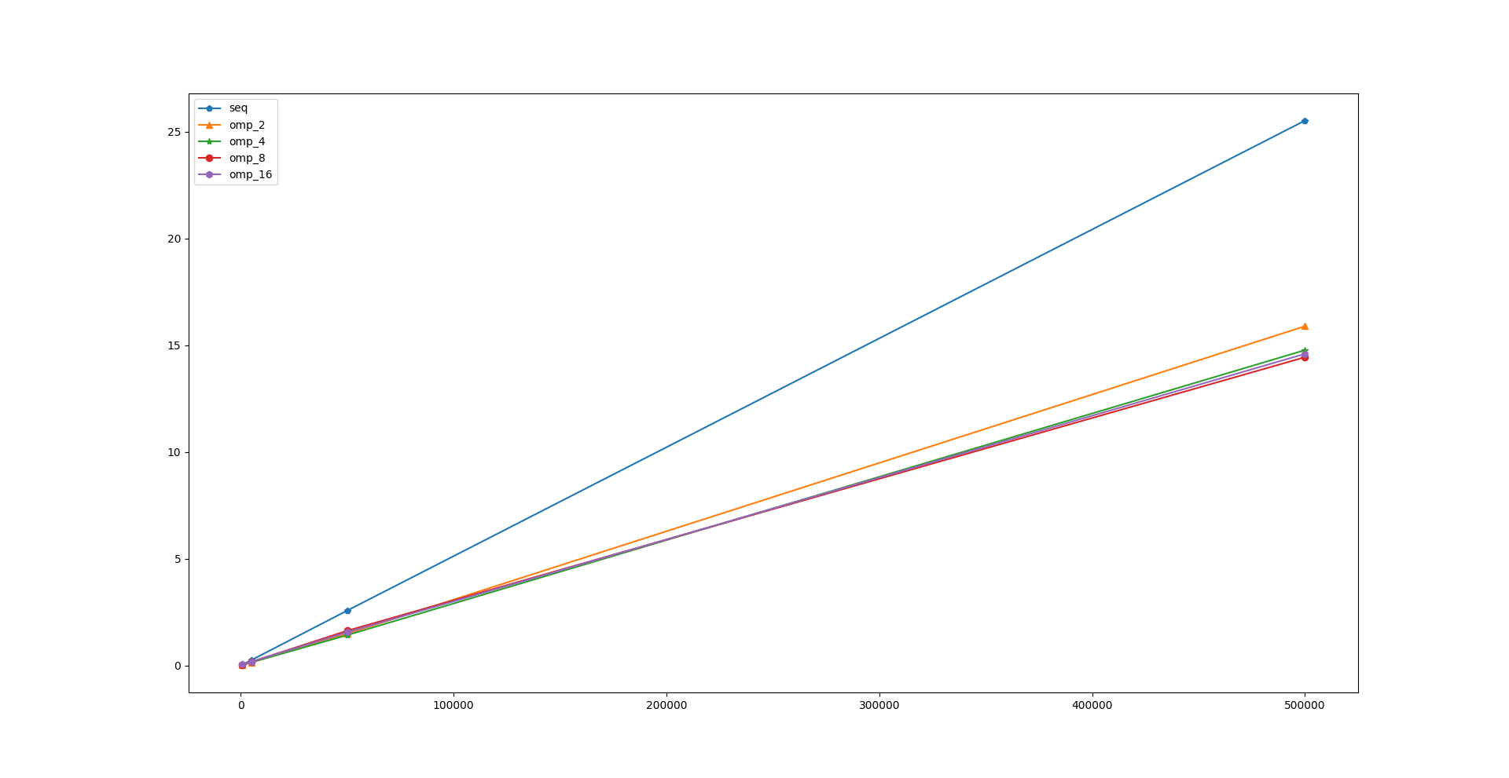
4-THREAD
Y-Axis=Time(s)
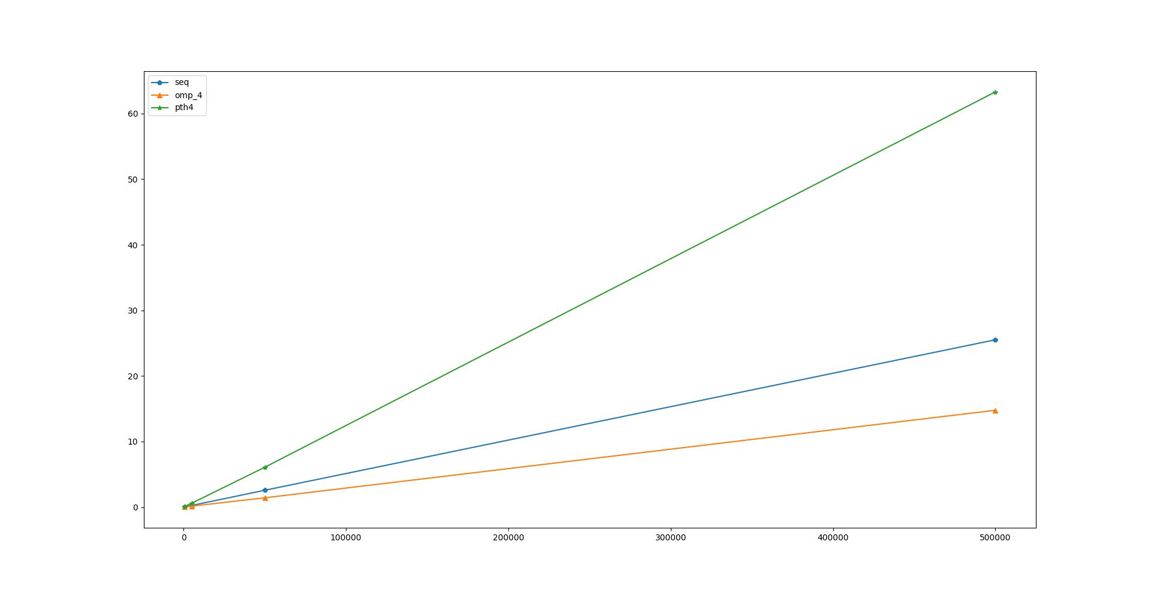

FIXED PROBLEM SIZE
VARYING NUMBER OF PROCESSORS
DATA_SET_SIZE :50000 points
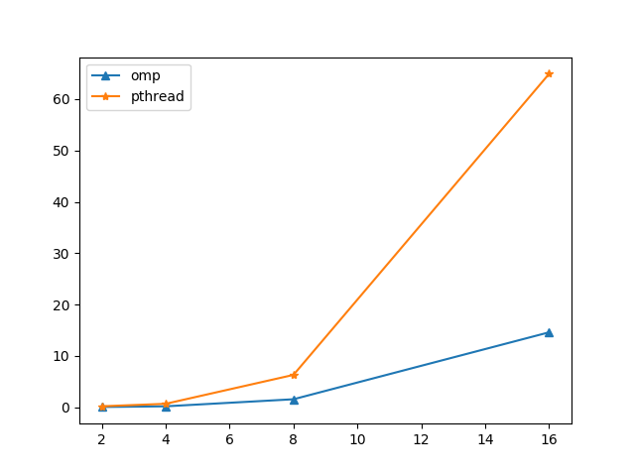
Y-Axis=Time(s)
EFFICIENCY
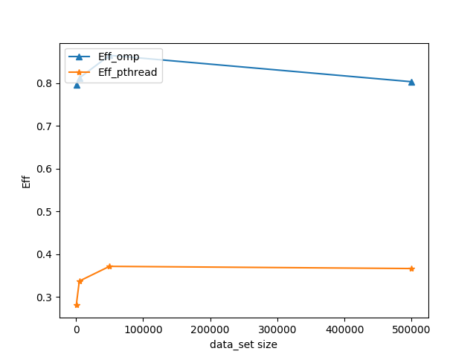
Fixed Number of processor but different data_size
Pthread efficency is really compare to OpenMP

FIXED PROBLEM SIZE BUT NUMBER OF PROCESSOR VARY
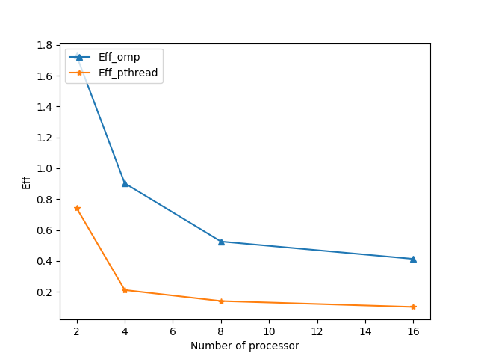
Speed Up for OMP
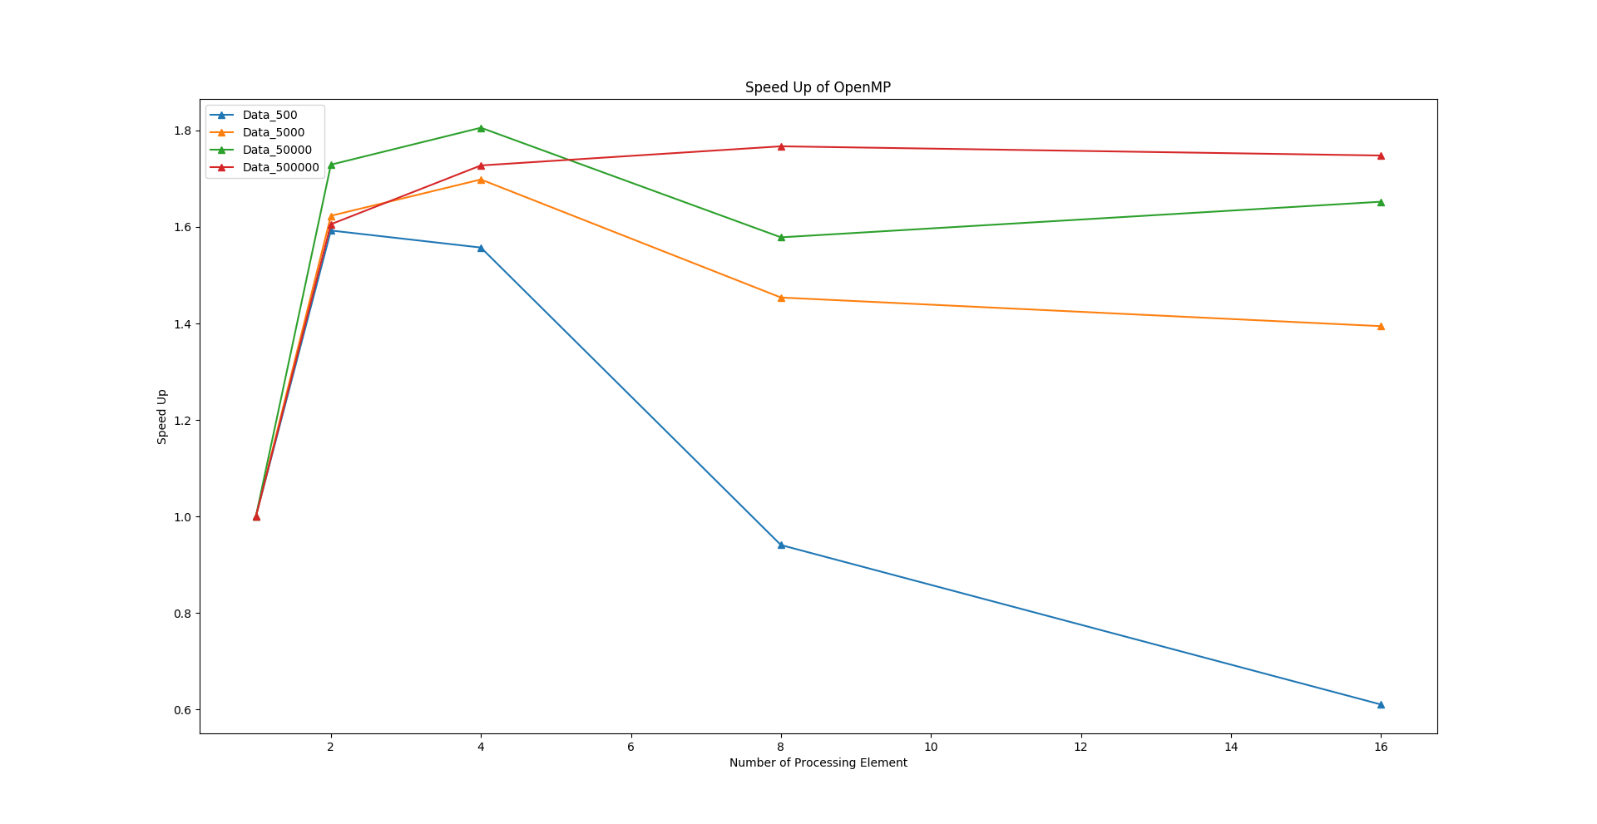
Speed Up of Pthread
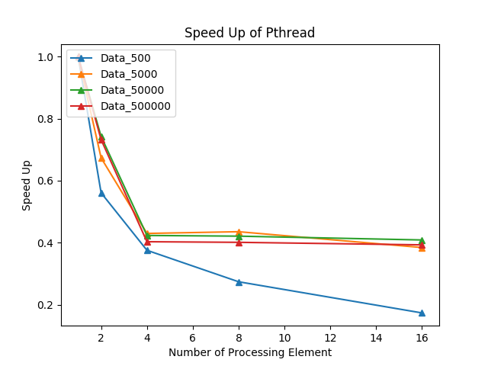
Performance detoriate for Pthreads!!
Design Decision
Select the right Implementation which is easily convertable to parallel code.
Parallelising Startegy
Parallelise two part of the algorithm.1)Assigning Clusters to data points.2)Recompute the centroid location of each cluster.
Load Balancing
The array in code code gets equally divided and each thread almost get equal work load.

