Geospatial Social Science Platform for Verified Photojournalism Research

Declaration: We, Group 1, confirm that this work submitted for assessment is our own and is expressed in our own words. Any uses made within it of the works of any other author, in any form (ideas, equations, figures, texts, tables, programs), are properly acknowledged at the point of use. A list of the references used is included.
From:
Student name | Student ID | Signature
Ansh Satish Acharya | 301297808
David Diei | 301288104
Issiaka Kone | 301304302
Krishna Shah | 301495323
Ngoc Ut Huong Ho | 301299380

Program: AI Capstone Project, COMP 385, Section 001, Group 1. Centennial College.
Date: October 12, 2026

Executive Summary

Table of Contents
Executive Summary 2
Table of Contents 3
List of Illustrations 5
1. Introduction 6
1.1 Background 6
1.2 The problem 6
1.3 Significance 7
1.4 What is new in this approach 7
1.5 Summary of literature review 7
1.6 Summary of the exploratory data analysis 9
2. Methodology 11
3. Results, Data and Analysis 13
3.1 Choosing the search model 13
3.2 Training the embedding model 14
3.3 AI summarization 15
3.4 The application's final configuration 16
3.5 Other results so far 16
3.6 Ranking the results of both searches 16
3.7 Stress test 17
3.8 Capacity of the free hosting 18
4. Conclusions 18
5. Recommendations 19
Bibliography 20
Appendix 1: Project Proposal 23
Appendix 2: Stakeholder Register 28
Appendix 3: System Specification 29
3.i Use case list and use case diagram 29
3.ii Use case descriptions (AI use cases) 30
3.iii Functional requirements 31
3.iv Non-functional requirements 32
Appendix 4: System Design 33
4.i List of technologies: hardware and software 33
4.ii AI capability description with data descriptions 33
4.iii Architecture design (AI capability) 36
4.iv Component diagram (AI capability) 37
4.v Database security 37
List of Acronyms 39
Glossary of Terms 39

List of Illustrations
Figures
Figure 1. Sample projects per study category and per UN SDG 9
Figure 2. Projects per category and words of text per project, partner samples and synthetic data 10
Figure 3. Held-out MRR and list F1 of each search method, with standard deviation across folds 13
Figure 4. ROUGE-1 and ROUGE-L of each summarizer, with standard deviation across folds 15
Figure 5. Use case diagram. Use cases that involve AI are shown in orange. 29
Figure 6. Architecture of the semantic search capability: indexing (top) and query (bottom). AI steps are shown in orange, data in green, decisions and fallbacks in amber. 36
Figure 7. Components of the AI capability and the files that implement them. AI components are shown in orange, data in green. 37

Tables
Table 1. Literature reviewed and its effect on the design 8
Table 2. Search methods compared by 5-fold cross-validation (mean ± SD of held-out folds) 13
Table 3. Hit@1 on held-out queries by kind of query 14
Table 4. Fine-tuning bge-small-en-v1.5, 5-fold cross-validation over projects (ranking without a cut-off) 14
Table 5. Summarizers compared against reference summaries (30 reports, 5-fold cross-validation) 15
Table 6. Final search configuration on all queries (application code) 16
Table 7. Reciprocal rank fusion on three example projects 17
Table 8. Stress test of the search API on 2 CPUs (9 projects, 20 seconds per level) 17
Table 9. Faults found by the stress test and their fixes 18
Table 10. Visits covered by Vercel's free Hobby plan 18
Table 11. Scope by course iteration (from the proposal) 27
Table 12. Stakeholder register 28
Table 13. Use case list 29
Table 14. Use case description, UC2: Semantic research search 30
Table 15. Use case description, UC5: AI summarization 31
Table 16. Functional requirements 31
Table 17. Non-functional requirements 32
Table 18. Technologies: hardware and software 33
Table 19. AI capability description: semantic research search 33
Table 20. AI capability description: AI summarization 34
Table 21. Data description: project record (table projects) 35
Table 22. Data description: documents and passages (tables documents and search_chunks) 35
Table 23. Data description: datasets used in this iteration 35
Table 24. Database security measures 37
Table 25. List of acronyms 39

1. Introduction

1.1 Background
Students now meet much of their information about world events on social media. False news travels farther and faster than true news on these platforms (Vosoughi et al., 2018), university students share misinformation for social reasons more than for accuracy (Chen et al., 2015), and even capable students judge a source by how its page looks instead of checking who is behind it (Wineburg & McGrew, 2019).
The reliable material exists. Photojournalists and social scientists document migration, climate change, political protest and community life in the field, and their work is checked by editors and peers. It is scattered across academic repositories, agency archives, personal portfolios and PDF theses, each with its own search page, and almost none of it can be explored by place. Research on geographic learning shows that working with spatial tools develops critical spatial thinking (Kim & Bednarz, 2013), yet the platforms students use daily give them no map of verified work.
The Charter, our industry partner, is building that map: a curated library of verified photojournalism and social science research in which every project is placed where it happened, carries a named author and institution, is tagged with the United Nations Sustainable Development Goals (United Nations, 2015), and shows a blue mark once a curator has checked it. The partner intends to license it to university libraries.

1.2 The problem
The problem stated in our proposal is fragmentation: verified research, visual documentation, geographic context, current events and academic discovery sit in separate systems, so a student studying migration or climate change must consult several sources before seeing both the evidence and where it comes from (Appendix 1).
Working with the partner since the proposal has sharpened this into two concrete problems that artificial intelligence can address:
- Discovery: A library is only useful if students can find what is in it. Keyword search finds a project only when the student types the words its author used. A student who searches for "people forced to leave home" does not find a project titled "The Darién Gap". The partner's projects are written by many authors, each with their own vocabulary, so this gap is the normal case.
- Curation: Before a project can be published, an administrator must read its PDF, write a summary, choose keywords, a category and SDG tags, and place it on the map. Done by hand for every project, this limits how fast the library can grow.
The project therefore offers two AI features: semantic search, which helps end users find projects by meaning, and AI summarization, which drafts a summary of an uploaded project for the administrator to review. Both are built in this iteration. Each AI model was chosen by comparing several candidates with cross-validation, and the comparison is reproducible from the repository.

1.3 Significance
- For students and researchers: one place to find verified work by place, topic or idea, in their own words, with the author and institution visible on every result.
- For administrators and curators: less repetitive reading and tagging, with every AI output presented as a suggestion they accept, edit or reject. Nothing produced by a model is published without a person's decision.
- For the partner: a platform that costs nothing to run beyond hosting. The partner asked that the solution use no paid services, so every model and library chosen is open source and runs on the server itself.
- For authors: their work becomes discoverable by people who do not know its title, while photographs and documents remain their property.

1.4 What is new in this approach
Existing archives offer keyword search over catalogue records. The Charter's approach differs in four ways:
- Search reads everything a project says: not only its title and keywords: the photo narration and the full text of its PDF are cut into passages, and every passage is searchable by meaning.
- Every result shows its evidence: the passage that matched and its similarity score, so users and curators can see why a project was returned instead of trusting a black box.
- Models are chosen and tuned on the platform's own data: five search methods and six summarizers were compared by cross-validation on a corpus built for this project, and fine-tuning was tested rather than assumed to help.
- AI drafts, people decide: the summary model writes a draft the administrator edits and confirms; photo narration is never generated. All of it runs on an ordinary CPU with open-source models, at no cost.

1.5 Summary of literature review
We reviewed literature in four areas. Table 1 lists the sources that shaped a design decision; the full reference list is in the Bibliography.
Misinformation and how students judge sources. Vosoughi et al. (2018) and Chen et al. (2015) establish the need for a verified alternative, and Wineburg and McGrew (2019) show that source identity must be visible, which is why every result in The Charter shows the author, the institution and the curation mark.
Keyword retrieval. Classical retrieval matches query terms against documents after stemming and stop-word removal and ranks by term weight (Manning et al., 2008). PostgreSQL implements this as full-text search (PostgreSQL Global Development Group, n.d.). It is fast, explainable and exact for names, but it cannot match a paraphrase. This is our baseline.
Semantic retrieval. BERT (Devlin et al., 2019) made contextual language representations available, and Sentence-BERT (Reimers & Gurevych, 2019) adapted it to produce one vector per sentence so that similar meanings can be found by cosine similarity. Dense passage retrieval showed that such vectors can beat keyword ranking when text is split into passages (Karpukhin et al., 2020). MiniLM (Wang et al., 2020) showed that a small distilled transformer keeps most of the accuracy at a fraction of the cost; BGE models (Xiao et al., 2023), one of which we chose, are small embedding models trained specifically for retrieval. The BEIR benchmark found that dense models do not always beat keyword ranking on data they were not trained on (Thakur et al., 2021), which is the argument for combining both; reciprocal rank fusion does this without tuning score scales (Cormack et al., 2009). For storage, hierarchical navigable small world graphs give fast approximate nearest-neighbour search (Malkov & Yashunin, 2020) and are available inside PostgreSQL through pgvector (Kane, n.d.).
Summarization. Extractive summarization selects existing sentences by word frequency (Luhn, 1958), which is our baseline. Abstractive models write new sentences: BART (Lewis et al., 2020), distilled into smaller versions for summarization (Shleifer & Rush, 2020), and T5 (Raffel et al., 2020), whose instruction-tuned FLAN-T5 versions follow prompts (Chung et al., 2022). Summaries are scored against references with ROUGE (Lin, 2004).
Training and evaluation. Sentence-embedding models are fine-tuned with a contrastive loss that treats the other pairs in a batch as negatives (Henderson et al., 2017). With small datasets, k-fold cross-validation gives a more reliable estimate than a single split and is the standard way to choose settings without testing on the data used to pick them (Kohavi, 1995). GDELT (Leetaru & Schrodt, 2013) remains a candidate data source if AI suggestions for News regions are added later, and the System Usability Scale (Brooke, 1996) is planned for end-user testing.
Table 1. Literature reviewed and its effect on the design
Source | Finding | Effect on our design
Reimers & Gurevych (2019) | Sentence vectors make meaning comparable by cosine similarity. | Semantic search compares the meaning of the query with every passage, so paraphrases are found.
Wang et al. (2020) | A small distilled transformer keeps most of the accuracy. | The model runs on a laptop CPU with no GPU, which meets the partner's no-cost requirement.
Karpukhin et al. (2020) | Retrieval works on short passages, not whole documents. | Project text and PDFs are split into passages of whole sentences before embedding.
Thakur et al. (2021) | Dense models can lose to keyword ranking on unfamiliar data. | Keyword search is kept as a baseline and combined with semantic search (hybrid mode).
Cormack et al. (2009) | Reciprocal rank fusion merges rankings without tuning. | Hybrid mode merges the two result lists by rank.
Malkov & Yashunin (2020); Kane (n.d.) | HNSW gives fast nearest-neighbour search and is available in PostgreSQL. | Vectors are stored in the same database as the projects; no separate vector database.
Xiao et al. (2023) | Small embedding models trained for retrieval. | bge-small-en-v1.5 was one of the three models compared, and won.
Kohavi (1995) | k-fold cross-validation for choosing settings. | Every model choice and cut-off was made by 5-fold cross-validation.
Henderson et al. (2017) | Contrastive training with in-batch negatives. | Loss used to fine-tune the embedding model.
Lin (2004); Shleifer & Rush (2020) | ROUGE; distilled BART summarizers. | Summarizers scored with ROUGE; distilbart-cnn-6-6 was chosen.
Manning et al. (2008) | Standard retrieval measures: precision, recall, reciprocal rank. | Evaluation reports Hit@1, Recall@3 and mean reciprocal rank against a judged query set.
Luhn (1958); Lewis et al. (2020) | Extractive and abstractive summarization. | Two extractive baselines built; four abstractive models compared against them.
Wineburg & McGrew (2019) | Readers need to see who is behind a source. | Every result shows author, institution and curation mark.

1.6 Summary of the exploratory data analysis
The partner has supplied 7 complete projects so far. Each has a title, description, category, place with coordinates, date, keywords, SDG tags, author profile and four photographs with narration. The full library has not been delivered yet, so this analysis describes the sample only (script: backend/eda/eda_sample_projects.py).
- Size and completeness: 7 projects by 7 authors (5 journalists, 2 academics). Every field is filled except the summary, which is empty for all of them. No project has a PDF yet.
- Class balance: News 3, Wildlife and human interaction 2, Anthropology 1, Urban life 1, Cross-border interactions 0 (Figure 1). SDG 10 appears on 6 of 7 projects and 6 of the 17 goals never appear.
- Text: Descriptions are short (22 to 40 words). Most of the text is in the photo narration (28 captions, median 35 words).
- Keywords: 59 distinct keywords, and only 5 are shared by more than one project, so keyword filters link few projects to each other.
- Coverage: The projects are in the Americas, Africa, China and Australia; Europe and South Asia are absent.
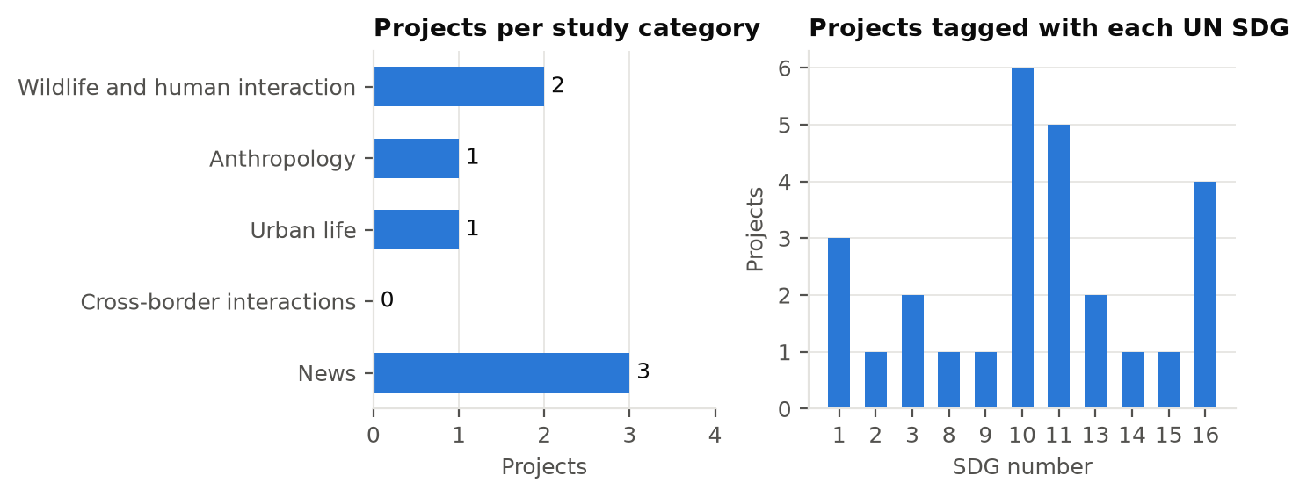
Figure 1. Sample projects per study category and per UN SDG
Seven projects are too few to choose or train a model, and none of them has a PDF or a reference summary, so the summarizer could not be measured at all. Until the partner supplies more projects, we built a synthetic dataset.
Synthetic dataset. 30 projects written by the team to the partner's exact record format, 6 in each of the five categories (so Cross-border interactions is no longer empty), set in 22 countries including Europe and South Asia, which the sample lacked, and dated 2021 to 2025. Each has a description, a 125 to 157-word field report that stands in for the uploaded PDF, and a two-sentence reference summary (29 to 42 words) written by hand. Every record is marked synthetic; it is used only for training and evaluation and never shown on the site (backend/data/synthetic).
Judged queries. 122 search queries with the projects a person judged relevant to each: 38 exact names, 70 paraphrases that avoid the project's own words, 5 broad topics and 9 off-topic queries that should return nothing; 13 have more than one relevant project (backend/model_training/search_eval/queries.json).
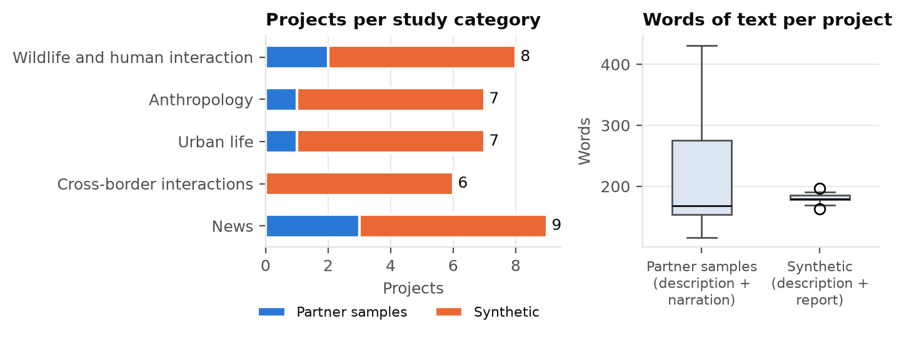
Figure 2. Projects per category and words of text per project, partner samples and synthetic data
What this means for the AI features: search must read the narration and PDFs, not only titles; the synthetic data gives every category enough projects and gives the summarizer reference summaries to be scored against; and because the team wrote both the synthetic projects and the queries, results on it must be confirmed on the partner's real projects when they arrive.

2. Methodology
The steps below are in the order they were done and follow the plan in the proposal (Appendix 1, Scope by Course Iteration). Steps 1 to 13 are complete; step 14 is the plan for the next iteration.
- Requirements: read the partner's three requirement documents and their Figma prototype, and wrote the proposal (September 20, 2026).
- Partner review (October 1, 2026): the partner made keyword search and text summarization the priorities, decided that projects are uploaded as PDFs and that photo narration is always written by the administrator, and asked for no paid services. The AI scope became two features: semantic search and AI summarization.
- Technology choices: replaced Google Maps (Google, n.d.) with a globe drawn with D3 (Bostock et al., 2011) from Natural Earth outlines (Natural Earth, n.d.), which needs no API key or billing, and chose FastAPI (Ramírez, n.d.) with PostgreSQL so the API and the AI code share one language.
- Data collection: loaded the partner's 7 sample projects; built a synthetic dataset of 30 projects with field reports and reference summaries, and 122 judged search queries (Section 1.6).
- Exploratory data analysis: measured size, completeness, class balance, text length and coverage of both datasets.
- Pre-processing: extract PDF text with pypdf; lower-case and strip accents for keyword search; split text into passages of whole sentences, one sentence overlapping, at a length chosen in step 8.
- Baselines: for search, keyword full-text search and TF-IDF; for summarization, the first two sentences (lead-2) and a word-frequency extractive summarizer.
- Search model selection and tuning: compared three pretrained embedding models (all-MiniLM-L6-v2, paraphrase-multilingual-MiniLM-L12-v2, bge-small-en-v1.5), each alone and combined with keyword search, against the two baselines. For each, 5-fold cross-validation over the queries chose the passage length (40, 60 or 90 words), the minimum similarity (0 to 0.8 in steps of 0.025) and the relative cut-off on four folds, and measured the fifth. The chosen setting maximised list F1, which rewards returning the relevant projects and nothing else.
- Training: fine-tuned the chosen model with a contrastive loss on pairs built from the corpus itself (a project's title, keywords or place paired with its own passages), using 5-fold cross-validation over projects so each test fold contains only projects the model never trained on. Two settings were tried.
- Summarizer selection and tuning: compared four pretrained sequence-to-sequence models (flan-t5-small, flan-t5-base, a t5-small summarizer and distilbart-cnn-6-6) with the two baselines on the 30 field reports, scored with ROUGE. 5-fold cross-validation over the reports chose each model's beam width and summary length.
- Integration: set the application to the chosen models and settings; the upload form now asks whether to draft an AI summary of the PDF and shows it for editing; every search result shows the passage that matched.
- Testing: automated tests for the API, search and summarization, including the fallbacks when a model is unavailable, run on SQLite and PostgreSQL; an end-to-end check of the application's final search settings.
- Load testing and hardening (November 2026): after the progress review of the architecture, merged the keyword and semantic rankings the same way in the deployed site as in the API (Section 3.6), stress-tested the search API and fixed the two faults it found (Section 3.7), measured what the free hosting can serve (Section 3.8) and secured both databases (Appendix 4.v).
- Next iteration: repeat steps 8 to 10 on the partner's full data with queries from people outside the team; collect administrator edits of AI summaries as training data; test with users.

3. Results, Data and Analysis
All results use the 37-project corpus (7 partner samples and 30 synthetic) and are produced by the scripts in backend/model_training, whose output files are in that folder. Unless stated otherwise, figures are the mean ± standard deviation over the five held-out folds of cross-validation, so no number comes from data used to choose the settings.

3.1 Choosing the search model
Table 2 and Figure 3 compare the methods on the 122 queries (113 with an answer). Hit@1 is the share of queries whose first result is relevant; Recall@3 the share of relevant projects in the first three results; MRR the mean of 1/rank of the first relevant result (Manning et al., 2008). List F1 compares the whole returned list with the relevant set, and for an off-topic query is 1 only if nothing is returned, so it also rewards a good cut-off.
Table 2. Search methods compared by 5-fold cross-validation (mean ± SD of held-out folds)
Method | Hit@1 | Recall@3 | MRR | List F1 | Off-topic rejected | Size (MB) | ms per query
Keyword (full-text) | 0.89 ± 0.07 | 0.93 ± 0.02 | 0.93 ± 0.04 | 0.59 ± 0.06 | 0.50 ± 0.50 | - | 32.2
TF-IDF | 0.90 ± 0.06 | 0.86 ± 0.07 | 0.90 ± 0.06 | 0.84 ± 0.05 | 0.60 ± 0.42 | - | -
all-MiniLM-L6-v2 | 0.89 ± 0.07 | 0.89 ± 0.08 | 0.91 ± 0.07 | 0.85 ± 0.05 | 0.70 ± 0.45 | 90 | 3.9
Hybrid: keyword + all-MiniLM-L6-v2 | 0.90 ± 0.06 | 0.91 ± 0.07 | 0.93 ± 0.06 | 0.90 ± 0.06 | 1.00 ± 0.00 | 90 | 3.9
paraphrase-multilingual-MiniLM-L12-v2 | 0.86 ± 0.03 | 0.86 ± 0.05 | 0.88 ± 0.04 | 0.83 ± 0.02 | 0.70 ± 0.45 | 235 | 10.8
Hybrid: keyword + paraphrase-multilingual-MiniLM-L12-v2 | 0.91 ± 0.04 | 0.90 ± 0.06 | 0.93 ± 0.04 | 0.89 ± 0.04 | 0.90 ± 0.22 | 235 | 10.8
bge-small-en-v1.5 | 0.95 ± 0.04 | 0.92 ± 0.06 | 0.96 ± 0.04 | 0.87 ± 0.04 | 0.80 ± 0.45 | 66 | 8.1
Hybrid: keyword + bge-small-en-v1.5 | 0.94 ± 0.06 | 0.90 ± 0.07 | 0.94 ± 0.06 | 0.86 ± 0.03 | 0.80 ± 0.45 | 66 | 8.1

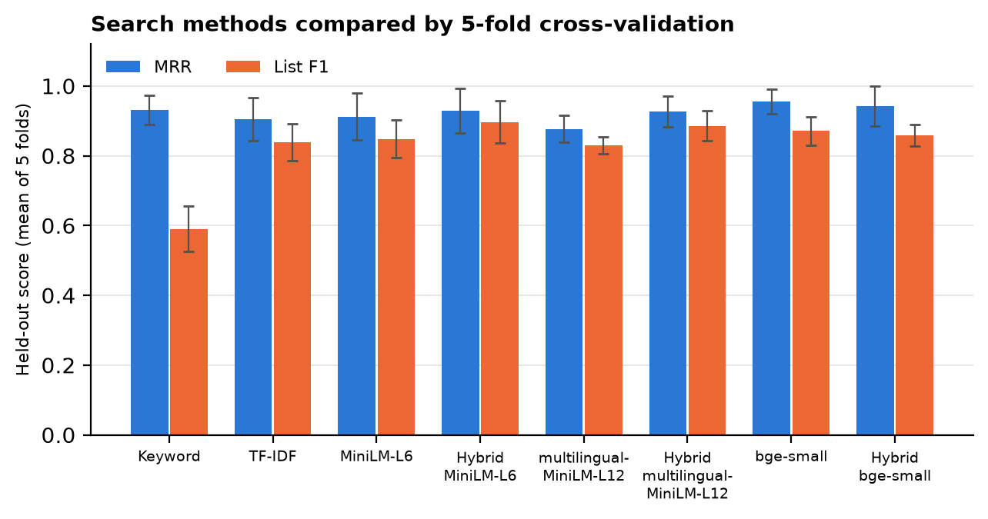
Figure 3. Held-out MRR and list F1 of each search method, with standard deviation across folds
Table 3. Hit@1 on held-out queries by kind of query
Method | exact (38) | paraphrase (70) | topic (5)
Keyword (full-text) | 1.00 | 0.86 | 0.60
TF-IDF | 1.00 | 0.86 | 0.80
all-MiniLM-L6-v2 | 0.95 | 0.86 | 0.80
Hybrid: keyword + all-MiniLM-L6-v2 | 1.00 | 0.86 | 0.80
paraphrase-multilingual-MiniLM-L12-v2 | 0.92 | 0.83 | 0.80
Hybrid: keyword + paraphrase-multilingual-MiniLM-L12-v2 | 1.00 | 0.87 | 0.80
bge-small-en-v1.5 | 0.97 | 0.93 | 1.00
Hybrid: keyword + bge-small-en-v1.5 | 1.00 | 0.90 | 1.00

Why bge-small-en-v1.5 was chosen:
- It is the most accurate method: Hit@1 0.95 ± 0.04 and MRR 0.96 ± 0.04, against 0.89 ± 0.07 and 0.93 ± 0.04 for keyword search.
- Its advantage is where meaning matters: on paraphrases it puts the right project first 93% of the time against 86% for keyword search, and on broad topics 100% against 60%.
- It is the smallest model (66 MB, against 90 and 235 MB) and answers in about 8.1 ms per query on a laptop CPU.
- The site is English only, so the multilingual model's extra size buys nothing; it was also the least accurate of the three.
Settings chosen. Across folds the cut-offs were stable, and refitting on all queries gave passages of 40 words, a minimum similarity of 0.575 and a relative cut-off of 0.95; these are the application's settings. Hybrid search (keyword plus bge-small) is kept as the “By meaning” mode because it never loses an exact name: its Hit@1 on exact-name queries is 1.00.
What was surprising: keyword search is stronger than the first evaluation suggested (Hit@1 0.89), because many paraphrases still share one ordinary word with the project. Its weakness is the cut-off: it returned results for 50% of off-topic queries, hence its low list F1 of 0.59.

3.2 Training the embedding model
Table 4. Fine-tuning bge-small-en-v1.5, 5-fold cross-validation over projects (ranking without a cut-off)
Training setting | Model | Hit@1 | Recall@3 | MRR
2 epochs, learning rate 2e-5 | Pretrained | 0.98 ± 0.03 | 1.00 ± 0.00 | 0.99 ± 0.02
 | Fine-tuned | 0.92 ± 0.06 | 0.99 ± 0.02 | 0.95 ± 0.03
1 epoch, learning rate 5e-6 | Pretrained | 0.98 ± 0.03 | 1.00 ± 0.00 | 0.99 ± 0.02
 | Fine-tuned | 0.96 ± 0.05 | 1.00 ± 0.00 | 0.98 ± 0.03

The model was fine-tuned five times per setting, each time without one fifth of the projects, and tested on the 100 queries about those unseen projects; each run used about 462 training pairs and took 4 minutes on a laptop CPU. Fine-tuning did not help: the pretrained model already ranks the right project first 98% of the time, and training on pairs made from titles and keywords pulled it toward matching those words. The gentler setting lost less, which confirms the effect comes from the training signal. We therefore keep the pretrained model and will retrain when real user queries, and the projects users open from them, are available as training pairs.

3.3 AI summarization
Table 5. Summarizers compared against reference summaries (30 reports, 5-fold cross-validation)
Method | ROUGE-1 | ROUGE-2 | ROUGE-L | Parameters (M) | Seconds per report
Lead-2 (first two sentences) | 0.303 ± 0.016 | 0.048 ± 0.012 | 0.180 ± 0.006 | - | 0.003
Word-frequency extractive (current baseline) | 0.317 ± 0.039 | 0.061 ± 0.033 | 0.202 ± 0.033 | - | 0.003
flan-t5-small | 0.227 ± 0.036 | 0.026 ± 0.015 | 0.133 ± 0.014 | 77 | 2.24
t5-small (summarization) | 0.300 ± 0.035 | 0.055 ± 0.023 | 0.193 ± 0.015 | 61 | 3.19
distilbart-cnn-6-6 | 0.339 ± 0.020 | 0.080 ± 0.020 | 0.217 ± 0.018 | 230 | 5.4
flan-t5-base | 0.232 ± 0.019 | 0.022 ± 0.007 | 0.139 ± 0.016 | 248 | 4.29

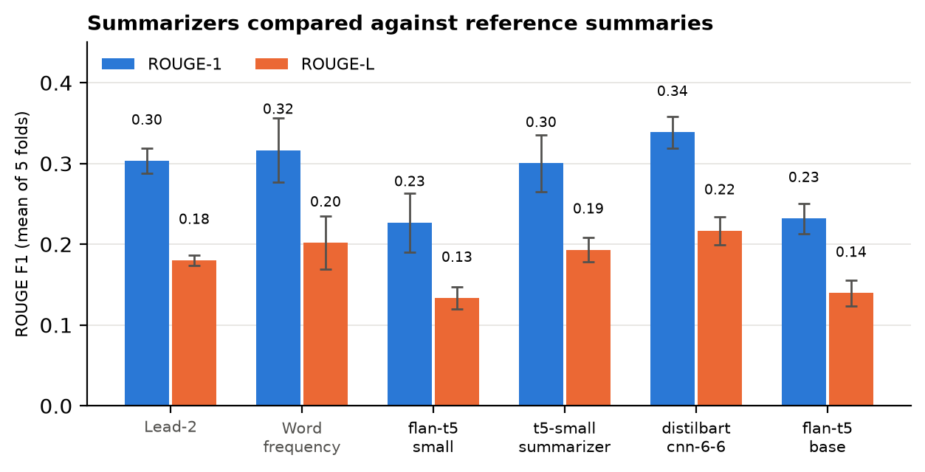
Figure 4. ROUGE-1 and ROUGE-L of each summarizer, with standard deviation across folds
distilbart-cnn-6-6 was chosen. It has the highest scores (ROUGE-L 0.217 against 0.202 for the word-frequency baseline), it was the only model to beat the baselines, and cross-validation chose the same settings in four of five folds (greedy decoding, up to 60 new tokens). The margin over the baseline is small and within the variation between folds, so the clearest gain is qualitative: the model shortens and joins sentences instead of copying the first ones.
The most important finding is a risk. The two FLAN-T5 models invented facts: for the report on elephants in Assam, India, flan-t5-small wrote “A herd of elephants in a remote region of China has been rescued by a community watch group.” Abstractive models can state things the document does not say, which is why the summary is only ever a draft that the administrator reviews, and why photo narration is never generated. The chosen model takes about 5 seconds per report on a laptop CPU, acceptable for a one-off step in the upload form.

3.4 The application's final configuration
With the chosen model and settings, the application's own search code was run on every query (backend/model_training/search_eval/evaluate_search.py). Because these settings were refitted on all the queries, these figures are slightly optimistic; the cross-validated results above are the fair estimate.
Table 6. Final search configuration on all queries (application code)
Queries | Mode | Hit@1 | Recall@3 | MRR
all (113) | keyword | 0.89 | 0.93 | 0.93
all (113) | semantic | 0.96 | 0.94 | 0.97
all (113) | hybrid | 0.96 | 0.95 | 0.97
exact (38) | keyword | 1.00 | 0.99 | 1.00
exact (38) | semantic | 0.97 | 0.97 | 0.97
exact (38) | hybrid | 0.97 | 0.99 | 0.99
paraphrase (70) | keyword | 0.86 | 0.93 | 0.91
paraphrase (70) | semantic | 0.94 | 0.95 | 0.96
paraphrase (70) | hybrid | 0.94 | 0.95 | 0.96
topic (5) | keyword | 0.60 | 0.50 | 0.70
topic (5) | semantic | 1.00 | 0.63 | 1.00
topic (5) | hybrid | 1.00 | 0.63 | 1.00

3.5 Other results so far
- Tests: the back end has 118 automated tests for the API, search, summarization and behaviour under load; they pass on SQLite and PostgreSQL. Tests confirm that when a model is unavailable, search falls back to keyword results, summaries fall back to the baseline and saving still works (NFR8), and that a server with no free database connection answers at once that it is busy.
- Cost: every model and library is open source and runs on a CPU. Nothing is paid for (NFR11).
These results have limits:
- The synthetic projects, the queries and the reference summaries were written by the team, which may make them easier than real data. All three experiments will be repeated on the partner's projects with outside users' queries.
- With 37 projects and 30 reports, fold-to-fold variation is large; differences smaller than one standard deviation are not conclusive.

3.6 Ranking the results of both searches
In the “By meaning” mode two searches run on every query: the semantic search returns the projects whose best passage passes the cut-off, ordered by cosine similarity, and the keyword search returns the projects that contain every word of the query, ordered by where the words appear (title, then tags, then text, then PDFs). The two lists are merged into one ranking by reciprocal rank fusion (Cormack et al., 2009): each project scores 1 / (60 + its position) in each list it appears in, and the two scores are added.
Positions are used instead of the raw scores because a cosine similarity and a full-text rank are on different scales and cannot be added. The constant 60 is the value from the original paper; it stops a single first place from outweighing everything else. Table 7 shows the effect on three projects. A project found by both searches comes first, an exact name stays near the top, and a paraphrase that shares no word with the query is still found. Ties go to the closer meaning.
Table 7. Reciprocal rank fusion on three example projects
Project | Meaning rank | Keyword rank | Score | Final rank
A, found by both searches | 1 | 3 | 1/61 + 1/63 = 0.0323 | 1st
C, found by keywords only | - | 1 | 1/61 = 0.0164 | 2nd
B, found by meaning only | 2 | - | 1/62 = 0.0161 | 3rd

The deployed site has no back-end server, so there the same model runs in the visitor's browser with Transformers.js (Hugging Face, n.d.). Until November it showed the semantic matches and then appended the keyword matches at the end; it now applies the same fusion and the same keyword rules as the API (accents ignored, each word must start a word in the project, scored by field). For example, the query “Oaxaca” now puts the Day of the Dead project first, marked as related by meaning and by keywords.

3.7 Stress test
The search API was run in a Linux container limited to 2 CPUs and 2 GB of memory, about the size of a small cloud server, with two worker processes and PostgreSQL (pgvector, HNSW index) in a second container. A script simulated N users who each search without pausing, which is a far heavier load than N real visitors; each level ran for 20 seconds over 20 queries mixing names and descriptions. Table 8 gives the searches answered per second and the time within which 95% of searches were answered (backend/stress_test).
Table 8. Stress test of the search API on 2 CPUs (9 projects, 20 seconds per level)
Users searching non-stop | Keyword: searches/s | Keyword: 95% within | Hybrid: searches/s | Hybrid: 95% within | Failed
1 | 55 | 23 ms | 16 | 93 ms | 0
5 | 45 | 0.26 s | 44 | 0.22 s | 0
10 | 44 | 0.75 s | 50 | 0.71 s | 0
25 | 46 | 1.5 s | 30 | 2.2 s | 0
50 | 21 | 6.1 s | 19 | 6.9 s | 0

One server of this size answers about 40 to 50 searches a second. A visitor searches perhaps once every 30 to 60 seconds while looking at the globe, so this is in the order of 1,000 people browsing at the same time. Answers stay within the 2-second target of NFR1 up to about 25 non-stop users. With the library enlarged to 1,009 projects (3,634 passages), one search took 26 ms by keyword and 54 ms by meaning, against 17 ms and 54 ms with 9 projects: the HNSW and GIN indexes keep the search itself fast, and most of each request is spent building the answer. Embedding the query takes about 8 ms of CPU and the database work 1 to 7 ms. The test found two faults, both fixed (Table 9).
Table 9. Faults found by the stress test and their fixes
Fault found | Fix
At 100 users every request failed: each waited 30 seconds for one of 15 database connections, then received a server error (500). | After 5 seconds without a free connection the API answers 503 (busy) with Retry-After, and the site searches in the browser instead. The pool size is a setting (DB_POOL_SIZE, DB_MAX_OVERFLOW).
With several worker processes the server did not start: each process altered the tables at the same time and PostgreSQL stopped them with a deadlock. | Setting up the schema takes a PostgreSQL advisory lock, so the processes do it one after another. A test starts four at once.
Each process let the model use every CPU core, so simultaneous searches competed for them. | EMBEDDING_THREADS=1 gives each search one core.

Limits: the load script ran on the same laptop as the containers, so above 50 non-stop users the laptop itself became a bottleneck and those levels are not reported. NFR2 (2 seconds with 10,000 projects) has been tested up to 1,009 projects so far.

3.8 Capacity of the free hosting
The deployed site is static: Vercel serves the page, the map data and the photographs from its content delivery network, and Supabase holds uploaded projects. Its limits are therefore monthly totals rather than people at the same moment. One visit to the live site (open the globe, sign in as a student, open three projects) was measured with the browser's developer tools: 19 requests and 1.1 MB from Vercel (Table 10).
Table 10. Visits covered by Vercel's free Hobby plan
Hobby plan allowance | Per month | Used by one first visit | Visits it covers
CDN requests | 1,000,000 | 19 requests | about 52,000
Fast Data Transfer | 100 GB | 1.1 MB | about 94,000
Function invocations | 1,000,000 | 0 (static site) | not a limit

- The free plan serves about 50,000 first-time visits a month (Vercel, n.d.-a, n.d.-b). Photographs, PDFs and map data are now cached for a day, so a returning visitor makes 2 requests instead of 15. A class of 40 opening the site together uses about 760 requests.
- The 34 MB sentence model is downloaded from Hugging Face and jsDelivr, not from Vercel, so it does not count against the plan.
- Supabase's free plan is the tighter limit: 5 GB of egress (plus 5 GB cached) at about 0.3 MB per visit is roughly 17,000 visits a month, and a free project pauses after a week without activity (Supabase, n.d.).
- The Hobby plan is for non-commercial use and cannot buy extra usage. If the partner runs the platform after the course, a paid plan is needed.

4. Conclusions
- Measured by cross-validation, bge-small-en-v1.5 is the best of the five search methods (Hit@1 0.95, MRR 0.96) and the smallest model, which is why it was chosen.
- Semantic search helps most where users describe a topic in their own words; for exact names keyword search is already perfect, so hybrid search keeps both.
- Fine-tuning on self-generated pairs did not improve a model that was already near its ceiling; real user queries are needed before further training is worthwhile.
- AI summarization is now an AI feature: distilbart-cnn-6-6 beat the baselines and drafts summaries in the upload form, but abstractive models can invent facts, so human review is essential.
- Both AI features run on an ordinary CPU at no cost, which meets the partner's requirement.
- Every search path now ends in a ranked list: the keyword and semantic rankings are merged by reciprocal rank fusion, and when the back end is busy or the model is missing the site falls back to keyword results or to the model in the browser.
- One small server (2 CPUs) answers about 40 to 50 searches a second, and the stress test found and fixed two faults that would have stopped the service under load.
- The free hosting serves about 50,000 first-time visits a month; Supabase's free plan (about 17,000) is the first limit to watch.

5. Recommendations

Bibliography
Bostock, M., Ogievetsky, V., & Heer, J. (2011). D3: Data-driven documents. IEEE Transactions on Visualization and Computer Graphics, 17(12), 2301–2309.
Brooke, J. (1996). SUS: A "quick and dirty" usability scale. In P. W. Jordan, B. Thomas, B. A. Weerdmeester, & I. L. McClelland (Eds.), Usability evaluation in industry (pp. 189–194). Taylor & Francis.
Chen, X., Sin, S.-C. J., Theng, Y.-L., & Lee, C. S. (2015). Why students share misinformation on social media: Motivation, gender, and study-level differences. The Journal of Academic Librarianship, 41(5), 583–592.
Chung, H. W., Hou, L., Longpre, S., Zoph, B., Tay, Y., Fedus, W., Li, Y., Wang, X., Dehghani, M., Brahma, S., Webson, A., Gu, S. S., Dai, Z., Suzgun, M., Chen, X., Chowdhery, A., Castro-Ros, A., Pellat, M., Robinson, K., ... Wei, J. (2022). Scaling instruction-finetuned language models. arXiv. https://arxiv.org/abs/2210.11416
Cormack, G. V., Clarke, C. L. A., & Büttcher, S. (2009). Reciprocal rank fusion outperforms Condorcet and individual rank learning methods. In Proceedings of the 32nd International ACM SIGIR Conference on Research and Development in Information Retrieval (pp. 758–759). ACM.
Devlin, J., Chang, M.-W., Lee, K., & Toutanova, K. (2019). BERT: Pre-training of deep bidirectional transformers for language understanding. In Proceedings of the 2019 Conference of the North American Chapter of the Association for Computational Linguistics (pp. 4171–4186). https://arxiv.org/abs/1810.04805
Google. (n.d.). Maps JavaScript API documentation. https://developers.google.com/maps/documentation/javascript
Henderson, M., Al-Rfou, R., Strope, B., Sung, Y.-H., Lukács, L., Guo, R., Kumar, S., Miklos, B., & Kurzweil, R. (2017). Efficient natural language response suggestion for Smart Reply. arXiv. https://arxiv.org/abs/1705.00652
Hugging Face. (n.d.). Transformers.js [Computer software]. https://github.com/huggingface/transformers.js
Kane, A. (n.d.). pgvector: Open-source vector similarity search for Postgres [Computer software]. https://github.com/pgvector/pgvector
Karpukhin, V., Oğuz, B., Min, S., Lewis, P., Wu, L., Edunov, S., Chen, D., & Yih, W. (2020). Dense passage retrieval for open-domain question answering. In Proceedings of the 2020 Conference on Empirical Methods in Natural Language Processing (pp. 6769–6781). https://arxiv.org/abs/2004.04906
Kim, M., & Bednarz, R. (2013). Development of critical spatial thinking through GIS learning. Journal of Geography in Higher Education, 37(3), 350–366.
Kohavi, R. (1995). A study of cross-validation and bootstrap for accuracy estimation and model selection. In Proceedings of the 14th International Joint Conference on Artificial Intelligence (pp. 1137–1143).
Leetaru, K., & Schrodt, P. A. (2013). GDELT: Global data on events, location and tone, 1979–2012 [Paper presentation]. International Studies Association Annual Convention.
Lewis, M., Liu, Y., Goyal, N., Ghazvininejad, M., Mohamed, A., Levy, O., Stoyanov, V., & Zettlemoyer, L. (2020). BART: Denoising sequence-to-sequence pre-training for natural language generation, translation, and comprehension. In Proceedings of the 58th Annual Meeting of the Association for Computational Linguistics (pp. 7871–7880). https://arxiv.org/abs/1910.13461
Lin, C.-Y. (2004). ROUGE: A package for automatic evaluation of summaries. In Text Summarization Branches Out (pp. 74–81). Association for Computational Linguistics.
Luhn, H. P. (1958). The automatic creation of literature abstracts. IBM Journal of Research and Development, 2(2), 159–165.
Malkov, Y. A., & Yashunin, D. A. (2020). Efficient and robust approximate nearest neighbor search using hierarchical navigable small world graphs. IEEE Transactions on Pattern Analysis and Machine Intelligence, 42(4), 824–836. https://arxiv.org/abs/1603.09320
Manning, C. D., Raghavan, P., & Schütze, H. (2008). Introduction to information retrieval. Cambridge University Press.
Natural Earth. (n.d.). Free vector and raster map data. https://www.naturalearthdata.com
PostgreSQL Global Development Group. (n.d.). PostgreSQL 16 documentation: Full text search. https://www.postgresql.org/docs/16/textsearch.html
Qdrant. (n.d.). FastEmbed [Computer software]. https://github.com/qdrant/fastembed
Raffel, C., Shazeer, N., Roberts, A., Lee, K., Narang, S., Matena, M., Zhou, Y., Li, W., & Liu, P. J. (2020). Exploring the limits of transfer learning with a unified text-to-text transformer. Journal of Machine Learning Research, 21(140), 1–67.
Ramírez, S. (n.d.). FastAPI [Computer software]. https://fastapi.tiangolo.com
Reimers, N., & Gurevych, I. (2019). Sentence-BERT: Sentence embeddings using Siamese BERT-networks. In Proceedings of the 2019 Conference on Empirical Methods in Natural Language Processing (pp. 3982–3992). https://arxiv.org/abs/1908.10084
Shleifer, S., & Rush, A. M. (2020). Pre-trained summarization distillation. arXiv. https://arxiv.org/abs/2010.13002
Supabase. (n.d.). Pricing. Retrieved November 9, 2026, from https://supabase.com/pricing
Thakur, N., Reimers, N., Rücklé, A., Srivastava, A., & Gurevych, I. (2021). BEIR: A heterogeneous benchmark for zero-shot evaluation of information retrieval models. In Proceedings of the Neural Information Processing Systems Track on Datasets and Benchmarks. https://arxiv.org/abs/2104.08663
United Nations. (2015). Transforming our world: The 2030 agenda for sustainable development (A/RES/70/1). United Nations General Assembly.
Vercel. (n.d.-a). Hobby plan. Retrieved November 9, 2026, from https://vercel.com/docs/plans/hobby
Vercel. (n.d.-b). Limits. Retrieved November 9, 2026, from https://vercel.com/docs/limits
Vosoughi, S., Roy, D., & Aral, S. (2018). The spread of true and false news online. Science, 359(6380), 1146–1151.
Wang, W., Wei, F., Dong, L., Bao, H., Yang, N., & Zhou, M. (2020). MiniLM: Deep self-attention distillation for task-agnostic compression of pre-trained transformers. Advances in Neural Information Processing Systems, 33, 5776–5788. https://arxiv.org/abs/2002.10957
Wineburg, S., & McGrew, S. (2019). Lateral reading and the nature of expertise: Reading less and learning more when evaluating digital information. Teachers College Record, 121(11), 1–40.
Xiao, S., Liu, Z., Zhang, P., & Muennighoff, N. (2023). C-Pack: Packaged resources to advance general Chinese embedding. arXiv. https://arxiv.org/abs/2309.07597
Zhang, J., Zhao, Y., Saleh, M., & Liu, P. J. (2020). PEGASUS: Pre-training with extracted gap-sentences for abstractive summarization. In Proceedings of the 37th International Conference on Machine Learning (pp. 11328–11339). https://arxiv.org/abs/1912.08777

Appendix 1: Project Proposal
The proposal submitted on September 20, 2026 is reproduced below without its attachments. The use case list, stakeholder register and requirements that were attached to it appear in their current form in Appendices 2 and 3.

Introduction
Social media and other digital platforms have become important sources of information for students; however, the rapid circulation of information online also creates challenges related to misinformation and source reliability. Research has shown that university students may encounter and share misinformation through social media, highlighting the importance of information literacy and critical evaluation of digital information (Chen et al., 2015).
At the same time, social science research related to political crises, migration, climate change, anthropology, urban life, border interactions, and community issues is distributed across academic publications, institutional repositories, news sources, photojournalism collections, and professional networks. This fragmentation makes it difficult for students and researchers to connect academic evidence with the geographic locations, people, institutions, and current events being studied.
The Charter addresses this problem through an institutional-access geospatial platform that combines verified photojournalism, social science research, geographic exploration, academic networking, new curated entries, events, and supporting institutions in one environment. The current interface design includes an interactive map; project discovery pages; filters for area of study, UN Sustainable Development Goals (SDGs), year, and keywords; a community area; curated new entries; sponsor information; academic events; and a user profile area containing contacts and messages, saved projects, and job opportunities.
The primary users are students, researchers, faculty, journalists, media professionals, and other approved institutional users. Artificial intelligence will support discovery and curation rather than replace academic or editorial judgment. AI outputs that affect published content will remain subject to administrator review.

Statement of the Issue (Problem Statement)
Digital-native students and researchers can access large volumes of online information, but accessibility does not guarantee reliability, organization, or geographic context. Geographic information, qualitative social science research, photojournalism, current-event information, institutional credentials, academic opportunities, and UN SDG information are commonly accessed through separate systems. A user studying migration, climate change, anthropology, urban life, or border interactions may therefore need to consult multiple sources before understanding both the research evidence and its geographic context.
The central problem addressed by The Charter is this fragmentation between verified research, visual documentation, geographic context, current events, and academic discovery. The project proposes a unified platform in which users can explore curated projects spatially and thematically while AI assists with research discovery, recommendation, geographic information extraction, and administrative content classification.

Project Objectives and Measurable Goals
The project will pursue the following measurable objectives:
- Develop a responsive full-stack platform that presents verified research and photojournalism through an interactive geographic interface and structured project pages.
- Allow users to combine area-of-study, UN SDG, year, and keyword filters and receive updated results within two seconds under normal test conditions.
- Implement two end-user AI use cases for semantic research discovery and personalized project/event recommendations.
- Implement three administrator AI use cases for project metadata classification, news-based geographic region detection, and content-similarity/quality review support.
- Achieve at least 80% precision for AI-generated geographic or metadata suggestions on a manually labelled evaluation set, with final thresholds refined after exploratory data analysis.
- Maintain human oversight by requiring administrator approval before AI-generated public-facing tags, SDG assignments, or News-region highlights are published.
- Evaluate the final system through AI metrics, unit/integration testing, end-user usability testing, and documented ethical/bias analysis.

Relevance and Expected Impact
The Charter is intended to reduce the time and effort required to move between research databases, geographic tools, current-event sources, and academic communities. The platform supports visual and spatial exploration while preserving links to authors, institutions, and original projects. For end users, the expected impact is faster discovery of geographically and thematically relevant work. For administrators and editors, AI-assisted classification and geographic extraction are intended to reduce repetitive curation work while keeping final editorial decisions under human control.

Proposed High-Level Solution
The proposed solution is a secure, full-stack geospatial platform organized around six visible areas in the current interface design: Map, Projects, Community, New Entries, Sponsors, and Events, together with an authenticated user profile/dashboard. Institutional users sign in using approved credentials. On the Map page, users explore projects geographically and filter them by five principal areas of study—Wildlife-Human Interaction, Anthropology, Urban Life, Border Interactions, and News—as well as UN SDG, year, and keywords. Project discovery pages display visual project cards with title, summary, author, institution, location, date, and topic tags.
The Community area supports member discovery and networking, including member categories, advanced search, contacts, and messaging. The New Entries area presents curated monthly selections and scheduled releases. The Events area provides competitions, colloquiums/conferences, and photography events with search and filtering. The user dashboard provides profile management, contacts and messages, saved projects, and job opportunities. Sponsor pages provide visibility for supporting organizations and sponsorship tiers.
AI is integrated as an assistance layer. End users receive semantic discovery and personalized recommendations. Administrators receive AI-generated metadata suggestions, geographic-region suggestions for News mode, and similarity/quality flags for review. The system does not automatically publish AI-generated editorial decisions.

Methodology
The project will follow an iterative full-stack software development and AI methodology. Development will proceed through requirements refinement, exploratory data analysis, model experimentation, front-end and back-end development, system integration, testing, and evaluation. The Figma prototype will serve as the current UI/UX reference for the major user-facing modules and navigation.
The interactive map layer will use a web mapping service such as the Google Maps JavaScript API or another approved mapping provider. The front end is planned around React-based reusable components for navigation, map controls, project cards, filters, community profiles, events, and dashboards. The back end will expose RESTful services for authentication, project metadata, user profiles, saved content, messaging, events, administrative functions, and AI inference. A relational database such as PostgreSQL will store structured project metadata, geographic coordinates, categories, SDGs, users, institutions, events, and AI review records. Final technology choices will be confirmed after the team reviews the industry partner’s data and deployment constraints.
Authentication and authorization will separate end-user and administrator permissions. Institutional email validation, password hashing, secure sessions/tokens, input validation, and role-based access control will protect restricted functionality. Automated tests will cover AI services, APIs, and key full-stack workflows.

AI Methodology
The AI design is organized into three related capabilities so that the project meets the course requirement for AI use cases on both the end-user and administrator sides without exceeding ten total use cases.

AI Capability 1: Semantic Research Discovery and Recommendation
This capability supports end users. Project titles, descriptions, keywords, categories, SDGs, locations, and other approved metadata will be converted into semantic representations using an NLP embedding model or transformer-based model. A user query will be compared with project representations to retrieve conceptually relevant projects even when the exact query words are not present. The same representations can support recommendations based on a user’s saved projects, research interests, and previously selected topics. The initial implementation will compare a simple lexical/TF-IDF baseline with a transformer-based semantic approach so that model choice can be justified using measured retrieval quality.

AI Capability 2: News-Based Geographic Region Detection
This capability supports administrators and the News map mode. Approved news headlines and summaries will be processed using Natural Language Processing and named-entity recognition to identify geographic entities. A transformer model such as BERT may be evaluated for contextual text analysis (Devlin et al., 2019). Identified locations will be geocoded and aggregated into candidate regions. The system will provide confidence/evidence to an administrator, who can approve, modify, or reject the suggested region before publication.

AI Capability 3: Administrative Metadata and Content Review Assistance
This capability assists administrators when new research or photojournalism projects are added. NLP models will analyze project titles, abstracts/descriptions, and approved metadata to suggest area-of-study labels, keywords, and relevant UN SDGs. A similarity component will compare a new submission with existing records to flag potentially duplicate or highly similar entries for manual review. These outputs are recommendations only; administrators remain responsible for final classification and publication decisions.

Data Handling and Model Evaluation
During Iteration 1, Exploratory Data Analysis (EDA) will document the number of records, missing values, duplicate records, text lengths, class distributions, geographic coverage, SDG distributions, and potential representation gaps. Data will be cleaned and normalized before model development. Personally identifiable information that is not required for the AI task will not be used as model input.
Evaluation will be matched to each AI task. Geographic entity extraction and metadata classification will use precision, recall, and F1-score on held-out manually labelled data. Semantic retrieval will use measures such as Precision@K or Recall@K and a small human relevance evaluation. Recommendation quality can be assessed using relevance feedback or hit rate on a controlled test set. Similarity/duplicate flags will be evaluated against manually reviewed pairs. Training/validation/test separation or cross-validation will be used where the available dataset size supports it. Baselines, hyperparameters, and model-selection decisions will be documented for reproducibility.

Ethical, Bias, and Regulatory Considerations
The Charter will use AI as a decision-support mechanism, not as an autonomous publisher or authority on social-science truth. Administrators retain responsibility for public-facing metadata and News-region decisions. AI-generated recommendations will be presented as suggestions and should expose supporting evidence or confidence where practical.
Bias can arise from uneven geographic coverage, language imbalance, institutional overrepresentation, unequal media coverage, and underrepresentation of particular communities or SDGs. EDA will therefore examine class and geographic distributions. Evaluation results should be broken down by relevant categories where the dataset allows, and the team will document known limitations rather than treating aggregate performance as universally representative.
The project will minimize personal data used by AI. Private messages will not be used for recommendation training. Institutional account data and user profile information will be protected through access controls and secure storage. Copyright, licensing, attribution, news-feed/API terms, map-provider terms, and consent requirements for supplied research/photojournalism data will be reviewed with the industry partner before production deployment.

Testing and Validation Plan
AI testing will include held-out evaluation data, cross-validation where appropriate, baseline comparison, error analysis, and documented metrics for each AI capability. Full-stack testing will include unit tests for AI preprocessing/inference and business logic, API/integration tests for front-end/back-end/database flows, and end-user tests covering authentication, map/project discovery, filtering, semantic search, recommendations, administrative AI review, and failure fallbacks. Results will be recorded in the Iteration 2 and final test plans.

Scope by Course Iteration
Table 11. Scope by course iteration (from the proposal)
Milestone | Planned Focus
Iteration 1 / Week 6 | Finalize data inventory and EDA; implement first AI pipeline/prototype; document 8 system use cases and 5 AI detailed use cases; functional/non-functional requirements; technology list; initial AI metrics/results.
Iteration 2 / Week 10 | Refactor AI services; cover all AI use cases; add unit tests; integrate AI with selected UI/admin workflows; complete architecture, class/component diagrams, interaction diagrams, Gantt chart, test plan, and UI/UX documentation.
Final / Week 14 | Complete frontend/backend integration; unit and integration testing; end-user testing; final AI evaluation; ethical/bias/regulatory analysis; reproducibility documentation; final report and group/individual demonstrations.

Hypothesis
It is hypothesized that integrating verified photojournalism and social science research with an interactive geospatial interface, structured academic filters, community and event discovery, and AI-assisted semantic retrieval will provide users with a more centralized and accessible method of discovering geographically relevant research. It is further hypothesized that AI-assisted metadata classification and geographic information extraction, combined with administrator verification, can reduce repetitive curation work while maintaining human oversight. These hypotheses will be evaluated through AI performance metrics, full-stack testing, and usability evaluation rather than assumed prior to implementation.

Appendix 2: Stakeholder Register
Table 12. Stakeholder register
Stakeholder | Role | Main Interest | Influence | Engagement
The Charter owner / industry partner | Sponsor and requirements owner | A trusted, usable platform aligned with the product vision | High | Regular demos and approvals
Administrators and editors | Content managers and AI reviewers | Efficient curation, reliable metadata, transparent AI suggestions | High | Interviews, workflow reviews, admin testing
Students and researchers | Primary end users | Fast discovery of reliable projects, events, and collaborators | High | Usability testing and feedback
Faculty / media / charter members | Community users and content contributors | Professional visibility, networking, collaboration | Medium | Feedback sessions
Photojournalists / project authors | Content authors | Accurate attribution and discoverability | Medium | Metadata/content review
Partner institutions and sponsors | Supporting organizations | Accurate affiliation and appropriate visibility | Medium | Milestone updates
Curators / editorial board | Quality and ethics reviewers | Methodological rigor, ethical engagement, scholarly quality | High | Curation workflow validation
Development team | Design, AI, full-stack implementation | Delivering scope, tests, and documentation | High | Weekly team meetings
Course instructor | Academic evaluator | Evidence that rubric and course outcomes are met | High | Milestone submissions
Map/news/data providers | External technology/data suppliers | Terms of use, licensing, quotas, reliability | Medium | Documentation and compliance review

Operational stakeholders, who use the system directly, are the two actor groups in the use cases: end users (students, researchers, faculty, media and charter members) and administrators (administrators, editors and curators).

Appendix 3: System Specification

3.i Use case list and use case diagram
Table 13. Use case list
ID | Actor | Use case | AI? | Description
UC1 | End user | Explore and filter projects | No | Explore the map and the catalogue; combine category, SDG, year and keyword filters; search by keyword.
UC2 | End user | Semantic research search | Yes | Search by meaning, in the user's own words, and receive ranked projects with the passage that matched.
UC3 | End user | Community and personal dashboard | No | Manage profile, contacts and messages, saved projects and job opportunities; discover members.
UC4 | Administrator | Manage and curate content | No | Create and edit projects; upload photographs with their narration and the project PDF; manage authors, events and new entries.
UC5 | Administrator | AI summarization | Yes | Upload a project PDF, receive an AI draft summary and keywords, then review, edit and save them.
UC6 | Administrator | Verify a project | No | Check a project's information and award the blue curation mark.
UC7 | Administrator | Manage News regions | No | Choose which regions of the map are shaded in News mode.

Change since the proposal: after the partner review of October 1, 2026, the AI use cases are the two AI features, semantic search (UC2) and AI summarization (UC5). The proposal's other AI use cases (recommendations, AI News regions and duplicate detection) are deferred.
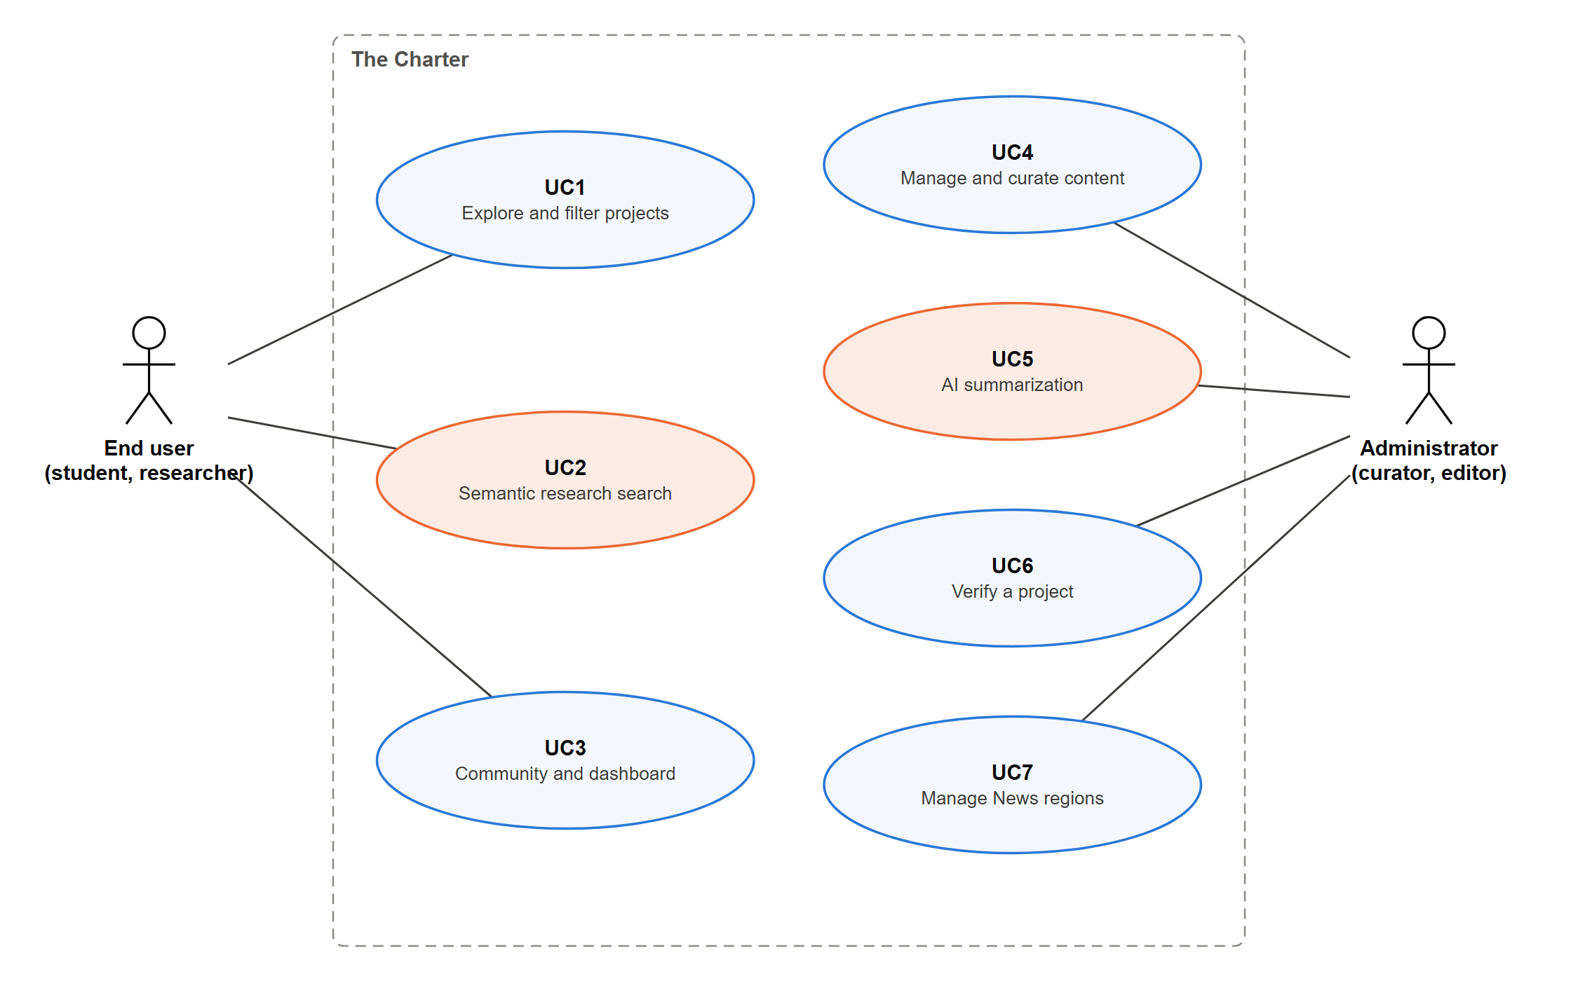
Figure 5. Use case diagram. Use cases that involve AI are shown in orange.

3.ii Use case descriptions (AI use cases)
Table 14. Use case description, UC2: Semantic research search
Field | UC2: Semantic research search
Actor | End user (student, researcher, faculty, journalist)
Description | The user describes a topic in their own words and receives the projects closest in meaning, best first, each with the passage that matched.
AI capability | Semantic retrieval: sentence embeddings compared by cosine similarity, merged with keyword ranking (hybrid).
Trigger | The user types in the search box with "By meaning" selected.
Preconditions | The user is signed in. Projects have been indexed: their text is split into passages and each passage has a vector.
Main flow | 1. The user enters a query.  2. The site sends it to GET /api/projects/search with mode = hybrid.  3. The system embeds the query with the sentence model.  4. The system finds the most similar passages and keeps the best passage of each project.  5. Passages below the relevance cut-off are discarded.  6. The system runs the keyword search and merges the two rankings.  7. The site lists the projects in rank order, each with the matched passage and its similarity, and shows their pins on the map.  8. The user may narrow the results with the category, SDG and year filters.
Alternative flows | A1. Nothing is close enough in meaning: the site says so and suggests rephrasing.  A2. The user selects "Keywords": only keyword matching is used.
Exceptions | E1. The model cannot be loaded: the system returns keyword results and tells the user that results are keyword matches only.  E2. The API cannot be reached: the site searches the titles, keywords and narration it already holds.
Postconditions | The user sees a ranked list of projects relevant to the meaning of the query, with the reason for each. Nothing is stored about the user.
Data used | Project title, place, keywords, description, summary, photo narration and PDF text. No user data.
Human oversight | The model ranks existing, curated projects and shows its evidence; it does not write or publish content.
Success measure | Hit@1, Recall@3 and MRR on a judged query set, compared with keyword search. Proposal target: retrieval precision of at least 80%.

Table 15. Use case description, UC5: AI summarization
Field | UC5: AI summarization
Actor | Administrator
Description | When the administrator uploads a project PDF, the system offers to summarize it. The AI writes a draft summary and suggests keywords, which the administrator reviews, edits and saves.
AI capability | Abstractive text summarization with distilbart-cnn-6-6, an open-source model chosen by cross-validation against five alternatives (Section 3.3). It runs on the server's CPU; no paid API.
Trigger | The administrator uploads a PDF in the project upload form.
Preconditions | The administrator is signed in and is creating or editing a project. The PDF has a text layer.
Main flow | 1. The administrator uploads the project PDF.  2. The system checks the file and stores it.  3. The system asks whether to generate a summary (Yes or No).  4. The system extracts the text from the PDF.  5. The AI model generates a draft summary and suggests keywords.  6. The system shows the draft in an editable field.  7. The administrator reviews it, edits it if needed and confirms.  8. The system saves the summary with the document's metadata and its status (suggested, edited or approved).
Alternative flows | A1. The administrator answers No: they write the summary themselves or leave it empty.  A2. The administrator rejects the draft: they ask for a new one or write their own.
Exceptions | E1. The PDF is scanned and has no text: the system says there is nothing to summarize.  E2. The file is not a PDF or is too large: it is rejected with a message.  E3. The abstractive model is unavailable: the extractive baseline summary is offered instead.
Postconditions | Only a summary confirmed by the administrator is stored and shown on the project page. The draft and the administrator's decision are kept for evaluation.
Data used | Text of the uploaded PDF. No personal data.
Human oversight | The summary is always a draft until the administrator confirms it. Photo narration is always written by the administrator and never generated.
Success measure | ROUGE-1 and ROUGE-L against summaries written by administrators, the administrator's rating, and the share of drafts accepted with few edits.

3.iii Functional requirements
Table 16. Functional requirements
ID | Requirement | Use case
FR1 | The system shall provide institutional sign-in and role-based access for approved users and administrators. | All
FR2 | The system shall display geolocated projects on an interactive map with zoom and project markers. | UC1
FR3 | The system shall let users filter projects by area of study, UN SDG, year range and keywords, in any combination. | UC1
FR4 | The system shall display project cards with image, title, description, author, institution, location, date and topic tags. | UC1
FR5 | The system shall provide keyword search over titles, descriptions, keywords, narration and PDF text, ranked by relevance. | UC1
FR6 | The system shall provide semantic search over project text and PDFs, returning ranked projects with the passage that matched. | UC2
FR7 | The system shall provide a Projects catalogue separate from the map, with the same filters. | UC1
FR8 | The system shall provide Community features: member discovery, advanced search, contacts and messaging. | UC3
FR9 | The user dashboard shall support profile editing, contacts and messages, saved projects and job opportunities. | UC3
FR10 | The system shall provide curated New Entries, an Events catalogue and sponsor information. | UC3, UC4
FR11 | Administrators shall upload a project as a PDF; the system shall store it, extract its text and make it searchable. | UC4
FR12 | Each photograph shall carry a narration written by the administrator; the system shall never generate narration. | UC4
FR13 | After a PDF is uploaded, the system shall ask whether to generate a summary, show the AI draft summary and suggested keywords for review and editing, and save them only when the administrator confirms. | UC5
FR14 | The system shall record the administrator's decision on each AI suggestion (accepted, edited or rejected). | UC5
FR15 | Administrators shall mark a project as verified, which shows the blue curation mark. | UC6
FR16 | Administrators shall choose which regions are shaded in News mode. | UC7

3.iv Non-functional requirements
Table 17. Non-functional requirements
ID | Category | Requirement
NFR1 | Performance | Primary pages shall load within 3 seconds on a typical broadband connection; filter and search interactions shall update within 2 seconds.
NFR2 | Scalability | Map and search requests shall still answer within 2 seconds with 10,000 projects, using pagination, marker clustering and database indexes.
NFR3 | Usability | At least 80% of usability-test participants shall complete the core project-discovery task without help.
NFR4 | Compatibility | The site shall work in current Chrome, Edge, Firefox and Safari, at widths from 360 px (phone) to desktop, with touch targets of at least 44 px.
NFR5 | Security | 100% of restricted endpoints shall reject requests without valid authorization, checked by automated tests; passwords shall be stored only as hashes; uploads shall be limited to PDFs of 50 MB and images of 25 MB, checked by file content.
NFR6 | Privacy | No personal data and no private messages shall be used as input to an AI model (0 personal fields in the model inputs).
NFR7 | AI transparency | 100% of AI outputs shall show their evidence or status: every semantic result shows the matched passage and its similarity score, and every AI summary is marked as a draft until the administrator confirms it.
NFR8 | Reliability | If the AI model is unavailable, 100% of non-AI functions (browsing, filters, keyword search, saving projects) shall keep working, and search shall fall back to keyword results within the 2-second target.
NFR9 | Accessibility | The interface shall meet WCAG 2.1 level AA: text contrast of at least 4.5:1, every control usable by keyboard, and no critical issues in an automated accessibility audit.
NFR10 | Reproducibility | Every reported AI result shall be reproducible with one command from the repository; the model name and version, settings and evaluation data shall be under version control.
NFR11 | Cost | The system shall have $0 in licence or usage fees: all models and libraries are open source and run on the server, with no paid external API.

NFR1 to NFR10 are from the proposal, with measurable targets added where the proposal had none. NFR11 was added when the partner confirmed that no paid services may be used.

Appendix 4: System Design

4.i List of technologies: hardware and software
Table 18. Technologies: hardware and software
Type | Item | Purpose
Hardware | Team laptops (Windows 11, 8 GB RAM, no dedicated GPU) | Development, testing and running the model on CPU
Hardware | Static hosting (Vercel, free tier) | Serves the 3D site
Hardware | Server for the API, database and model (to be chosen; tested at 2 CPUs and 2 GB RAM, Section 3.7) | Planned deployment of the back end
Software: AI | bge-small-en-v1.5 (BAAI), ONNX | Sentence embeddings for semantic search
Software: AI | distilbart-cnn-6-6, PyTorch 2.14 (CPU), Transformers 4.57 | AI summarization
Software: AI training | sentence-transformers 5.7, scikit-learn 1.9 (TF-IDF), rouge-score | Fine-tuning, baselines and evaluation
Software: AI | FastEmbed 0.9, ONNX Runtime 1.31, NumPy 2.4 | Runs the model on CPU; vector arithmetic
Software: AI | pgvector 0.8.6 (HNSW index, cosine distance) | Stores and searches passage vectors
Software: AI (browser) | Transformers.js 3.0, bge-small-en-v1.5 (8-bit) | Search by meaning in the visitor's browser on the deployed site
Software: AI | pypdf 6.19 | Extracts text from uploaded PDFs
Software: back end | Python 3.11, FastAPI 0.141, Uvicorn 0.54, Pydantic 2.13 | REST API and validation
Software: back end | SQLAlchemy 2.0, psycopg 3.3 | Database access
Software: data | PostgreSQL 16 with PostGIS 3.4 (SQLite for quick local runs) | Projects, authors, documents, map queries, full-text search
Software: data | Supabase (free plan): PostgreSQL with row-level security, file storage | Uploaded projects on the deployed site
Software: data | Docker and Docker Compose | Runs the database with both extensions; Linux image of the API for the stress test
Software: front end | HTML, CSS, JavaScript, D3 7, topojson-client 3.1, Natural Earth outlines | 3D globe site; no map API key
Software: testing | pytest 9.1, HTTPX, Playwright (headless browser checks) | Automated tests of the API and the site
Software: analysis | Matplotlib 3.10 | EDA and result figures
Software: tools | Git and GitHub, draw.io, Figma (partner's prototype) | Version control, diagrams, UI reference

4.ii AI capability description with data descriptions
The project has two AI features, both built and evaluated in this iteration: semantic research search (UC2) and AI summarization (UC5). The two tables below describe them.
Table 19. AI capability description: semantic research search
Element | Description
Purpose | Find projects by meaning, so that a user's own words retrieve relevant verified projects even when they differ from the project's wording.
Input | A text query of up to 200 characters; a mode (keyword, semantic or hybrid); a result limit.
Pre-processing | Indexing: project fields and PDF text are split into passages of whole sentences of at most 40 words with one sentence of overlap (length chosen by cross-validation). Keyword text is lower-cased and stripped of accents.
Model | bge-small-en-v1.5: a small transformer trained for retrieval, 384-dimension unit-length vectors, 66 MB. Chosen over two other pretrained models and two lexical baselines by 5-fold cross-validation (Section 3.1). Fine-tuning was tested and did not improve it, so the pretrained weights are used (Section 3.2).
Processing | The query vector is compared with every passage vector by cosine similarity (pgvector HNSW index on PostgreSQL; NumPy without pgvector). Each project takes the score of its best passage. Passages below 0.575, or below 95% of the best score, are dropped (cut-offs chosen by cross-validation). In hybrid mode the ranking is merged with the every-word keyword ranking by reciprocal rank fusion (k = 60, Section 3.6). On the deployed site, which has no back-end server, the same model and the same fusion run in the visitor's browser.
Output | A ranked list of projects. Each result has a score, how it was found (keyword, semantic or both), the matched passage, its similarity and the PDF it came from if any.
Human oversight | The capability ranks curated projects and shows its evidence. It creates and publishes nothing.
Fallback | Every path ends in a ranked list. If the back end is busy (503), fails or takes more than 8 seconds, the site searches in the browser. If the model cannot be loaded, hybrid mode returns keyword results only and says so (mode_used = keyword). Without pgvector, vectors are compared with NumPy. Saving projects is unaffected.
Success measures | Hit@1, Recall@3, MRR and list F1 on the judged query set, cross-validated, against keyword search and TF-IDF; no result for off-topic queries; response within 2 seconds, checked by a stress test (Section 3.7).
Limitations | Evaluated on 37 projects, 30 of them synthetic, with queries written by the team. Single-word names are weak semantic queries, which hybrid mode covers. Rare or specialist terms may be matched less well.
Cost | None: open-source model run on the server's CPU.

Table 20. AI capability description: AI summarization
Element | Description
Purpose | Draft a summary of an uploaded project for the administrator, so that publishing a project takes less reading and writing.
Input | The text of the uploaded PDF, or the typed description if there is no PDF.
Pre-processing | Text is extracted page by page with pypdf; empty pages are skipped. Text is split into sentences.
Model | distilbart-cnn-6-6 (230 million parameters), a distilled BART model trained to summarize news, run with PyTorch on the CPU. Greedy decoding, up to 60 new tokens; long documents are summarized in pieces of about 350 words and the piece summaries summarized again. Chosen over three other models and two baselines by ROUGE with 5-fold cross-validation (Section 3.3).
Output | A draft summary of two or three sentences, shown in an editable field labelled as an AI draft; keywords are suggested separately.
Human oversight | The administrator decides whether to summarize, then reviews, edits and confirms. Nothing is published unconfirmed. Photo narration is never generated.
Fallback | If the model is unavailable, the word-frequency baseline answers and the form says so; the administrator can always write the summary by hand.
Success measures | ROUGE-1, ROUGE-2 and ROUGE-L against reference summaries (cross-validated); later, the administrator's edits and rating.
Limitations | Abstractive models can state facts the document does not contain; the evaluated FLAN-T5 models did. About 5 seconds per report on a laptop CPU. Evaluated on 30 synthetic reports.
Cost | None: open-source model run on the server's CPU.

Data descriptions
Table 21. Data description: project record (table projects)
Field | Type | Description | Use by the AI capability
title | Text, up to 500 characters | Project title | Embedded (first passage); keyword weight A
description | Text; 22 to 40 words in the sample | Author's description | Embedded; keyword weight C
summary | Text, optional | Short summary confirmed by the administrator | Embedded; keyword weight C
captions | List of text; 11 to 114 words each | Narration written by the administrator, one per photograph | Embedded; keyword weight C
keywords | List of text; 8 to 11 per project | Author or administrator keywords | Embedded with the title; keyword weight B
location_name, lat, lng | Text and two numbers | Place name and coordinates | Place name embedded and keyword weight B; coordinates used by the map only
category | One of 5 values | Study category | Not used by the AI features
sdgs | List of codes SDG1 to SDG17 | UN SDG tags | Not used by the AI features
date, verified | Date and true/false | Project date and curation mark | Not used
images | List of file paths | Photographs (JPEG, PNG or WebP) | Not used; planned for image search
author | Name, role, affiliation, links | Author profile | Name and affiliation in keyword weight B only

Table 22. Data description: documents and passages (tables documents and search_chunks)
Field | Type | Description
Document: title, filename, pages, size | Text and numbers | An uploaded PDF belonging to a project
Document: text | Long text | Text extracted from the PDF. Searchable but never returned by the API. Embedded in passages; keyword weight D
Document: summary, keywords | Text and list | Suggestions produced from the PDF, editable by the administrator
Passage: project, document, position | References and a number | Which project, and which PDF if any, a passage belongs to, and its order
Passage: text | Text, up to 40 words | The passage shown to the user as the reason for a match
Passage: embedding | 384 numbers | The sentence vector, stored as vector(384) with an HNSW index
Passage: model | Text | Name of the model that produced the vector, so vectors from different models are never mixed

Table 23. Data description: datasets used in this iteration
Item | Description
Partner samples | 7 projects, 7 authors, 28 photographs with narration. File: backend/data/samples/projects.json. Supplied by the partner for development; not for redistribution.
Synthetic projects | 30 projects, 6 per category, in 22 countries, each with a field report (125 to 157 words) stored as the project's document and a reference summary. Written by the team; marked synthetic; never shown on the site. File: backend/data/synthetic/projects.json.
Judged queries | 122 queries: 38 exact names, 70 paraphrases, 5 topics, 9 off-topic; 13 with several relevant projects. File: backend/model_training/search_eval/queries.json.
Splits | 5-fold cross-validation: over queries (stratified by kind) to choose search settings; over projects to test fine-tuning on unseen projects; over reports to choose summarizer settings. Seed 42.
Personal data | None used by any model. Author names are public attribution; synthetic authors are fictional.

4.iii Architecture design (AI capability)
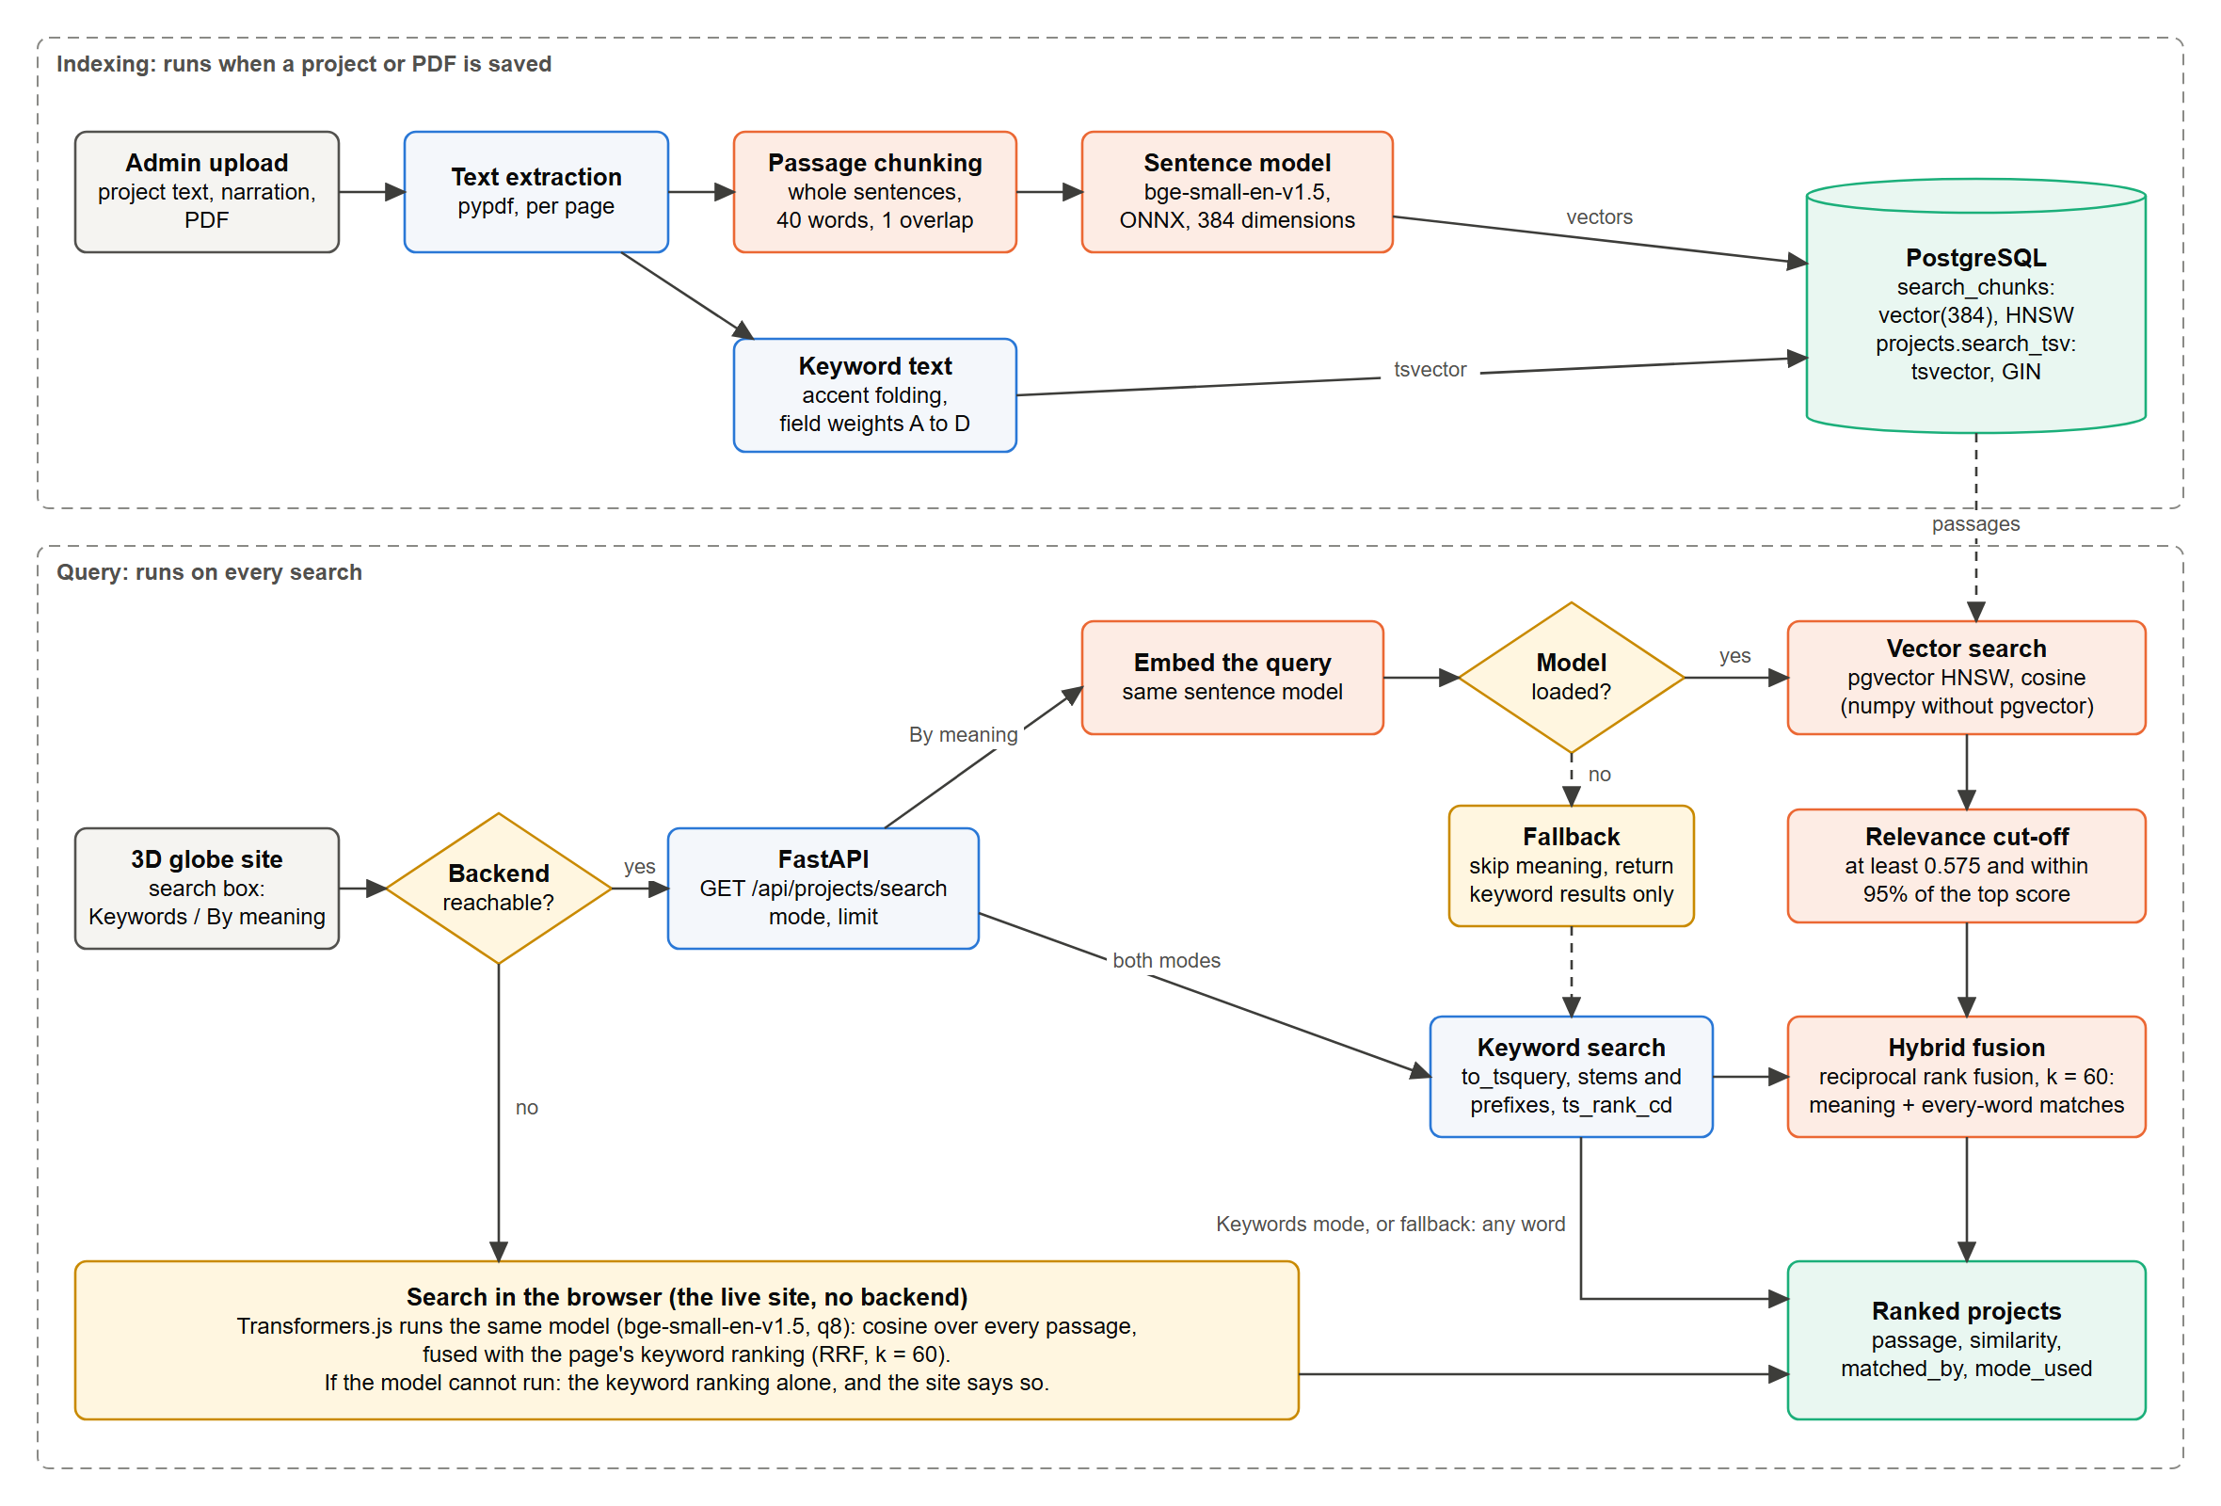
Figure 6. Architecture of the semantic search capability: indexing (top) and query (bottom). AI steps are shown in orange, data in green, decisions and fallbacks in amber.
Indexing runs when a project or PDF is saved. Query runs on every search. Both use the same sentence model, so a query and a passage are always compared in the same vector space. Every path ends in the ranked list: if the back end cannot be reached, the site searches in the browser; if the model is not loaded, the fallback returns keyword results only; in Keywords mode the keyword ranking is the answer and fusion is skipped. The diagram was corrected after the progress review, where the fallback had no outcome. The editable source is docs/diagrams/ai-capability-architecture.drawio.

4.iv Component diagram (AI capability)
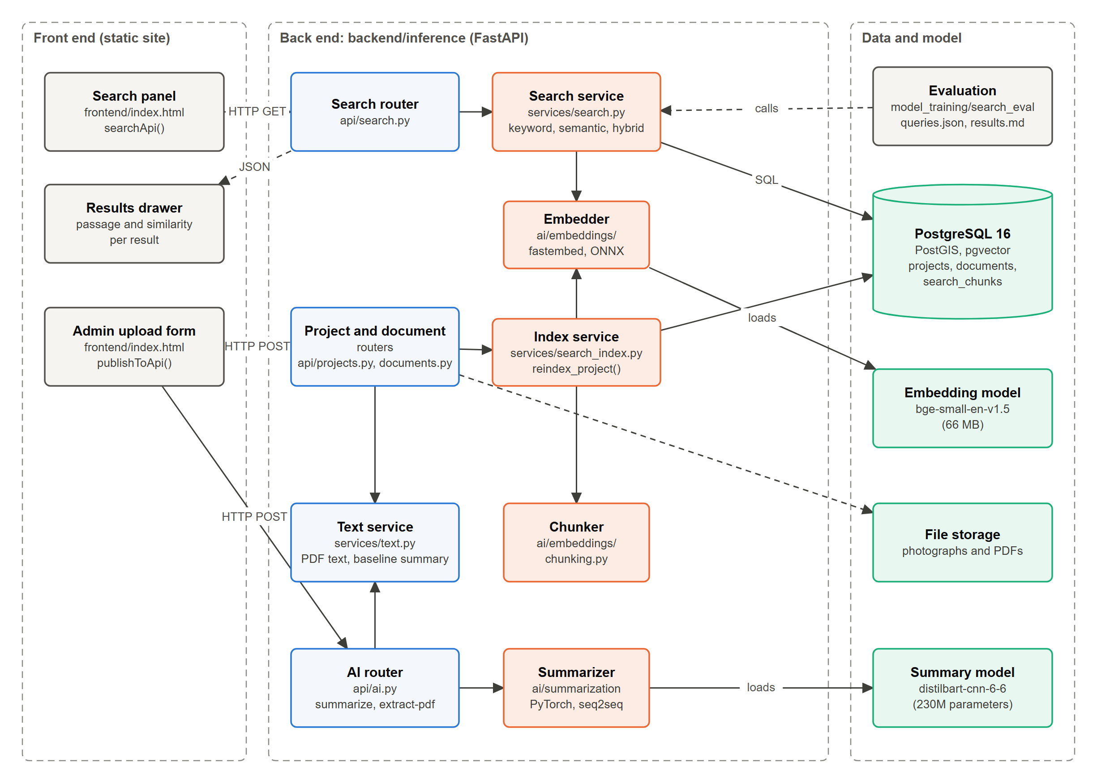
Figure 7. Components of the AI capability and the files that implement them. AI components are shown in orange, data in green.

4.v Database security
The platform uses PostgreSQL twice: Supabase holds the deployed site's uploads, and a Docker database holds the API's library and search index. The table below lists the measures, which support NFR5; the full instructions are in docs/security/postgresql.md.
Table 24. Database security measures
Measure | Where | Status
Row-level security: the database checks every read and write; only accounts in the admins table may change data | Supabase (schema.sql, pages.sql) | In place
Only the public anon key in the website; the service_role key, which skips the policies, never in the frontend | Deployed site | In place
Every query uses bound parameters, so search text cannot inject SQL | API | In place
Uploads limited to JPEG, PNG, WebP and PDF, 50 MB per file, administrators only | Supabase storage | In place
Privileges the site's roles never need removed (writing for visitors, reading the administrators list, TRUNCATE); tested on a copy set up like Supabase | Supabase (security.sql) | Added November 2026; to run on the live project
Database port open to the local computer only; password from an environment variable | Docker database | Added November 2026
Separate API role with only read and write rights, 5-second statement timeout, SSL, firewall on port 5432 | API database in deployment | Planned
Public sign-ups off, two-factor authentication, Security Advisor, backup before the demo | Supabase dashboard | To do

List of Acronyms
Table 25. List of acronyms
Acronym | Meaning
AI | Artificial intelligence
API | Application programming interface
CDN | Content delivery network
CPU | Central processing unit
EDA | Exploratory data analysis
FR | Functional requirement
GDELT | Global Database of Events, Language and Tone
GIN | Generalized inverted index (PostgreSQL index type used for full-text search)
GiST | Generalized search tree (PostgreSQL index type used for map queries)
GPU | Graphics processing unit
HNSW | Hierarchical navigable small world (index for nearest-neighbour search)
JSON | JavaScript Object Notation
MRR | Mean reciprocal rank
NFR | Non-functional requirement
NLP | Natural language processing
ONNX | Open Neural Network Exchange (portable model format)
PDF | Portable Document Format
REST | Representational state transfer
RLS | Row-level security (PostgreSQL)
ROUGE | Recall-Oriented Understudy for Gisting Evaluation (summary quality measure)
RRF | Reciprocal rank fusion
TF-IDF | Term frequency, inverse document frequency
SDG | United Nations Sustainable Development Goal
SQL | Structured Query Language
UC | Use case
UI | User interface
WCAG | Web Content Accessibility Guidelines

Glossary of Terms
Abstractive summarization: Summarization that writes new sentences, as opposed to copying sentences from the text.
Blue mark: The curation mark shown on a project once an administrator has verified its information.
Chunking: Splitting long text into short passages so that each passage fits what the sentence model can read.
Cross-validation: Splitting the data into k parts (folds), choosing settings on k-1 of them and measuring on the remaining one, k times, so no result comes from data used to choose the settings.
Cosine similarity: A measure of how close two vectors point in the same direction, from -1 to 1; used here to compare meanings.
Cut-off: The minimum similarity a passage needs to count as related to the query (0.575 with the chosen model).
Embedding: A list of numbers produced by a model to represent the meaning of a text; similar texts get similar embeddings.
Extractive summarization: Summarization that selects the most representative sentences of the text and keeps them as they are.
Fallback: What the system does when a part is unavailable, so the user still gets an answer; here, keyword results when the model is missing and search in the browser when the API is busy.
Fine-tuning: Continuing to train a pretrained model on data from the project's own domain.
Full-text search: Keyword search that matches words after reducing them to their stems and ranks documents by where and how often the words appear.
Hit@1: The share of test queries whose first result is relevant.
Hybrid search: A search that merges the keyword ranking and the semantic ranking into one list.
List F1: The F1 score of the whole list a search returns against the relevant projects; 1 for an off-topic query only if nothing is returned.
Narration: The text written by the administrator to accompany each photograph; it is never generated by AI.
Passage: A short piece of a project's text, of at most 40 words, that is embedded and searched.
pgvector: A PostgreSQL extension that stores embeddings and finds the most similar ones.
PostGIS: A PostgreSQL extension for geographic data, used for map queries.
Recall@3: The share of the relevant projects that appear in the first three results.
ROUGE: A family of measures of how many words and word sequences a summary shares with a reference summary.
Reciprocal rank fusion: A way to merge ranked lists in which each item scores 1 / (60 + its rank) in every list it appears in.
Sequence-to-sequence model: A language model that reads a text and writes a new text, used here to write summaries.
Row-level security: A PostgreSQL feature that checks every row read or written against a policy, so the database itself enforces who may see or change data.
Semantic search: Search by meaning: projects are found because their text means something similar to the query, even when the words differ.
Sentence model: A pretrained language model that turns a sentence or passage into an embedding.
Stress test: Running a system under a growing number of simultaneous users to find its capacity and the faults that appear under load.
Synthetic data: Records written to resemble real data, used for training and evaluation when real data is scarce.
Stemming: Reducing a word to its root so that "migrating" and "migration" match.

